Supplementary information:

Pleural mesothelioma cell-derived sEVs promote epithelial-to-mesenchymal transition and T-cell suppression through the PD-L1 expression

Sareh Zhand^{1,2¥}, Hamidreza Aboulkheyr ^{2¥}, Emma M Rath^{3,4}, Dale Mark Goss², Andrew Cheng¹, Julia Shi Hua Ngai¹, Ziyu Wang^{5,6,7}, Jiayan Liao¹, Olivia Guido⁸, Elizabeth Lawfull⁸, Xiaofeng Cheng¹, Marco A. Enriquez Martinez⁹, Nick Wastra van Holthe⁹, Alan E. Rowan^{9,†}, Majid Ebrahimi Warkiani^{1,2,#, *}, Yuen Yee Cheng^{2*}

¹ Institute for Biomedical Materials and Devices, Faculty of Science, University of Technology Sydney, New South Wales 2007, Australia
2 School of Biomedical Engineering, University of Technology Sydney, Sydney, New South Wales 2007, Australia
³ Giannoulatou Laboratory, Victor Chang Cardiac Research Institute, Darlinghurst, New South Wales, 2010, Australia.
⁴ School of Clinical Medicine, Faculty of Medicine and Health, University of New South Wales, Sydney, New South Wales 2052, Australia
⁵ Charles Perkin Centre, Sydney, New South Wales 2006, Australia
⁶ School of life and Environmental science, university of Sydney, Sydney, New South Wales 2006, Australia
⁷ The Baird Institute, Sydney, New South Wales 2042, Australia
⁸ Australian BioResources, Moss Vale, New South Wales 2577, Australia
⁹ Australian Institute for Bioengineering and Nanotechnology, University of Queensland, Queensland, Australia

† Current affiliation of Alan E. Rowan is University of Wollongong, NSW, Australia
# current affilication of Majid Ebrahimi Warkiani is Advanced Biosciences and Bioengineering Research Center, American University of Sharjah, UEA
¥These authors contributed equally as the first author.

* Corresponding authors:

Majid Ebrahimi Warkiani (Majid.Warkiani@uts.edu.au)
School of Biomedical Engineering, University of Technology Sydney, Sydney, New South Wales 2007, Australia

Yuen Yee Cheng (yuenyee.cheng@uts.edu.au)
School of Biomedical Engineering, University of Technology Sydney, Sydney, New South Wales 2007, Australia

Materials and methods
Reagents
Primary antibodies for western blotting and immunostaining included anti-human CD63 (H5C6), CD9 (HI9a), CD81 (5A6), GAPDH (FF26A/F9), anti-human CD324 (E-cadherin)–Alexa Fluor 594 (324118), anti-human vimentin–Alexa Fluor 488 (677809), and Brilliant Violet 785 anti-mouse CD4 (100453) (BioLegend). Rat anti-mouse CD8a PerCP-Cy5.5 (561109) was from BD Biosciences. Anti-PD-L1 polyclonal antibody (PA5-20343), HRP-goat anti-rabbit IgG (H+L) (31460), anti-mouse CD3 (16-0032-82), anti-mouse CD28 (16-0281-82), and goat anti-rabbit Alexa Fluor 647 (A-21244) were from Thermo Fisher Scientific/eBioscience. Core reagents included RIPA buffer (89900), BCA assay kit (23227), 4× Bolt LDS buffer (B0007), PVDF membranes (88585), Bolt 4–12% Bis-Tris gels (NW04120BOX), SuperSignal West Dura (37071), Alamar Blue (DAL1025) and RNase A (EN0531) (Thermo Fisher Scientific). PBS, BSA (A3059-10G), paraformaldehyde (441244), Triton X-100 (93443), propidium iodide (P4864), PKH67 (PKH67GL-1KT), Amicon Ultra-0.5 10 kDa MWCO (ACS501024) and DTT (10197777001) were from Sigma-Aldrich. Human PD-L1 ELISA (ab277712), anti-E-cadherin (AB314063-1001), anti-vimentin (AB20346) and human cytokine array (ab133996) were from Abcam. StemXVivo EMT supplement (CCM017) and Proteome Profiler Mouse Cytokine Array Panel A (ARY006) were from R&D Systems. DAPI (130-111-570) was from Miltenyi Biotec. Human/Mouse TGF-β1 Uncoated ELISA Kit (88-8350) was from Invitrogen, Australia. Phospho-SMAD2/SMAD3 (Ser465/467, Ser423/425) antibody (PA5-110155) was Thermo Fisher Scientific, Australia.

Bioinformatics analysis
Genomic and transcriptomic data for TCGA mesothelioma (n = 87) were downloaded from the UCSC Xenabrows data hub (https://xenabrowser.net/). TME inference and stromal/immune scoring were performed using published algorithms. ¹ Immune-cell clustering and proportion estimation used Immun-Cell AI. ² The stromal and immune scores of samples were calculated according to the previously developed algorithm ¹. All data and statistical analysis were performed under R-Studio.

Nanoparticle tracking analysis.
Nanoparticle tracking analysis (NTA) was performed on a ZetaView PMX-420 QUATT system (Particle Metrix, Germany) equipped with a 532nm green laser for determining the sEV concentration and size distribution. 100µL isolated sEV samples were diluted to 500µL with freshly filtered PBS (0.22µm filter) and loaded into the detection chamber by syringe. The camera was manually set and kept the same for all samples with a slider shutter of 650 and slider gain 50. 30s videos were recorded, and the number of captures was 5. The detection threshold was set to 6, and the blur and max jump distance were automatically set. The temperature was maintained at 25ºC. The data were processed by the NTA software (8.05.14 SP7 version).

Western blot
In order to evaluate the purity of the sEV isolation, the MSTO-211H and AB1 cell derived sEVs were lysed by adding an equal volume of RIPA Lysis and Extraction Buffer (Thermo Fisher, USA). The protein concentration of the sEVs were measured using a Pierce BCA protein assay kit (Pierce Biotechnology), according to the manufacturer's instructions. For western blot analysis, sEV proteins (2×10⁸ particles; ~5µg) were resolved using Bolt™ 4-12% Bis-Tris Plus Gels (Invitrogen, USA). Samples were diluted in 4X Bolt™ LDS Sample Buffer (Thermo Fisher) and heated up at 95ºC for 5 minutes, then transferred on to polyvinylidene difluoride (PVDF) membranes (Thermo Fisher, USA). The murine and human samples were run in two separate membranes. The PVDF membrane was blocked for one hour at room temperature with 5% non-fat powdered milk in PBS-T (PBS and 0.5% Tween-20) and incubated overnight at 4ºC with the following primary antibodies separately: The anti-human PD-L1, anti-human CD63, purified anti human CD9, purified anti human CD81, and purified anti-GAPDH (1:500 in PBS-T). The anti-mouse PD-L1, anti-mouse CD63, purified anti mouse CD9, purified anti mouse CD81, and purified anti-GAPDH (1:500 in PBS-T). In the next step, the blots were incubated with appropriate HRP-conjugated goat anti-mouse IgG, and goat anti rabbit IgG secondary antibody (1:2000), and HRP-conjugated goat anti-rabbit IgG secondary antibody (1:20,000) in PBS-T for 2 hours at room temperature. The blots were washed three times with PBS-T buffer for 5 minutes after each incubation step then visualized using with a SuperSignal West Dura Extended Duration Substrate (Thermofisher, USA). The PD-L1 protein was resolved under fully denaturing and reducing conditions, however, the CD63, CD9, CD81, and GAPDH proteins were resolved under non-reducing conditions.

Cryo electron microscopy (Cryo-EM)
Cryo-electron microscopy (cryo-EM) was utilized to examine the morphology of small extracellular vesicles (sEVs) isolated via ultracentrifugation. In this procedure, approximately 4.5 μL of sEV sample (equivalent to around 10^6 particles) was applied onto glow discharged Quantifoil R2/2 copper grids (Quantifoil Micro Tools). The grids were then blotted for 2.5 s in a chamber maintained at 95% humidity before being plunged into liquid ethane using a Lecia EM GP device (Leica Microsystem). Imaging was conducted using a Talos Arctica cryoTEM (Thermo Fisher Scientific) operating at 200kV, with the specimen maintained at liquid nitrogen temperatures. Images were captured at 28000× magnification using a Falcon 3EC direct detector camera operated in linear mode.

sEV uptake analysis
The sEVs isolated from NCI-H28 cells were labelled PKH67 according to the manufacture's protocol, purified by ultracentrifugation (190,000×g, 2 hours, 2–8 °C) and Amicon 10 kDa filtration The NCI-H28 cells were seeded on 12-well dishes, and 10 μg labelled sEVs were added into each well. After 4h, 6h, and 24h incubation, the cells were washed twice with PBS and fixed with 4% paraformaldehyde in PBS for 30 minutes at room temperature. Nuclei were stained with DAPI. The cellular uptake of sEVs was examined by confocal microscopy (Leica stellaris 5, Wetzlar, Germany). The internalization of sEVs was confirmed visually by the presence of intracellular punctate fluorescence in the cytoplasm of the cells.

Liquid Chromatography–Tandem Mass Spectrometry (LC–MS/MS)
Protein isolation and processing followed an adapted workflow based on previously described STAGE Tip methods ³. Protein content from each cell and isolated sEV sample was determined using the Pierce BCA Protein Assay Kit (Thermo Fisher Scientific, Waltham, USA) according to manufacturer’s protocol. For LC–MS/MS preparation, approximately 50 µg protein (as determined by the BCA assay) was diluted in digestion buffer containing 100 mM HEPES (pH 8.5) and 1% sodium deoxycholate (SDC) at a 1:10 ratio. Tris (2-carboxyethyl) phosphine hydrochloride (500 mM) and iodoacetamide (1 M) were added at a 1:25 ratio to the sample volume, and the mixture heated to 95 °C for 5 min for denaturation, reduction, and alkylation. After cooling to room temperature, proteins were digested overnight at 37 °C using sequencing-grade trypsin (1 µg/µL; Promega, USA) at an enzyme:substrate ratio of 1:50. Digestion was stopped by adding an equal volume of acetonitrile containing 1% trifluoroacetic acid (TFA). Peptides were cleaned and enriched using STAGE Tips prepared from SDB-RPS Empore disks (47 mm; 3 M) cut with a 14G flat-ended needle and inserted into 100 µL pipette tips. Following vortex mixing, ~10 µg of digested peptides was loaded onto each tip, washed with 100 µL of 99% acetonitrile + 1% TFA, and eluted with 50 µL of 5% ammonium hydroxide in 80% acetonitrile by centrifugation at 1000 × g for 5 minutes into autosampler vial inserts. Eluates were dried in a high-power SpeedVac (Thermo Fisher Scientific) for 1 hour and resuspended in 100 µL of 0.1% formic acid to achieve a final peptide concentration of 0.4 µg/µL. Using an Acquity M-class nanoLC system (Waters, USA), 5 µL of peptide solution was loaded at 15 µL/min for 3 minutes onto a nanoEase Symmetry C18 trapping column (180 µm × 20 mm), then transferred to a heated (45 °C) picofrit column (75 µm ID × 350 mm; New Objective, USA) packed with SP-120-1.7-ODS-BIO resin (1.7 µm, Osaka Soda Co., Japan). Peptides were separated with a gradient of 5–30% MS buffer B (98% acetonitrile + 0.2% formic acid) over 90 min, 30–80% over 3 min, held at 80% for 2 min, then returned to 5% over 3 min. Ionization was performed at 2400 V, and a data-dependent MS/MS method was run on a Q Exactive Plus mass spectrometer (Thermo Fisher Scientific, USA). The survey scan range was 350–1500 Da at 70,000 resolutions for peptides with charge state ≥2, AGC target 3e6, and maximum injection time 50 ms. The top 12 precursor ions were selected for fragmentation in the HCD cell (1.4 m/z isolation window), AGC target 1e5, maximum injection time 100 ms, with product ions analysed in the Orbitrap at 17,500 resolutions over 120–2000 Da. Dynamic exclusion was set at 30 s. MS/MS data were processed in PEAKS Studio X Pro against the human proteome database (2025) and a common contaminant list. Search parameters were: no fixed modifications; variable modifications including deamidation, oxidation, carbamidomethylation, and demethylation ; trypsin as the protease; up to three missed cleavages allowed; peptide mass tolerance 10 ppm; MS/MS mass tolerance 0.05 Da. Results were filtered for peptides with –log10 p scores corresponding to an FDR < 1%, defined where decoy matches represented <1% of total identifications.
For each comparison group, Gene Set Enrichmement Analysis (GSEA) was carried out for all genes having limma differential expression analysis results, ranked by the t-statistic from highest to lowest and including genes that did not reach statistical significance. GSEA was carried out in R (version 4.5.1), using the fgsea package ⁴, for the Reactome pathways (reactome.db version 1.92.0) ⁵ and for Gene Ontology Biological pathways (msigdbr version 2025.1.Hs) ⁶ fetched from msigdbr (version 25.1.1), using pathway sizes of 10 to 500 genes.

List of videos.
Video 1: Uptake of PKH67-labeled sEVs (green) by NCI-H28 cells at 6 h; nuclei counterstained with DAPI (blue).
Video 2: Time-lapse migration assay of H28 cells. Cells were stained with CellTracker and imaged overnight every 30 minutes using a TIE1 microscope. (A) H28 control: baseline migration of untreated H28 cells. (B) H28 + sEV: H28 cells treated with sEV derived from MSTO cells, showing enhanced migratory behavior. (C) H28 + EMT kit: H28 cells treated with EMT inducing kit, displaying altered migration patterns compared to control.

List of Figures:
Figure S1: Proteomic profiling and functional enrichment analysis of H28 and MSTO derived sEVs. (A) Heatmap of differentially expressed proteins in sEVs derived from H28 versus MSTO cells, shown as z-scores, reveals distinct proteomic signatures enriched in stress-response, proteostasis, and cytoskeletal remodeling proteins. (B) Reactome GSEA highlights enrichment in pathways related to cellular responses to stress and stimuli, cell cycle regulation, ARE-mediated mRNA stability, and programmed cell death. (C) GO:BP enrichment analysis identifies positively enriched processes including cell growth, defense responses, protein folding, and cell differentiation, while cell-substrate adhesion is negatively enriched.
Figure S2: Proteomic landscape and pathway enrichment analysis of H28 and MSTO mesothelioma cells. (A) Heatmap of differentially expressed proteins (z-scores) demonstrates distinct proteomic signatures between H28 and MSTO cells, with enrichment of metabolic enzymes, proteasome subunits, and cytoskeletal regulators. (B) GO:BP enrichment analysis further reveals upregulation of processes including oxidative phosphorylation, protein folding, and chromatin organization, with negative enrichment of pathways related to cell adhesion and cytoskeletal dynamics, consistent with the more mesenchymal-like phenotype of MSTO cells. (C) Reactome GSEA of cellular proteomes highlights broad enrichment of pathways involved in metabolic regulation, DNA repair, cell cycle control, and stress responses, reflecting intrinsic molecular differences between H28 and MSTO cells.
Video 1:
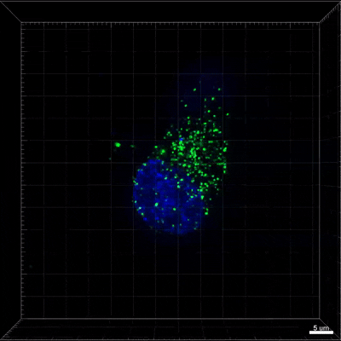

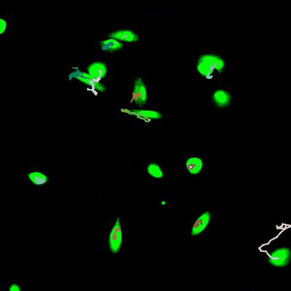
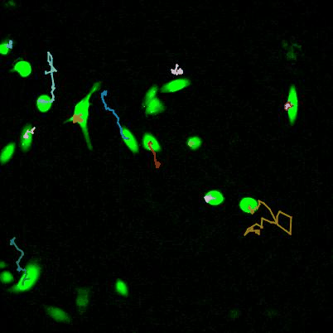
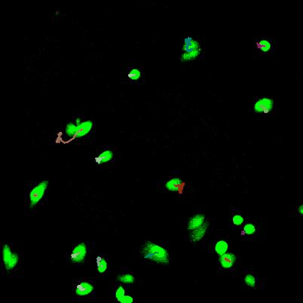
Video 2:
H28+EMT kit
H28+sEV
H28

Fig S1
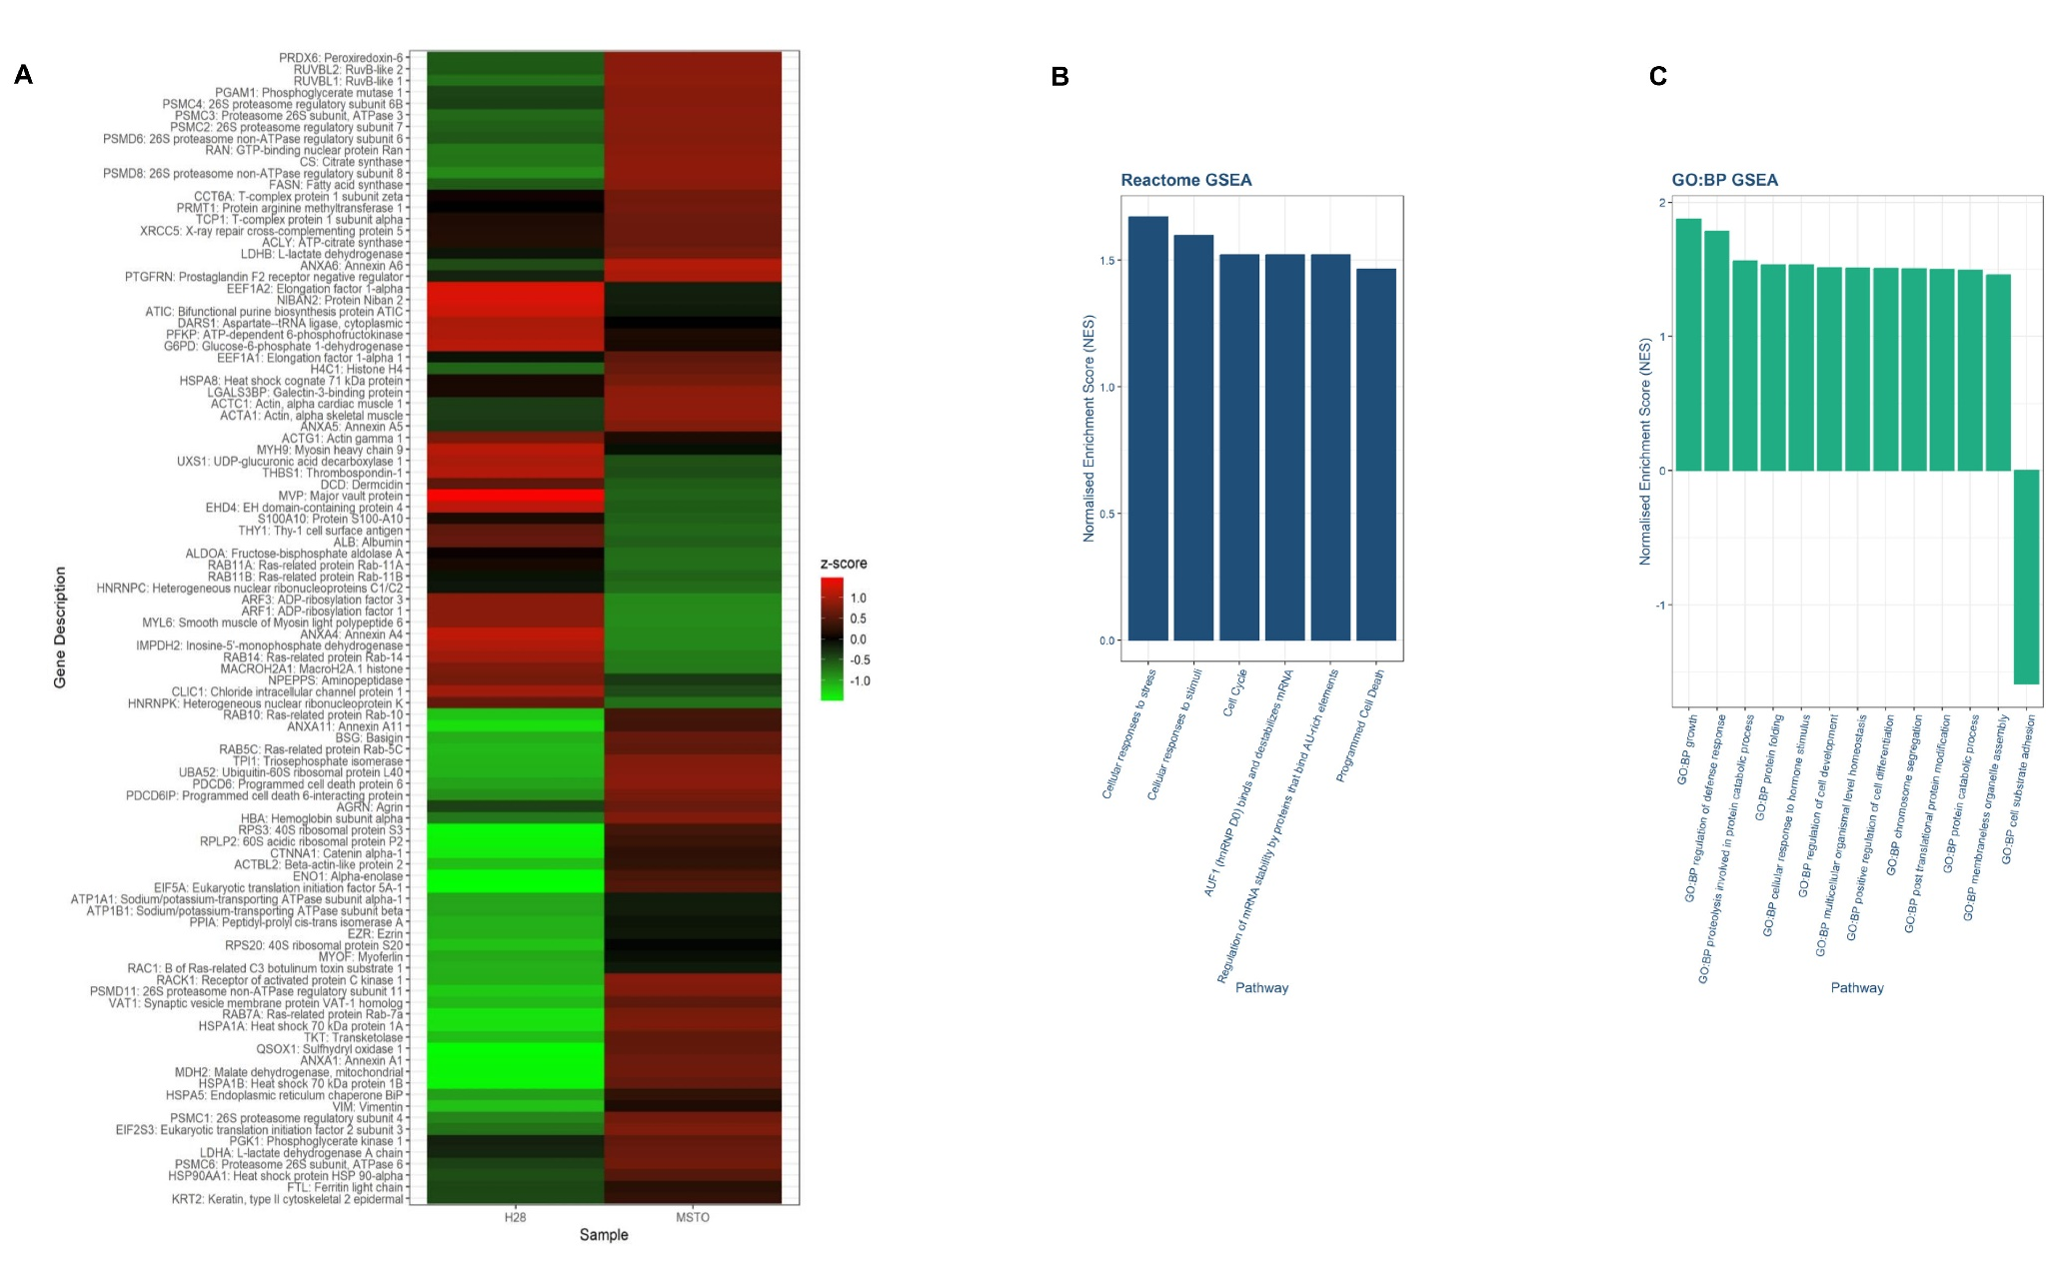
Fig S2
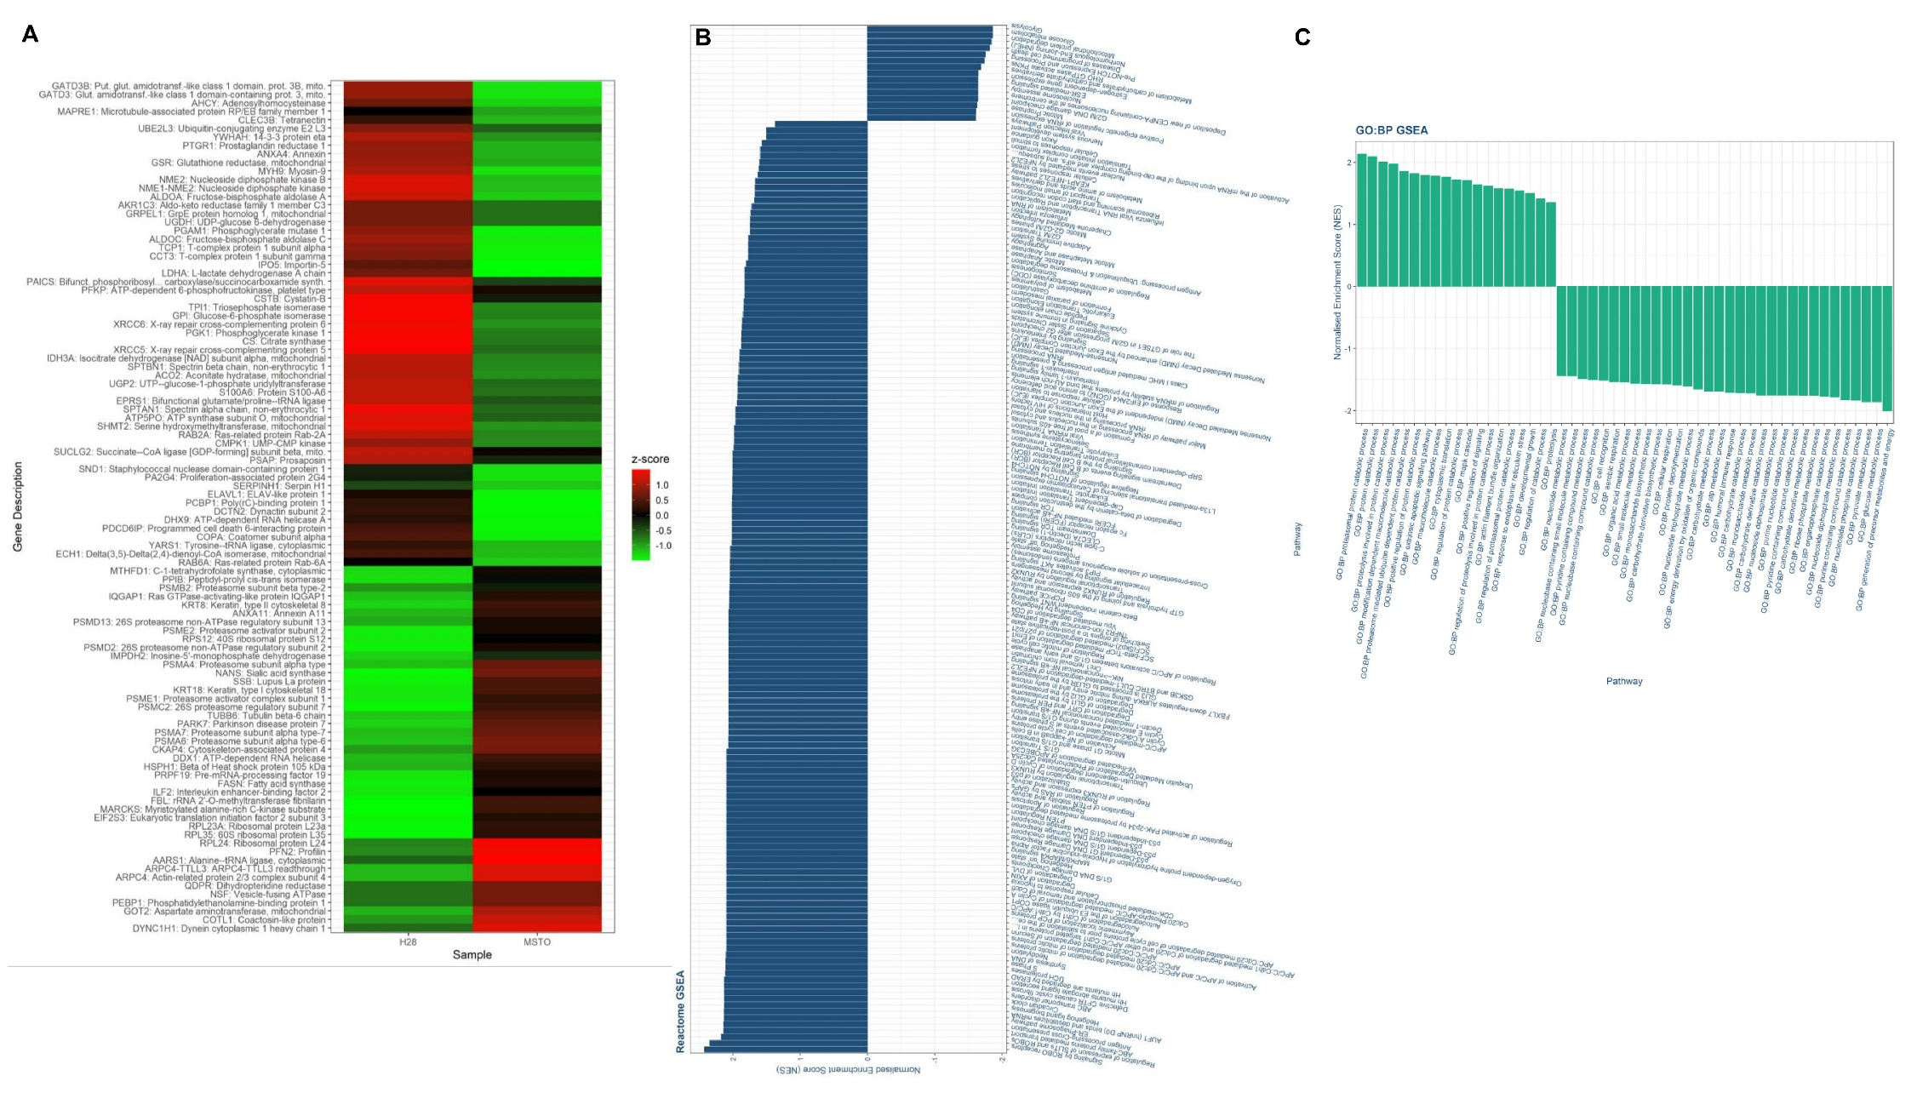

References:
1 Thorsson, V. et al. The Immune Landscape of Cancer. Immunity 48, 812-830.e814 (2018). https://doi.org/10.1016/j.immuni.2018.03.023
2 Miao, Y. R. et al. ImmuCellAI: A Unique Method for Comprehensive T-Cell Subsets Abundance Prediction and its Application in Cancer Immunotherapy. Adv Sci (Weinh) 7, 1902880 (2020). https://doi.org/10.1002/advs.201902880
3 Harney, D. J. et al. Small-protein Enrichment Assay Enables the Rapid, Unbiased Analysis of Over 100 Low Abundance Factors from Human Plasma*[S]. Molecular & Cellular Proteomics 18, 1899-1915 (2019). https://doi.org/https://doi.org/10.1074/mcp.TIR119.001562
4 Korotkevich, G. et al. Fast gene set enrichment analysis. bioRxiv, 060012 (2021). https://doi.org/10.1101/060012
5 Milacic, M. et al. The Reactome Pathway Knowledgebase 2024. Nucleic Acids Res 52, D672-d678 (2024). https://doi.org/10.1093/nar/gkad1025
6 Aleksander, S. A. et al. The Gene Ontology knowledgebase in 2023. Genetics 224 (2023). https://doi.org/10.1093/genetics/iyad031

