SUPPORTING INFORMATION

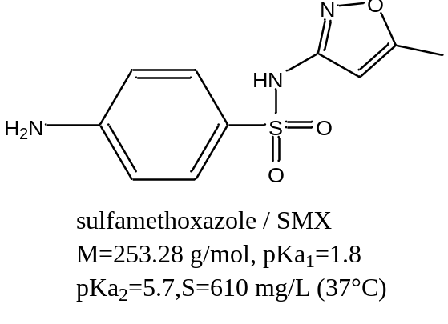
Fig.S1 Structure and selected chemical properties of Sulfamethoxazole (SMX) [1-3]

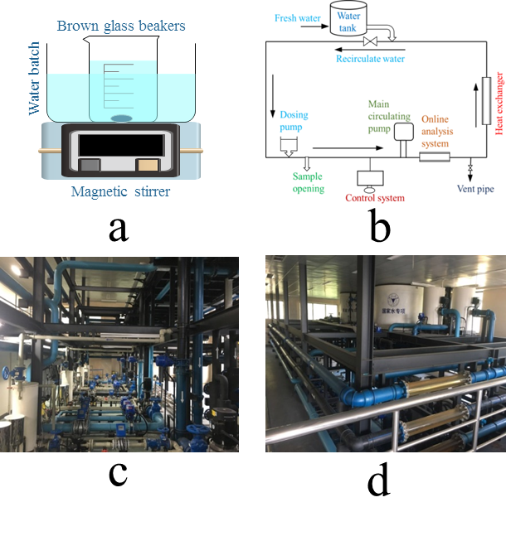
Fig.S2 Schematic representation of batch reactor (a) and water distribution systems (b is the illustration of WDS model, c and d are real pictures)

Table S1 Characteristics of tap water in Hangzhou, Zhejiang, China
Water | pH | Temperature  (℃) | Dissolved oxygen  (DO, mg/L) | Conductivity  (μs/cm) | Total organic carbon  (TOC, mg/L) | Residual chlorine concentration  (mg/L)
Tap water | 7.11-7.49 | 18.15-21.35 | 8.20-9.63 | 563-607 | 3.087-4.265 | 0.03-0.08

Table S2 Sequences of primers for PCR and qPCR.
Target gene | Primer pairs | 5′→3′sequence
sul 1 | sul 1 F | CGCACCGGAAACATCGCTGCAC
sul 1 | sul 1 R | TGAAGTTCCGCCGCAAGGCTCG
sul 2 | sul 2 F | TCCGGTGGAGGCCGGTATCTGG
sul 2 | sul 2 R | CGGGAATGCCATCTGCCTTGAG
intI1 | IntI1-F | GGCTTCGTGATCICCTGCTT
intI1 | IntI1-R | CATTCCTGGCCGTGGTTCT
16S rDNA | V3-FW(341F) | CCTACGGGAGGCAGCAG
16S rDNA | V3-RV(518R) | ATTACCGCGGCTGCTGG
The qPCRs were conducted in 96-well plates with a final volume of 20 μL mixture, containing 10μL SYBR Premix Ex Taq (TaKaRa, Bio, Shiga, Japan), 7.2 μL DNA-free water, 2 μL template DNA and 0.2 μM forward and reverse primers. The temperature procedure was as the following: initial denaturation step for 180 s at 95 °C and then 35 cycles of amplification containing denaturation for 30 s at 94 °C, annealing for 30 s at 55 °C and extension for 60 s at 72 °C, with a final extension step for 600 s at 72 °C.

Table S3 First-order rate constants (k₁) and goodness of fit (R²) of SMX degradation at different chlorine concentration.
FC(mg/L) | Batch reactor |  |  | WDS
FC(mg/L) | k₁(min⁻¹) | R² |  | k₁(min⁻¹) | R²
0.4 | 0.07394 | 0.9934 |  | 0.07087 | 0.9746
0.6 | 0.15341 | 0.99709 |  | 0.09473 | 0.98961
0.8 | 0.26667 | 0.99944 |  | 0.17617 | 0.99431
1.0 | 0.34836 | 0.9995 |  | 0.24479 | 0.95029

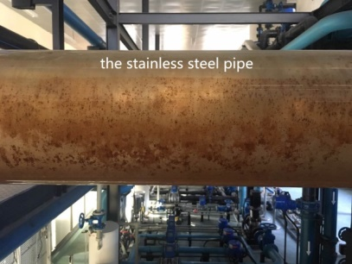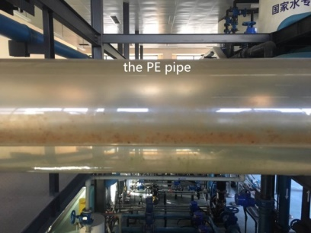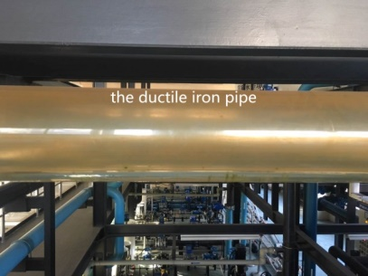
Fig. S3 The sediment existed in the stainless steel, PE pipe and ductile iron pipe through the visible pipe section.

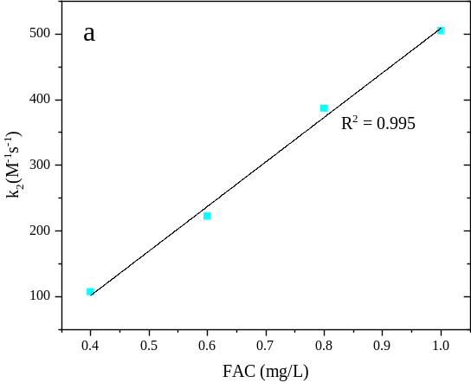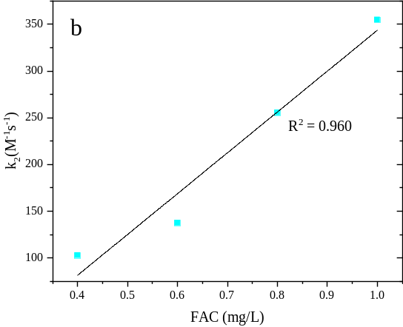
Fig. S4 Second order kinetics (k₂) plot of SMX degradation in batch reactor(a) and WDS(b).

Table S4 First-order rate constants (k) and goodness of fit (R²) of SMX degradation at different pH.
Batch reactor |  |  |  | WDS
pH | k(min⁻¹) | R² |  | pH | k(min⁻¹) | R²
6.3 | 0.117 | 0.999 |  | − | − | −
6.6 | 0.132 | 0.974 |  | 6.6 | 0.097 | 0.989
6.9 | 0.139 | 0.999 |  | 7.0 | 0.107 | 0.973
7.2 | 0.110 | 0.999 |  | 7.4 | 0.085 | 0.988
7.5 | 0.092 | 0.992 |  | 7.8 | 0.058 | 0.979
7.8 | 0.085 | 0.994 |  | 8.2 | 0.045 | 0.970
8.1 | 0.064 | 0.993 |  | − | − | −
8.4 | 0.050 | 0.999 |  | − | − | −
8.7 | 0.038 | 0.993 |  | − | − | −
9.0 | 0.027 | 0.970 |  | − | − | −

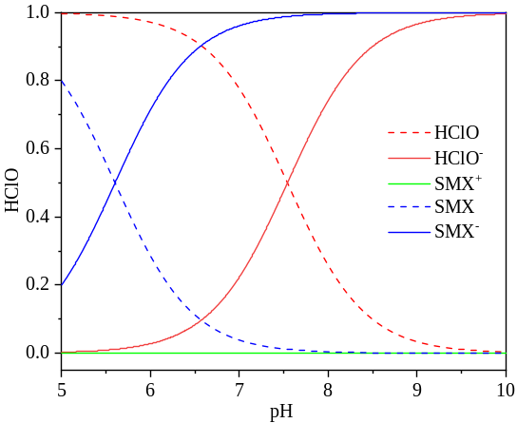
Fig. S5 Mole fraction of HClO and SMX at different pH

Table S5 First-order rate constants (k), goodness of fit (R²) and Reynolds number (Re) of SMX degradation at different flow velocities in WDS (ductile iron pipe).
Flow rate(m/s) | WDS
Flow rate(m/s) | k(min⁻¹) | R² | Re
0.7 | 0.129 | 0.986 | 117318
1.0 | 0.190 | 0.995 | 167597
1.3 | 0.211 | 0.984 | 217877
1.5 | 0.201 | 0.994 | 251396

Table S6 First-order rate constants (k), goodness of fit (R²) of SMX degradation in different pipe materials
Pipe materials | WDS
Pipe materials | k(min⁻¹) | R²
Polyethylene pipe (PE) | 0.139 | 0.992
Stainless steel (SS) | 0.358 | 0.976
Ductile iron (DI) | 0.191 | 0.996

REFERENCES
[1] M.C. Dodd, C.H. Huang, Transformation of the antibacterial agent sulfamethoxazole in reactions with chlorine: Kinetics mechanisms, and pathways, Environmental Science & Technology 38(21) (2004) 5607-5615. https://doi.org/10.1021/es035225z.
[2] A. Bialk-Bielinska, S. Stolte, J. Arning, U. Uebers, A. Boschen, P. Stepnowski, M. Matzke, Ecotoxicity evaluation of selected sulfonamides, Chemosphere 85(6) (2011) 928-933. https://doi.org/10.1016/j.chemosphere.2011.06.058.
[3] Y. Yao, Y. Zhang, B. Gao, R.J. Chen, F. Wu, Removal of sulfamethoxazole (SMX) and sulfapyridine (SPY) from aqueous solutions by biochars derived from anaerobically digested bagasse, Environ. Sci. Pollut. Res. 25(26) (2018) 25659-25667. https://doi.org/10.1007/s11356-017-8849-0.

