Supplementary Material
Closing the science–planning gap in wetland salinization: a managed-transition framework tested in the Indian Sundarbans

Appendix S1. Search strategy and reproducibility
Database: Scopus. Records retrieved and exported: 775 (1986-2025)

Search query (applied to title, abstract and keyword fields):
TITLE-ABS-KEY (salinization AND wetland)
Equivalent interface entry: the search was run in the Scopus document search with the field set to “Article title, Abstract, Keywords” and the search term "Salinization wetland," which returned 775 documents. No date, language or document-type limits were applied at the search stage.
Fields exported: authors, title, year, source, volume/issue, citations, DOI, affiliations, abstract, author and index keywords, document type, language. The cited-references field was not included; co-citation analysis was therefore not performed (a stated limitation).

Appendix S2. Study-selection accounting (selection schematic; not a formal PRISMA screening)
Stage | n
Records identified from Scopus (database search) | 775
Records screened for relevance to wetland salinization | 775
Full corpus retained for bibliometric and topic-model analysis | 775
Studies assessed in depth for the mechanistic synthesis | 23
Core studies in qualitative synthesis (Section 5) | 23

All 775 Scopus records retrieved were used for the bibliometric and topic-model analyses. From these, 23 studies with the strongest causal attribution and management relevance were selected for the in-depth mechanistic synthesis (Section 5). Selection was purposive rather than an exhaustive, dual-screened systematic review; no protocol was registered and no inter-rater agreement statistic was computed. This table is therefore presented as a study-selection schematic rather than a PRISMA screening record, and the corresponding figure (Fig. 1A) should be read in the same way. All 23 studies listed in Appendix S5 are included in the manuscript reference list.

Appendix S3. Bibliometric and corpus indicators
Indicator | Value
Documents | 775
Timespan | 1986–2025
Sources (journals/books) | 367
Total citations | 25,951
Mean citations per document | 33.5
Median citations | 12
Corpus h-index | 73
Annual growth (2015–2025) | ~+141%
Bradford Zone 1 (core) | 23 sources / 260 articles
Bradford Zone 2 | 88 sources / 257 articles
Bradford Zone 3 | 256 sources / 258 articles

Keyword normalisation merged spelling and plural variants (e.g., salinization/salinisation; sea-level rise/sea level rise; wetland/wetlands) prior to co-occurrence and thematic analysis.

Appendix S4. LDA topic model - full term lists
Model: Latent Dirichlet Allocation. Document–term matrix: titles + abstracts + author keywords; min_df = 5, max_df = 0.5; unigrams and bigrams; English stop-words plus domain-generic terms (including “significantly,” “increased,” etc.) removed. Model order was examined over k = 3-6 using perplexity and UMass topic coherence (table below). Perplexity decreased monotonically across k = 3-6 and UMass coherence was maximized at k = 3, decreasing monotonically thereafter; k = 4 was therefore selected for interpretability rather than for fit (see Section 2.5), because under k = 3 the coastal-squeeze terms (coastal, sea level, tidal, marsh, saltwater, intrusion) load onto the salinization-ecology topic rather than forming a separate topic. The full k = 3 term list can be regenerated from the deposited analysis code. The model was fitted in Python using scikit-learn (Latent Dirichlet Allocation) with a fixed random seed for reproducibility. The fifteen highest-probability terms per topic for the reported k = 4 solution are listed below (probability in parentheses).
k | Perplexity | UMass coherence | Selected
3 | 1824 | -1.244
4 | 1811 | -1.354 | ✓
5 | 1772 | -1.408
6 | 1741 | -1.412

Land use, rivers & groundwater (n = 259)
groundwater (0.0183), river (0.0133), land (0.0129), ecological (0.0101), soil (0.008), surface (0.007), lake (0.0068), basin (0.0056), use (0.0056), delta (0.0053), flow (0.0051), vegetation (0.005), development (0.0047), china (0.0046), arid (0.0046)
Salinization ecology & biodiversity (n = 212)
species (0.0096), freshwater (0.0083), salinization (0.0063), salt (0.0062), ecosystems (0.0062), change (0.0059), australia (0.0056), aquatic (0.0056), biodiversity (0.0055), climate (0.0052), lakes (0.0047), management (0.0047), environmental (0.0045), concentrations (0.0043), changes (0.0042)
Soil salinization & vegetation (n = 173)
soil (0.0555), salt (0.0114), soil salinity (0.0099), saline (0.0098), plant (0.0096), content (0.0074), soils (0.0072), microbial (0.0068), community (0.0068), carbon (0.0065), organic (0.0058), soil salinization (0.0053), plants (0.0052), species (0.0046), nitrogen (0.0044)
Coastal squeeze & sea-level rise (n = 131)
coastal (0.0286), sea (0.0166), level (0.014), sea level (0.0119), freshwater (0.0109), rise (0.0105), level rise (0.0091), tidal (0.0088), marsh (0.0087), saltwater (0.0079), intrusion (0.0065), salt (0.0059), change (0.0057), ecosystem (0.0052), climate (0.0049)

Appendix S5. Characteristics and quality appraisal of the 23 core studies
Each core study carried into the mechanistic synthesis (Section 5) is characterized below by system, location, design, dominant salinization driver and evidence type, and appraised on three dimensions - strength of causal attribution (Attr.), directness of evidence (Direct.), and relevance to urban planning/management (Relev.) - each scored Low/Medium/High. The appraisal is intended to make the evidential weight of each study transparent; no study was excluded based on its scores.
Study | System | Location | Design | Driver | Evidence | Attr. | Direct. | Relev.
Kaushal et al. 2021 | Freshwater systems (review) | Global / N. America | Synthesis | Multiple (FSS) | Synthesis | High | Medium | High
Herbert et al. 2015 | Freshwater wetlands | Global | Synthesis | Salinization | Synthesis | High | Medium | High
Tully et al. 2019 | Coastal farms/forests | Eastern USA | Synthesis | Saltwater intrusion | Synthesis | High | Medium | High
Middleton & Souter 2016 | Forested wetlands | USA/Australia | Synthesis + field | SLR / hydrologic change | Mixed | High | High | High
Gu et al. 2018 | Salt marshes | China | Quantitative trend | Coastal squeeze / land use | Primary | High | High | High
Borchert et al. 2018 | Coastal wetlands | USA | Spatial modeling | SLR / coastal squeeze | Modeling | Medium | Medium | High
Bhattachan et al. 2018 | Coastal landscapes | Eastern USA | Field + modeling | Saltwater intrusion | Mixed | High | Medium | High
Safi et al. 2018 | Coastal aquifers/cities | Lebanon (Beirut) | Case + policy | Saltwater intrusion | Primary | Medium | High | High
Czajkowski et al. 2017 | Urban groundwater | S. Florida, USA | Hydro-economic model | Saltwater intrusion | Modeling | Medium | Medium | High
Carol et al. 2015 | Freshwater lenses | Argentina | Hydrogeochemistry | Upconing / intrusion | Primary | High | High | Medium
Holland et al. 2006 | Riparian forest (Eucalyptus) | Lower Murray, Australia | Field | Groundwater salinization | Primary | High | High | Medium
White & Kaplan 2017 | Coastal wetlands | USA | Synthesis | Saltwater intrusion | Synthesis | Medium | Medium | High
Moomaw et al. 2018 | Wetlands (carbon) | Global | Synthesis/policy | Climate / management | Synthesis | Medium | Medium | High
Waltham et al. 2019 | Floodplain wetlands | Great Barrier Reef, Aus. | Case / restoration | Connectivity / salinity | Primary | Medium | High | High
Coppenolle & Temmerman 2019 | Tidal wetlands | Global cities | Spatial analysis | SLR / NbS | Modeling | Medium | Medium | High
Narayan et al. 2017 | Coastal wetlands | NE USA | Quantitative valuation | Flood / storm | Primary | High | Medium | High
Gornitz 1991 | Coastal zones | Global | Hazard assessment | SLR | Synthesis | Medium | Low | Medium
Nielsen et al. 2003 | Freshwater ecosystems | Australia | Experimental/review | Salinity | Mixed | High | High | Medium
Reid et al. 2019 | Freshwater biodiversity | Global | Synthesis | Multiple threats | Synthesis | Medium | Low | Medium
Davidson 2014 | Wetlands (area) | Global | Quantitative review | Loss / conversion | Synthesis | Medium | Medium | Medium
Alikhani et al. 2021 | Urban wetlands | Global | Review | Urbanization | Synthesis | Medium | Low | High
Mukherjee 2015 | Urban wetlands | Kolkata, India | Case study | Urbanization | Primary | Medium | Medium | High
Stanley & Warne 1998 | Delta | Nile, Egypt | Geomorphic analysis | Subsidence / salinization | Primary | Medium | Medium | Medium

Attr. = strength of causal attribution; Direct. = directness of evidence (primary field/empirical vs. synthesis/modeling); Relev. = relevance to urban planning or management.

Appendix S6. Science–planning interface analyses
This appendix documents the two lexicon-based analyses reported in Section 4.6 and Figure 4 of the main text, so that they can be reproduced and their sensitivity tested. Both are co-mention counts over the combined title, abstract, author-keyword and index-keyword text of all 775 records, computed by case-insensitive substring matching. They index how often topics are discussed together, not whether a coupling has been empirically demonstrated or is effective.
S6.1 Term lists (lexicons)
Planning / governance lexicon (“engagement” term set): planning, land use, land-use, land management, zoning, spatial plan, master plan, urban plan, governance, policy, policies, regulation, regulatory, statutory, management plan, accommodation space, managed realignment, managed retreat, setback, buffer zone, migration corridor, environmental flow, e-flow, environmental water, decision-making, decision making, stakeholder, institutional, land-use change, catchment management, integrated management, adaptation planning, coastal management, wetland management.
Driver term sets:
• FSS / inland salinization: freshwater salinization syndrome, road salt, de-icing, deicing, alkaliniz, internal eutrophication, ion exchange, weathering, sulfid, sulphid, salt loading, chloride.
• Saltwater intrusion: saltwater intrusion, salt-water intrusion, seawater intrusion, sea water intrusion, saline intrusion, salt wedge, aquifer saliniz.
• Coastal squeeze / SLR: coastal squeeze, sea level rise, sea-level rise, landward migration, marsh migration, wetland migration, transgression, accommodation space.
• Forested-wetland decline: ghost forest, forest retreat, tree mortality, regeneration failure, recruitment, tidal freshwater forest, dieback, canopy.
Planning-instrument term sets:
• Recruitment-based restoration: restoration, recruitment, revegetat, replant, early detection, monitoring, assisted migration, planting.
• Environmental flows / flushing: environmental flow, e-flow, environmental water, freshwater release, flushing, flow regime, water allocation, managed flooding, hydrological restoration.
• Accommodation-space zoning: accommodation space, zoning, setback, buffer, migration corridor, managed realignment, managed retreat, land use plan, land-use plan, spatial plan.
• Groundwater / drainage governance: groundwater management, abstraction, pumping, drainage, ditch, canal, water table, aquifer management, extraction, tide gate, sluice.
S6.2 Science–planning engagement by period (Fig. 4A)
Period | Records | Records engaging planning/  governance vocabulary | % engaging
≤2000 | 41 | 14 | 34%
2001-2005 | 30 | 12 | 40%
2006-2010 | 91 | 36 | 40%
2011-2015 | 118 | 39 | 33%
2016-2020 | 179 | 43 | 24%
2021-2025 | 291 | 84 | 29%
All (1986–2025)¹ | 775 | 233 | 30%
¹ Whole corpus including the 25 early-access 2026 records; period rows cover 1986–2025. “% engaging” = records containing ≥1 planning/governance term ÷ records in the period.
S6.3 Driver × planning-instrument coverage matrix (Fig. 4B)
Driver \ instrument | Recruitment-based restoration | Environmental flows / flushing | Accommodation-space zoning | Groundwater / drainage governance | Driver total²
FSS / inland salinization | 40 | 1 | 4 | 32 | 132
Saltwater intrusion | 21 | 2 | 1 | 23 | 101
Coastal squeeze / SLR | 24 | 4 | 2 | 18 | 121
Forested-wetland decline | 18 | 0 | 1 | 5 | 35
Instrument total² | 227 | 23 | 24 | 161 | —
² Cell = records co-mentioning that driver and instrument. Row/column totals are records mentioning the driver (or instrument) at all and are not the sum of the cells, because a record may match several term sets. Cells ≤4 (environmental flows; accommodation-space zoning) are highlighted in Fig. 4B as priority research gaps.
S6.4 Sensitivity
Both findings are qualitative in nature and robust to reasonable lexicon variation. Broadening or narrowing the planning lexicon by individual terms shifts the engaged share by a few percentage points but does not change the two conclusions: the planning-engaged share does not increase across periods despite roughly seven-fold growth in output, and environmental-flow management and accommodation-space zoning remain the least-represented instruments across all four drivers.

Appendix S7. Supplementary figures
The four figures below support analyses reported in the main text but are not required to follow its argument. Figures S1 and S2 document the productivity and topic structure of the corpus; Figures S3 and S4 document the climate forcing and land-cover context of the empirical study. All are reproduced at the same resolution as the main-text figures.

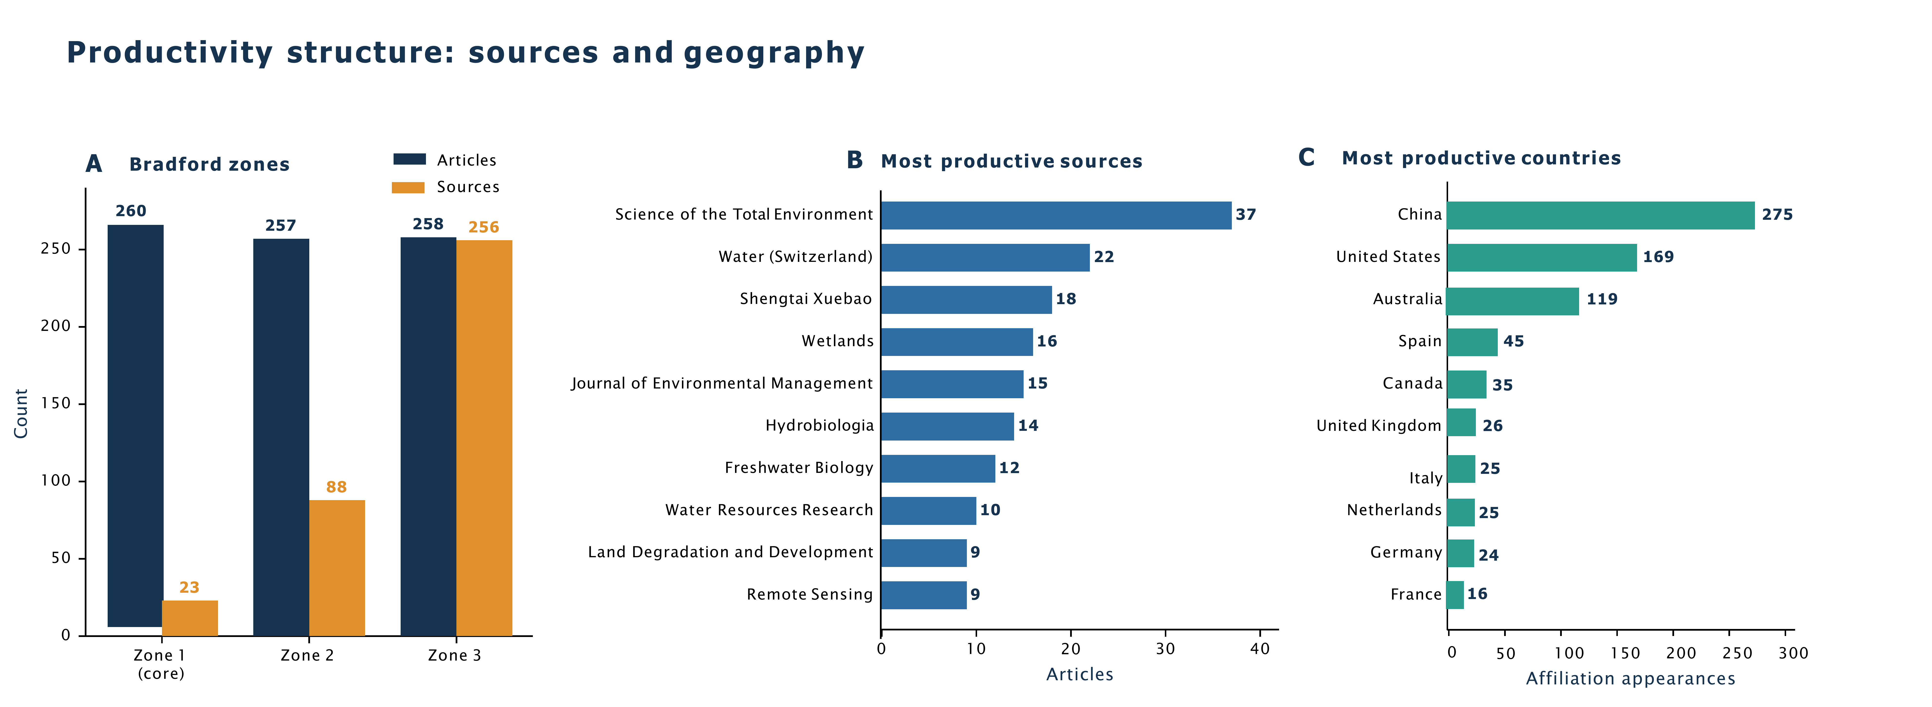
Fig. S1. Productivity structure of the field. (A) Bradford’s law of source scatter (three zones, each 1/3 of output; 23 core journals make up Zone 1). (B) Most productive sources; (C) Most productive countries according to the number of author affiliations.

Fig. S2. Latent topic structure and research fronts from LDA (k = 4). (A) The four research fronts, ranked by the number of documents for which each topic is dominant (259, 212, 173 and 131 documents; 775 in total). (B) The eight leading terms defining each front, shown in order of topic probability. Topic labels are interpretive; model-selection diagnostics (perplexity and UMass coherence over k) appear in Table 6a and the full leading-term lists and counts in Table 6b.

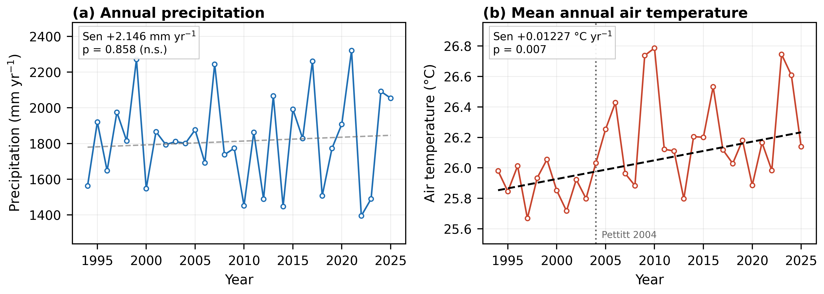
Fig. S3. Climate forcing, 1994–2025. (a) Annual precipitation and (b) mean annual air temperature from ERA5 reanalysis. Dashed lines are Theil–Sen slopes, drawn black where the Mann–Kendall test is significant at α = 0.05 and grey and labelled n.s. otherwise. The dotted line in (b) marks the Pettitt change point.

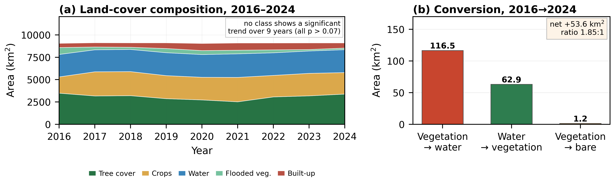
Fig. S4. Land cover, 2016–2024. (a) Annual composition of the classified area; no class shows a statistically significant trend over this nine-year window, so conversion totals rather than annual slopes are reported. (b) Conversion between 2016 and 2024, showing directional exchange from vegetation to water.

