 | Beit Zeinab Khatoon | Beit Amna Bint Salem | Beit El Sinnari |  |  | Beit Moustafa Ga’afr |  | Beit Khorazati | Beit Al Harawi | Beit Al-Kiritliya | Beit Amna Bent Salem
Section A-A  H /w | 1.75/1.35 | 1.6/1.3 | 1.7/1.35 |  | 1.6/2.15 | 1.15/0.55 | 1.3/ 0.8 | 1.45/1.0 | 1.65/1.25 | 2.05/1.45 | 1.8/1.85
 | 1.3 | 1.23 | 1.26 |  | 0.75 | 2 | 1.6 | 1.45 | 1.32 | 1.4 | 0.97
Section B-B  H /w | 1.75/1.35 | 1.6/1.75 | 1.75/1.25 |  | 1.5/2.25 |  | 1.15/0.55 | 1.45/1.15 | 1.65/1.15 | 2.05/1.3 | 1.8/1.0
 | 1.29 | 0.9 | 1.4 |  | 0.65 |  | 2 | 1.25 | 1.43 | 1.53 | 1.8
low aspect ratio (shallow courtyards | less than 1
Courtyards with a moderate aspect ratio | 1 - 2
High Aspect ratio narrow & deep | 2 or higher

Table1. Duration and distribution of sunlight exposure throughout different times of the day

 | BEIT ZEINAB KHATOON | BEIT EL SINNARI | BEIT MOUSTAFA GA’AFR | BEIT KHORAZATI | BAYT AL HARAWI | HOUSE OF AL-KIRITLIYA | BEIT AMNA BENT SALEM
Angle from North | ~20 | ~15 | ~15 | ~15 | ~15 | ~-35 | ~-35
Façade Azimuth | SW 200 | SW195 | SW195 | SW195 | SW195 | SE 145 | SE 145
08:00 am |  |  |  |  |  | ~40° | ~40°
09:00 am | ~50° | ~50° | ~50° | ~50° | ~50°  ~55° | ~55° | ~55°
10:00 am | ~62° | ~62° | ~62° | ~62° | ~62° | ~65° | ~65°
11:00 am | ~70° | ~70° | ~70° | ~70° | ~70° | ~70° | ~70°
12:00 pm | ~76° | ~76° | ~76° | ~76° | ~76° | ~75° | ~75°
01:00 pm | ~76° | ~76° | ~76°  ~73° | ~76° | ~76° | ~76° | 76°
02:00 pm | ~70° | ~70° | ~70° | ~70° | ~70°
03:00 pm | ~60° | ~60° | ~60° | ~60° | ~60°
04:00 pm | ~45° | ~45° | ~45° | ~45° | ~45°
Total Hours | 8 hours | 8 Hours | 4 hours | 8 hours | 6 hours | 5 hours | 6 hours
W to H | 0.8 | 0.8 | 0.5 -0.6 | 0.8 | 0.7 | 0.7 | 0.6

Grazing light l Oblique light begins hitting
Exposure begins l Moderate oblique
Still strong, slight obliqueness
Peak exposure
Unreachable

Table 2. Duration and distribution of sunlight exposure throughout different times of the day

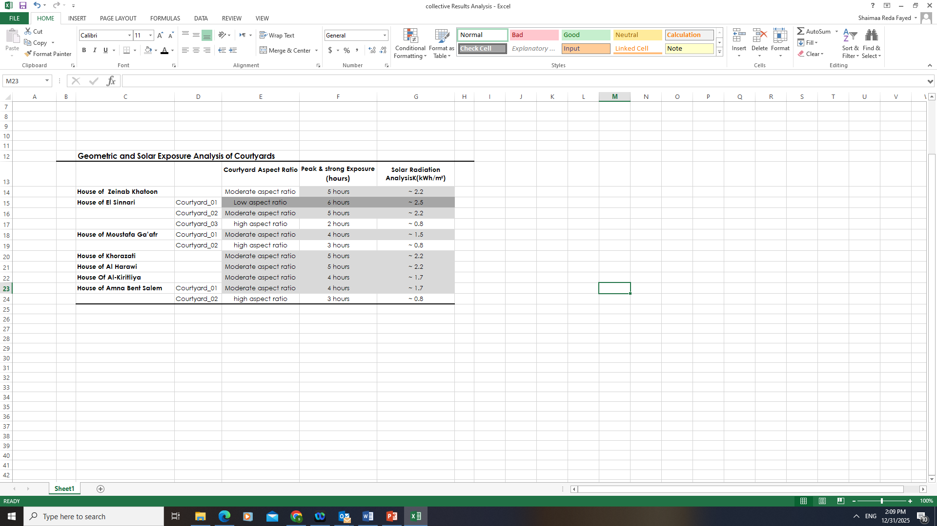
Courtyard as a Cool Reservoir
Updraft Exhaust System

Table 4. Collective Analysis of Courtyard Orientation, Aspect Ratio, and Solar Exposure

