Original western blots
Full unedited gel/blot for Figure_1G
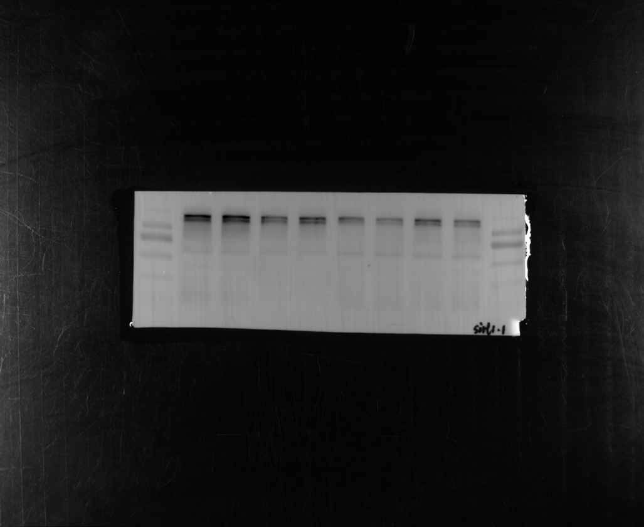
130kDa
55kDa
40kDa
100kDa
70kDa
SIRT1
(110kDa)
130kDa
40kDa
55kDa
70kDa
100kDa
A/S4
A/S3
A/S2
A/S1
Ctrl4
Ctrl3
Ctrl2
Ctrl1
55kDa
70kDa
100kDa
40kDa
β-actin
(42kDa)
Ctrl4
Ctrl1
Ctrl3
A/S1
A/S2
A/S3
A/S4
Ctrl2
40kDa
55kDa
100kDa
70kDa
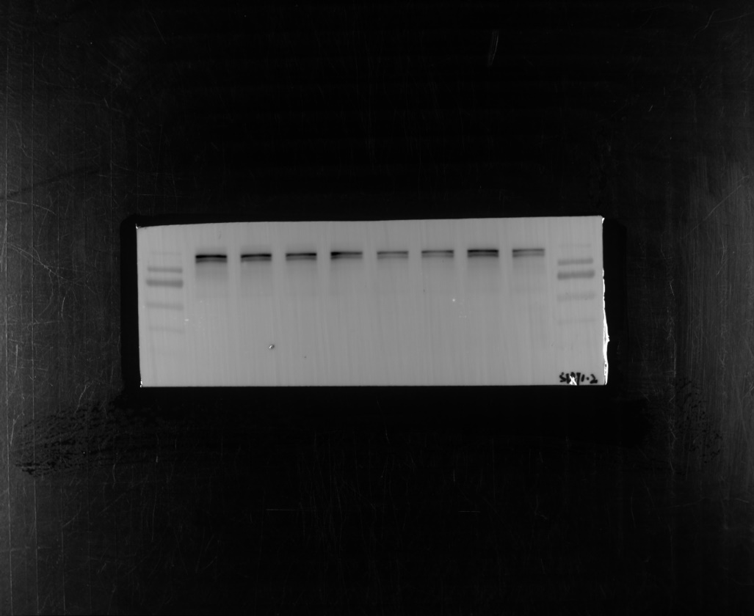
Ctrl6
Ctrl5
Ctrl7
A/S6
A/S5
Ctrl8
A/S7
A/S8
130kDa
100kDa
70kDa
55kDa
40kDa
55kDa
130kDa
40kDa
70kDa
100kDa
SIRT1
(110kDa)
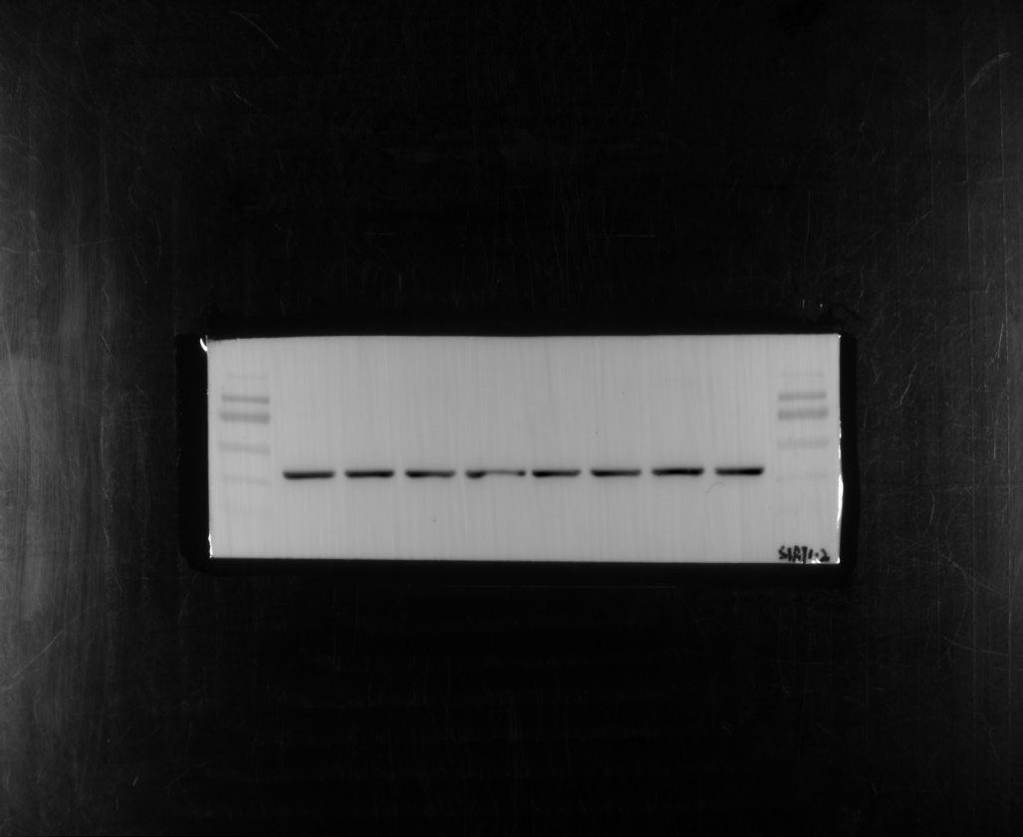
β-actin
(42kDa)
130kDa
100kDa
40kDa
55kDa
70kDa
40kDa
70kDa
100kDa
130kDa
55kDa
A/S6
Ctrl7
A/S8
A/S7
A/S5
Ctrl8
Ctrl6
Ctrl5

Full unedited gel/blot for Figure_3K
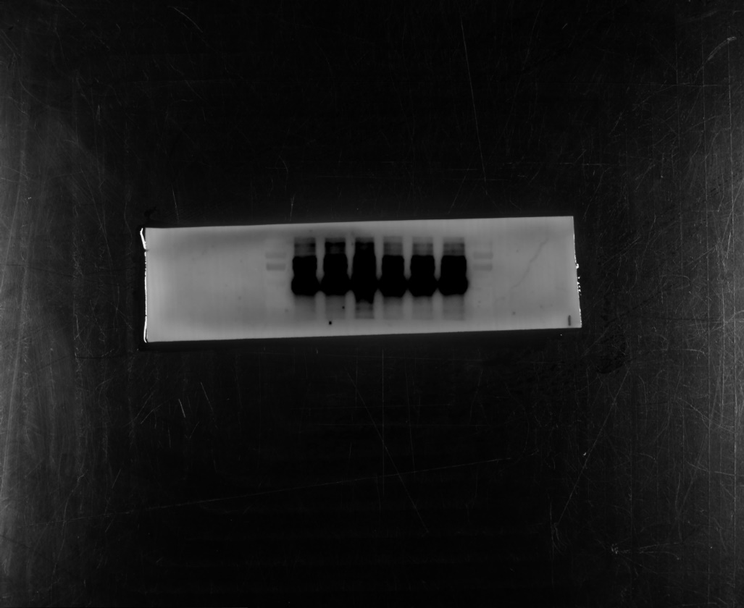
HT22+CM^{BV2}-1
HT22+CM^{BV2}-2
HT22+CM^{BV2}-3
HT22+CM^{M1}-1
HT22+CM^{M1}-2
HT22+CM^{M1}-3
SIRT1
(110kDa)
70kDa
100kDa
55kDa
130kDa
40kDa
40kDa
130kDa
55kDa
70kDa
100kDa
HT22+CM^{BV2}-1
HT22+CM^{BV2}-2
HT22+CM^{BV2}-3
HT22+CM^{M1}-1
HT22+CM^{M1}-2
HT22+CM^{M1}-3
β-actin
(42kDa)
130kDa
100kDa
70kDa
55kDa
70kDa
100kDa
130kDa
55kDa
40kDa
40kDa
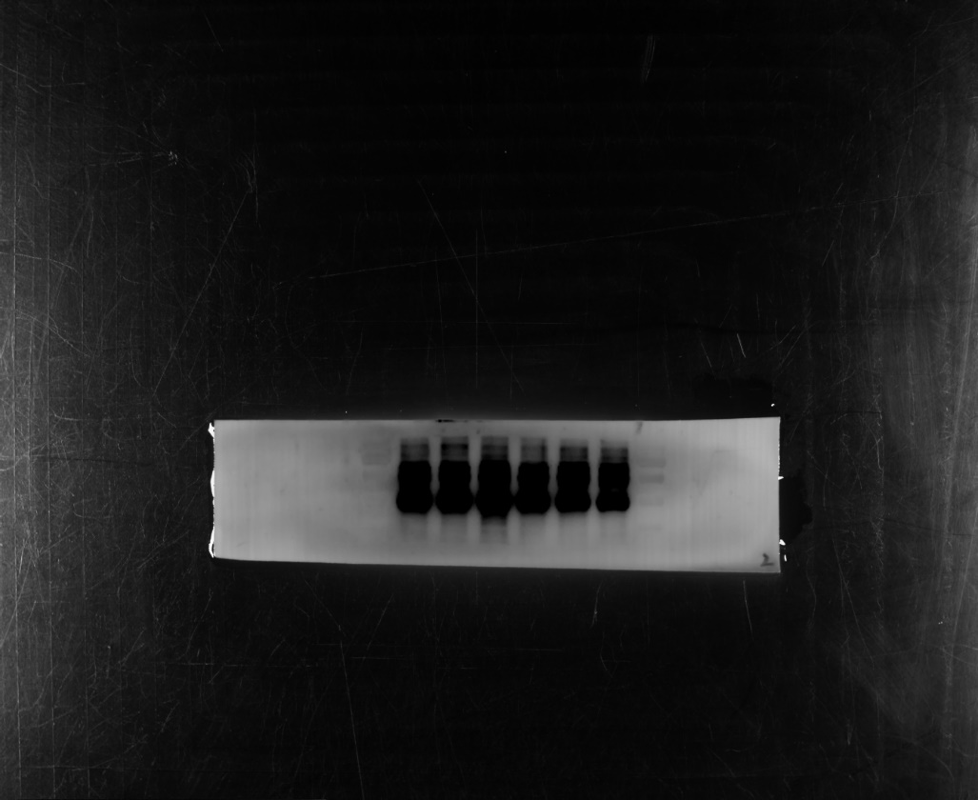
HT22+CM^{BV2}-4
HT22+CM^{BV2}-5
HT22+CM^{BV2}-6
HT22+CM^{M1}-4
HT22+CM^{M1}-5
HT22+CM^{M1}-6
SIRT1
(110kDa)
130kDa
100kDa
55kDa
130kDa
55kDa
40kDa
70kDa
100kDa
40kDa
70kDa
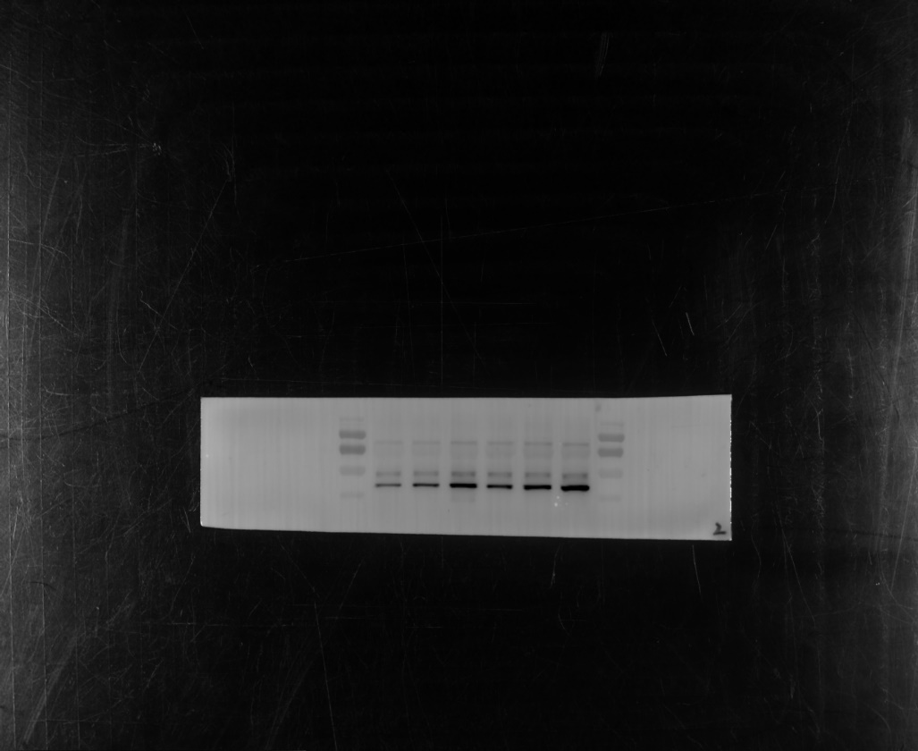
HT22+CM^{BV2}-4
HT22+CM^{BV2}-5
HT22+CM^{BV2}-6
HT22+CM^{M1}-4
HT22+CM^{M1}-5
HT22+CM^{M1}-6
β-actin
(42kDa)
70kDa
55kDa
130kDa
100kDa
40kDa
100kDa
70kDa
40kDa
55kDa
130kDa

Full unedited gel/blot for Figure_5F
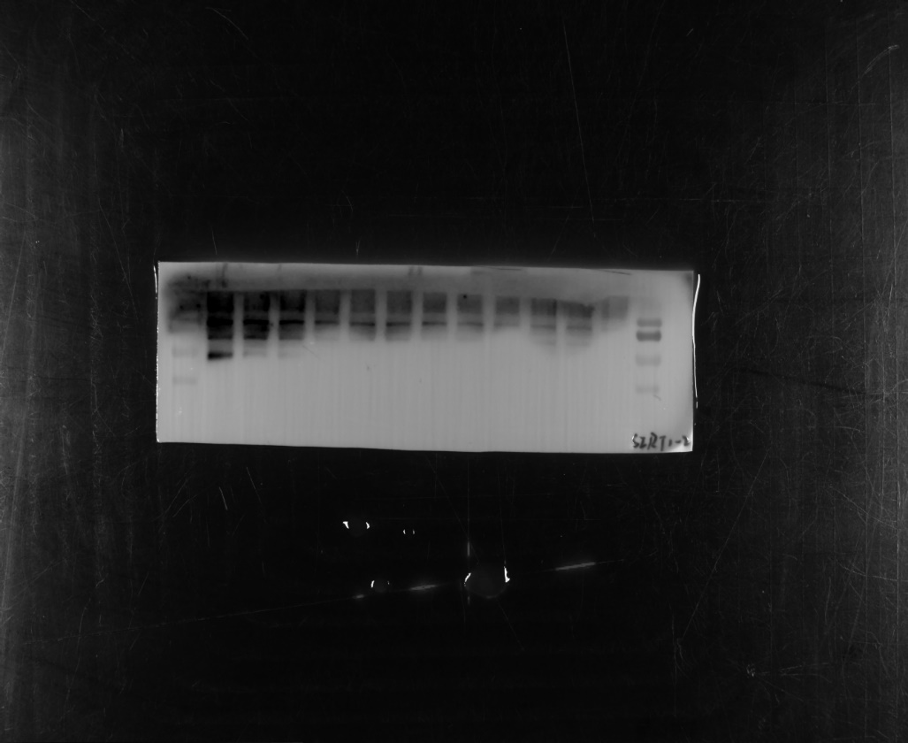
siRNA-1
siRNA-2

siRNA-3

siRNA-4

siRNA-5

siRNA-6
-6
Vector-1
Vector-2

Vector-3

Vector-4

Vector-5

Vector-6
-6
SIRT1
(110kDa)
70kDa
40kDa
100kDa
55kDa
130kDa
100kDa
70kDa
40kDa
55kDa
130kDa
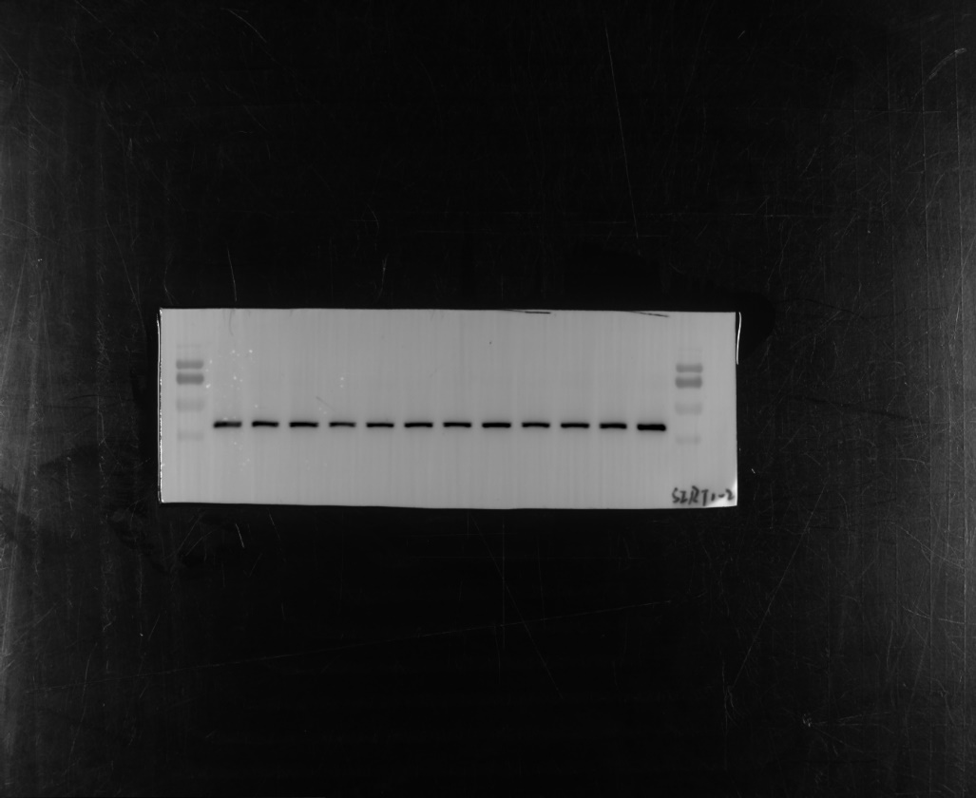
Vector-1
Vector-2

Vector-3

Vector-4

Vector-5

Vector-6
-6
siRNA-1
siRNA-2

siRNA-3

siRNA-4

siRNA-5

siRNA-6
-6
β-actin
(42kDa)
55kDa
130kDa
100kDa
70kDa
100kDa
55kDa
70kDa
40kDa
130kDa
40kDa

Full unedited gel/blot for Figure_6E
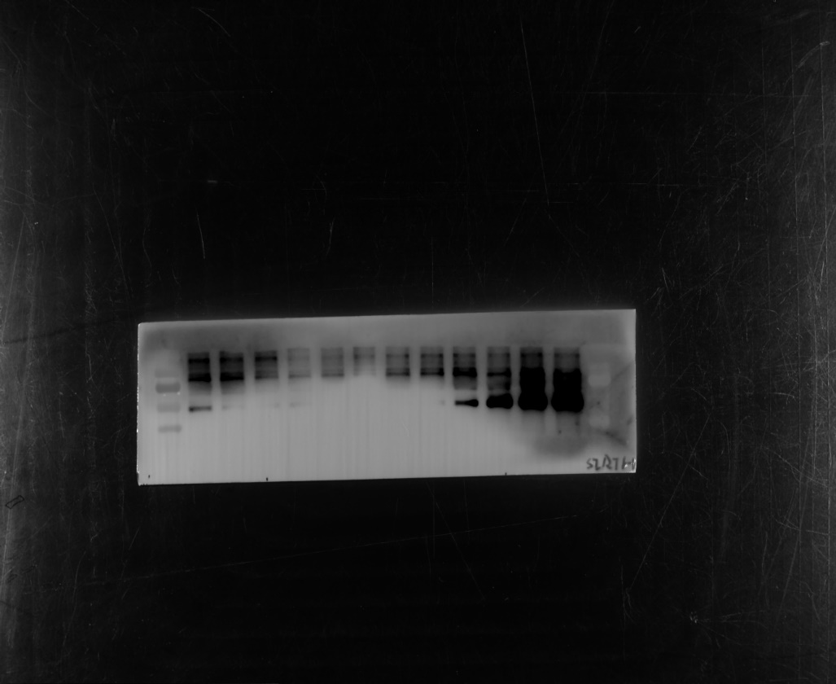
Ctrl+vector-1
Ctrl+vector-2

Ctrl+vector-3

LPS+vector-1
LPS+vector-2
LPS+vector-3
LPS+circ_29625-1
LPS+circ_29625-2
LPS+circ_29625-3
Ctrl+circ_29625-1
Ctrl+circ_29625-2
Ctrl+circ_29625-3
SIRT1
(110kDa)
40kDa
130kDa
100kDa
55kDa
70kDa
40kDa
130kDa
100kDa
55kDa
70kDa
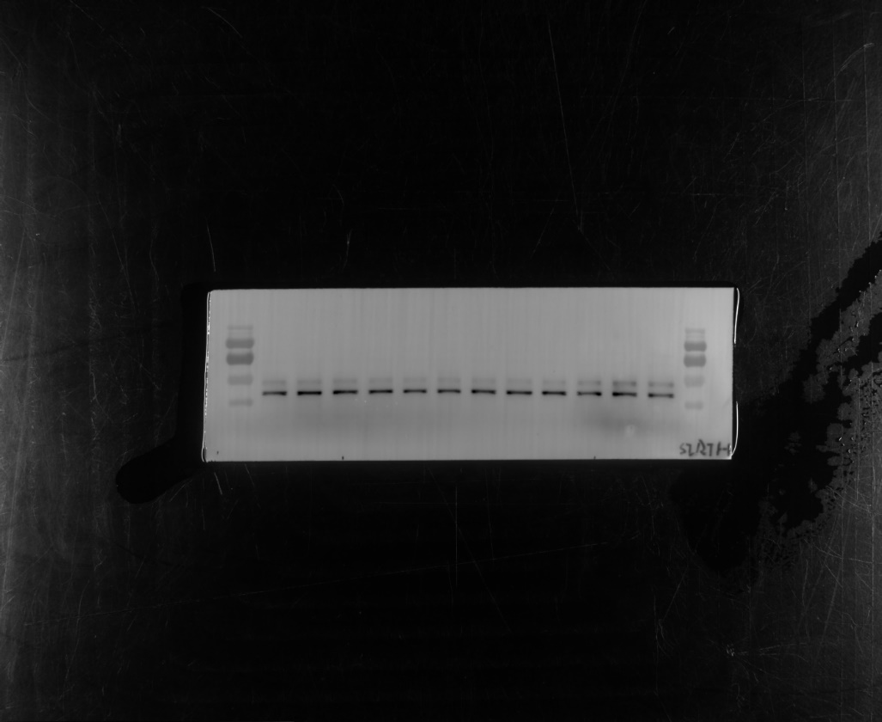
β-actin
(42kDa)
Ctrl+vector-1
Ctrl+vector-2

Ctrl+vector-3

LPS+vector-1
LPS+vector-2
LPS+vector-3
LPS+circ_29625-1
LPS+circ_29625-2
LPS+circ_29625-3
Ctrl+circ_29625-1
Ctrl+circ_29625-2
Ctrl+circ_29625-3
40kDa
130kDa
100kDa
55kDa
70kDa
40kDa
130kDa
100kDa
55kDa
70kDa
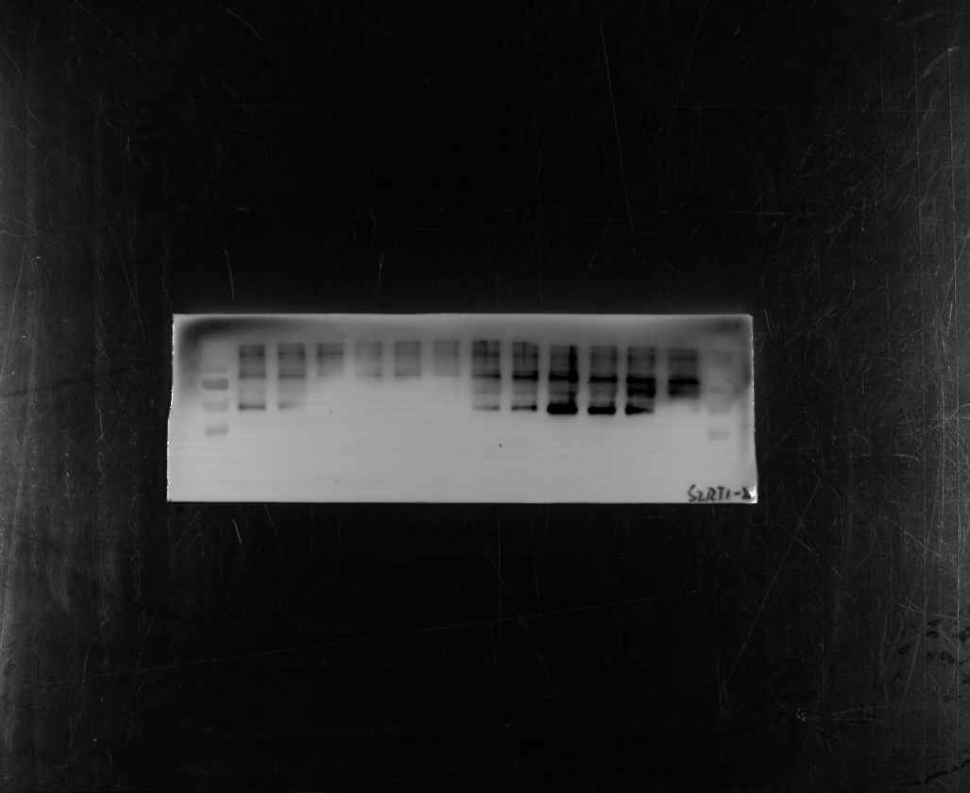
SIRT1
(110kDa)
Ctrl+vector-4
Ctrl+vector-5
Ctrl+vector-6
LPS+vector-4
LPS+vector-5
LPS+vector-6
LPS+circ_29625-4
LPS+circ_29625-5
LPS+circ_29625-6
Ctrl+circ_29625-4
Ctrl+circ_29625-5
Ctrl+circ_29625-6
40kDa
130kDa
100kDa
55kDa
70kDa
40kDa
130kDa
100kDa
55kDa
70kDa
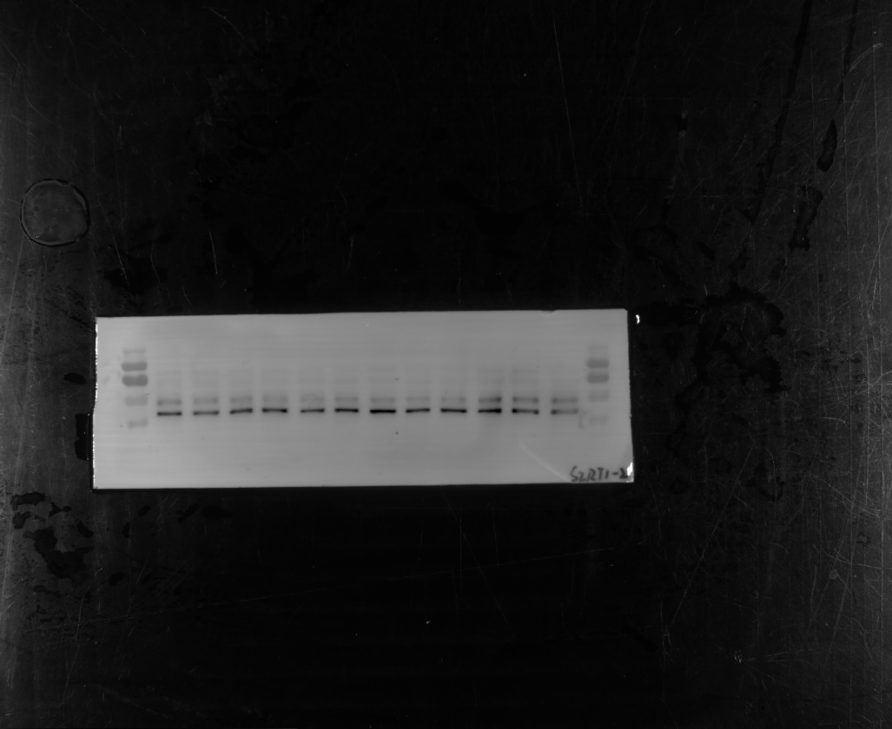
β-actin
(42kDa)
Ctrl+vector-4
Ctrl+vector-5
Ctrl+vector-6
LPS+vector-4
LPS+vector-5
LPS+vector-6
LPS+circ_29625-4
LPS+circ_29625-5
LPS+circ_29625-6
Ctrl+circ_29625-4
Ctrl+circ_29625-5
Ctrl+circ_29625-6
40kDa
130kDa
100kDa
55kDa
70kDa
40kDa
130kDa
100kDa
55kDa
70kDa

Full unedited gel/blot for Figure_7E
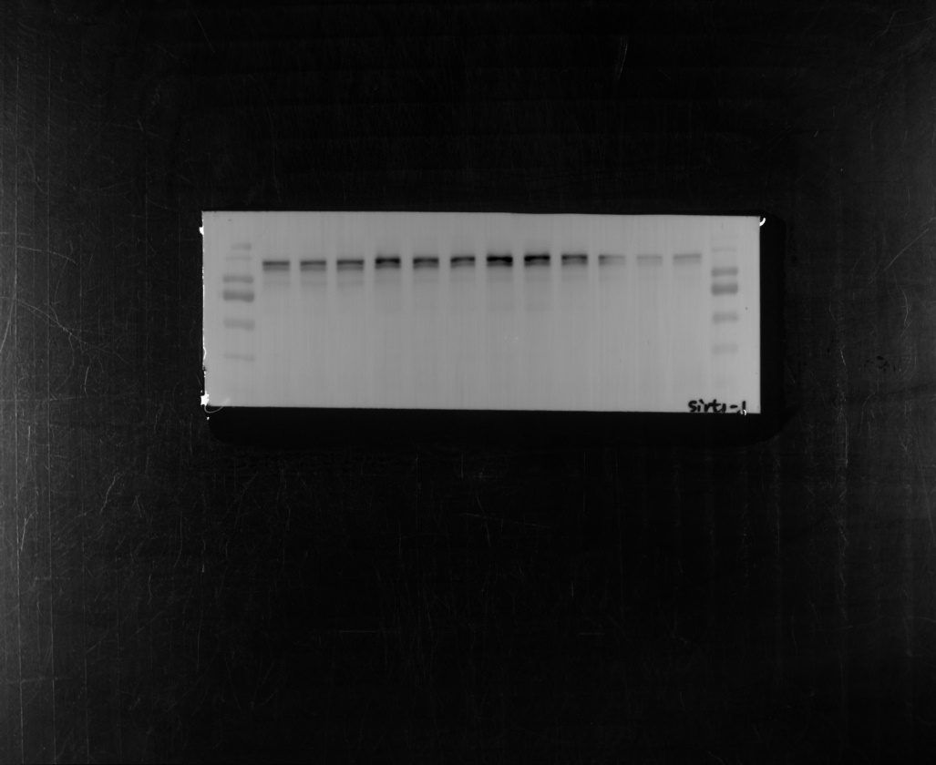
A/S+AAV-mCherry+AAV-EGFP-1
A/S+AAV-mCherry+AAV-EGFP-2
A/S+AAV-mCherry+AAV-EGFP-3
A/S+circ_29625+AAV-EGFP-1

A/S+circ_29625+AAV-EGFP-2
A/S+circ_29625+AAV-EGFP-3
A/S+AAV-mCherry+SIRT1-1
A/S+AAV-mCherry+SIRT1-2
A/S+AAV-mCherry+SIRT1-3
A/S+circ_29625+shRNA (SIRT1)-1
-1-1
A/S+circ_29625+shRNA (SIRT1)-2
-1-1

A/S+circ_29625+shRNA (SIRT1)-3
-1-1

40kDa
130kDa
100kDa
55kDa
70kDa
180kDa
40kDa
130kDa
100kDa
55kDa
70kDa
180kDa
SIRT1
(110kDa)
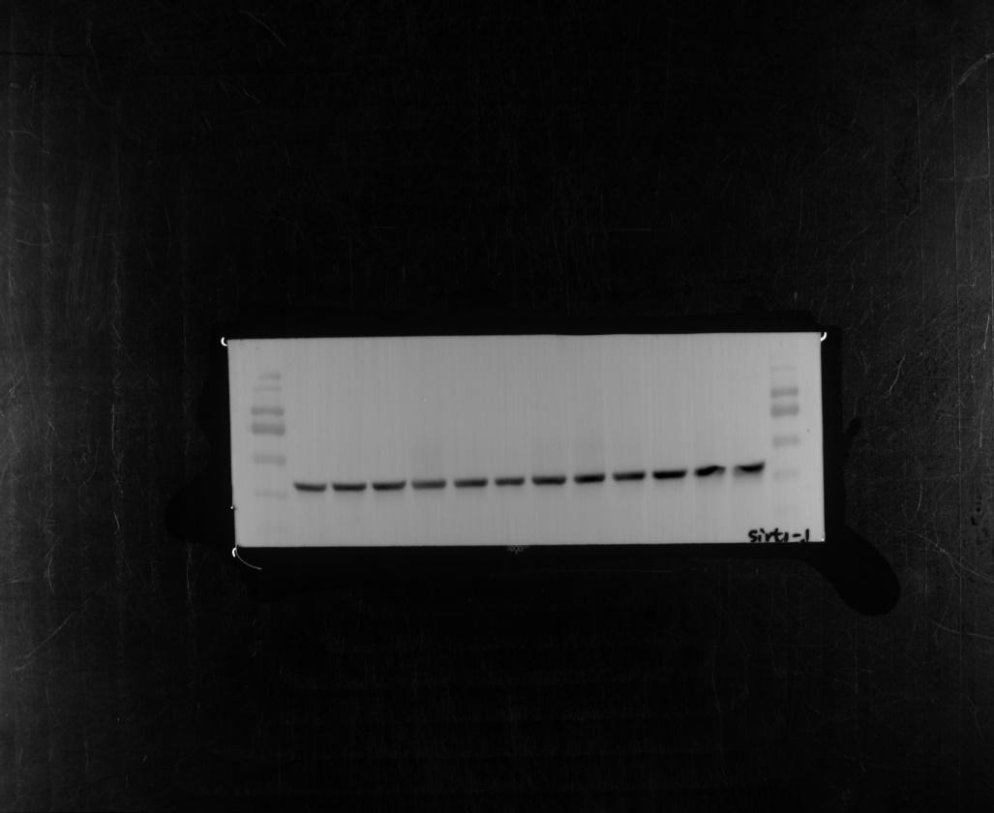
β-actin
(42kDa)
40kDa
130kDa
100kDa
55kDa
70kDa
180kDa
40kDa
130kDa
100kDa
55kDa
70kDa
180kDa
A/S+AAV-mCherry+AAV-EGFP-1
A/S+AAV-mCherry+AAV-EGFP-2
A/S+AAV-mCherry+AAV-EGFP-3
A/S+circ_29625+AAV-EGFP-1

A/S+circ_29625+AAV-EGFP-2
A/S+circ_29625+AAV-EGFP-3
A/S+AAV-mCherry+SIRT1-1
A/S+AAV-mCherry+SIRT1-2
A/S+AAV-mCherry+SIRT1-3
A/S+circ_29625+shRNA (SIRT1)-1
-1-1
A/S+circ_29625+shRNA (SIRT1)-2
-1-1

A/S+circ_29625+shRNA (SIRT1)-3
-1-1

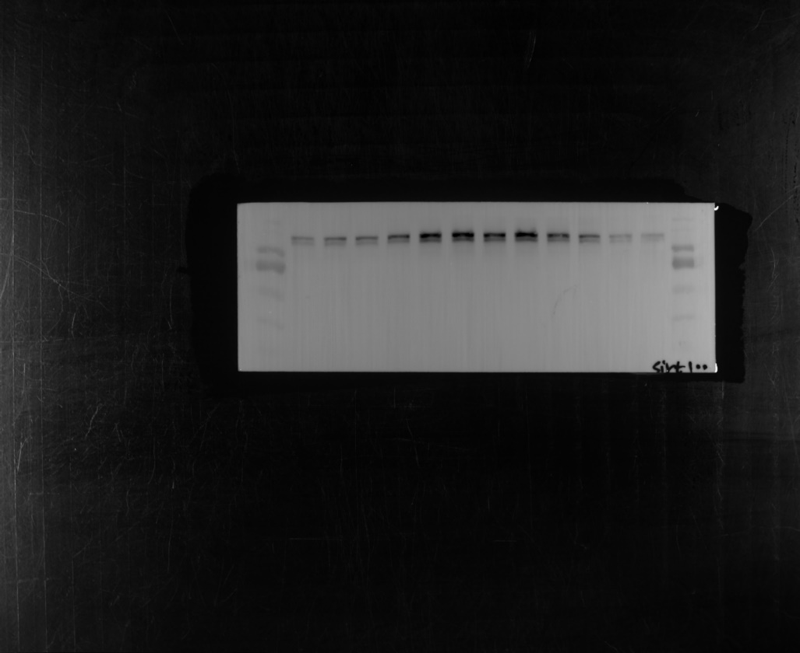
A/S+AAV-mCherry+AAV-EGFP-4
A/S+AAV-mCherry+AAV-EGFP-5
A/S+AAV-mCherry+AAV-EGFP-6
A/S+circ_29625+AAV-EGFP-4
A/S+circ_29625+AAV-EGFP-5
A/S+circ_29625+AAV-EGFP-6
A/S+AAV-mCherry+SIRT1-4
A/S+AAV-mCherry+SIRT1-5
A/S+AAV-mCherry+SIRT1-6
A/S+circ_29625+shRNA (SIRT1)-4
A/S+circ_29625+shRNA (SIRT1)-5
A/S+circ_29625+shRNA (SIRT1)-6
SIRT1
(110kDa)
40kDa
130kDa
100kDa
55kDa
70kDa
180kDa
40kDa
130kDa
100kDa
55kDa
70kDa
180kDa
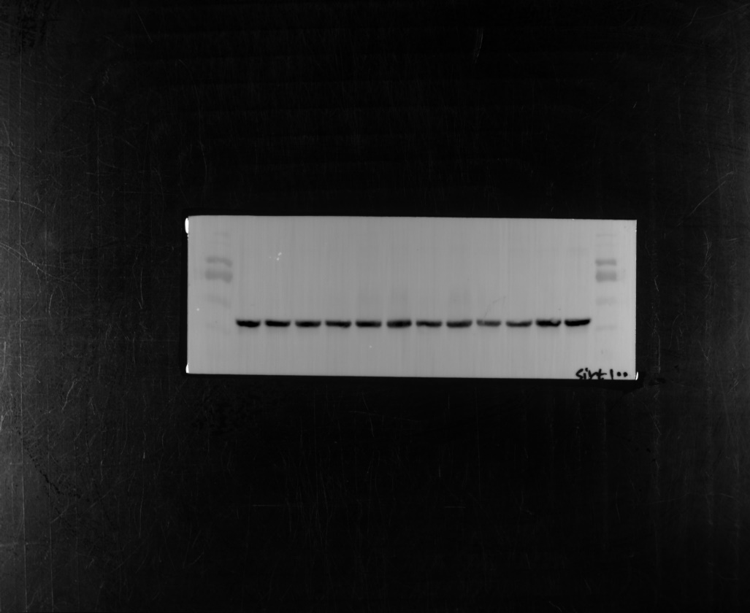
A/S+AAV-mCherry+AAV-EGFP-4
A/S+AAV-mCherry+AAV-EGFP-5
A/S+AAV-mCherry+AAV-EGFP-6
A/S+circ_29625+AAV-EGFP-4
A/S+circ_29625+AAV-EGFP-5
A/S+circ_29625+AAV-EGFP-6
A/S+AAV-mCherry+SIRT1-4
A/S+AAV-mCherry+SIRT1-5
A/S+AAV-mCherry+SIRT1-6
A/S+circ_29625+shRNA (SIRT1)-4
A/S+circ_29625+shRNA (SIRT1)-5
A/S+circ_29625+shRNA (SIRT1)-6
β-actin
(42kDa)
40kDa
130kDa
100kDa
55kDa
70kDa
180kDa
40kDa
130kDa
100kDa
55kDa
70kDa
180kDa

