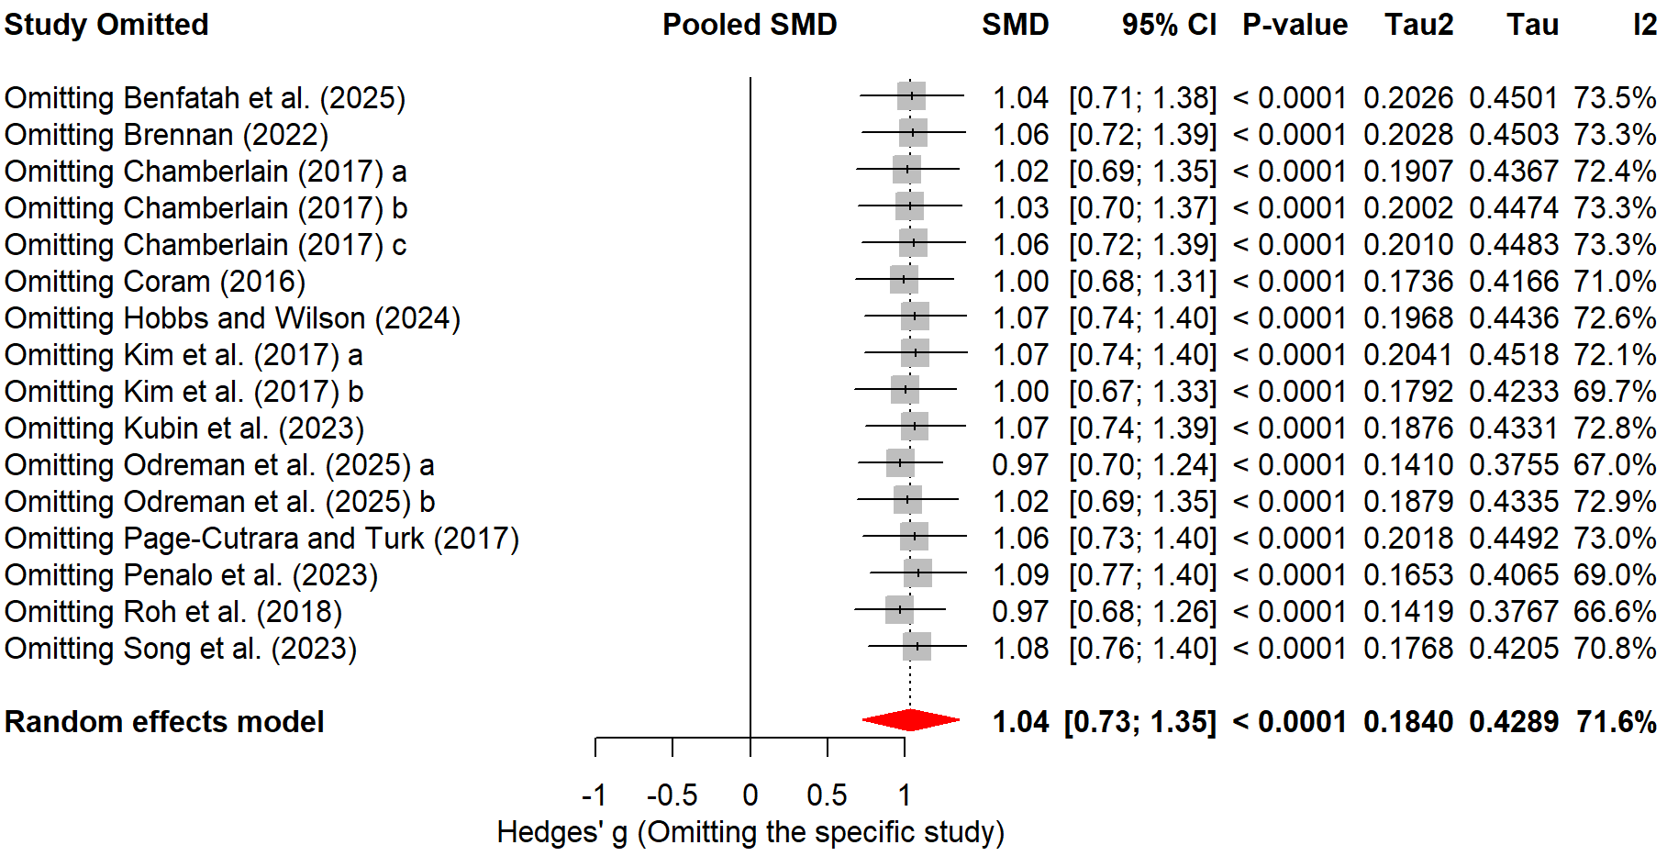
(a)
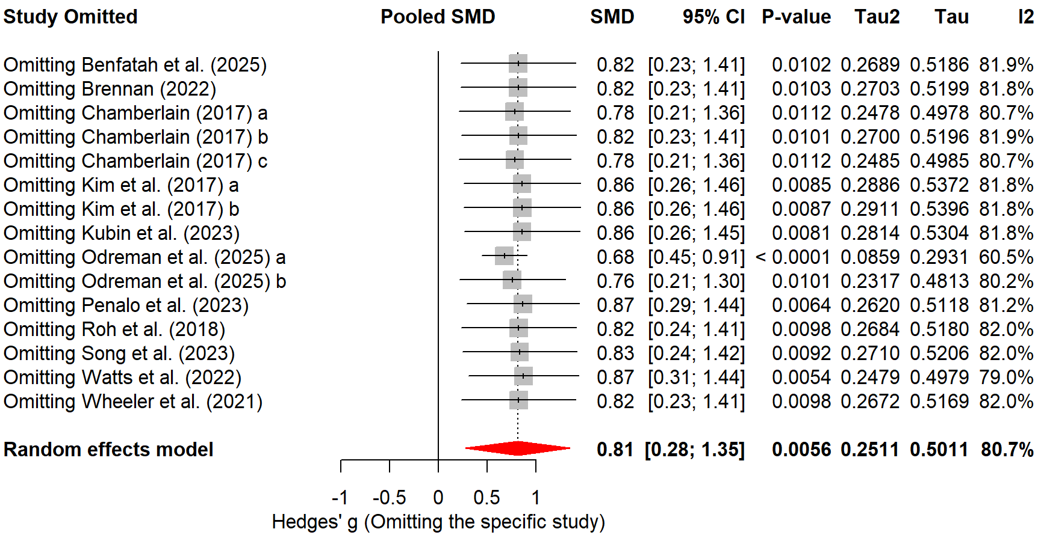
(b)
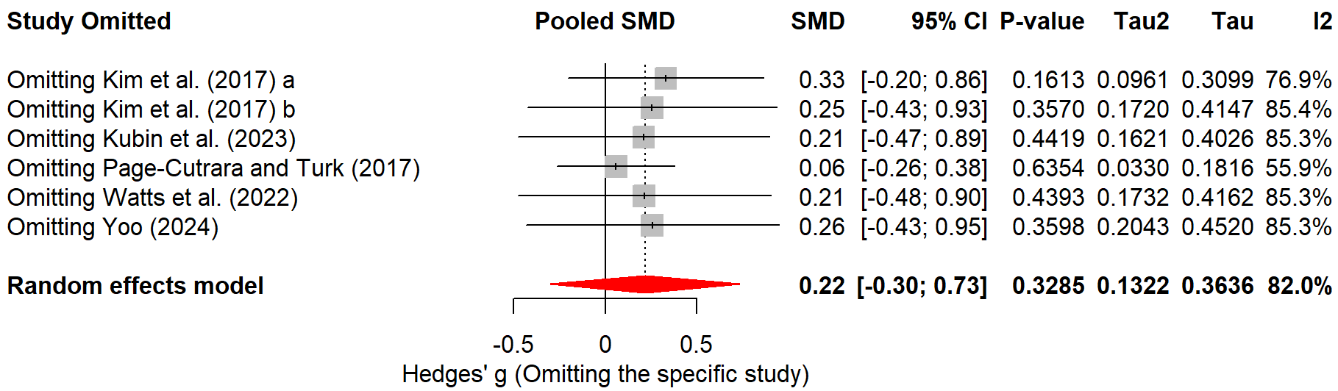
(c)
Supplementary Figure S1. Leave-one-out sensitivity analysis for three primary outcome domains
(a) Simulation performance (k = 16). (b) Psychological safety (k = 15). (c) Simulation experience (k = 6). Each row represents the pooled random-effects estimate (Hedges' g) obtained upon iterative omission of the labeled study, with the grey square denoting the point estimate and horizontal lines denoting the 95% confidence interval. The red diamond at the bottom of each panel represents the overall pooled estimate including all studies (reference). Analyses were conducted using the DerSimonian-Laird estimator to ensure algorithmic convergence under iterative data reduction. For simulation performance, omission of any individual study did not alter statistical significance, with pooled SMDs ranging from 0.97 to 1.09 (all P < 0.0001). For psychological safety, all iterations yielded positive and statistically significant estimates (SMD range: 0.68–0.87; all P < 0.05), confirming the robustness of the overall effect. For simulation experience, consistent with the non-significant primary analysis, no single omission produced a statistically significant pooled estimate across any iteration. SMD, standardized mean difference; CI, confidence interval; I², inconsistency index; τ², between-study variance.

