Supplementary Material
Association between glycerin enema and 14-day unplanned revisits in children with acute viral gastroenteritis: a dual-center retrospective cohort study
Liu Shaohua, Qiu Jianwu, Li Haohua, Jin Tiexia, Bao Xiao, Zuo Yunlong

Additional file 1: Table S1. Baseline characteristics before propensity score matching
Characteristic | Enema group (n=351) | Control group (n=369) | SMD
Age, months, mean ± SD | 46.77 ± 32.15 | 43.69 ± 39.55 | 0.086
Male, n (%) | 215 (61.25) | 246 (66.67) | 0.113
Fever, n (%) | 91 (25.93) | 94 (25.47) | 0.010
Intravenous fluid, n (%) | 110 (31.34) | 79 (21.41) | 0.227
Non-diarrhea presentation, n (%) | 271 (77.21) | 98 (26.56) | 1.176
Antibiotic use, n (%) | 16 (4.56) | 54 (14.63) | —
Symptom duration ≥3 days, n (%) | 0 (0) | 18 (4.88) | —
SMD, standardized mean difference. SMD < 0.1 indicates adequate covariate balance.

Additional file 2: Figure S1
【插入位置：Figure S1（Figure_S1_smd_loveplot.png / .tiff）插入于此段之后】
Figure S1. Covariate balance before and after propensity score matching.
Absolute standardized mean differences (SMDs) for the five matching covariates before (gray circles) and after (blue triangles) matching. The dashed red line indicates SMD = 0.1; values below this threshold indicate adequate covariate balance. After matching, all five covariates achieved SMD < 0.1 (maximum |SMD| = 0.004).
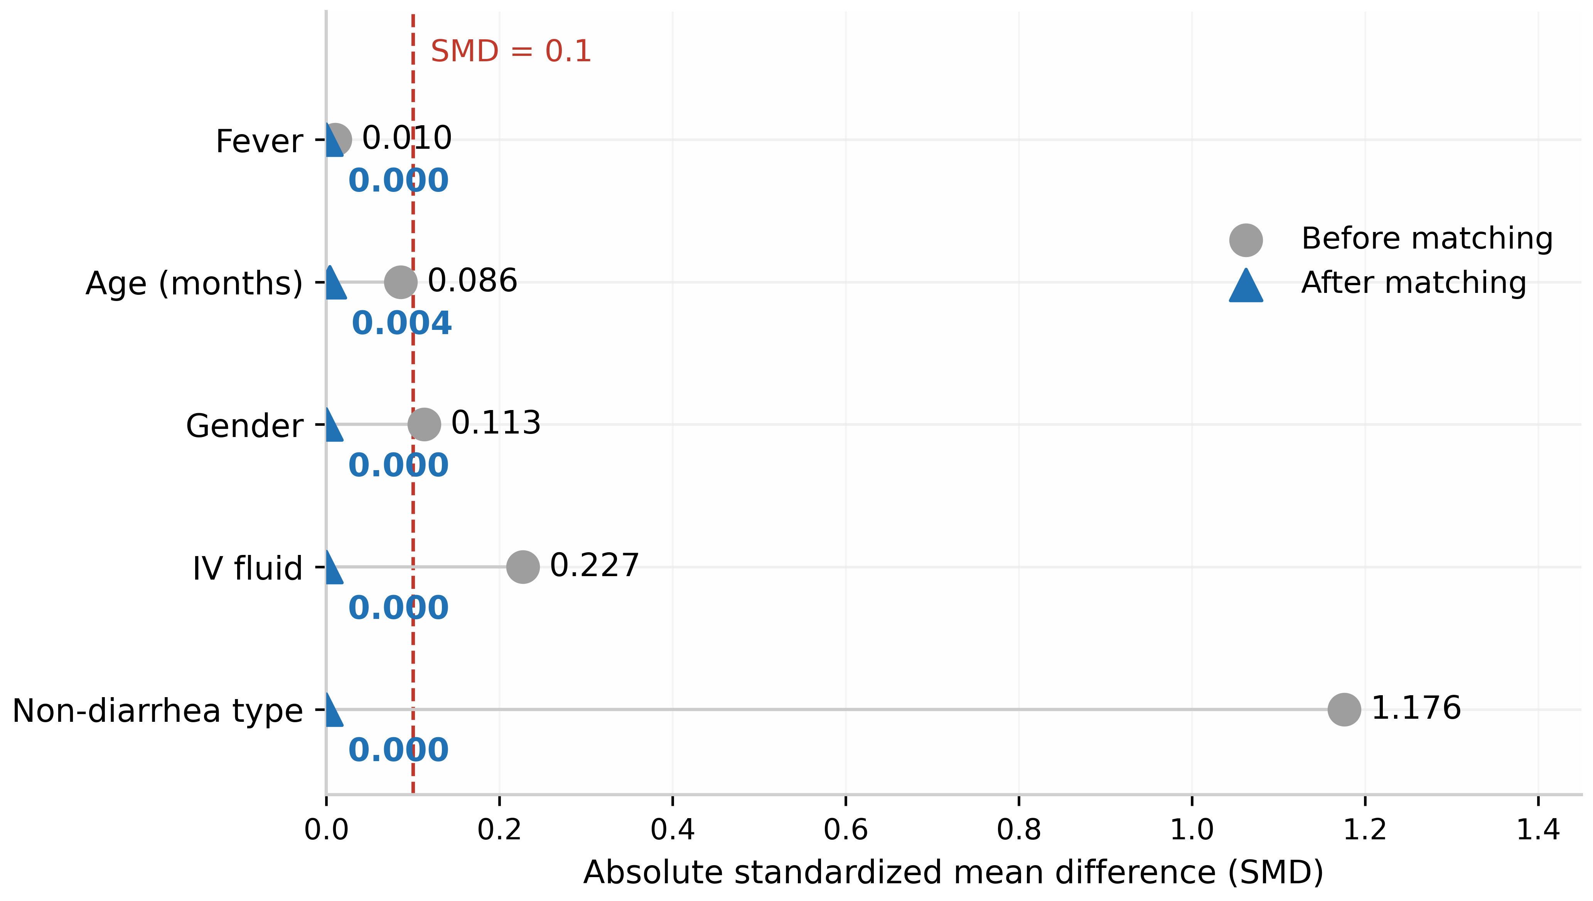
Figure S1

Additional file 3: Figure S2
【插入位置：Figure S2（Figure_S2_evalue.png / .tiff）插入于此段之后】
Figure S2. E-value sensitivity analysis for unmeasured confounding.
The point-estimate E-value (13.90) was derived from the Firth penalized logistic regression odds ratio (OR = 0.139), and the conservative E-value (3.99) from the 95% confidence interval limit nearest the null (0.438). The E-value represents the minimum strength of association that an unmeasured confounder would need to have with both the exposure (glycerin enema) and the outcome (14-day unplanned revisit), conditional on measured covariates, to fully explain away the observed association. The dashed line at E = 1.0 indicates no robustness to unmeasured confounding.
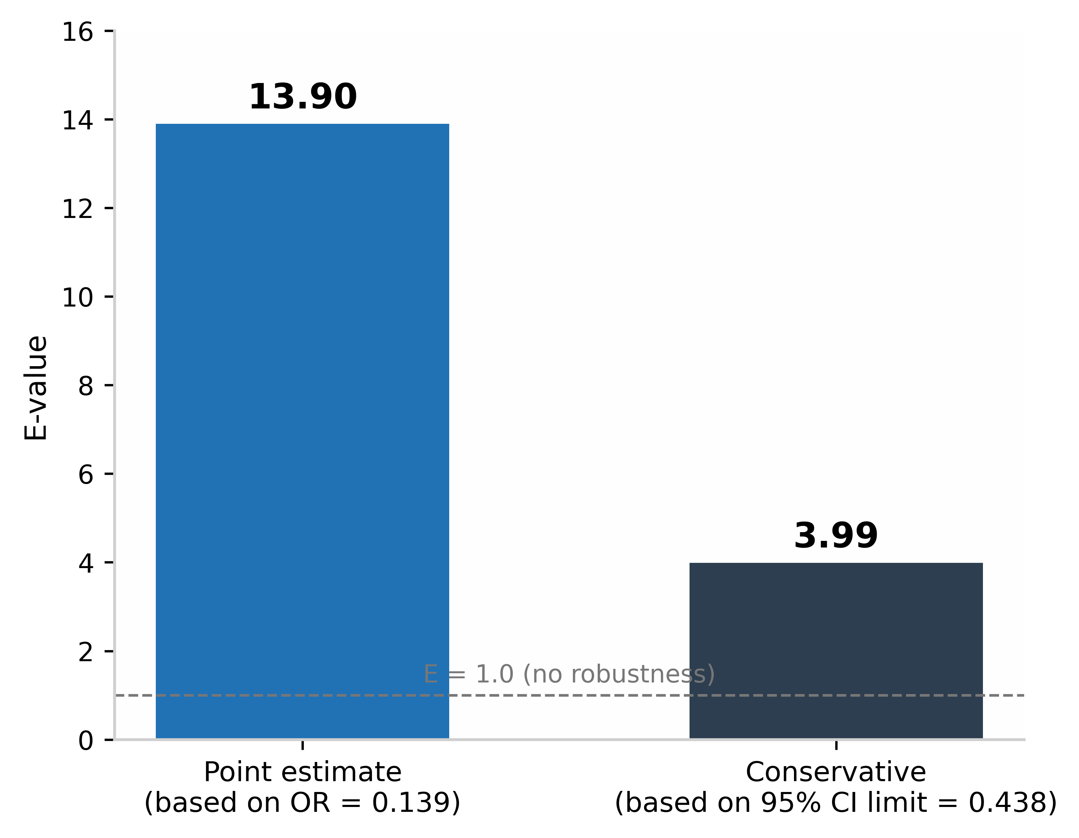
Figure S2

Additional file 4: Figure S3
【插入位置：Figure S3（Figure_S3_outcomes_summary.png / .tiff）插入于此段之后】
Figure S3. Summary of effect estimates for the primary outcome across analytic approaches.
Odds ratios (95% CI, log scale) for the 14-day unplanned revisit outcome estimated by the primary paired McNemar exact test (diamond), Firth penalized logistic regression (square), and the paired McNemar exact test after excluding hospitalized children (149 pairs; square). The dashed vertical line indicates an odds ratio of 1.0. *Exact McNemar OR = 0 with an exact one-sided 97.5% upper confidence bound; the lower bound is shown with an arrow.
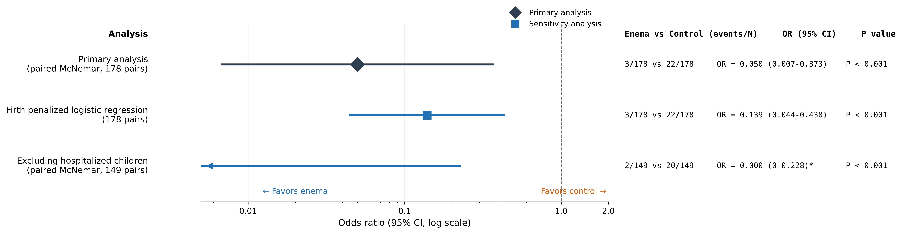
Figure S3

Additional file 5: Table S2. Subgroup analysis of the primary outcome after propensity score matching
Subgroup | Pairs, n | Enema revisit, n/N (%) | Control revisit, n/N (%) | b | c | OR (95% CI) | P value
Overall | 178 | 3/178 (1.69) | 22/178 (12.36) | 1 | 20 | 0.050 (0.007–0.373) | <0.001
Non-diarrhea type | 98 | 2/98 (2.04) | 11/98 (11.22) | 1 | 10 | 0.100 (0.013–0.781) | 0.012
Diarrhea type | 80 | 1/80 (1.25) | 11/80 (13.75) | 0 | 10 | 0.048 (0.003–0.813)* | 0.002
b, number of pairs in which only the enema group revisited; c, number of pairs in which only the control group revisited. P for interaction = 0.678. *OR estimated with Haldane-Anscombe continuity correction (exact McNemar OR = 0).

Additional file 6: Operational definitions of variables
Variable | Enema group | Control group | Type
Age in months | Directly from the “age in months” field | Converted from “X years X months” format | Continuous
Gender | Male = 1, female = 0 | Male = 1, female = 0 | Categorical
Fever | “Fever” in presenting complaint = 1 | “Fever” in presenting complaint = 1 | Binary
Intravenous fluid | “Intravenous fluid” recorded as “yes” | “Infusion” field non-empty = 1 | Binary
Non-diarrhea presentation | “Diarrhea in presenting complaint” recorded as “no” | Absence of “diarrhea/loose stool” keywords in complaint = 1 | Binary
14-day unplanned revisit | Record flagged “follow-up visit” within 14 calendar days of baseline registration, with a different registration time, within the same serial number; scheduled rechecks excluded | Same | Binary
Revisit time | Days from baseline registration to first valid follow-up registration; censored at 14 days if no revisit | Same | Time-to-event
Antibiotic use | “Antibiotic use” recorded as “yes” | “Antibiotic” field non-empty = 1 | Binary
Hospitalization | “Hospitalized” recorded as “yes” | “Hospitalized” recorded as “yes” = 1 | Binary
Symptom duration ≥3 days | Interval from baseline registration to last follow-up registration within the same serial number ≥3 calendar days (visit-based proxy, subject to information bias) | Same | Binary
Note: The unit of analysis was the patient serial number, representing a single acute episode rather than a permanent patient identity. Independent episodes occurring more than 14 days apart in the same child were counted under separate patient serial numbers.
Missing rates for all variables were <5%; continuous variables were imputed with the median and categorical variables with the mode.

Additional files 7–9（单独提交，不嵌于本文档）
- Additional file 7: STROBE checklist（含页码与行号）
- Additional file 8: RECORD checklist（含页码与行号）
- Additional file 9: Statistical analysis code（Python 3.13）

