Supplementary information for

Large-scale in silico spectral library supplies scalable structural priors for de novo molecular generation

Yingbin Xiang¹, Jie Hong², Ting Jiang^{1*}, Wei Xu¹

¹School of Medical Science and Engineering, Beijing Institute of Technology, Beijing 100081, China
²Kunshan Nier Precision Instrumentation Inc., Kunshan, 215316, China

*Corresponding Author:
Ting Jiang
School of Medical Science and Engineering
Beijing Institute of Technology
Haidian, Beijing, 100081, China
Email:6120230051@bit.edu.cn
Contents
- Supplementary Figures
  - Statistical comparison of pretraining data, training data, test data, and generated in silico library
  - Feature importance analysis and performance evaluation of the reranking model.
  - Impact of in silico spectra database pretraining and retrieval-based reranking on model performance.
  - Low chemical similarity between MassSpecGym training set and PFAS compounds.
- Supplementary Tables
  - Parameter settings for SiTGen
  - Parameter breakdown
  - Training hyperparameters
  - Retrieval and reference sampling parameters (LightGBM)
  - LightGBM reranking dataset construction
  - Feature engineering details
  - LightGBM reranker training hyperparameters
  - FlashEntropy reranking search parameters

1 Supplementary Figures
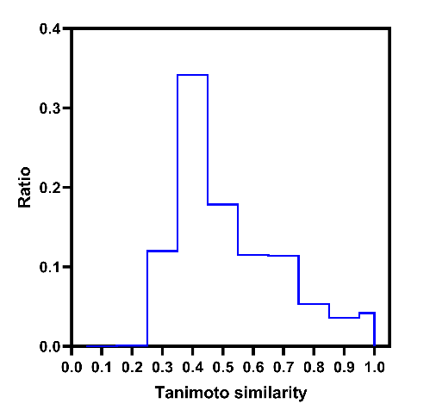
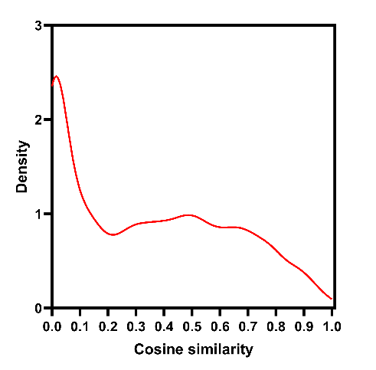
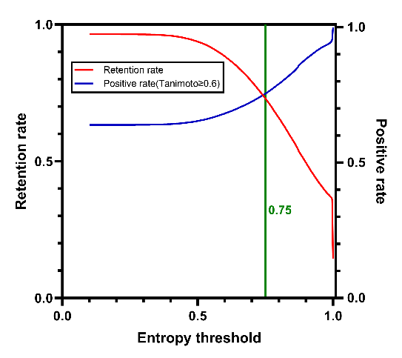
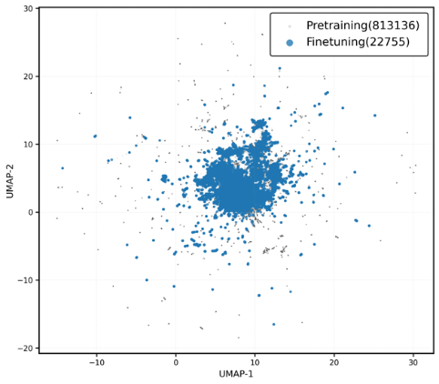
1.1 Supplementary Figures 1 | Statistical comparison of pretraining data, training data, test data, and generated in silico spectra database
(A)
(B)
(C)
(D)
Mean = 0.3413
Mean = 0.3413
Supplementary Figures 1: (A) UMAP visualization of molecular representations from the pretraining and fine-tuning datasets. (B) Distribution of maximum Tanimoto similarities between MassSpecGym training set and test set. (C) Optimization of the entropy similarity threshold for spectral retrieval. Self-retrieval on the MassSpecGym training set. The retention rate and proportion of positive matches are shown as functions of the entropy threshold. A threshold of 0.75 (green line) was selected to balance retrieval coverage and reference reliability. (D) Density distribution of cosine similarities between in silico and experimental MS/MS spectra for the same structures. A random subset of 1,000 compounds with both experimental and predicted spectra available was selected for comparison. The mean cosine similarity between paired spectra was 0.3413.

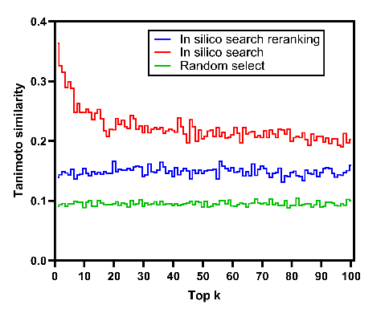
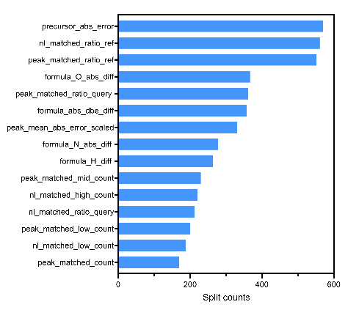
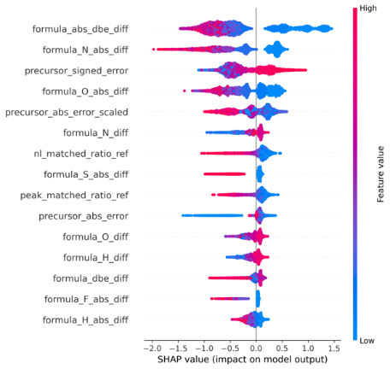
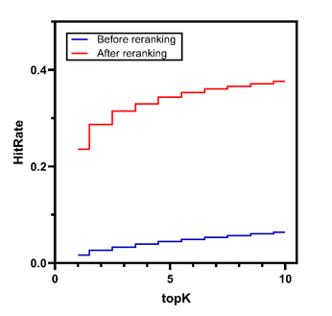
1.2 Supplementary Figures 2 | Feature importance analysis and performance evaluation of the in silico spectral database search result reranking model.
(A)
(B)
(C)
(D)
Supplementary Figures 2: (A) SHAP analysis showing the contribution of individual features to the LightGBM reranker prediction. (B) Feature importance ranking based on split counts in the LightGBM model. (C) Comparison of candidate prioritization strategies based on retrieved structural similarity. LightGBM reranking preferentially promotes structurally relevant candidates compared with direct in silico retrieval and random ranking. (D) Enrichment of correct candidates after reranking. The proportion of candidates containing the correct molecular structure increases substantially after reranking across different top-k retrieval settings.

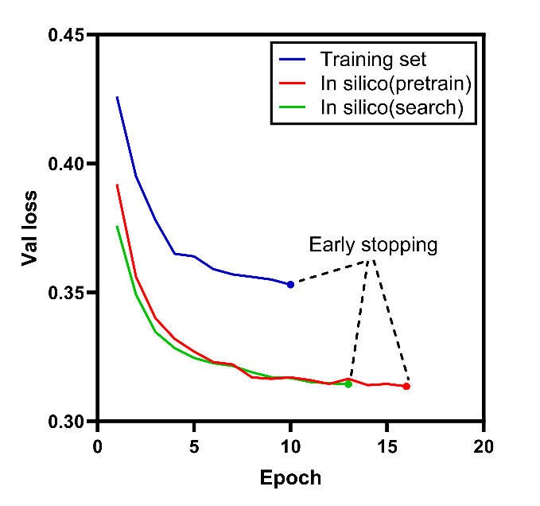
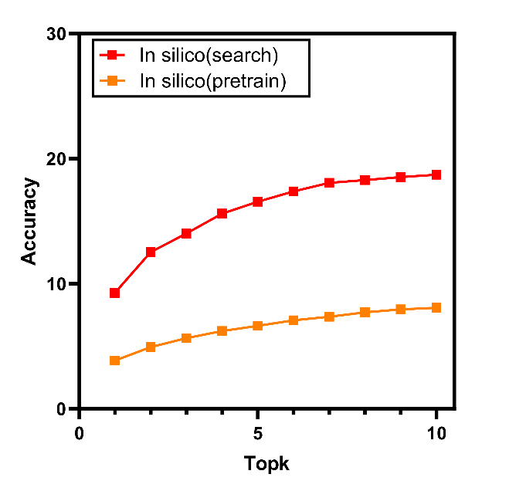
1.3 Supplementary Figure 3 | Effect of different utilization strategies of in silico spectra database on model performance.
(A)
(B)
Supplementary Figure 3: (A) Validation loss curves under different utilization strategies. Models were trained using experimental training-set references without in silico spectral libraries(Training set), in silico spectral libraries used only for pretraining (In silico pretrain), and in silico spectral libraries combined with spectral retrieval and reranking for reference selection (in silico search). Direct training with experimental references, in silico spectra database pretraining, and retrieval-based reference selection represent progressively enhanced utilization of in silico spectral information. (B) Top-k generation accuracy under different in silico spectra database utilization strategies. While in silico spectral pretraining expands the accessible chemical space, retrieval and reranking of informative references are required to achieve optimal molecular generation performance.
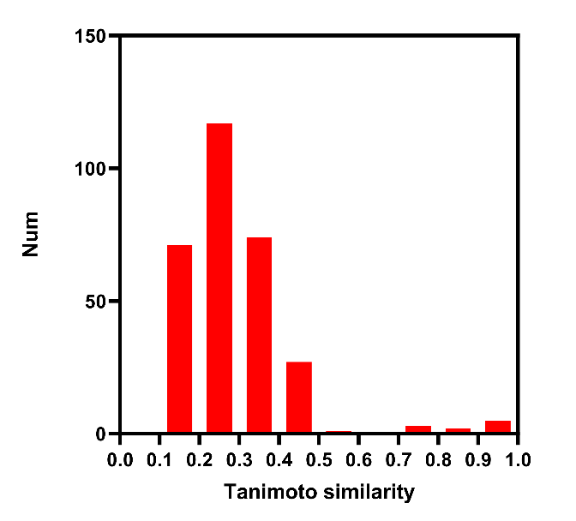
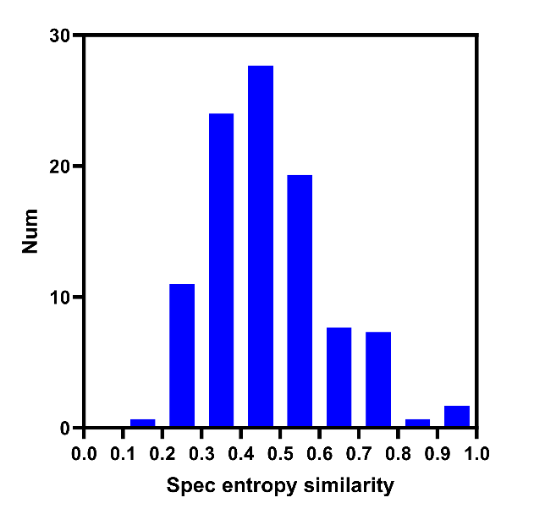
1.4 Supplementary Figure 4 | Chemical and spectral similarity between the external PFAS dataset and the training space.
(A)
(B)
Supplementary Figure 4：（A）Distribution of the maximum molecular Tanimoto similarity between PFAS molecules and molecules in the training dataset. The low structural similarity indicates that the PFAS dataset represents a largely unexplored chemical space relative to the training molecules. （B）Distribution of the maximum spectral entropy similarity between PFAS spectra and the reference spectra in the training space. Despite limited structural overlap, spectral retrieval identifies related molecular patterns, enabling reference-guided generation for external compounds.

2 Supplementary tables
2.1 Supplementary Tables 1 | Parameter settings for SiTGen
Global Transformer configuration
Parameter | Value
Model dimension (d_model) | 512
Feed-forward dimension (d_ff) | 2048
Query/key dimension(d_k) | 64
Value dimension (d_v) | 64
Number of encoder layers | 6
Number of decoder layers | 6
Number of attention heads | 8
SMILES vocabulary size | 41
Dropout rate | 0.1
MS/MS fragment peaks(N) | 100
Activation function | GELU
Normalization | Pre-LayerNorm
Parameter initialization | Kaiming initialization
SMILES vocabulary | <PAD>, <SOS>, <EOS>, 0,1,2,3,4,5,6,7,8,9, H, C, N, O, F, P, S, Cl ,Br ,I ,Si , '[',']','(',')',',','%','+','=','-','#','.',h, c ,n ,o ,p ,s

2.2 Supplementary tables 2 | Parameter breakdown
Architecture and parameter breakdown of SiTGen
Component | Layer | Parameters | Percentage
Spectrum embeddings
Spectrum intensity embedding  ($100×1→100×512$) | 1 | 132096 | 0.220%
Sinusoidal m/z encoding  ($100→100×512$) | - | 0 | 0.000%
Precursor-ion token construction  ($1→1×512$) | - | 0 | 0.000%
Spectrum embeddings subtotal | - | 132096 | 0.220%
Spectrum Transformer encoder
Encoder self-attention  ($101×512→101×512$) | 6 | 6291456 | 10.464%
Encoder FFN  (512$→2048→512$) | 6 | 12582912 | 20.928%
Encoder LayerNorms | 6*2 | 12288 | 0.020%
Spectrum Transformer encoder subtotal | - | 18886656 | 31.412%
SMILES embedding
SMILES token embedding  ($152×1→152×512$) | - | 20992 | 0.035%
Molecular-formula projection  ($11×1→11×512$) | - | 134656 | 0.224%
SMILES embedding subtotal | - | 155648 | 0.259%
Reference Transformer encoder
Reference self-attention  (101$×512→101×512$) | 3 | 3145728 | 5.232%
Reference FFN  (512$→2048→512$) | 3 | 6291456 | 10.464%
Reference LayerNorms | 2*3 | 6144 | 0.01%
Reference Transformer encoder subtotal | - | 9443328 | 15.706%
Main Transformer decoder
Decoder masked self-attention  (152$×512→152×512$) | 6 | 6291456 | 10.464%
Reference cross-attention | 6 | 6291456 | 10.464%
Spectrum cross-attention | 6 | 6291456 | 10.464%
Decoder FFN  (512$→2048→512$) | 6 | 12582912 | 20.928%
Decoder LayerNorms | 6 | 24576 | 0.041%
Main Transformer decoder | - | 31481856 | 52.361%
Entire model | - | 60124713 | 100.000%

2.3 Supplementary tables 3 | Training hyperparameters
Training hyperparameters
Parameter | Pre-training | Fine-tuning
Trainable modules | Decoder and reference encoder | Full model
Batch size | 64 | 32
Maximum epochs | 20 | 40
Optimizer | AdamW | AdamW
Maximum learning rate | $$2×{10}^{-4}$$ | $$1×{10}^{-6}$$
Initial learning rate | $$2×{10}^{-5}$$ | $$2×{10}^{-7}$$
Weight decay | $$1×{10}^{-4}$$ | $$1×{10}^{-5}$$
Adam$β_{1}$ | 0.9 | 0.9
Adam$β_{2}$ | 0.98 | 0.98
Adam epsilon | $$1×{10}^{-9}$$ | $$1×{10}^{-9}$$
LR scheduler | OneCycleLR | OneCycleLR
LR annealing | Cosine | Cosine
Warm-up proportion | 5% | 5%
Final learning rate | $$2×{10}^{-7}$$ | $$2×{10}^{-10}$$
Loss function | Cross-entropy | Cross-entropy
Mixed precision | bfloat16 | bfloat16
Early stopping | - | Patience 10
Random seed | 42 | 42

2.4 Supplementary tables 4 | Retrieval and reference sampling parameters (LightGBM)
Retrieval and reference sampling parameters
Parameter | Value | Description
Search algorithm | FlashEntropySearch hybrid search | -
MS2 tolerance | 0.01 Da | -
Entropy score threshold | 0.1 | -
Positive reference number | 10 | -
High-negative reference number | 5 | High entropy similarity but low Tanimoto similarity
Random-negative reference number | 5 | Random negative
m/z-negative reference number | 5 | Precursor-close negatives
Positive reference threshold | Tanimoto ≥0.6 | -
Negative reference threshold | Tanimoto <0.3 | -
Molecular fingerprint | Morgan fingerprint | -
Fingerprint size | 2048 | -

2.5 Supplementary tables 5 | LightGBM reranking dataset construction
dataset construction
Parameter | Value
Ranking algorithm | LightGBM Ranker
Label type | graded relevance
Label number | 3 levels
Label 2 | Tanimoto ≥0.8
Label 1 | 0.6≤Tanimoto<0.8
Label 0 | Tanimoto<0.6
Peak tolerance | 0.01Da
Neutral loss tolerance | 0.01Da

2.6 Supplementary tables 6 | Feature engineering details
Feature engineering details
Feature | Description | Feature num
Peak matched count | - | 1
Peak matched low, mid, high | Low:$mz<\frac{M}{3}$, Mid:$\frac{M}{3}≤mz<\frac{2M}{3}$, High:$\frac{2M}{3}≤mz$ | 3
Peak mean, mean abs error scaled | - | 2
Peak query, ref peak count | - | 2
Peak matched ratio query, ref | - | 2
Neutral-loss matched count | - | 1
Neutral-loss matched low, mid, high | Low:$mz<\frac{M}{3}$, Mid:$\frac{M}{3}≤mz<\frac{2M}{3}$, High:$\frac{2M}{3}≤mz$ | 3
Neutral-loss mean, mean abs error scaled | - | 2
Neutral-loss query, ref peak count | - | 2
Neutral-loss matched ratio query, ref | - | 2
Elemental difference features | $$\{C,H,O,N,P,S,F,Cl,Br,I,Si\}$$  Diff and abs diff | 22
Double bond equivalent (DBE) features(query DBE, ref DBE ,DBE , abs DBE) | $$DBE=C-\frac{H}{2}+\frac{N}{2}+\frac{P}{2}+1-\frac{X}{2}$$  Where $X=F+Cl+Br+I$ | 4
Precursor signed, abs, abs scaled error | - | 3
Total |  | 49

2.7 Supplementary tables 7 | LightGBM reranker training hyperparameters
LightGBM hyperparameters
Hyperparameter | Value
Framework | LightGBM
Boosting type | GBDT
Learning rate | 0.03
Number of boosting rounds | 3000
Early stopping rounds | 150
Number of leaves | 31
Minimum child samples | 30
Row subsampling ratio | 0.8
Feature subsampling ratio | 0.8
Label gain | [0,1,2]
Random seed | 42

2.8 Supplementary tables 8 | FlashEntropy reranking search parameters
reranking search parameters

Parameter | Value
Search algorithm | FlashEntropySearch hybrid search
Pre-reranking candidates | 5000
Final candidates | 10
Entropy similarity threshold | 0.1
MS/MS mass tolerance | 0.01Da

