Table1. Bone marrow aspiration examination and Special blood tests
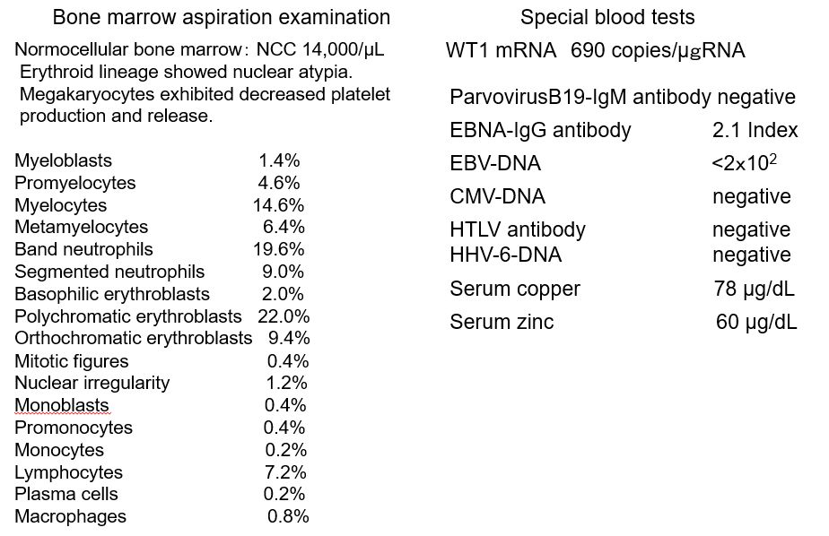
Bone marrow aspiration examination showed that dysplastic erythroid lineage cells
with nuclear atypia was observed, and megakaryocytes showed poor platelet production
and release ability. Blast cells accounted for 1.4% of marrow cells. WT1 mRNA was
elevated (690 copies/μg RNA). No viral reactivation, including Parvovirus B-19, was
detected, and the serum zinc and copper levels were within the normal ranges.
Abbreviations: cytomegalovirus, CMV; Epstein-Barr virus, EBV; Human herpesvirus 6,
HHV-6; Human T-cell leukemia virus type 1, HTLV

