Materials Supplementary
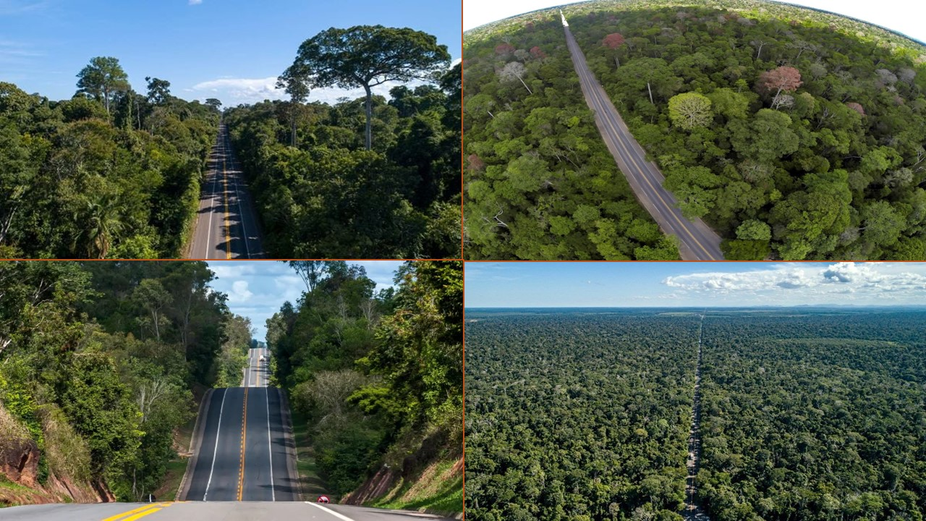
View of the highway section crossing the Sooretama Biological Reserve (Espírito Santo State, Brazil), where the field surveys were conducted and the data used in this study were collected.

