Figure S1. Important mass spectrograms of 4 anthocyanins, cyaniding and dihydroquercetin.
- Peonidin O-hexoside, C₂₂H₂₃O₁₁, Molecular weight 463.123.
- Cyanidin 3-O-malonylhexoside, C₂₄H₂₃O₁₄, Molecular weight 535.1. The Mass spectrometry information is +MS: 535 [M]⁺; +MS²[M]⁺: 287 [Cyanidin].
- Cyanidin O-syringic acid, C₂₄H₁₉O₁₀, Molecular weight 466.1.
- Cyanidin 3,5-diglucoside, C₂₇H₃₁O₁₆, Molecular weight 611, KEGG ID: C08639. The Mass spectrometry information is m/z experimental [M]⁺: 611.16; MS²: 433.11, 271.06; Retention time: 16.57 min.
- Cyanidin, C₁₅H₁₁O₆, Molecular weight 287.24, KEGG ID: C05905. The Mass spectrometry information is m/z: 287.05; Retention time: 31.0 min
- Dihydroquercetin, C₁₅H₁₂O₇, Molecular weight 304.06, KEGG ID: C01617. The Mass spectrometry information is [M]+ at m/z 305.0581 giving MS^{n} ions at m/z 287.01 (-H₂O) and m/z 257.96 (-H₂O-CO).

a | 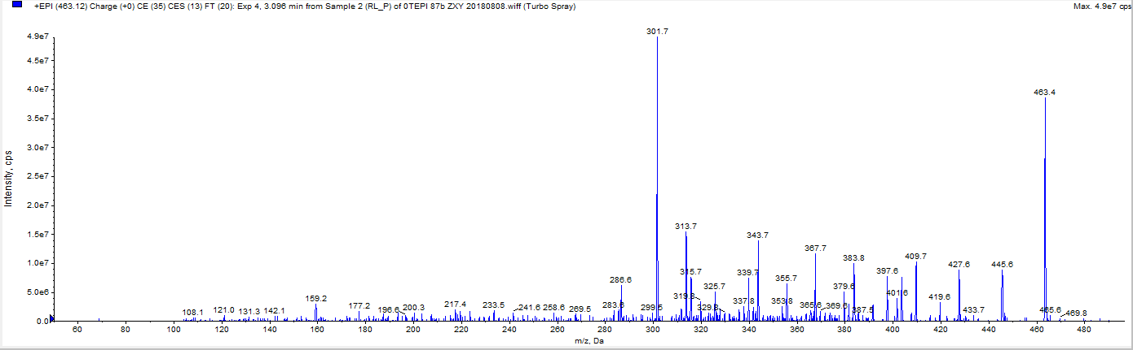
b | 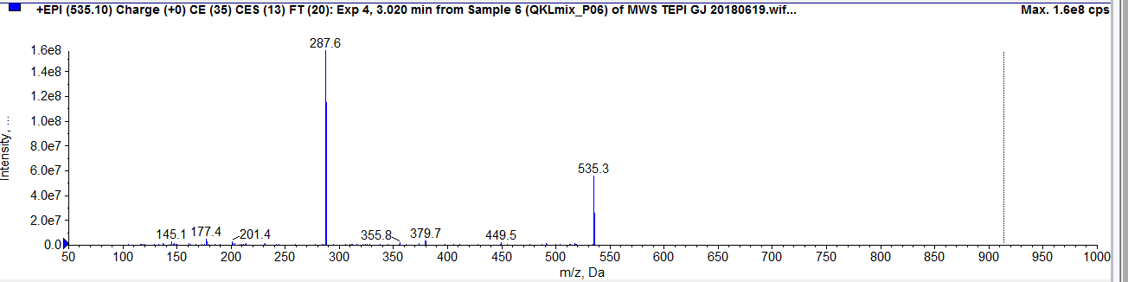
c | 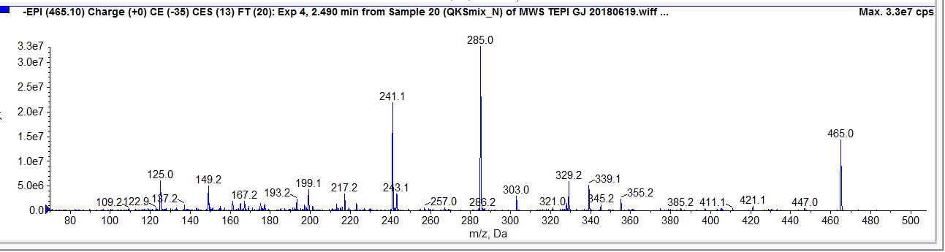
d | 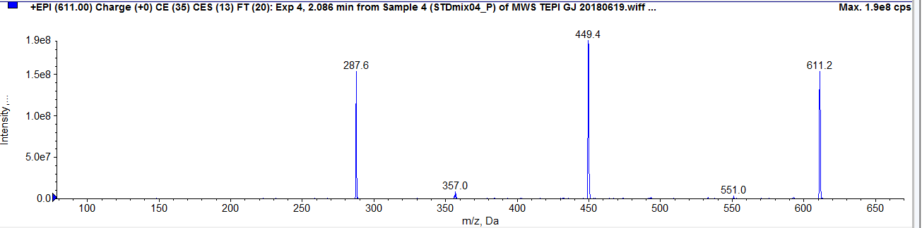
e | 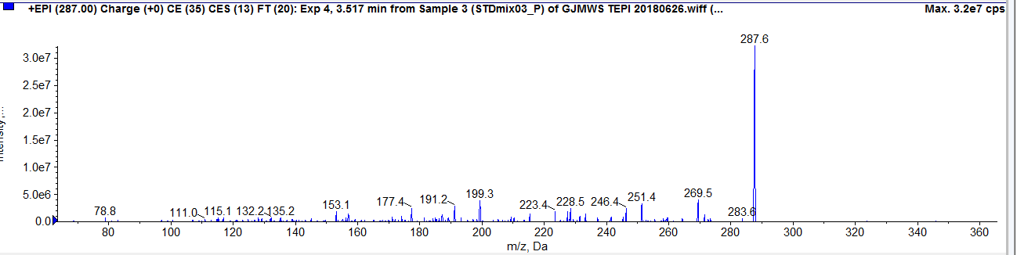
f | 