Figure S2. Some KEGG Enrichment pathways of differential metabolites
ko00944 Flavone and flavonol biosynthesis pathway
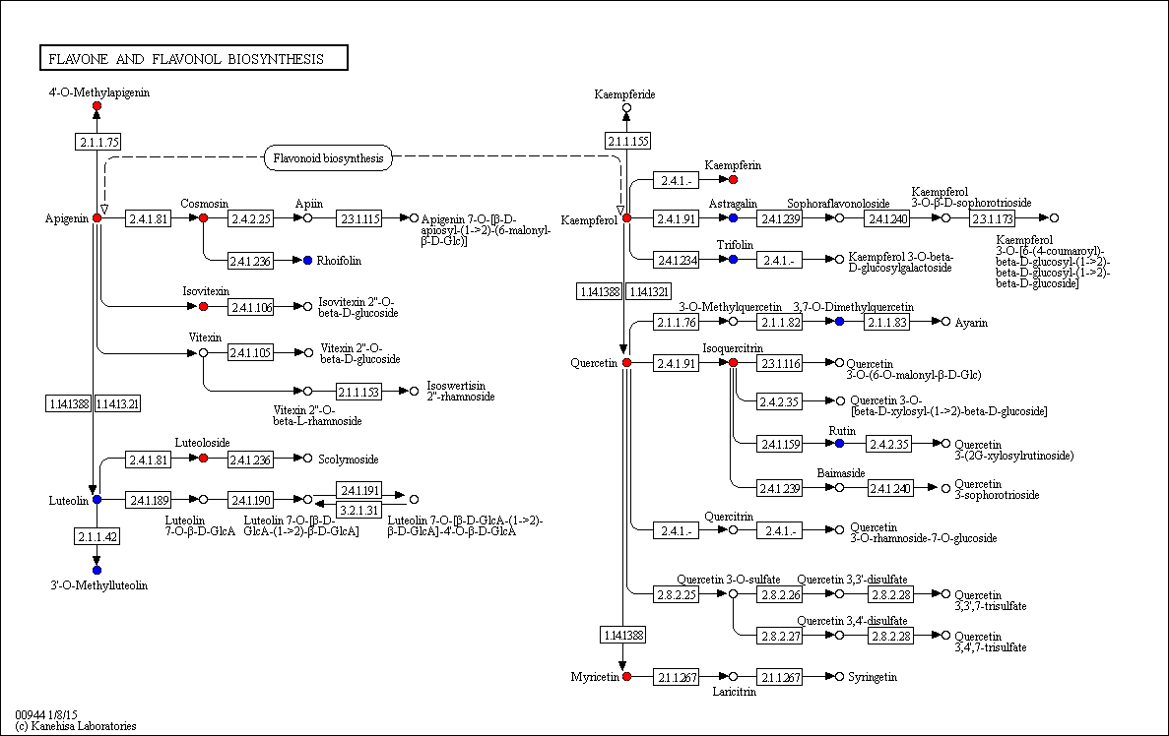

ko00941 Flavonol biosynthesis pathway
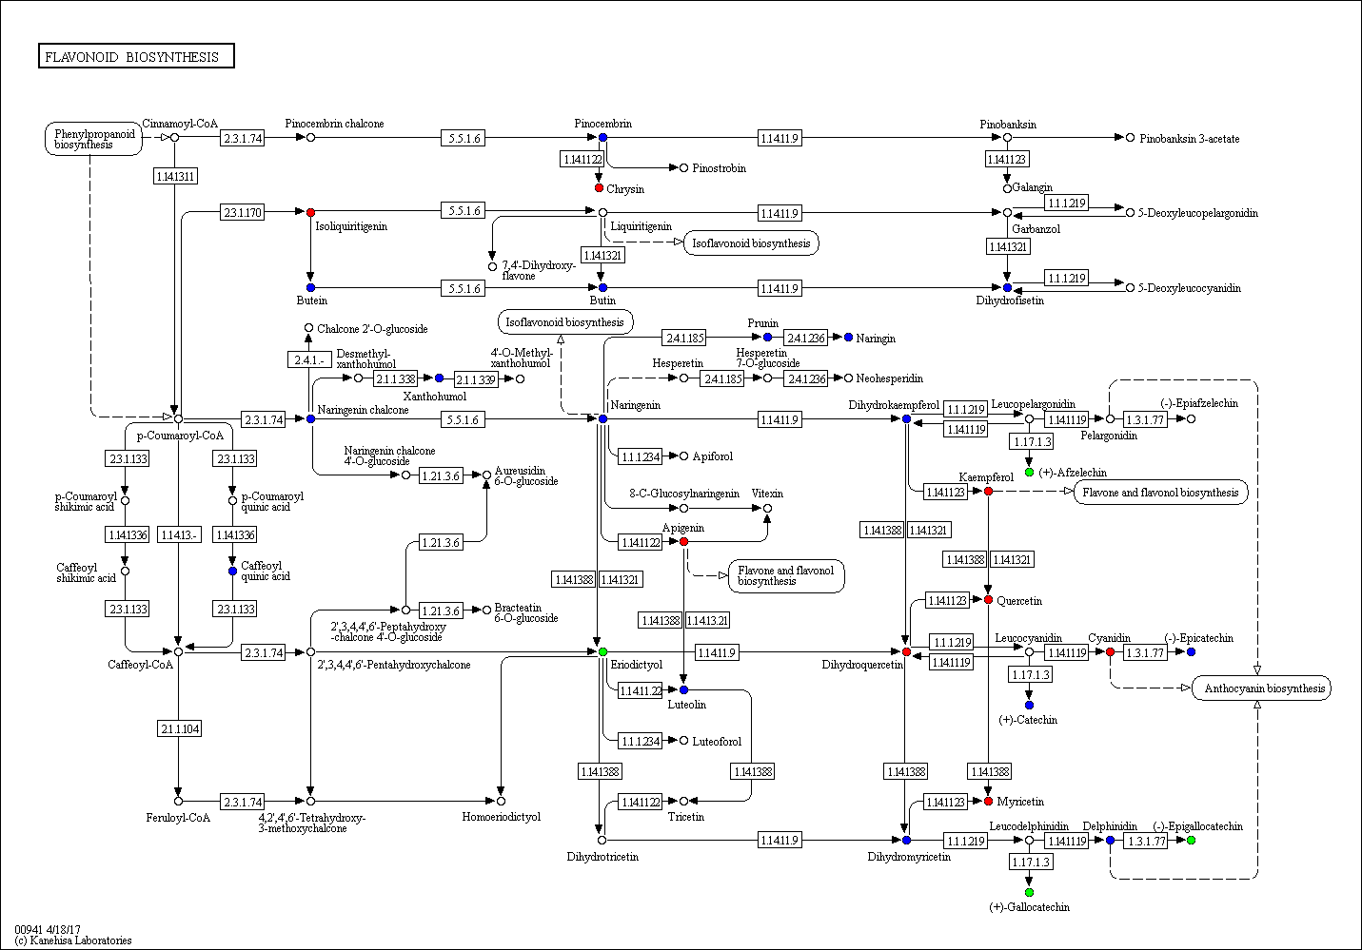

ko00942 Anthocyanin biosynthesis pathway
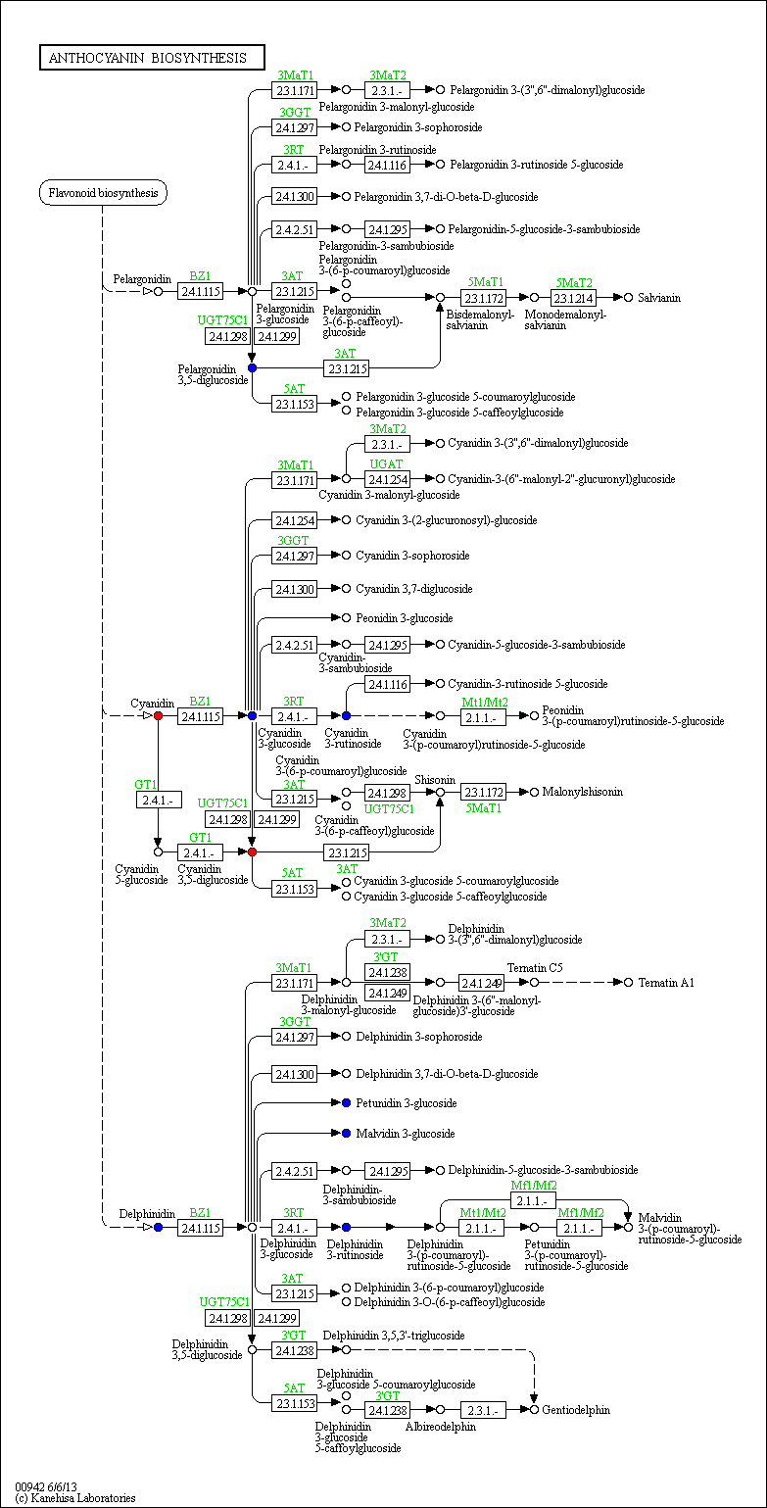
ko01230 Biosynthesis of amino acids pathway
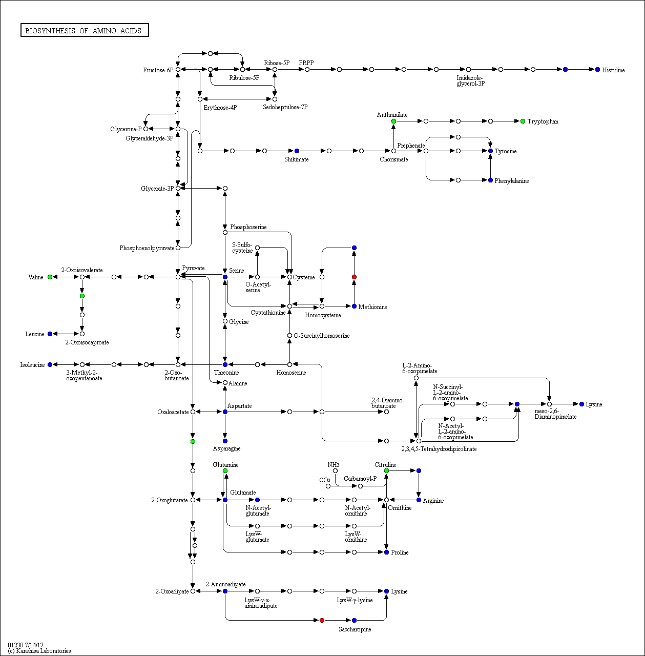

ko00480 Glutathione metabolism pathway
