ko00195 Photosynthesis pathway
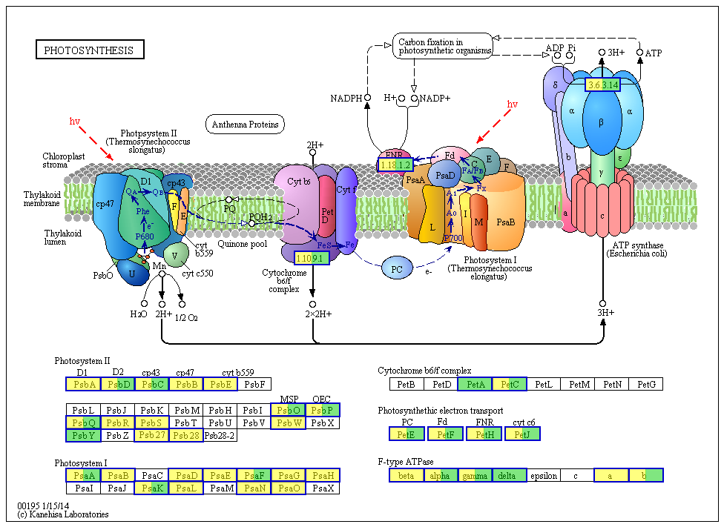

ko00196 Photosynthesis antenna proteins
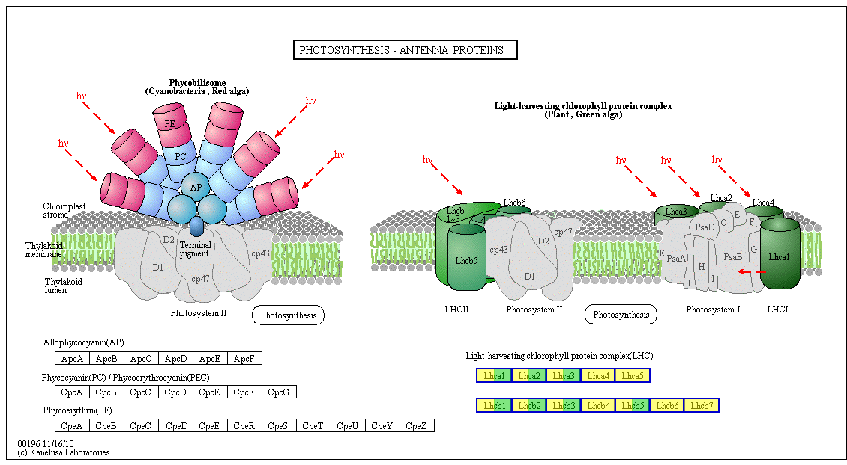
Figure S5. Differentially expressed genes of Photosynthesis Pathways

