Supplementary Materials: Results
Supplementary Table S1. Checkpoint comparison and CD8+ T-cell association statistics in the retained TCGA-HNSC analysis.
Gene | Comparison P | BH FDR | FDR < 0.05 | CD8 Spearman r
CTLA4 | 0.009266 | 0.022346 | Yes | 0.464507
TIGIT | 0.135686 | 0.169608 | No | 0.611133
LAG3 | 0.015901 | 0.022715 | Yes | 0.651854

Supplementary Table S2. Validation details for the reconstructed CTLA4-TIGIT two-gene risk score.
Metric | Value
TIGIT coefficient | -0.0945158
CTLA4 coefficient | -0.0737717
LAG3 coefficient included in score | No
Exact matched samples | 467
Maximum absolute score residual | 1.443e-15
Median score cutoff | -0.388726
Low-risk / high-risk samples | 233 / 234
Overall-survival log-rank P | 0.000481
High-risk versus low-risk hazard ratio (95% CI) | 1.64 (1.24-2.18)

Supplementary Table S3. CTLA4 and TIGIT values across retained annotated single-cell lineages. These source files are summary matrices, not cell-level objects.
Annotated lineage | CTLA4 | TIGIT
Keratinocytes | 0.00161 | 0.00269
Mast | 0.00745 | 0.02115
Malignant | 0.00432 | 0.00428
Mono/Macro | 0.01378 | 0.01042
NK | 0.51396 | 0.65352
Epithelial | 0.00000 | 0.00000
Endothelial | 0.00852 | 0.01003
Treg | 0.51974 | 0.72234
CD8T | 0.75203 | 0.96051

Supplementary Table S4. Mouse-model group summaries. Values are mean +/- SD; Holm-adjusted P values compare each treatment with anti-IgG within outcome family. CD8 and FoxP3 are workbook scores, not cells/HPF; the score definition is not available in the retained source.
Outcome | Group | Mean +/- SD | Holm-adjusted P
Tumor weight (g) | anti-CTLA4 | 0.286 +/- 0.041 | 9.81e-07
Tumor weight (g) | anti-IgG | 0.770 +/- 0.068 | Reference
Tumor weight (g) | anti-LAG3 | 0.268 +/- 0.030 | 1.75e-06
Tumor weight (g) | anti-TIGIT | 0.541 +/- 0.147 | 0.0104
Day-21 tumor volume (mm3) | anti-CTLA4 | 267.870 +/- 32.456 | 4.44e-06
Day-21 tumor volume (mm3) | anti-IgG | 866.358 +/- 83.170 | Reference
Day-21 tumor volume (mm3) | anti-LAG3 | 240.948 +/- 30.402 | 4.44e-06
Day-21 tumor volume (mm3) | anti-TIGIT | 446.435 +/- 80.055 | 4.57e-06
CD8 score | anti-CTLA4 | 0.423 +/- 0.119 | 1.5e-09
CD8 score | anti-IgG | 2.642 +/- 0.163 | Reference
CD8 score | anti-LAG3 | 0.217 +/- 0.100 | 1.5e-09
CD8 score | anti-TIGIT | 1.961 +/- 0.184 | 5.12e-05
FoxP3 score | anti-CTLA4 | 0.564 +/- 0.238 | 6.1e-08
FoxP3 score | anti-IgG | 2.671 +/- 0.215 | Reference
FoxP3 score | anti-LAG3 | 0.277 +/- 0.080 | 2.4e-07
FoxP3 score | anti-TIGIT | 1.127 +/- 0.109 | 5.76e-07

Supplementary Data 1. The unmodified workbook OSCC_mouse_model_data.xlsx contains the retained mouse-level and field-level source data used for Supplementary Table S4 and Figure 5.

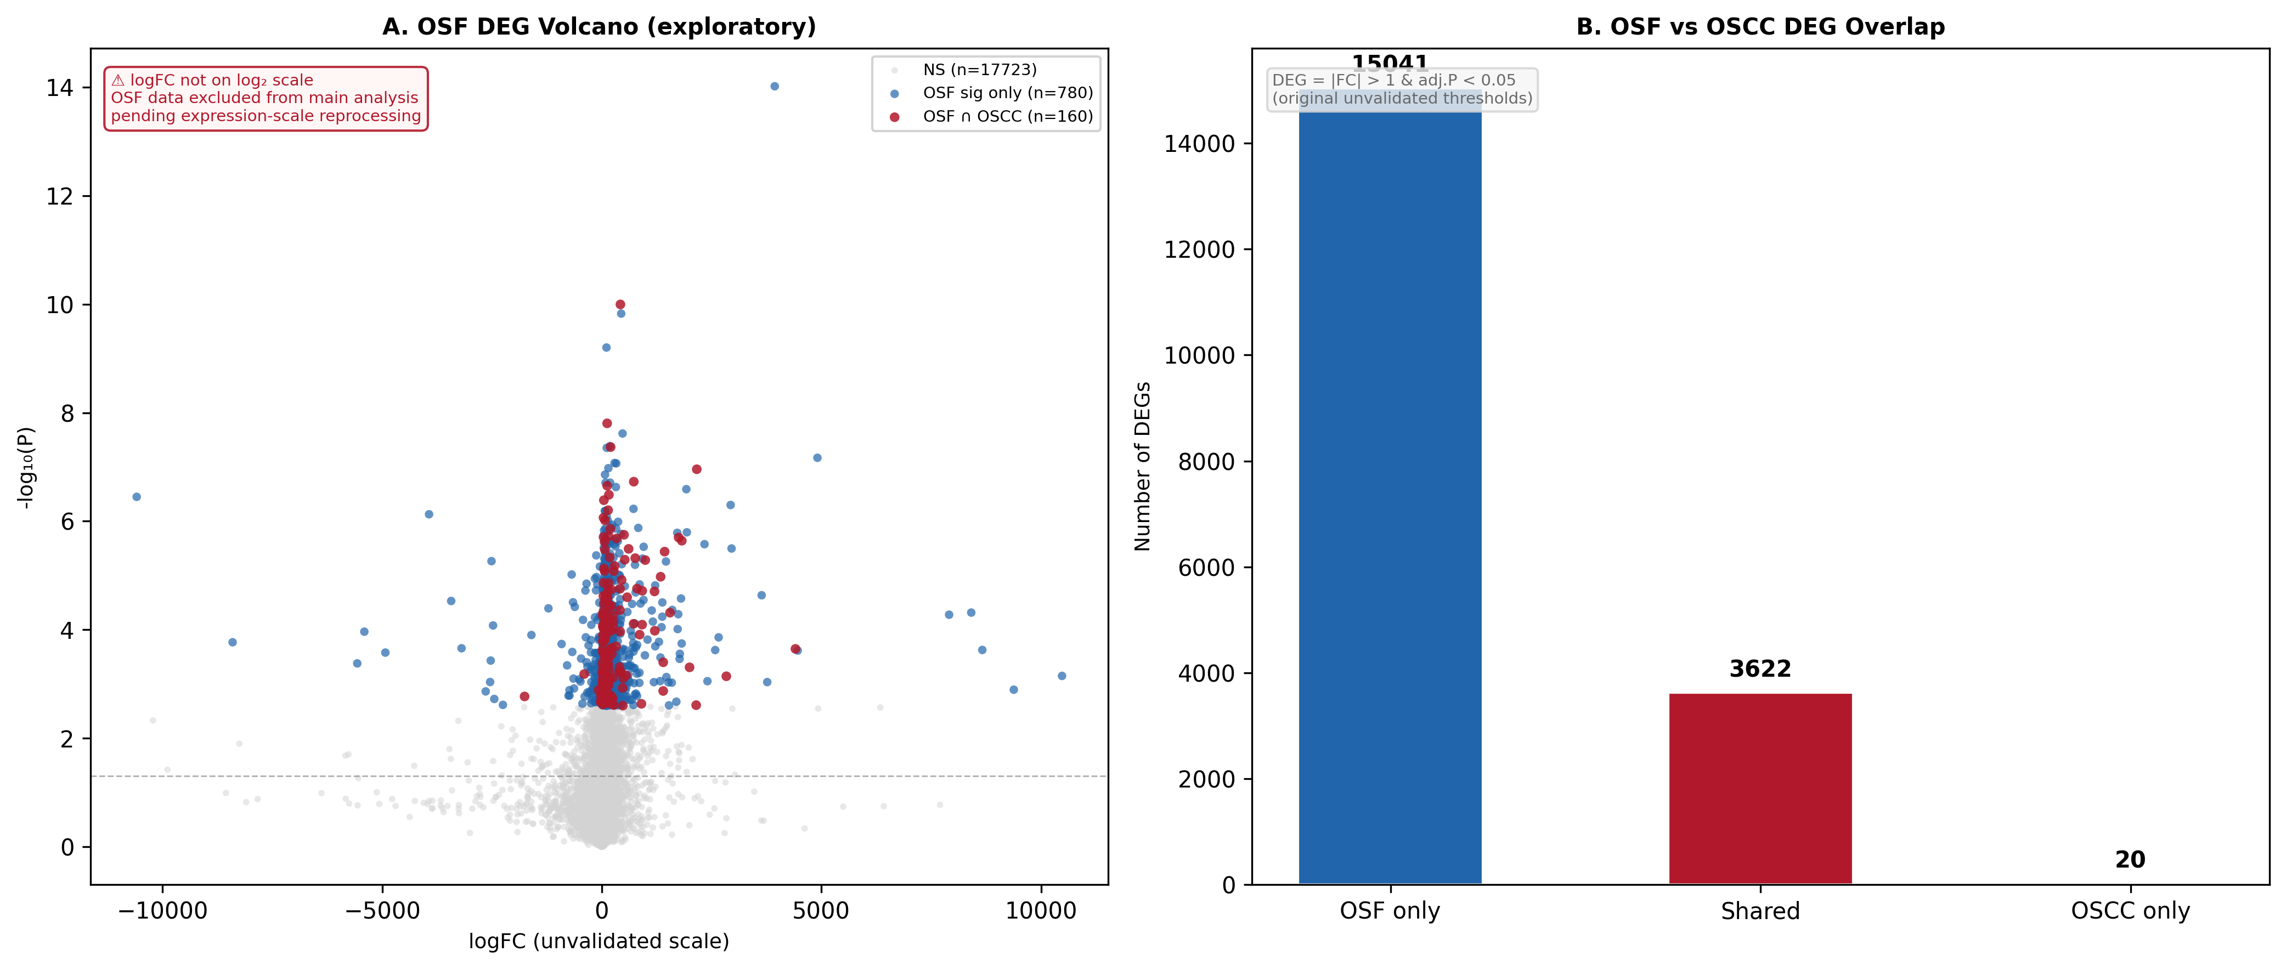
Figure S1. OSF exploratory differential expression analysis (excluded from main results). (A) Volcano plot of OSF DEG results. The logFC scale is not on log₂ and therefore cannot be interpreted as fold-change; these data were excluded pending expression-scale reprocessing. (B) Overlap between OSF and OSCC DEGs identified under the original unvalidated thresholds (|FC| > 1, adj.P < 0.05).
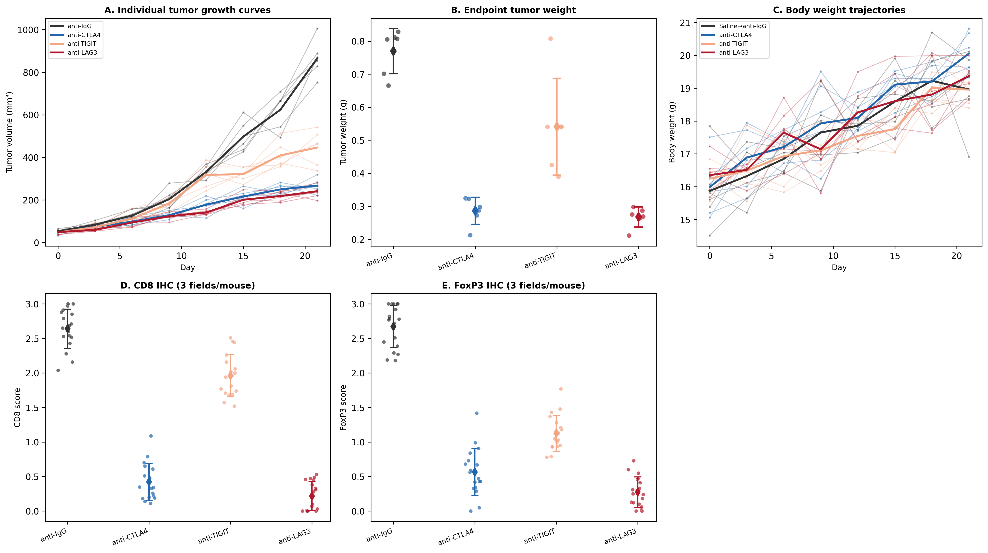
Figure S2. Individual animal-level data for checkpoint blockade in the OSCC mouse model (n = 6 per group). (A) Individual tumor growth curves (thin lines) with group means (thick lines). (B) Endpoint tumor weights; individual values and mean ± SD. (C) Body weight trajectories; 'Saline→anti-IgG' denotes the isotype-control group (raw source label: Saline; confirmed study design: anti-IgG). (D–E) Individual IHC field scores (3 fields per mouse, 18 points per group) for CD8 and FoxP3. Score values are from the retained workbook; the scoring definition is not available and values should not be interpreted as cells/HPF.
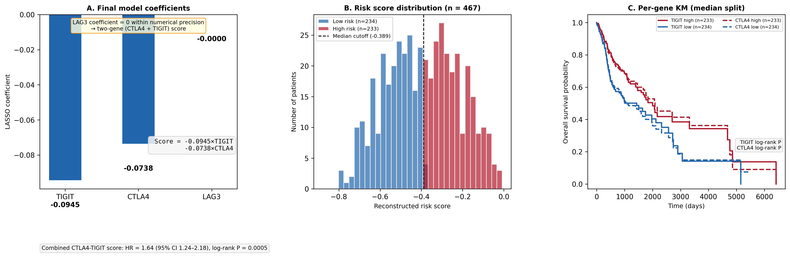
Figure S3. CTLA4-TIGIT two-gene risk model derivation (n = 467 TCGA-HNSC). (A) Final LASSO model coefficients. LAG3 coefficient is zero within numerical precision, confirming the retained model is a two-gene score. (B) Distribution of reconstructed risk scores stratified by original risk group. (C) Per-gene Kaplan-Meier overall survival curves (median split) for TIGIT and CTLA4 individually, showing each gene's univariate prognostic association. The combined CTLA4-TIGIT score (Figure 3) integrates both signals.

