Supplementary Figure S1. Study design and explainable machine learning workflow
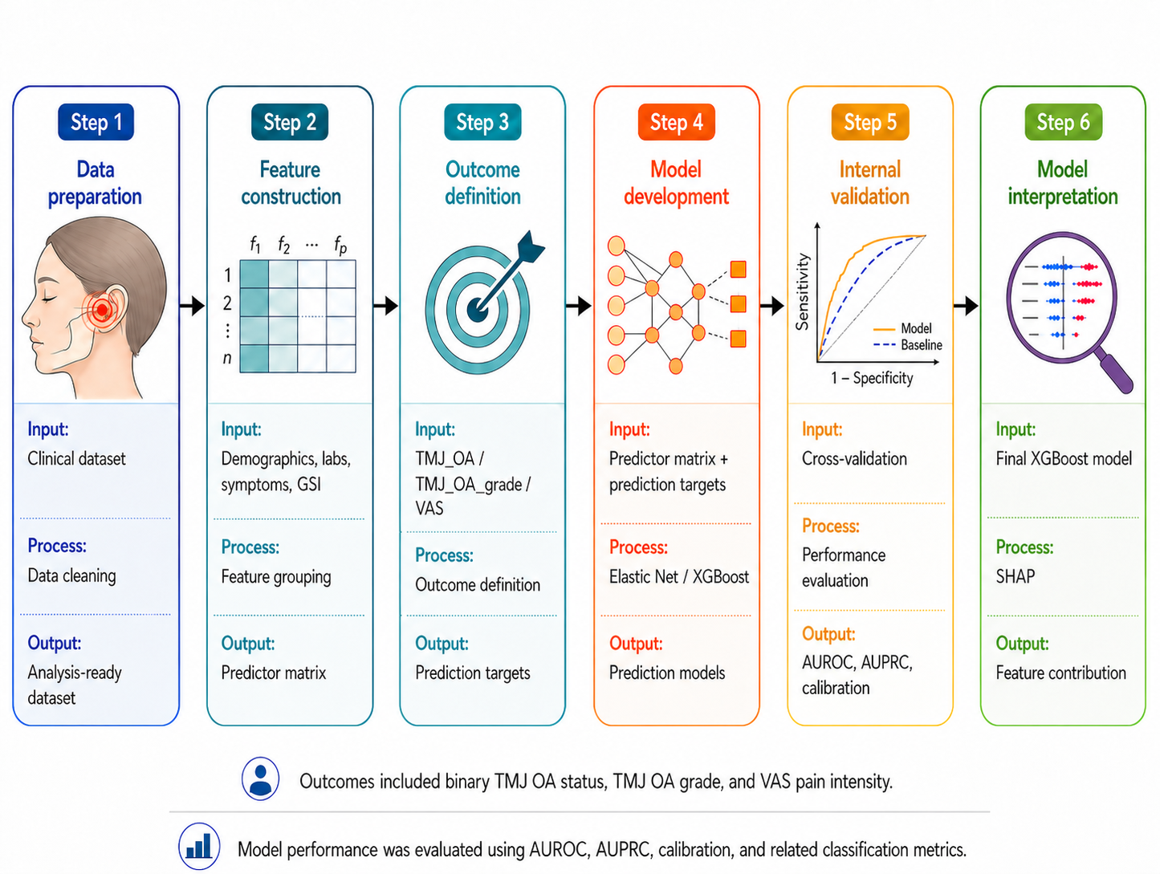
A schematic of the study design and explainable machine learning workflow. The patients with temporomandibular joint arthralgia underwent clinical assessment, CBCT imaging, laboratory testing, serum vitamin D measurement, and psychological assessments. The outcomes included binary TMJ OA status, TMJ OA grade, and VAS pain intensity. Elastic Net and XGBoost models were developed using prespecified nested feature blocks and internally assessed using a stratified 80:20 train-test split. The model performance was assessed using AUROC, AUPRC, calibration, and classification metrics. A SHAP analysis was performed to interpret the feature-level contributions in the final XGBoost model.
Abbreviations: AUPRC, area under the precision–recall curve; AUROC, area under the receiver operating characteristic curve; CBCT, cone-beam computed tomography; SHAP, Shapley additive explanations; TMJ OA, temporomandibular joint osteoarthritis; VAS, visual analog scale; XGBoost, extreme gradient boosting.

Supplementary Figure S2. ROC and calibration curves for the machine learning prediction of temporomandibular joint osteoarthritis
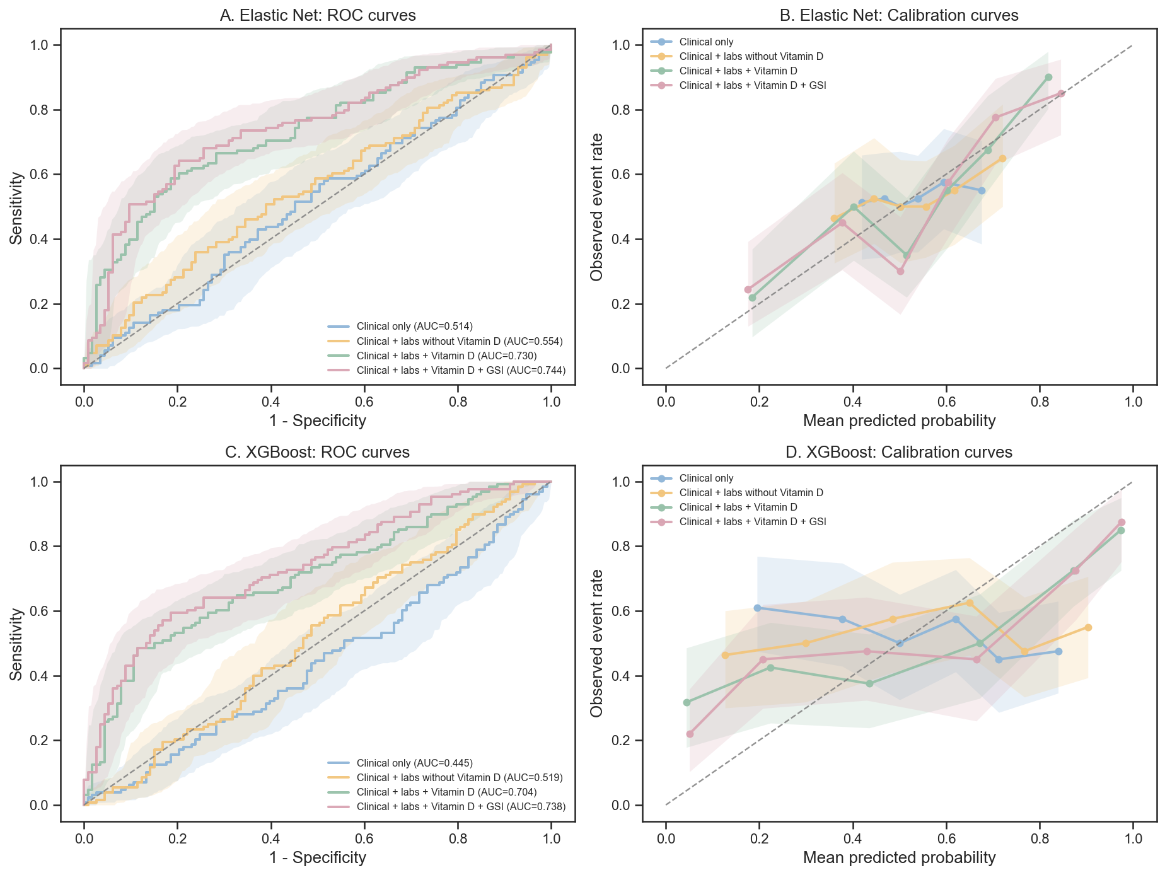

The ROC and calibration curves for the four prespecified model blocks used to predict the binary TMJ OA status. A. The ROC curves for Elastic Net models. B. The calibration curves for the Elastic Net models. C. The ROC curves for the XGBoost models. D. The calibration curves for the XGBoost models. The four model blocks were defined as clinical only, clinical + labs without vitamin D, clinical + labs + vitamin D, and clinical + labs + vitamin D + GSI. Model performance was assessed in the held-out test set after an internal stratified 80:20 train-test split. The shaded areas indicate bootstrap-based 95% confidence intervals.
Abbreviations: AUROC, area under the receiver operating characteristic curve; GSI, Global Severity Index; ROC, receiver operating characteristic; TMJ OA, temporomandibular joint osteoarthritis; XGBoost, extreme gradient boosting.

Supplementary Figure S3. SHAP-based interpretation of the final XGBoost model for temporomandibular joint osteoarthritis prediction
(A)
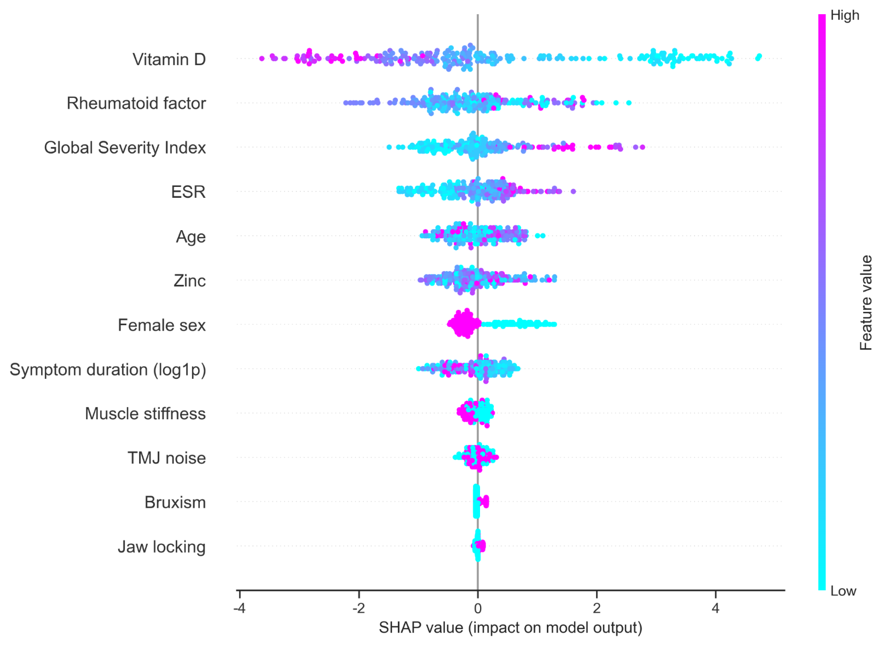
(B)
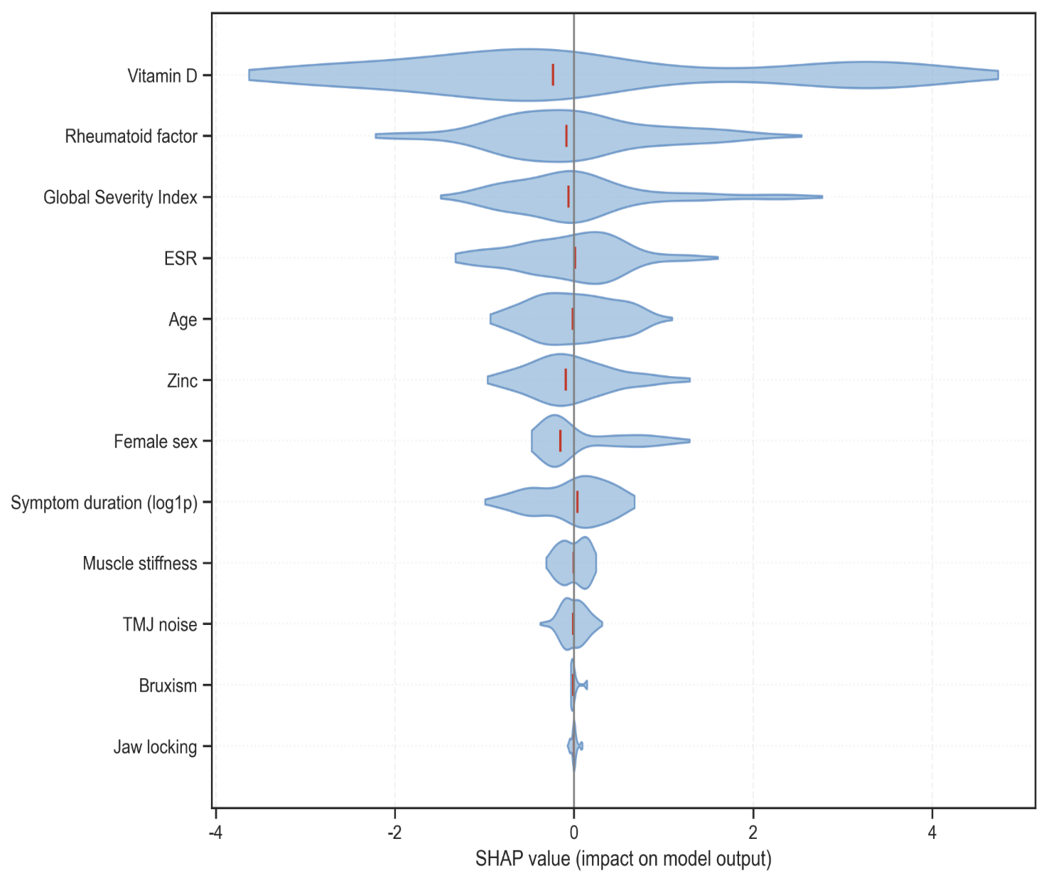
The SHAP-based interpretation of the final XGBoost model for binary TMJ OA prediction. A. A SHAP summary plot showing the contribution of each feature to the prediction of TMJ OA. Each point represents an individual observation. The x-axis indicates the SHAP value, wherein positive values increase the predicted probability of TMJ OA and negative values decrease it. The features are ordered according to their overall importance. The point color represents the relative feature value, ranging from low to high. B. The SHAP violin plot showing the distribution and directionality of the feature effects. The width of each violin reflects the density of the SHAP values for that feature, while the vertical markers indicate the central tendency of the distribution. The features are ordered by mean absolute SHAP value.
Abbreviations: ESR, erythrocyte sedimentation rate; RF, rheumatoid factor; SHAP, Shapley additive explanations; TMJ OA, temporomandibular joint osteoarthritis; XGBoost, extreme gradient boosting.

Supplementary Figure S4. Association between vitamin D status and pain intensity
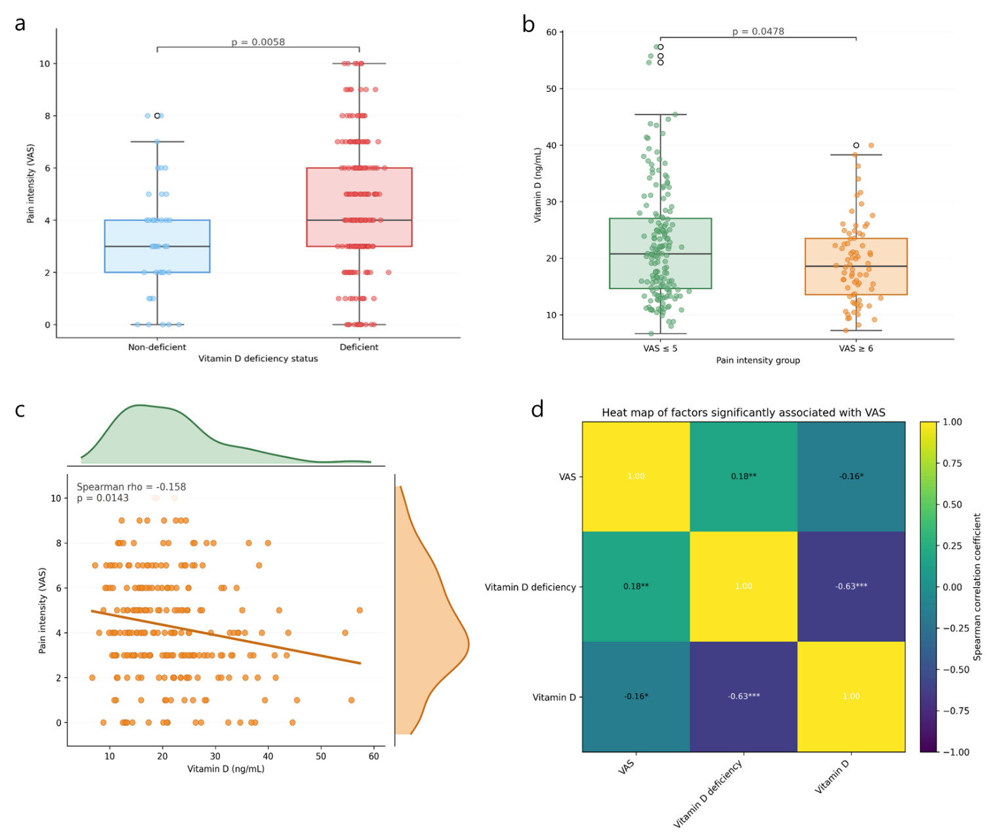
The association between serum vitamin D status and VAS pain intensity. A. The distribution of VAS pain intensity according to the vitamin D deficiency status. B. The distribution of the serum vitamin D levels according to the pain intensity group, dichotomized as a VAS of ≤ 5 and VAS of ≥ 6. C. A scatter plot showing the association between the serum vitamin D level and VAS pain intensity, with marginal density plots summarizing the distributions of vitamin D and VAS. The fitted line indicates the overall trend, while Spearman’s rank correlation coefficient and p-value are shown. The individual data points are overlaid on box plots. The boxes indicate the interquartile range, horizontal lines indicate the medians, and whiskers represent the range excluding outliers. The group differences were assessed using the Mann–Whitney U test.
Abbreviations: VAS, visual analog scale.

Supplementary Figure S5. Correlation heat map of factors associated with temporomandibular joint osteoarthritis severity
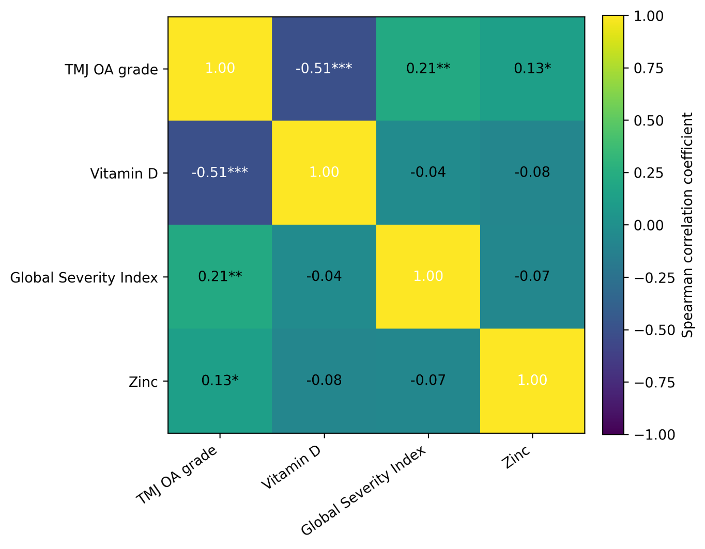
Heat map showing Spearman correlations among TMJ OA grade and variables associated with TMJ OA severity in screening analyses. Vitamin D deficiency was excluded to avoid redundancy with continuous serum vitamin D level. Correlation coefficients are shown within cells. Asterisks indicate statistical significance.
TMJ OA, temporomandibular joint osteoarthritis. *p < 0.05, **p < 0.01, ***p < 0.001.
Supplementary Table S1. Factors associated with pain intensity based on Spearman correlation analysis
Outcome | Variable | Spearman ρ | p-value | Interpretation
VAS Pain intensity | Vitamin D deficiency | 0.178 | 0.0056 | Deficiency associated with higher pain intensity
VAS Pain intensity | Vitamin D | -0.158 | 0.0143 | Lower vitamin D associated with higher pain intensity
VAS Pain intensity | Muscle stiffness | 0.119 | 0.064 | Positive trend, not statistically significant
VAS Pain intensity | ESR | 0.114 | 0.078 | Positive trend, not statistically significant
VAS Pain intensity | Female sex | 0.111 | 0.086 | Positive trend, not statistically significant
VAS Pain intensity | TMJ noise | -0.103 | 0.112 | Not statistically significant
VAS Pain intensity | GSI | 0.084 | 0.210 | Not statistically significant
VAS Pain intensity | Bruxism | 0.080 | 0.218 | Not statistically significant
VAS Pain intensity | RF | 0.077 | 0.235 | Not statistically significant
VAS Pain intensity | Symptom duration | -0.067 | 0.299 | Not statistically significant
VAS Pain intensity | TMJ OA | -0.060 | 0.354 | Not statistically significant
VAS Pain intensity | Age | 0.054 | 0.406 | Not statistically significant
VAS Pain intensity | Zinc | -0.029 | 0.651 | Not statistically significant
VAS Pain intensity | TMJ OA grade | -0.019 | 0.775 | Not statistically significant
VAS Pain intensity | Jaw locking | -0.012 | 0.854 | Not statistically significant
Pain intensity was assessed using the VAS. Spearman’s rank correlation coefficients were calculated to examine associations between VAS pain intensity and clinical, serologic, psychological, and TMJ OA-related variables. Statistical significance was defined as p < 0.05. Only vitamin D deficiency and continuous vitamin D level showed statistically significant correlations with VAS pain intensity. ESR, muscle stiffness, and female sex showed weak positive trends but did not reach statistical significance.
ESR, erythrocyte sedimentation rate; GSI, Global Severity Index; RF, rheumatoid factor; TMJ OA, temporomandibular joint osteoarthritis; VAS, visual analog scale.
Supplementary Table S2. Exploratory associations between SCL-90-R symptom dimensions and VAS pain intensity
SCL-90-R dimension | Adjusted β | 95% CI | p-value | FDR-adjusted p-value
Somatization | 0.056 | 0.005 to 0.108 | 0.033 | 0.153
Obsessive-compulsive symptoms | 0.018 | -0.023 to 0.059 | 0.386 | 0.497
Interpersonal sensitivity | -0.006 | -0.047 to 0.035 | 0.775 | 0.775
Depression | 0.018 | -0.020 to 0.057 | 0.351 | 0.497
Anxiety | 0.037 | -0.016 to 0.091 | 0.172 | 0.495
Hostility | 0.032 | -0.025 to 0.089 | 0.275 | 0.495
Phobic anxiety | 0.069 | 0.005 to 0.132 | 0.034 | 0.153
Paranoid ideation | -0.021 | -0.056 to 0.015 | 0.248 | 0.495
Psychoticism | 0.010 | -0.047 to 0.066 | 0.740 | 0.775
Exploratory linear regression models were fitted separately for each SCL-90-R symptom dimension, with VAS pain intensity as the outcome. Adjusted β represents the estimated change in VAS pain intensity per 1-unit increase in each SCL-90-R dimension. Each model was adjusted for age, sex, TMJ OA grade, serum vitamin D, ESR, RF elevation, zinc, muscle stiffness, jaw locking, and bruxism. GSI was not included in these exploratory models to avoid overlap with individual SCL-90-R dimensions. FDR-adjusted p-values were calculated using the Benjamini–Hochberg method across the nine SCL-90-R dimensions.
CI, confidence interval; ESR, erythrocyte sedimentation rate; FDR, false discovery rate; GSI, Global Severity Index; RF, rheumatoid factor; SCL-90-R, Symptom Checklist-90-Revised; TMJ OA, temporomandibular joint osteoarthritis; VAS, visual analog scale.
Supplementary Table S3. DeLong’s test summary for AUROC comparisons between nested machine learning models
Algorithm | Comparison | ΔAUROC | DeLong p-value
Elastic Net | Clinical + labs without Vitamin D vs Clinical only | +0.020 | 0.705
Elastic Net | Clinical + labs + Vitamin D vs Clinical + labs without Vitamin D | +0.201 | 0.023
Elastic Net | Clinical + labs + Vitamin D + GSI vs Clinical + labs + Vitamin D | +0.037 | 0.175
Elastic Net | Clinical + labs + Vitamin D vs Clinical only | +0.221 | 0.028
Elastic Net | Clinical + labs + Vitamin D + GSI vs Clinical only | +0.258 | 0.013
XGBoost | Clinical + labs without Vitamin D vs Clinical only | −0.054 | 0.595
XGBoost | Clinical + labs + Vitamin D vs Clinical + labs without Vitamin D | +0.263 | 0.001
XGBoost | Clinical + labs + Vitamin D + GSI vs Clinical + labs + Vitamin D | −0.018 | 0.687
XGBoost | Clinical + labs + Vitamin D vs Clinical only | +0.209 | 0.021
XGBoost | Clinical + labs + Vitamin D + GSI vs Clinical only | +0.191 | 0.067
ΔAUROC was calculated as the AUROC of the latter model minus that of the former model. DeLong’s test was used for paired AUROC comparisons between nested models evaluated on the same held-out test set. Positive ΔAUROC values indicate improved discrimination in the latter model. The primary comparison was the clinical-laboratory model without vitamin D versus the corresponding model after adding serum vitamin D.
AUROC, area under the receiver operating characteristic curve; GSI, Global Severity Index. Statistical significance was defined as p < 0.05.
Supplementary Table S4. SHAP-based feature importance and adjusted logistic regression estimates for TMJ OA prediction
Rank | Feature | Mean absolute SHAP | βᵃ | Adjusted ORᵇ | 95% CI | p-value
1 | Vitamin D | 1.719 | −1.043 | 0.352 | 0.229–0.542 | < 0.001***
2 | Rheumatoid factor | 0.696 | 0.003 | 1.003 | 0.767–1.312 | 0.980
3 | Global Severity Index | 0.564 | 0.631 | 1.879 | 1.166–3.029 | 0.010*
4 | ESR | 0.469 | 0.227 | 1.255 | 0.959–1.642 | 0.098
5 | Age | 0.379 | 0.019 | 1.019 | 0.855–1.216 | 0.832
6 | Zinc | 0.373 | 0.101 | 1.106 | 0.915–1.338 | 0.297
7 | Female sex | 0.358 | −0.546 | 0.580 | 0.289–1.161 | 0.124
8 | Symptom duration (log1p) | 0.329 | 0.189 | 1.208 | 0.957–1.525 | 0.111
9 | Muscle stiffness | 0.129 | −0.396 | 0.673 | 0.358–1.265 | 0.219
10 | TMJ noise | 0.109 | −0.003 | 0.997 | 0.513–1.937 | 0.992
11 | Bruxism | 0.034 | −0.213 | 0.808 | 0.380–1.719 | 0.580
12 | Jaw locking | 0.022 | −0.310 | 0.733 | 0.370–1.455 | 0.375
The mean absolute SHAP values were derived from the final XGBoost model for TMJ OA prediction. The β coefficients and adjusted ORs were derived from multivariable logistic regression with TMJ OA status as the outcome. The continuous variables were scaled for clinical interpretability as follows: age per 10 years, vitamin D per 10 ng/mL, ESR per 10 mm/hr, RF per 10 units, zinc per 10 units, and GSI per 10 points. The symptom duration was log-transformed using log1p.
ᵃThe β coefficients represent the log-odds estimates from multivariable logistic regression.
ᵇThe adjusted ORs were measured as exp(β), with 95% CIs calculated as exp(β ± 1.96 × standard error).
Abbreviations: CI, confidence interval; ESR, erythrocyte sedimentation rate; GSI, Global Severity Index; OR, odds ratio; RF, rheumatoid factor; SHAP, Shapley additive explanations; TMJ OA, temporomandibular joint osteoarthritis; XGBoost, extreme gradient boosting. Statistical significance was defined as follows: p < 0.05, *p < 0.05, and ***p < 0.001.

