Supplementary material
Local and regional drivers of standing-water metacommunities on a riverine island
Aquatic Sciences
Igor Kokavec¹, Marta Illýová✝, Tomáš Čejka²*
¹ Institute of Zoology, Slovak Academy of Sciences, Dúbravská cesta 9, SK-84506 Bratislava, Slovakia
² Institute of Botany, Plant Science and Biodiversity Centre, Slovak Academy of Sciences, Dúbravská cesta 9, SK-84523 Bratislava, Slovakia
e-mail: t.cejka@gmail.com

Appendix 1

Basic characteristics of sampling sites with species richness of zooplankton and molluscs recorded during the study; R – reference standing waters, A – artificial standing waters

Site | Latitude | Longitude | Area (m²) | Zooplankton species richness | Mollusca species richness
R1 | 47.79414 | 18.01331 | 1289 | 15 | 0
R2 | 47.7949 | 18.01449 | 1036 | 13 | 8
R3 | 47.78781 | 18.16627 | 2862 | 15 | 11
R4 | 47.86095 | 18.12562 | 47580 | 18 | 15
R5 | 47.87206 | 17.92652 | 235 | 12 | 2
R6 | 47.76197 | 17.73627 | 3431 | 23 | 6
R7 | 47.76429 | 17.73333 | 1815 | 17 | 3
R8 | 48.05751 | 17.24555 | 34102 | 29 | 7
R9 | 47.79293 | 17.73208 | 4887 | 18 | 11
R10 | 47.8862 | 17.93994 | 3895 | 15 | 0
R11 | 47.89086 | 18.05211 | 146127 | 28 | 13
R12 | 48.04326 | 17.56425 | 4470 | 23 | 2
R13 | 47.83441 | 17.95292 | 3110 | 19 | 0
R14 | 47.85674 | 17.54202 | 17664 | 18 | 15
R15 | 47.82186 | 17.83115 | 1492 | 18 | 2
R16 | 47.82069 | 17.74323 | 4662 | 17 | 9
R17 | 47.82083 | 17.73574 | 2137 | 14 | 9
R18 | 48.16481 | 17.26238 | 43667 | 22 | 11
R19 | 47.75942 | 17.74586 | 3110 | 24 | 6
R20 | 47.86027 | 18.14045 | 1919 | 20 | 16
A1 | 47.91315 | 18.19611 | 43743 | 22 | 3
A2 | 48.00171 | 18.17506 | 60395 | 17 | 2
A3 | 47.89883 | 17.64959 | 134000 | 18 | 2
A4 | 48.10903 | 17.36336 | 4949 | 12 | 2
A5 | 48.01691 | 17.48046 | 9980 | 18 | 1
A6 | 47.99989 | 17.58078 | 11564 | 18 | 4
A7 | 47.89479 | 18.01808 | 23460 | 17 | 1
A8 | 48.17561 | 17.26225 | 126043 | 20 | 6
A9 | 47.80884 | 18.10583 | 24703 | 18 | 2
A10 | 47.80861 | 18.10841 | 53065 | 13 | 1
A11 | 48.00412 | 17.54342 | 11961 | 16 | 2
A12 | 48.06813 | 17.38969 | 6933 | 16 | 4
A13 | 47.83951 | 17.60054 | 33837 | 24 | 6
A14 | 48.07759 | 17.42814 | 40663 | 16 | 5
A15 | 48.0425 | 17.41921 | 5166 | 19 | 6
A16 | 48.09923 | 17.22736 | 31589 | 25 | 3
A17 | 47.8438 | 17.8175 | 61431 | 33 | 11
A18 | 47.93578 | 17.6106 | 30658 | 22 | 7
A19 | 47.85378 | 17.55509 | 12845 | 19 | 8
A20 | 47.85307 | 17.55698 | 6072 | 18 | 6
A21 | 47.85242 | 17.55883 | 35823 | 15 | 5
A22 | 47.82779 | 17.70407 | 31036 | 13 | 3

Appendices 2 and 3 can be found here:
Kokavec et al. Appendices 2,3
Appendix 4

Do small standing waters on a large riverine island conform to the principles of island biogeography?

Igor Kokavec¹, Marta Illýová✝, Tomáš Čejka²*

- DHARMA diagnostic of the reduced model, testing the influence of TIB predictors on mollusc species richness
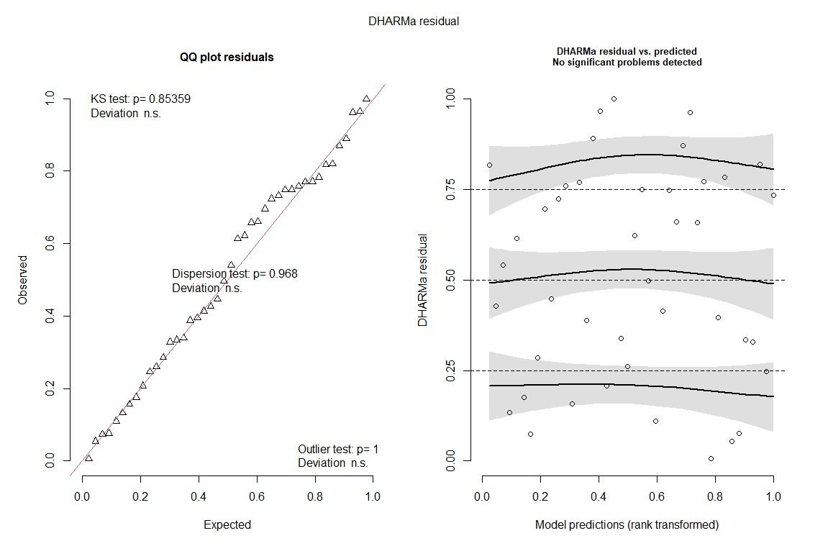

- DHARMA diagnostic of the reduced model testing the influence of TIB predictors on zooplankton species richness
