Graphical Abstract
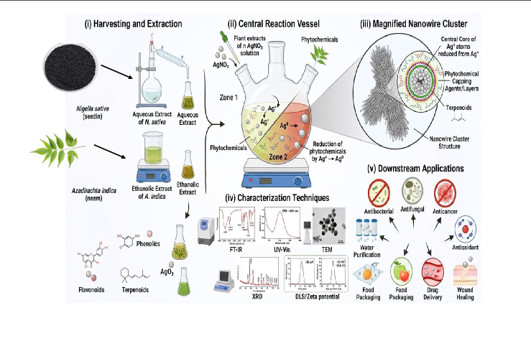
(Left to right): (i) Nigella sativa seeds and Azadirachta indica leaves harvested and their aqueous/ethanolic extraction processes; (ii) a central reaction vessel with two zones, where extracts are added to AgNO₃ solution, and in which the Ag⁺ is reduced to Ag⁰ through the action of flavonoids, phenolics and terpenoids, causing a color change from pale yellow/green to reddish-brown; (iii) a nanowire cluster of AgNP (Ag⁺ atoms reduced to Ag⁰), with a central core surrounded by layers of phytochemicals; (iv) icons for the principal characterization techniques (FT-IR, UV-Vis, TEM, XRD, DLS/zeta potential) and (v) a semicircular array of downstream biological/industrial applications including antibacterial, antifungal, anticancer, antioxidant, wound healing, drug delivery, food packaging and water purification.

