Supplement to:

Circular economy and decarbonization reshape appliance material demand and emissions in Europe
Adriana Gómez-Sanabria ^{1*}, Xiaoyang Zhong* ^{1,2,3}, Alessio Mastruci¹, Sara Giorgi¹, Pallav Purohit¹, Volker Krey¹

¹ Energy, Climate and Environment Program, International Institute for Applied Systems Analysis, Laxenburg, Austria
² Institute of Environment and Ecology, Tsinghua Shenzhen International Graduate School, Tsinghua University, Shenzhen, China
³Institute of Environmental Sciences (CML), Leiden University, Leiden, The Netherlands
⁴ T6 Ecosystems, Rome, Italy

Contents

1. Region classification 3
2. The role of digitalisation in the circularity of household appliances: Digital Product Passport (DDP) 3
3. Results 4
3.1 Household appliances dynamics determine the availability of material outflows 4
3.2 End-of-life treatment and provision of secondary materials 4
3.3 Combined effects of circularity, energy efficiency, and energy system decarbonization on greenhouse gas emissions 6
4. Methods 6

Figures

Figure S1. Materials outflows and end-of-life treatment by scenario 5
Figure S2. Materials dynamics by appliance category and scenario 6
Figure S3. Emissions in 2050 by appliance, source and scenario 7

Tables

Table S1. Regional Classification 3
Table S2. DDP as enabler of circularity in the household appliances sector 4
Table S3. Interpretation of the Eu policy landscape 8
Table S4. Material composition of representative household appliance in percentage % 9
Table S5. Household appliance lifetime-baseline 9
Table S6. Household appliance substitutability rate - Baseline 13
Table S7. Energy intensity for representative products 14

Region classification
Table S1. Regional Classification
Region | Countries
Eastern Europe | Bulgaria, Czech Republic, Estonia, Croatia, Hungary, Lithuania, Latvia, Poland, Romania, Slovenia, Slovakia.
Western Europe | Austria, Belgium, Switzerland, Cyprus, Germany, Denmark, Spain, Finland, France, United Kingdom, Greece, Ireland, Italy, Luxembourg, Malta, Netherlands, Norway, Portugal, Sweeden.

The role of digitalisation in the circularity of household appliances: Digital Product Passport (DDP)

The Digital Product Passport (DDP) is a key innovation under the 2024 Ecodesign for Sustainable Products Regulation¹ to store and share relevant data about a product's sustainability, durability and other environmental aspects. DDP has been considered as an enabler of circular economy in the household appliances sector. Table S2 presents the enabling aspects of DDP within the Narrow-Slow-Close strategies {Citation}.

Table S2. DDP as enabler of circularity in the household appliances sector
Narrow | Slow | Close
Resource Efficiency: DDP reveals material types & quantities guiding designers and manufacturers toward sustainable (optimized design*), resource-efficient choices that reduce overall consumption.  Enabling: material replacement & lightweighting | Extension of lifetime: DDP tracks product lifespan, maintenance, and key components. Provides detailed info for repair, refurbishment, and remanufacturing.  Enabling: lifetime extension & increase of reuse of appliances | Facilitate material reuse and recycling: DDPs can improve the collection, sorting, and reprocessing of materials by clearly identifying material types and components at the end of a product's life.  Enabling: increase collection & sorting rates & facilitates reuse & recycling of materials

Results
The following section presents details supporting the results of the study.

Household appliances dynamics determine the availability of material outflows

Figure S1 presents material outflows by scenario as well as end-of-life treatment.

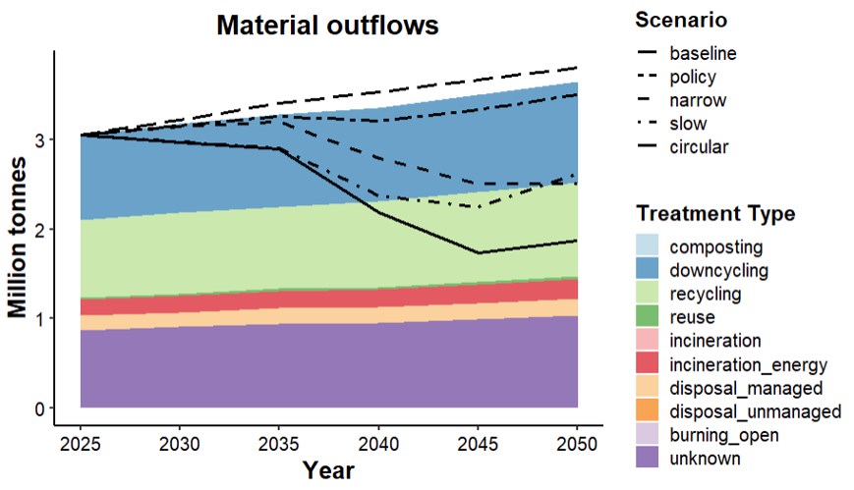
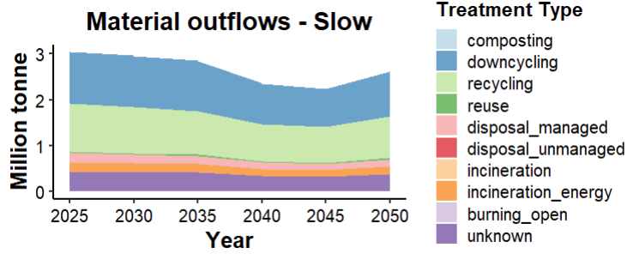
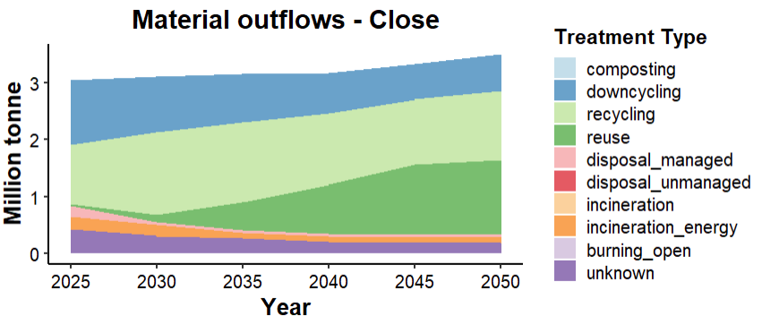
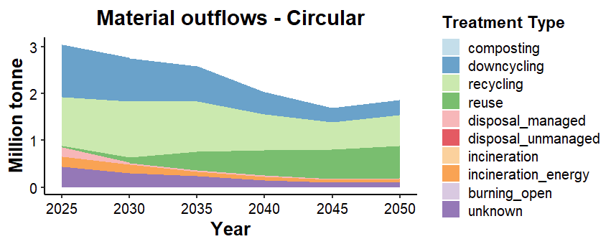
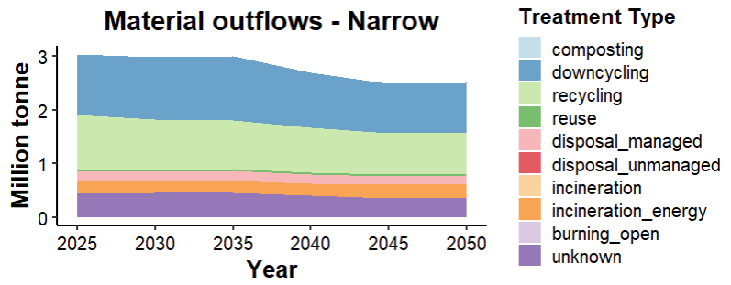

Figure S1. Materials outflows and end-of-life treatment by scenario

End-of-life treatment and provision of secondary materials

The impacts of circular economy strategies differ across appliance categories due to variations in product lifetimes, material composition, ownership patterns, and stock dynamics. Appliances with longer service lives and lower replacement rates generally exhibit larger reductions in material inflows and end-of-life outflows, while categories undergoing changes in market penetration or technology adoption may experience additional shifts in material demand. Although increased collection, reuse, and recycling improve the availability of secondary materials across all appliance groups, the extent to which these materials can substitute primary resources depends on the balance between material demand, stock accumulation, and the generation of end-of-life products.
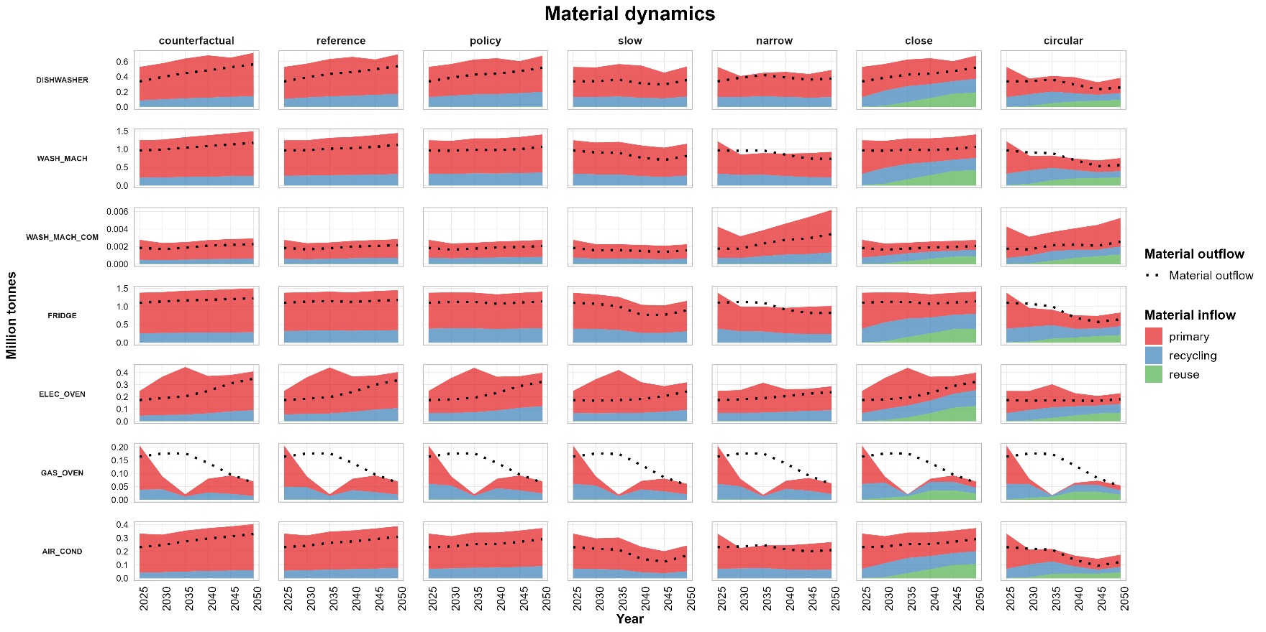

Figure S2. Materials dynamics by appliance category and scenario

Combined effects of circularity, energy efficiency, and energy system decarbonization on greenhouse gas emissions

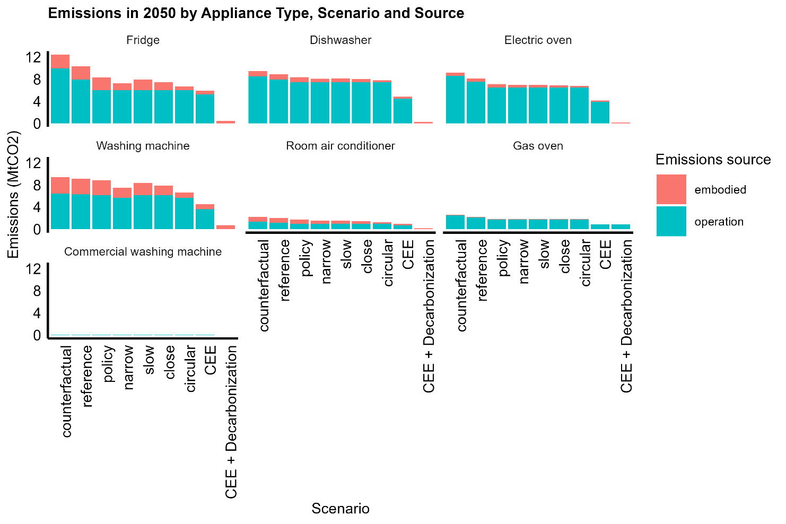
Figure S3. Emissions in 2050 by appliance, source and scenario

Methods
EU policy landscape
Table S3. Interpretation of the Eu policy landscape
EU policy / instrument | Main objective | Key measures relevant to household appliances | Circular strategy represented
Ecodesign for Sustainable Products Regulation (ESPR) (Regulation (EU) 2024/1781) | Improve environmental performance of products across their life cycle. | Product durability, repairability, upgradeability, recycled content, material efficiency, energy efficiency, Digital Product Passport, information requirements. Product-specific regulations for washing machines, dishwashers and refrigerators. | Narrow, Slow, Energy efficiency, Close
Energy Labelling Regulations (e.g. Regulations (EU) 2019/2014, 2019/2022, 2019/2017, 2019/2019) | Improve appliance energy efficiency through consumer information and minimum performance requirements. | Energy labels, minimum energy performance standards, reduced electricity consumption during use phase. | Energy efficiency
Right to Repair Directive (Directive (EU) 2024/1799) | Increase product lifetime through repair. | Repair obligations, spare parts availability, repair information, consumer access to repair services. | Slow
Extended Producer Responsibility (EPR) under the WEEE Directive (Directive 2012/19/EU) | Improve collection and environmentally sound management of waste electrical and electronic equipment. | Producer responsibility, collection systems, reuse, refurbishment, recycling, recovery targets. | Close
Waste Electrical and Electronic Equipment (WEEE) Directive | Increase recovery of valuable materials and reduce environmental impacts from electronic waste. | Separate collection, preparation for reuse, recycling and material recovery. | Close
Circular Economy Act | Strengthen circularity across the European economy and increase resource efficiency. | Expected to strengthen secondary material markets, circular business models, resource efficiency and demand-side measures. | Narrow, Slow, Close
Digital Product Passport (under ESPR) | Improve traceability and information availability throughout the product life cycle. | Product composition, repair instructions, maintenance history, recycled content, end-of-life information. | Narrow, Slow, and Close
Product-as-a-Service / Servitisation (supported through Circular Economy initiatives) | Reduce product ownership while maintaining service provision. | Leasing, sharing, Laundry-as-a-Service, manufacturer ownership models, higher utilisation rates. | Narrow

Description of the scenarios
Household appliances are composed of different materials, specially, plastics and metals. In general, large household appliances are dominated by steel and other metals while small household appliances are dominated by plastic ². The assumed material composition of the household appliances is presented in Table S3 and first lifetime in Table S4.

Table S4. Material composition of representative household appliance in percentage %
Material | Room air conditioner | Frigde | Washing machine | Dishwasher | Electric/Gas oven Built-in
Weight in kg | 44.8 | 69.6 | 66.7 | 41.5 | 28.4
Other Plastics | 18.00 | 16.60 | 9.50 | 16.38 | 3.53
Polystyrene | 0.00 | 13.40 | 0.00 | 0.22 | 0.00
Polypropylene | 0.00 | 2.50 | 6.60 | 10.20 | 1.00
Acrylonitrile-styrene (ABS) | 0.00 | 1.50 | 1.60 | 1.20 | 0.00
Glass | 0.00 | 10.00 | 2.00 | 0.00 | 15.00
Metals | 68.80 | 50.80 | 55.60 | 60.45 | 69.15
Aluminium | 1.80 | 2.40 | 3.40 | 0.25 | 1.15
Copper | 21.90 | 2.20 | 1.90 | 1.30 | 1.00
Steel | 45.10 | 46.20 | 50.30 | 58.90 | 67.00
Electronics | 2.40 | 0.50 | 2.90 | 2.90 | 0.40
Other material | 10.80 | 4.70 | 21.8 | 8.65 | 10.92
 |  | Includes stainless steel
Sources | Rodrigues-Quintero et al., (2021)³, Hischier et al., 2020⁴, Magalini et al., 2017²

Table S5. Household appliance lifetime-baseline
Household appliance type ${(HH}_{a})$ | Lifetime first- generation $(lt)$ | Lifetime second- generation $(lt)$ | Reuse % | Source
Fridge & Refrigerator (Combi) | 10 | 3 | 5 – 5.5 | Reale et al., (2019)⁵
Room air conditioner | 10 | 3 | 0 | Reale et al., (2019)⁵
Washing machine | 12 | 4 | 3 | Boyano Larriba et al., (2017)⁶ Reale et al., (2019)⁵
Dishwasher | 12 | 4 | 3 | Boyano Larriba et al., (2017)⁷ Reale et al., (2019)⁵
Electric oven/Gas oven (built in) | 15 | 5 | 0 | Bertoldi, P et al., (2021)⁸ Reale et al., (2019)⁵

Collection rates

The WEEE Directive 2002/96/EC and the amendment WEEE Directive 2012/19/EU⁹ are the legislative acts that set out the rules on managing WEEE. The Directive grouped the electrical and electronic products in 10 categories. After 2018, all electrical and electronic equipment (EEE) is classified into six categories. Following the Directive, washing machines, dishwashers, and ovens are classified as large household appliances while fridges-refrigerators and air conditioners as temperature exchange equipment (refrigerators and air conditioners). The Directive states that from 2019 onwards the minimum collection rate to be achieved annually is 65% of the average weight of EEE put on the market (POM) in the three proceeding years, or 85% of the WEEE generated in a member state. The collection rate should be calculated as a percentage of the weight of WEEE generated on the territory of the Member State the same year. Some countries such as Lithuania, Malta, Poland and Romania had a derogation period of two years¹⁰. There are some countries with explicit targets regarding reuse ranging from 3% to 4% of the total WEEE collected ¹⁰. Obstacles in the quantification of WEEE collection are related to the unknown exports for reuse and illegal exports. There is also an unknown fraction mixed in the residual municipal waste, but this is more related to small appliances. Note that in this model collection rates are based on the total WEEE generated method.

The appliances collected within the official WEEE EU-system might undergo the following treatments:
Preparation for reuse at appliance level: Includes, checking, cleaning, or repairing, by which products or components that have become waste are prepared so that they can be -reused without any further pre-processing. We intended to use the information reported as preparation for reuse in the Eurostat Dataset [env_waseleeos__custom_9495528]. However, the dataset has quite a bit of missing information, and therefore, its direct use is not possible. Consequently, it is necessary to come up with various assumptions to close that gap.

The assumption includes the repair and reuse of appliances done directly by the consumers and/or producers. The aim of repairing household appliances is to restore the functions to enable reuse or extend the lifetime of the object for the same owner. Furthermore, the repair of the appliance can also enable the reuse of a product by changing the owner either by selling (repair and second-hand shops) or donation¹¹. The assumptions on repair/reuse of the appliances is explained below:

- Refrigerators: The percentage of reused refrigerators is based on Domestic Refrigerator and Freezers Report¹². The study shows that refrigerators are the households’ appliances least frequently purchased as second-hand. An average of 5% was applied for EU14 countries (without the UK) and 5.5% was applied to EU13 countries when data were not available.
- Dishwashers and washing machines: The information provided in Boyano-Larriba (2017)⁷ shows data for washing machines. However, it is assumed that the level of reuse can be transferable to dishwashers. It is indicated that around 3% of these appliances might be reused. We have used this value for all EU27 + United Kingdom.
- Cooking appliances/built-in ovens: The Review study of Ecodesign and Energy Labelling for Cooking appliances³ reveals that the market for reused and remanufactured cooking appliances is very limited. “In terms of reusing and remanufacturing products, relevant stakeholders state they cannot provide any information on the market for re-used products as no conclusive data about that market”. We have assumed 0% reuse of built-in ovens for the baseline scenario.
- Room air conditioners: Assumed to be 0%.

Recycling: The recycling of WEEE is an important abatement strategy to reduce pressure on the environment. In the EU there are some Directives directly influencing recycling and reusing of WEEE. The WEEE Directive 2002/96/EC and the amendment WEEE Directive 2012/19/EU⁹ are the main legislative acts that set out the rules on managing WEEE. The Ecodesign for Sustainable Product Regulation¹ defines some aspects that must be considered to reuse and recycle materials in electrical and electronic equipment. The ROHS Directive 2002/95/EC and the amendment ROHS Directive 2017/2102¹³ on the restriction of the use of certain hazardous substances in electrical and electronic equipment.

- Pre-processing/depollution/dismantling (including depollution): The majority of EOL household appliances go through the pre-processing stage in which some components, substances and mixtures are removed from the WEEE stream (e.g., power cables, capacitators, devices containing HFC, etc). Prior to recycling, collected WEEE are processed in various steps which include dismantling (management of toxic substances from refrigerators and air conditioners), shredding and fractioning which include magnetic separators, eddy currents and density/optical separators^{14,15}. Usually, ferrous metals are sorted by magnetic separation, non-ferrous metals are sorted by Eddy current separators and plastics mainly by density separators¹⁶.
- Substitutability rate: The substitutability rate (or functional recycling) refers here to the rate of avoided production of virgin materials for the same or similar purpose. This information is exogenous to the model and has been gathered from various sources (see Table S4).

Plastic polymers: The brominate (Br) content of each polymer and losses during sorting determine each polymer recovery potential. While PE and PP reach high levels of recovery rates up to 85%, ABS and PS have some recycling constraints due to the high Br content ¹⁷. To obtain secondary polymers with similar characteristics to the virgin materials requires some processes such as shredding, extrusion and moulding. It also generates a further loss of materials. The substitutability rates for plastic polymers are taken from ¹⁷.
Aluminium: Secondary aluminium production includes new scrap and old scrap. New scrap, scrap generated during the manufacturing process, constitutes the highest fraction of secondary aluminium (70%). Old scrap, scrap generated at the end of life of a product, accounts for 12% of secondary aluminium production¹⁸. Passarini et al.,(2018)¹⁸ estimates that of the total aluminium at the end-of-life (old scrap), 51% (51% - 69%) resulted in functional recycling (EOL-RR). Thought aluminium is known for being highly recyclable, the presence of alloying elements in aluminium alloys hinders the functional recycling of post-consumer scrap ^{18,19}. Household appliances contain cast aluminium alloys. Aluminium in consumer durable accounts for 6% of the finished products manufactured.
Steel: Secondary steel is divided into three main types depending on the origin. Scrap from steel making itself, scrap from manufacturing steel products (new scrap), and end-of-life scrap, or post-consumer scrap. Generally, the old scrap is highly contaminated. Most of the steel used in household appliances is stainless steel (nickel-containing austenitic). Stainless steel accounts for around 3% of the global steel production. Recycling stainless steel saves more greenhouse gas emissions than carbon steel scrap ²⁰. Recent estimates show that at a global level 90% of stainless steels are recycled at the end of life. 65% - 70% is used to make new stainless steel (assumed to be functional recycling) and 30%- 35% is used to make new carbon steel ²¹.
Copper: Secondary cooper (new and old scrap) constitutes a significant input to processing. Of the total amount of cooper old scrap (at the end-of-life), 28 % is used in functional recycling (EOL-RR) ^{18,22}. Copper in consumer and general durable goods accounts for 6% of the finished products manufactured.
Bioplastics: In general, bioplastics are either made from renewable sources (bio-based), are biodegradable, are created through biological process or by combining both processes. Biodegradation and composting of biodegradable plastics is difficult and required specific conditions that are difficult to meet in home composting. In addition, most of the composting facilities reject biodegradable plastics. In terms of biological recycling, microorganism and their hydrolysing enzymes can convert the polymers into monomers (as in chemical recycling). However, although promising, these methods are
currently underexplored. The application of bioplastics in products that require durability is still unexplored ²³.
Table S6. Household appliance substitutability rate - Baseline
Material | Substitutability rate | Source
Polystyrene (PS) | 0.65 | Cardamone et., 2021¹⁷
Polypropylene (PP) | 0.67 | Cardamone et., 2021¹⁷
Acrylonitrile-styrene (ABS) | 0.49 | Cardamone et., 2021¹⁷
Aluminium (Al) | 0.51 | Passarini et al., 2018¹⁸; Talens Peiró et al., 2018²²
Steel | 0.65 | Team Stainless, 2019²¹
Copper | 0.28 | Passarini et al., 2018 ¹⁸; Talens Peiró et al., 2018²²
Glass | 0

Energy efficiency: Information on energy intensity for representative products in each category has been sourced from the European Product Registry for Energy Labelling-EPREL with further improvements projected by 2050 to reflect the substantial potential for energy efficiency gains. Values represent an average of representative products by label. Additionally, it is assumed that by 2050 all appliances will be category A.
Table S7. Energy intensity for representative products
Energy Efficiency class | Dishwasher | Washing machine |  | Washing machine commercial | Fridge & Refrigerator (combi) | Electric oven | Gas oven
Energy Efficiency class | Energy consumption (per cycle eco 40-60 programme) in KWh | Energy consumption (per cycle eco 40-60 programme) in KWh | Energy consumption (per cycle eco 40-60 programme) in KWh |  | Kwh/year | Kwh/cycle (55min ~1h) | Kwh-gas/cycle (55min ~1h)
2020
A | 0.55 | 0.43 |  | 0.47 | 119.20 | 0.59 | 0.92
B | 0.64 | 0.52 |  | 0.60 | 141.50 | 0.60 | 1.15
C | 0.75 | 0.59 |  | 0.76 | 160.25 | 0.74 | 1.44
D | 0.82 | 0.69 |  | 0.94 | 193.50 | 0.82 | 1.80
E | 0.91 | 0.77 |  | 1.00 | 229.00 | 0.91 | 2.63
F | 0.85 | 0.86 |  | 1.12 | 253.00 | 0.99 | 4.17
G | 1.03 | 1.01 |  | 1.26 | 279.52 | 0.91 | 5.70
2050
A | 0.41 | 0.32 |  | 0.35 | 75.10 | 0.41 | 0.65
B | 0.48 | 0.39 |  | 0.45 | 89.15 | 0.42 | 0.81
C | 0.56 | 0.44 |  | 0.57 | 100.96 | 0.52 | 1.01
D | 0.62 | 0.52 |  | 0.71 | 121.91 | 0.57 | 1.26
E | 0.68 | 0.57 |  | 0.75 | 144.27 | 0.64 | 1.84
F | 0.63 | 0.65 |  | 0.84 | 159.39 | 0.69 | 2.92
G | 0.77 | 0.76 |  | 0.94 | 176.09 | 0.64 | 3.99

References

1. European Commission. Regulation (EU) 2024/1781 of the European Parliament and of the Council establishing a framework for the setting of ecodesign requirements for sustainable products, amending Directive (EU) 2020/1828 and Regulation (EU) 2023/1542 and repealing Directive 2009/125/EC. (2024).
2. Magalini, F., Ruediger, K., Jaco, H., Otmar, D. & Deepali, S. K. Material Flows of the Home Appliance Industry. (2017).
3. Rodriguez Quintero, R. et al. JRD Technical Reports. Review Study of Ecodesign and Energy Labelling for Cooking Appliances. (2021).
4. Hischier, R., Reale, F., Castellani, V. & Sala, S. Environmental impacts of household appliances in Europe and scenarios for their impact reduction. Journal of Cleaner Production 267, 121952 (2020).
5. Reale, F., Castellani, V., Hischier, R., Corrado, S. & Sala, s. Consumer Footprint. Basket of Products Indicators on Household Appliances. (2019).
6. Boyano Larriba, A. et al. Ecodesign and Energy Label for Household Washing Machines and Washer Dryers. (2017) doi:10.2760/029939,.
7. Boyano Larriba, A. et al. Ecodesign and Energy Label for Household Dishwashers. (2017) doi:10.2760/024232.
8. Bertoldi, P., López-Lorente, J. & Labanca, N. Energy Consumption and Energy Efficiency Trends in the EU-28 2000-2014. (2021) doi:10.2760/024232.
9. European Commission. Directive 2012/19/EU of the European Parliament and of the Council of 4 July 2012 on waste electrical and electronic equipment (WEEE) (recast) Text with EEA relevance. (2012).
10. Baldé, C. P., Wagner, M., Iattoni, G. & Kuehr, R. In-Depth Review of the WEEE Collection Rates and Targets in the EU-28, Norway, Switzerland, and Iceland, 2020. https://weee-forum.org/wp-content/uploads/2022/12/Update-of-WEEE-Collection_web_final_nov_29.pdf (2020).
11. Gobert, J., Allais, R. & Deroubaix, J.-F. Repair and reuse: Misalignments between stakeholders and possible users. Journal of Cleaner Production 317, 128454 (2021).
12. ISIS. Preparatory Studies for Eco-Design Requirements of EuPs. LOT13: Domestic Refrigerators and Freezers. Final Report. Draft Version. (2007).
13. European Commission. Directive (EU) 2017/2102 of the European Parliament and of the Council of 15 November 2017 amending Directive 2011/65/EU on the restriction of the use of certain hazardous substances in electrical and electronic equipment (Text with EEA relevance. ). (2017).
14. Johansson, J. & Luttropp, C. Material hygiene: improving recycling of WEEE demonstrated on dishwashers. Journal of Cleaner Production 17, 26–35 (2009).
15. López, M. et al. E-waste dismantling as a source of personal exposure and environmental release of fine and ultrafine particles. Science of The Total Environment 833, 154871 (2022).
16. Ardente, F., Pastor, M. C., Mathieux, F. & Peiró, L. T. Analysis of end-of-life treatments of commercial refrigerating appliances: Bridging product and waste policies. Resources, Conservation and Recycling 101, 42–52 (2015).
17. Cardamone, G. F., Ardolino, F. & Arena, U. About the environmental sustainability of the European management of WEEE plastics. Waste Manag 126, 119–132 (2021).
18. Passarini, F., Ciacci, L., Nuss, P. & Manfredi, S. Material Flow Analysis of Aluminium, Copper, and Iron in the EU28. (2018).
19. Raabe, D. et al. Making sustainable aluminum by recycling scrap: The science of “dirty” alloys. Progress in Materials Science 128, 100947 (2022).
20. Pothen, F. & Hundt, C. European post-consumer steel scrap in 2050: A review of estimates and modeling assumptions. (2024).
21. Team Stainless. The Global Life Cycle of Stainless Steels. (2019).
22. Talens Peiró, L., Nuss, P., Mathieux, F. & Andrea Blengini, G. Towards Recycling Indicators Based on EU Flows and Raw Material Systems Analysis Data. (2018).
23. Rosenboom, J.-G., Langer, R. & Traverso, G. Bioplastics for a circular economy. Nature Reviews Materials 7, 117–137 (2022).
24. European Commission. EPREL – European Product Registry for Energy Labelling. (2025).

EOL_RR: End of life functional recycling rate

