Supplementary Information (Online Resource 1)
Production-network embedding and embodied carbon–energy footprints in semiconductor supply chains: An MRIO scenario analysis of Taiwan, Japan, and the United States
Journal: Journal of Industrial Ecology
Authors: Takuya Shimamuraᵃ, Shunsuke Managiᵇ
ᵃ Faculty of Engineering, Kyushu University, 744 Motooka, Nishi-ku, Fukuoka-shi, Fukuoka, 819-0395, Japan
ᵇ Urban Institute, Kyushu University, 744 Motooka, Nishi-ku, Fukuoka-shi, Fukuoka, 819-0395, Japan
Corresponding author: Shunsuke Managi. E-mail: managi@doc.kyushu-u.ac.jp
This Supplementary Information accompanies the main manuscript. All values are computed from the 2022 Eora Full multi-region input–output (MRIO) table, with carbon measured using the EDGAR CO₂ satellite (I-EDGARv5.0-CO₂) and energy using the Eora I-ENERGY satellite. Because I-ENERGY is frozen after 2011, energy results are treated only as a 2022 cross-sector diagnostic. Reductions are reported as positive magnitudes, D(r) = 1 − m(r)/m(τ), relative to Taiwan’s baseline multiplier, m(τ). Long sector-level tables are supplied as machine-readable sheets (Supplementary Data S1–S6) in Online Resource 2, listed at the end.

S1. Host-sector multipliers and Japan sector-specific results
This section reports the sector-specific embodied multipliers used in the host-country comparison. In the main text, the reported Japan value is the descriptive midpoint (arithmetic mean) of the unrounded multipliers for Japan’s two semiconductor-related sectors, Semiconductor devices (6072) and Integrated circuits (6073). Sector-specific CO₂ scenario results are reported in Table 3 of the main text; the full sector-specific multipliers, the corresponding energy results, and additional audit diagnostics are reported here.
All reductions are reported as positive magnitudes relative to Taiwan’s Semiconductors sector. Energy is reported as a 2022 cross-sector diagnostic because the Eora I-ENERGY satellite is frozen after 2011.

Table S1. Host-sector embodied multipliers and Scenario A reductions
Country / host | Sector index | Sector label | EDGAR CO₂ multiplier (Gg/kUSD) | Energy multiplier (TJ/kUSD) | CO₂ per embodied energy (Gg/TJ) | CO₂ reduction vs Taiwan | Energy reduction vs Taiwan
Taiwan | 11348 | Semiconductors | 4.0675e-03 | 0.14423 | 0.0282 | baseline | baseline
Japan | 6072 | Semiconductor devices | 4.3277e-04 | 4.7896e-03 | 0.0904 | 89.36% | 96.68%
Japan | 6073 | Integrated circuits | 4.6873e-04 | 5.5285e-03 | 0.0848 | 88.48% | 96.17%
Japan | avg | Simple average of 6072 and 6073 | 4.5075e-04 | 5.1590e-03 | 0.0874 | 88.92% | 96.42%
United States | 13452 | Semiconductor and related device manufacturing | 2.6234e-04 | 3.7684e-03 | 0.0696 | 93.55% | 97.39%
Notes. CO₂ multipliers use EDGAR CO₂. Energy multipliers use Eora I-ENERGY and are interpreted as cross-sector diagnostics, not as time-series evidence. The Japan value reported in the main text is the simple average of sectors 6072 and 6073, computed at the multiplier level. The Fig. 3 diagnostic scatter reports the two Japanese sectors separately; the main manuscript therefore describes Japan’s CO₂ per unit of embodied energy as approximately 0.085–0.090 Gg CO₂/TJ. The individual CO₂-per-energy values are 0.0282 (Taiwan), 0.0904 (Japan 6072), 0.0848 (Japan 6073), 0.0874 (Japan average), and 0.0696 (United States). The CO₂ reductions and Japan-average values are taken directly from the scenario output; the sector-specific energy reductions are calculated from the embodied energy multipliers as 1 − m_energy(host)/m_energy(Taiwan).

S2. Upstream category mapping and classification rules
This section documents the classification scheme used to aggregate sector-level upstream contributions in Fig. 2 and in the upstream decomposition tables. The decomposition is first computed at the sector level as
$c_{g}\left(i→j\right) = q_{g,i} L_{ij},$
where $c_{g}\left(i→j\right)$ is the contribution of upstream sector $i$ to the embodied multiplier of target sector $j$. Categories are used only for reporting and interpretation; the sector-level contribution identity is unchanged.
The same classification rule is applied across all targets and supplying countries. Sector categories describe what kind of upstream input a contribution represents, while supplying country and domestic/foreign status describe where the contribution originates. These two dimensions are kept separate.

Table S2. Upstream contribution category definitions
Category | Definition / scope | Notes
target_direct | Target sector’s own direct satellite intensity | Used to align the decomposition with Scenario B1a
target_self_loop | Recursive same-sector requirement, $q_{g,j}\left(L_{jj}−1\right)$ | Reported separately from target direct contribution
electricity | Electric power generation, transmission, distribution, electric utilities | Excludes false positives from electrical equipment/electrical machinery
other_utilities_gas_steam_water | Gas supply, steam, water supply, sewerage, waste management, utilities | Fixed category assignment; sectors flagged by the audit as utility-adjacent are retained in identified-other and do not alter the fixed Fig. 2 shares
iron_steel | Iron, steel, ferroalloys, pig iron, crude steel, blast furnace | Final-product metal goods are reviewed manually
non_ferrous_metals | Aluminum/aluminium, copper, zinc, nickel, lead, tin, non-ferrous metals, precious metals | Reported separately in source mapping; can be grouped into metals in figures
chemicals_petrochem | Chemicals, petrochemicals, petroleum refining, coke, plastics, resins, rubber, fertilizers, synthetic materials | Petroleum refining and petrochemical raw materials are important in the Energy decomposition
coal_mining_fossil | Coal mining, crude oil, natural gas extraction, fossil extraction, lignite | Includes coal products where relevant
other_electronics_machinery | Electronics, semiconductor-related components, integrated circuits, computers, machinery, instruments, precision/optical devices | Target sector itself is excluded and handled as target direct / self-loop
services_trade | Wholesale, retail, trade, transport, logistics, finance, real estate, business services, R&D, professional services, administrative services, communication | Services/trade is substantive, not residual
domestic_other_identified | Domestic identified sectors not otherwise classified | Broad category; not automatically an artifact
foreign_upstream_other | Foreign identified sectors not otherwise classified | Foreign identified-other category (about 2.2% of the Taiwan CO₂ multiplier; itemized in Table S3c). This category is not identical to the Fig. 2 display segment “Foreign upstream”, which aggregates all non-pseudo foreign contributions across sector categories. Row-level supplementary data retain each contributor’s original sector label, country, and value
pseudo_residual_balancing | Statistical discrepancy, balancing, dummy, unspecified, residual, re-export, adjustment, and not-elsewhere-classified sectors identified by the keyword rule | The main residual-account diagnostic category
unclassified_manual_check | Sectors requiring manual review before final figure generation | Entries with non-negligible contributions are flagged and reviewed manually before final figure use

Supplementary Data S2. Sector-level category assignment file for top contributors
The sector-level category assignments for the top contributors are provided in the Data S2 sheet of Online Resource 2 (ESM_2.xlsx):
Data S2 (upstream_category_assignment)
Key columns include:
Column | Description
contributor_index | Eora global sector index
contributor_country | Contributor country
contributor_sector_name | Native Eora sector label
target_label | Taiwan / Japan 6072 / Japan 6073 / Japan average / United States
metric | EDGAR CO₂ or Energy
initial_category | Automated category assignment
manual_category | Manual category after review
domestic_or_foreign | Domestic if contributor country equals target country; foreign otherwise
contributor_country_group | Mainland China, Hong Kong, EU27, Korea, Singapore, ASEAN, Rest of world, etc.
classification_keywords_matched | Keywords used for automated classification
pseudo_residual_flag | Whether sector belongs to strict pseudo/residual/balancing group
electricity_false_positive_flag | Whether electricity keyword was excluded as false positive
manual_review_required | Whether manual review was required
manual_note | Reason for manual classification or reclassification
contribution_value | Signed contribution to multiplier
share_of_multiplier | Signed contribution share
abs_contribution_value | Absolute contribution
share_of_abs_contributions | Absolute contribution share
Notes. The category assignment matters because Fig. 2 tests whether the Scenario A multiplier contrast is associated with identifiable MRIO-represented upstream sectors rather than residual or unspecified accounts. Pseudo/residual, unclassified, and negative-contribution diagnostics are reported in Table S3d. The top identified-other contributors are listed in Table S3c, with broader top-contributor coverage provided in Supplementary Data S2.

S3. Upstream decomposition audit and residual-account diagnostics
This section reports audit diagnostics for the upstream decomposition used in Fig. 2. The purpose is to verify that the embodied-multiplier decompositions reconcile with the reference multipliers and that the Taiwan–Japan–United States multiplier contrast is not driven primarily by pseudo, residual, or balancing accounts.

Table S3a. Reconciliation of upstream decomposition to reference multipliers
Target | Indicator | Reference multiplier | Sum of sector-level contributions | Absolute error | Relative error | Pass/fail
Taiwan 11348 | EDGAR CO₂ | 4.067473e-03 | 4.067473e-03 | 4.3e-18 | ~machine precision | Pass
Japan 6072 | EDGAR CO₂ | 4.327722e-04 | 4.327722e-04 | 9.8e-19 | ~machine precision | Pass
Japan 6073 | EDGAR CO₂ | 4.687278e-04 | 4.687278e-04 | 1.2e-18 | ~machine precision | Pass
Japan average | EDGAR CO₂ | 4.507500e-04 | 4.507500e-04 | 1.1e-18 | ~machine precision | Pass
United States 13452 | EDGAR CO₂ | 2.623369e-04 | 2.623369e-04 | 4.3e-19 | ~machine precision | Pass
Taiwan 11348 | Energy | 1.442311e-01 | 1.442311e-01 | 2.5e-16 | ~machine precision | Pass
Japan 6072 | Energy | 4.789586e-03 | 4.789586e-03 | 9.5e-18 | ~machine precision | Pass
Japan 6073 | Energy | 5.528511e-03 | 5.528511e-03 | 1.2e-17 | ~machine precision | Pass
Japan average | Energy | 5.159048e-03 | 5.159048e-03 | 1.0e-17 | ~machine precision | Pass
United States 13452 | Energy | 3.768351e-03 | 3.768351e-03 | 7.4e-18 | ~machine precision | Pass
Notes. All ten target × indicator decompositions reconcile with the reference embodied multipliers to within machine precision, and known diagnostic anchors reproduce independent project diagnostics, including Taiwan’s domestic electricity contributions.

Table S3b. Key grouped upstream shares used in the main text
Target | Indicator | Domestic electricity share | Domestic heavy-industry / utility share | Foreign upstream share | Strict pseudo/residual/balancing share | Notes
Taiwan 11348 | EDGAR CO₂ | 49.6% | 59.7% | 7.89% | 0.047% | High multiplier concentrated in domestic electricity and heavy-industry upstream sectors
Japan average | EDGAR CO₂ | 32.4% | 36.9% | 21.29% | 0.26% | Intermediate structure; lower absolute multiplier than Taiwan
United States 13452 | EDGAR CO₂ | 3.4% | 7.0% | 44.76% | 0.49% | More foreign-upstream-intensive structure; low absolute multiplier
Taiwan 11348 | Energy | 56.9% | 91.9% | 2.73% | 0.01% | Domestic electricity and heavy-industry/utility upstream groups dominate
Japan average | Energy | 43.6% | 53.8% | 23.38% | 0.82% | Supplementary diagnostic
United States 13452 | Energy | 19.2% | 31.6% | 42.10% | 0.12% | Supplementary diagnostic
Notes. EDGAR CO₂ is the main environmental indicator. Energy is reported as a supplementary 2022 cross-sector diagnostic because I-ENERGY is frozen after 2011. Strict pseudo/residual/balancing shares remain below 0.5% in every CO₂ decomposition (maximum 0.49%, for the US sector). In the energy diagnostic, these shares are also small, with a maximum value of 0.82% for the Japan average; this does not affect the CO₂-based conclusions. In the domestic-electricity column, the Taiwan figures (49.6% for CO₂ and 56.9% for energy) refer to the single dominant electricity sector, consistent with Section 4.1 of the main text, whereas the Japan and US figures refer to the broader “electricity” category defined in S2. The two conventions differ only slightly: for Taiwan, the broader category accounts for about 50.0% of the CO₂ multiplier. The domestic heavy-industry/utility share is inclusive of electricity; in Fig. 2 and Fig. S2, electricity is shown as a separate stacked segment, so electricity plus the other heavy-industry/utility segment equals this inclusive share.

Table S3c. Taiwan identified-other audit: top contributors
The Taiwan EDGAR CO₂ decomposition contains an identified-other component equivalent to 14.77% of the multiplier (12.54% domestic identified-other plus 2.23% foreign identified-other). This category is dominated by named real sectors rather than strict pseudo/residual/balancing accounts. The top ten Taiwan-domestic contributors are listed below; together, they account for about 7.4 percentage points of the 12.54% domestic identified-other component.
Rank | Sector | Eora index | Share of Taiwan EDGAR CO₂ multiplier | Manual classification
1 | Gas | 11360 | 1.75% | Utility-like; retained in identified-other to preserve the fixed Fig. 2 grouping
2 | Nonresidential Building Construction | 11363 | 0.94% | Broad but interpretable: construction
3 | Other Metals | 11323 | 0.93% | Metals-related; retained in identified-other to preserve the fixed Fig. 2 grouping
4 | Research & Development Services | 11390 | 0.84% | Services-related; retained in identified-other to preserve the fixed Fig. 2 grouping
5 | Public Works | 11364 | 0.64% | Broad but interpretable: construction
6 | Other Electrical Materials | 11340 | 0.61% | Broad but interpretable: materials
7 | Other Construction | 11365 | 0.47% | Broad but interpretable: construction
8 | Motor Vehicles | 11352 | 0.42% | Broad but interpretable: transport equipment
9 | Other Metal Products | 11329 | 0.41% | Metals-related; retained in identified-other to preserve the fixed Fig. 2 grouping
10 | Undistributed | 11407 | 0.40% | Eora “Undistributed” residual-style named sector
Notes. The top nine contributors are identifiable real domestic sectors. The tenth, Eora “Undistributed” (index 11407), contributes about 0.40% of the Taiwan EDGAR multiplier. It is a named Eora residual-style sector and is distinct from the strict pseudo/residual/balancing group used in the Fig. 2 classification; it is the source of the main manuscript’s “about 0.4% Undistributed” statement.
The sector names in Table S3c are native Eora sector labels used for audit transparency; they should not be interpreted as process-level semiconductor fabrication categories.

Table S3d. Residual-account and negative-contribution diagnostics
Diagnostic | Taiwan | Japan average | United States | Interpretation
Strict pseudo/residual/balancing share (CO₂ decomposition) | 0.047% | 0.26% | 0.49% | Strongly weighs against a residual-, pseudo-, or balancing-account interpretation of the multiplier contrast
Eora “Undistributed” residual-style named sector | 0.40% | — | — | Taiwan-native sector; not present in the Japan or US classification
Negative contribution share | negligible | negligible | negligible | Negative contributions do not materially affect interpretation
Reconciliation error | machine precision | machine precision | machine precision | Decomposition identity holds
Notes. The upstream decomposition supports the main manuscript’s interpretation that the Scenario A multiplier contrast is associated with identifiable MRIO-represented upstream structures. It does not prove fab-level physical efficiency differences, and it does not—and is not intended to—rule out sector-boundary or product-mix differences. Because Eora preserves native sectoral classifications, the embodied multipliers may reflect both real production-network differences and aggregation differences; these differ from the residual-, pseudo-, and balancing-account categories addressed by this audit and reflect MRIO sectoral boundaries rather than fab-level efficiency. The Eora “Undistributed” sector (index 11407) is a Taiwan-native sector; the Japan and US classifications contain no corresponding residual-style named sector.

S4. Scenario contrasts and sensitivity diagnostics
This section reports the scenario contrasts and sensitivity diagnostics used to support the mechanism interpretation. All reductions are reported as positive magnitudes. The corresponding signed footprint changes are negative when host multipliers are lower than Taiwan’s baseline.

Table S4a. Scenario A / B1a / B1b contrasts for EDGAR CO₂ (sector-specific and descriptive midpoint)
Host | Scenario A reduction | B1a reduction | B1b reduction | B1b − B1a | A − B1b
Semiconductor devices (6072) | 89.36% | 4.49% | 20.00% | 15.50 pp | 69.36 pp
Integrated circuits (6073) | 88.48% | 5.22% | 20.72% | 15.50 pp | 67.75 pp
Japan average | 88.92% | 4.86% | 20.36% | 15.50 pp | 68.56 pp
United States | 93.55% | 5.88% | 22.94% | 17.06 pp | 70.61 pp
Notes. B1a retains Taiwan’s input structure and substitutes only the target sector’s direct satellite intensity. B1b is cumulative over B1a and additionally reassigns the direct electricity-input coefficient to the host electricity sector while holding the monetary input coefficient unchanged. The gaps across Scenario A, B1b, and B1a are scenario-based contrasts that track sensitivity to stepwise counterfactual assumptions, not a causal or Shapley-type decomposition. The A − B1b gap is the largest remaining gap and reflects host production-network embedding rather than target-sector direct intensity or direct electricity-input reassignment alone (Fig. S1). B1b reassigns only the direct electricity input and leaves the indirect electricity embodied through other Taiwan upstream suppliers unchanged, so it does not capture all of Taiwan’s electricity-related embodied emissions.

Table S4b. RS-CLEAN host-electricity decarbonization sensitivity
Host | Host electricity CO₂ reduction | Scenario A CO₂ reduction | Marginal gain vs 0%
Japan average | 0% | 88.92% | —
Japan average | 50% | 90.72% | +1.80 pp
Japan average | 75% | 91.62% | +2.71 pp
Japan average | 100% | 92.53% | +3.61 pp
United States | 0% | 93.55% | —
United States | 50% | 93.66% | +0.11 pp
United States | 75% | 93.71% | +0.16 pp
United States | 100% | 93.77% | +0.22 pp
Notes. RS-CLEAN reduces the host electricity sector’s CO₂ intensity by 50%, 75%, and 100%. The marginal effects are modest for Japan and very small for the United States (Fig. S3). The small US increment reflects both the already low US semiconductor embodied multiplier and the small contribution of the selected US electricity sectors to that multiplier under the EDGAR allocation. Host electricity sector sets: Japan — index 6132 (main), 6133 (on-site), 6135 (steam); United States (Industries side) — index 13240 (main), 13628 (Federal), 13631 (State and local government utilities).

Table S4c. US electricity and semiconductor entity diagnostics
Diagnostic | Baseline / main specification | Alternative specification | Effect
US Scenario A EDGAR-native correction | 93.5504% reduction | 92.6615% reduction | Reported reduction magnitude decreases by 0.89 pp
US B1b electricity entity diagnostic | Industries-side electricity sector 13240 | Commodities-side same-named sector 13669 | Change in United States B1b CO₂ below 0.1 pp, approximately +0.07 pp
US electricity entity consistency | US semiconductor sector 13452 on Industries side | — | EDGAR + Industries-side 13240 is the main manuscript specification
US semiconductor entity diagnostic | Industries-side sector 13452 (Scenario A reduction 93.550%) | Commodities-side same-named sector 13881 (93.544%) | Scenario A CO₂ reduction changes by 0.006 pp
Notes. The EDGAR-native correction replaces the US electricity-sector CO₂ allocation with a native-intensity benchmark. It is a diagnostic rather than an independent robustness result because the native I-GHG series is frozen. The US electricity-entity diagnostic checks whether using the same-named Commodities-side electricity entity instead of the Industries-side electricity sector affects B1b; the conclusion is not sensitive to this entity choice. The semiconductor-entity diagnostic is limited to Scenario A: using the same-named Commodities-side semiconductor entity (13881) instead of the Industries-side entity (13452) changes the Scenario A CO₂ reduction by 0.006 percentage points; B1a and B1b were not recomputed for this auxiliary diagnostic.

Table S4d. 2019 cross-section robustness
Year | Host | Scenario A CO₂ reduction | B1a CO₂ reduction | B1b CO₂ reduction | A − B1b gap | Interpretation
2019 | Japan average | 87.80% | 4.83% | 20.42% | 67.39 pp | Same A > B1b > B1a hierarchy
2019 | United States | 91.11% | 5.04% | 20.15% | 70.97 pp | Same A > B1b > B1a hierarchy
2022 | Japan average | 88.92% | 4.86% | 20.36% | 68.56 pp | Main year
2022 | United States | 93.55% | 5.88% | 22.94% | 70.61 pp | Main year
Notes. CO₂-based conclusions and the Scenario A / B1a / B1b hierarchy are qualitatively stable between 2019 and 2022. Energy is not interpreted as an independent time-series robustness check because I-ENERGY is frozen after 2011.

Table S4e. Scenario A / B1a / B1b contrasts for Energy (2022 cross-sector diagnostic; sector-specific, descriptive midpoint, and United States). B1a values are slightly negative because the host sectors’ direct energy intensities in the extract are marginally higher than Taiwan’s; magnitudes are below 0.3% in all cases.
Host sector | Scenario A reduction | B1a reduction | B1b reduction | B1b − B1a | A − B1b
Semiconductor devices (6072) | 96.68% | −0.13% | 20.55% | 20.68 pp | 76.12 pp
Integrated circuits (6073) | 96.17% | −0.19% | 20.50% | 20.68 pp | 75.67 pp
Japan-average (descriptive midpoint) | 96.42% | −0.16% | 20.52% | 20.68 pp | 75.90 pp
United States (13452) | 97.39% | −0.26% | 20.09% | 20.35 pp | 77.29 pp
Notes. Energy values are 2022 cross-sector diagnostics under the post-2011 fixed-vintage I-ENERGY satellite, not evidence of time-series change. B1b − B1a and A − B1b are computed from the unrounded values.

Table S4f. B1b routing audit for the Japan reassignment. The audit confirms that the B1b step moves only the direct electricity-input coefficient from the Taiwan electricity row (11359) to the host electricity row (Japan 6132) within the Taiwan Semiconductors column (11348), leaving the column sum unchanged to machine precision. The pre-existing destination coefficient is negligible.
Quantity | Value
Moved direct coefficient (11359 → 6132 routing, column 11348) | 0.021879
Source cell before / after | 0.021879 / 0
Destination cell before / after | 7.5 × 10⁻¹⁰ / 0.021879
Column-sum change after reassignment | −1.1 × 10⁻¹⁶ (machine precision)
Notes. This routing edit is common to the B1b calculations for both Japanese host sectors; the sector-specific difference enters through the substituted target-sector direct intensity, not through a different electricity destination row. Values are reported in the Data S4 sheet of Online Resource 2.

Supplementary Figures
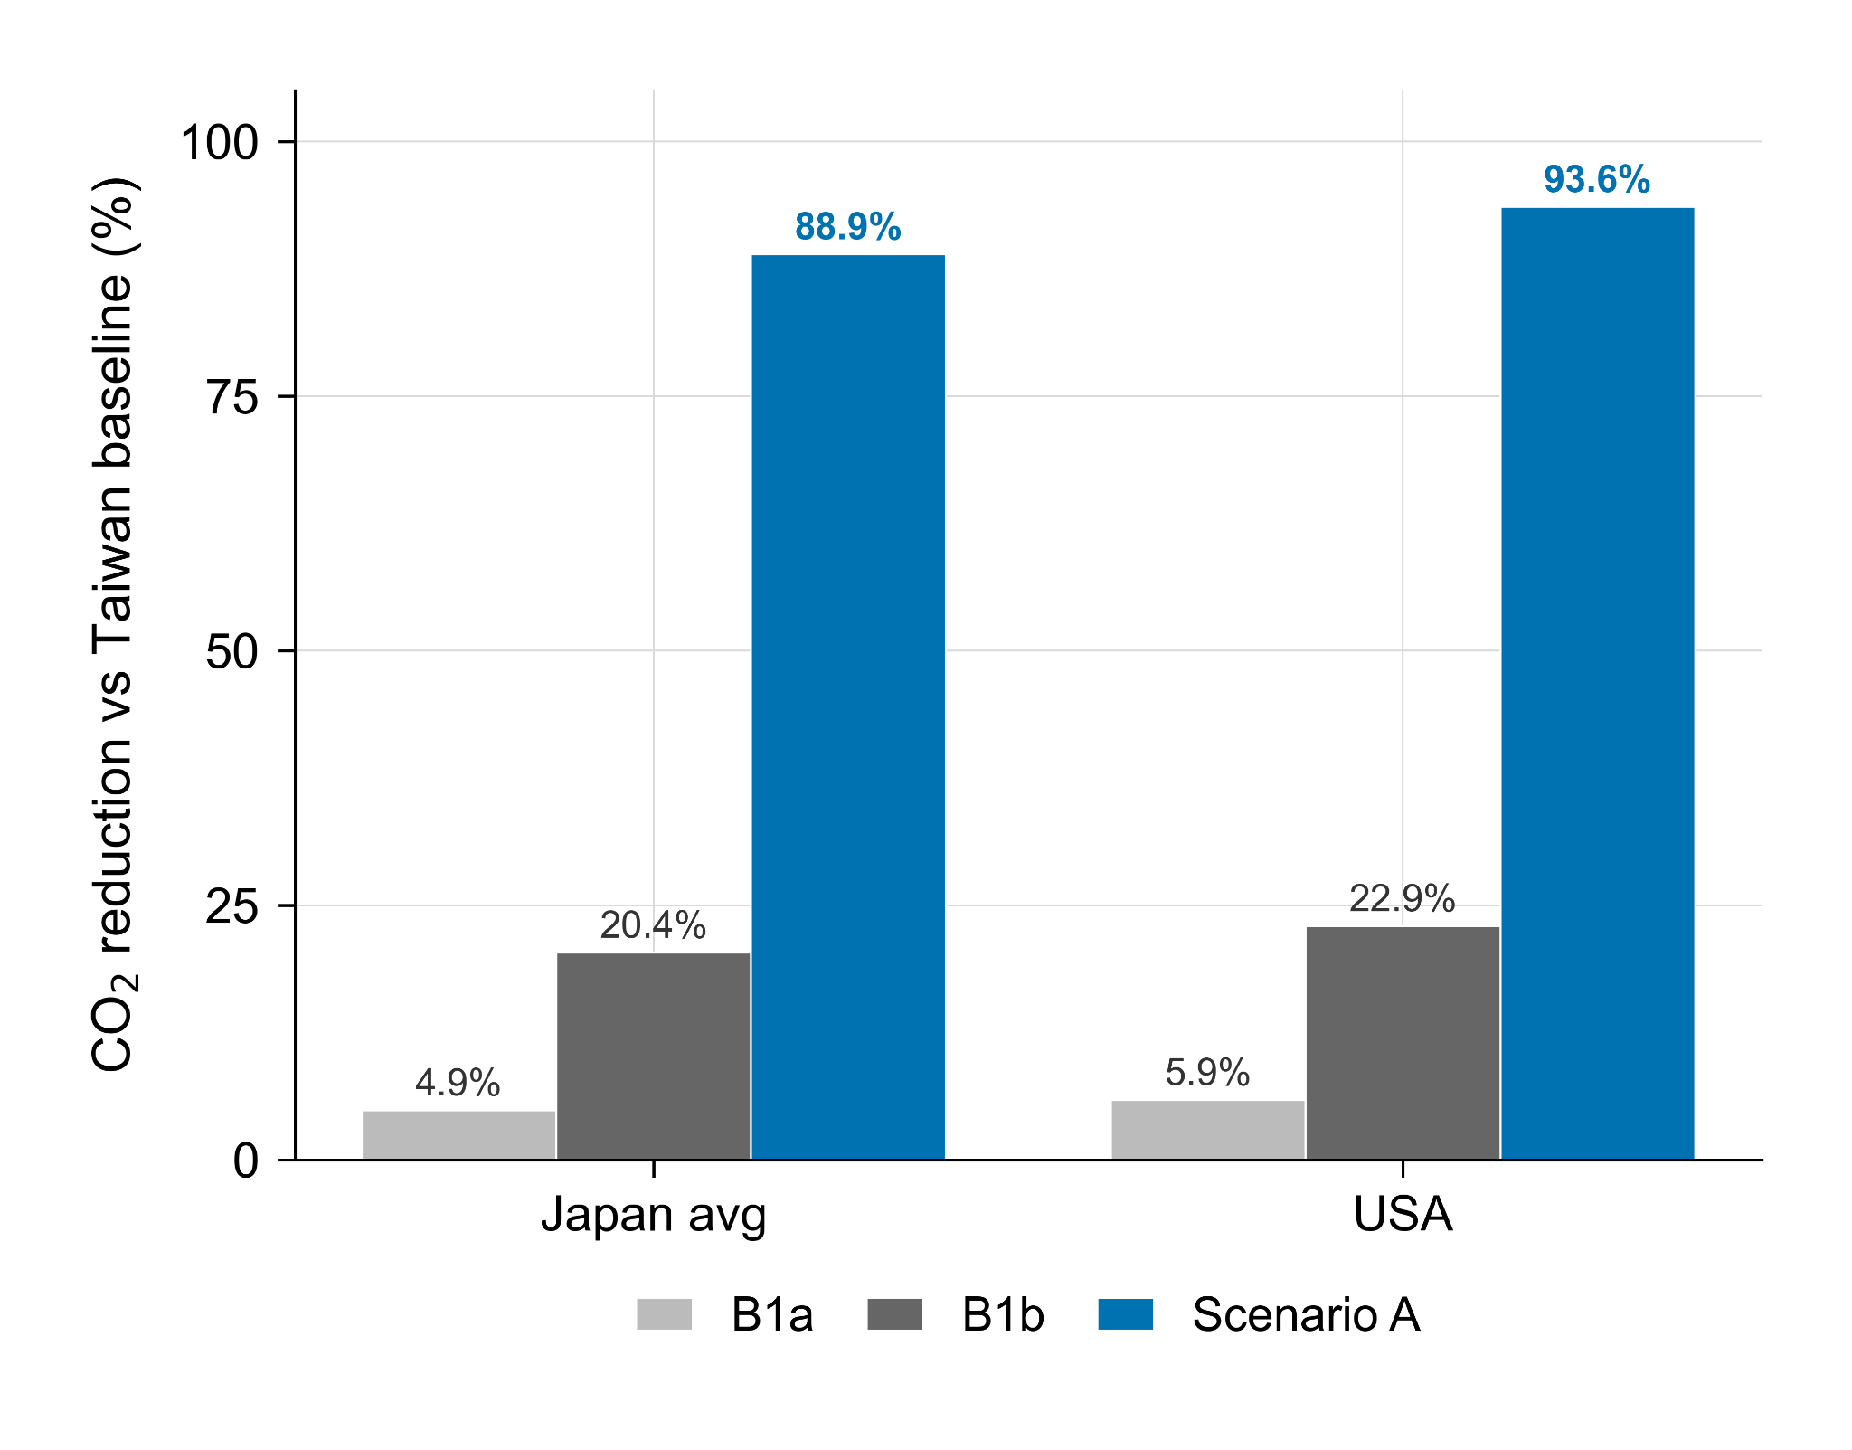
Figure S1. Grouped bars showing EDGAR CO₂ reductions for the host-country-structure scenario (A) and the Taiwan-structure-transfer scenarios (B1a and B1b) for the Japan-average and US hosts, visualizing the A > B1b > B1a hierarchy reported in Table S4a. The gaps are scenario-based contrasts, not causal or Shapley-type decompositions.
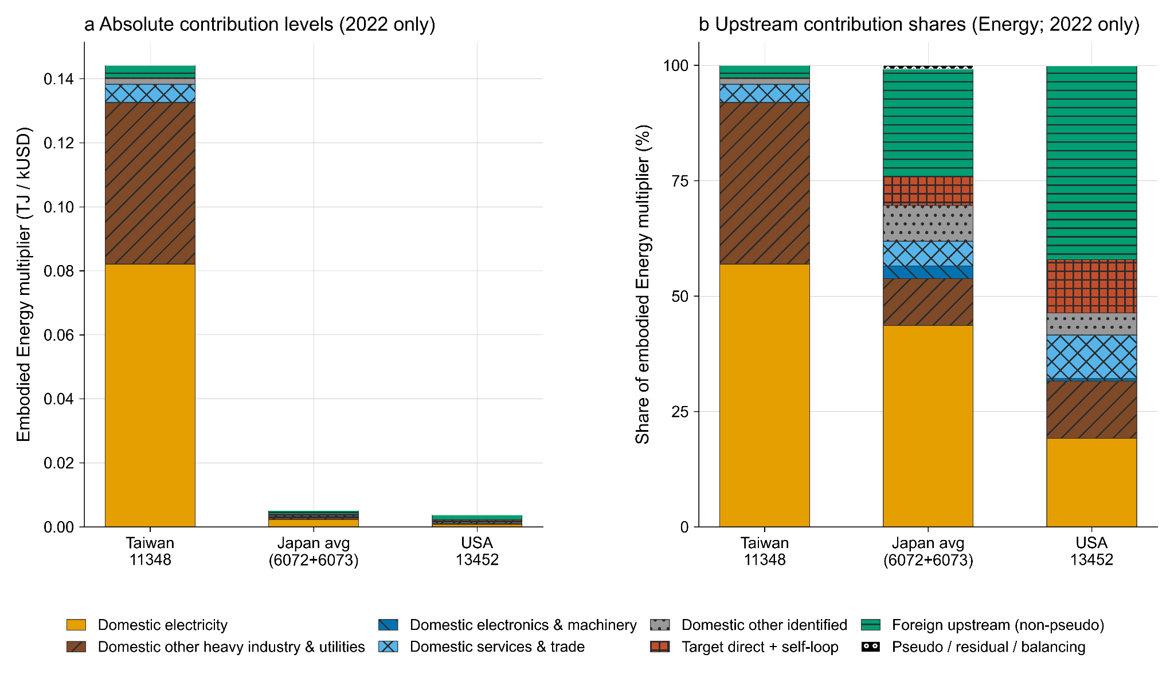
Figure S2. Upstream decomposition of Eora-based embodied energy multipliers for Taiwan, Japan, and US semiconductor-related sectors. Panel a reports absolute contribution levels, and Panel b reports shares of each target’s multiplier. The energy decomposition is reported as a 2022 cross-sector diagnostic because the Eora I-ENERGY satellite is frozen after 2011. Contribution groups are MRIO sectoral categories, not process-level fab engineering categories.
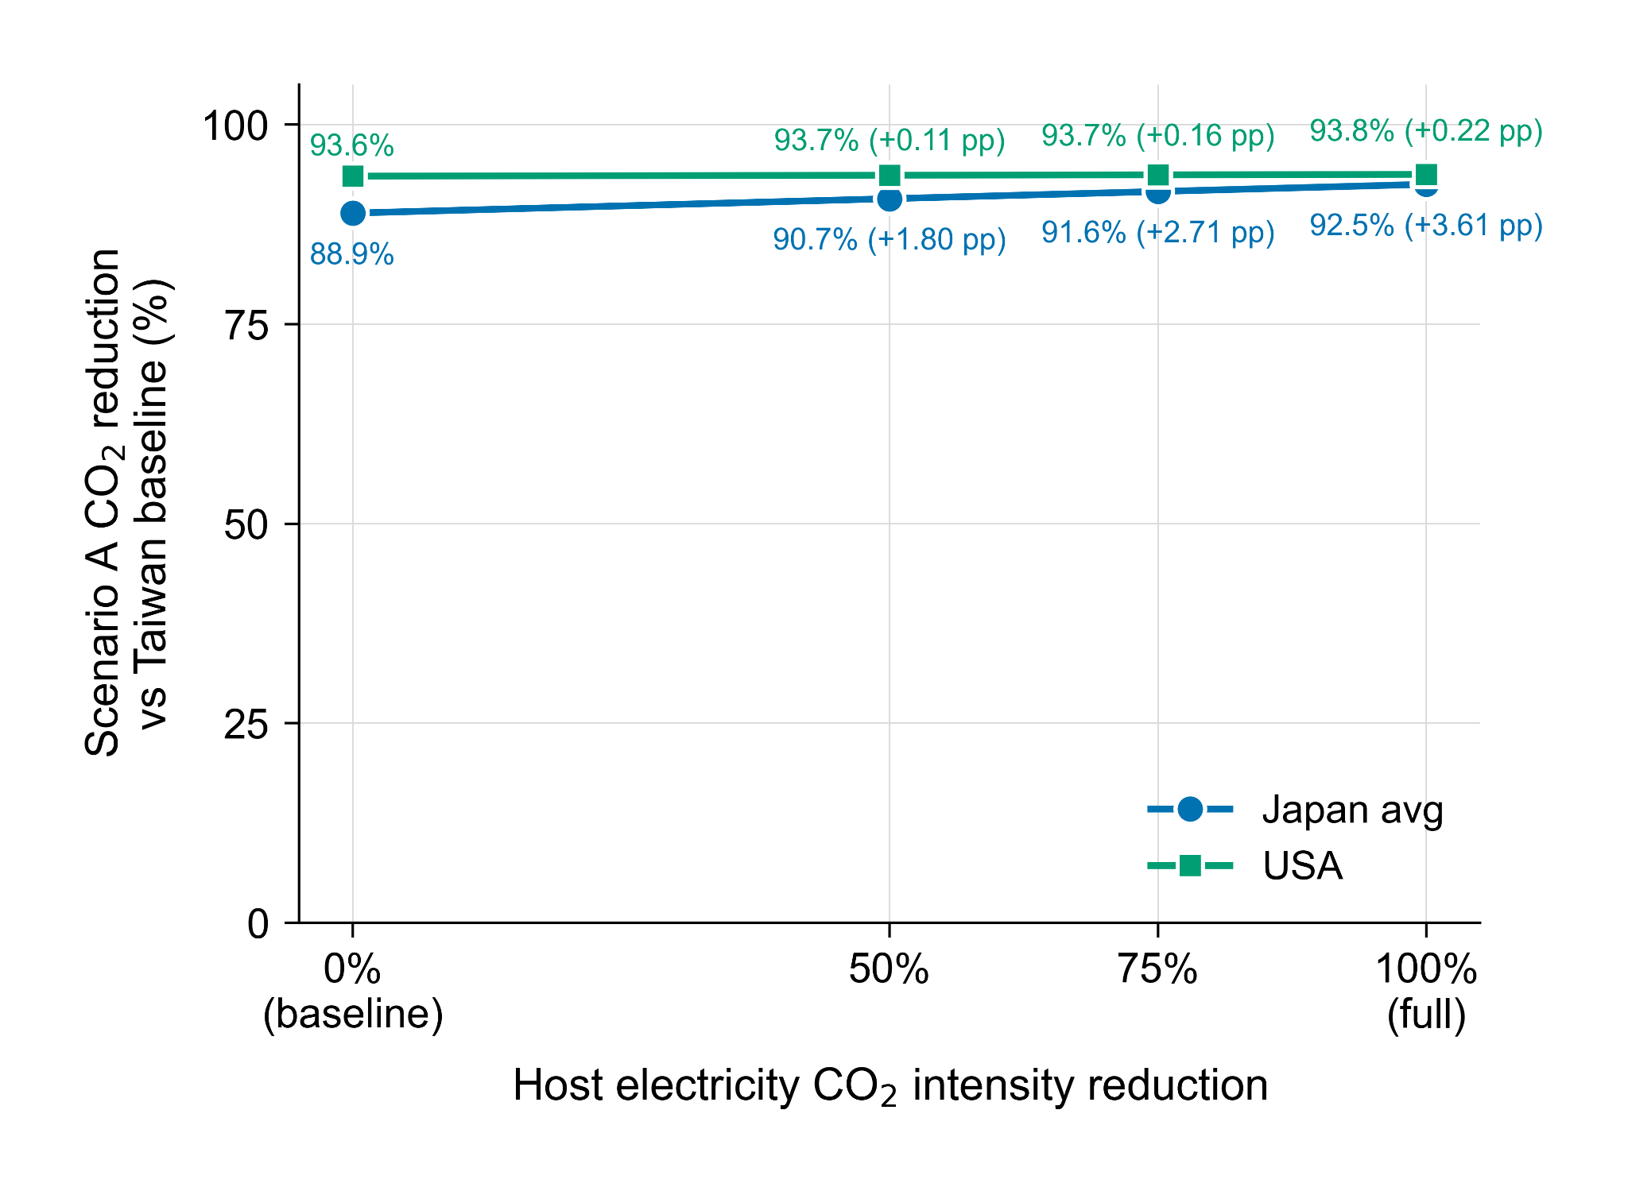
Figure S3. Scenario A EDGAR CO₂ reductions for the Japan-average and US hosts as the host electricity sector’s CO₂ intensity is reduced by 0%, 50%, 75%, and 100% (RS-CLEAN). The marginal effect of additional host-electricity decarbonization is limited relative to the Scenario A host-structure contrast, and is especially small for the United States.

Supplementary data files
The following sheets are provided in Online Resource 2 (ESM_2.xlsx). The underlying Eora Full MRIO database is available under license from WorldMRIO and cannot be redistributed by the authors; this workbook contains derived tables sufficient to verify the reported multipliers, scenario contrasts, upstream decompositions, and sensitivity diagnostics.
Sheet in Online Resource 2 (ESM_2.xlsx) | Purpose
Data S1 (host_sector_multipliers) | Multipliers and Scenario A reductions for Taiwan, Japan 6072, Japan 6073, the Japan average, and the United States
Data S2 (upstream_category_assignment) | Sector-level upstream category assignments for the top 200 contributors per target and indicator (a disclosure extract whose coverage varies by target and indicator; category definitions are in Table S2)
Data S3 (upstream_decomposition_audit) | Reconciliation, grouped decomposition, pseudo/residual diagnostics, negative-contribution diagnostics
Data S4 (sensitivity_diagnostics) | Scenario A/B1a/B1b contrasts (CO₂ and Energy), RS-CLEAN sensitivity, US electricity and semiconductor entity diagnostics, the 2019 cross-section, and the Japan B1b routing audit
Data S5 (japan_sector_scenarios) | Sector-specific Scenario A/B1a/B1b results for Japan 6072 and 6073 (CO₂ and Energy), including B1a step, electricity increment, and A−B1b gap in percentage points; source data for Table 3 (main text) and Tables S4a/S4e.
Data S6 (midpoint_reconciliation) | Reconciliation of the reported Japan-average multipliers against the reconstructed arithmetic mean of the unrounded sector-specific multipliers, with absolute and relative differences.
Notes on the deposited data files. Supplementary Data S2 is a top-200 contributor disclosure extract for each target × indicator combination; its coverage varies by target and indicator (for Taiwan × EDGAR it covers about 87% of absolute contributions, and for some host × indicator combinations it is lower), so it should not be read as the full sector universe. Full grouped shares, reconciliation, and pseudo/residual diagnostics are reported in Supplementary Data S3 and Table S3b; category definitions are provided in Table S2. In Supplementary Data S3, grouped contributions are reported both as all totals and as per-country-group breakdowns; the all rows reproduce the Table S3b shares and should not be summed with the country-group rows. Columns containing the legacy term routing (for example, min_x_new_after_routing) are retained for schema compatibility; in the main manuscript and this Supplementary Information, these refer to direct electricity-input reassignment or electricity-entity assignment. Per-column descriptions are provided in the deposited file headers.

