SUPPLEMENTARY MATERIAL

Supplementary Table 1. Modified and reference experimental conditions of the established protocol to determine the robustness of multiplex LFD.

Condition | Reference |  | Modification
LFD
Deviation in the extraction procedure
Sample weight (g) | 1 |  | 0.8 | 1.2
Extraction buffer volume (mL) | 9 |  | 8 | 10
Deviation in the assay
Assay volume (μL) | 150 |  | 100 | 300
Assay time (min) | 10 |  | 2 | 5

Supplementary Table 2. Data for the non-specific target lines determined in hazelnut, almond and walnut extracts using the naked eye and an objective reader. At least six independent extracts of each nut were analyzed in several replicates.

Hazelnut test line |  |  | Naked eye |  | Strip reader
 | (µg/g) | N | x |  | x | Mean | SD | POD | LCL | ULC
Almond protein | 50 | 10 | 10 |  | 10 | 18.0 | 17.0 | 1.00 | 0.72 | 1.00
 | 10 | 10 | 5 |  | 5 | 4.5 | 4.8 | 0.50 | 0.24 | 0.76
 | 5.0 | 10 | 0 |  | 0 | 1.4 | 1.3 | 0.00 | 0.00 | 0.28
 | 2.0 | 10 | 0 |  | 0 | 1.3 | 1.1 | 0.00 | 0.00 | 0.28
 | 1.0 | 40 | 0 |  | 0 | 0.4 | 0.4 | 0.00 | 0.00 | 0.28
 | 0.1 | 20 | 0 |  | 0 | 0.0 | 0.0 | 0.00 | 0.00 | 0.28
Walnut protein | 50 | 10 | 10 |  | 10 | 8.7 | 5.0 | 1.00 | 0.72 | 1.00
 | 10 | 10 | 0 |  | 0 | 0.4 | 0.6 | 0.00 | 0.00 | 0.28
 | 5.0 | 10 | 0 |  | 0 | 0.6 | 0.5 | 0.00 | 0.00 | 0.28
 | 2.0 | 10 | 0 |  | 0 | 0.5 | 0.8 | 0.00 | 0.00 | 0.28
 | 1.0 | 40 | 0 |  | 0 | 0.3 | 0.2 | 0.00 | 0.00 | 0.09
 | 0.5 | 40 | 0 |  | 0 | 1.0 | 0.5 | 0.00 | 0.00 | 0.09
 | 0.1 | 20 | 0 |  | 0 | 4.0 | 0.3 | 0.00 | 0.00 | 0.16
Almond test line |  |  | Naked eye |  | Strip reader
 | (µg/g) | N | x |  | x | Mean | SD | POD | LCL | ULC
Hazelnut protein | 50 | 10 | 0 |  | 0 | 0.9 | 1.1 | 0.00 | 0.00 | 0.28
 | 10 | 10 | 0 |  | 0 | 0.5 | 0.4 | 0.00 | 0.00 | 0.28
 | 5.0 | 10 | 0 |  | 0 | 1.0 | 0.5 | 0.00 | 0.00 | 0.09
 | 2.5 | 40 | 0 |  | 0 | 1.3 | 0.5 | 0.00 | 0.00 | 0.09
 | 1.0 | 40 | 0 |  | 0 | 1.2 | 0.5 | 0.00 | 0.00 | 0.16
Walnut protein | 50 | 10 | 0 |  | 0 | 3.0 | 0.7 | 0.00 | 0.00 | 0.28
 | 10 | 10 | 0 |  | 0 | 0.9 | 0.2 | 0.00 | 0.00 | 0.28
 | 5.0 | 10 | 0 |  | 0 | 0.9 | 0.6 | 0.00 | 0.00 | 0.28
 | 2.0 | 10 | 0 |  | 0 | 0.8 | 0.7 | 0.00 | 0.00 | 0.28
 | 1.0 | 40 | 0 |  | 0 | 1.1 | 0.5 | 0.00 | 0.00 | 0.09
 | 0.5 | 40 | 0 |  | 0 | 0.4 | 0.3 | 0.00 | 0.00 | 0.09
 | 0.1 | 20 | 0 |  | 0 | 1.6 | 0.8 | 0.00 | 0.00 | 0.16
Walnut test line |  |  | Naked eye |  | Strip reader
 | (µg/g) | N | x |  | x | Mean | SD | POD | LCL | ULC
Hazelnut protein | 50 | 10 | 0 |  | 0 | 1.9 | 0.7 | 0.00 | 0.00 | 0.28
 | 10 | 10 | 0 |  | 0 | 1.4 | 0.3 | 0.00 | 0.00 | 0.28
 | 5.0 | 40 | 0 |  | 0 | 1.2 | 0.7 | 0.00 | 0.00 | 0.09
 | 2.5 | 40 | 0 |  | 0 | 1.1 | 0.5 | 0.00 | 0.00 | 0.09
 | 1.0 | 20 | 0 |  | 0 | 1.0 | 0.4 | 0.00 | 0.00 | 0.16
Almond protein | 50 | 10 | 0 |  | 0 | 1.3 | 0.5 | 0.00 | 0.00 | 0.28
 | 10 | 10 | 0 |  | 0 | 0.8 | 0.8 | 0.00 | 0.00 | 0.28
 | 5.0 | 10 | 0 |  | 0 | 0.9 | 0.4 | 0.00 | 0.00 | 0.28
 | 2.0 | 10 | 0 |  | 0 | 0.9 | 1.2 | 0.00 | 0.00 | 0.28
 | 1.0 | 40 | 0 |  | 0 | 0.9 | 0.3 | 0.00 | 0.00 | 0.09
 | 0.1 | 20 | 0 |  | 0 | 0.4 | 0.5 | 0.00 | 0.00 | 0.28
N: number of replicates assayed. X: number of positive results. POD: Probability of detection (POD). LCL: lower control limit (95% CI). UCL: upper control limit (95%CI). SD: standard deviation of optical reader signal.

Hazelnut signal threshold: 4.0, Almond signal threshold: 3.7, Walnut signal threshold:3.1

Supplementary Table 3. Evaluation of the hook effect of the LFD with protein extracts of raw hazelnut, almond, and walnut diluted in buffer extraction. Results from the analysis of two strips from three independent extractions (n=6). The highest concentration for each allergen corresponds to the undiluted extract.
 | Positive Strip reader (%) |  |  | Strip reader (signal a.u)
Hazelnut protein (mg/g) | Hazelnut  TL | Almond  TL | Walnut  TL | Hazelnut  TL | Almond  TL | Walnut  TL
120 | 0 | 0 | 0 | 1.9 | 2,6 | 1,5
30.0 | 100 | 16 | 0 | 24.2 | 3.5 | 2,6
1.2 | 100 | 33 | 0 | 71.3 | 3.8 | 2,8
Almond protein (mg/g)
190 | 0 | 0 | 0 | 0.6 | 3,2 | 2.0
47.5 | 16 | 100 | 0 | 2.3 | 18.4 | 1,4
1.9 | 100 | 100 | 0 | 21.4 | 88.2 | 2,0
Walnut protein (mg/g)
149 | 50 | 100 | 100 | 3,2 | 8,9 | 11,2
35.0 | 100 | 100 | 100 | 8,2 | 30,2 | 40,0
1.5 | 100 | 100 | 100 | 7,2 | 35,0 | 84,6
*a.u.: arbitrary unitsTL: Test line
Hazelnut signal threshold: 4.0, Almond signal threshold: 3.7, Walnut signal threshold:3.1

sp|E3SH28|PRU01_PRUDU MAK---AFVFSLCLLLVFNGCLAARQS----QLSPQNQCQLNQLQAREPDNRIQAEAGQI 53
tr|Q8W1C2|Q8W1C2_CORAV MAKLILVS-FSLCLLVLFNGCLGINVGLRRQQQRYFGECNLDRLNALEPTNRIEAEACQI 59
sp|Q2TPW5|JUGR4_JUGRE MAKPILLSIYLFLIVALFNGCLAQSGGR---QQQQFGQCQLNRLDALEPTNRIEAEAGVI 57
*** : : :: :*****. . * .:*:*::*:* ** ***:*** *

sp|E3SH28|PRU01_PRUDU ETWNFNQEDFQCAGVAASRITIQRNGLHLPSYSNAPQLIYIVQGRGVLGAVFSGCPETFE 113
tr|Q8W1C2|Q8W1C2_CORAV ESWDHNDQQFQCAGVAVIRRTIEPNGLLLPQYSNAPELIYIERGRGITGVLFPGCPETFE 119
sp|Q2TPW5|JUGR4_JUGRE ESWDPNNQQFQCAGVAVVRRTIEPNGLLLPQYSNAPQLVYIARGRGITGVLFPGCPETFE 117
*:*: *:::*******. * **: *** **.*****:*:** :***: *.:* *******

sp|E3SH28|PRU01_PRUDU ESQQSSQQGRQQEQEQERQQQQQGEQGRQQGQQEQQQERQGRQQGRQQQEEGRQQEQQQG 173
tr|Q8W1C2|Q8W1C2_CORAV DPQQQSQQGQRQGQGQ-------------------------------------------- 135
sp|Q2TPW5|JUGR4_JUGRE ESQRQSQQGQ-------------------------------------------------- 127
: *:.****:

sp|E3SH28|PRU01_PRUDU QQGRPQQQQQFRQFDRHQKTRRIREGDVVAIPAGVAYWSYNDGDQELVAVNLFHVSSDHN 233
tr|Q8W1C2|Q8W1C2_CORAV --------SQRSEQDRHQKIRHFREGDIIALPAGVAHWCYNDGDSPVVTVSLLHTNNYAN 187
sp|Q2TPW5|JUGR4_JUGRE --------SREFQQDRHQKIRHFREGDIIAFPAGVAHWSYNDGSNPVVAISLLDTNNNAN 179
.: : ***** *::****::*:*****:*.****.. :*::.*:.... *

sp|E3SH28|PRU01_PRUDU QLDQNPRKFYLAGNPENEFNQQGQSQPRQQGEQGRPGQHQQPFGRPRQQEQQGSGNNVFS 293
tr|Q8W1C2|Q8W1C2_CORAV QLDENPRHFYLAGNPDDEHQRQGQQQFGQRRRQQ---QHS-HG-EQGEQEQQGEGNNVFS 242
sp|Q2TPW5|JUGR4_JUGRE QLDQNPRNFYLAGNPDDEFRPQGQQEYEQHRRQQ---QRQ-QRPGEHGQQQRGLGNNVFS 235
***:***:*******::*.. ***.: *: .* *:. *:*:* ******

sp|E3SH28|PRU01_PRUDU GFNTQLLAQALNVNEETARNLQGQNDNRNQIIRVRGN-LDFVQPPRGRQEREHEERQQ-- 350
tr|Q8W1C2|Q8W1C2_CORAV GFDAEFLADAFNVDVDTARRLQSNQDKRRNIVKVEGR-LQVVRPERSRQEWERQERQERE 301
sp|Q2TPW5|JUGR4_JUGRE GFDADFLADAFNVDTETARRLQSENDHRRSIVRVEGRQLQVIRPRWSREEQEREERKERE 295
**::::**:*:**: :***.**.::*:*..*::*.*. *:.::* .*:* *::**::

sp|E3SH28|PRU01_PRUDU ---EQLQQERQQQGGQLMANGLEETFCSLRLKENIGNPERADIFSPRAGRISTLNSHNLP 407
tr|Q8W1C2|Q8W1C2_CORAV SEQERERQRRQG-GRGRDVNGFEETICSLRLRENICTRSRADIYTEQVGRINTVNSNTLP 360
sp|Q2TPW5|JUGR4_JUGRE RERESESERRQSRRGGRDDNGLEETICTLRLRENIGDPSRADIYTEEAGRISTVNSHTLP 355
* :.** **:***:*:***:*** .****:: ..***.*:**:.**

sp|E3SH28|PRU01_PRUDU ILRFLRLSAERGFFYRNGIYSPHWNVNAHSVVYVIRGNARVQVVNENGDAILDQEVQQGQ 467
tr|Q8W1C2|Q8W1C2_CORAV VLRWLQLSAERGDLQREGLYVPHWNLNAHSVVYAIRGRARVQVVDDNGNTVFDDELRQGQ 420
sp|Q2TPW5|JUGR4_JUGRE VLRWLQLSAERGALYSDALYVPHWNLNAHSVVYALRGRAEVQVVDNFGQTVFDDELREGQ 415
:**:*:****** : :.:* ****:*******.:**.*.****:: *::::*:*:::**

sp|E3SH28|PRU01_PRUDU LFIVPQNHGVIQQAGNQGFEYFAFKTEENAFINTLAGRTSFLRALPDEVLANAYQISREQ 527
tr|Q8W1C2|Q8W1C2_CORAV VLTIPQNFAVAKRAESEGFEWVAFKTNDNAQISPLAGRTSAIRALPDDVLANAFQISREE 480
sp|Q2TPW5|JUGR4_JUGRE LLTIPQNFAVVKRARNEGFEWVSFKTNENAMVSPLAGRTSAIRALPEEVLATAFQIPRED 475
:: :***..* ::* .:***:.:***::** :. ****** :****::***.*:** **:

sp|E3SH28|PRU01_PRUDU ARQLKYNRQETIALSSSQQRRAVV----------- 551
tr|Q8W1C2|Q8W1C2_CORAV ARRLKYNRQETTLVRSSRSSSERKRRSESEGRAEA 515
sp|Q2TPW5|JUGR4_JUGRE ARRLKFNRQESTLVRSRPSRSRSS---RSERRAEV 507
**:**:****: : * .

Supplementary Figure 1. Sequence (UniProt: https://www.uniprot.org/) alignment of Pru du 6 (E3SH28), Jug r 4 (Q8W1C2) and Cor a 9 (Q8W1C2) with Clustal Omega (1.2.4) (https://www.ebi.ac.uk/jdispatcher/msa/clustalo). (* = identical residues; * = highly conserved substitutions: = weakly conserved substitutions; gap = non-conserved positions).

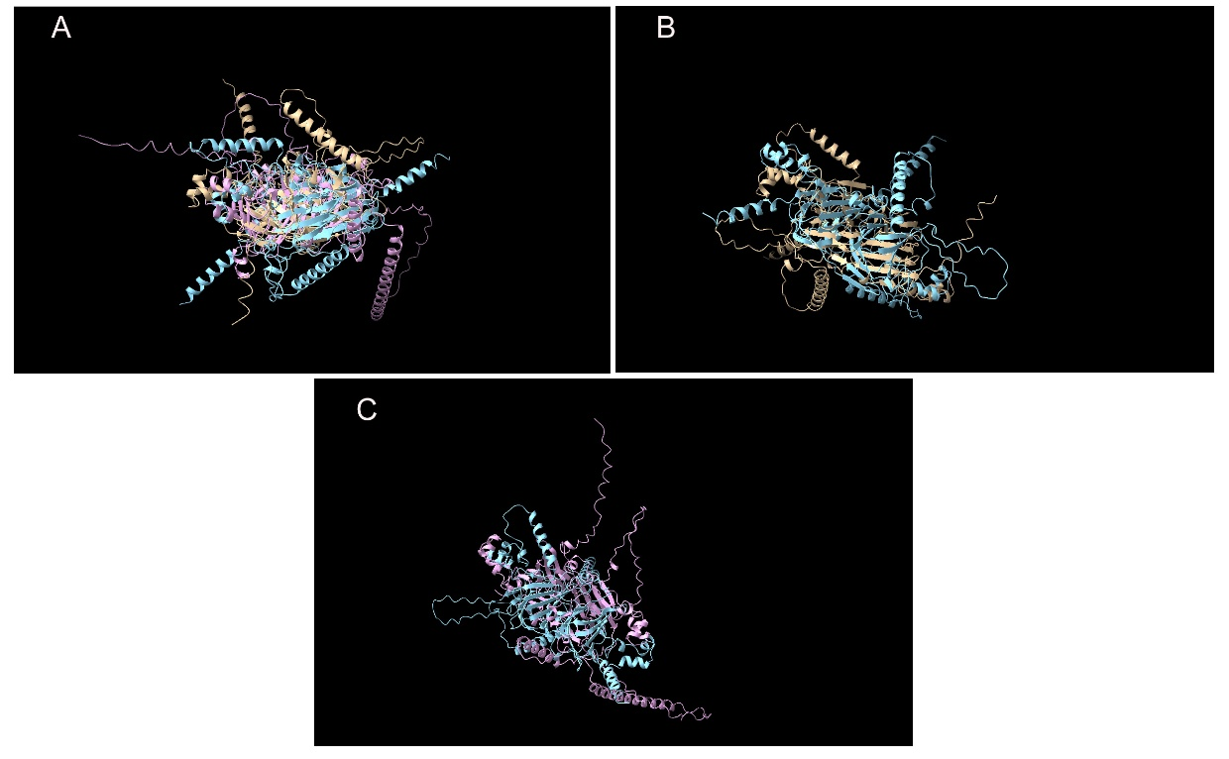
Supplementary Figure 2. 3D Alignment of the predicted structures of the 11S proteins of almond, hazelnut and walnut from three different three-dimensional perspectives (A, B, C) with the software Chimera X1.10.01. Pru du 6 (AF-E3SH28--F1-model_v6.pdb)  Cor a 9 (AF-Q8W1C2-F1- model_v6.pdb) Jug r 4 (AF-Q2TPW5-F1-model_v6.pdb) from alpha fold.

CLUSTAL O(1.2.4) multiple sequence alignment

tr|Q8H2B9|Q8H2B9_PRUDU ---MKVVAAYLLAVLG-GN-----TT----PSAEDLKDILGSVGAETDD--DRI------ 39
tr|D0PWG2|D0PWG2_CORAV MARLATLAALFAALLLVAHAAAFRTTITTVDVDEDIVNQQGRRGESCREQAQRQQNLNQC 60
sp|P93198|2SS_JUGRE -------AALLVALLFVANAAAFRTTITTMEIDEDIDN-PRRRGEGCREQIQRQQNLNHC 52
** : *:* .: ** **: : * : :*

tr|Q8H2B9|Q8H2B9_PRUDU -------------------------------------------------QLLLSEVKGKD 50
tr|D0PWG2|D0PWG2_CORAV QRYMRQQSQYGSYDGSNQQQQQELEQCCQQLRQMDERCRCEGLRQAVMQ--QQGEMRGEE 118
sp|P93198|2SS_JUGRE QYYLRQQSRSGGYDEDNQ--RQHFRQCCQQLSQMDEQCQCEGLRQVVRRQQQQQGLRGEE 110
::*::

tr|Q8H2B9|Q8H2B9_PRUDU ITELIASGREKLASVPSGGGAVAVAAPGAGAGAAAPAAAEPKKEEKVEEKEDTDDDMGFS 110
tr|D0PWG2|D0PWG2_CORAV MREVMETARD------------------------------------------LPNQCRLS 136
sp|P93198|2SS_JUGRE MEEMVQSARD------------------------------------------LPNECGIS 128
: *:: :.*: :: :*

tr|Q8H2B9|Q8H2B9_PRUDU LFD-------- 113
tr|D0PWG2|D0PWG2_CORAV PQRCEIRSARF 147
sp|P93198|2SS_JUGRE SQRCEIRRSWF 139

Supplementary Figure 3. Sequence (UniProt: https://www.uniprot.org/) alignment of Cor a 14 (D0PWG2), Pru du 5 (Q8H2B9) and Jug r 1 (P93198) with Clustal Omega (https://www.ebi.ac.uk/jdispatcher/msa/clustalo). (* = identical residues;* = highly conserved substitutions; : = weakly conserved substitutions; gap = non-conserved positions).

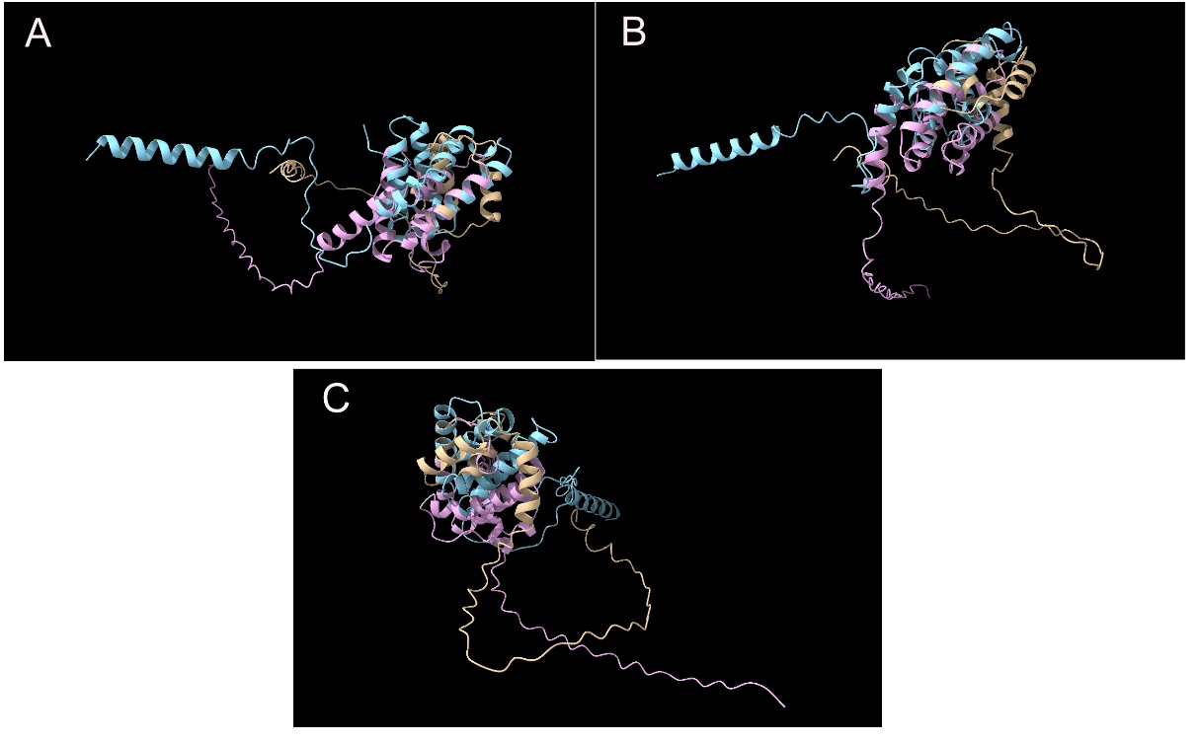

Supplementary Figure 4. 3D Alignment of the different predicted structures of the 2S proteins of almond, hazelnut and walnut from three different three-dimensional perspectives with the software Chimera X1.10.01 (A, B, C). Pru du 5 (AF-E3SH28--F1-model_v6.pdb) Cor a 14 (AF-Q8W1C2-F1- model_v6.pdb) Jug r 1 (AF-Q2TPW5-F1-model_v6.pdb) from alpha fold.

Supplementary Table 4. Results of the robustness determination of multiplex LFD at 1 µg/g of walnut and almond protein and 5 µg/g of hazelnut protein spiked in herb liquor. Effect of the deviations in the protocol on the sensitivity of the test.

Deviations in the extraction procedure
Sample portion (g)
 | 0.8 (n= 2) | 1 (n=2) | 1.2 (n=2)
5µg/g Hazelnut protein | P | P | P
1µg/g Almond protein | P | P | P
1µg/g walnut protein | P | P | P
Extraction buffer volume (mL)
 | 9 (n= 2) | 10 (n= 2) | 11 (n= 2)
5µg/g Hazelnut protein | P | P | P
1µg/g Almond protein | P | P | P
1µg/g walnut protein | P | P | P
Deviations in the analysis procedure
Assay volume (mL)
 | 0.10 (n= 2) | 0.15 (n= 2) | 0.20 (n= 2)
5µg/g Hazelnut protein | P | P | P
1µg/g Almond protein | P | P | P
1µg/g walnut protein | P | P | P
Assay time (min)
 | 2 (n=2) | 5 (n=2) | 10 (n=2)
5µg/g Hazelnut protein | N | N | P
1µg/g Almond protein | N | P | P
1µg/g walnut protein | N | P | P
n: number of independent extractions, N: negative, P: positive

