Supplementary material for:
Modulation of Pacific-Origin Rossby Wave Teleconnections by Atlantic SSTs in CMIP6 Large Ensembles

Ramón Fuentes-Franco,1,3 Julia F. Lockwood,2 Nick Dunstone,2 Adam A. Scaife,2,4 Torben Koenigk1,3

1 Rossby Centre, SMHI, Norrköping, Sweden

2 Met Office Hadley Centre, Exeter, United Kingdom

3 Bolin Centre for Climate Research, Stockholm University, Stockholm, Sweden

4 Department of Mathematics and Statistics, University of Exeter, Exeter, United Kingdom

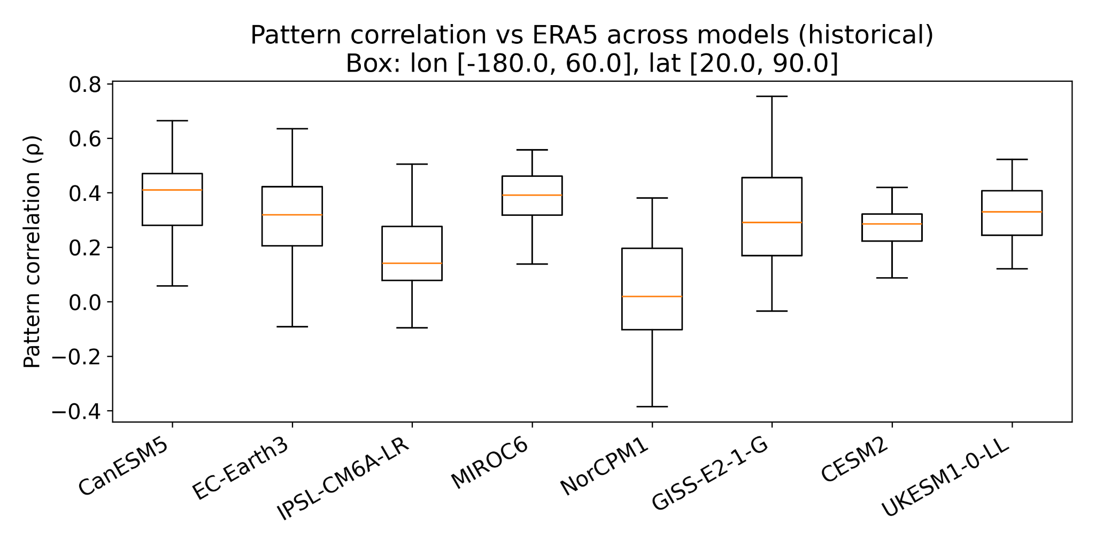
Figure S1.Spatial pattern correlation (ρ) between ERA5 and individual members of CMIP6 large ensembles for the JJA Z500 response associated with RWS variability over the North-East Pacific. Correlations are computed over the domain lon [-180°, 60°], lat [20°, 90°]. Boxplots show the distribution across ensemble members for each model. The horizontal line indicates the median, boxes represent the interquartile range, and whiskers denote the ensemble spread.

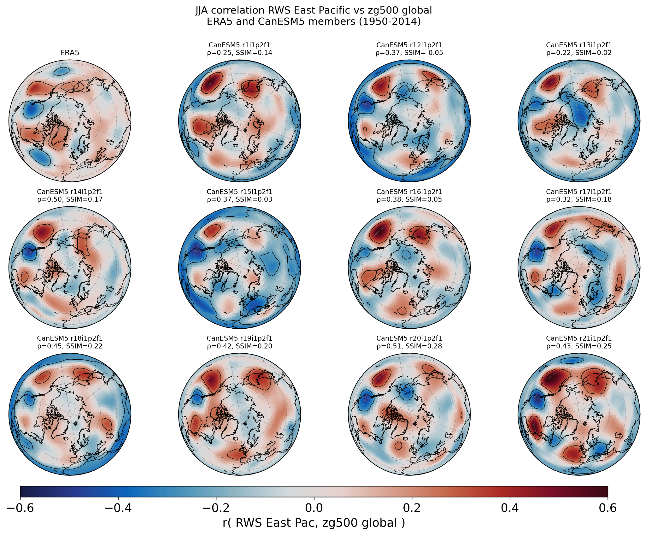
Figure S2. JJA correlation patterns between the East Pacific RWS and global Z500 in ERA5 (upper left) and selected individual CanESM5 ensemble members (1950–2014). Values indicate Pearson spatial pattern correlation (ρ) and Structural Similarity Index (SSIM) with respect to ERA5, computed over 20–90° N and 180° W–60° E. While the large-scale wavetrain structure is broadly reproduced across members, notable differences in amplitude, phase, and regional expression are evident, underscoring the importance of large ensembles for quantifying uncertainty around the observed teleconnection pattern.

Structural Similarity Index (SSIM)

The Structural Similarity Index (SSIM) is a metric designed to quantify the similarity between two spatial fields by jointly assessing their agreement in terms of mean value, variance, and spatial structure. Unlike pointwise error metrics or simple correlations, SSIM explicitly accounts for spatial organization, making it well suited for comparing large-scale climate patterns.

Given two spatial fields x and y, SSIM is defined as:
$$SSIM(x,y) \text{=}(2μ_{x}​ μ_{y} \text{+}C_{1} )(2σ_{xy}​ \text{+}C_{2} ​ )\text{/} (μ_{x}²​ \text{+}μ_{y}²​ \text{+}C_{1})(σ_{x}²​ \text{+}σ_{y}²​ \text{+}C_{2} )​$$

where $μ_{x}​$and $μ_{y}$ are the spatial means of the two fields, $σ_{x}²​$ and $σ_{y}²$ are their spatial variances, and $σ_{xy}​$ is the spatial covariance between them. The constants $C_{1}$ and $C_{2}$ are small positive values introduced to stabilize the metric when the denominators are close to zero; they are typically defined as C₁=(k₁L)² and C₂=(k₂L)², where L is the data range and k₁ and k₂ are fixed parameters. SSIM values range from −1 to 1, where 1 indicates perfect structural similarity between the two fields, values close to 0 indicate little structural agreement, and negative values reflect anti-correlated spatial structures.
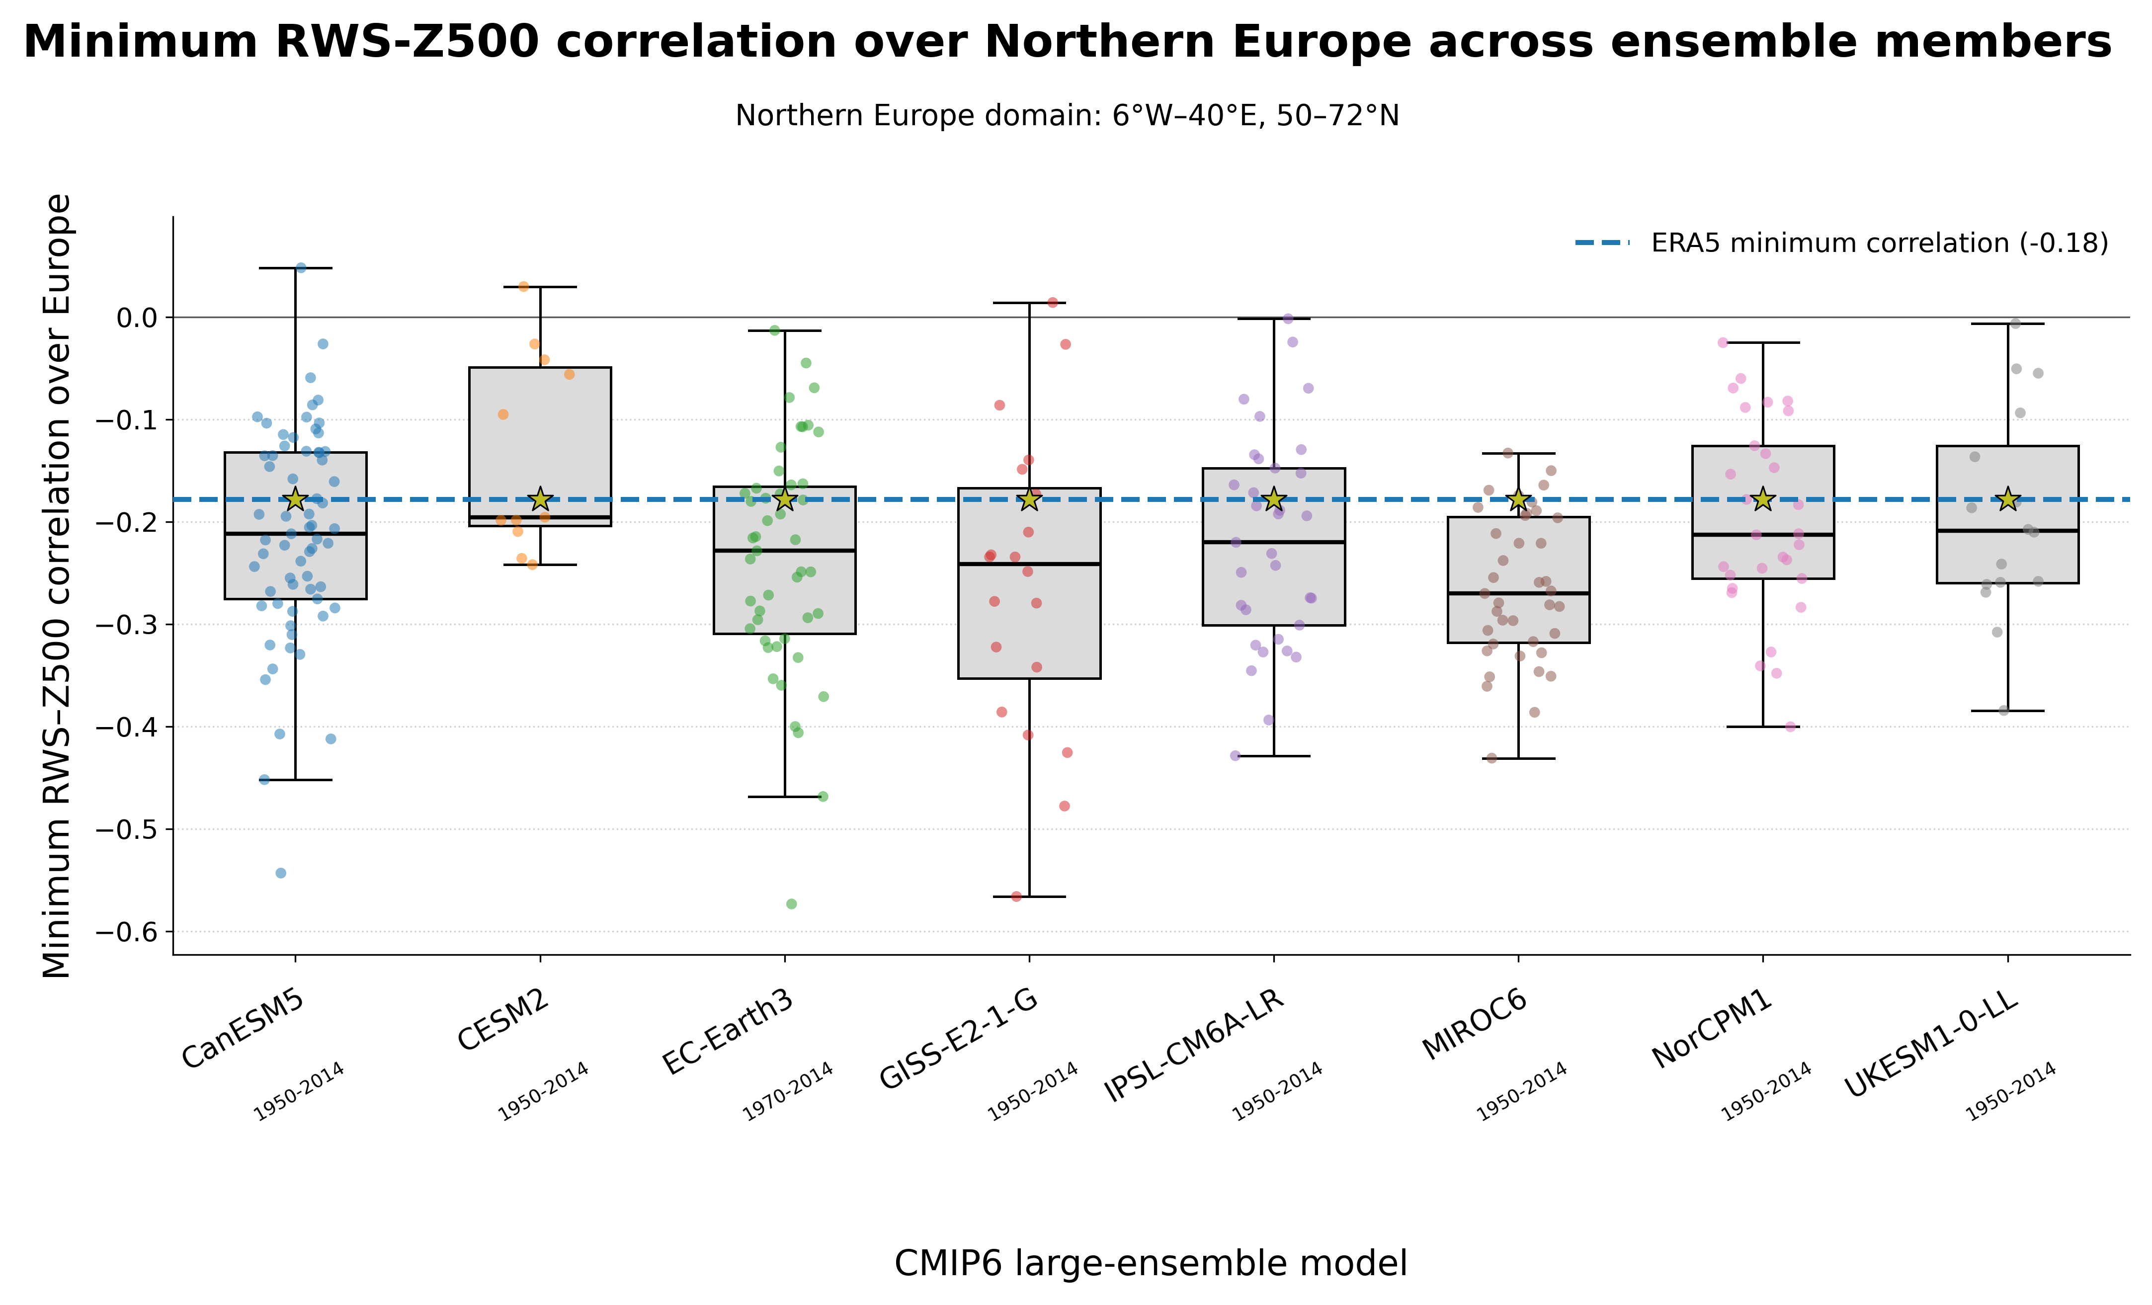
Figure S3. Minimum RWS–Z500 correlation over Europe across ensemble members. For each CMIP6 large-ensemble model, the minimum Pearson correlation between the northeastern Pacific RWS index and Z500 within the European domain (6°W–40°E, 50–72°N) was computed for every individual ensemble member. Boxplots show the distribution of these minimum-correlation values across ensemble members for each model (boxes: interquartile range; horizontal line: median; whiskers: full ensemble spread; gold star: ensemble mean). The number of ensemble members per model (n) is given above each box. The dashed blue line marks the corresponding ERA5 minimum correlation (−0.18). For every model, the ERA5 value falls within, or at the immediate edge of, the interquartile range, indicating that the strength of the observed teleconnection over Northern Europe is consistent with the models' own internal variability.

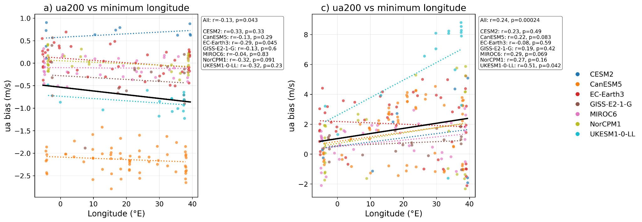

Figure S4. Relationship between zonal wind bias at 200 hPa (ua200; m s⁻¹) and the longitudinal position of the minimum correlation between RWS in the eastern Pacific and Z500 over Europe. The minimum correlation is identified within the European domain (6°W–40°E, 50–72°N, area enclosed by green box in Figures 5 and 6) and defined as the mean longitude of a 2×2 grid-point square surrounding the minimum. (Left) ua200 bias averaged over the North Atlantic jet region (40.5–56°N, 68–30°W, area enclosed within the yellow box in Figures 5 and 6). (Right) ua200 bias averaged locally over the same 2×2 grid-point square used to define the minimum correlation. Each point represents an ensemble member, and colors indicate different climate models. Solid lines show linear regressions across all members, with corresponding slope, correlation coefficient (r), and p-value indicated.
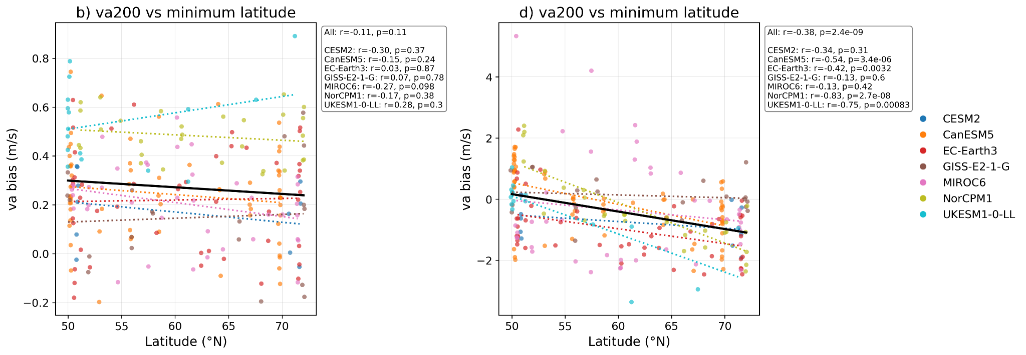

Figure S5. Relationship between meridional wind bias at 200 hPa (va200; m s⁻¹) and the longitudinal position of the minimum correlation between RWS in the eastern Pacific and Z500 over Europe. The minimum correlation is identified within the European domain (6°W–40°E, 50–72°N, area enclosed by green box in Figures 5 and 6) and defined as the mean longitude of a 2×2 grid-point square surrounding the minimum. (Left) va200 bias averaged over the North Atlantic jet region (40.5–56°N, 68–30°W, area enclosed within the yellow box in Figures 5 and 6). (Right) ua200 bias averaged locally over the same 2×2 grid-point square used to define the minimum correlation. Each point represents an ensemble member and colors indicate different climate models. Solid lines show linear regressions across all members, with corresponding slope, correlation coefficient (r), and p-value indicated.

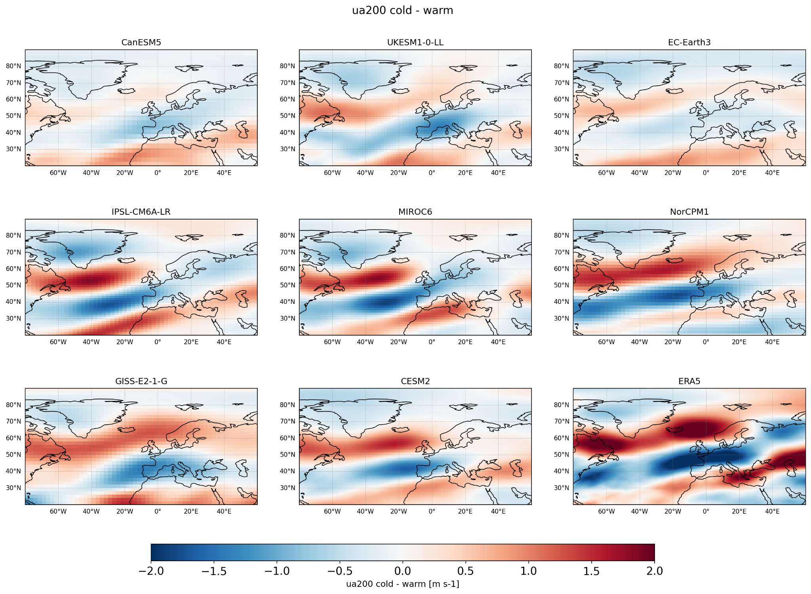
Figure S6. Composite differences in summer (JJA) 200 hPa zonal wind (ua200; m s⁻¹) between colder-than-average and warmer-than-average North Atlantic SST conditions (cold minus warm). Results are shown for individual CMIP6 models and ERA5, using composites derived from precomputed states based on North Atlantic temperature anomalies.
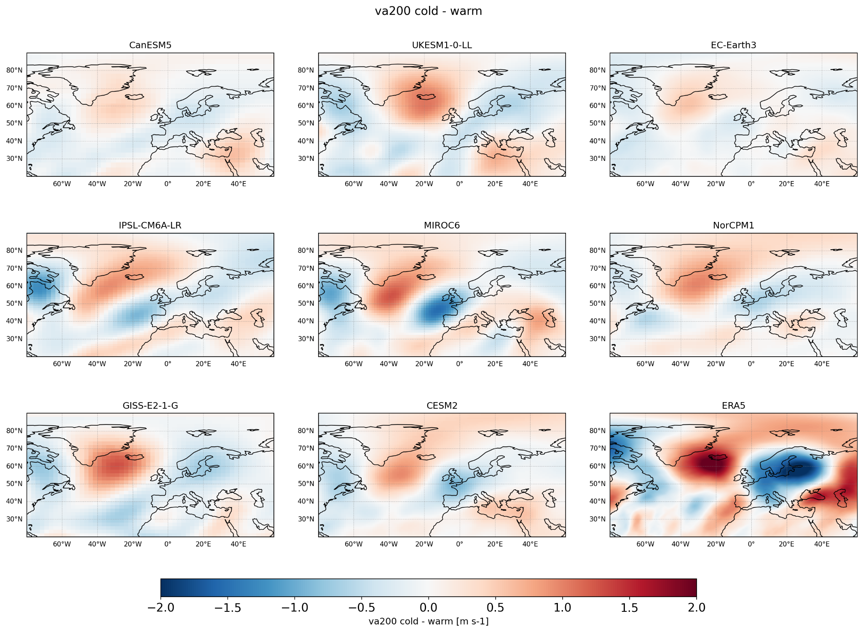
Figure S7. Composite differences in summer (JJA) 200 hPa meridional wind (va200; m s⁻¹) between colder-than-average and warmer-than-average North Atlantic SST conditions (cold minus warm). Results are shown for individual CMIP6 models and ERA5.

