Supplementary Materials for
Intra-block fault strain accommodation reshapes continental deformation of the Bayan Har block in Tibet
Wenting Zhang^{1,2,3}, Lingyun Ji^{2*}, Chuanjin Liu², Liangyu Zhu², Heping Sun¹, Rumeng Guo^{1*}
1.State Key Laboratory of Precision Geodesy, Innovation Academy for Precision Measurement Science and Technology, Chinese Academy of Sciences, Wuhan, China.
2.The Second Monitoring and Application Center, China Earthquake Administration, Xi'an, China.
3.College of Earth and Planetary Sciences, University of Chinese Academy of Sciences, Beijing, China.

* Corresponding authors: Lingyun Ji (jilingyun@smac.ac.cn); Rumeng Guo (guorm@apm.ac.cn)

Contents of this file
Supplementary Figs. S1 to S8
Tables S1

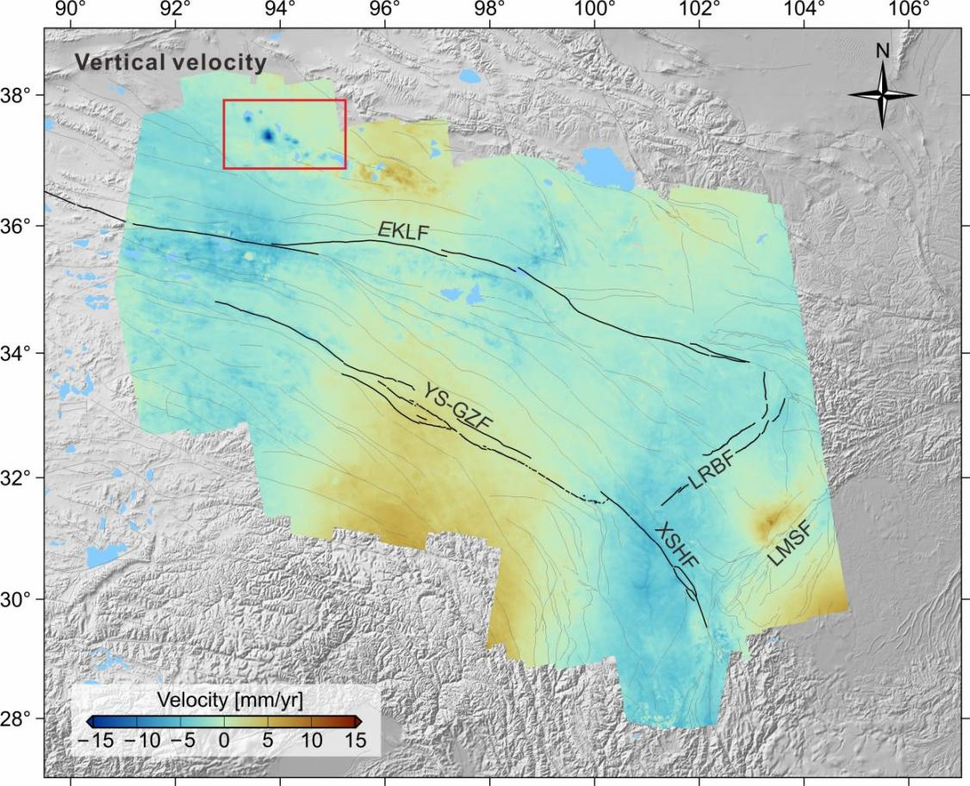
Fig. S1. The decomposed vertical deformation velocities. Red rectangle represents the area with localized subsidence.

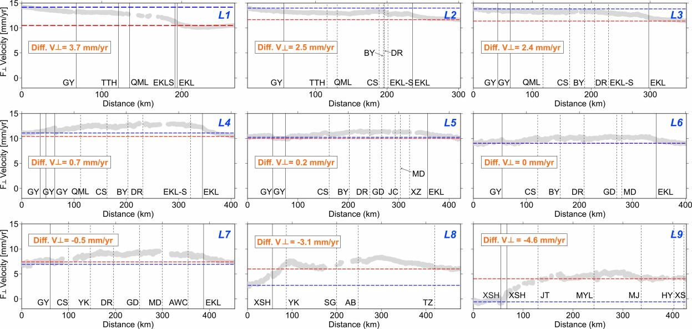
Fig. S2. Fault-perpendicular velocities along profiles L1 to L9 in Fig. 2D. The red and blue dashed lines denote fault-perpendicular velocities at the southern and northern ends of the profile, respectively. The orange label indicates velocity differences across the profile (southern minus northern).

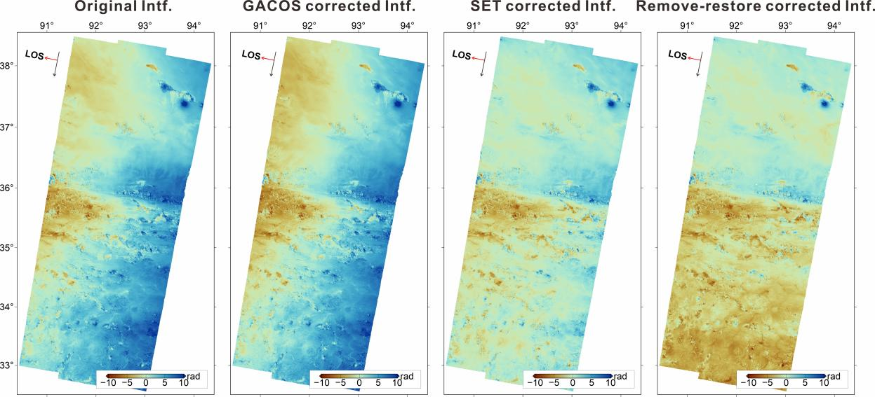
Fig. S3. Examples of atmospheric delay, Solid Earth Tides effects, and residual long-wavelength phase correction of the interferogram 20141214_20170225 along T150D
.
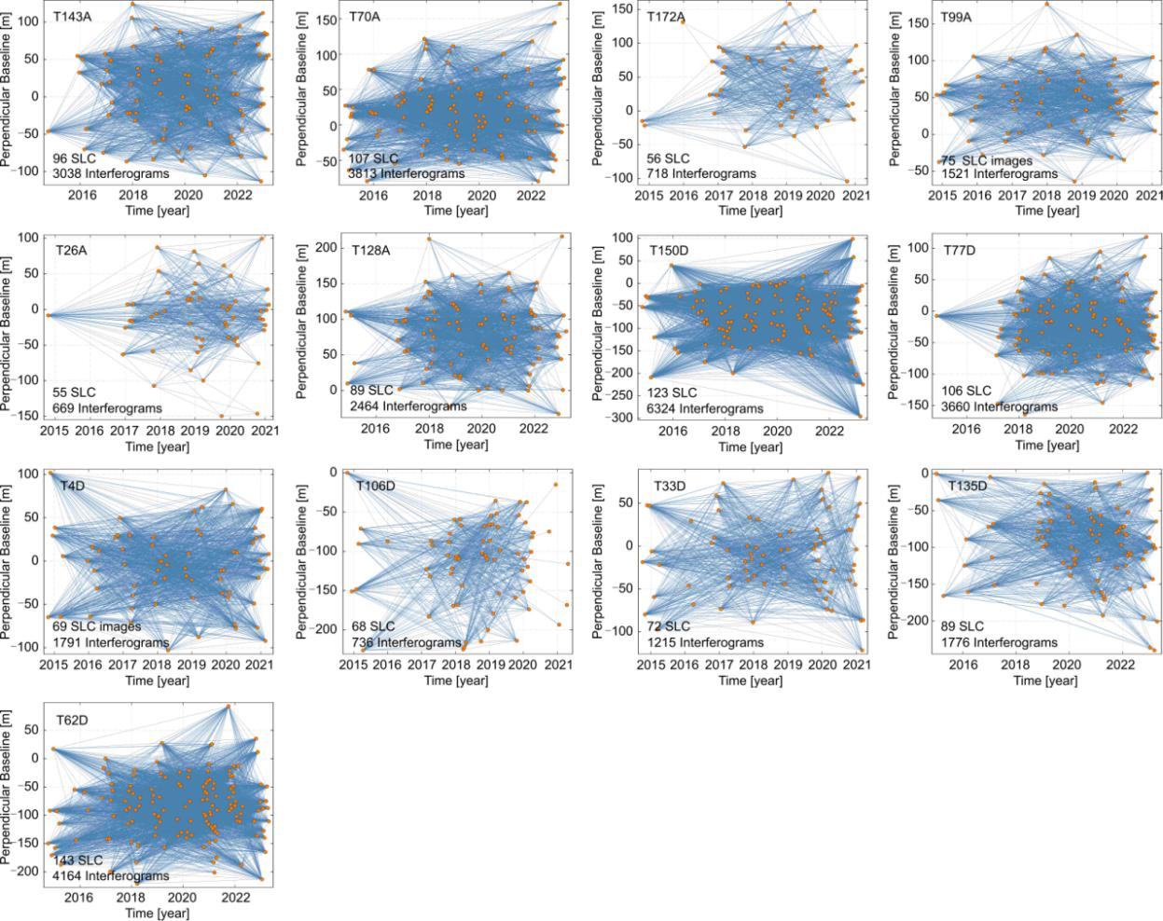
Fig. S4. Spatiotemporal baselines of interferograms selected for MT-InSAR analysis.

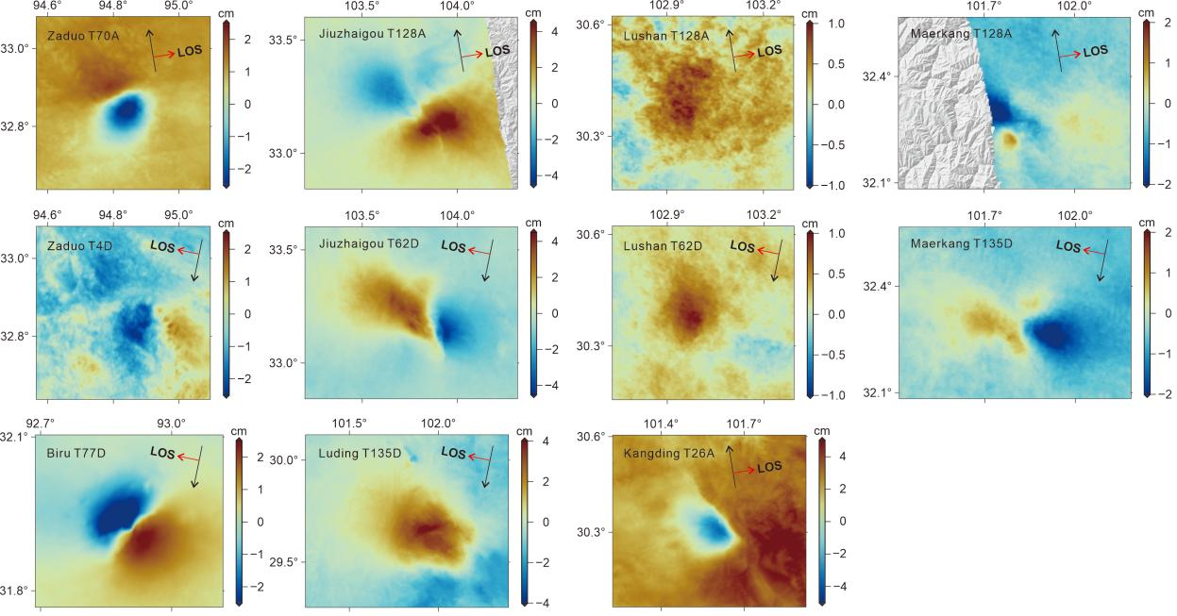
Fig. S5. Coseismic-related deformation from our signal decomposition along ascending (a-f) and descending (g-m) tracks. It is the best fitting amplitude of a step-function centered on the coseismic time.

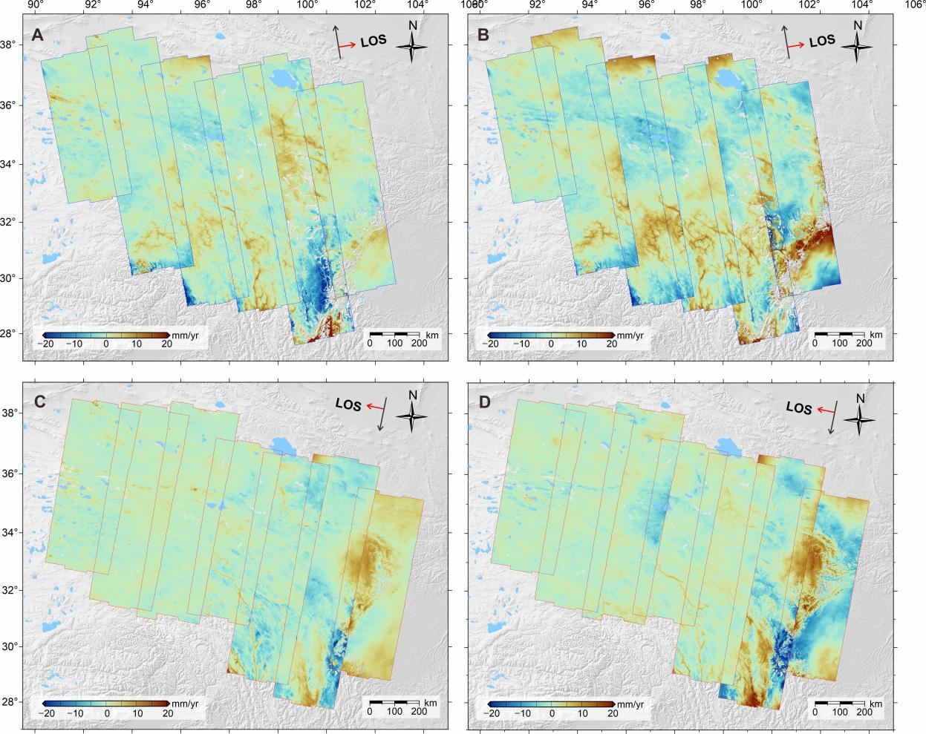
Fig. S6. Amplitude of the seasonal signal extracted from time series analysis. a sine components of ascending tracks, b cosine components of ascending tracks, c sine components of descending tracks, d cosine components of descending tracks.

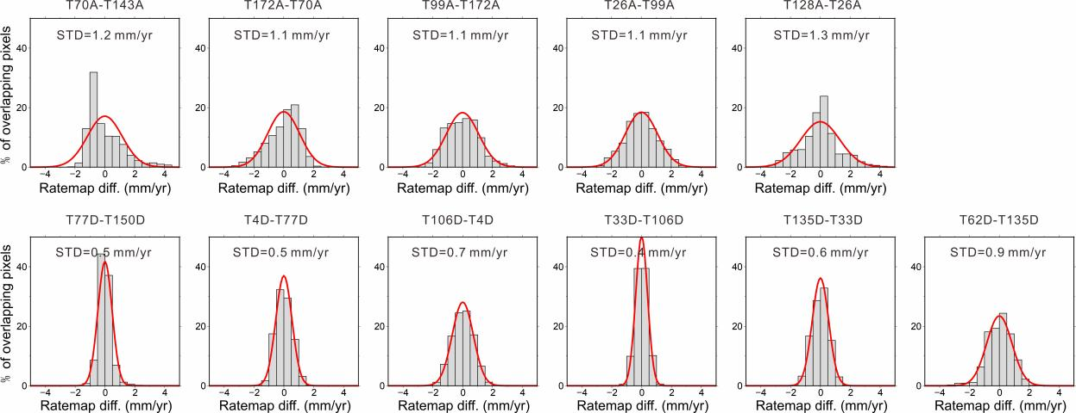
Fig. S7. Histograms of velocity differences in overlapping areas between adjacent tracks. Red curves represent the best-fitting Gaussian distributions.

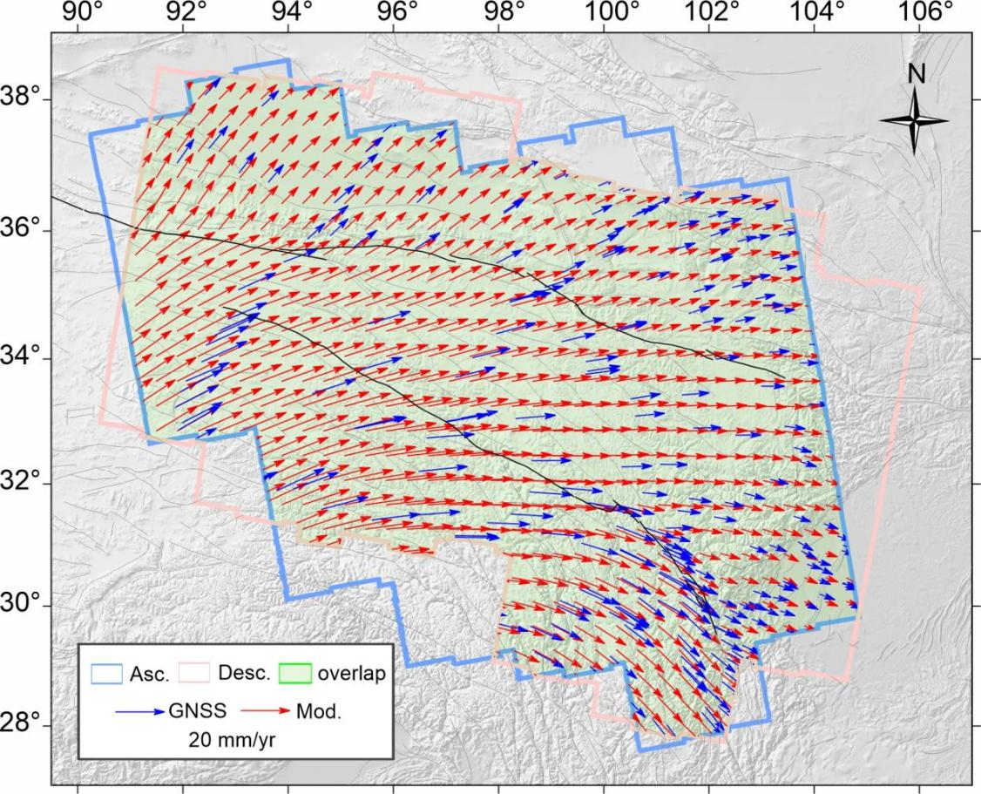
Fig. S8. Comparison of the GNSS velocity (blue vectors) and the integrated horizontal velocity field (red vectors).

Event name | Epicenter |  | Date | Mgnitude | Affected Tracks
Event name | Lon. | Lat. | Date | Mgnitude | Affected Tracks
Kanding | 101.78 | 30.24 | 20141122 | Mw 6.1 | T26A T135D
Zaduo | 94.95 | 32.79 | 20161017 | Mw6.0 | T70A T4D
Jiuzhaigou | 103.82 | 33.20 | 20170808 | Mw 7.0 | T128A T62D
Biru | 92.92 | 31.84 | 20210319 | Mw 5.8 | T77D
Maduo | 98.34 | 34.59 | 20210521 | Mw 7.4 | T172A T99A T26A T4D T106D T33D
Lushan | 103.06 | 30.34 | 20220601 | Mw 5.8 | T128A T62D
Maerkang | 101.86 | 32.23 | 20220609 | Mw 5.9 | T26A T128A D135D
Luding | 102.24 | 29.50 | 20220905 | Mw 6.7 | T026A T135D
Table S1. Information of earthquakes > M5.8 during observation period and their affected tracks.

