Supplementary Information for

Long-Term Changes in Heatwave-Ozone Compound Events and Spatially Heterogeneous Ozone Associations across China
Zhihe Yuanª，Xiaoling Zhang^{a, b,*}, Xinying Qin^{a, b}, Yulu He^{a, c},
Yijia Yinª，Yong Chenª
ª Climate Change and Resource Utilization in Complex Terrain Regions Key Laboratory of Sichuan Province, School of Atmospheric Sciences, Chengdu University of Information Technology, Chengdu 610225, Sichuan, China
^{b} Chengdu Plain Urban Meteorology and Environment Observation and Research Station of Sichuan Province/Sichuan Provincial Engineering Research Center for Meteorological Disaster Prediction and Early Warning, Chengdu 610225, Sichuan, China
^{c} Leipzig Institute for Meteorology, Leipzig University, Leipzig 04103, Germany
*Corresponding author.
E-mail address: xlzhang@ium.cn (X. Zhang)

Supplementary Table S1. Administrative composition of the six urban agglomerations and their corresponding geographical divisions used in this study.
Urban agglomeration | Abbreviation | Provinces/Cities included | Geographical division
Beijing-Tianjin-Hebei | BTH | Beijing, Tianjin, Hebei | NC
Central China | CEN | Henan, Hubei | CC
Eastern China | EST | Shandong, Shanghai, Jiangsu, Anhui, Zhejiang | EC
Northeast China Plain | NEP | Liaoning, Jilin | NE
Pearl River Delta | PRD | Guangzhou, Shenzhen, Zhuhai, Foshan, Dongguan, Zhongshan, Huizhou, Jiangmen, Zhaoqing | SC
Sichuan Basin | SCB | Chongqing, Chengdu, Deyang, Mianyang, Suining, Meishan, Ziyang, Neijiang, Zigong, Luzhou, Yibin, Nanchong, Guang'an, Dazhou, Bazhong, Ya'an, Guangyuan, Leshan | SWC

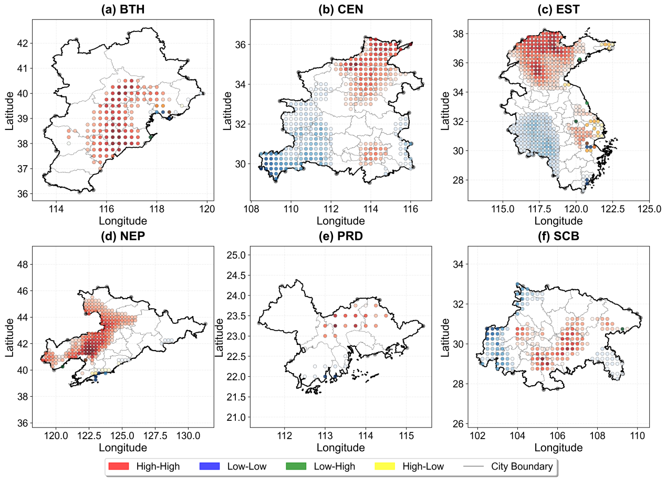

Supplementary Figure S1. Local spatial clustering patterns of O₃ concentrations in six major urban agglomerations in 2010.High-High (HH) clusters are predominantly concentrated in the southern plains of BTH, the Yangtze River Delta core area within EST, and the Guangzhou-Foshan metropolitan area in PRD. Low-Low (LL) clusters are primarily distributed in the western mountainous margins of SCB and the northern territories of NEP. HL and LH outliers occur only sporadically, occupying less than 5% of the total grid cells across most agglomerations.

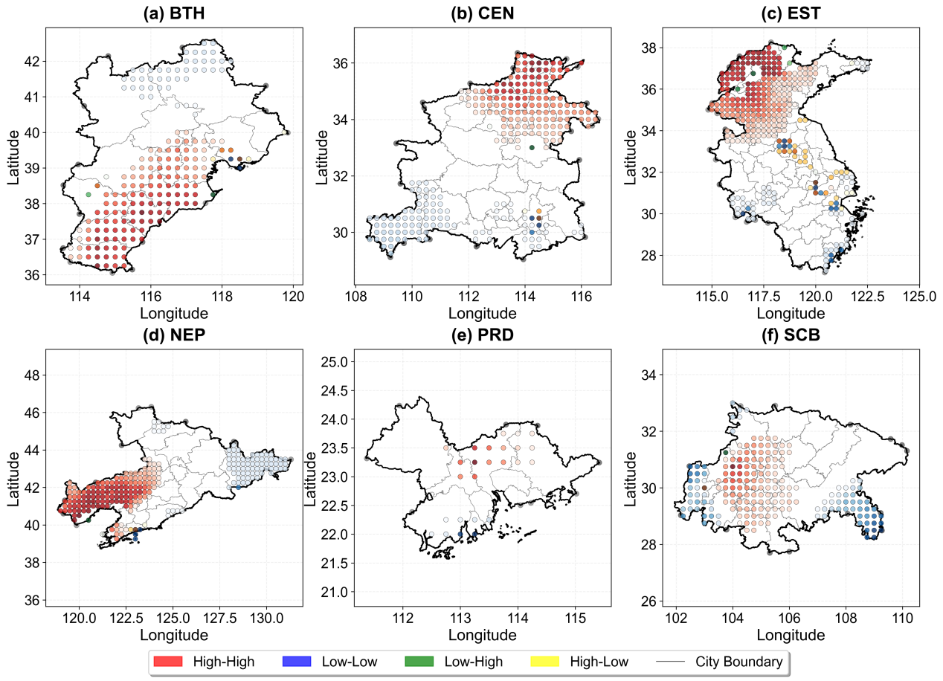

Supplementary Figure S2. Local spatial clustering patterns of O₃ concentrations in six major urban agglomerations in 2020. HH clusters in CEN form a continuous high-pollution corridor extending from Zhengzhou to Wuhan. HH clusters in EST extend across southern Shandong and northern Jiangsu. HH clusters in SCB are consolidated along the basin floor, while LL clusters persist along the western and eastern basin margins. The proportion of HH clusters exceeds 50% in most agglomerations.

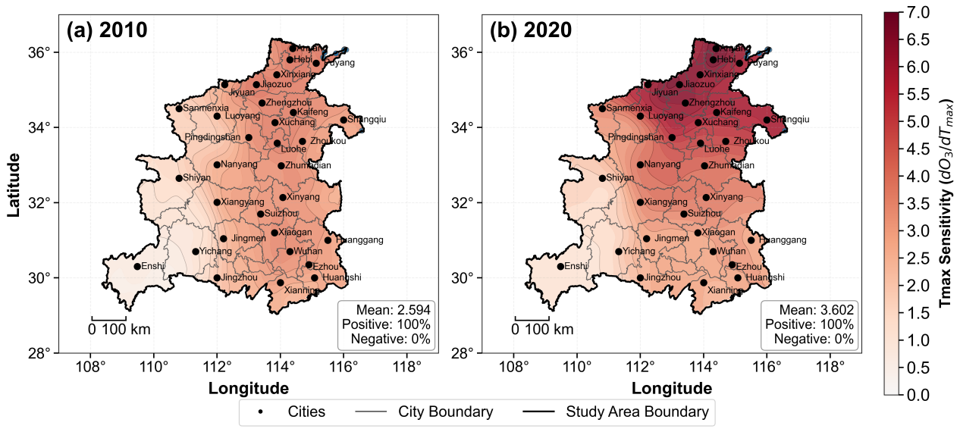

Supplementary Figure S3. Spatial distribution of Tmax sensitivity coefficients for ozone in Central China (CEN) in 2010 and 2020. The regional average sensitivity increases from 2.59 in 2010 to 3.60 in 2020. High-sensitivity zones (coefficients exceeding 3.0)

are concentrated around the Zhengzhou metropolitan area and northern Henan in 2010. By 2020, high-sensitivity zones expand to encompass the Zhengzhou-Kaifeng urban corridor, the Wuhan metropolitan area, and most of the North China Plain within CEN. Western

Hubei and the southwestern mountainous areas consistently exhibit lower sensitivity, with

coefficients below 2.0.

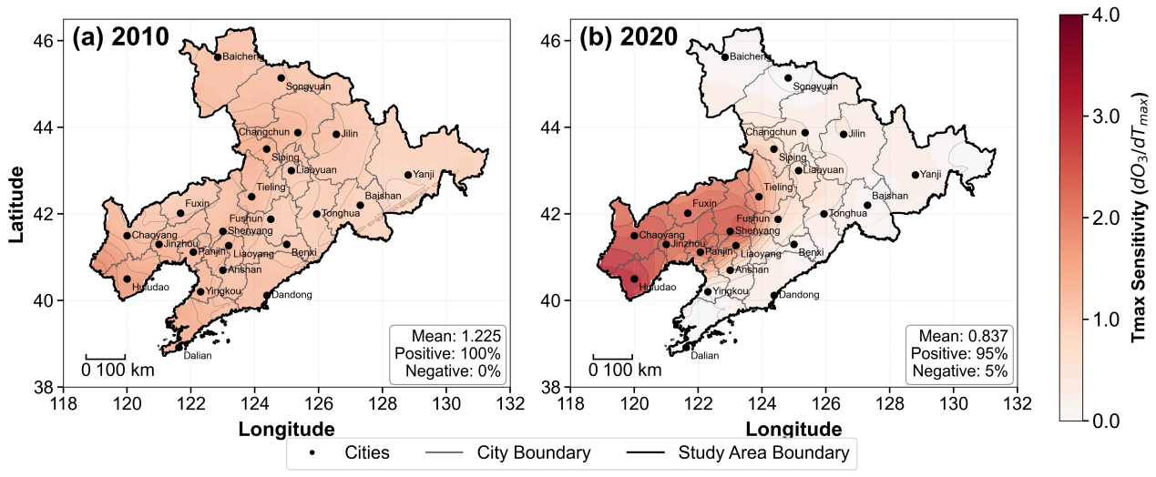
Supplementary Figure S4. Spatial distribution of Tmax sensitivity coefficients for ozone in Northeast China Plain (NEP) in 2010 and 2020. The regional average sensitivity decreases from 1.23 in 2010 to 0.84 in 2020. In 2010, high-sensitivity zones (coefficients exceeding 1.5) are mainly distributed in the central Liaoning urban belt, including Shenyang, Anshan, and the coastal areas around Dalian. By 2020, these zones contract considerably, with only southwestern Liaoning retaining relatively elevated sensitivity. Most grid cells in Jilin and Heilongjiang provinces exhibit coefficients below 0.5.

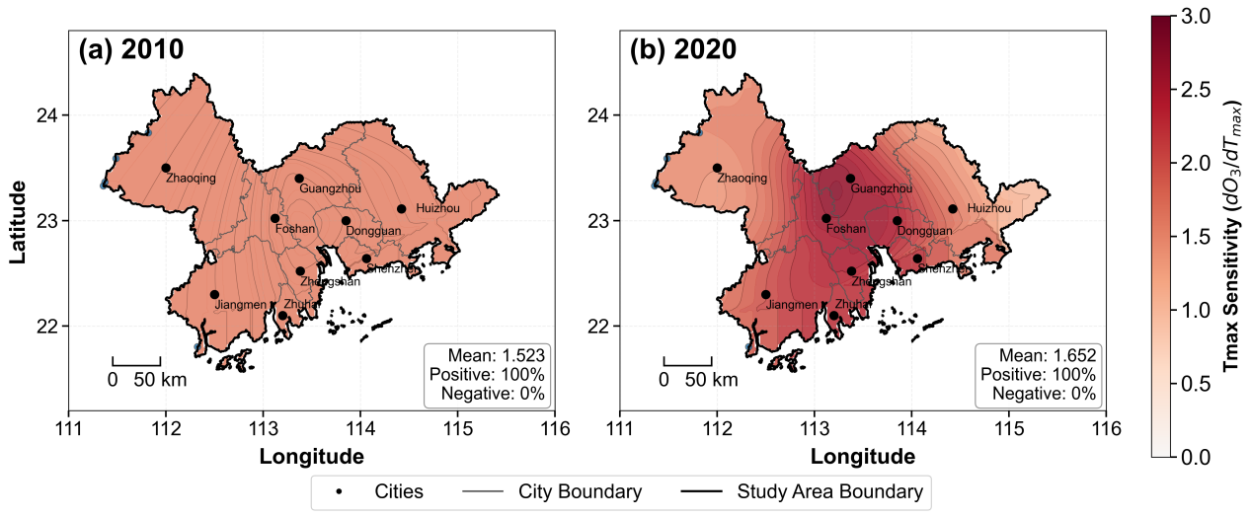
Supplementary Figure S5. Spatial distribution of Tmax sensitivity coefficients for ozone in the Pearl River Delta (PRD) in 2010 and 2020. The regional average sensitivity increases from 1.52 in 2010 to 1.65 in 2020. In 2010, the spatial distribution is relatively homogeneous, with coefficients predominantly ranging between 1.0 and 2.0. By 2020, a distinct high-sensitivity cluster emerges around the Guangzhou-Foshan metropolitan core, with coefficients exceeding 2.5. Coastal areas, including Zhuhai and Jiangmen, maintain lower sensitivity levels with coefficients below 1.5.

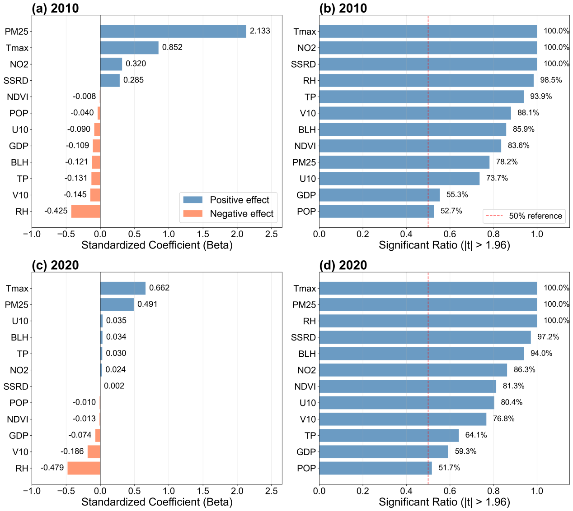
Supplementary Figure S6. Relative contributions of driving factors to ozone in Central China (CEN) based on MGWR.In 2010, PM_{2.5} exhibits the strongest positive effect (β=2.133, 100% significance), followed by Tmax (β=0.852, 100%) and NO₂ (β=0.320, 100%). In 2020, Tmax emerges as the primary positive driver (β=0.662, 100%), while PM_{2.5} (β=0.491, 100%) retains a substantial but reduced influence. SSRD increases to β=0.426 (100%). RH demonstrates the strongest inhibitory effect, with coefficients of β=-0.425 in 2010 and β=-0.479 in 2020.

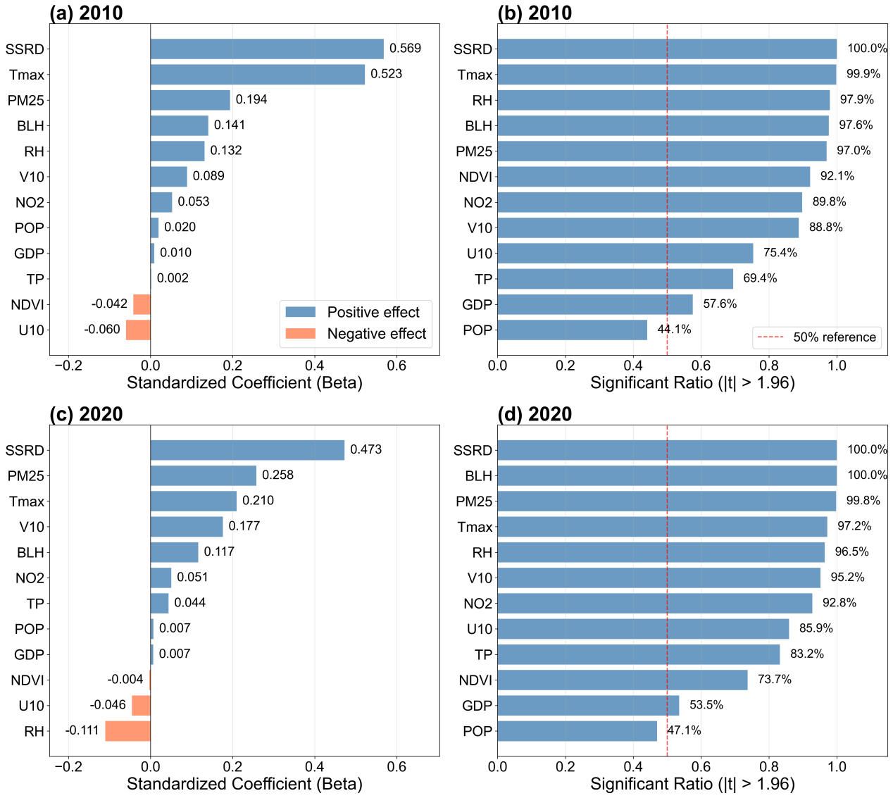
Supplementary Figure S7. Relative contributions of driving factors to ozone in Northeast China Plain (NEP) based on MGWR. In 2010, SSRD (β=0.569, 100% significance) and Tmax (β=0.523, 99.9%) are the dominant positive drivers. In 2020, SSRD (β=0.473, 99.8%) remains the most influential factor, while Tmax (β=0.210, 95.6%) exhibits weakened but persistent significance. PM_{2.5} demonstrates an increasing positive effect, with coefficients rising from β=0.182 (84% significance) in 2010 to β=0.258 (95% significance) in 2020. RH exhibits a modest negative effect (β=-0.111 in 2020). Socioeconomic variables, including POP and GDP, remain statistically insignificant across the majority of grid cells.

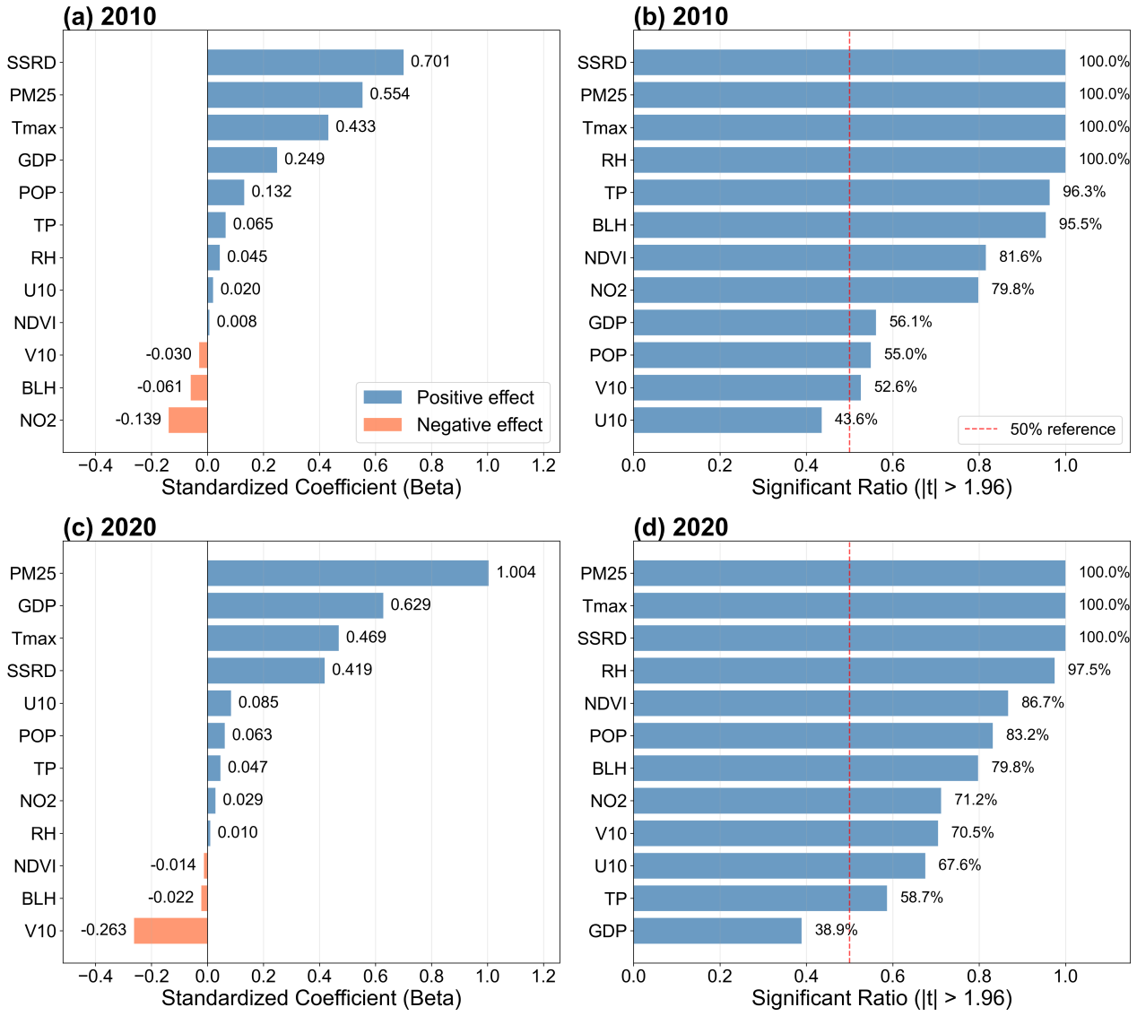
Supplementary Figure S8. Relative contributions of driving factors to ozone in the Pearl River Delta (PRD) based on MGWR. In 2010, SSRD (β=0.701, 100% significance) is the strongest positive driver, followed by PM_{2.5} (β=0.554, 100%) and Tmax (β=0.433, 100%). In 2020, PM_{2.5} (β=1.004, 100%) becomes the dominant factor, surpassing SSRD (β=0.419, 100%) and Tmax (β=0.469, 100%). GDP demonstrates a markedly enhanced contribution (β=0.629, 98% significance). V10 maintains a consistently negative effect (β=-0.263 in 2020).

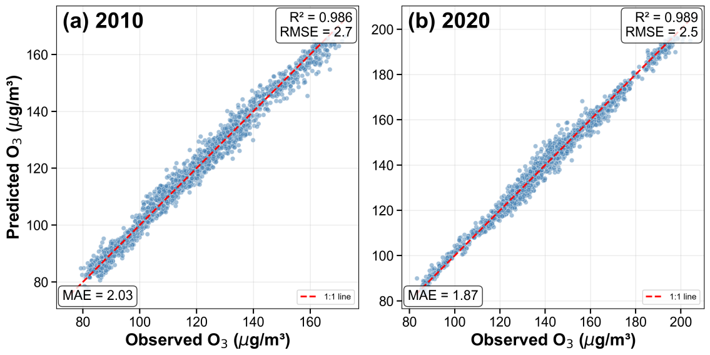
Supplementary Figure S9. MGWR model validation for ozone concentrations in BTH . Scatter plots of observed versus predicted MDA8 O₃ concentrations for 2010 (a) and 2020 (b). The coefficient of determination (R²) values are 0.986 for 2010 and 0.989 for 2020, with corresponding RMSE values of 2.7 μg/m³ and 2.5 μg/m³, and MAE values of 2.03 μg/m³ and 1.87 μg/m³.
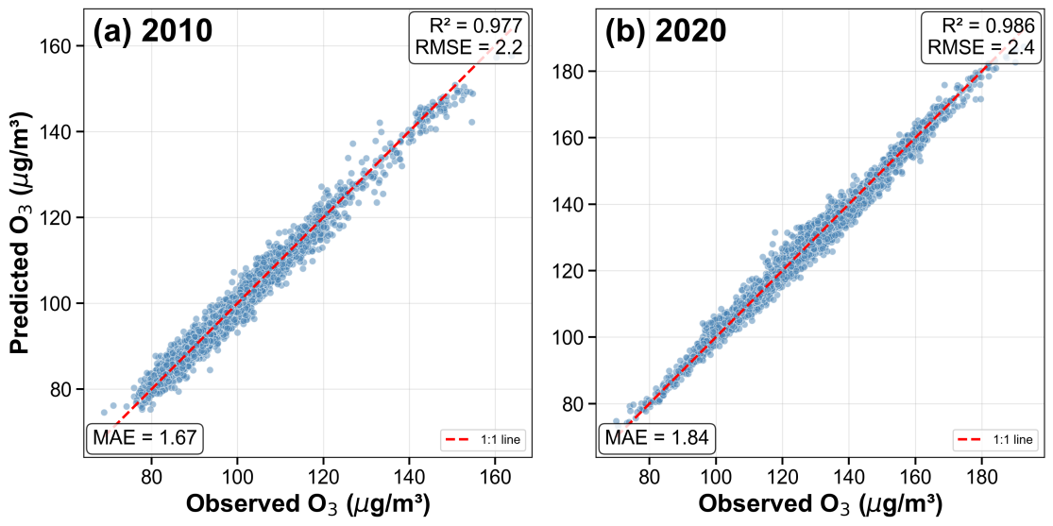
Supplementary Figure S10. MGWR model validation for ozone concentrations in CEN . Scatter plots of observed versus predicted MDA8 O₃ concentrations for 2010 (a) and 2020 (b). The model achieves R² values of 0.977 (2010) and 0.986 (2020), with RMSE values of 2.2 μg/m³ and 2.4 μg/m³, and MAE values of 1.67 μg/m³ and 1.84 μg/m³, respectively. These metrics confirm the robust predictive capability of the MGWR model for this region.
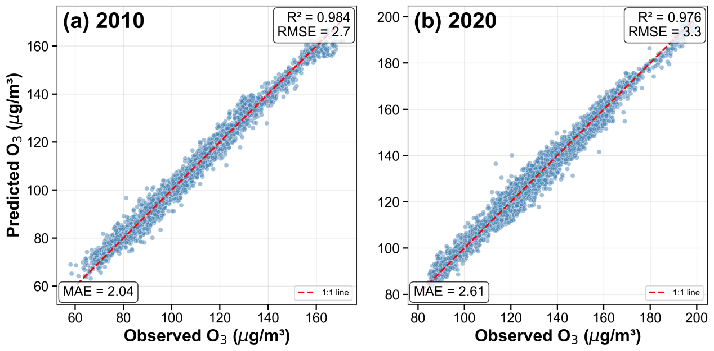
Supplementary Figure S11. MGWR model validation for ozone concentrations in EST . Scatter plots of observed versus predicted MDA8 O₃ concentrations for 2010 (a) and 2020 (b). The model achieves R² values of 0.984 (2010) and 0.976 (2020), with RMSE values of 2.7 μg/m³ and 3.3 μg/m³, and MAE values of 2.04 μg/m³ and 2.61 μg/m³, respectively. The strong alignment of data points along the 1:1 reference line confirms the excellent predictive performance of the MGWR model for this region.
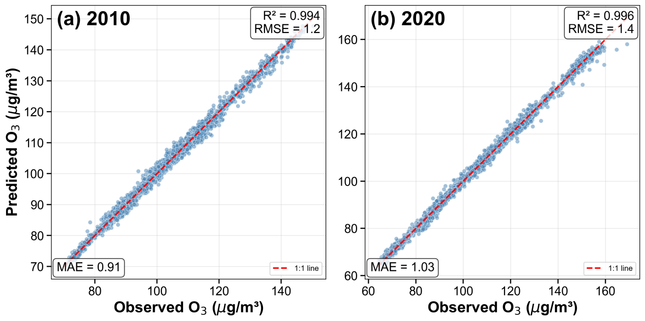
Supplementary Figure S12. MGWR model validation for ozone concentrations in NEP . Scatter plots of observed versus predicted MDA8 O₃ concentrations for 2010 (a) and 2020 (b). The model exhibits outstanding predictive accuracy, with R² values of 0.994 (2010) and 0.996 (2020), RMSE values of 1.2 μg/m³ and 1.4 μg/m³, and MAE values of 0.91 μg/m³ and 1.03 μg/m³. These results indicate near-perfect model fit.

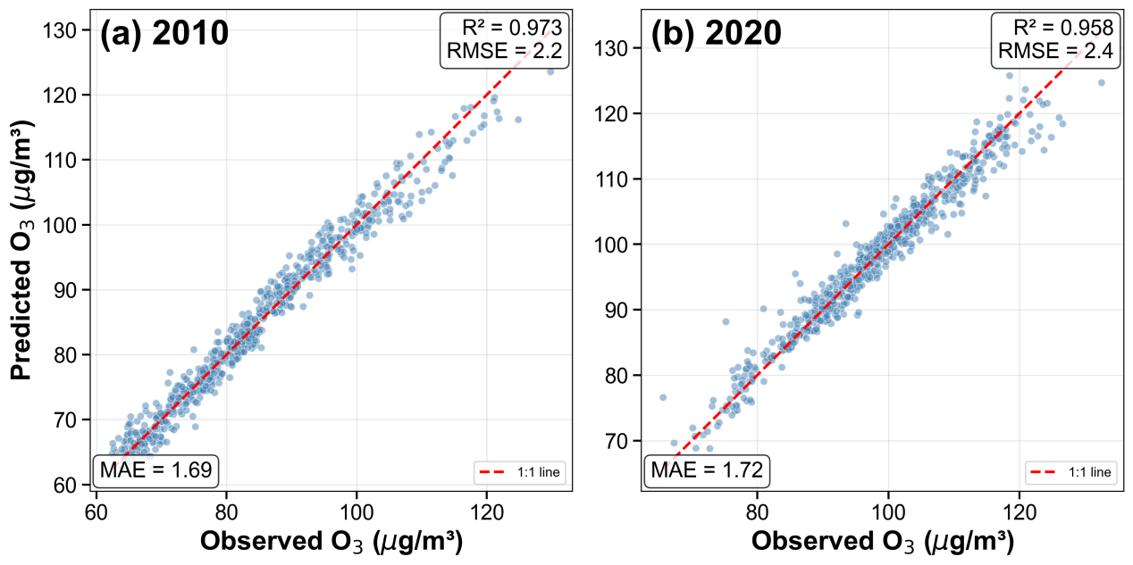
Supplementary Figure S13. MGWR model validation for ozone concentrations in PRD . Scatter plots of observed versus predicted MDA8 O₃ concentrations for 2010 (a) and 2020 (b). The R² values are 0.973 (2010) and 0.958 (2020), with RMSE values of 2.2 μg/m³ and 2.4 μg/m³, and MAE values of 1.69 μg/m³ and 1.72 μg/m³. The satisfactory performance confirms the model's applicability for this region.
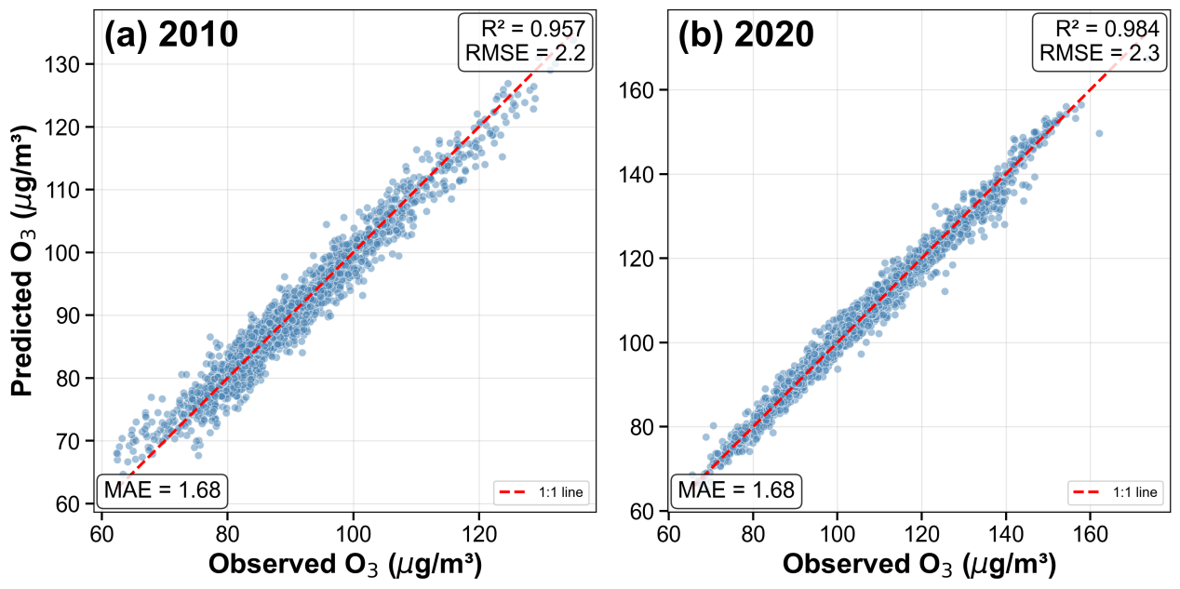
Supplementary Figure S14. MGWR model validation for ozone concentrations in SCB . Scatter plots of observed versus predicted MDA8 O₃ concentrations for 2010 (a) and 2020 (b). The R² values are 0.957 (2010) and 0.984 (2020), with RMSE of 2.2 μg/m³ and 2.3 μg/m³, and MAE of 1.68 μg/m³ for both years. The strong alignment of data points along the 1:1 line confirms the reliability of the MGWR approach for ozone prediction in this basin region.

