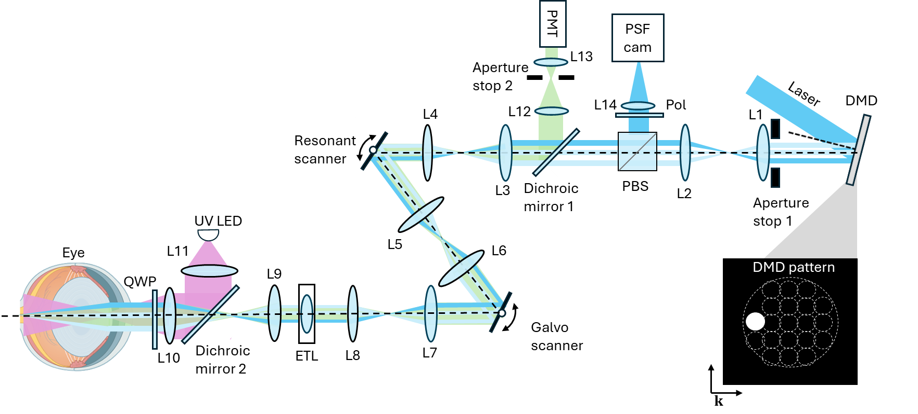
Figure S1 Schematic of PI-SLO system.

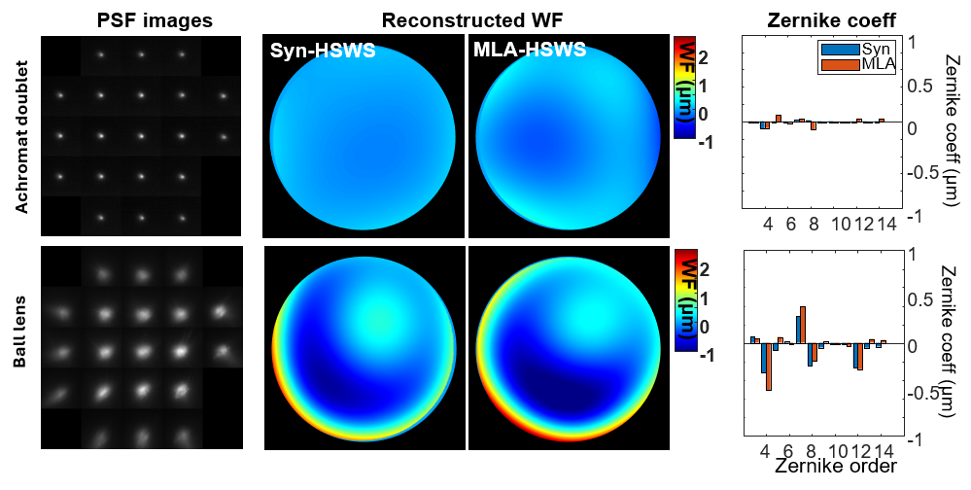

Figure S2 Validation of synthetic Hartmann-Shack wavefront sensing measurement. Wavefront validation of the syn-HSWS using an achromatic doublet (top) and a ball lens (bottom). Left, spotgrams acquired with the syn-HSWS. Middle, reconstructed wavefronts measured by the syn-HSWS and a conventional microlens array (MLA)-based Shack–Hartmann wavefront sensor (SHWFS). Right, comparison of the corresponding Zernike coefficients measured by the syn-HSWS (blue) and the MLA-based SHWFS (red). The achromatic doublet exhibits only minor aberrations, whereas the ball lens exhibits pronounced spherical aberration and coma, demonstrating close agreement between the two wavefront sensing methods over both low- and high-aberration conditions.

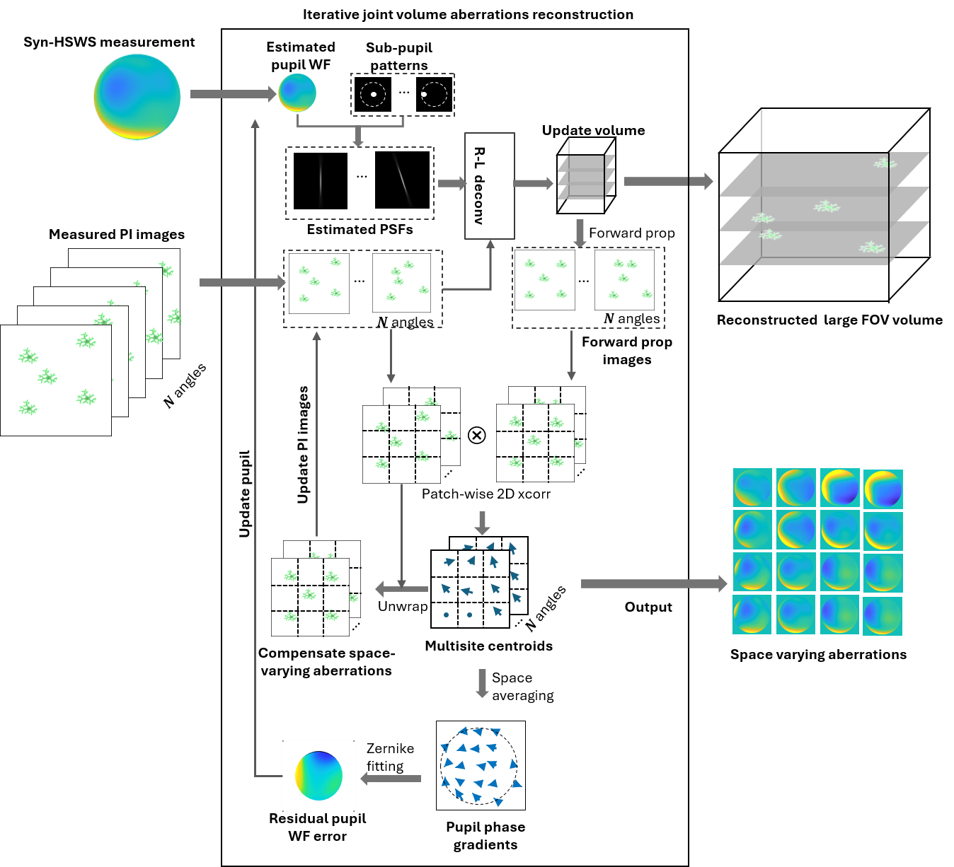

Figure S3 Illustration of 3D reconstruction routine

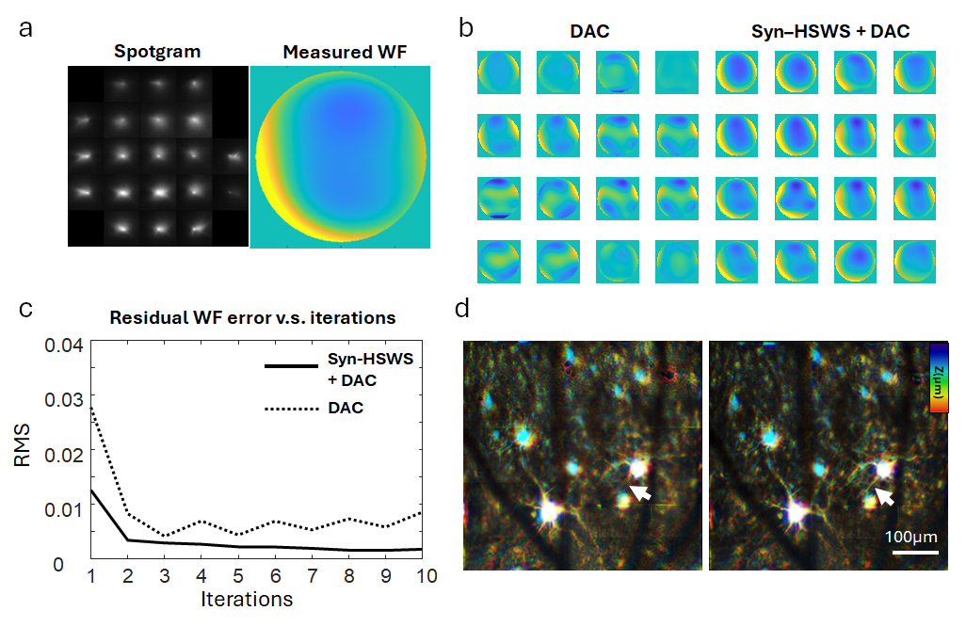
Figure S4 Validation of syn-HSWS in living mouse retina. a, Spotgram of the syn-HSWS and the reconstructed wavefront measured from a living mouse eye. b, Estimated space-varying aberrations across a 15° × 15° FOV without (left) and with (right) syn-HSWS measurements as a prior. c, Residual estimated wavefront (WF) error as a function of reconstruction iteration. Syn-HSWS initialization resulted in a lower root-mean-square (RMS) error at the first iteration and converged to a smaller residual error throughout the reconstruction compared with reconstruction without a prior. d, Depth color-coded reconstructed volume of GCaMP6s-expressing retinal neurons in a living mouse without and with syn-HSWS initialization. The arrow indicates a representative dendritic arbor that was recovered with syn-HSWS initialization but was not resolved without the prior.

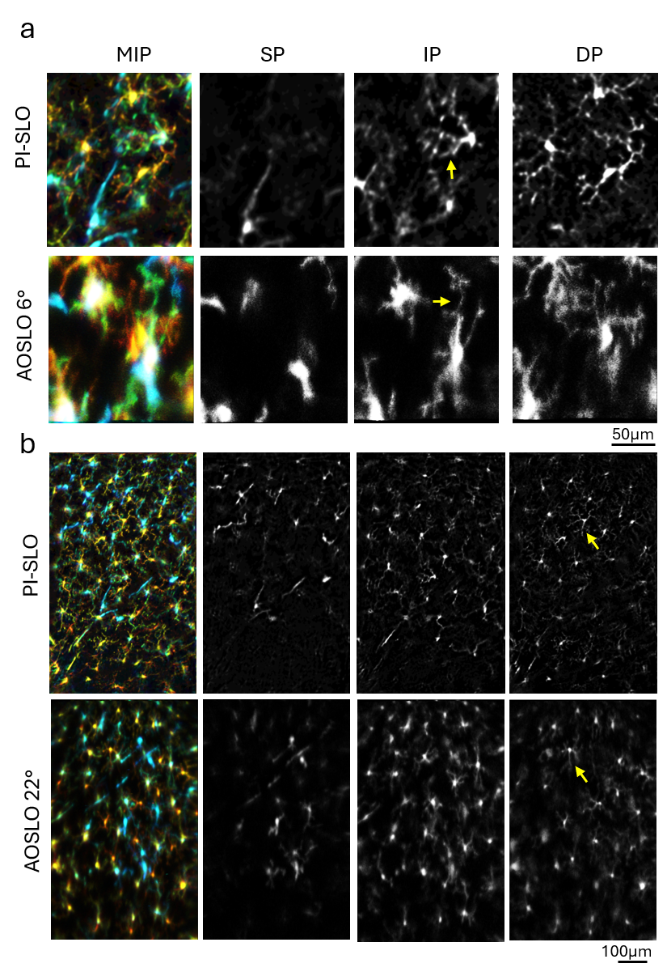
Figure S5 Comparison of GFP-expressing resident immune cells imaged with PI-SLO and AOSLO under 6° (a) and 22° FOVs (b). Under the 6° FOV, AOSLO resolved microglial processes with sharper and thinner profiles than PI-SLO. Under the 22° FOV, the AOSLO image became severely blurred and degraded toward the peripheral region, whereas PI-SLO maintained relatively uniform image quality across the field. Representative structures are indicated by yellow arrows.

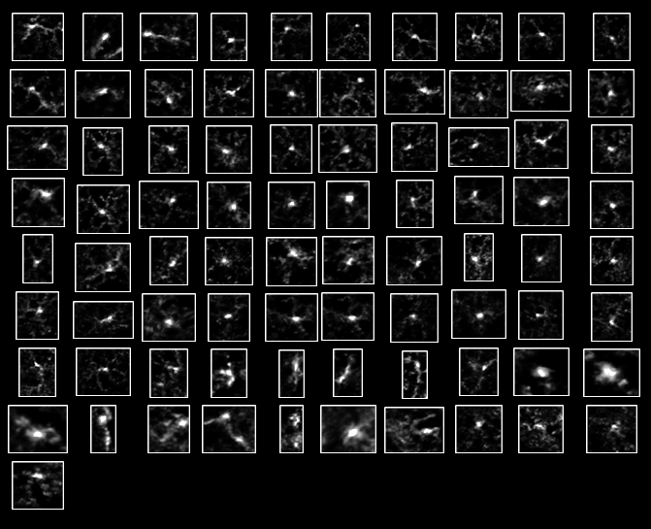

Figure S6 Manually selected ROIs of 91 single resident immune cells.
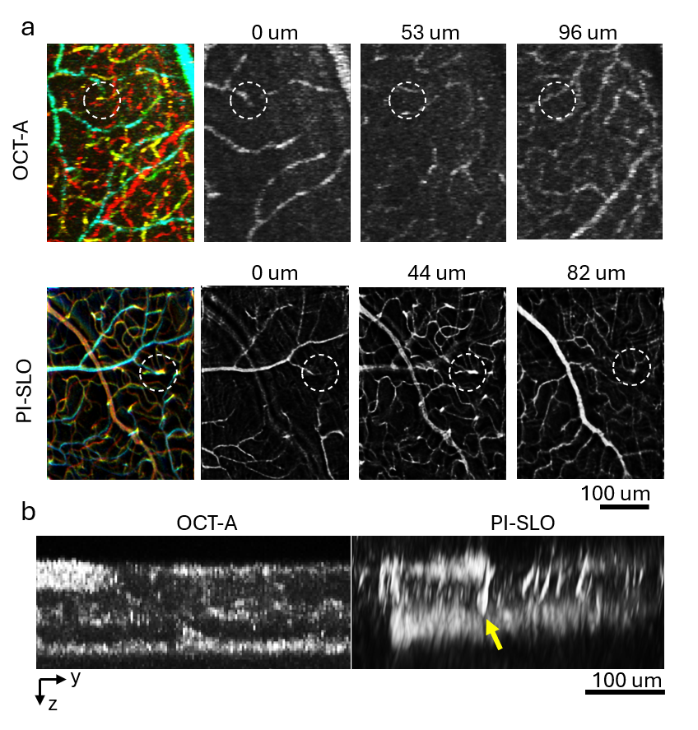
Figure S7 Comparison of retinal vascular network imaging using OCT-A and PI-SLO. a, Mouse retinal vascular network imaged with OCT-A and PI-SLO. The circle highlights a diving vessel, which appears as a discontinuity in the OCT-A (Top) image but is continuously resolved by PI-SLO (Bottom). b, Sideview profile of the 3D vascular networks in the two modalities, yellow arrow highlights the axial profile of a diving vessel.
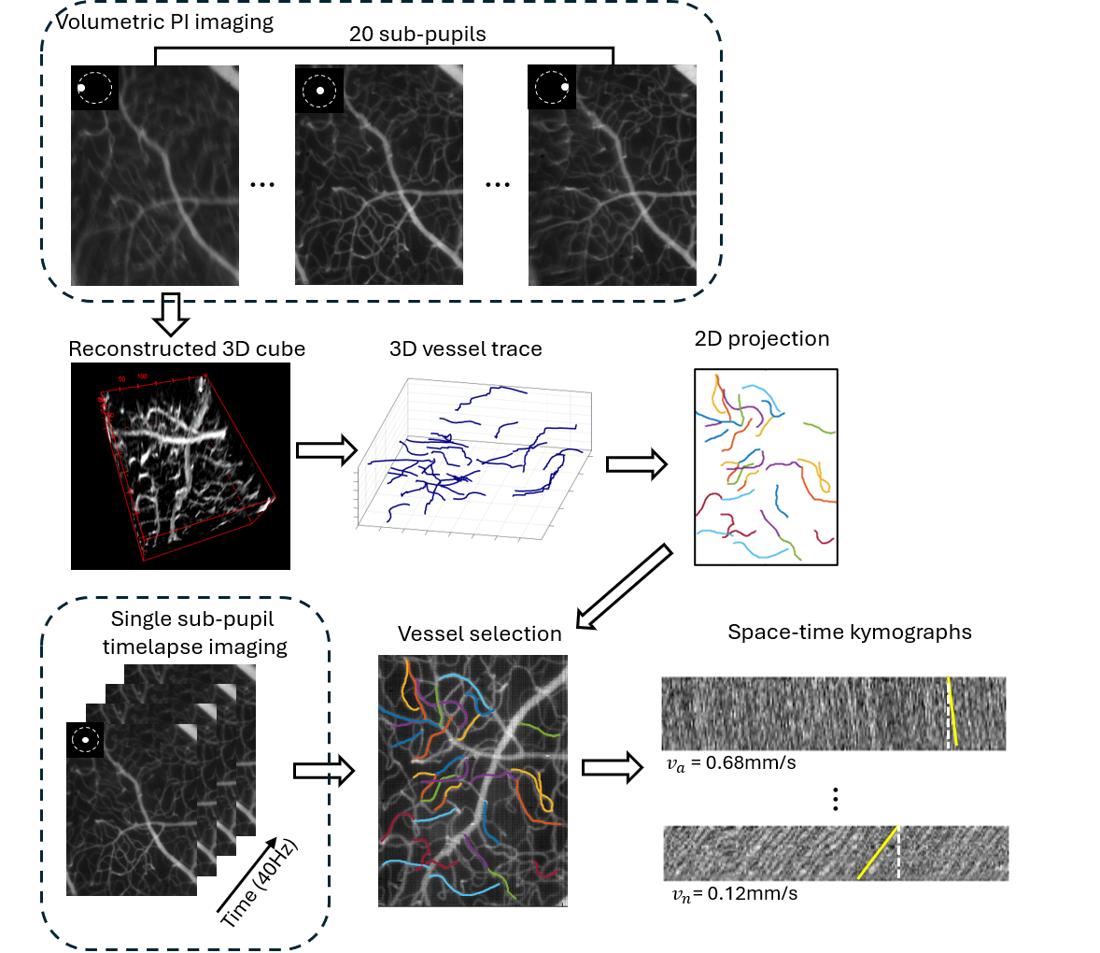

Figure S8 Routine to measure 3D blood flow velocity using PI-SLO.

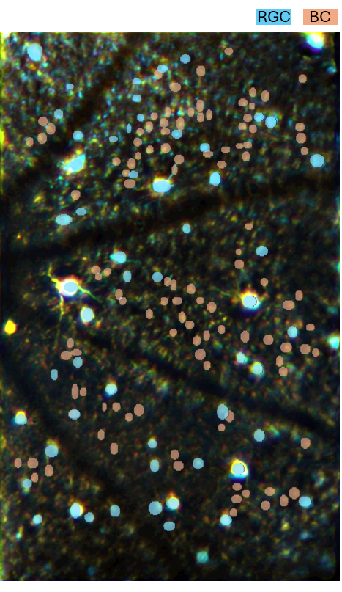
Figure S9 Manual cell segmentation mask for calcium fluorescent signal extraction

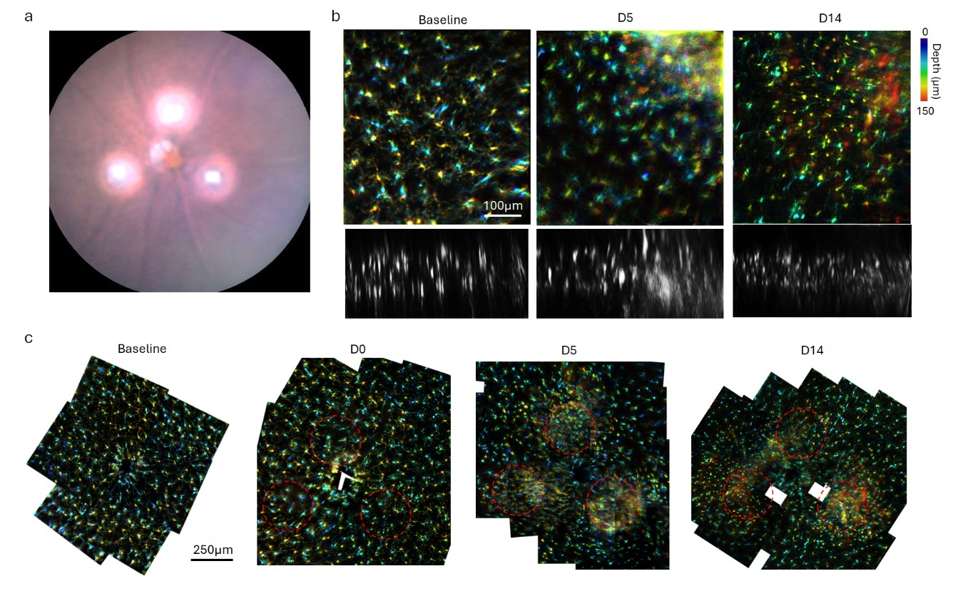
Figure S10 Longitudinal imaging of retinal immune responses following laser ablation. a, Widefield fundus image of the mouse retina showing the locations of three laser-induced ablation sites. b, Maximum intensity projections (MIPs) of longitudinal 3D PI-SLO imaging of GFP-expressing CX3CR1-positive retinal immune cells acquired from approximately the same field of view at baseline, 5 days (D5), and 14 days (D14) after laser injury. At baseline, resident immune cells exhibit a ramified morphology across the three retinal layers. By D5 and D14, activated immune cells accumulate around the lesion sites, accompanied by strong fluorescence signals extending into the deeper retinal layers. c, Montage of depth color-coded MIPs from the same retinal region at each time point, illustrating the spatiotemporal progression of the immune response following laser ablation.

