Supplementary material
Journal: Irrigation Science
Article: Beyond SAR: evaluating CROSS for predicting soil structural stability under recycled water irrigation
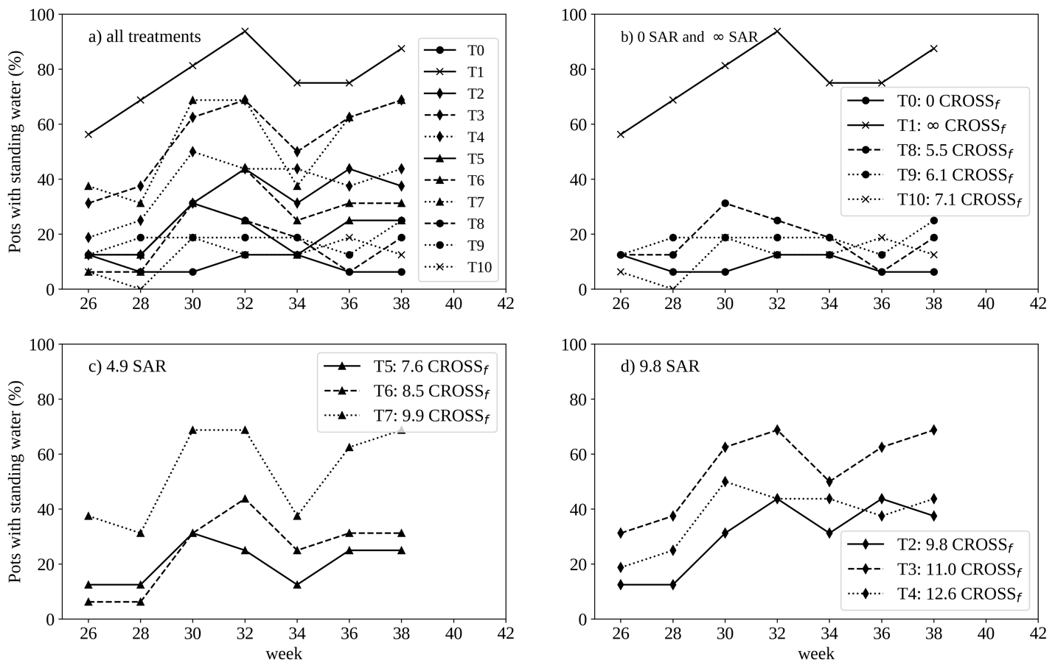

Online Resource 1
Temporal evolution of the percentage of pots with standing water measured before irrigation events during weeks 26-38 of the greenhouse experiment. Panels show (a) all treatments, (b) 0-SAR treatments and T1, (c) treatments with SAR = 4.9 and (d) treatments with SAR = 9.8.
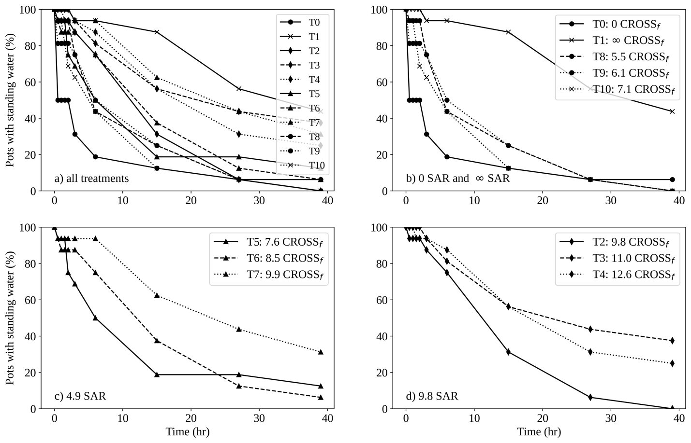

Online Resource 2
Temporal evolution of standing water occurrence during the 39-h drainage period after irrigation termination. Panels show (a) all treatments, (b) 0-SAR treatments and T1, (c) treatments with SAR = 4.9 and (d) treatments with SAR = 9.8.

