Supplementary Materials
Dynamic functional-connectivity graph-theory analysis of IGD versus HC
Table S1. Geometric-elbow diagnostics across candidate state numbers (K = 2–10)
K | Full-window inertia | 40-s median distance | 60-s median distance | 80-s median distance | Elbow frequency, 40/60/80 s | Aggregate result
2 | 17,011,740 | 0.000 | 0.000 | 0.000 | 0.0/0.0/0.0%
3 | 16,086,555 | 0.222 | 0.223 | 0.202 | 9.3/8.0/15.3%
4 | 15,699,764 | 0.299 | 0.294 | 0.223 | 54.7/66.7/45.3% | Median elbow
5 | 15,516,519 | 0.251 | 0.250 | 0.190 | 30.7/22.0/17.3% | Best curve: 40/80 s
6 | 15,189,798 | 0.213 | 0.208 | 0.151 | 2.7/3.3/14.7%
7 | 15,038,768 | 0.174 | 0.160 | 0.101 | 2.7/0.0/4.7%
8 | 14,925,136 | 0.114 | 0.113 | 0.054 | 0.0/0.0/2.7%
9 | 14,814,602 | 0.062 | 0.059 | 0.066 | 0.0/0.0/0.0%
10 | 14,739,773 | 0.000 | 0.000 | 0.000 | 0.0/0.0/0.0%
Note. The primary full-window analysis used 19,152 windows and 100 starts per K; the fixed maximum point-to-line distance selected K = 4. Sensitivity analyses used six temporally stratified windows per participant (684 windows) and 150 starts per K for each window length. Distances shown are from median-inertia curves, which selected K = 4 at 40, 60, and 80 s. K = 4 was modal across initialization-level elbows, although below 50% at 80 s; best-inertia curves selected K = 5 at 40 and 80 s. The 60-s sampled centroids matched full-window centroids at r = 0.988–0.993. Across 100 group-stratified split halves, median matched-centroid r was 0.894 (2.5th–97.5th percentile, 0.351–0.920), with 15/100 repetitions containing one r < 0.50. One 80-s centroid was unstable relative to 60 s (r = 0.373); all other cross-window matches were r = 0.950–0.989. K = 4 was retained as a literature-comparable resolution, not as uniquely optimal.
Figure S1. Geometric-elbow and K = 4 stability diagnostics
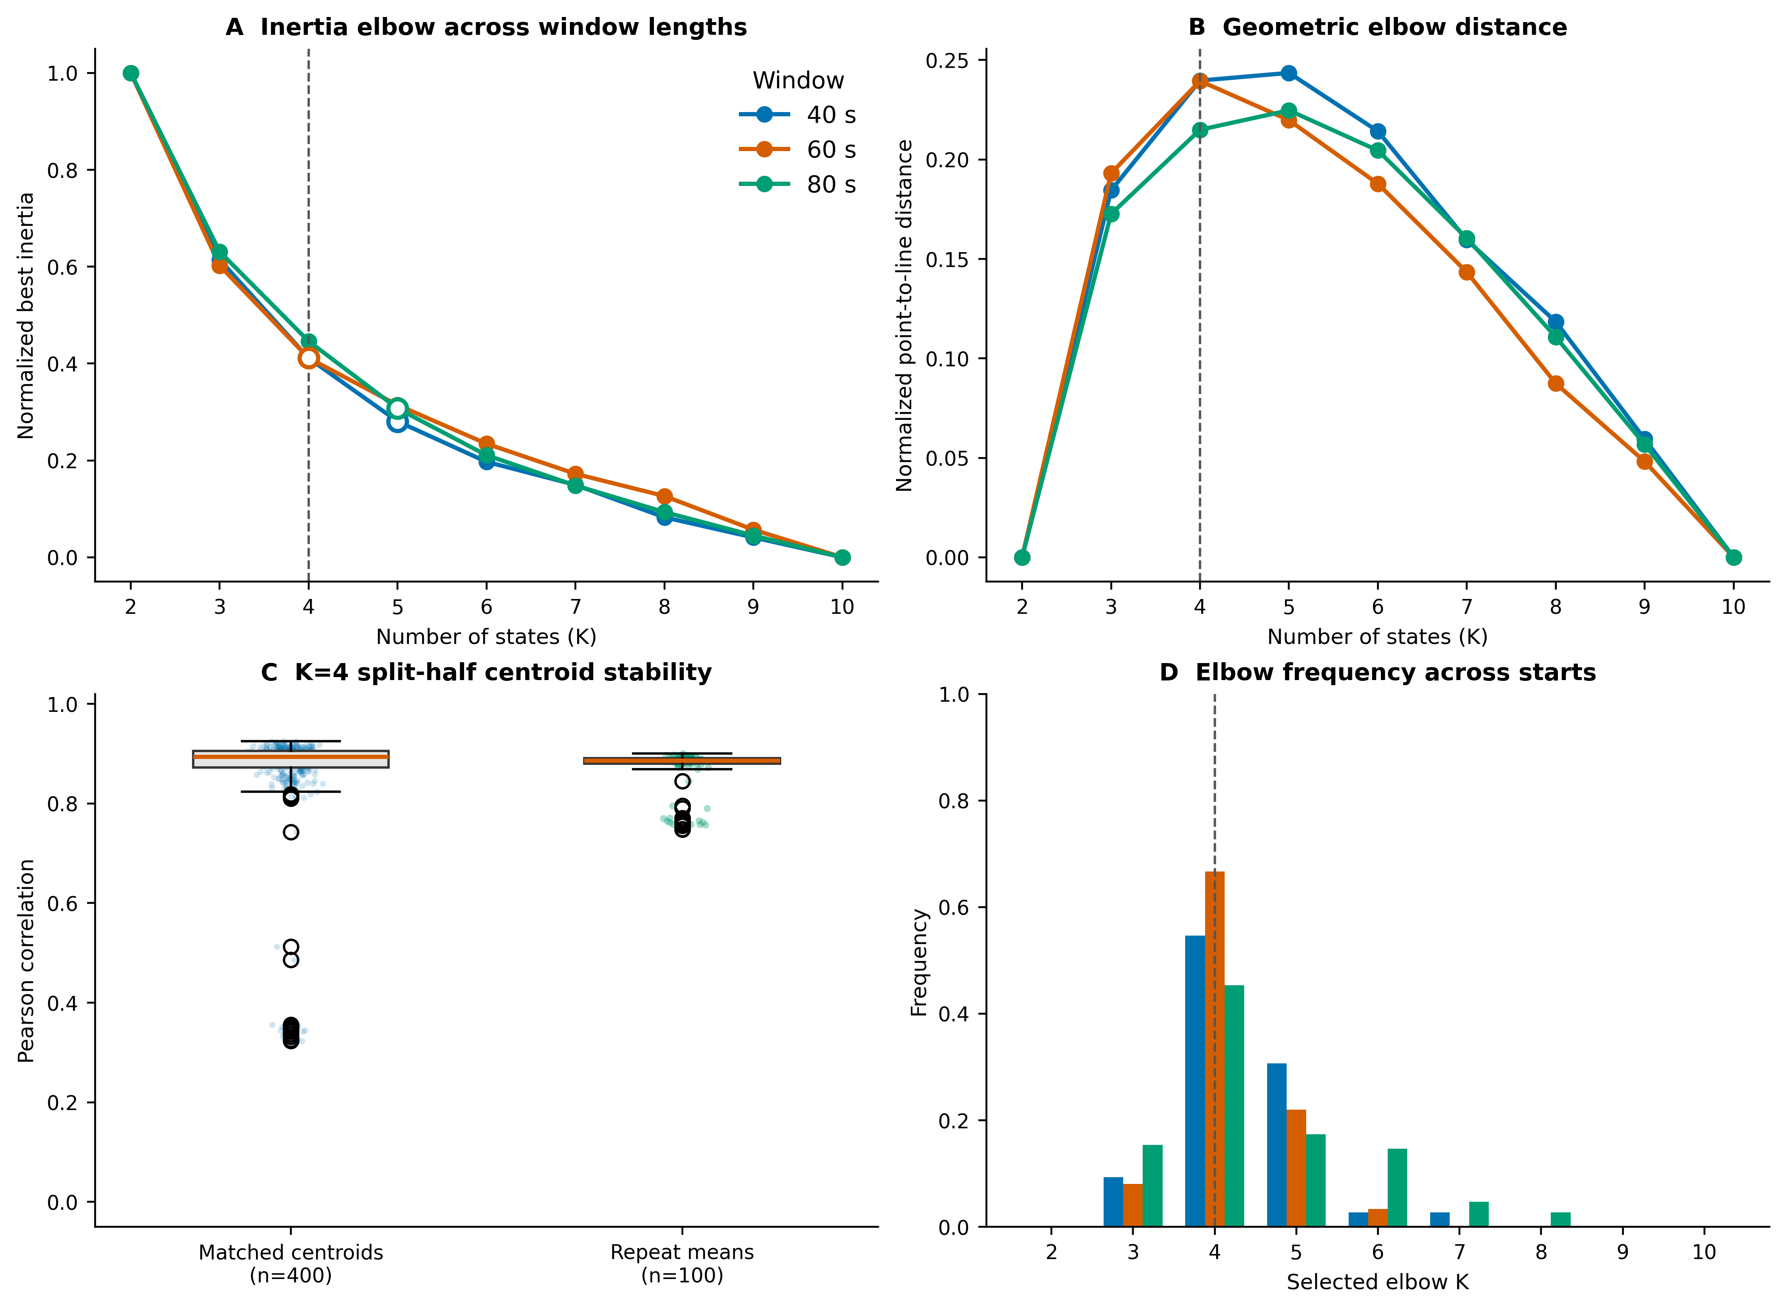
Caption. Panel A shows normalised best-inertia curves across 40-, 60-, and 80-s windows; open symbols mark the best-curve elbows. Panel B shows the corresponding normalised point-to-line distances. Panel C shows 400 matched centroid correlations and 100 repeat-mean correlations from group-stratified split halves at K = 4. Panel D shows elbow-selection frequencies across 150 matched initialization curves for each window length. Dashed vertical lines mark K = 4.
Table S2. State-specific analytic sample sizes and graph-feature availability
State | Complete global-graph cases | IGD IAT-SVR n | SVR predictor features
State 1 | 50 (22 HC / 28 IGD) | 28 | aCp, aEg, aEloc, aLp, aSigma
State 2 | 110 (52 HC / 58 IGD) | 58 | aCp, aEg, aEloc, aLp, aSigma
State 3 | 105 (53 HC / 52 IGD) | 52 | aCp, aEg, aEloc, aLp, aSigma
State 4 | 85 (40 HC / 45 IGD) | 45 | aCp, aEg, aEloc, aLp, aSigma
Note. Complete cases are participants expressing the state and having valid covariates and graph metrics; no missing state-by-participant cell was imputed. No minimum state-window count beyond state expression was imposed. IAT-SVR was restricted to IGD participants and used the five listed AUC-integrated global graph features.
Table S3. Non-State-4 global graph-theory statistics
State | Metric | HC, mean ± SD | IGD, mean ± SD | β (IGD − HC) | t | df | P | FDR q within state
1 | aCp | 0.210 ± 0.008 | 0.210 ± 0.006 | 0.0000 | 0.020 | 44 | 0.984 | 0.984
1 | aEg | 0.153 ± 0.013 | 0.148 ± 0.012 | -0.0045 | -1.216 | 44 | 0.230 | 0.604
1 | aEloc | 0.244 ± 0.013 | 0.242 ± 0.011 | -0.0021 | -0.604 | 44 | 0.549 | 0.641
1 | aLp | 1.076 ± 0.130 | 1.125 ± 0.120 | 0.0416 | 1.147 | 44 | 0.258 | 0.604
1 | aGamma | 0.462 ± 0.081 | 0.445 ± 0.051 | -0.0155 | -0.794 | 44 | 0.431 | 0.604
1 | aLambda | 0.388 ± 0.011 | 0.391 ± 0.013 | 0.0029 | 0.908 | 44 | 0.369 | 0.604
1 | aSigma | 0.439 ± 0.073 | 0.420 ± 0.045 | -0.0178 | -1.039 | 44 | 0.304 | 0.604
2 | aCp | 0.209 ± 0.008 | 0.209 ± 0.008 | 0.0000 | 0.019 | 104 | 0.985 | 0.985
2 | aEg | 0.178 ± 0.008 | 0.177 ± 0.010 | -0.0013 | -0.794 | 104 | 0.429 | 0.698
2 | aEloc | 0.259 ± 0.008 | 0.258 ± 0.008 | -0.0010 | -0.680 | 104 | 0.498 | 0.698
2 | aLp | 0.898 ± 0.069 | 0.913 ± 0.112 | 0.0190 | 1.061 | 104 | 0.291 | 0.684
2 | aGamma | 0.514 ± 0.073 | 0.502 ± 0.076 | -0.0157 | -1.076 | 104 | 0.284 | 0.684
2 | aLambda | 0.389 ± 0.009 | 0.389 ± 0.010 | -0.0004 | -0.222 | 104 | 0.825 | 0.962
2 | aSigma | 0.487 ± 0.066 | 0.475 ± 0.068 | -0.0140 | -1.056 | 104 | 0.293 | 0.684
3 | aCp | 0.194 ± 0.013 | 0.194 ± 0.011 | -0.0007 | -0.280 | 99 | 0.780 | 0.974
3 | aEg | 0.194 ± 0.006 | 0.194 ± 0.006 | 0.0000 | 0.032 | 99 | 0.974 | 0.974
3 | aEloc | 0.260 ± 0.007 | 0.260 ± 0.006 | -0.0004 | -0.270 | 99 | 0.788 | 0.974
3 | aLp | 0.795 ± 0.047 | 0.797 ± 0.049 | 0.0006 | 0.061 | 99 | 0.951 | 0.974
3 | aGamma | 0.607 ± 0.083 | 0.606 ± 0.077 | -0.0049 | -0.308 | 99 | 0.758 | 0.974
3 | aLambda | 0.388 ± 0.007 | 0.388 ± 0.006 | -0.0009 | -0.684 | 99 | 0.496 | 0.974
3 | aSigma | 0.573 ± 0.071 | 0.572 ± 0.071 | -0.0027 | -0.187 | 99 | 0.852 | 0.974
Note. AUC-integrated global metrics were tested with GLM: metric ~ group + sex + age + education + mean framewise displacement. The table reports FDR correction across seven metrics within each state. No metric in States 1–3 survived this correction. Under sensitivity correction across all 28 state-by-metric tests, State 4 aEloc, aGamma, and aSigma remained significant (all q = 0.026).
Figure S2. Non-State-4 global graph effects
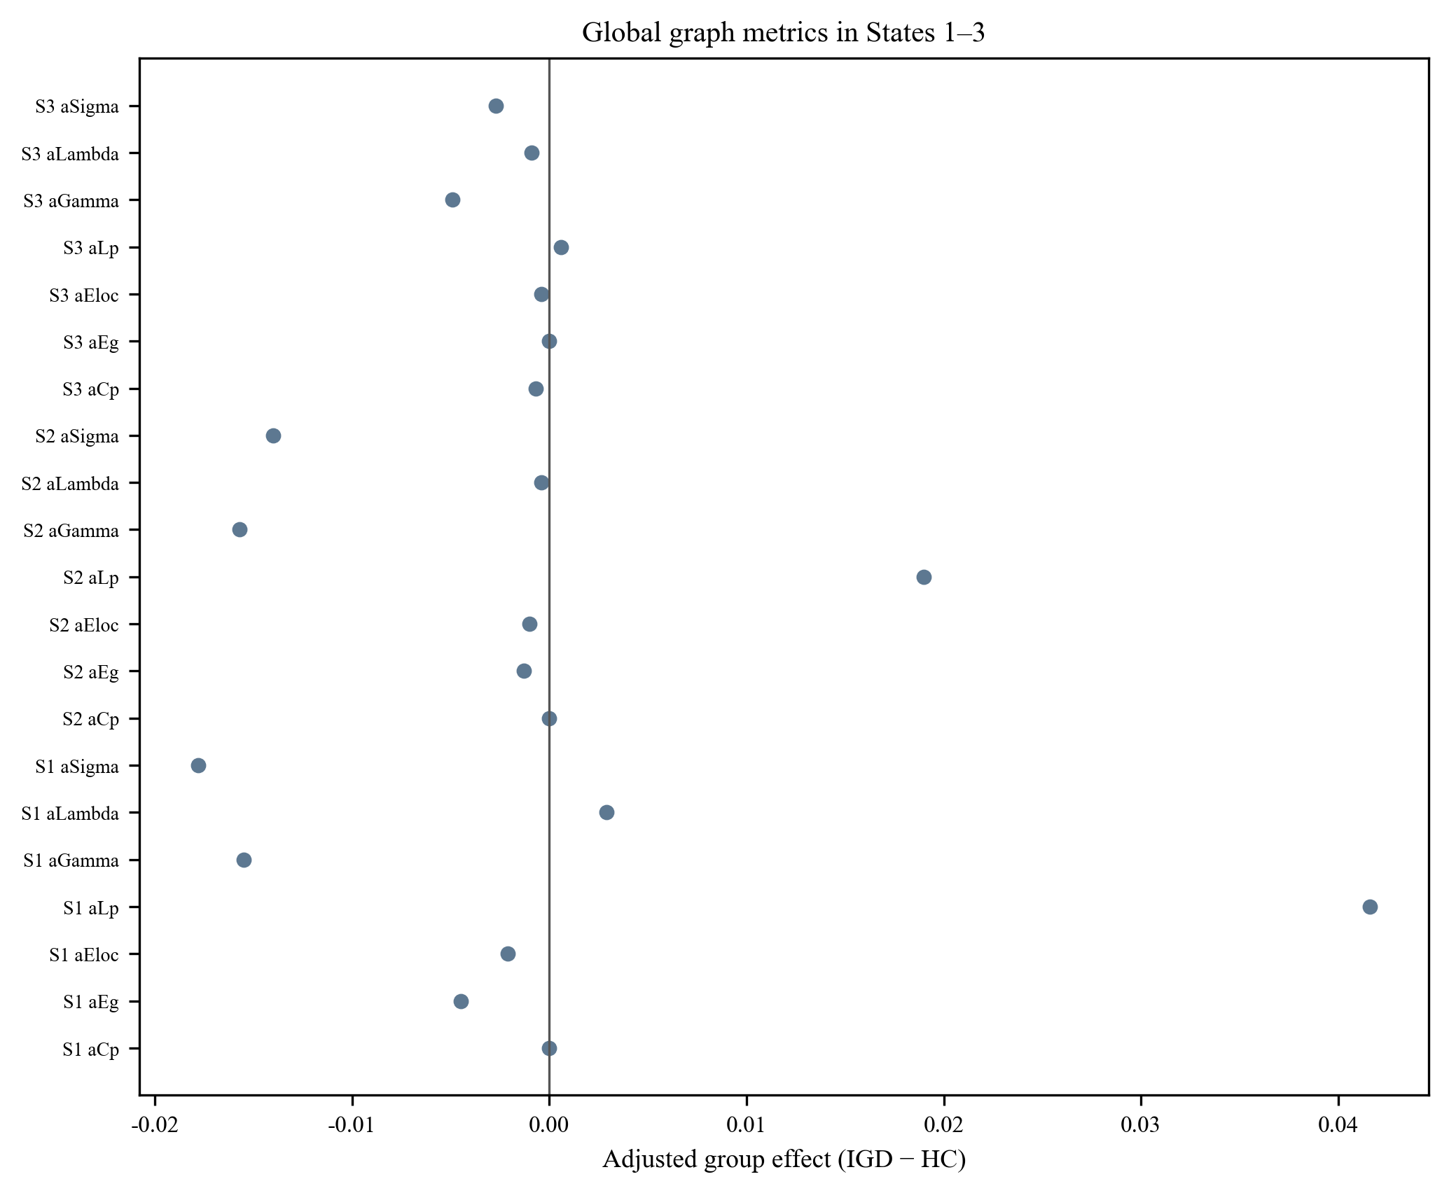
Caption. Adjusted global graph effects in States 1–3; corresponding State 4 estimates are reported in main Table 3.
Table S4. Nodal results under whole-analysis FDR correction
Scope | Metrics | Tests | Minimum P | Minimum BH-FDR q | Tests with q < 0.05
All four states | aNodalDegree and aNodalEfficiency | 1,280 | <0.001 | 0.223 | 0
Note. The prespecified nodal family comprised all tests across four states, two nodal measures, and 160 nodes (4 × 2 × 160 = 1,280). Benjamini–Hochberg FDR correction was applied once across the complete family; no nodal effect survived at q < 0.05.
Table S5. Primary and repeated nested-cross-validation IAT-SVR results
State | IGD n | LOOCV r | LOOCV Q² / MAE / RMSE | FL P | FDR q | Nested r, median [2.5–97.5%] | Nested Q², median [2.5–97.5%] | Nested MAE / RMSE, median
1 | 28 | 0.249 | −0.314 / 8.55 / 10.57 | 0.5579 | 0.5579 | 0.229 [0.019–0.355] | −0.339 [−0.893–0.015] | 8.58 / 10.66
2 | 58 | 0.559 | 0.265 / 7.94 / 9.77 | 0.0024 | 0.0096 | 0.538 [0.436–0.597] | 0.215 [−0.726–0.327] | 8.31 / 10.10
3 | 52 | 0.354 | 0.008 / 8.46 / 10.49 | 0.1510 | 0.2013 | 0.288 [0.089–0.415] | −0.042 [−0.303–0.141] | 8.62 / 10.75
4 | 45 | 0.566 | 0.310 / 7.49 / 9.40 | 0.0074 | 0.0148 | 0.581 [0.470–0.662] | 0.300 [0.134–0.423] | 7.48 / 9.47
Note. Linear SVR used aCp, aEg, aEloc, aLp, and aSigma. Covariate residualisation and scaling were fitted only within each training set. The primary model used fixed C = 1 and epsilon = 0.1 with leave-one-out cross-validation. FL P is the two-sided p value from 5,000 Freedman–Lane reduced-model residual permutations repeating the complete LOOCV pipeline; q is Benjamini–Hochberg FDR across four states. Nested validation comprised 100 repeated outer five-fold runs with inner four-fold selection of C and epsilon by RMSE. Brackets show the 2.5th–97.5th percentiles across repetitions. State 2 and State 4 survived primary FDR and had positive median nested Q²; the State 2 Q² interval nevertheless included negative values.
Figure S3. Repeated nested-cross-validation distributions across all states
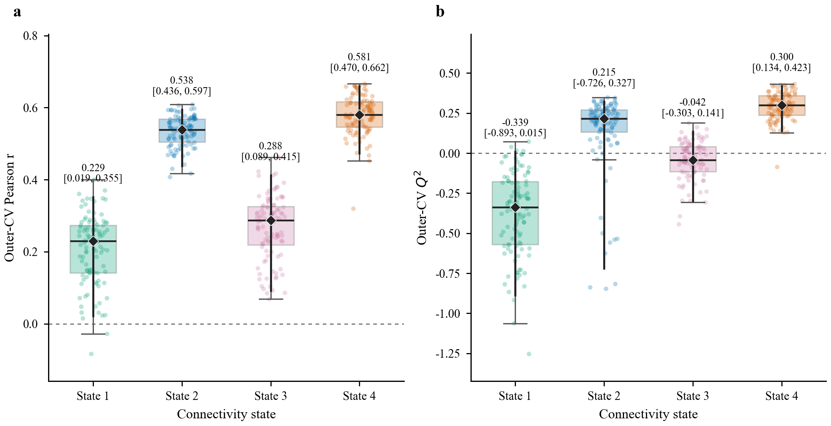
Table S6. IAT-SVR analysis specification and outcome definition
Item | Value | Scope | Details
Target variable | IAT total score (iat_score) | 58 IGD participants | Higher scores indicate greater symptom severity
Target provenance | Study-team final IAT file | SHA-256 | 826E3AC5BCFA47AE45B8CA3638E16E8E45AC0F10411163E51C2500AC99088085
Feature set | aCp, aEg, aEloc, aLp, aSigma | State-specific AUC graph metrics | aGamma and aLambda excluded
Fold-wise preprocessing | Covariate residualisation and standardisation | Every inner, outer, and LOOCV training set | Age, sex, education, and mean framewise displacement
Primary model | Linear SVR; fixed LOOCV | C = 1.0; epsilon = 0.1 | Pearson r, Q², MAE, and RMSE
Primary inference | Freedman–Lane residual permutation | 5,000 two-sided permutations | Complete fixed-parameter LOOCV pipeline repeated
Robustness validation | 100 repeated nested five-fold CV | Inner four-fold RMSE tuning | C = 0.01–100; epsilon = 0.01–2
Multiple comparison | Four state-level permutation p values | Benjamini–Hochberg FDR | State 2 q = 0.0096; State 4 q = 0.0148
Note. The same complete IAT outcome was used across all four state-specific models. State-specific sample sizes reflect state expression (States 1–4: n = 28, 58, 52, and 45). The nested grid was C = {0.01, 0.1, 1, 10, 100} and epsilon = {0.01, 0.1, 0.5, 1, 2}; inner-fold RMSE selected the parameters. Random seed was 20260720.

