Supplementary Material

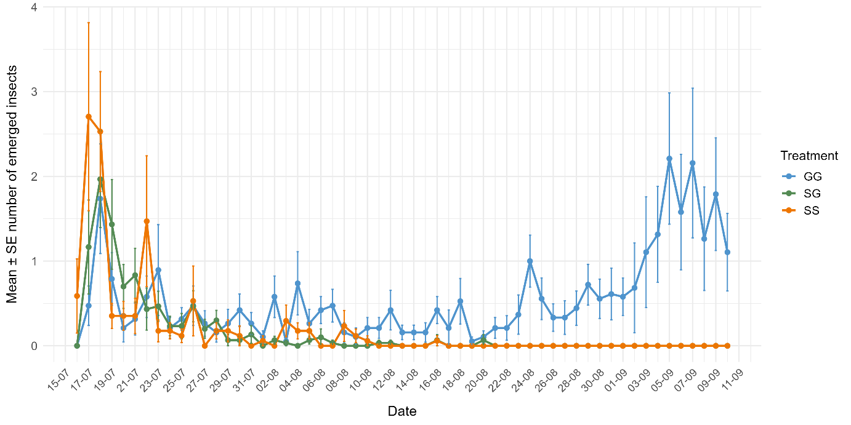
Fig. 6 - Temporal dynamics of insect emergence by treatment groups. Mean daily number of emerged insects per replicate (± SE) for the three treatments groups over the study period: GG (two individuals of X. germanus in shared rearing medium), SG (one individual of X. saxesenii and one individual of X. germanus), and SS (two individuals of X. saxesenii). Points represent mean values, error bars indicate standard errors, and lines connect temporal trends within each treatment.

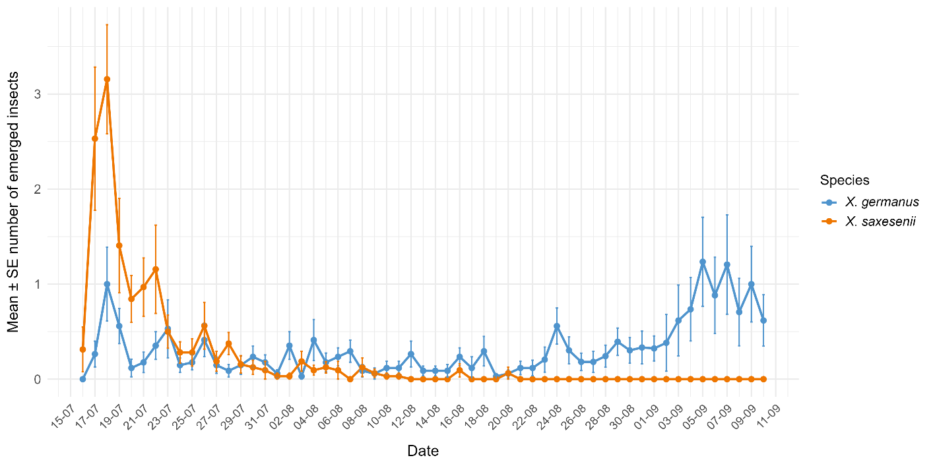
Fig. 7 - Temporal dynamics of insect emergence by species. Mean daily number of emerged insects per replicate (± SE) for X. germanus and X. saxesenii over the study period. Points represent mean values, error bars indicate standard errors, and lines connect temporal trends within each species.

