CHETTIANDU CUISINE ANALYSIS

Gender
 |  | Frequency | Percent
Valid | Male | 196 | 49.0
Valid | Female | 204 | 51.0
Valid | Total | 400 | 100.0
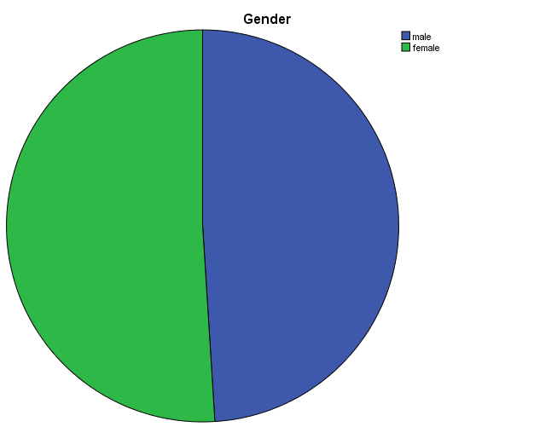

From the above table 4.1.1, It shows that 49% of respondents are male and 51% of respondents are female. Here the majority of the respondents are female.

Age
 |  | Frequency | Percent
Valid | 18-25 | 107 | 26.8
Valid | 26-35 | 131 | 32.8
Valid | 36-45 | 106 | 26.5
Valid | 46-55 | 46 | 11.5
Valid | 56-65 | 6 | 1.5
Valid | 65 & above | 4 | 1.0
Valid | Total | 400 | 100.0

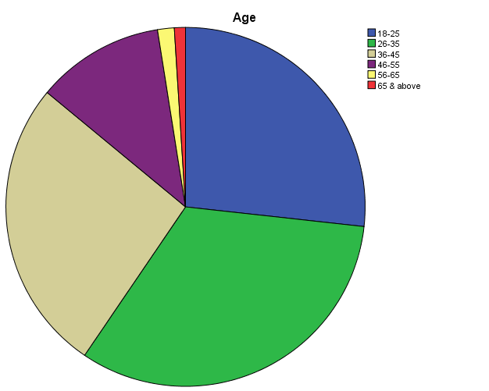

From the above table 4.1.2, It shows that 26.8% of respondents are 18-25 years, 32.8% of respondents are 26-35 years, 26.5% of respondents are 36-45 years,11.5% of respondents are 46-55 and 1.5% of respondents are 55-65%, 1% of respondents are 65 & above. Here the majority of the respondents are 26- 35 years of age.

Marital status
 |  | Frequency | Percent
Valid | single | 157 | 39.3
Valid | married | 243 | 60.8
Valid | Total | 400 | 100.0

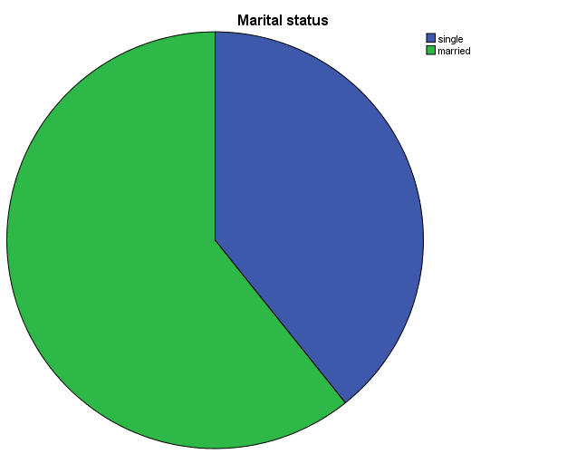

From the above table 4.1.3, it shows that 39.3% of respondents are single, 60.8% of respondents are married. Here the majority of the respondents are Married.

Education
 |  | Frequency | Percent
Valid | Higher secondary | 99 | 24.8
Valid | Diploma | 59 | 14.8
Valid | UG | 171 | 42.8
Valid | PG | 59 | 14.8
Valid | Professional degree | 12 | 3.0
Valid | Total | 400 | 100.0

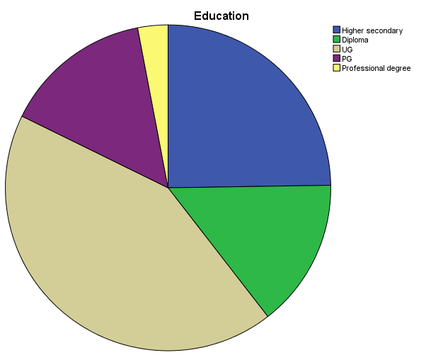

From the above table 4.1.4, it shows that 24.8% of respondents are Higher Secondary, 14.8% of respondents are Diploma, 42.8% of respondents of UG, 14.8% of respondents of PG, 3% of respondents of Professional degree. Here the majority of the respondents are UG.

Occupation
 |  | Frequency | Percent
Valid | student | 94 | 23.5
Valid | self employed | 165 | 41.3
Valid | govt.employee | 31 | 7.8
Valid | corporate | 58 | 14.5
Valid | entrepreneur | 27 | 6.8
Valid | academician | 25 | 6.3
Valid | Total | 400 | 100.0

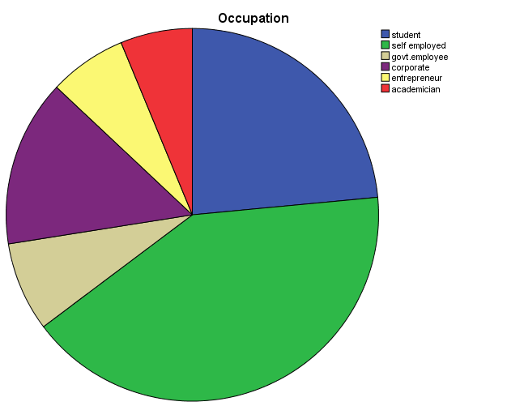

From the above table 4.1.5, it shows that 23.5% of respondents are Student, 41.3% of respondents are Self-employed, 7.8% of respondents of Govt employed, 14.5% of respondents of Corporate, 6.8% of respondents are Entrepreneur and 6.3% of respondents are Academician. Here the majority of the respondents are Self-employed.

Nationality
 |  | Frequency | Percent
Valid | Indian | 361 | 90.3
Valid | Foreigner | 39 | 9.8
Valid | Total | 400 | 100.0

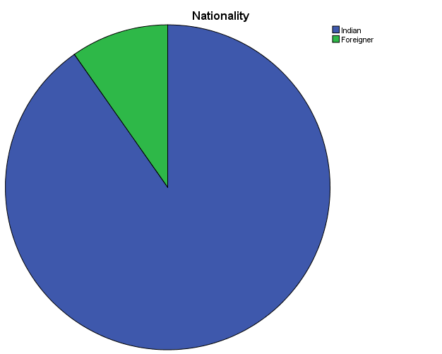

From the above table 4.1.6, it shows that 90.3% of respondents are Indian and 9.8% of respondents are Foreigner. Here the majority of the respondents are Indian.

Monthly income
 |  | Frequency | Percent
Valid | 50000 or lower | 266 | 66.5
Valid | 50000-100000 | 106 | 26.5
Valid | 100001-200000 | 19 | 4.8
Valid | 300001 & above | 9 | 2.3
Valid | Total | 400 | 100.0

From the above table 4.1.7, it shows that 66.5% of respondents are 50000 or lower, 26.5% of respondents are 50000-100000, 4.8% of respondents of 100001-200000, 2.3% of respondents of 300001 & above. Here the majority of the respondents are 50000 or lower.
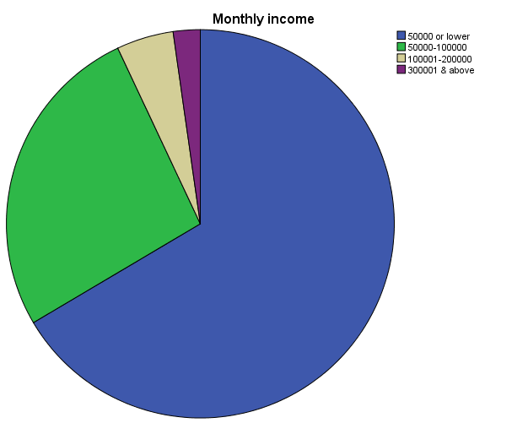

Location
 |  | Frequency | Percent
Valid | Madurai | 200 | 50.0
Valid | Karaikudi | 200 | 50.0
Valid | Total | 400 | 100.0

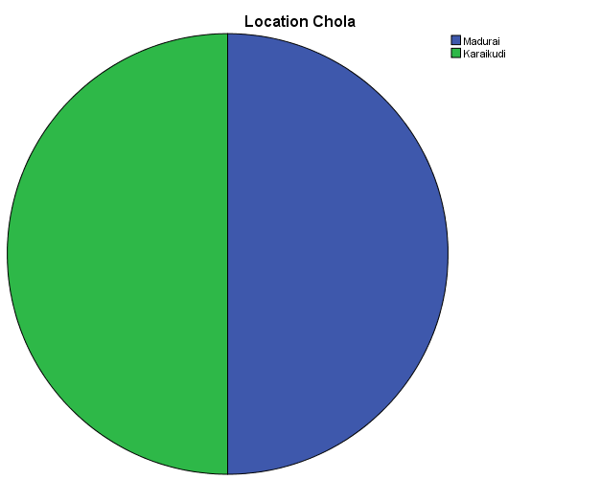

From the above table 4.1.8, it shows that 50% of respondents are Madurai and 50% of respondents are Karaikudi.

Preference destination
 |  | Frequency | Percent
Valid | Culture & Heritage | 235 | 58.8
Valid | Geographic significance | 82 | 20.5
Valid | Cuisine | 83 | 20.8
Valid | Total | 400 | 100.0

From the above table 4.1.9, it shows that 58.8% of respondents prefer Culture and Heritage, 20.5% of respondents prefer Geographical significance and 20.8% of respondents prefer Cuisine. Here the majority of the respondents prefer Culture and Heritage.
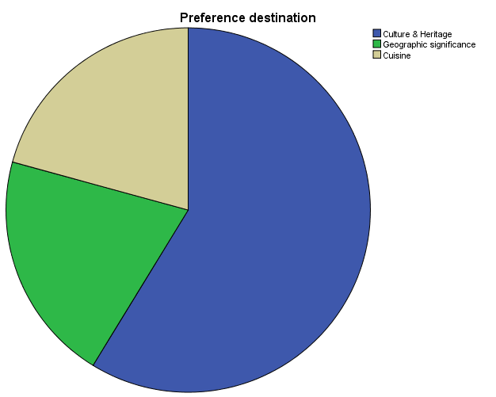

Perception of Most Favourite Dish
 |  | Responses
 |  | N | Percent
Favourite Dish | Bun parotta | 356 | 10.7%
Favourite Dish | Kari dosa | 346 | 10.4%
Favourite Dish | Jigarthanda | 370 | 11.1%
Favourite Dish | Paal kozhukattai | 353 | 10.6%
Favourite Dish | Mallipoo idly | 244 | 7.3%
Favourite Dish | Kuzhi paniyaram | 258 | 7.7%
Favourite Dish | Thean kuzhal | 220 | 6.6%
Favourite Dish | Kotthu parotta | 261 | 7.8%
Favourite Dish | Idiappam | 350 | 10.5%
Favourite Dish | Mutton chukka | 316 | 9.5%
Favourite Dish | Kola urundai | 257 | 7.7%
Total |  | 3331 | 100.0%

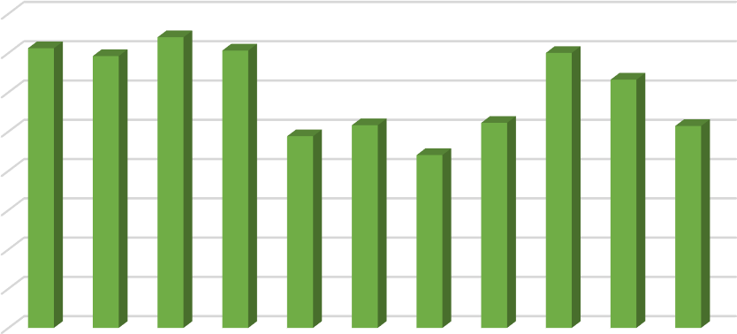
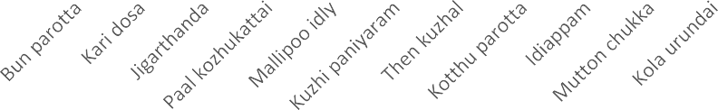
Favourite Dish of Chettinadu cuisine
400
350
300
250
200
150
100
50
0

The above table 4.4.11 shows that the category of the applications that respondent’s favourite dish from Chettinadu cuisine is Jigarthanda depicted by 11.1%, followed by Bun parotta depicted by 10.7%, followed by Paal Kolukattai depicted by 10.6%, followed by Idiyappam depicted by 10.5%, followed by Kari dosa depicted by10.4%.

Perception of Chettinadu cuisine
 |  | Frequency | Percent
Valid | Spicy | 271 | 67.8
Valid | Sweet | 25 | 6.3
Valid | Balanced | 103 | 25.8
Valid | No idea | 1 | .3
Valid | Total | 400 | 100.0

From the above table 4.1.11, it shows that 67.8% of respondent’s perception is Spicy, 6.3% of respondent’s perception is Sweet, 25.8% of respondent’s perception is Balanced, 0.3% of respondent’s perception is No idea. Here the majority of the respondent’s perception is Spicy.
