Gender
 |  | Frequency | Percent
Valid | Men | 170 | 42.5
Valid | Women | 230 | 57.5
Valid | Total | 400 | 100.0
TEMPLE CUISINE ANALYSIS

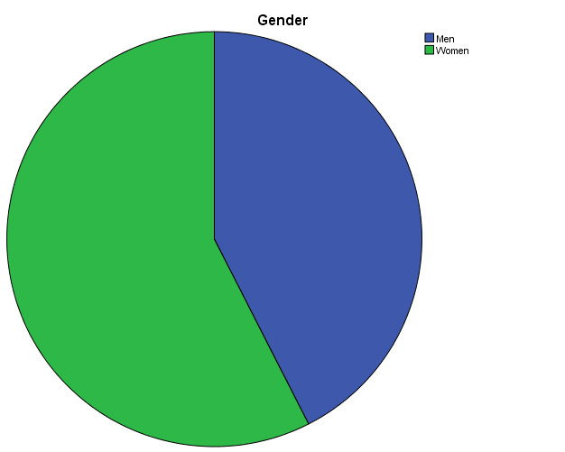

From the above table 4.1.1, It shows that 42.5% of respondents are male and 57.5% of respondents are female. Here the majority of the respondents are female.

Age
 |  | Frequency | Percent
Valid | 18-25 | 104 | 26.0
Valid | 26-35 | 86 | 21.5
Valid | 36-45 | 125 | 31.3
Valid | 46-55 | 53 | 13.3
Valid | 56-65 | 21 | 5.3
Valid | 65 & above | 11 | 2.8
Valid | Total | 400 | 100.0

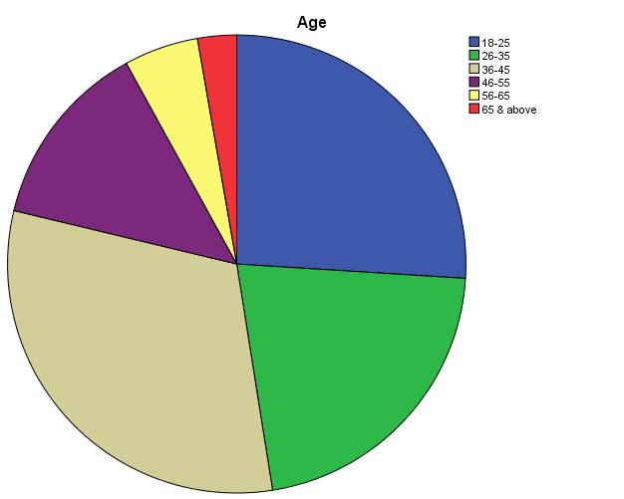

From the above table 4.1.2, It shows that 26% of respondents are 18-25 years, 21.5% of respondents are 26-35 years, 31.3% of respondents are 36-45 years,13.3% of respondents are 46-55 and 5.3% of respondents are 55-65%, 2.8% of respondents are 65 & above. Here the majority of the respondents are 36- 45 years of age

Marital status
 |  | Frequency | Percent
Valid | Single | 196 | 49.0
Valid | Married | 204 | 51.0
Valid | Total | 400 | 100.0

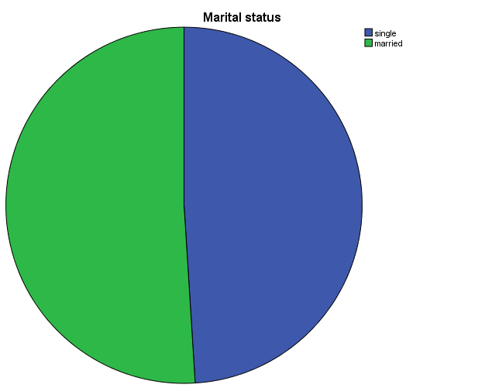

From the above table 4.1.3, it shows that 49% of respondents are single, 51% of respondents are married. Here the majority of the respondents are Married.

Education
 |  | Frequency | Percent
Valid | Higher secondary | 99 | 24.8
Valid | Diploma | 124 | 31.0
Valid | UG | 98 | 24.5
Valid | PG | 63 | 15.8
Valid | Professional degree | 16 | 4.0
Valid | Total | 400 | 100.0

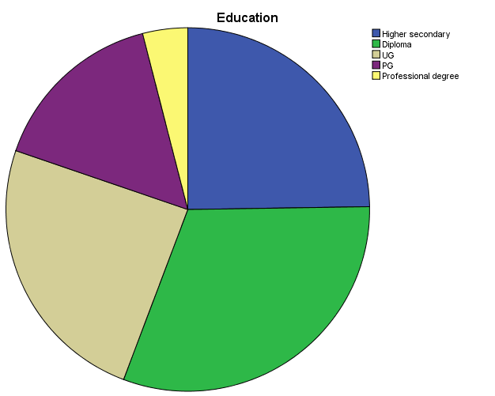

From the above table 4.1.4, it shows that 24.8% of respondents are Higher Secondary, 31% of respondents are Diploma, 24.5% of respondents of UG, 15.8% of respondents of PG, 4% of respondents of Professional degree. Here the majority of the respondents are Diploma.

Occupation
 |  | Frequency | Percent
Valid | Student | 140 | 35.0
Valid | Self employed | 139 | 34.8
Valid | Govt.employee | 26 | 6.5
Valid | Corporate | 55 | 13.8
Valid | Entrepreneur | 34 | 8.5
Valid | Academician | 6 | 1.5
Valid | Total | 400 | 100.0

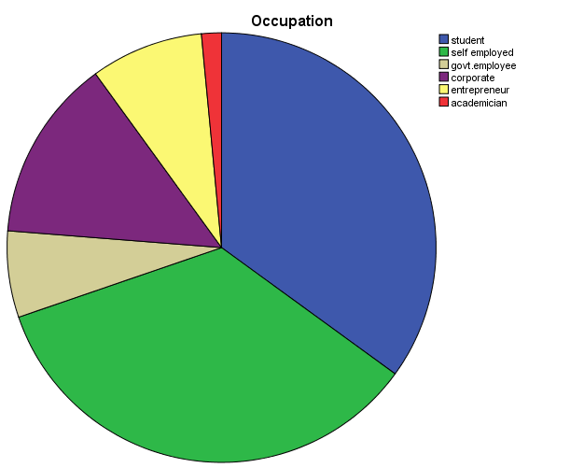

From the above table 4.1.5, it shows that 35% of respondents are Student, 34.8% of respondents are Self-employed, 6.5% of respondents of Govt employed, 13.8% of respondents of Corporate, 8.5% of respondents are Entrepreneur and 1.5% of respondents are Academician. Here the majority of the respondents are Student.

Nationality
 |  | Frequency | Percent
Valid | Indian | 393 | 98.3
Valid | Foreigner | 7 | 1.8
Valid | Total | 400 | 100.0

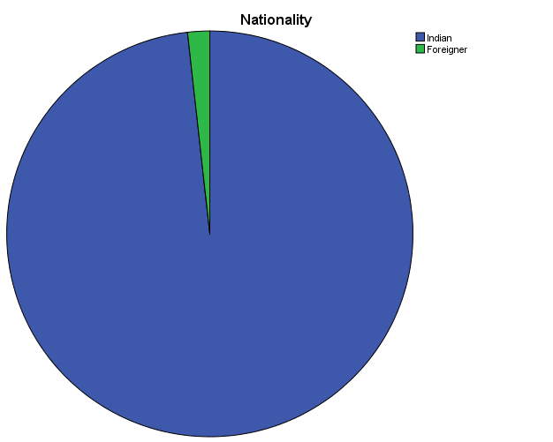

From the above table 4.1.6, it shows that 98.3% of respondents are Indian and 1.8% of respondents are Foreigner. Here the majority of the respondents are Indian.

Monthly income
 |  | Frequency | Percent
Valid | 50000 or lower | 260 | 65.0
Valid | 50000-100000 | 83 | 20.8
Valid | 100001-200000 | 29 | 7.3
Valid | 200001-300000 | 16 | 4.0
Valid | 300001 & above | 12 | 3.0
Valid | Total | 400 | 100.0

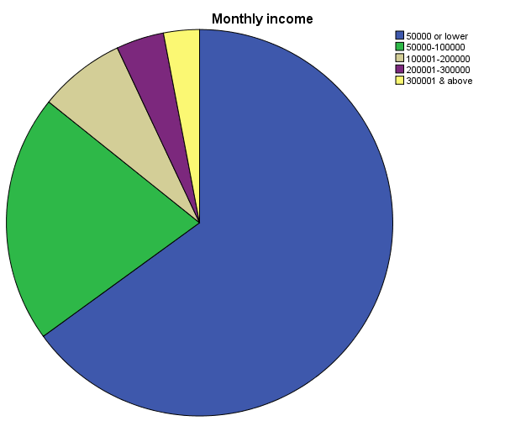

From the above table 4.1.7, it shows that 65% of respondents are 50000 or lower, 20.8% of respondents are 50000-100000, 7.3% of respondents of 100001-200000, 4% of respondents of 200001-300000, 3% of respondents of 300001 & above. Here the majority of the respondents are 50000 or lower.

Location
 |  | Frequency | Percent
Valid | Kumbakonam | 200 | 50.0
Valid | Trichy | 200 | 50.0
Valid | Total | 400 | 100.0

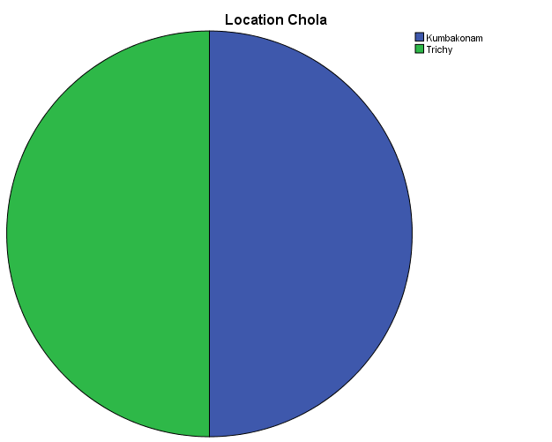

From the above table 4.1.8, it shows that 50% of respondents are Kumbakonam and 50% of respondents are Trichy.

Preference destination
 |  | Frequency | Percent
Valid | Culture & Heritage | 132 | 33.0
Valid | Geographic significance | 211 | 52.8
Valid | Cuisine | 57 | 14.3
Valid | Total | 400 | 100.0

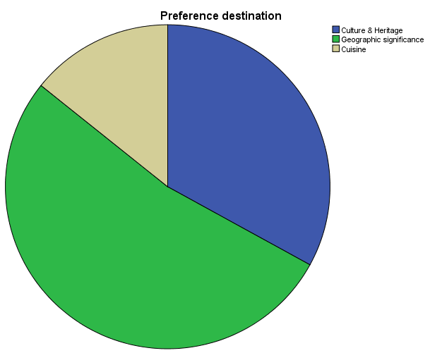

From the above table 4.1.9, it shows that 33% of respondents prefer Culture and Heritage, 52.8% of respondents prefer Geographical significance and 14.3% of respondents prefer Cuisine. Here the majority of the respondents prefer Geographical significance.

Perception of Most Fav Dish
 |  | Responses
 |  | N | Percentage
Favourite Dish | Adaiaviyal | 174 | 13.7%
Favourite Dish | Degree coffee | 216 | 17.1%
Favourite Dish | Thavalai vadai | 189 | 14.9%
Favourite Dish | Kumbakonam kadappa | 200 | 15.8%
Favourite Dish | Kutharavaali dosai | 210 | 16.6%
Favourite Dish | Puliyodarai | 93 | 7.3%
Favourite Dish | Parupu usuli | 116 | 9.2%
Favourite Dish | Akkaravadisal | 68 | 5.4%
Total |  | 1266 | 100.0%

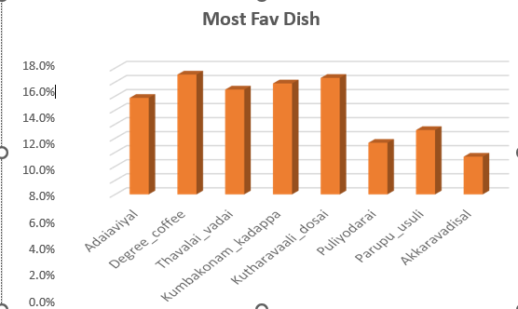

From the above table 4.1.10, the Perception on dishes that respondent likes the most is Degree coffee by 17.1% , followed by Kuthuravali Dosa by 16.6% , followed by Kumbakonam Kadappa by 15.8% , followed by Thavalai vadai by 14.9% , followed by Adaiavival by 13.7 followed by Parupu Usuli by 9.2% , followed by Puliyodarai by 7.3 and then Akkaravadisal by 5.4%.

Perception of Temple cuisine

 |  | Frequency | Percent
Valid | Spicy | 126 | 31.5
Valid | Sweet | 99 | 24.8
Valid | Balanced | 123 | 30.8
Valid | No idea | 52 | 13.0
Valid | Total | 400 | 100.0

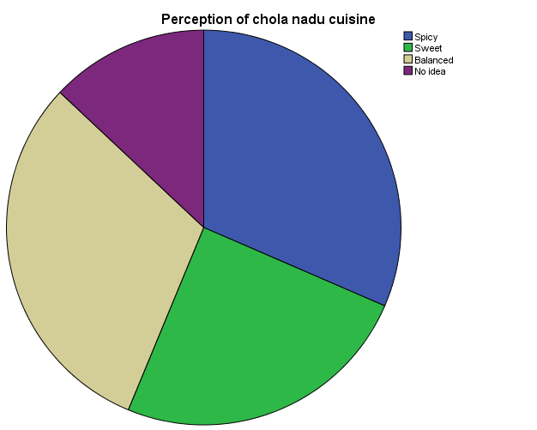

From the above table 4.1.11, it shows that 31.5% of respondent’s perception is Spicy, 24.8% of respondent’s perception is Sweet, 30.8% of respondent’s perception is Balanced, 13% of respondent’s perception is No idea. Here the majority of the respondent’s perception is Spicy.

