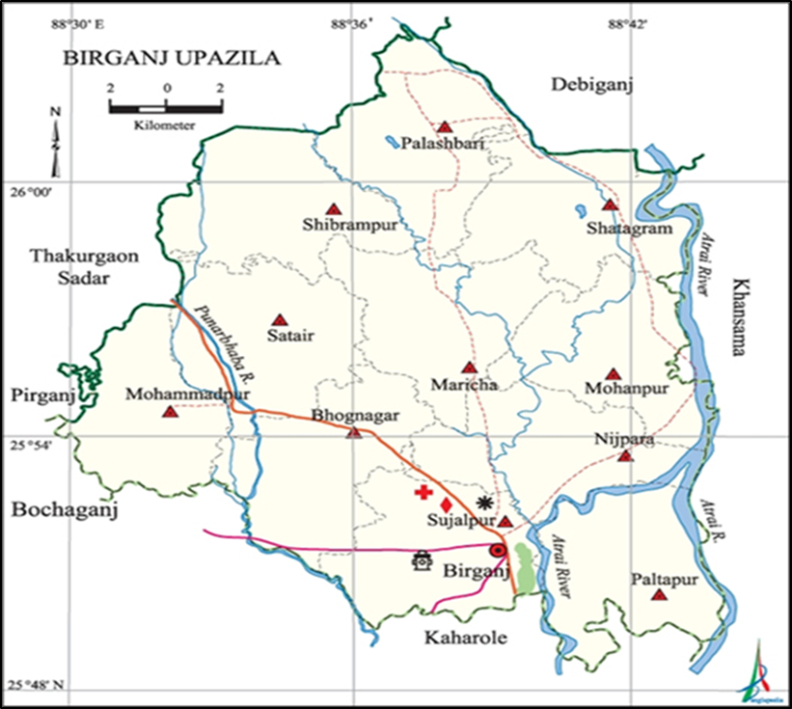
Supplementary Materials

S.Fig.1: Birganj Upazila of Dinajpur District. The study was implemented in three unions (Mohanpur, Satair, and Shatagram)
Legend: The study was conducted in Birganj Upazila of Dinajpur district, Rangpur Division in northern Bangladesh. The study was implemented in three unions (Mohanpur, Satair, and Shatagram). The primary target population included adults aged 18 years and older who consume any kind of tobacco.

S.Table 1: 4-day training agenda for the study facilitators
 | Day 01
Time | Topic
8:30-9:00 | Registration
9:00-9:15 | Inauguration, introduction and ice breaking, training objectives and ground rules
9:15-9:30 | Pre-test
9:30-10:00 | Session 01: Overview of the project
10:00-11:00 | Session 02: Discussion on basic interview skills and techniques
11:00-11:15 | Tea Break
11:15- 12:00 | Session 03: Research ethics
12:00-13:30 | Session 04: Behavioural and Clinical risk factors for NCDs: 5X5 framework for NCD prevention and control  Tobacco use, physical inactivity, unhealthy diet, alcohol consumption, air pollution
 | Day 02
9:00-9:30 | Recap
9:30-10:00 | Session 05: Healthy lifestyle: Basics of counselling
10:00-10:15 | Tea Break
10:15-11:30 | Session 06: Brief interventions (5A-5R counselling) for non-communicable disease risk factors: Tobacco cessation using BCC materials (Demonstration)
11:30-13:00 | Session 07: Brief interventions (5A-5R counselling) for non-communicable disease risk factors: Tobacco cessation (exercise and role play)
13:00-13:30 | Post-test and Certificate distribution for CHCPs and training evaluation
 | Day 03
9:00-9:30 | Recap
9:30-10:30 | Session 08: Use of Digital device for data collection and participant contact
10:30-10:45 | Tea
10:45-12:00 | Session 09: Household listing and invitation to participants
12:00-12:30 | Session 10: Mock on household listing
12:30-13:30 | Session 11: Discussion on health and lifestyle questionnaire
14:30-15:30 | Session 12: MOCK session on health and lifestyle questionnaire
15:45-17:00 | Session 12: MOCK session on health and lifestyle questionnaire (Cont.)
 | Day 04
9:00-9:30 | Recap
9:30-10:00 | Session 13: Session on participant follow-up
10:15-11:00 | Session 14: Mock on participant follow-up
11:00-11:30 | Session 15: Logistics and workplan distribution
11:30-12:00 | Post-test for CHW and training evaluation
12:00-12:30 | Training ending and Certificate distribution
12:30-13:30 | Facilitators meeting

S. Figure 2.1: Mean score at pre- and post-test by type of trainee

S. Figure 2.2a: Change of score of the CHCPs between pre and post-test

S. Figure 2.2b: Change of score of the CHWs between pre and post-test

S. Figure 2.2c: Change of score of the BRAC JPGSPH staff between pre and post-test

S. Figures 2.1 and 2.2a, 2.2b, 2.2c illustrate a comparison of the average score and absolute score of different types of participants before and after the training. Improvement has been noticed in all groups of participants at the post-test. Out of the highest possible score of 16, the mean score of the CHCPs was 5.5 on the pre-test and 12.4 in the post-test. The CHWs scored 4.67 on the pre-test and 11.34 on the post-test, and the office staff scored 11.5 on the pre-test and 15.5 on the post-test. Overall, the mean score for all participants 5.4 in the pre-test and 12.85 in the post-test. The difference between the mean score in the post-test and the pre-test was 7.45.

S. Table 2: Overall Evaluation of training by the Participants (% of the participants)
Total evaluation (n= 7)
Question | Very confident (%) | Confident (%) | Somewhat | A little confident (%)
Question | Very confident (%) | Confident (%) | Confident (%) | A little confident (%)
Confidence about raising NCD risk factors awareness | 28.57 | 71.41 | 0.00 | 0.00
Confidence about tobacco cessation using 5A-5R counseling | 42.86 | 57.14 | 0.00 | 0.00
Confidence about data collection using digital technology | 14.29 | 57.14 | 28.57 | 0.00

The majority of the facilitators were very confident in addressing NCD risk factors, promoting tobacco cessation using 5A-5R counseling, and collecting data using digital technology.

