Supplementary Figures and Audit Table
From Benchmark Reuse to Benchmark Audit: A Version-Aware Re-Evaluation of a Public MODIS Wildfire Benchmark with Uncertainty-Aware Modeling
This supplement provides one benchmark-audit summary table and four descriptive figures retained for transparency and readability. These materials complement the main-text uncertainty-aware figures and help document the original benchmark context, compact performance patterns, and representative-split summaries.

Supplementary Table S1. Benchmark audit snapshot for the repository-described dataset and the downloadable CSV analyzed in the manuscript.
Aspect | Repository description / README | Downloaded CSV analyzed in this study
File-level object | Repository summary for the benchmark case study | WildFires_DataSet.csv currently downloadable from the repository
Predictor naming | NDVI, LST, Thermal Anomalies, class | NDVI, LST, burned-area indicator, CLASS
Number of rows | 804 rows | 1,713 rows
Class counts | 386 fire; 418 no-fire | 386 fire; 1,327 no-fire
Row-level metadata | Regional narrative provided in README, but no row-level coordinates or timestamps are listed there | No row-level coordinates or timestamps are provided in the public CSV

Figures
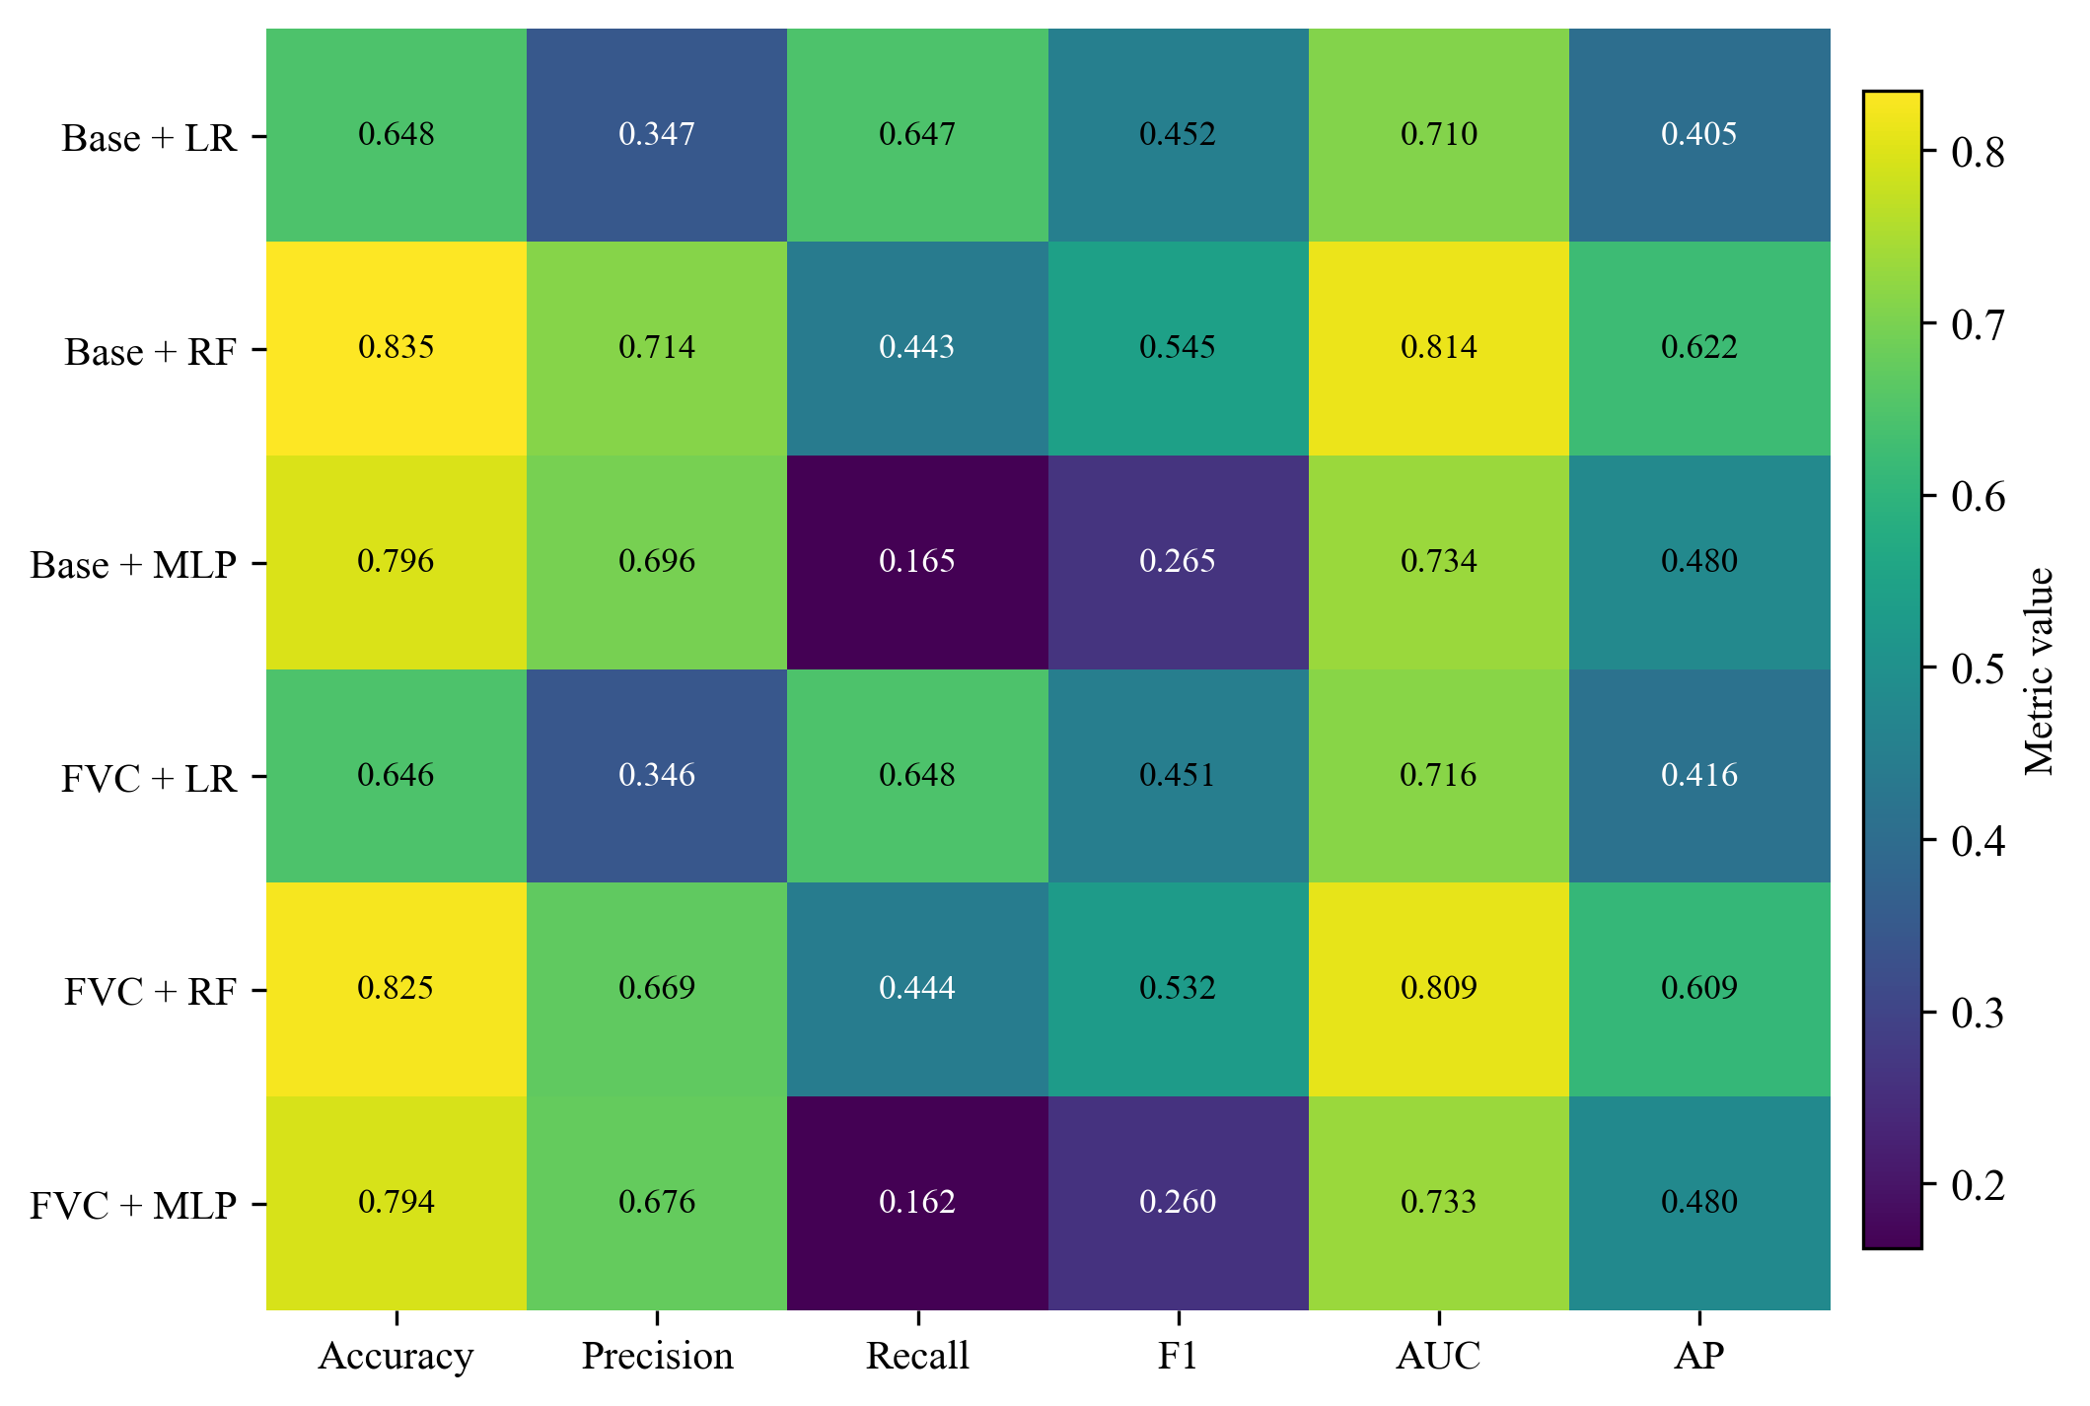
Fig. S1 Compact descriptive heatmap of mean performance across the original repeated-holdout benchmark configurations.

Figure S2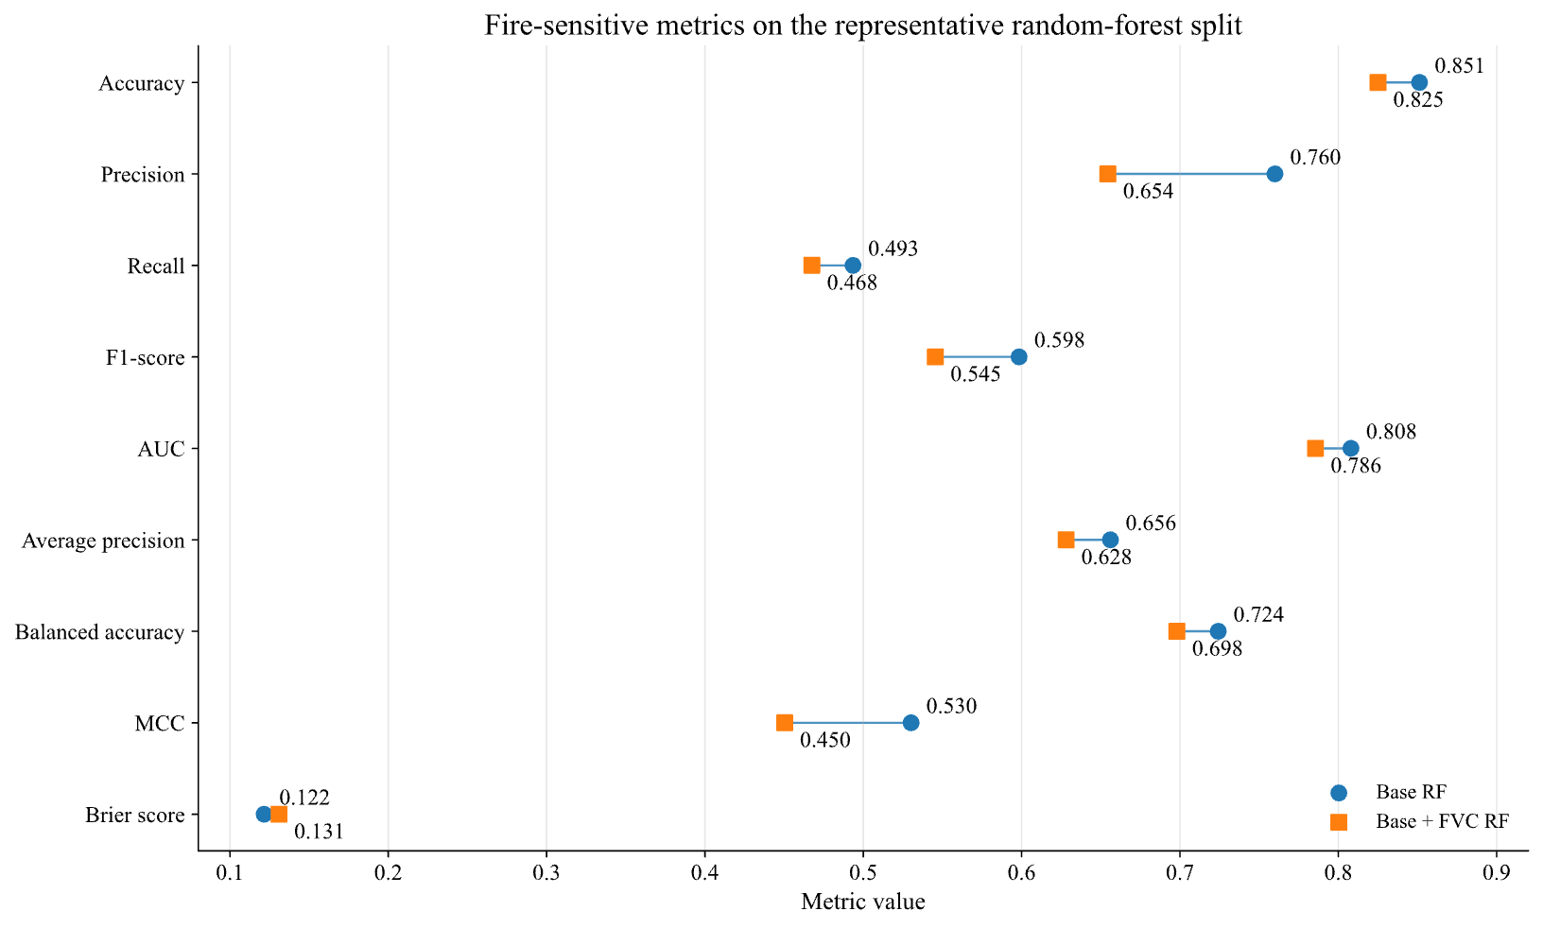

Fig. S2 Representative-split fire-sensitive metrics for the base and FVC-augmented random-forest models.

Figure S3
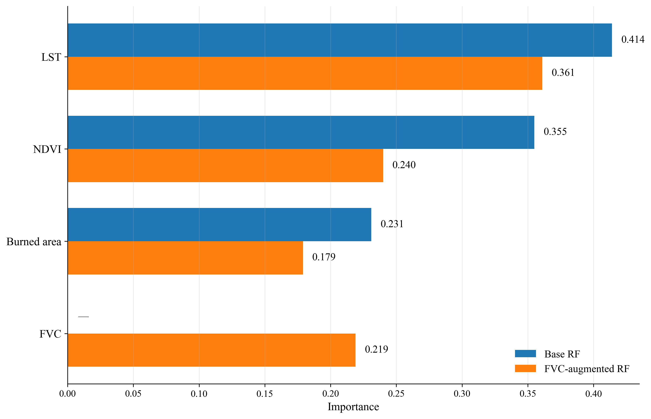
Fig. S3 Original descriptive feature-importance comparison for the base and FVC-augmented random-forest models.

