Supplementary Information for
Reducing Methane Emissions Along Global Natural Gas Supply Chain through Import Standards
Ryna Cui¹*, Jiaxun Sun^{2,1}, Xinzhao Cheng¹, Rachel Hoesly¹, Julie Miller³, Andy G. LaFleur¹, Xiaopu Sun³, Brinda Yarlagadda¹, Christoph Bertram¹, Gabrielle Dreyfus^{3,5}, Richard (“Tad”) Ferris³, Nathan Hultman¹, Steven J. Smith¹, Mengye Zhu^{1,4}
¹ Center for Global Sustainability, University of Maryland, College Park, MD, USA
² Department of Geographical Sciences, University of Maryland, College Park, MD, USA
³ Institute for Governance & Sustainable Development, Washington D.C., USA
⁴ Doerr School of Sustainability, Stanford University, Stanford, CA, USA
⁵ Department of Physics, Georgetown University, Washington, DC, USA

*Corresponding author: ycui10@umd.edu

Supplementary Methods
- Scenario Design and Implementation
This section provides detailed scenario descriptions (Table S1) and the implementation method in GCAM, specifically along the four dimensions—climate policy, geopolitical shifts, methane emission controls in the gas sector, and natural gas (NG) import standards.
Climate policy: Net-zero targets are implemented as two separate emissions constraints in GCAM, one for China to reach carbon neutrality by 2060 and one aggregate constraint for the rest of world (ROW) to reach net zero carbon emissions by 2050. For China, a linear pathway from 2025 emission levels to -5 MtCO₂ in 2060 are applied as total fossil fuel and industrial CO₂ emissions constraints, with the assumption that China’s land sink offsets the residual non-CO₂ emissions in 2060 and achieve net zero GHG emissions. For ROW combined, a linear pathway from 2025 emission levels to -5 MtCO₂ in 2050 are applied as aggregate constraints on total fossil fuel and industrial CO₂ emissions. Small carbon prices are also set up on land use change CO₂ emissions.
Geopolitical shifts: The logit-based Armington bilateral trade framework allows us to track and adjust the future bilateral trade flows of LNG and pipeline natural gas between the exporting and importing regions. Share-weight is a parameter of the logit function to reflect non-economic factors that affect the choice between different supplies, and the 2021 values are calibrated, where non-zero values represent existing trade partnership in 2021 and linearly increase to 1 by 2100. We implement the cut of Russian gas exports to the rest of Europe by assigning a zero share-weight of Russian pipeline gas and LNG exports to the five GCAM regions in Europe (EU-15, EU-12, Ukraine, Europe_Non_EU, and European Free Trade Association).
Methane emission controls: For gas-sector CH₄ mitigation assumptions, we group NG producers into two groups Leaders (Australia/New Zealand, Canada, EU-12, EU-15, European Free Trade Association, Japan, Middle East, South Korea, Taiwan, USA) and Laggards (the rest GCAM regions). Exogenous CH₄ emissions factors are assigned for the Leader producing countries to achieve the methane intensity threshold starting 2030 under both the Lead and LeadLag scenarios; and exogenous CH₄ emissions factors are assigned for the Laggard producing countries to achieve the methane intensity threshold starting 2035 under only the LeadLag scenarios.
NG import standards: For import standards, we select five climate-forward gas-importing countries (China, EU-15, EU-12, Japan, South Korea) to adopt the trade restrictions based on methane intensity of gas supply. Similar to the implementation of cutting off Russian gas to Europe, we use the share-weight of the logit function for the Armington bilateral trade to represent the trade restrictions between countries. For the two Lead scenarios, we assign a zero share-weight of pipeline gas and LNG exports from the Laggards to the five climate-forward importing countries starting 2030 and only allow exports from the Leaders through 2100. For the two LeadLag scenarios, we assign a zero share-weight of pipeline gas and LNG exports from the Laggards only in 2030 and allow exports from all regions starting 2035.
Additional adjustments are made to better reflect recent trends and projections of gas demand in China under the reference scenarios.

Table S1. Detailed scenario descriptions
Scenario Name | Assumptions
Ref  (Reference) | Climate Policy: None  Geopolitical Shifts: None  Methane Emission Controls: None  NG Import Standards: None
Ref_Lead  (Reference + Leaders) | Climate Policy: None  Geopolitical Shifts: Europe cuts off imports of Russian gas starting 2025  Methane Emission Controls:  - China: reduces natural gas methane emissions (Production + Transmission + Distribution) to 0.25% by 2025 and 0.2% by 2030  - Rest of Leaders: reduce methane emissions (Production + Transmission + Liquefaction + LNG Shipping) to 0.2% by 2030  NG Import Standard: Climate-forward gas-importing countries cut gas imports from laggard NG producing regions with methane intensity larger than 0.2% by 2030
Ref_LeadLag  (Reference + Leaders + Laggards) | Climate Policy: None  Geopolitical Shifts: Europe cuts off imports of Russian gas starting 2025  Methane Emission Controls:  - China: reduces natural gas methane emissions (Production + Transmission + Distribution) to 0.25% by 2025 and 0.2% by 2030  - Rest of Leaders: reduce methane emissions (Production + Transmission + Liquefaction + LNG Shipping) to 0.2% by 2030  - Laggards: reduce methane emissions (Production + Transmission + Liquefaction + LNG Shipping) to 0.2% by 2035  NG Import Standard: Climate-forward gas-importing countries cut gas imports from laggard NG producing regions with methane intensity larger than 0.2% in 2030; No trade restrictions by 2035 based on methane intensity as all nations achieve 0.2% methane emissions intensity standard.
NZ  (Net Zero Carbon Policy) | Climate Policy: China carbon neutrality (net zero GHG emissions) by 2060; ROW net zero carbon emissions by 2050  Geopolitical Shifts: None  Methane Emission Controls: None  NG Import Standard: None
NZ_Lead  (Net Zero Carbon Policy + Leaders) | Climate Policy: China carbon neutrality (net zero GHG emissions) by 2060; ROW net zero carbon emissions by 2050  Geopolitical Shifts: Europe cuts off imports of Russian gas starting 2025  Methane Emission Controls:  - China: reduces natural gas methane emissions intensity (Production + Transmission + Distribution) to 0.25% by 2025 and 0.2% by 2030  - Rest of Leaders: reduce methane emissions (Production + Transmission + Liquefaction + LNG Shipping) to 0.2% by 2030  NG Import Standard: Climate-forward gas-importing countries cut gas imports from laggard NG producing regions with methane intensity larger than 0.2% in 2030.
NZ_LeadLag  (Net Zero Carbon Policy + Leaders + Laggards) | Climate Policy: China carbon neutrality (net zero GHG emissions) by 2060; ROW net zero carbon emissions by 2050  Geopolitical Shifts: Europe cuts off imports of Russian gas starting 2025  Methane Emission Controls:  - China: reduces natural gas methane emissions (Production + Transmission Distribution) to 0.25% by 2025 and 0.2% by 2030  - Rest of Leaders: reduce methane emissions (Production + Transmission + Liquefaction + LNG Shipping) to 0.2% by 2030  - Laggards (all other regions): reduce methane emissions (Production + Transmission + Liquefaction + LNG Shipping) to 0.2% by 2035  NG Import Standard: Climate-forward gas-importing countries cut gas imports from laggard NG producing regions with methane intensity larger than 0.2% in 2030; No trade restrictions by 2035 based on methane intensity as all nations achieve 0.2% methane emissions intensity standard.

- Additional information for calculating CH₄ emissions along the LNG supply chain
We attribute CH₄ emissions along the LNG supply chain to bilateral trade flows comprising four components: Scope 1 emissions at the point of production and transmission/liquefaction, and Scope 3 emissions from shipping and regasification.
Scope 1: Production. Production stage CH₄ emissions of the exporter are allocated to each importer proportional to their share of the exporter’s total natural gas output (domestic consumption plus all exports).
$$E_{\text{x→m}}^{\text{prod}}=E_{\text{x}}^{\text{prod}}×\frac{q_{\text{x→m}}}{Q_{\text{x}}^{\text{NG}}}$$
Scope 1: Transmission and Liquefaction. Transmission stage CH₄ emissions of the exporter are allocated to each importer proportional to their share of the exporter’s total LNG export volume.
$$E_{\text{x→m}}^{\text{trans}}{=E}_{\text{x}}^{\text{trans}}×\frac{q_{\text{x→m}}}{Q_{\text{x}}^{\text{LNG}}}$$
Scope 3: Shipping. CH₄ emissions from LNG shipping are resolved directly at the bilateral (exporter-importer) level and require no further allocation.
Scope 3: Regasification. Regasification emissions of the importers are allocated back to each exporting region proportional to that exporter’s share of the importer’s total LNG supply.
$$E_{\text{x→m}}^{\text{reg}}{=E}_{\text{m}}^{\text{reg}}×\frac{q_{\text{x→m}}}{Q_{\text{m}}^{\text{LNG}}}$$
Total attributed emissions for each exporter-importer pair are the sum of all four components. These bilateral emission estimates are the basis of the CH₄ emission side of the Sankey diagrams presented in Figure 3 and Figures S6-S8.
Emissions factors from the literature used in the analysis are presented below for liquefaction (Table S2), regasification (Table S3), shipping (Table S4), and different shipping routes for China (Table S5).

Table S2. CH₄ emission factors for liquefaction. Emissions were derived from CO₂-eq using the reported GWP value, where applicable.
Methane Emissions | Unit | Source | Notes | Location
0.000880556 | gCH4/MJ  NG throughput | Zhu Y., Allen D. T., & Ravikumar A. P. (2024) Geospatial Life Cycle Analysis of Greenhouse Gas Emissions from US Liquefied Natural Gas Supply Chains, ACS Sustainable Chem. Eng. 12(49): 17843–17854. https://doi.org/10.1021/acssuschemeng.4c07255. | Table S14 - combines methane emissions from fuel gas combustion, liquefaction leaks, and flare stacks, then transformed by GWP100=36 | Sabine Pass, USA
0.001111111 | gCH4/MJ LNG delivered | Zhu Y., Allen D. T., & Ravikumar A. P. (2024) Geospatial Life Cycle Analysis of Greenhouse Gas Emissions from US Liquefied Natural Gas Supply Chains, ACS Sustainable Chem. Eng. 12(49): 17843–17854. https://doi.org/10.1021/acssuschemeng.4c07255. | Table S39  GWP100=36 | Sabine Pass, USA
0.017684564 | gCH4/MJ LNG | Innocenti F., Robinson R., Gardiner T., Howes N., & Yarrow N. (2023) Comparative Assessment of Methane Emissions from Onshore LNG Facilities Measured Using Differential Absorption Lidar, Environ. Sci. Technol. 57(8): 3301–3310. https://doi.org/10.1021/acs.est.2c05446. | Table S14 - site L1  GWP100=29.8 | Undisclosed
0.013557047 | gCH4/MJ LNG | Innocenti F., Robinson R., Gardiner T., Howes N., & Yarrow N. (2023) Comparative Assessment of Methane Emissions from Onshore LNG Facilities Measured Using Differential Absorption Lidar, Environ. Sci. Technol. 57(8): 3301–3310. https://doi.org/10.1021/acs.est.2c05446. | Table S14 - site L2  GWP100=29.8 | Undisclosed
0.008322148 | gCH4/MJ LNG | Innocenti F., Robinson R., Gardiner T., Howes N., & Yarrow N. (2023) Comparative Assessment of Methane Emissions from Onshore LNG Facilities Measured Using Differential Absorption Lidar, Environ. Sci. Technol. 57(8): 3301–3310. https://doi.org/10.1021/acs.est.2c05446. | Table S14 - site L3a  GWP100=29.8 | Undisclosed
0.006442953 | gCH4/MJ LNG | Innocenti F., Robinson R., Gardiner T., Howes N., & Yarrow N. (2023) Comparative Assessment of Methane Emissions from Onshore LNG Facilities Measured Using Differential Absorption Lidar, Environ. Sci. Technol. 57(8): 3301–3310. https://doi.org/10.1021/acs.est.2c05446. | Table S14 - site L3b  GWP100=29.8 | Undisclosed
0.029117647 | gCH4/MJ LNG | Balcombe P., Anderson K., Speirs J., Brandon N., & Hawkes A. (2015) Methane and co2 emissions from the natural gas supply chain an evidence assessment, Sustainable Gas Institute, p 1-88. https://vibe.cira.colostate.edu/ogec/docs/reports/SGI_White_Paper_methane-and-CO2-emissions_WEB-FINAL.pdf | Table 6 - Methane contribution (revised)  GWP100=34 | US biased, but considers worldwide, 240 studies
0.078 | gCH4/MJ | Howarth R. W. (2024) The greenhouse gas footprint of liquefied natural gas (LNG) exported from the United States, Energy Science & Engineering 12(11): 4843–4859. https://doi.org/10.1002/ese3.1934. | Table 4 | US based facility
0.0165 | gCH4/MJ | IEA (2025) Assessing emissions from LNG supply and abatement options, International Energy Agency: Assessing Emissions from LNG Supply and Abatement Options. | Figure 1  GWP100=30 | Global Avg
0.019068447 | GLOBAL MEAN

Table S3. CH₄ emission factors for regasification. Emissions were derived from CO₂-eq using the reported GWP value, where applicable.
Methane Emissions | Unit | Source | Notes | Location
0.002941176 | gCH4/MJ LNG | Balcombe P., Anderson K., Speirs J., Brandon N., & Hawkes A. (2015) Methane and co2 emissions from the natural gas supply chain an evidence assessment, Sustainable Gas Institute, p 1-88. https://vibe.cira.colostate.edu/ogec/docs/reports/SGI_White_Paper_methane-and-CO2-emissions_WEB-FINAL.pdf | Table 6 - Methane contribution (revised)  GWP100=34 | US biased, but considers worldwide, 240 studies
0.003020134 | gCH4/MJ LNG | Innocenti F., Robinson R., Gardiner T., Howes N., & Yarrow N. (2023) Comparative Assessment of Methane Emissions from Onshore LNG Facilities Measured Using Differential Absorption Lidar, Environ. Sci. Technol. 57(8): 3301–3310. https://doi.org/10.1021/acs.est.2c05446. | Table S14 - site L1  GWP100=29.8 | Undisclosed
0.003691275 | gCH4/MJ LNG | Innocenti F., Robinson R., Gardiner T., Howes N., & Yarrow N. (2023) Comparative Assessment of Methane Emissions from Onshore LNG Facilities Measured Using Differential Absorption Lidar, Environ. Sci. Technol. 57(8): 3301–3310. https://doi.org/10.1021/acs.est.2c05446. | Table S14 - site L2  GWP100=29.8 | Undisclosed
0.003666667 | gCH4/MJ | IEA (2025) Assessing emissions from LNG supply and abatement options, International Energy Agency: Assessing Emissions from LNG Supply and Abatement Options. | Figure 1  GWP100=30 | Global Avg
0.003329813 | GLOBAL MEAN

Table S4. CH₄ emission factors for shipping. Emissions were derived from CO₂-eq using the reported GWP value, where applicable.
Methane Emissions | Unit | Distance (nm) | Source | Notes | Locations/Route | Emissions intensity per nautical mile
0.018333333 | gCH4/MJ | NA | IEA (2025) Assessing emissions from LNG supply and abatement options, International Energy Agency: Assessing Emissions from LNG Supply and Abatement Options. | Figure 1  GWP100=30; | NA | NA
0.023214286 | gCH4/MJ LNG | 4520 | Zhu Y., Allen D. T., & Ravikumar A. P. (2024) Geospatial Life Cycle Analysis of Greenhouse Gas Emissions from US Liquefied Natural Gas Supply Chains, ACS Sustainable Chem. Eng. 12(49): 17843–17854. https://doi.org/10.1021/acssuschemeng.4c07255. | Table S39; ship details Table S40; Abadi Brunei Gas Carriers Mitsubishi  GWP100=28;  Steam turbine engine | US-UK | 5.1359E-06
0.043260714 | gCH4/MJ LNG | 9966 | Zhu Y., Allen D. T., & Ravikumar A. P. (2024) Geospatial Life Cycle Analysis of Greenhouse Gas Emissions from US Liquefied Natural Gas Supply Chains, ACS Sustainable Chem. Eng. 12(49): 17843–17854. https://doi.org/10.1021/acssuschemeng.4c07255. | Table S24; methane slip  GWP100=28;  Steam turbine engine | US-China | 4.34083E-06
0.022378571 | gCH4/MJ LNG | 4520 | Zhu Y., Allen D. T., & Ravikumar A. P. (2024) Geospatial Life Cycle Analysis of Greenhouse Gas Emissions from US Liquefied Natural Gas Supply Chains, ACS Sustainable Chem. Eng. 12(49): 17843–17854. https://doi.org/10.1021/acssuschemeng.4c07255. | Table S24; ship details Table S40; methane slip  GWP100=28;  Steam turbine engine | US-UK | 4.95101E-06
0.017657143 | gCH4/MJ LNG | 4520 | Zhu Y., Allen D. T., & Ravikumar A. P. (2024) Geospatial Life Cycle Analysis of Greenhouse Gas Emissions from US Liquefied Natural Gas Supply Chains, ACS Sustainable Chem. Eng. 12(49): 17843–17854. https://doi.org/10.1021/acssuschemeng.4c07255. | Table S30; methane slip  GWP100=28;  X-DF engine | US-UK | 3.90645E-06
0.035975 | gCH4/MJ LNG | 9966 | Zhu Y., Allen D. T., & Ravikumar A. P. (2024) Geospatial Life Cycle Analysis of Greenhouse Gas Emissions from US Liquefied Natural Gas Supply Chains, ACS Sustainable Chem. Eng. 12(49): 17843–17854. https://doi.org/10.1021/acssuschemeng.4c07255. | Table S30; methane slip  GWP100=28;  X-DF engine | US-China | 3.60977E-06
0.018343434 | gCH4/MJ LNG delivered | 5,553 | Balcombe P., Heggo D. A., & Harrison M. (2022) Total Methane and CO2 Emissions from Liquefied Natural Gas Carrier Ships: The First Primary Measurements, Environ. Sci. Technol. 56(13): 9632–9640. https://doi.org/10.1021/acs.est.2c01383. | Main Text, p 9634 Table SI-2; converting kg LNG to MJ LNG using 55MJ=1kg LNG conversion (High heating value); distance only incldues laden voyage, but emissions measurements include for return trip; 15.8 day trip from US to Belsgium; ship name: GasLog Galveston; X-DF engine | US-Belgium | 3.30337E-06
0 | gCH4/MJ LNG delivered | 4897.4372 | Howarth R. W. (2024) The greenhouse gas footprint of liquefied natural gas (LNG) exported from the United States, Energy Science & Engineering 12(11): 4843–4859. https://doi.org/10.1002/ese3.1934. | Supp Table B;  Steam turbine engine | US-UK | 0
0.052727273 | gCH4/MJ LNG delivered | 4897.4372 | Howarth R. W. (2024) The greenhouse gas footprint of liquefied natural gas (LNG) exported from the United States, Energy Science & Engineering 12(11): 4843–4859. https://doi.org/10.1002/ese3.1934. | Supp Table B;  LNG dual-fuel engine | US-UK | 1.07663E-05
0.025454545 | gCH4/MJ LNG delivered | 4897.4372 | Howarth R. W. (2024) The greenhouse gas footprint of liquefied natural gas (LNG) exported from the United States, Energy Science & Engineering 12(11): 4843–4859. https://doi.org/10.1002/ese3.1934. | Supp Table B;  LNG dual-fuel engine | US-UK | 5.19752E-06
0.001818182 | gCH4/MJ LNG delivered | 4897.4372 | Howarth R. W. (2024) The greenhouse gas footprint of liquefied natural gas (LNG) exported from the United States, Energy Science & Engineering 12(11): 4843–4859. https://doi.org/10.1002/ese3.1934. | Supp Table B;  Diesel powered engine | US-UK | 3.71252E-07
0 | gCH4/MJ LNG delivered | 15097.8216 | Howarth R. W. (2024) The greenhouse gas footprint of liquefied natural gas (LNG) exported from the United States, Energy Science & Engineering 12(11): 4843–4859. https://doi.org/10.1002/ese3.1934. | Supp Table C;  Steam turbine engine | US-China | 0
0.174545455 | gCH4/MJ LNG delivered | 15097.8216 | Howarth R. W. (2024) The greenhouse gas footprint of liquefied natural gas (LNG) exported from the United States, Energy Science & Engineering 12(11): 4843–4859. https://doi.org/10.1002/ese3.1934. | Supp Table C;  LNG dual-fuel engine | US-China | 1.1561E-05
0.085454545 | gCH4/MJ LNG delivered | 15097.8216 | Howarth R. W. (2024) The greenhouse gas footprint of liquefied natural gas (LNG) exported from the United States, Energy Science & Engineering 12(11): 4843–4859. https://doi.org/10.1002/ese3.1934. | Supp Table C;  LNG dual-fuel engine | US-China | 5.66006E-06
0.005454545 | gCH4/MJ LNG delivered | 15097.8216 | Howarth R. W. (2024) The greenhouse gas footprint of liquefied natural gas (LNG) exported from the United States, Energy Science & Engineering 12(11): 4843–4859. https://doi.org/10.1002/ese3.1934. | Supp Table C;  Diesel powered engine | US-China | 3.6128E-07
0.127777778 | gCH4/MJ LNG delivered | 10000 | Rosselot K. S., Allen D. T., & Ku A. Y. (2021) Comparing Greenhouse Gas Impacts from Domestic Coal and Imported Natural Gas Electricity Generation in China, ACS Sustainable Chem. Eng. 9(26): 8759–8769. https://doi.org/10.1021/acssuschemeng.1c01517 | SI - equation S21, page S12 for Shainghai; 3600 MJ per MWh engine type = WÄRTSILÄ 50DF; 22.67 days at sea, including round trip; estimate distance is 10000nm - but actually not given in paper;  LNG multi-fuel engine | US-China | 1.27778E-05
6.25765E-06 | Global Mean

Table S5. CH₄ emission factors for China shipping routes
Importer_Region | Exporter_Region | Distance in Nautical Miles* | Emissions Intensity (gCH4/MJ LNG)**
China | USA | 10000 | 0.0625765
China | Africa_Northern | 7951.45096 | 0.049757397
China | Africa_Southern | 8709.5548 | 0.054501346
China | Africa_Western | 11274.3648 | 0.070551029
China | Australia_NZ | 5237.612 | 0.032775143
China | Canada | 5291.608 | 0.033113031
China | Central America and Caribbean | 5214.39372 | 0.032629851
China | Central Asia | 8545.40696 | 0.053474166
China | EU-15 | 12205.25584 | 0.076376219
China | European Free Trade Association | 12205.25584 | 0.076376219
China | Indonesia | 2300.76956 | 0.014397411
China | Japan | 307.7772 | 0.001925962
China | Middle East | 8545.40696 | 0.053474166
China | Russia | 11665.29584 | 0.072997339
China | South America_Southern | 5996.79576 | 0.037525849
China | South Korea | 307.7772 | 0.001925962
China | Southeast Asia | 3509.74 | 0.021962725
Notes:
* Distances based on estimates from Fig 1 in Zeng W. (2022) China’s LNG import risk assessment based on the perspective of global governance, Scientific Reports 12(15754): 1–12. Converted values from kilometers to nautical miles using 0.53996 nm/km.
** Emissions intensity is the global mean from Table 3 multiplied by nautical distance.

Figure S1. Primary energy consumption by source: (a) global total, (b) China, and (c) rest of climate-forward importers in 2021 and under six scenarios in 2035 and 2060.

Figure S2. Natural gas supply for (a) global total, (b) China, and (c) rest of climate-forward importers in 2021 and under six scenarios in 2035 and 2060.

Figure S3. Change in NG supply by source from the reference to the other five scenarios in 2035 and 2060 for (a) global total, (b) China, and (c) the rest of climate-forward importing countries (EU imports include both pipeline gas and LNG, while no pipeline trade for Japan and South Korea).

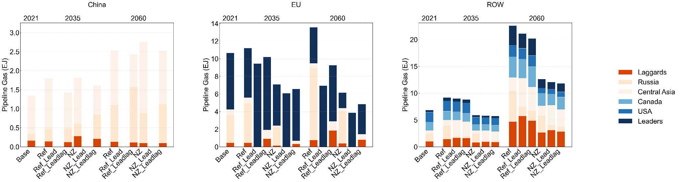
Figure S4. Pipeline gas imports by suppliers for China, EU, and other importing countries without trade restrictions in 2021 and under six scenarios in 2035 and 2060.

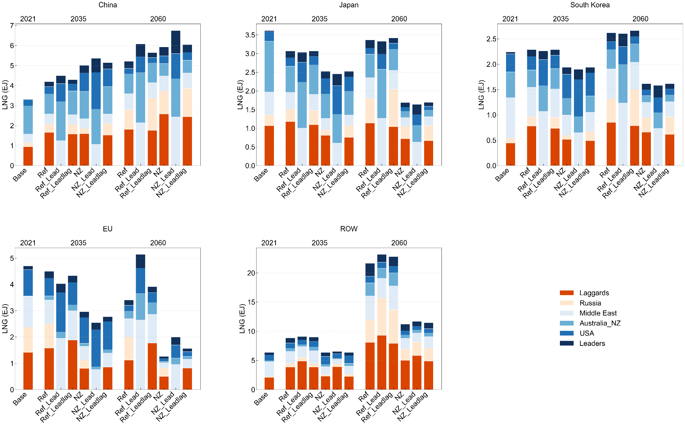
Figure S5. LNG imports by suppliers for China, Japan, South Korea, EU, and other importing countries without trade restrictions in 2021 and under six scenarios in 2035 and 2060.

Figure S6. Bilateral LNG trade flows and attributed methane (CH₄) emissions between exporting and importing regions in 2060 under (a) Ref scenario, (b) Ref_Lead scenario, and (c) Ref_LeadLag scenario. In each panel, the two central columns represent importing regions, while the two outer columns represent exporting regions. Left flows show attributed Scope 1 and Scope 3 CH₄ emissions (Tg CH₄) for gas imports; right flows show LNG trade volume (EJ) between exporters and importers. The left and right scales are independent.

Figure S7. Bilateral LNG trade flows and attributed methane (CH₄) emissions between exporting and importing regions in 2035 under (a) NZ scenario, (b) NZ_Lead scenario, and (c) NZ_LeadLag scenario. In each panel, the two central columns represent importing regions, while the two outer columns represent exporting regions. Left flows show attributed Scope 1 and Scope 3 CH₄ emissions (Tg CH₄) for gas imports; right flows show LNG trade volume (EJ) between exporters and importers. The left and right scales are independent.

Figure S8. Bilateral LNG trade flows and attributed methane (CH₄) emissions between exporting and importing regions in 2060 under (a) NZ scenario, (b) NZ_Lead scenario, and (c) NZ_LeadLag scenario. In each panel, the two central columns represent importing regions, while the two outer columns represent exporting regions. Left flows show attributed Scope 1 and Scope 3 CH₄ emissions (Tg CH₄) for gas imports; right flows show LNG trade volume (EJ) between exporters and importers. The left and right scales are independent.

Figure S9. Bilateral LNG (a) and pipeline (b) trade flows between exporting and importing GCAM regions in 2021.

Figure S10. Bilateral LNG trade flows between GCAM exporting and importing regions under Ref (a,b), Ref_Lead (c,d), and Ref_LeadLag (e,f) in 2035 and 2060.
Figure S11. Bilateral LNG trade flows between GCAM exporting and importing regions under NZ (a,b), NZ_Lead (c,d), and NZ_LeadLag (e,f) in 2035 and 2060.
Figure S12. Bilateral pipeline gas trade flows between GCAM exporting and importing regions under Ref (a,b), Ref_Lead (c,d), and Ref_LeadLag (e,f) in 2035 and 2060.
Figure S13. Bilateral pipeline gas trade flows between GCAM exporting and importing regions under NZ (a,b), NZ_Lead (c,d), and NZ_LeadLag (e,f) in 2035 and 2060.
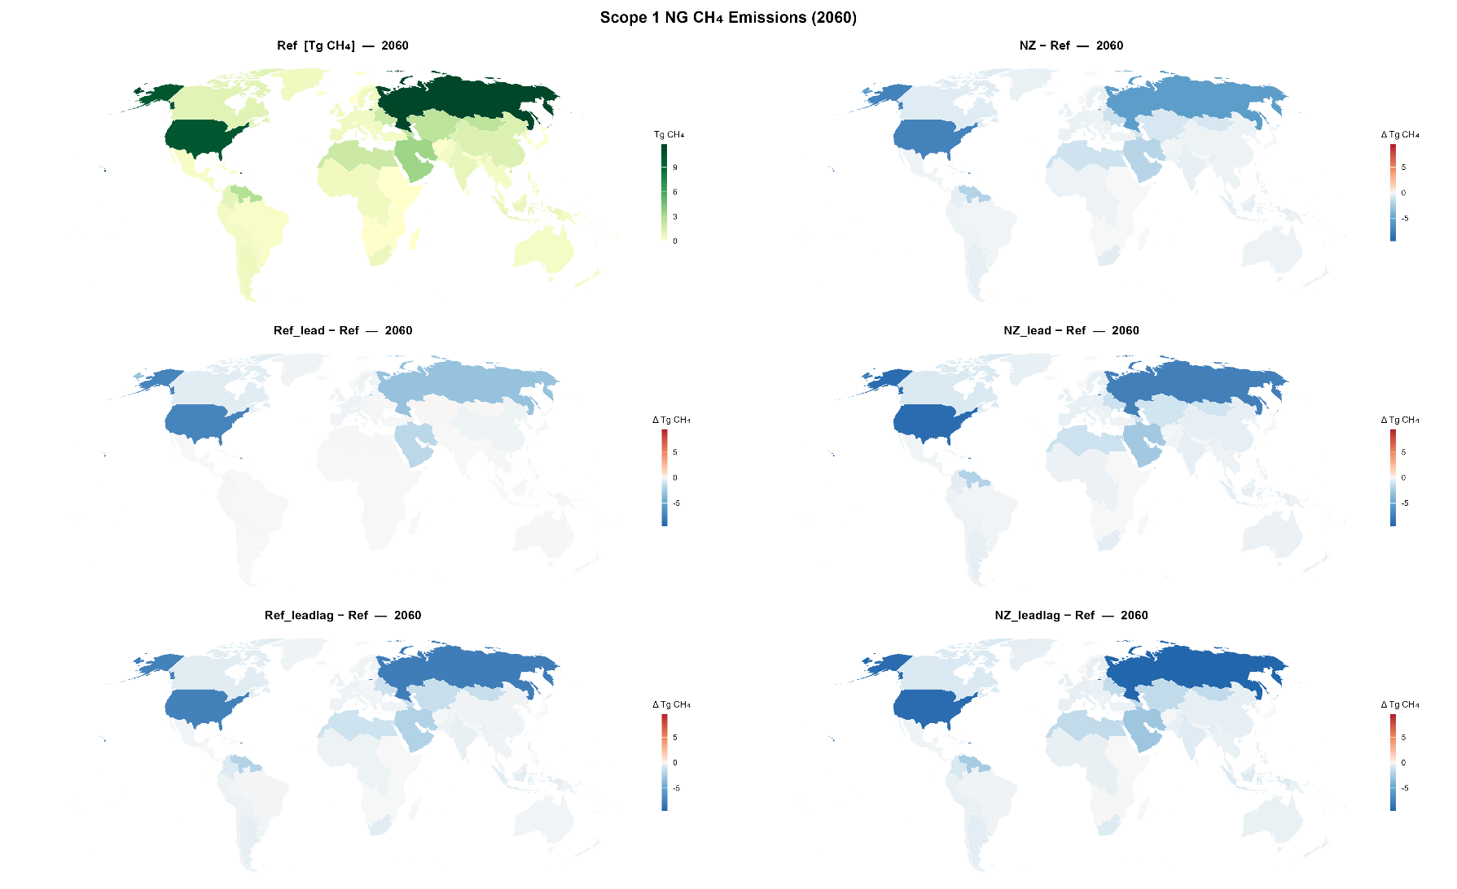
Figure S14. Scope 1 NG CH₄ Emissions (Production + Transmission within region) in 2060 under Ref scenario and the changes from Ref scenario to the rest five scenarios

