Chromosome-scale genome assembly and population genomic analysis of Phomopsis asparagi pathogen reveal genetic diversity among geographical populations
Yu Shi¹, Chun-Xia Yang¹, Hao-Han Ning¹, Yi-Ran Wang¹, Yuan Wang³, Guo-Bing Cui¹, Wu-Jun Gao^{1,2}, Shu-Fen Li^{1,*}

¹College of Life Sciences, Henan Normal University, Xinxiang 453007, China

²The Observation and Research Field Station of Taihang Mountain Forest Ecosystems of Henan Province, Xinxiang, Henan 453007, China

³Xinxiang Zhaofeng Agricultural Technology Co., Ltd., Xinxiang 453007, China

*Corresponding author: Shu-Fen Li (lishufen@htu.cn)

Table of Contents
Fig. S1 Conidial morphology of eight P. asparagi strains from different geographical regions.
Fig. S2 Mycelial morphology of eight P. asparagi strains from different geographical regions.
Fig. S3 Kmer distribution map of P. asparagi genome
Fig. S4 Genome GC content and sequencing depth distribution map of the P. asparagi
Fig. S5 Genome annotation and gene classification analysis.
Fig. S6 Functional annotation ananlysis of the whole genome of P. asparagi strain.
Fig. S7 The classification of Eukaryotic Orthologous Groups (KOG) of the annotated unigenes.
Fig. S8 Functional annotation ananlysis of the whole genome of P. asparagi strain.
Table S1. Summary statistics of genome K-mer of P. asparagi.
Table S2. HiC-Pro mapping results statistics.
Table S3. Summary statistics of chromosome sequence distribution.

Table S4. Statistics of alignment results of second-generation sequencing data.
Table S5. BUSCO evaluation results of P. asparagi genome.
Table S6. Summary statistics of gene structure annotations in H. lupulus genome.
Table S7. Summary statistics for repetitive element annotations in the P. asparagi genome.
Table S8. Non-coding RNA predicition results of P. asparagi genome.
Table S9. Predicted pseudogenes in P. asparagi genome.
Table S10. Statistics of apping alignment results for P. asparagi isolate.
Fig. S1 Mycelial morphology of eight P. asparagi strains from different geographical regions.
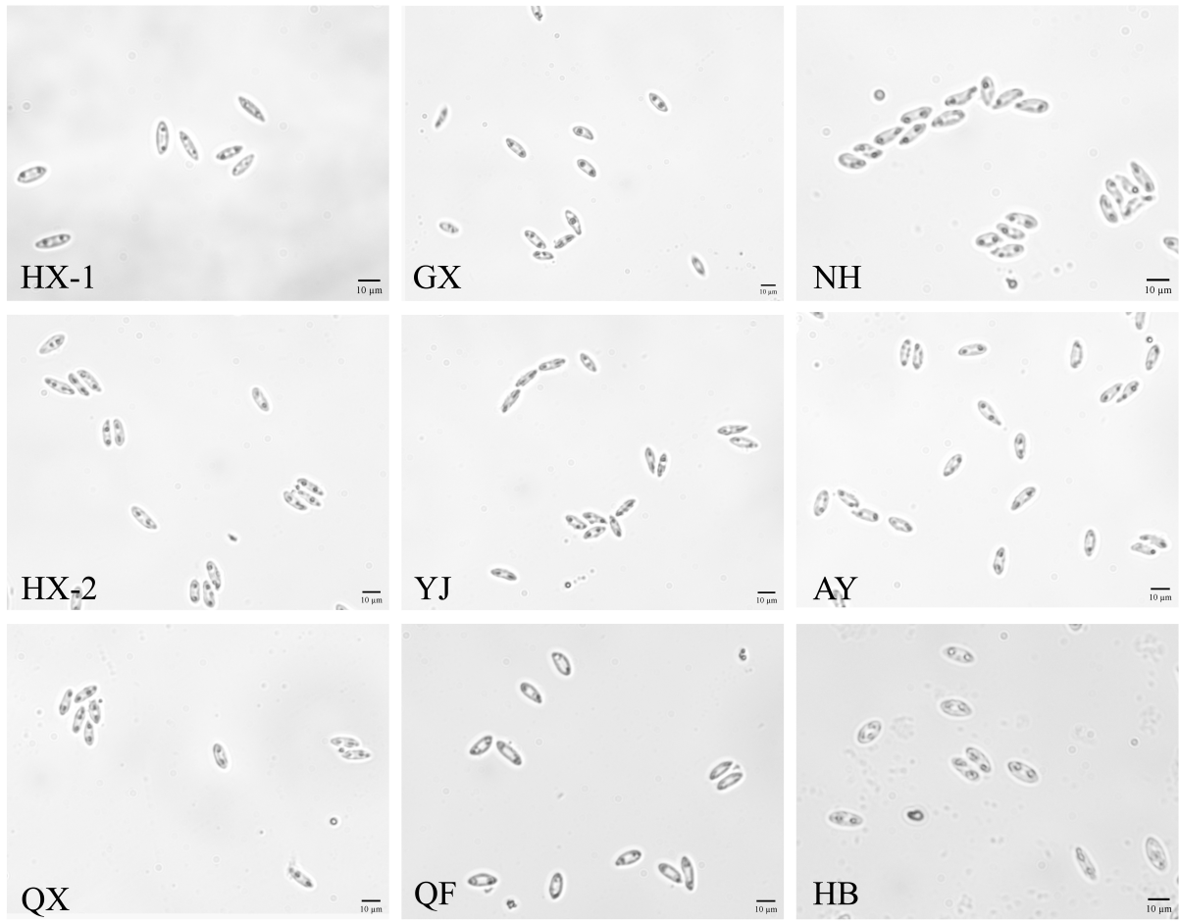
Fig. S2 Conidial morphology of eight P. asparagi strains from different geographical regions.

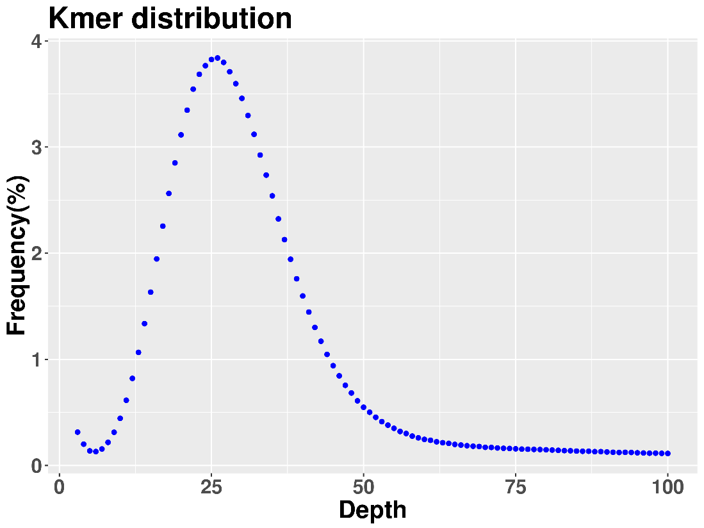
Fig. S3 Kmer distribution map of P. asparagi genome
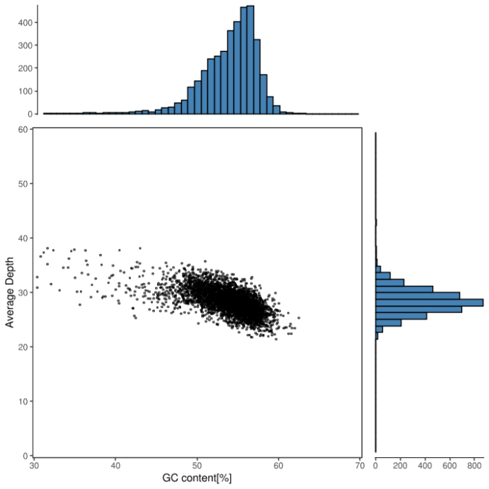
Fig. S4 Genome GC content and sequencing depth distribution map of P. asparagi.
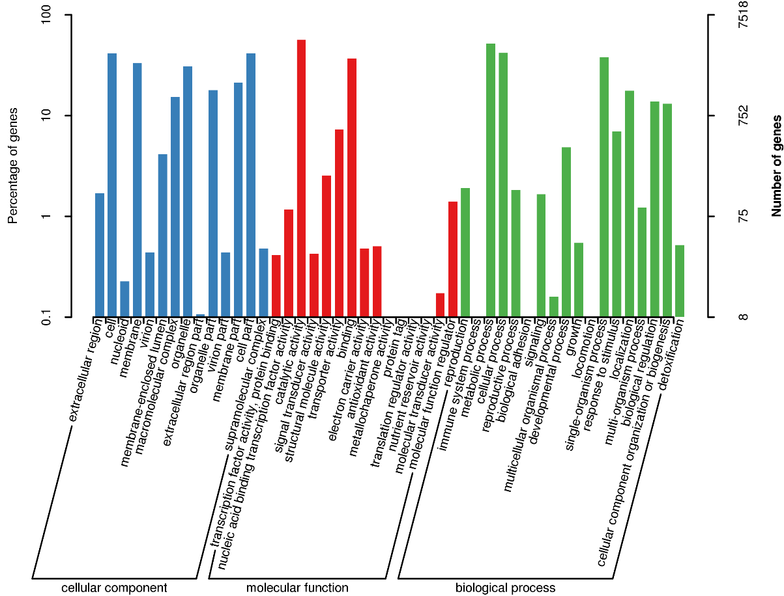
Fig. S5 Functional classification of Gene Ontology (GO) annotations in the genome of the P.asparagi.
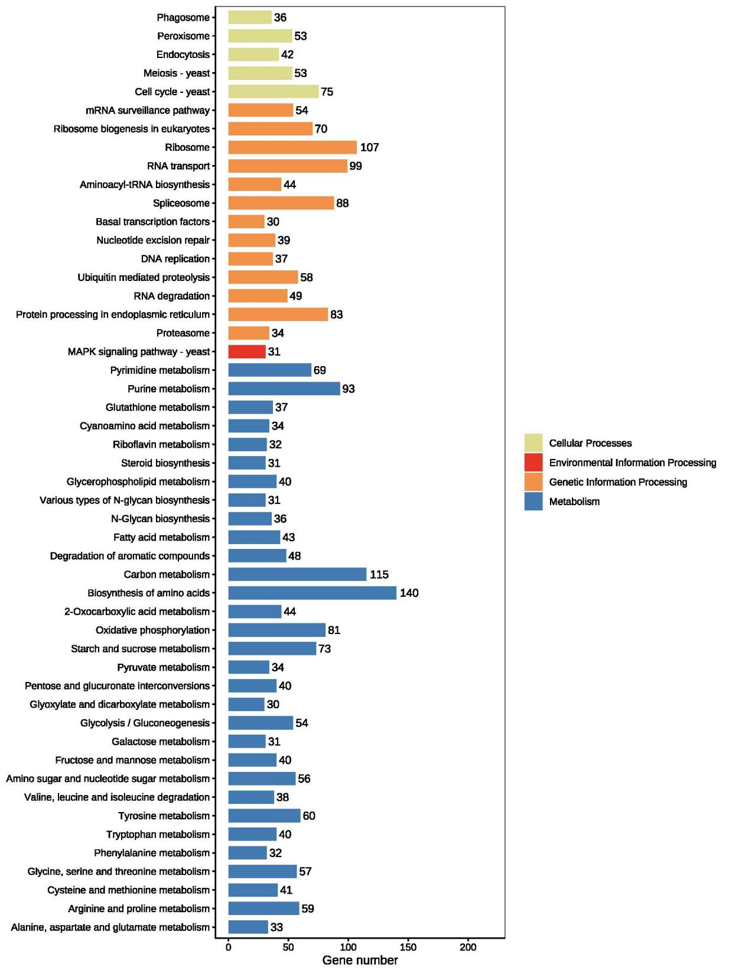
Fig. S6 Kyoto Encyclopedia of Genes and Genomes (KEGG) and classification on the annotated unigenes. In total, 3,604 unigenes were grouped into 112 pathways, including cellular processes, environmental information processing, genetic information processing and metabolism.
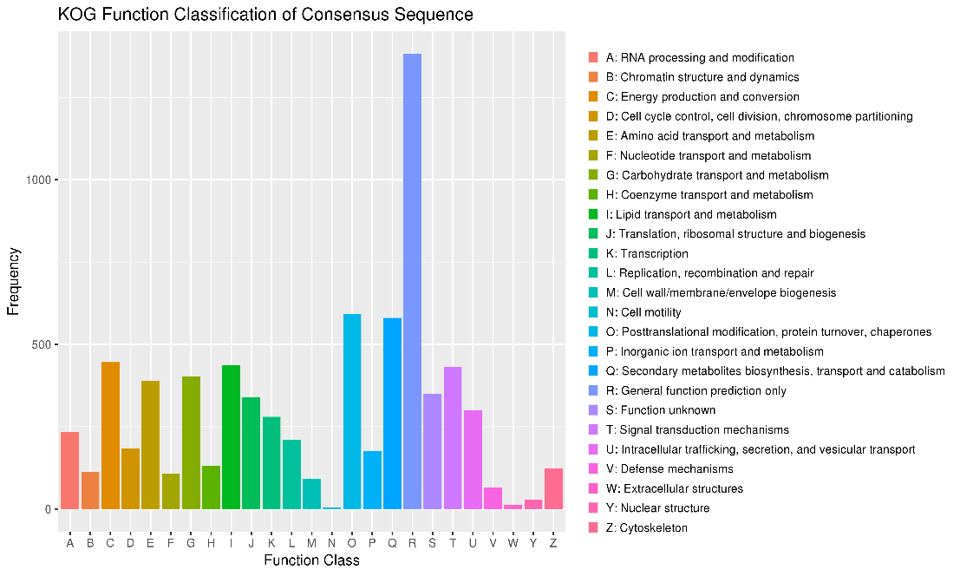
Fig. S7 The classification of Eukaryotic Orthologous Groups (KOG) of the annotated unigenes. All unigenes were aligned to the KOG database to predict and classify possible functions. Out of 6545 genes were grouped into 25 KOG classifications.
Fig. S8 Functional annotation analysis of the whole genome of P. asparagi strain. (A) The histogram presents the CAZy (Carbohydrate-Active Enzymes) functional annotation. A total of 931 CAZy-encoding genes were identified, which are classified into six major functional categories, including glycoside hydrolases, auxiliary activities, carbohydrate esterases, glycosyl transferases, carbohydrate-binding modules and polysaccharide lyases. (B) Functional annotation of transporter proteins was performed on the predicted protein sequences of P. asparagi strain using the TCDB database. A total of 133 genes were annotated, which are distributed in 5 major categories: channels/pores, electrochemical potential-driven transporters, primary active transporters, accessory factors involved in transport and incompletely characterized transport systems. (C) Distribution of annotated homologous species in the TCDB database for P. asparagi genome.
Table S1. Summary statistics of genome K-mer of P. asparagi
Measure | Value
Total K-mer count | 2,763,810,616
Valid K-mer count | 2,698,831,689
Estimated genome size / Mbp | 102.78
Repetitive content / % | 58.96
Heterozygosity rate / % | 0.34

Table S2. HiC-Pro mapping results statistics
Type | Pairs count | Percent (%)
Total read pairs | 44,392,046 | 100.00
Mapped reads | 82,947,741 | 93.43
Unique mapped read pairs | 33,251,800 | 74.90

Table S3. Summary statistics of chromosome sequence distribution
Group | Sequence number | Sequence length (bp)
Lachesis Group1 | 1 | 13,523,886
Lachesis Group2 | 2 | 13,017,923
Lachesis Group3 | 1 | 12,386,621
Lachesis Group4 | 1 | 11,694,366
Lachesis Group5 | 4 | 11,281,672
Lachesis Group6 | 4 | 11,023,864
Lachesis Group7 | 3 | 8,023,736
Lachesis Group8 | 1 | 7,973,092
Total sequences clustered (Ratio %) | 17（51.52） | 88,925,163 (99.65)
Total sequences ordered and oriented (Ratio %) | 17（100） | 88,925,163 (100)

Table S4. Statistics of alignment results of second-generation sequencing data
Library | Mapped (%) | Properly Mapped (%) | Coverage (%) | Depth (%)
350 bp | 98.33 | 88.11 | 99.93 | 34.61

Table S5 BUSCO evaluation results of P. asparagi genome
Complete BUSCOs(C) | Complete and single-copy BUSCOs(S) | Complete and duplicated BUSCOs(D) | Fragmented BUSCOs(F) | Missing BUSCOs(M) | Total lineage BUSCOs
285 (98.28%) | 284 (97.93%) | 1 (0.34%) | 1 (0.34%) | 4 (1.38%) | 290

Table S6. Summary statistics of gene structure annotations in P. asparagi genome
Method | Software | Species | Gene  number
Ab initio based | AUGUSTUS |  | 11,364
 | Genscan |  | 11,918
 | GeneID |  | 21,159
 | GlimmerHMM |  | 14,084
 | SNAP |  | 15,308
RNAseq based | PASA |  | 19,519
 | TransDecoder |  | 32,913
Homology-based | GeMoMa | Cytospora leucostoma | 9,833
 |  | Valsa mali | 10,500
 |  | Valsa sordida | 9,635
Integration | EvidenceModeler |  | 33,796

Table S7. Summary statistics for repetitive element annotations in the P. asparagi genome
Type |  |  | Number | Length (bp) | % in genome
Class Ⅰ | LTR | Copia | 1,435 | 3,839,833 | 4.30
Class Ⅰ | LTR | Gypsy | 540 | 1,739,264 | 1.95
Class Ⅰ | nonLTR | DIRS | 240 | 271,886 | 0.30
Class Ⅰ | nonLTR | LINE | 63 | 18,338 | 0.02
Class Ⅰ | nonLTR | PLE|LARD | 389 | 342,910 | 0.38
Class Ⅰ | nonLTR | SINE | 34 | 5,240 | 0.01
Class Ⅰ | nonLTR | SINE|TRIM | 158 | 97,716 | 0.11
Class Ⅰ | nonLTR | TRIM | 106 | 67,911 | 0.08
Class Ⅰ | nonLTR | Unknown | 300 | 611,801 | 0.69
Class Ⅱ | Crypton |  | 1 | 52 | 0.00
Class Ⅱ | Helitron |  | 7 | 523 | 0.00
Class Ⅱ | MITE |  | 619 | 135,589 | 0.15
Class Ⅱ | TIR |  | 1,102 | 1,344,642 | 1.51
Class Ⅱ | Unknown |  | 60 | 6,749 | 0.01
PotentialHostGene |  |  | 45 | 52,967 | 0.06
SSR |  |  | 15,110 | 25,318,294 | 28.37
Unknown |  |  | 8,471 | 4,525,700 | 5.07
Total |  |  | 20,210 | 35,652,562 | 39.95

Table S8. Non-coding RNA predicition results of P. asparagi genome
RNA classify | Number | Family Number
rRNA | 39 | 4
tRNA | 204 | 51
Other ncRNA | 94 | 31

Table S9. Predicted pseudogenes in P. asparagi genome
Pesudogene number | Pesudogene size (bp) | Average Pesudogene Length (bp)
26 | 50105 | 1927.11

Table S10 Statistics of apping alignment results for P. asparagi isolate
Sample_ID​​ | Mapped (%) | Average  depth (x) | Coverage (%) | Coverage at  Least 4× (%)
GX | 93.46 | 48.89 | 84.92 | 75.10
NH | 99.08 | 112.76 | 99.93 | 99.81
HX-2 | 98.86 | 111.65 | 99.95 | 99.87
YJ | 98.04 | 65.02 | 99.93 | 99.84
AY | 98.26 | 128.12 | 99.96 | 99.87
QX | 99.25 | 76.83 | 99.84 | 99.60
QF | 99.27 | 94.41 | 99.91 | 99.75
HB | 99.44 | 75.02 | 99.86 | 99.65

