Molecular Fingerprint-regulated Cu(Ⅱ) Adsorption in Acidic Soil by Biomass Burning Smoke-derived DOM: Feedstock Specificity and Aging Effects
Zhigeng Wang¹, Ruxin Tong², Weifeng Chen^{1*}, Yanling Deng^{3*}, Huiying Zhang⁴, Jinzhi Ni¹, Hui Jia², Malcom Frimpong Dapaah², Abdallah Abdelfattah ⁵
¹Institute of Geography, Ministry of Education Key Laboratory of Humid Subtropical Eco-geographical Process, Fujian Provincial Key Laboratory of Plant Ecophysiology, School of Geographical Sciences, Fujian Normal University, Fuzhou, Fujian 350007, China
²School of the Environment and Safety Engineering, Jiangsu University, Zhenjiang, 212013, China
³ Technical Centre for Soil, Agriculture and Rural Ecology and Environment, Ministry of Ecology and Environment, Beijing 100012, China
⁴ School of Environment, Tsinghua University, Beijing, 100084, China
⁵ Department of Public Works Engineering, Faculty of Engineering, Tanta University, Tanta 31511, Egypt
Manuscript prepared for Journal of Soils and Sediments
*Corresponding author:
Weifeng Chen (fengweichen1986@163.com; CWF_geo@fjnu.edu.cn)
*Yanling Deng (dengyanling@tcare-mee.cn)
Text S1 Details of UV-vis and Fluorescence spectroscopic determination
BBS-DOM samples were measured using the UV-Vis spectrophotometer (Shimadzu, Japan) across a wavelength range of 190-800 nm at 1 nm intervals, with a 1 cm path length quartz cuvette and ultrapure water as the blank reference. The UV-vis spectral indices are calculated using the following formula:
a_{m}=2.303·A/l (1)
SUVA₂₅₄= a₂₅₄/C_{DOC} (2)
Where A is the measured absorbance at the corresponding wavelength, l (m) is the optical path length, a₂₂₀ and a₂₅₄ (m⁻¹) are the absorption coefficients at 220 nm and 254 nm, respectively, and C_{DOC} (mg/L) is the DOC concentration of the BBS-DOM sample for UV-Vis analysis.
Fluorescence excitation-emission matrix (EEM) spectra of BBS-DOM solutions were acquired using a fluorescence spectrophotometer (Hitachi, Japan), with excitation (Ex) wavelengths scanned from 200 to 550 nm at 5 nm intervals and emission (Em) wavelengths from 220 to 600 nm at 2 nm intervals. Ultrapure water was used for Raman scattering correction and blank subtraction (He et al., 2021). Parallel factor analysis (PARAFAC) was performed on the EEM dataset using the DOM Fluor Toolbox in MATLAB R2023a (Quan et al., 2020). The PARAFAC model statistically decomposes the complex mixture of DOM fluorophores into independent fluorescent components, enabling the estimation of the underlying EEM spectra of individual components across samples (Quan et al., 2020; Stedmon et al., 2008). Split-half analysis, residual analysis, and visual inspection were used to validate the optimal number of fluorescent components. Four fluorescent components (C1~C4) were identified in this study, with the maximum fluorescence intensity (F_{max}) of each component obtained from the model. The relative abundance of each component was calculated as the ratio of its F_{max} to the sum of F_{max} values of all four components (Song et al., 2020).
Text S2 Fourier Transform Ion Cyclotron Resonance Mass Spectrometry (FT-ICR MS) Analysis
Samples were directly injected into the electrospray ionization (ESI) source via a syringe pump at a flow rate of 180 μL/h, and ionized in negative ion mode. The capillary voltage and end plate offset were set to 4.5 kV and -500 V, respectively. For ion source parameters, the ion accumulation time was set to 0.65 s, the octupole radio frequency (RF) was set to 5 MHz with a peak-to-peak amplitude (Vp-p) of 350 V. The argon-filled hexapole collision cell was operated at a frequency of 2 MHz with an RF amplitude of 1400 Vp-p, and the ion accumulation time in the collision cell was 0.02 s. The optimized mass for the quadrupole was set to 170 Da, the time-of-flight was set to 0.65 s, and the mass range was set to 150-800 Da. A total of 128 consecutive 4-megaword FT-ICR transients were co-added to improve the signal-to-noise ratio and dynamic range. A procedural blank was processed and analyzed following the same protocol to check for potential contamination. The mass spectrum was externally calibrated with arginine clusters in negative ion mode. Internal recalibration of the final spectrum was performed using quadratic calibration in Data Analysis 5.0 (Bruker Daltonics), with peaks of typical O₅⁻containing species used as reference masses. A typical mass resolving power (m/Δm50%, where Δm50% is the full width of the mass spectral peak at half maximum) of >450,000 was achieved at m/z 319, with an absolute mass error of <0.2 ppm (Song et al., 2018; Jiang et al., 2021).
Molecular formulas were classified into different compound groups based on their elemental compositions: CHO compounds contained only C, H, and O atoms; CHON compounds contained C, H, O, and N atoms; CHOP compounds contained C, H, O, and P atoms; CHOS compounds contained C, H, O, and S atoms; CHOSP compounds contained C, H, O, S, and P atoms; CHONP compounds contained C, H, O, N, and P atoms; CHONS compounds contained C, H, O, N, and S atoms; CHONSP compounds contained C, H, O, N, S, and P atoms. Other compounds included molecular formulas with elemental compositions of CH, CHN, CHNP, CHNS, CHNSP, CHP, CHS, and CHSP. The modified aromaticity index (AI_{mod}) and double bond equivalent (DBE) were calculated using the following equations:
AI_{mod}=(1+C-0.5O-S-0.5H-0.5N)/(C-0.5O-S-N) (S1)
DBE=C-0.5H+0.5N+1 (S2)
In the equations provided below, C, H, O, N, and S represent the number of carbon, hydrogen, oxygen, nitrogen, and sulfur atoms, respectively, in each assigned molecular formula. The DBE/C ratio is defined as the double bond equivalent (DBE) value divided by the number of carbon atoms in the corresponding molecular formula. The equations used to calculate the molecular characteristic indices for each sample are presented below:
Mass=Σ(Mass_{i}·I_{i})/ΣI_{i} (S3)
DBE=Σ(DBE_{i}·I_{i})/ΣI_{i} (S4)
AI_{mod}=Σ(AI_{modi}·I_{i})/ΣI_{i} (S5)
In the equations below, i denotes the i assigned molecular formula, and I_{i} represents the relative peak intensity of the i molecular formula. The interpretation and definition of each molecular characteristic index are detailed in Table S1.
Text S3 Characterization of BBS-DOM-Amended Soil Properties
Soil pH Determination: soil pH was measured at a soil-to-water mass ratio of 1:2.5. Briefly, soil samples (including both unamended control and BBS-DOM-amended soils) were mixed with deionized water, and the suspension was allowed to stand for 2 h to reach equilibrium. The supernatant was then collected, and pH was measured using a pre-calibrated pH meter. All measurements were performed in triplicate, and the average value was reported as the final pH of each sample. Soil Organic Carbon Content Determination: collected soil samples were air-dried and sieved through a 200-mesh sieve to remove coarse particles. Soil organic carbon content was determined using an elemental analyzer. All measurements were performed in triplicate, and the average value was reported for each sample. Soil Specific Surface Area and Micropore Area Determination: the specific surface area of soil samples was measured using an automatic specific surface area analyzer. First, unamended soil and BBS-DOM-amended soil samples were vacuum degassed at 100 ℃ for 12 h to completely remove moisture and adsorbed gases from the samples. The N₂ adsorption-desorption isotherms were then measured at liquid nitrogen temperature (77 K). The specific surface area of the samples was calculated using the Brunauer-Emmett-Teller (BET) method, and the micropore area was analyzed using the t-plot model. Soil Cation Exchange Capacity (CEC) Determination: soil CEC was determined using the ammonium acetate exchange method. Briefly, air-dried soil samples were sieved through a 200-mesh sieve, and 3.0 g of soil was weighed into a 50 mL centrifuge tube. 30 mL of 1 mol/L ammonium acetate solution was added to the tube, and the mixture was thoroughly homogenized using a vortex shaker. The tube was then placed in a constant temperature shaker and oscillated at 220 rpm for 6 h at 25 ℃. After oscillation, the suspension was centrifuged at 4000 rpm for 5 min, and the supernatant was discarded. To remove excess ammonium acetate from soil pores, 30 mL of 95% ethanol was added to the centrifuge tube, and the mixture was fully homogenized via vortexing, followed by centrifugation at 4000 rpm for 5 min and supernatant discard. This washing step was repeated 3 times. For the fourth wash, the sample was homogenized with 95% ethanol, oscillated at 220 rpm for 6 h at room temperature, centrifuged at 4000 rpm for 5 min, and the supernatant was discarded. Nessler's reagent was used to verify the complete removal of ammonium ions from the supernatant (indicated by a colorless or faint yellow solution). Subsequently, 30 mL of 10% NaCl solution was added to the centrifuge tube. The mixture was thoroughly homogenized via vortexing, oscillated at 220 rpm for 6 h at 25 ℃, centrifuged at 4000 rpm for 5 min, and filtered through a 0.45 μm membrane filter to collect the supernatant. The ammonium (NH₄⁺) concentration in the supernatant was determined using a continuous flow analyzer. All measurements were performed in triplicate, and the average value was used for calculation. The calculation equation is as follows:
CEC (cmol⁽⁺⁾/kg) = (NH₄⁺×0.03/3)/18×100 (S6)
Table S1. Interpretations of molecular characteristic index by FT-ICR MS.
Parameters | Interpretations | References
O/C | The higher the O/C, the higher the polarity | Roth et al., 2013; Chen et al., 2021
H/C | The higher the H/C ratio, the lower the aromaticity and the higher the lipophilicity. | Roth et al., 2013; Chen et al., 2021
AI_{mod} | The higher the AI_{mod}, the more aromatic compounds. | Roth et al., 2013; Chen et al., 2021
DBE | The higher the DBE, the higher the degree of unsaturation (depending on the number of π bonds and rings) | Roth et al., 2013; Chen et al., 2021
DBE/C | The higher the DBE/C ratio, the higher the bond density of C=C | Roth et al., 2013; Chen et al., 2021

Table S2. Physical-chemical properties of soil.
 | Organic Carbon (mg/g) | Specific Surface Area (m²/g) | Micropore Area (m²/g) | pH | DOC (mg/g)
Soil | 7.45±0.09 | 20.80 | 3.67 | 4.14±0.05 | 0.09±0.004

Table S3. The meanings of the fluorescence components of BBS-DOM.
Components | Ex / Em | Meaning | References
C1 | Ex =235nm and 290nm  /Em=374 nm | Large humic-like matters | Chen et al., 2003; Tang et al., 2019;  Zhang et al., 2019;  Ye et al., 2020.  Yu et al., 2023
C2 | Ex =265nm and 350nm  /Em=446 nm | Fulvic-like matters
C3 | Ex =235nm and 325nm  /Em=398 nm | Large humic-like matters
C4 | Ex =215nm and 275nm  /Em=314 nm | Polyphenol-like matters

Table S4. Elemental compositions of various biomasses.
Biomasses | C(wt.%) | H(wt.%) | O(wt.%) | N(wt.%)
AF | 41.03±0.09 | 5.48±0.00 | 42.07±0.24 | 3.85±0.06
PW | 45.35±0.65 | 5.51±0.00 | 46.85±0.44 | 0.07±0.02
CS | 40.88±0.12 | 5.29±0.00 | 46.97±0.44 | 1.14±0.003

Table S5. The pH values of various BBS-DOM samples.
BBS-DOM | AF300 | AF600 | PW300 | PW600 | CS300 | CS600
pH | 5.07±0.01 | 8.36±0.02 | 3.37±0.02 | 3.25±0.04 | 3.36±0.02 | 3.20±0.01
Table S6. Fitting parameters of Langmuir and Freundlich models for Cu(Ⅱ) adsorption by original and BBS-DOM-amended soils at different aging times.
Samples | Aging time (month) | Langmuir |  |  | Freundlich
Samples | Aging time (month) | Q_{m} (mg·g⁻¹) | K_{L} (L/mg) | R² | n | K_{F} (mg^{1-n}·L^{n}/g) | R²
original soil | 0 | 1.22±0.18 | 0.02±0.01 | 0.96 | 0.54±0.03 | 0.07±0.01 | 0.99
original soil | 1 | 1.05±0.14 | 0.03±0.01 | 0.90 | 0.43±0.04 | 0.12±0.02 | 0.97
original soil | 3 | 1.17±0.08 | 0.03±0.01 | 0.98 | 0.48±0.02 | 0.10±0.01 | 0.99
AF300-soil | 0 | 0.99±0.14 | 0.04±0.01 | 0.91 | 0.45±0.03 | 0.10±0.01 | 0.98
AF300-soil | 1 | 1.05±0.1 | 0.05±0.01 | 0.93 | 0.40±0.00 | 0.14±0.00 | 1.00
AF300-soil | 3 | 1.21±0.22 | 0.04±0.02 | 0.81 | 0.42±0.07 | 0.15±0.04 | 0.90
AF600-soil | 0 | 1.02±0.09 | 0.09±0.03 | 0.88 | 0.33±0.02 | 0.22±0.02 | 0.99
AF600-soil | 1 | 1.19±0.13 | 0.07±0.03 | 0.87 | 0.34±0.03 | 0.23±0.03 | 0.96
AF600-soil | 3 | 1.21±0.12 | 0.08±0.03 | 0.87 | 0.35±0.02 | 0.23±0.02 | 0.99
PW300-soil | 0 | 1.16±0.26 | 0.02±0.01 | 0.91 | 0.55±0.05 | 0.06±0.01 | 0.97
PW300-soil | 1 | 1.06±0.12 | 0.03±0.01 | 0.93 | 0.44±0.03 | 0.11±0.01 | 0.98
PW300-soil | 3 | 1.12±0.13 | 0.03±0.01 | 0.95 | 0.48±0.02 | 0.09±0.01 | 0.99
PW600-soil | 0 | 0.89±0.09 | 0.03±0.01 | 0.96 | 0.48±0.04 | 0.08±0.01 | 0.98
PW600-soil | 1 | 1.03±0.15 | 0.03±0.01 | 0.90 | 0.45±0.04 | 0.10±0.02 | 0.97
PW600-soil | 3 | 1.08±0.13 | 0.03±0.01 | 0.95 | 0.49±0.02 | 0.09±0.01 | 0.99
CS300-soil | 0 | 1.01±0.11 | 0.03±0.01 | 0.97 | 0.50±0.03 | 0.08±0.01 | 0.99
CS300-soil | 1 | 0.98±0.08 | 0.04±0.01 | 0.95 | 0.42±0.00 | 0.12±0.00 | 1.00
CS300-soil | 3 | 1.06±0.13 | 0.03±0.01 | 0.92 | 0.45±0.02 | 0.11±0.01 | 0.99
CS600-soil | 0 | 1.06±0.14 | 0.02±0.01 | 0.95 | 0.52±0.03 | 0.07±0.01 | 0.99
CS600-soil | 1 | 0.94±0.09 | 0.04±0.01 | 0.94 | 0.41±0.00 | 0.12±0.00 | 1.00
CS600-soil | 3 | 0.92±0.09 | 0.04±0.01 | 0.93 | 0.43±0.03 | 0.11±0.01 | 0.99
Table S7. Properties of different elemental molecules in various BBS-DOM.
Compound | Properties | AF300 | AF600 | PW300 | PW600 | CS300 | CS600
CHOP | H/C | 1.49 | 1.58 | 1.47 | 1.48 | 1.39 | 1.45
CHOP | O/C | 0.55 | 0.45 | 0.61 | 0.64 | 0.57 | 0.61
CHOP | AI_{mod} | 0.12 | 0.12 | 0.07 | 0.05 | 0.14 | 0.09
CHOP | DBE | 5.29 | 4.95 | 5.36 | 4.97 | 6.12 | 5.40
CHOP | Mass | 329.7 | 324.1 | 344.6 | 331.9 | 346.4 | 336.7
CHOS | H/C | 1.68 | 1.66 | 1.45 | 1.51 | 1.24 | 1.35
CHOS | O/C | 0.48 | 0.49 | 0.23 | 0.25 | 0.45 | 0.40
CHOS | AI_{mod} | 0.08 | 0.07 | 0.20 | 0.16 | 0.24 | 0.18
CHOS | DBE | 3.40 | 3.38 | 6.65 | 5.57 | 6.55 | 5.82
CHOS | Mass | 345.0 | 329.5 | 340.5 | 333.9 | 320.1 | 316.9
CHONS | H/C | 1.75 | 1.67 | 1.36 | 1.40 | 1.52 | 1.42
CHONS | O/C | 0.36 | 0.39 | 0.26 | 0.28 | 0.37 | 0.31
CHONS | O/N | 3.88 | 3.95 | 1.70 | 1.94 | 2.64 | 1.97
CHONS | AI_{mod} | 0.07 | 0.06 | 0.20 | 0.17 | 0.13 | 0.17
CHONS | DBE | 4.66 | 4.87 | 7.98 | 7.59 | 6.53 | 7.20
CHONS | Mass | 409.3 | 395.9 | 393.1 | 402.4 | 409.9 | 371.7
CHONSP | H/C | 2.07 | 2.14 | 2.00 | 2.02 | 2.04 | 2.04
CHONSP | O/C | 0.13 | 0.13 | 0.23 | 0.23 | 0.20 | 0.22
CHONSP | O/N | 0.66 | 0.88 | 0.96 | 0.94 | 0.76 | 0.90
CHONSP | AI_{mod} | 0.02 | 0.02 | 0.01 | 0.01 | 0.01 | 0.02
CHONSP | DBE | 3.87 | 3.24 | 4.36 | 4.13 | 3.96 | 4.18
CHONSP | Mass | 451.1 | 447.2 | 411.2 | 409.2 | 375.8 | 397.8
Table S8. Effects of BBS-DOM input on the physical and chemical properties of original soil under different aging time.
Samples | Aging time (month) | Organic carbon (mg/g) | Specific surface area (m²/g) | Microporous area (m²/g) |  | CEC (cmol/kg) | pH
original soil | 0 | 7.45±0.09 aC | 20.80 | 3.67 | 8.83±0.04 |  | 4.14±0.05 cB
original soil | 1 | 7.80±0.21 aC | 21.61 | 3.72 | 7.35±0.04 |  | 4.78±0.09 aB
original soil | 3 | 7.32±0.73 aB | 20.64 | 3.47 | 7.55±0.03 |  | 4.59±0.05 bCD
AF300-soil | 0 | 8.36±0.06 bB | 18.90 | 2.00 | 7.54±0.14 |  | 4.20±0.05 bB
AF300-soil | 1 | 8.86±0.28 aAB | 19.58 | 2.95 | 7.53±0.24 |  | 5.01±0.08 aB
AF300-soil | 3 | 8.14±0.10 aA | 20.24 | 3.16 | 7.43±0.48 |  | 5.1±0.09 aB
AF600-soil | 0 | 8.72±0.27 aA | 17.78 | 0.85 | 7.50±0.06 |  | 5.24±0.18 aA
AF600-soil | 1 | 8.55±0.19 aB | 19.11 | 2.30 | 7.25±0.05 |  | 5.54±0.05 aA
AF600-soil | 3 | 8.12±0.16 bA | 19.26 | 1.88 | 7.42±0.13 |  | 5.72±0.08 aA
PW300-soil | 0 | 8.78±0.16 abAB | 18.82 | 2.17 | 7.50±0.03 |  | 3.72±0.05 bD
PW300-soil | 1 | 8.82±0.17 aAB | 19.52 | 2.93 | 7.68±0.09 |  | 4.27±0.05 aC
PW300-soil | 3 | 8.26±0.10 bA | 20.28 | 3.83 | 7.63±0.17 |  | 4.45±0.08 aD
PW600-soil | 0 | 8.49±0.26 abAB | 19.34 | 2.22 | 8.62±0.05 |  | 3.74±0.04 bD
PW600-soil | 1 | 8.79±0.05 aAB | 19.24 | 2.34 | 7.53±0.08 |  | 3.76±0.08 bD
PW600-soil | 3 | 8.32±0.25 bA | 19.88 | 3.40 | 7.63±0.17 |  | 4.36±0.05 aD
CS300-soil | 0 | 8.18±0.23 bB | 19.32 | 2.39 | 8.86±0.07 |  | 3.87±0.04 cC
CS300-soil | 1 | 8.98±0.14 aA | 19.10 | 2.90 | 7.37±0.11 |  | 4.00±0.04 bCD
CS300-soil | 3 | 8.19±0.11 bA | 20.18 | 3.85 | 7.70±0.07 |  | 4.64±0.05 aC
CS600-soil | 0 | 8.29±0.05 bB | 19.12 | 2.07 | 8.73±0.06 |  | 3.78±0.02 bCD
CS600-soil | 1 | 8.78±0.26 aAB | 19.23 | 2.40 | 7.46±0.02 |  | 4.00±0.24 bD
CS600-soil | 3 | 8.36±0.17 bA | 20.35 | 3.93 | 7.70±0.00 |  | 4.51±0.06 aCD
Different capital letters represent significant differences in spectral indicators among different BBS-DOM-soil, and different lowercase letters represent significant differences in spectral indicators for different aging times (p<0.05).
Fig. S1. The UV-Vis absorbance spectra of different BBS-DOM. AF, PW, and CS indicate alfalfa- pinewood-, and corn straw-derived BBS-DOM, respectively; the suffixes “300” and “600” indicate the smoldering and flaming conditions.
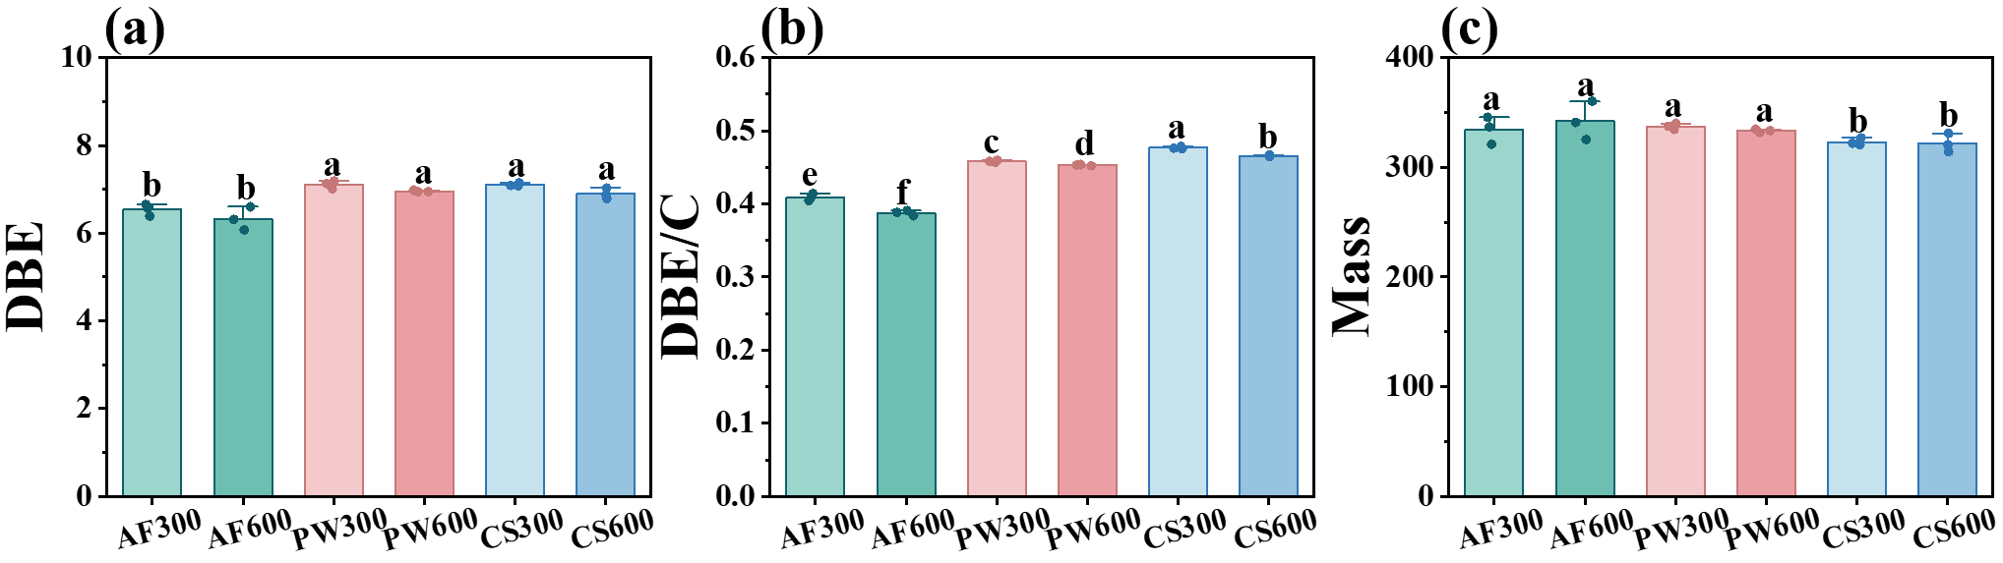
Fig. S2. The molecular characteristic of BBS-DOM, including DBE (a), DBE/C (b) and Mass (c). Different lowercase letters indicate significant differences among different BBS-DOMs (p<0.05).

Fig. S3. The van Krevelen diagrams (O/C vs. H/C) of organic molecules in different BBS-DOM samples. AF, PW, and CS indicate alfalfa- pinewood-, and corn straw-derived BBS-DOM, respectively; the suffixes “300” and “600” indicate the smoldering and flaming conditions.

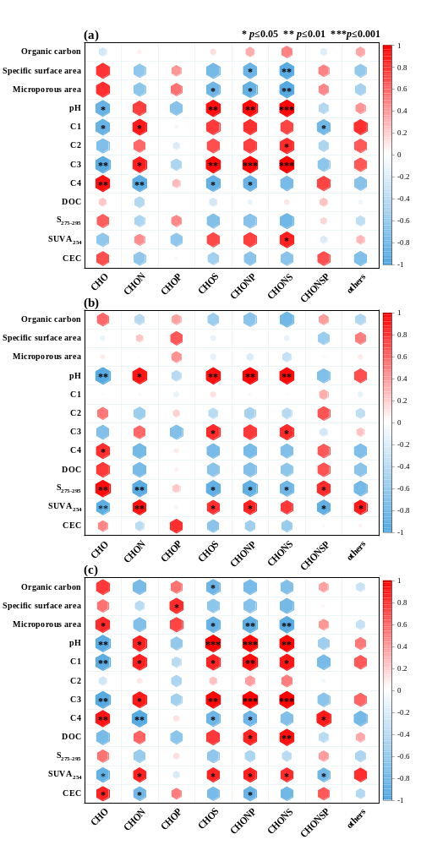
Fig. S4. Correlation matrix of elemental compound intensities of BBS-DOM and soil properties after different aging times, (a) unaged, (b) aged 1 month, and (c) aged 3 months.
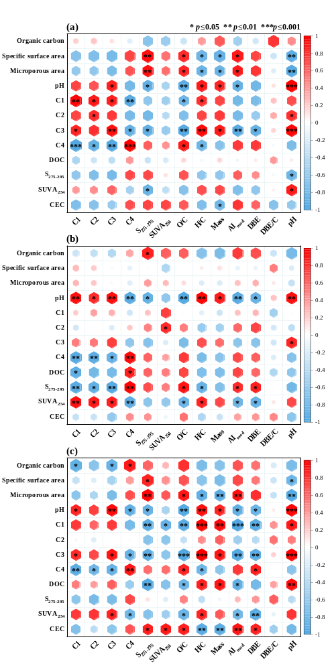
Fig. S5. Correlation matrix of properties of the BBS-DOM and soil properties after different aging times, (a) unaged, (b) aged 1 month, and (c) aged 3 months.
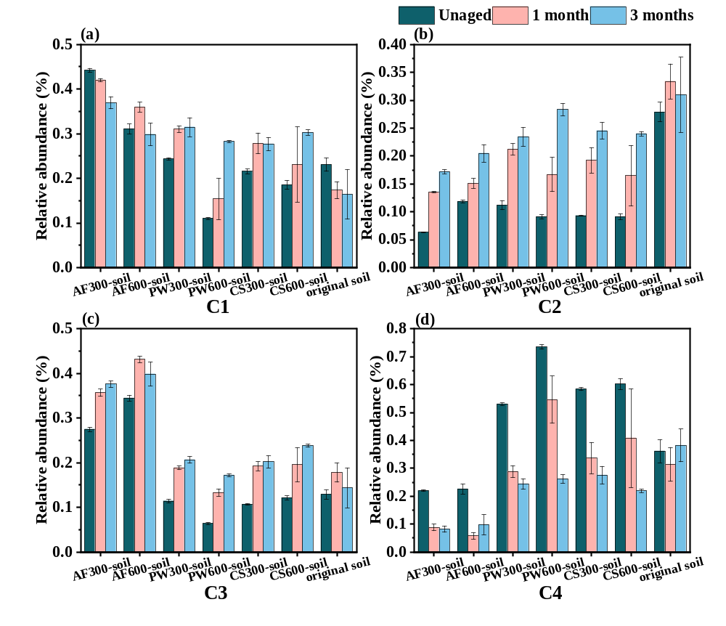
Fig. S6. Relative abundance of fluorescent components in soil DOM after BBS-DOM addition and aging.
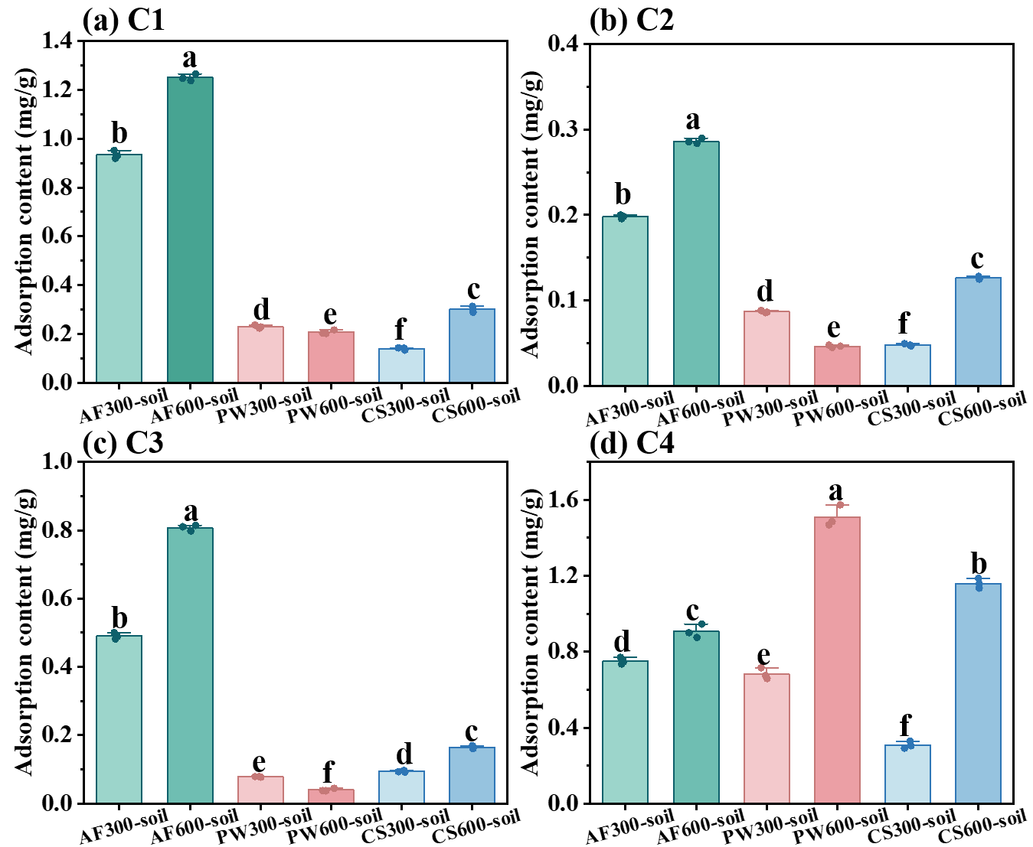
Fig. S7. Solid-phase adsorption content of fluorescent components of BBS-DOM on soil. Different lowercase letters indicate significant differences among different BBS-DOMs (p<0.05).

References
Chen H, Ersan M. S, Tolic N, et al. Chemical characterization of dissolved organic matter as disinfection byproduct precursors by UV/fluorescence and ESI FT-ICR MS after smoldering combustion of leaf needles and woody trunks of pine (Pinus jeffreyi). Water Res. 2021, 209, 117962.
Chen W, Westerhoff P, Leenheer J, et al. Fluorescence excitation-emission matrix regional integration to quantify spectra for dissolved organic matter. Environ. Sci. Technol. 2003, 37, 5701-5710.
He C, He X, Li J, et al. The spectral characteristics of biochar-derived dissolved organic matter at different pyrolysis temperatures. J. Environ. Chem Eng. 2021, 9, 106075.
Jiang H, Li J, Sun R, et al. Molecular Dynamics and Light Absorption Properties of Atmospheric Dissolved Organic Matter. Environ. Sci. Technol. 2021, 55, 10268-10279.
Quan G, Fan Q, Zimmerman A R, et al. Effects of laboratory biotic aging on the characteristics of biochar and its water-soluble organic products. J. Hazard. Mater. 2020, 382, 121071.
Roth V, Dittmar T, Gaupp R, et al. Latitude and pH driven trends in the molecular composition of dom across a north south transect along the yenisei river. Geochim. Cosmochim. Ac. 2013, 123, 93-105.
Song J, Li M, Jiang B, et al. Molecular Characterization of Water-Soluble Humic like Substances in Smoke Particles Emitted from Combustion of Biomass Materials and Coal Using Ultrahigh-Resolution Electrospray Ionization Fourier Transform Ion Cyclotron Resonance Mass Spectrometry. Enviro. Sci. Techn. 2018, 52, 2575-2585.
Song C, Shan S, Yang C, et al. The comparison of dissolved organic matter in hydrochars and biochars from pig manure. Sci.Total Environ. 2020, 720, 137423.
Stedmon C, Bro R. Characterizing dissolved organic matter fluorescence with parallel factor analysis: a tutorial. Limnol. Oceanog-Meth, 2008, 6, 572-579.
Tang J, Wang W, Yang L, et al. Variation in quantity and chemical composition of soil dissolved organic matter in a peri-urban critical zone observatory watershed in Eastern China. Sci. Total Environ. 2019, 688, 622-631.
Ye Q, Wang Y, Zhang Z, et al. Dissolved organic matter characteristics in soils of tropical legume and non-legume tree plantations. Soil Biol. Biochem. 2020, 148, 107880.
Yu S, Zhang H, Ni J, et al. Spectral characteristics coupled with self-organizing maps analysis on different molecular size-fractionated water-soluble organic carbon from biochar. Science of Total Environment, 2023, 857: 159424.
Zhang Y, Zhang B, He Y, et al. DOM as an indicator of occurrence and risks of antibiotics in a city-river reservoir system with multiple pollution sources. Sci. Total Environ. 2019, 686, 276-289.

