Supplementary Materials
Included
Studies included in review (n = 7)
Identification
Studies screened (n = 475)
Studies sought for retrieval (n = 71)
Studies assessed for eligibility (n = 71)
References removed (n = 538)
Duplicates identified (n = 538)
Other reasons/references (n = 0)
Studies excluded (n = 404)
Studies not retrieved (n = 0)
Studies excluded (n = 64)
Wrong patient population (n = 61)
Self-reported exposure (n = 1)
Outcomes by benign breast subtypes not presented within race groups (n = 2)
Screening
Benign breast disease studies from databases described in the methods (n = 1,013)

Supplementary Figure 1. PRISMA 2020 flow diagram for identification of benign breast disease studies as of February 24, 2026; among women from diverse racial backgrounds worldwide

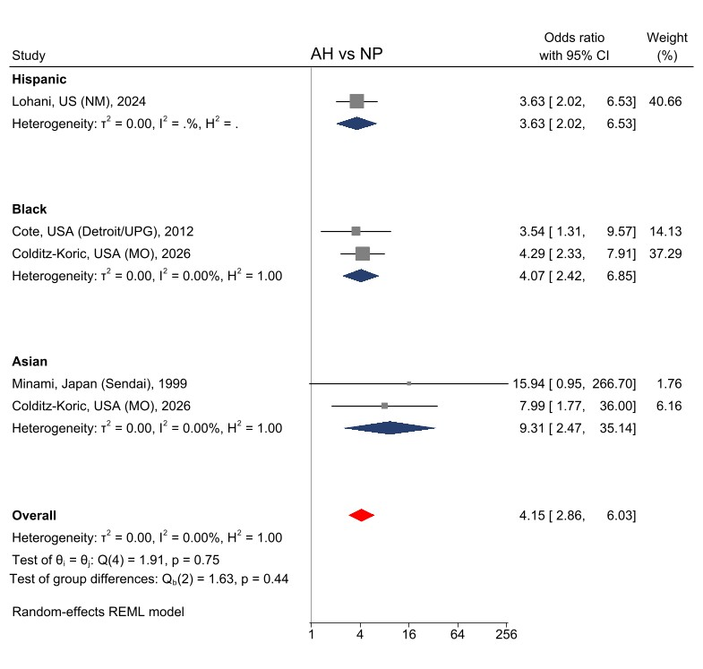
Supplementary Figure 2: Forest plot for meta-analysis of subsequent breast cancer risk for women diagnosed with atypical hyperplasia (AH) of benign breast lesions diagnosed between 1972–2023, exclusion of 2 studies without clear separation of cases within 6-months of follow-up

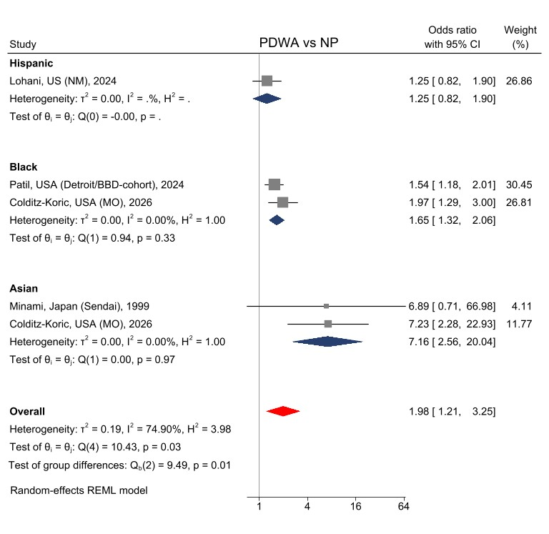
Supplementary Figure 3: Forest plot for meta-analysis of subsequent breast cancer risk for women diagnosed with proliferative disease without atypia (PDWA) of benign breast lesions diagnosed between 1972–2023, exclusion of 2 studies without clear separation of cases within 6-months of follow-up
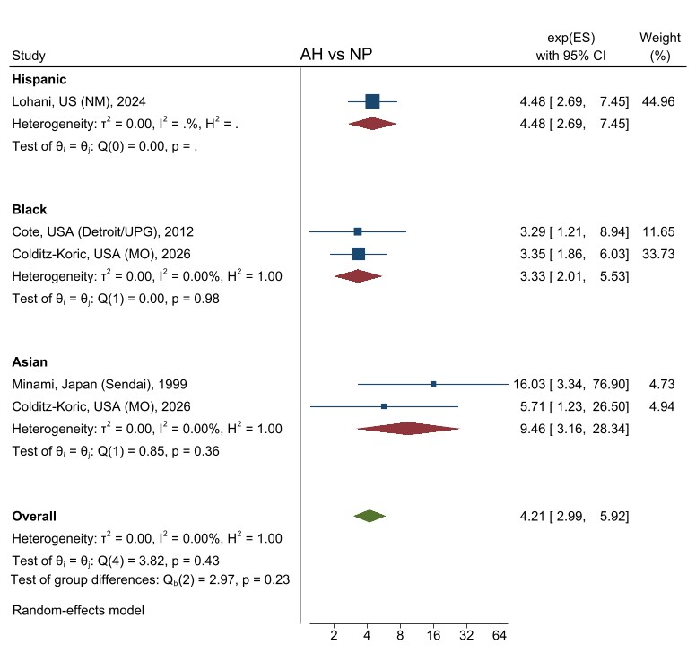
Supplementary Figure 4: Forest plot for meta-analysis of subsequent breast cancer risk for women diagnosed with atypical hyperplasia (AH) of benign breast lesions diagnosed between 1972–2023, presented by race and ethnicity standardized risk estimates on a log-scale of the original study risk estimates
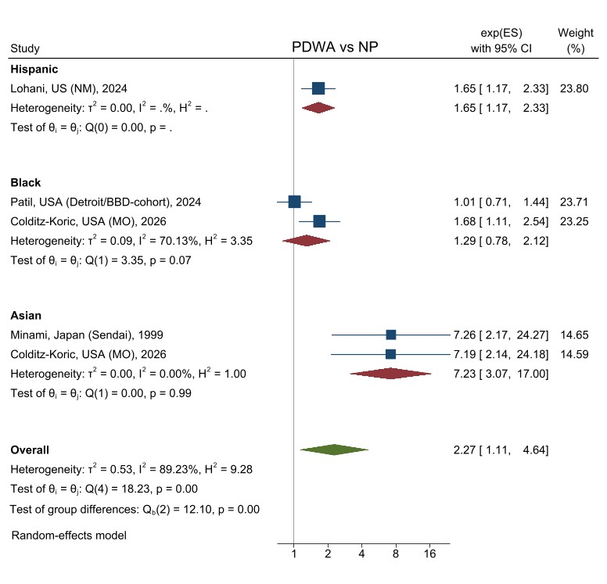
Supplementary Figure 5: Forest plot for meta-analysis of subsequent breast cancer risk for women diagnosed with proliferative disease without atypia (PDWA) of benign breast lesions diagnosed between 1972–2023, presented by race and ethnicity standardized risk estimates on a log-scale of the original study risk estimates

A

B

Supplementary Figure 6: Funnel plot of subsequent risk of breast cancer after benign breast disease for women diagnosed with atypical hyperplasia (A) and proliferative disease without atypia (B) subtypes of benign breast lesions, n = 8 studies (1972–2023)

Supplementary Table 1. Original risk estimates from observational cohort studies of histologic BBD stratification and subsequent risk of breast cancer included in this meta-analysis
Author/  race | World  region | Year published | NP |  |  | PDWA |  |  | AH
 |  |  | RR | 95%CI |  | RR/OR/HR | 95%CI |  | RR/OR/HR | 95%CI
Hispanic
Lohani | USA, NM | 2024 | 1.84 | (1.46, 2.32) |  | 1.65 | (1.17, 2.33) |  | 4.48 | (2.69, 7.44)
Louro | Spain, Barcelona | 2020 | 1.95 | (1.68, 2.27) |  | 3.19 | (2.46, 4.13) |  | 3.82 | (2.23, 6.56)
Black
Koric ª | USA, MO | 2026 |  |  |  | 1.68 | (1.11, 2.53) |  | 3.35 | (1.86, 6.02)
Patil | USA, MI/MDCSS | 2024 |  |  |  | 1.01 | (0.71, 1.45)
Cote | USA, MI/MDCSS | 2012 |  |  |  | 1.16 | (0.64, 2.12) |  | 3.29 | (1.21, 8.93)
Asian
Koric ª | USA, MO | 2026 |  |  |  | 7.19 | (2.14, 24.2) |  | 5.71 | (1.23, 26.5)
Minami | Japan, Sendai | 1999 | 0.93 | (0.11, 7.66) |  | 7.26 | (2.17, 24.26) |  | 16.00 | (3.34, 76.87)
Nomura | Japan, Kyushu | 1993 | 0.75 | (0.08, 6.68) |  | 4.00 | (0.34, 9.85) |  | 25.20 | (3.68, 172.8)
Abbreviations: BBD, benign breast disease; NP, nonproliferative disease; PDWA, proliferative disease without atypia; AH, atypical hyperplasia
ª Population of Black and Asian women from the same study cohort

Supplementary Table 2. Newcastle-Ottawa Quality Assessment tool for cohort studies, applied to studies worldwide of women from diverse racial and ethnic backgrounds diagnosed with benign breast disease for the assessment of subsequent breast cancer risk
 | Lohani et al. | Louro et al. | Koric et al. | Patil et al. | Cote et al. | Minami et al. | Nomura et al.
Selection (maximum: 4 stars/points)
1) Representativeness of the exposed cohort
a) Truly representative (one point) | 1 | 1 | 1 | 1 | 1 | 1 | 1
b) Somewhat representative (one point)
c) Selected group
d) No description of the derivation of the cohort
2) Selection of the non-exposed cohort
a) Drawn from the same community as the exposed cohort (one point) | 1 | 1 | 1 | 1 | 1 | 1 | 1
b) Drawn from a different source
c) No description of the derivation of the non-exposed cohort
3) Ascertainment of exposure
a) Secure record (e.g., surgical record) (one point) | 1 | 1 | 1 | 1 | 1 | 1 | 1
b) Structured interview (one point)
c) Written self-report
d) No description
e) Other
4) Demonstration that outcome of interest was not present at start of study | 1 | 1 | 1 | 1 | 1 | 1 | 1
a) Yes (one point)
b) No
Comparability (maximum: 2 points)
1) Comparability of cohorts on design or analysis controlled for confounders
a) The study controls for age, sex and marital status (one point)
b) Study controls for other factors (list) __ (one point) | 1 | 1 | 1 | 1 | 1 | 1 | 1
c) Cohorts are not comparable on the basis of the design or analysis controlled for confounders
Outcome (maximum: 3 points)
1) Assessment of outcome
a) Independent blind assessment (one point)
b) Record linkage (one point) | 1 | 1 | 1 | 1 | 1 | 1 | 1
c) Self report
d) No description
e) Other
2) Was follow-up long enough for outcomes to occur
a) Yes (one point) | 1 | 1 | 1 | 1 | 1 | 1 | 1
b) No
Indicate the median/mean duration of follow-up and a brief rationale for the assessment above:____ | 12.8 yrs | 7.8 yrs | 6, 7 yrs | 6.4 yrs | 10.1 yrs | 7.6 yrs | 8 yrs
3) Adequacy of follow-up of cohorts
a) Complete follow-up of all subject accounted for (one point)
b) Subjects lost to follow up unlikely to introduce bias (one point) | 1 | 1 | 1 | 1 | 1 | 1 | 1
c) Follow up rate less than 80% and no description of those lost
d) No statement
Note: "A study can be given a maximum of one point (star) for each numbered item within the Selection and Outcome categories. A maximum of two points can be given for Comparability." Good quality if: 3-4 points in Selection; 1-2 in Comparability; 2-3 in Outcome. Fair quality if: 2 points in Selection; 1-2 points in Comparability; 2-3 in Outcome. Poor Quality if any of these 0-1 points.

Supplementary Table 3. Assessment of stability in heterogeneity of observational cohort studies of histologic BBD stratification included in this meta-analysis, with the removal of one study at a time
BBD subtype |  |  |  | PDWA |  |  |  | AH
 | Race/ | World  region |  | I² (%) | N | p-value |  | I² (%) | N | p-value
All studies | ethnicity | World  region | Year | 0.00 | 7 | 0.0677 |  | 64.72 | 7 | 0.0102
Lohani (left-out) | Hispanic | USA, NM | 2024 | 67.93 | 6 | 0.0223 |  | 71.40 | 6 | 0.0100
Louro (left-out) ª | Hispanic | Spain, Barcelona | 2020 | NA | NA | NA |  | 0.00 | 6 | 0.3470
Cote (left-out)^{b} | Black | USA, MI/MDCSS | 2012 |  | 6 |  |  | 75.03 | 6 | 0.0051
Patil (left-out) | Black | USA, MI/MDCSS | 2024 | 73.25 | 6 | 0.0401 |  | 64.72 | 6 | 0.0102
Koric (left-out) | Black | USA, MO | 2026 | 75.01 | 6 | 0.0593 |  | 71.35 | 6 | 0.0087
Minami (left-out) | Asian | Japan, Sendai | 1999 | 0.00 | 6 | 0.0710 |  | 66.79 | 6 | 0.0085
Koric (left-out) | Asian | USA, MO | 2026 | 0.00 | 6 | 0.4114 |  | 67.12 | 6 | 0.0095
Nomura (left-out) | Asian | Japan, Kyushu | 1993 | 0.00 | 6 | 0.0557 |  | 56.68 | 6 | 0.0369
Abbreviations: BBD, benign breast disease; NP, nonproliferative disease; PDWA, proliferative disease without atypia; AH, atypical hyperplasia
ª Convergence not achieved during tau2 estimation
^{b} The analysis of AH only, Cote and Patil overlap for the assessment of the PDWA subtype of benign breast lesions

