Supplementary Materials

Supplementary Note 1. Further detailed descriptions and results of MAPLES system evolution
Confidence in launching the prospective deployment was established through retrospective evaluation of the 2018-2022 cohorts and pilot prospective deployment in the Fall 2023 cohort, which demonstrated strong agreement between AI-generated and human SPEs of clinical notes.¹⁹ Concurrently with the prospective deployment, we continuously expanded the multimodal assessment pipeline as foundation model capabilities, modality support, and context window lengths improved. The pipeline evolved from text-based post-encounter note grading (Fall 2023 – Fall 2024 cohorts), to transcript-based assessment of communication and physical examination performance (Spring 2025 cohort), and ultimately to native audio and video-based evaluation (Fall 2025 – Spring 2026 cohorts) (Table 2). This parallel development strategy enabled incremental validation of each modality while maintaining operational continuity for active OSCE administrations.
The first addition to clinical note grading and validation was the transcript-based grading of the full OSCE encounter, for 227 MS1 learners of the Spring 2025 cohort (Table 2). The transcript was extracted from the audio recording of the OSCE. This prospective deployment demonstrated 96% item-level agreement across 4,320 SPE-reviewed items. Among adjudicated disagreements in transcript-based communication and PE items, physician expert scores aligned with AI grades in 50% of cases, SPE grades in 35%, and neither in 15%.
The next addition, video, was deployed in Fall 2025 and Spring 2026. Our confidence in the prospective deployment of video-based AI assessment came from a thorough retrospective analysis of the multicamera video-based grading of the Fall 2024 cohort, which showed strong agreement between AI and physician-expert scores (quadratic-weighted Cohen’s κ = 0.832 and agreement = 92.3% using 3-camera fusion native video²⁵).
These results, combined with faculty leadership confidence in system readiness, established sufficient evidence to proceed with prospective activation for the full multimodal AI grading of OSCE encounters starting with the Fall 2025 cohort.
Across the differently designed adjudication cohorts, physician scores aligned with AI scores in 32% of disagreements in Fall 2023,18 50% in Spring 2025, and 76.0% in Fall 2025. Because cohorts, selection rules, and adjudication protocols differed, these descriptive values should not be interpreted as a temporal performance trend.

Supplementary Fig. 1 | AI–SPE score agreement by effective response-scale size.
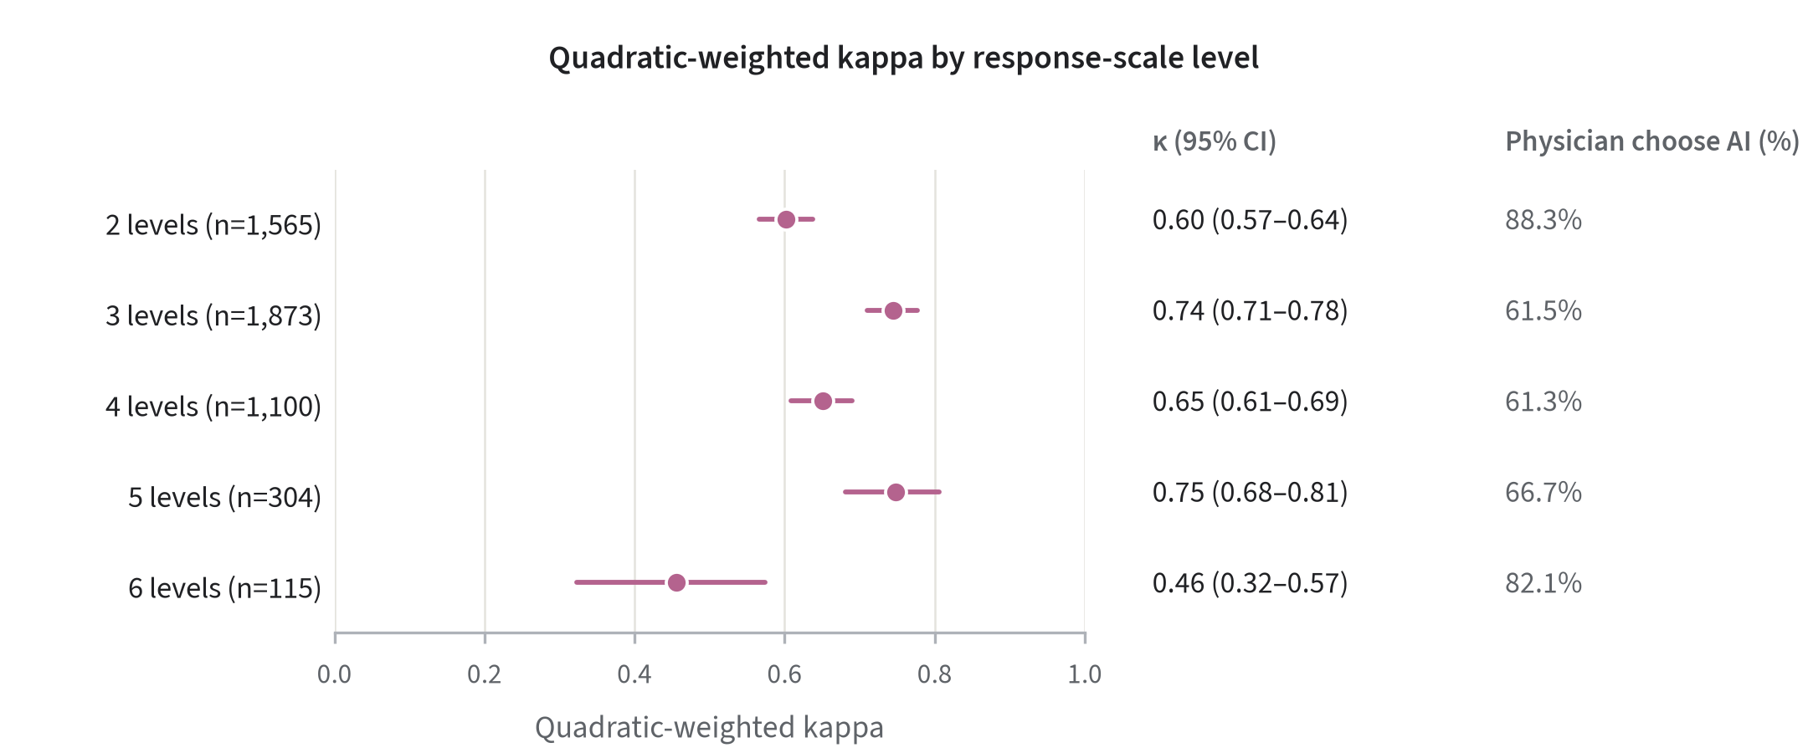

Quadratic-weighted kappa (κ) (QWK) between artificial intelligence (AI) and standardized patient evaluator (SPE) scores within each effective response-scale stratum (two to six levels; scale validation and corrections are defined in the main Methods) among 4,957 valid reviewed items in the routed review set. The scale-specific analysis excluded 16 items with scores outside the validated response range from the 4,973 items independently rescored by SPEs blinded to AI scores across 28 routed learners. QWK is a chance-corrected ordinal agreement measure that penalizes larger category differences more heavily. Points show QWK estimates; horizontal lines show learner-clustered 95% percentile-bootstrap confidence intervals (2,000 resamples). Text columns give the valid reviewed-item count per stratum and physician alignment with AI as n/N (%) among selected adjudicated non-tie disagreements in that stratum. Physician adjudicators were not blinded to whether a score came from AI or the SPE, and these alignment percentages describe the selected adjudication subset only; confidence intervals apply to the QWK estimates, not to the physician-alignment annotations. All estimates are conditional on the routed low-scoring review set and do not describe cohort-wide performance.

Supplementary Fig. 2 | AI–SPE score agreement by competency domain.

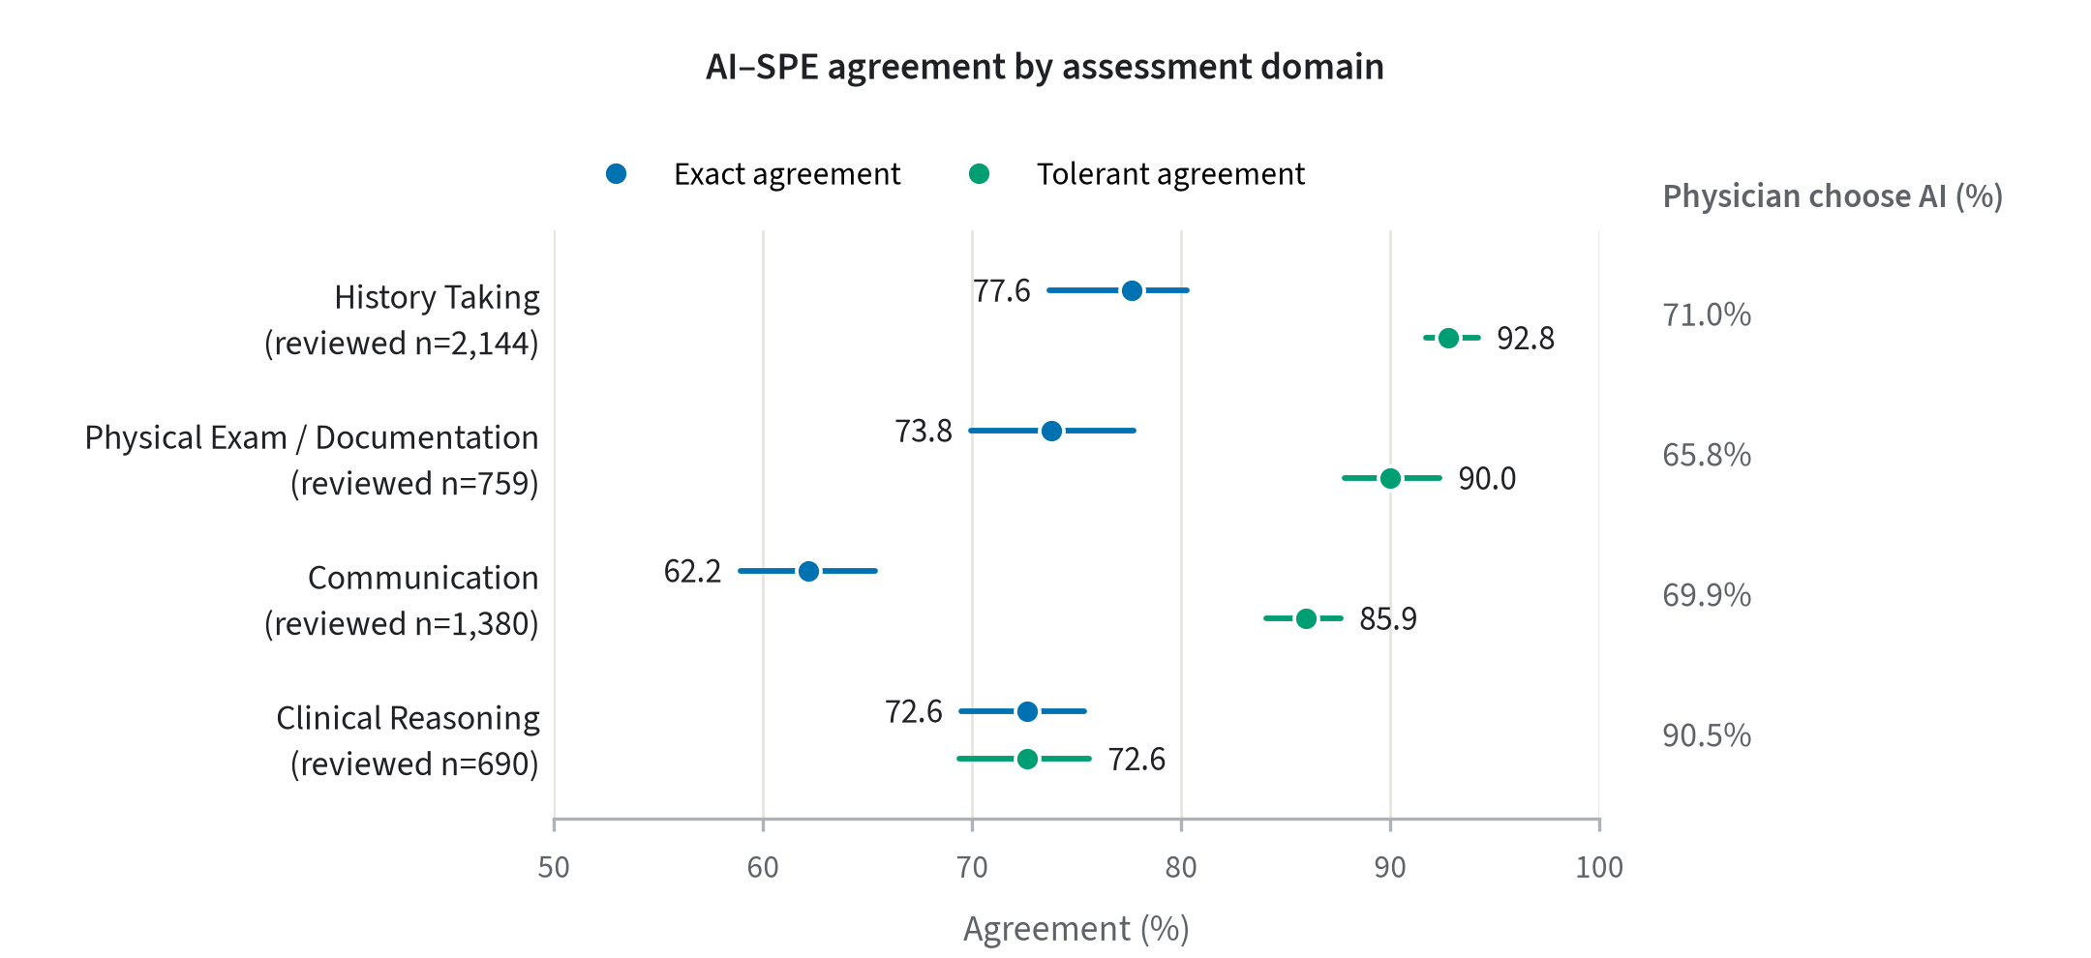
Exact (blue) and tolerant (green) agreement between artificial intelligence (AI) and standardized patient evaluator (SPE) scores across four competency domains (history taking, communication, physical examination/documentation, and clinical reasoning) among the 4,973 items independently rescored by SPEs blinded to AI scores in the routed review set. Exact agreement required identical scores. Tolerant agreement required identical scores for binary items and permitted a one-category difference for ordinal items with three or more response levels. Clinical-reasoning items were binary, so exact and tolerant estimates coincide for that domain. Points show agreement estimates; horizontal lines show learner-clustered 95% percentile-bootstrap confidence intervals (2,000 resamples). Text columns give the reviewed item count per domain and physician alignment with AI as n/N (%) among selected adjudicated non-tie disagreements. Physician adjudicators were not blinded to whether a score came from AI or the SPE, and the alignment percentages describe the selected adjudication subset only; confidence intervals apply to the agreement estimates, not to the physician-alignment annotations. All agreement estimates are conditional on the routed low-scoring review set and do not describe cohort-wide performance.

Supplementary Fig. 3 | AI–SPE score agreement across station forms.
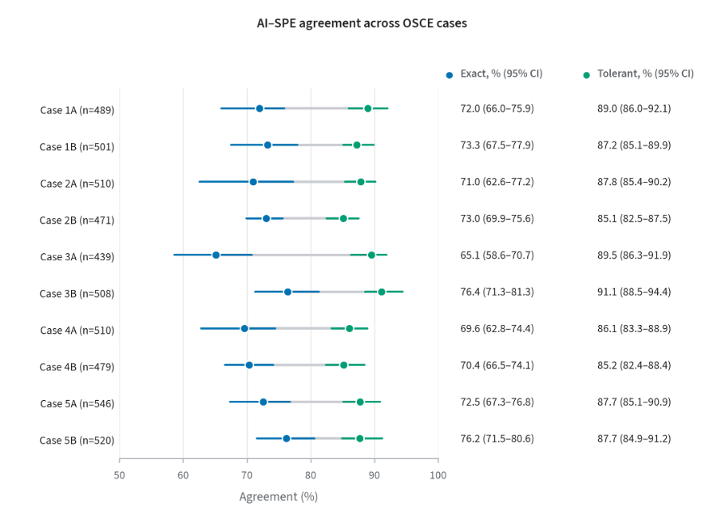
Exact (blue) and tolerant (green) agreement between artificial intelligence (AI) and standardized patient evaluator (SPE) scores across the ten station forms among the 4,973 items independently rescored by SPEs blinded to AI scores in the routed review set. Exact agreement required identical scores. Tolerant agreement required identical scores for binary items and permitted a one-category difference for ordinal items with three or more response levels. Points show agreement estimates; horizontal lines show learner-clustered 95% percentile-bootstrap confidence intervals (2,000 resamples). The ten forms (1A-5B) are A/B alternatives within five clinical themes; each learner completed one form per theme. Reviewed-item counts are shown for each form. All estimates are conditional on the routed low-scoring review set and do not describe cohort-wide performance.

Supplementary Fig. 4 | Learner-order concordance between AI and SPE aggregate scores.
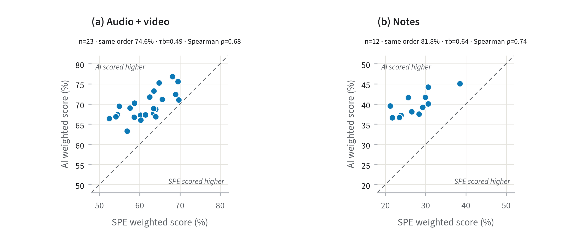
Aggregate ordering statistics for routed learners whose items were independently rescored by standardized patient evaluators (SPEs) blinded to artificial intelligence (AI) scores. The primary analyses included 23 learners for audio/video items (253 possible learner pairs; 252 comparable after excluding one pair tied under either source) and 12 learners for note items (66 possible and comparable pairs; no ties), analyzed separately. Scores are normalized aggregate rubric scores expressed as percentages and calculated from each learner's valid reviewed items. a, Pairwise ordering retention, defined as the percentage of comparable learner pairs for which both scoring sources placed the same learner higher, with learner-clustered 95% percentile-bootstrap confidence intervals (2,000 resamples). Pairs tied under either source were excluded. The open Notes marker shows the sensitivity specified in the analysis plan, restricted to the 11 learners retaining all five cases (55 possible and comparable pairs). b, Kendall tau-b with learner-clustered 95% percentile-bootstrap confidence intervals (2,000 resamples), using the standard tie correction; the axis spans the full -1 to 1 range. The open Notes marker again denotes the complete-five-case sensitivity. c, Median absolute within-pair score gaps, in percentage points, for concordant and discordant pairs on the AI and SPE score scales, with pair counts labeled; this panel uses the primary reviewed-tail analyses only. The analyses were post hoc and restricted to routed learners, so they do not establish ordering in the full cohort or differences between modality strata. No learner-level score coordinates or data points are displayed.

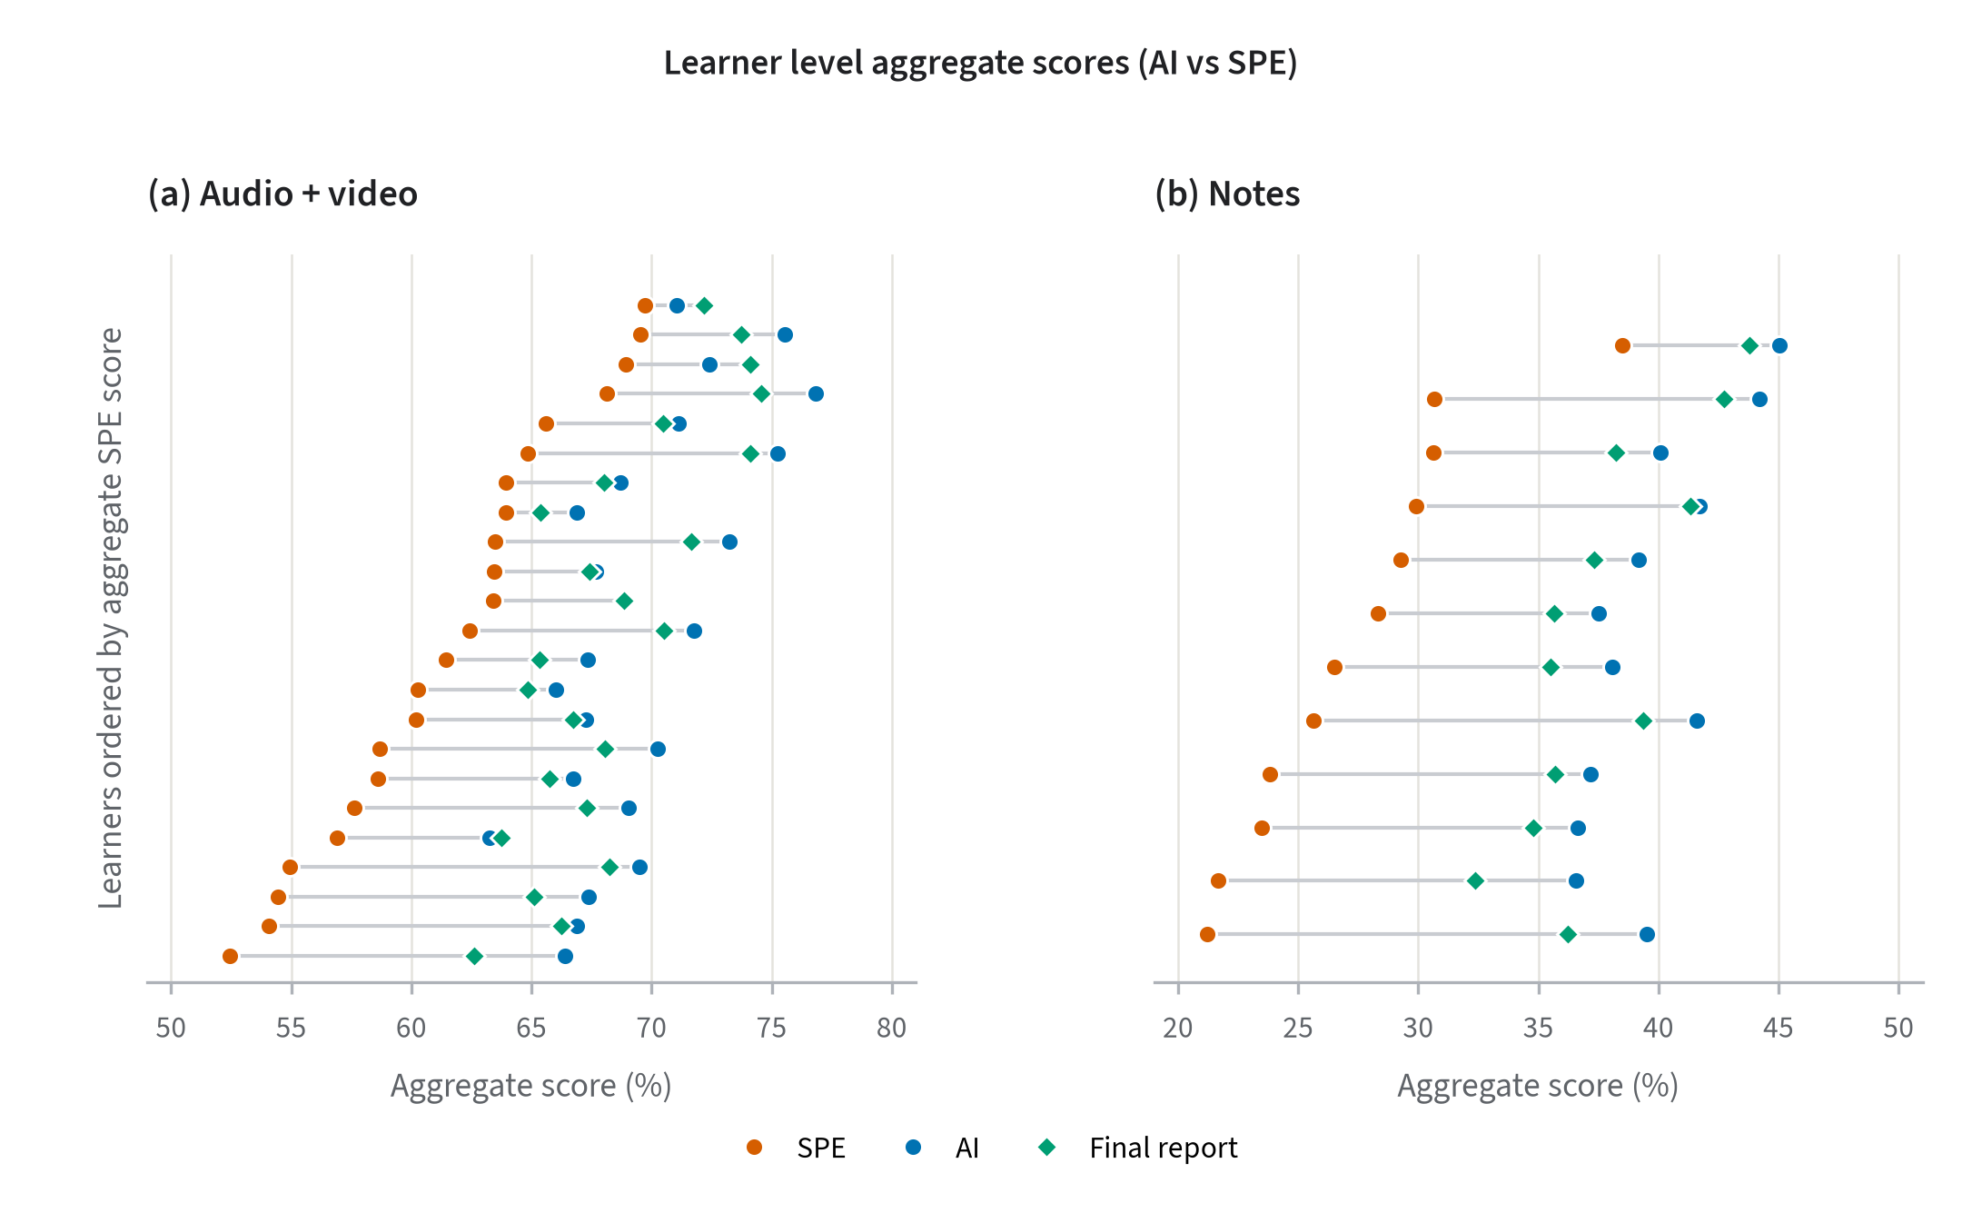
Supplementary Fig 5. Learner-level aggregate scores by scoring source. Each horizontal line represents one learner in the reviewed tail, ordered by aggregate specialized patient evaluator (SPE) score within each stratum. Points show rubric-weighted aggregate scores from the SPE, AI, and final report for 23 audio/video learners and 12 Notes learners. Final-report scores incorporate physician-adjudicated values where available and otherwise retain the AI score. This post hoc comparison is limited to reviewed learners and does not assess score agreement or ranking across the full cohort.

Supplementary Note 2. Definitions and examples of physician expert reasoning for different error categories that contribute to the differences between AI and SPE grading.
Category 1: Over permissive scoring
- Definition: The grader credited higher than the adjudicator's grade: credited a response that was present but did not meet the bar (overly generous scoring of real-but-insufficient evidence).
- Example of AI error:
  - Question: Physical Exam: Tympanic Membranes?
  - Modality: Notes
  - Available responses:
    - (1) Does not document appearance of tympanic membranes
    - (2) Documents appearance of tympanic membranes in the physical exam section.
  - Model response: (2)
    - Model rationale: The student documented "No abnormalities" for the ears. This is a general statement but is accepted as documenting the appearance of the tympanic membranes as normal.
  - Physician expert response: (1)
    - Physician expert rationale: not specific enough, AI too generous
- Example of SPE error:
  - Question: Identifies potential barriers (e.g., cost, transportation, side effects) and concerns about the patient's ability to follow the plan
  - Modality: Audio
  - Available responses:
    - (1) Does not inquire about potential barriers to the plan.
    - (2) Asks a leading or closed-ended question that discourages the patient from disclosing barriers (e.g., "You can do this, right?").
    - (3) Asks a single, generic open-ended question to inquire about barriers. (e.g., "Is this something you're willing and able to do?")
    - (4) Asks an open-ended question about barriers (e.g., "Do you anticipat any challenges to being able to follow through on this plan?") BUT, if appropriate, fails to explore any expressed concerns (e.g., missing school, social pressure, difficulty avoiding screens) in more detail.
    - (5) Asks an open-ended question about barriers (e.g., "Do you anticipate any challenges to being able to follow through on this plan?") AND, if appropriate, explores any expressed concerns (e.g., missing school, social pressure, difficulty avoiding screens) in more detail.
  - SPE response: (3)
  - Physician expert response: (1)
    - Physician expert rationale: He only asked if there were any questions; there was no attempt to identify barriers
Category 2: Evidence oversight
- Definition: The grader missed evidence that was actually present (under-credit), or the evidence for the given grade was unclear.
- Example of AI error:
  - Question: Identifies potential barriers (e.g., cost, transportation, side effects) and concerns about the patient's ability to follow the plan
  - Modality: Audio
  - Available responses:
    - (1) Does not inquire about potential barriers to the plan.
    - (2) Asks a leading or closed-ended question that discourages the patient from disclosing barriers (e.g., "You can do this, right?").
    - (3) Asks a single, generic open-ended question to inquire about barriers. (e.g., "Is this something you're willing and able to do?")
    - (4) Asks an open-ended question about barriers (e.g., "Do you anticipat any challenges to being able to follow through on this plan?") BUT, if appropriate, fails to explore any expressed concerns (e.g., missing school, social pressure, difficulty avoiding screens) in more detail.
    - (5) Asks an open-ended question about barriers (e.g., "Do you anticipate any challenges to being able to follow through on this plan?") AND, if appropriate, explores any expressed concerns (e.g., missing school, social pressure, difficulty avoiding screens) in more detail.
  - Model response: (1)
    - Model rationale: Evidence: None. The student does not inquire about any potential barriers to the patient following the proposed plan. The rubric requires the student to ask a question to elicit these barriers; simply responding to a patient's question does not meet the criteria.
  - Physician expert response: (2)
    - Physician expert rationale: At the end of describing the plan, the student quickly said, "Sound ok?" I think this most fits with a 2 as it was leading in tone and encouraged the patient to simply say yes.
- Example of SPE error:
  - Question: Uses verbal techniques such as neutral utterances (e.g., "mm-hmm") and echoing (repeating brief patient responses, then remaining silent) to encourage patient to tell their own story.
  - Modality: Audio
  - Available responses:
    - (1) Does not use neutral utterances or echoing during interview
    - (2) Uses neutral utterances or echoing one or two times during the interview but misses opportunities to encourage the patient to tell their own story
    - (3) Uses neutral utterances or echoing on multiple occasions to effectively encourage patient to give more information using their own words
  - SPE response: (1)
  - Physician expert response: (3)
    - Physician expert rationale: He used echoing in the beginning at least twice. I'm not sure about the "Okay," which he does a lot. It's effective, so I'm giving credit.
Category 3: Rubrics lack of specificity
- Definition: The rubric item itself is ambiguous, poorly designed, overlapping, or needs revised wording/options; the disagreement stems from item design, not grader skill.
- Example of AI error:
  - Question: Student asks about the patient’s family history
  - Modality: Audio
  - Available responses:
    - (1) Student fails to ask about any medical problems in the patient's family members
    - (2) Student asks about medical problems in the patient's family members but fails to follow-up on important details such as approximate age of diagnosis
    - (3) Student asks about medical problems in the patient's family members and follows up on appropriate diagnoses such as approximate age they were diagnosed, if appropriate
  - Model response: (3)
    - Extracted evidence: "Any family history of kidney stones, by any chance?"
    - Model rationale: The student asks about a relevant family history (kidney stones). The patient answers "no," so there is no opportunity or need to follow up on details like the age of diagnosis. This fulfills the requirements of the skill.
  - Physician expert response: (1)
    - Physician expert rationale: specific relevant questions, but not a general inquiry about medical problems
- Example of SPE error:
  - Question: Discusses suspected diagnosis and alternatives
  - Modality: Audio
  - Available responses:
    - (1) Does not discuss the suspected or possible diagnosis.
    - (2) Discusses only one possible diagnosis but is vague. (e.g., "This could be an infection" or "This could be a problem with your heart.")
    - (3) Discusses multiple possible diagnoses, but only lists vague categories of disease. (e.g. "I'm worried this could be something wrong with your heart, but it could also be something like an infection."
    - (4) Discusses one specific diagnosis, but alternative diagnoses are vague. (e.g., "I'm worried this could be a heart attack, but it could also be something with your lungs or your muscles."
    - (5) Discusses multiple specific diagnoses but does not differentiate between what they think is most likely versus other diagnoses they would like to consider or rule out. (e.g. "It's possible this is an infection, like a pneumonia, or it could be something going on with your heart, like a heart attack.")
    - (6) Discusses multiple specific possible diagnoses and points out what diagnosis they think is most likely and diagnoses that they think are less likely or diagnoses that they would like to rule out.
  - SPE response: (2)
  - Physician expert response: (4)
    - Physician expert rationale: Agree with AI here. We need to say specifically "vague or absent" on the rubric instead of just vague.
Category 4: Wrong documentation placement
- Definition: The adjudicator flags that the finding was entered in the wrong answer box: the student did record the finding, but in a different note section/box than the item requires (e.g., in the history box instead of the physical-exam or justification box); the dispute is over whether documentation in the wrong box earns credit.
- Example of AI error:
  - Question: Supporting History: Palpitations
  - Modality: Notes
  - Available responses:
    - (1) Does not list palpitations or heart racing in the supporting history section.
    - (2) Lists palpitations or heart racing in the supporting history section.
  - Model response: (2)
    - Model rationale: The student lists "pounding heartbeat" in the supporting history for the diagnosis of Anxiety. "Pounding heartbeat" is an equivalent term for palpitations or heart racing.
  - Physician expert response: (1)
    - Physician expert rationale: wrong box
- Example of SPE error:
  - Question: Documentation of Onset
  - Modality: Notes
  - Available responses:
    - (1) Does not document the onset of symptoms.
    - (2) Documents the onset of symptoms, but with a significantly incorrect or vague timeframe.
    - (3) Documents that the onset of symptoms was approximately 5 days ago.
  - SPE response: (1)
  - Physician expert response: (3)
    - Physician expert rationale: documents in support physical exam, but rubric isn't clear when they have to mention. It is absent from the history which is a red flag, certainly
Category 5: Clinical Knowledge
- Definition: The student used a synonym, abbreviation, paraphrase, or implication clinically equivalent to the rubric term (e.g., 'lethargy'~'fatigue', 'STI'='STD', 'liver enzymes'~'LFTs').
- Example of AI error:
  - Question: Supporting Physical Exam: Heart Rhythm
  - Modality: Notes
  - Available responses:
    - (1) Does not list heart rhythm findings in the supporting physical exam section.
    - (2) Lists heart rhythm findings in the supporting physical exam section.
  - Model response: (2)
    - Extracted evidence: Supporting Physical Exam: Anxiety, tachycardia
    - Model rationale: The student lists "tachycardia" as a supporting physical exam finding for both Diagnosis #2 and #3. Tachycardia is a finding related to the heart's rate and rhythm, fulfilling the requirement to list heart rhythm findings.
  - Physician expert response: (1)
    - Physician expert rationale: tachy is rate not rhythm.
- Example of SPE error:
  - Question: Discusses suspected diagnosis and alternatives
  - Modality: Audio
  - Available responses:
    - (1) Does not discuss the suspected or possible diagnosis.
    - (2) Discusses only one possible diagnosis but is vague. (e.g., "This could be an infection" or "This could be a problem with your heart.")
    - (3) Discusses multiple possible diagnoses, but only lists vague categories of disease. (e.g. "I'm worried this could be something wrong with your heart, but it could also be something like an infection."
    - (4) Discusses one specific diagnosis, but alternative diagnoses are vague. (e.g., "I'm worried this could be a heart attack, but it could also be something with your lungs or your muscles."
    - (5) Discusses multiple specific diagnoses but does not differentiate between what they think is most likely versus other diagnoses they would like to consider or rule out. (e.g. "It's possible this is an infection, like a pneumonia, or it could be something going on with your heart, like a heart attack.")
    - (6) Discusses multiple specific possible diagnoses and points out what diagnosis they think is most likely and diagnoses that they think are less likely or diagnoses that they would like to rule out.
  - SPE response: (2)
  - Physician expert response: (5)
    - Physician expert rationale: The AI is actually doing some nice extrapolation here that I wouldn't expect out of a lay grader. The student is using lay language that the AI correctly connects to specific diagnoses. The rubric differentiates specific from vague with examples like "something wrong with your heart" for vague. I would agree this student is more specific than that even though he doesn't use medical terms.
Category 6: Fabricated evidence
- Definition: The grader credited evidence that was NOT present / NOT performed; the AI hallucinated evidence that did not exist.
- Example of AI error (exclusive to AI):
  - Question: Examines ears
  - Modality: Video
  - Available responses:
    - (1) Does not perform
    - (2) Examines only one ear
    - (3) Examines both ears but fails to put speculum on otoscope
    - (4) Examines both ears including using an otoscope with a speculum to examine external ear canals and tympanic membranes
  - Model response: (4)
    - Model rationale: The student states her intention to look in the patient's ears and proceeds to do so. She uses an otoscope with a speculum attached and examines both the right and left ears, looking into the external ear canals. This performance meets all the criteria for a score of 4.
  - Physician expert response: (3)
    - Physician expert rationale: She examined both ears but did not put a speculum on the otoscope and did not insert it into the ear canals.
Category 7: Observability limit
- Definition: Recording artifacts did not allow the maneuver to be confirmed (camera angle/visibility, etc.); resolved on benefit-of-the-doubt.
- Example of AI error:
  - Question: Introduces self (name and title) to patient and others in the room
  - Modality: Audio
  - Available responses:
    - (1) Does not introduce self.
    - (2) Provides an incomplete introduction (e.g., gives name but not title/role, or introduces self to the patient but not the mother).
    - (3) Clearly states their full name and professional title/role to both the patient and the mother.
  - Model response: (1)
    - Model rationale: The student does not introduce themself in the provided transcript. The recording starts after this part of the encounter would have taken place. Based on the available evidence, the student did not perform this action.
  - Physician expert response: (3)
    - Physician expert rationale: This is going to be an ipad issues, I suspect; clearly introduces himself
- Example of AI error:
  - Question: Assess for edema in the lower extremities
  - Modality: Video
  - Available responses:
    - (1) Does not perform
    - (2) Assesses for edema in only one lower extremity
    - (3) Presses in one area on each side, briefly.
    - (4) Presses in multiple areas but not all three on each side or not for long enough.
    - (5) Presses for at least 2 seconds over dorsum of feet, behind medial malleoli, and over shins bilaterally.
  - SPE response: (1)
  - Physician expert response: (5)
    - Physician expert rationale: I could not see all three locations or both sides; I will give credit since I can't see; she definitely did at least one level for sufficient time on each side.

Supplementary Note 3. Rubric Item Examples
Grading item question: Discusses suspected diagnosis and alternatives
- Domain: Communication, Providing Information
- Modality: Audio
- Scoring criteria:
  - Response 1 (score 0.0): Does not discuss the suspected or possible diagnosis.
  - Response 2 (score 0.2): Discusses only one possible diagnosis but is vague. (e.g., "This could be an infection" or "This could be a problem with your heart.")
  - Response 3 (score 0.4): Discusses multiple possible diagnoses but only lists vague categories of disease (e.g., "I'm worried this could be something wrong with your heart, but it could also be something like an infection.")
  - Response 4 (score 0.6): Discusses one specific diagnosis, but alternative diagnoses are vague (e.g., "I'm worried this could be a heart attack, but it could also be something with your lungs or your muscles.")
  - Response 5 (score 0.8): Discusses multiple specific diagnoses but does not differentiate between what they think is most likely versus other diagnoses they would like to consider or rule out. (e.g., "It's possible this is an infection, like pneumonia, or it could be something going on with your heart, like a heart attack.")
  - Response 6 (score 1.0): Discusses multiple specific possible diagnoses and points out what diagnosis they think is most likely and diagnoses that they think are less likely or diagnoses that they would like to rule out.
Grading item question: Social History: Alcohol Use
- Domain: History-Taking, Hypothesis Driven
- Modality: Notes
- Scoring criteria:
  - Response 1 (score 0.0): Does not document alcohol use.
  - Response 2 (score 0.5): Documents alcohol use, but with an incorrect or vague frequency/quantity (e.g., 'socially').
  - Response 3 (score 1.0): Documents that the patient drinks 3 glasses of wine nightly.
Grading item question: Assess for edema in the lower extremities
- Domain: Physical Examination, Technique
- Modality: Video
- Scoring criteria:
  - Response 1 (score 0.0): Does not perform
  - Response 2 (score 0.2): Assesses for edema in only one lower extremity.
  - Response 3 (score 0.5): Presses in one area on each side, briefly.
  - Response 4 (score 0.8): Presses in multiple areas but not all three on each side or not for long enough.
  - Response 5 (score 1.0): Presses for at least 2 seconds over dorsum of feet, behind medial malleoli, and over shins bilaterally.

Supplementary Video 1. Video instructions of MAPLES platform
In this version of this article, please click the following link to play the video in a separate window. https://youtu.be/tHvS2kqRc2Q?si=FgBuSIwZyv_4uNbu

Supplementary Table 1. Number of rubric items per case per modality, for 5 variant themes, station A and B, in Fall 2025.
Case | Note | Audio | Video | Total
Case 1A | 45 | 17 | 5 | 67
Case 1B | 45 | 16 | 5 | 66
Case 2A | 41 | 17 | 5 | 63
Case 2B | 40 | 16 | 5 | 61
Case 3A | 47 | 17 | 4 | 68
Case 3B | 48 | 16 | 4 | 68
Case 4A | 45 | 17 | 3 | 65
Case 4B | 45 | 16 | 4 | 65
Case 5A | 49 | 17 | 4 | 70
Case 5B | 50 | 16 | 4 | 70
Total | 455 | 165 | 43 | 663

