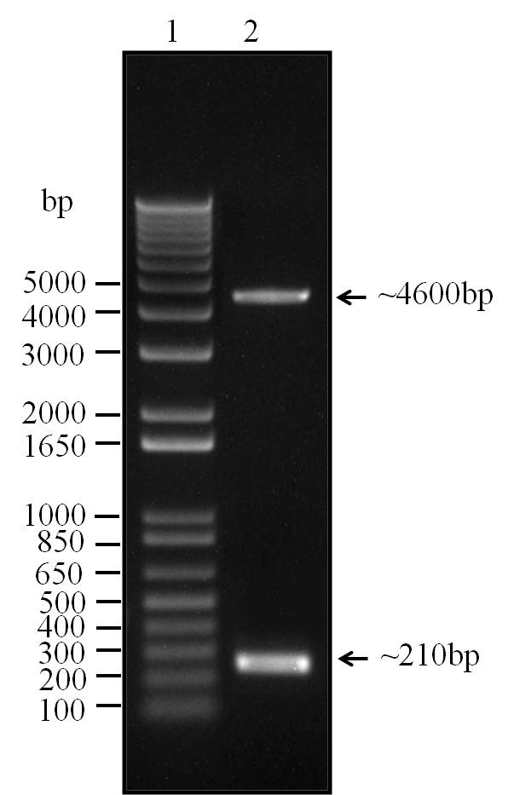
Figure 3. pSG1151T clone double digested with Xba1 and SacII
(Lane 1 – 1 kb DNA Ladder, Lane 2 – pSG1151T clone double digested)
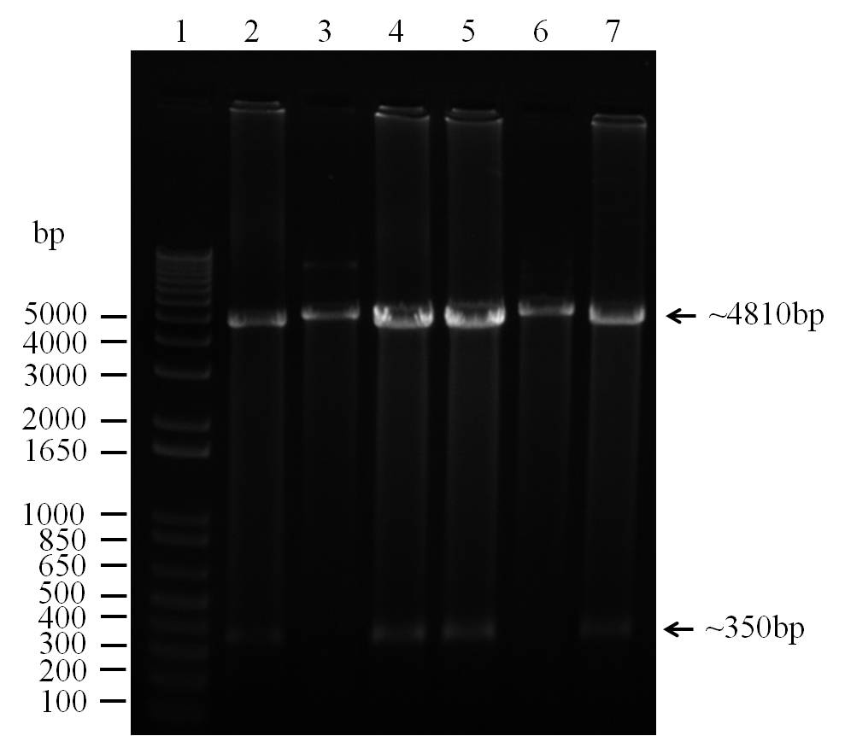
Figure S2. pDSA clones double digested with KpnI and XhoI
(Lane 1 – 1 kb DNA Ladder, Lane 2,3 – pDSA1 clone double digested
Lane 4,5 – pDSA2 clone double digested, Lane 6,7 – pDSA3 clone double digested)
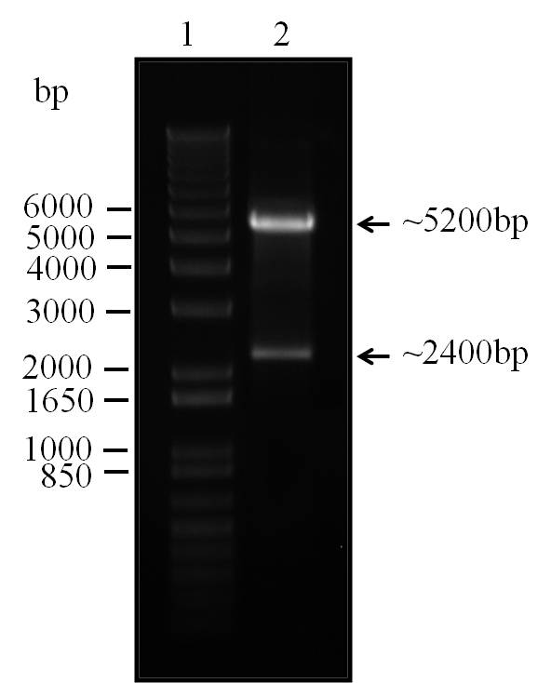
Figure S3. Digested clone of cold peptidase gene
(Lane 1 - 1 kb DNA Ladder, Lane 2 - double digested plasmid clone)

