Title Page

Supplemental Information
for manuscript
Individual differences in post-release behaviour and survival shape outcomes in a headstarting programme for the critically endangered gharial

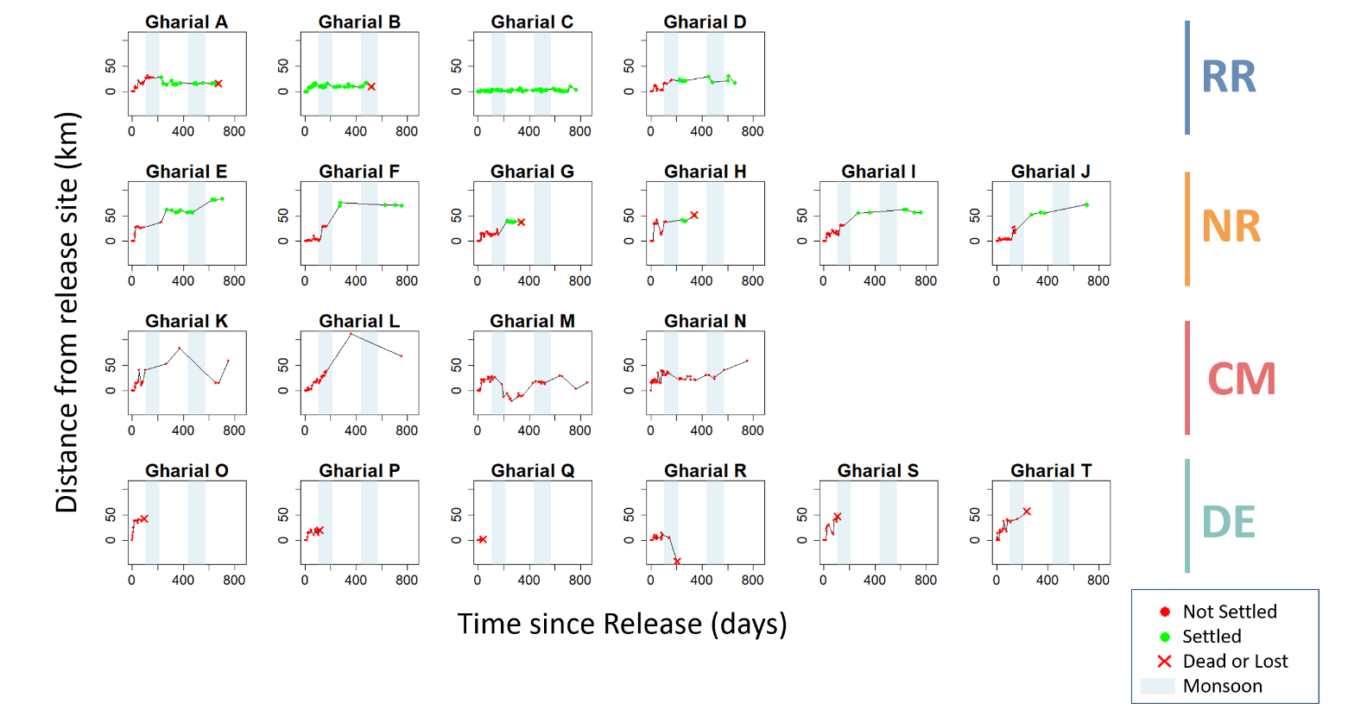

Figure S1: Gharial movement patterns shown as distance from the release site over time until final detection (due to death, loss, or tag battery failure). Red points indicate datapoints with variability greater than 20 km (i.e. no asymptote reached). Green points indicate datapoints where variability is less than 20 km over at least two months, indicating an asymptote and residency within a river stretch <20 km. One shift between asymptotes was permitted where a residency site was destroyed, requiring resettlement. Gharial were assigned to movement groups based on behaviour: RR, individuals that established residency in the release river (Rapti); RN, individuals that established residency after the first monsoon in the larger downstream river, the Narayani; MC, individuals that moved continuously through the monitoring period and never established residency; and DE, individuals that died or were lost (presumed dispersed) early, before establishing residency.

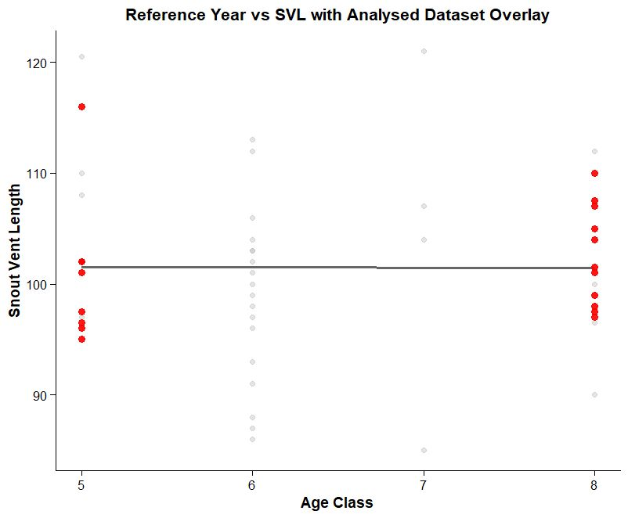

Figure S2: Snout–vent length (SVL) for a subset of gharial released into the rivers of Chitwan between 2000 and 2021, across four age classes. The reference dataset (n = 28) is shown in grey, and the dataset from this study (n = 20) in red. The trendline indicates no relationship between age and size.

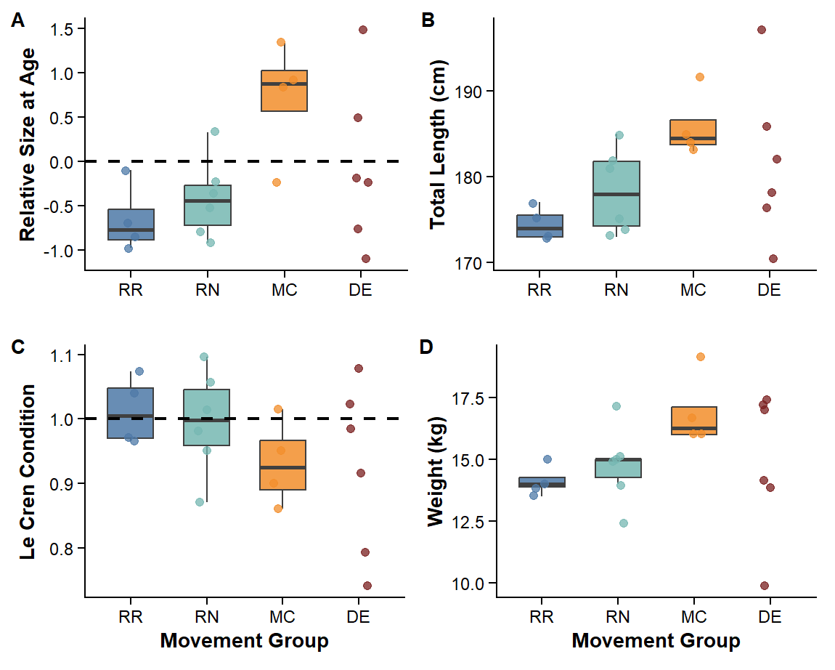
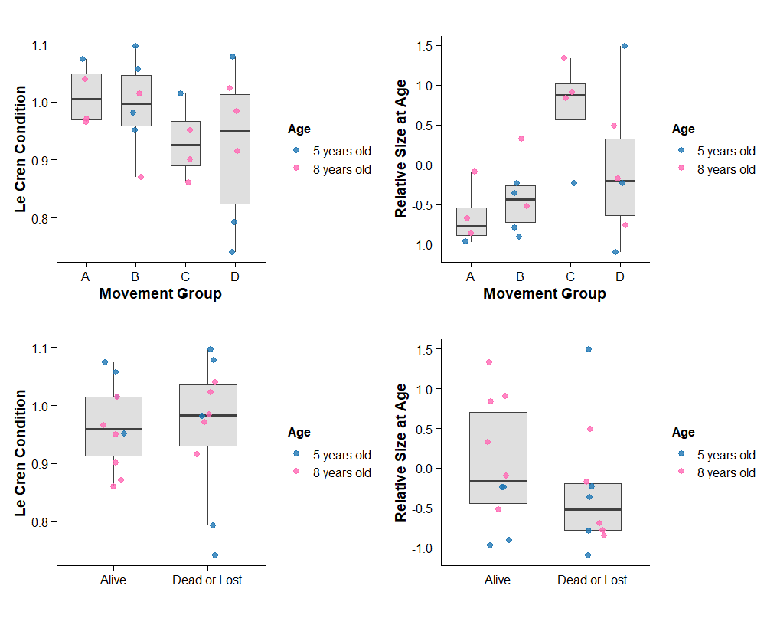
Figure S3: Relationships between movement behaviour, survival, and morphological traits at release. Top panels show Le Cren condition (left) and relative size at age (right) across movement groups (Resident Rapti, Resident Narayani, Moving Continuously, Died/Dispersed Early), while bottom panels show the same variables by survival outcome (Alive vs Dead or Lost). Points represent individual gharial, coloured by age class.

