Appendix:
Proximity Feasibility Index worked example
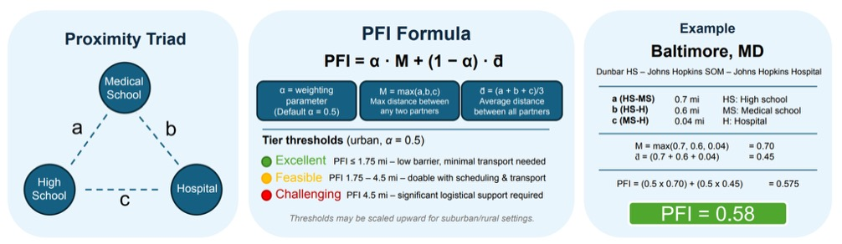
Figure 3. Framework for quantifying geographic feasibility of the LINK-Med proximity triad. The Proximity Triad models the geographic relationship among the three core LINK-Med partners: a high school (HS), medical school (MS), and hospital (H). The PFI equation incorporates both the longest travel leg (M) and the average distance across all three legs (d̄), weighted by parameter α (default = 0.5), to estimate logistical feasibility for sustained program participation. Lower PFI values indicate greater geographic accessibility and convenience and lower transportation burden. Thresholds classify partnerships as excellent, feasible, or challenging. The right panel illustrates the calculation of the PFI using an example triad in Baltimore, Maryland.

