SUPPLEMENTARY TABLES AND FIGURES

SUPPLEMENTARY TABLES
Supplementary Table S1.
Result of Short Demographic Survey and Student Screening for Cause of Staying with a Single Parent.
Characteristics of students | Grade | Frequency
Characteristics of students | Grade | Abdi Bori Secondary School |  | Mettu High School |  | Total
Characteristics of students | Grade | population | sample | population | sample | population | sample
Divorce | Grade 9th | 18 | 6 | 14 | 5 | 29 | 11
Divorce | Grade 10th | 52 | 21 | 39 | 15 | 100 | 36
Divorce | Grade 11th | 18 | 6 | 14 | 5 | 29 | 11
Divorce | Grade 12th | 18 | 6 | 13 | 4 | 28 | 10
Divorce | Total | 106 | 39 | 80 | 29 | 186 | 68
Death | Grade 9th
Death | Grade 10th
Death | Grade 11th
Death | Grade 12th
Death | Total |  |  |  |  | 101
Separation because of job | Grade 9th
Separation because of job | Grade 10th
Separation because of job | Grade 11th
Separation because of job | Grade 12th
Separation because of job | Total |  |  |  |  | 73
Other reasons | Grade 9th
Other reasons | Grade 10th
Other reasons | Grade 11th
Other reasons | Grade 12th
Other reasons | Total |  |  |  |  | 38
Grand Total |  |  |  |  |  | 398
Note; Sample Selection Procedure for Adolescent from Divorced families (AFDF) (only divorce data was taken from the above table)
The above table shows the procedures through which the population of Adolescent students from divorced parents was identified by using short demographic survey prior to conducting the study.
Source: Baseline numbers retrieved from the legal data files of the Ilu Ababor Zone Vital Events Registration Agency and the Mettu Woreda Court (2021).

Supplementary Table S2.
Frequency Distribution and Summary of Missing Values Across All Variables (N = 136).
MisValeu_of_All_V
 |  | Frequency | Percent | Valid Percent | Cumulative Percent
Valid | .00 | 43 | 31.6 | 31.6 | 31.6
Valid | 1.00 | 55 | 40.4 | 40.4 | 72.1
Valid | 2.00 | 21 | 15.4 | 15.4 | 87.5
Valid | 3.00 | 7 | 5.1 | 5.1 | 92.6
Valid | 5.00 | 1 | .7 | .7 | 93.4
Valid | 7.00 | 1 | .7 | .7 | 94.1
Valid | 8.00 | 1 | .7 | .7 | 94.9
Valid | 23.00 | 5 | 3.7 | 3.7 | 98.5
Valid | 24.00 | 1 | .7 | .7 | 99.3
Valid | 25.00 | 1 | .7 | .7 | 100.0
Valid | Total | 136 | 100.0 | 100.0
Note- MisValeu = Missing Values of all variables
Supplementary Table S3
Box's Test of Equality of Covariance Matrices for Academic Performance Outcomes.
Box's M | 4.006
F | 1.313
df1 | 3
df2 | 2925959.048
Sig. | .268
Tests the null hypothesis that the observed covariance matrices of the dependent variables are equal across groups.
a. Design: Intercept + Group

Sapplementary Table S4
Descriptive statistics for academic outcomes
 | Group of participants | Mean | Std. Deviation | N
Students' academic self-perception | Adolescent from Intact family | 3.8500 | .37120 | 65
Students' academic self-perception | Adolescent from Divorced family | 3.6641 | .40128 | 64
Students' academic self-perception | Total | 3.7578 | .39605 | 129
Students' Semister Avarage Point | Adolescent from Intact family | 66.7580 | 2.68885 | 65
Students' Semister Avarage Point | Adolescent from Divorced family | 63.0008 | 3.30132 | 64
Students' Semister Avarage Point | Total | 64.8940 | 3.54058 | 129

Sapplementary Table S5
Box's Test of Equality of Covariance Matrices for Multi-Dimensional Psychological outcomes
Box's M | 22.610
F | 3.672
df1 | 6
df2 | 116781.566
Sig. | .001
Tests the null hypothesis that the observed covariance matrices of the dependent variables are equal across groups.
a. Design: Intercept + Gender + Group + Group * Gender

Sapplementary Table S6
Multivariate Test of Homogeneity of Regression Slopes (Group × Gender Interaction Assumptions) for MANCOVA Models.
Effect |  | Value | F | Hypothesis df | Error df | Sig.
Gender | Pillai's Trace | .097 | 4.412^{b} | 3.000 | 123.000 | .006
Gender | Wilks' Lambda | .903 | 4.412^{b} | 3.000 | 123.000 | .006
Gender | Hotelling's Trace | .108 | 4.412^{b} | 3.000 | 123.000 | .006
Gender | Roy's Largest Root | .108 | 4.412^{b} | 3.000 | 123.000 | .006
Group | Pillai's Trace | .057 | 2.487^{b} | 3.000 | 123.000 | .064
Group | Wilks' Lambda | .943 | 2.487^{b} | 3.000 | 123.000 | .064
Group | Hotelling's Trace | .061 | 2.487^{b} | 3.000 | 123.000 | .064
Group | Roy's Largest Root | .061 | 2.487^{b} | 3.000 | 123.000 | .064
Group * Gender | Pillai's Trace | .049 | 2.123^{b} | 3.000 | 123.000 | .101
Group * Gender | Wilks' Lambda | .951 | 2.123^{b} | 3.000 | 123.000 | .101
Group * Gender | Hotelling's Trace | .052 | 2.123^{b} | 3.000 | 123.000 | .101
Group * Gender | Roy's Largest Root | .052 | 2.123^{b} | 3.000 | 123.000 | .101
a. Design: Intercept + Gender + Group + Group * Gender
b. Exact statistic

Sapplementary Tabale S7
Levene's Test of Equality of Error Variancesfor Transformed Psychological outcomes
 | F | df1 | df2 | Sig.
T score of Internalizing bhr-After Transformed | 2.194 | 1 | 127 | .141
Students' life satisfaction score-transformed | .354 | 1 | 127 | .553
Externalizing bhr Symtom score-tranformed | .464 | 1 | 127 | .497
Tests the null hypothesis that the error variance of the dependent variable is equal across groups.
a. Design: Intercept + Gender + Group + Group * Gender

Sapplementary Table S8:
Descriptive statistics for psychological outcomes
Descriptive Statistics
 | Group of participants | Mean | Std. Deviation | N
Externalizing bhr Symtom score-tranformed | Adolescent from Intact family | 1.8914 | .42875 | 65
Externalizing bhr Symtom score-tranformed | Adolescent from Divorced family | 1.8977 | .43884 | 64
Externalizing bhr Symtom score-tranformed | Total | 1.8945 | .43210 | 129
Students' life satisfaction score-transformed | Adolescent from Intact family | 3.6673 | .59212 | 65
Students' life satisfaction score-transformed | Adolescent from Divorced family | 3.6013 | .57087 | 64
Students' life satisfaction score-transformed | Total | 3.6346 | .58035 | 129
Internalizing bhr(T-score) | Adolescent from Intact family | 47.0323 | 8.65450 | 65
Internalizing bhr(T-score) | Adolescent from Divorced family | 53.0141 | 10.42927 | 64
Internalizing bhr(T-score) | Total | 50.0000 | 10.00000 | 129

Table 9:
Descriptive Statistics for Social outcomes
 | Group of participants | Mean | Std. Deviation | N
SWS_Loneliness | Adolescent from Intact family | 2.5622 | .49971 | 65
SWS_Loneliness | Adolescent from Divorced family | 3.4219 | .84870 | 64
SWS_Loneliness | Total | 2.9887 | .81581 | 129
SWS_SocialRejection | Adolescent from Intact family | 2.4495 | .44203 | 65
SWS_SocialRejection | Adolescent from Divorced family | 3.4817 | .77001 | 64
SWS_SocialRejection | Total | 2.9616 | .81114 | 129
SWS_SocAnxiety_Score | Adolescent from Intact family | 2.8262 | .22589 | 65
SWS_SocAnxiety_Score | Adolescent from Divorced family | 3.1047 | .65863 | 64
SWS_SocAnxiety_Score | Total | 2.9643 | .50849 | 129

Supplementary Table S10
Copy of Cohen’s Power Analysis Framework Matrix Table 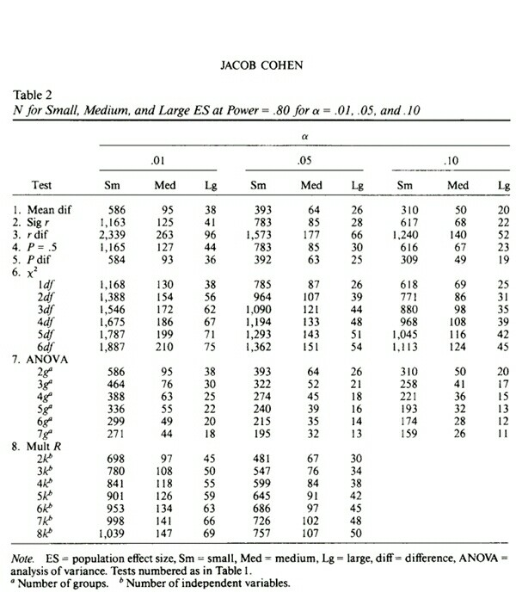
Note. Adapted from Statistical Power Analysis for the Behavioral Sciences (2nd ed., p. 151), by J. Cohen, 1988, Lawrence Erlbaum Associates.

Supplementary Table S11:
Tests of Normality (Kolmogorov-Smirnov and Shapiro-Wilk) for Academic, Psychological, and Social Variables Across Sample Groups (N = 129).
Tests of Normality
Variables | Group of participant | Kolmogorov-Smirnov |  | Shapiro-Wilk
Variables | Group of participant | df | Sig. | df | Sig.
Academic function
Students' Semester Average Point | AFIF | 65 | .200 | 65 | .123
Students' Semester Average Point | AFDF | 64 | .086 | 64 | .195
Students’ academic self-perception | AFIF | 65 | .200 | 65 | .285
Students’ academic self-perception | AFDF | 64 | .067 | 64 | .177
Psychological wellbeing
Student life satisfaction score | AFIF | 65 | .037 | 65 | .311
Student life satisfaction score | AFDF | 64 | .067 | 64 | .457
Internalizing behavior symptoms | AFIF | 65 | .092 | 65 | .038
Internalizing behavior symptoms | AFDF | 64 | .185 | 64 | .194
Externalizing behavior symptoms | AFIF | 65 | .090 | 65 | .164
Externalizing behavior symptoms | AFDF | 64 | .200 | 64 | .345
Social wellbeing scale
Loneliness | AFIF | 65 | .087 | 65 | .099
Loneliness | AFDF | 64 | .051 | 64 | .054
Social rejection | AFIF | 65 | .054 | 65 | .070
Social rejection | AFDF | 64 | .057 | 64 | .207
Social anxiety | AFIF | 65 | .053 | 65 | .156
Social anxiety | AFDF | 64 | .200 | 64 | .381
Note: AFIF-.Adolescent From Intact Family, AFDF- Adolescent From Divorced Family
df- degree of frequency

Supplementary Table S12
Descriptive Metrics Layout: Means, Standard Deviations, Skewness, and Kurtosis of All Variables Across Sample Groups (N = 129).
Variables | Group of participants | N | M | SD | Skew | Kurt
Students' Semester Average Point | AFIF | 65 | 66.76 | .33 | .12 | .03
Students' Semester Average Point | AFDF | 64 | 63 | .41 | .12 | -.20
Students’ academic self-perception | AFIF | 65 | 3.90 | .01 | .12 | -.54
Students’ academic self-perception | AFDF | 64 | 3.67 | .10 | -.04 | -.39
Student life satisfaction score | AFIF | 65 | 3.70 | .07 | -.18 | -.45
Student life satisfaction score | AFDF | 64 | 3.60 | .70 | -.16 | -.33
Internalizing behavior symptoms | AFIF | 65 | 47.03 | 1.07 | -.34 | -.45
Internalizing behavior symptoms | AFDF | 64 | 53.01 | 1.30 | .15 | -.44
Externalizing behavior symptoms | AFIF | 65 | 1.89 | .05 | .02 | -.45
Externalizing behavior symptoms | AFDF | 64 | 1.97 | .10 | .21 | -.19
Loneliness | AFIF | 65 | 2.5 | .06 | .26 | -.31
Loneliness | AFDF | 64 | 3.4 | .11 | -.41 | -.64
Social rejection | AFIF | 65 | 2.45 | .10 | .10 | -.52
Social rejection | AFDF | 64 | 3.48 | .10 | -.24 | -.56
Social anxiety | AFIF | 65 | 2.83 | .10 | .32 | -.29
Social anxiety | AFDF | 64 | 3.10 | .10 | .24 | -.38
Note:M-mean, SD-standard deviation, Skew-skewness, Kurt-kurtosis, AFIF-.Adolescent From Intact Family, AFDF- Adolescent From Divorced Family

Supplementary Table S13
Results of Preliminary Demographic Covariate Group Differences (Gender, Parent SES, and Grade Level) Across Outcome Variables.
Tested covariates variables | Outcome variables | p- value (Sig) | Partial Eta Squared | Results
Gender | Academic outcomes (λ) | .937 | .001 | Non-significant
Gender | Students' Semester Average Point | .729 | .001 | Non-significant
Gender | Students’ academic self-perception | .986 | <.001 | Non-significant
Gender | Psychologicaloutcomes (λ) | .005 | .099 | Significant
Gender | Life Satisfaction | .002 | .076 | Significant
Gender | Internalizing behavior symptom | .514 | .003 | Non-significant
Gender | Externalizing problems | .089 | .023 | Non-significant
Gender | Social wellbeing(λ) | .144 | .042 | Non-significant
Parents’ SES | Academic outcomes (λ) | .720 | .008 | Non-significant
Parents’ SES | Students' Semester Average Point | .495 | .011 | Non-significant
Parents’ SES | Students’ academic self-perception | .587 | .008 | Non-significant
Parents’ SES | Psychological outcomes (λ) | .311 | .028 | Non-significant
Parents’ SES | Life Satisfaction | .106 | .035 | Non-significant
Parents’ SES | Internalizing behavior symptom | .377 | .015 | Non-significant
Parents’ SES | Externalizing problems | .747 | .005 | Non-significant
Parents’ SES | Social wellbeing (λ) | .674 | .016 | Non-significant
Parents’ SES | Loneliness | .514 | .011 | Non-significant
Parents’ SES | Social rejection | .788 | .004 | Non-significant
Parents’ SES | Social anxiety | . 260 | .021 | Non-significant
Grade level (9th – 12th ) | Academic outcomes (λ) | .222 | .032 | Non-significant
Grade level (9th – 12th ) | Students' Semester Average Point | .363 | .025 | Non-significant
Grade level (9th – 12th ) | Students’ academic self-perception | .208 | .036 | Non-significant
Grade level (9th – 12th ) | Psychological outcomes (λ) | .808 | .014 | Non-significant
Grade level (9th – 12th ) | Life Satisfaction | .653 | .013 | Non-significant
Grade level (9th – 12th ) | Internalizing behavior symptom | .570 | .016 | Non-significant
Grade level (9th – 12th ) | Externalizing problems | .944 | .003 | Non-significant
Grade level (9th – 12th ) | Social wellbeing(λ) | . 569 | . 020 | Non-significant
Grade level (9th – 12th ) | Loneliness | .304 | .029 | Non-significant
Grade level (9th – 12th ) | Social rejection | .231 | .034 | Non-significant
Grade level (9th – 12th ) | Social anxiety | .625 | .014 | Non-significant
Note:- λ=Wilks' Lambda, Computed using alpha = .05
Supplementary Table S14:
Levene's Test of Equality of Error Variance fo students’ academic functioning domain
 | F | df1 | df2 | Sig.
Students' Semester Average Point | 3.798 | 1 | 127 | .054
Students' academic self-perception | .169 | 1 | 127 | .682
Source: Survey Result, 2021

SUPPLEMENTARY FIGURES
Test of Normality For All Varibalesused in The Curren Stiudy
Visual inspections of Histograms and Box plot for Both Groups (AFIF & AFDF)
  - Academic Performance
    - Student’s End of Semester Average Point
Supplementary Figure S1
Histograms of Student’s End of Semester Average Point for both groups
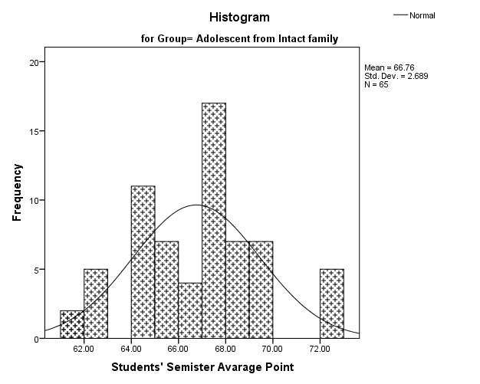
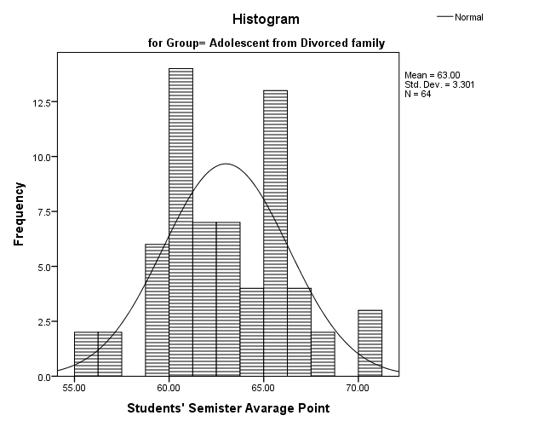

Supplementary Figire S2 Supplementary Figire S3
Box Plot Q-Q Plot
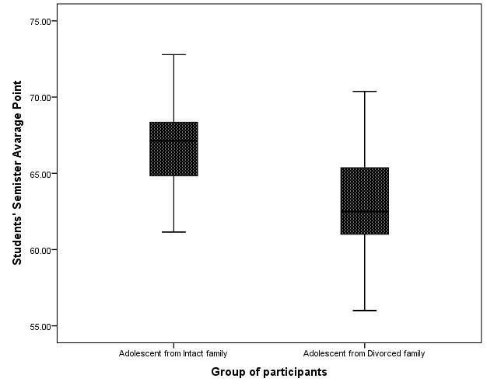
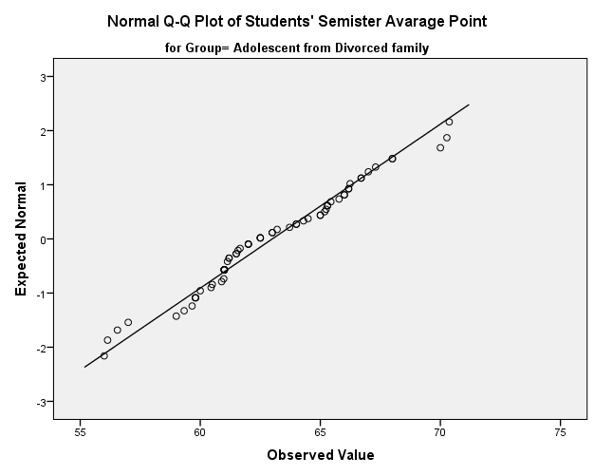

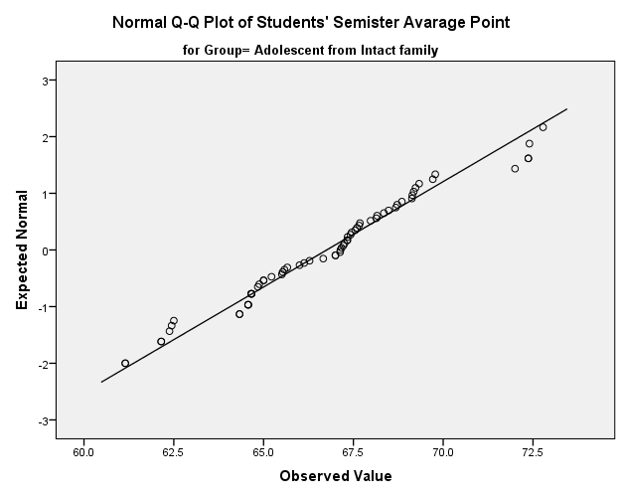

  - Student’s Academic Self-perception Scale
Supplementary Figure S4
Histograms of Student’s Self-perception Scale for both groups
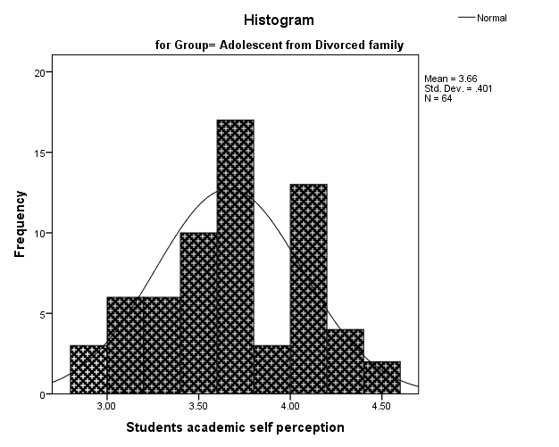
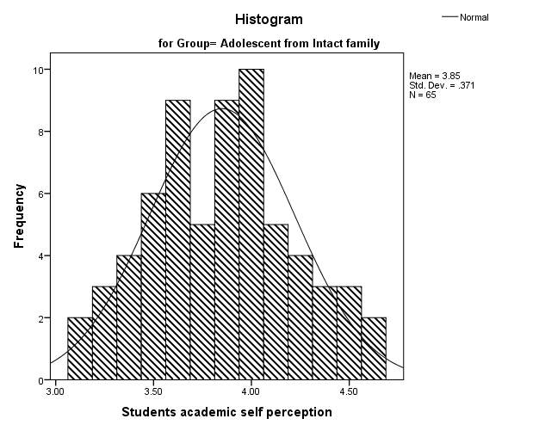
Supplementary Figure S5
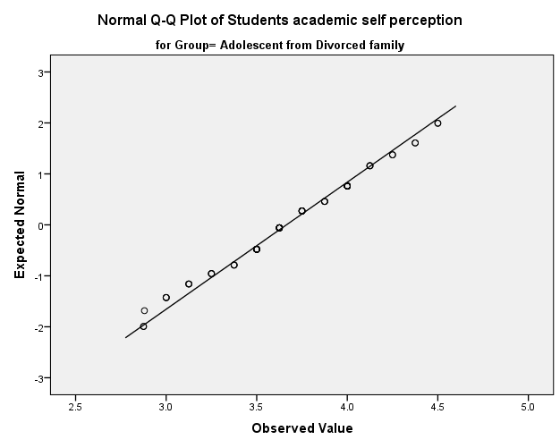
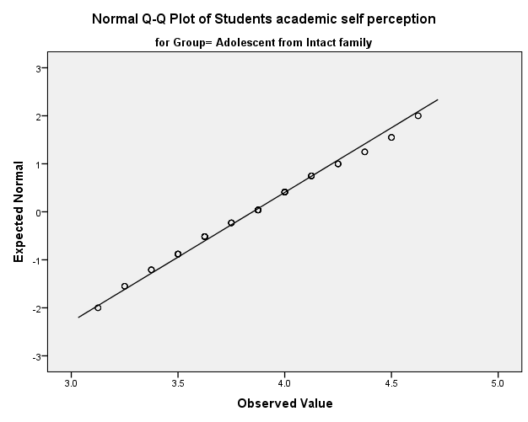

- Psychologicalwellbeing
  - Life Satisfaction Scale for Both Groups
Supplementary Figure S6:
Histograms ofLife Satisfaction Scale for Both Groups
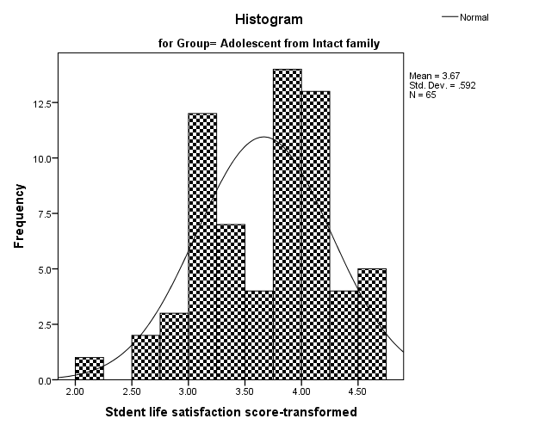
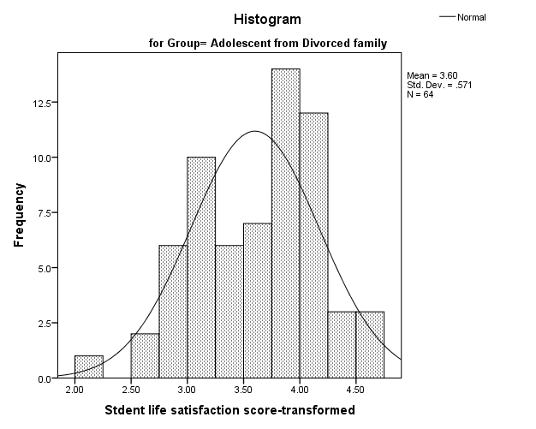
Supplementary Figure S7
Box plot of Life Satisfaction Scale for Both Groups
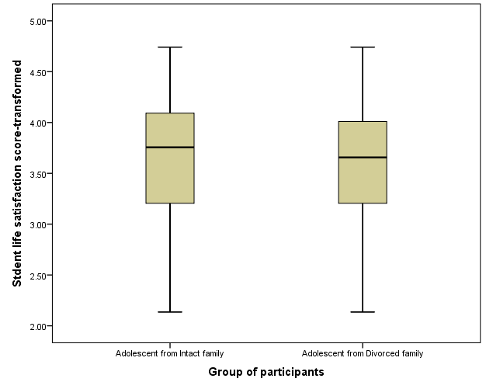

  - Internalizing behavior symptoms
Supplementary Figure S8
Histograms of Internalizing behavior symptoms for Both Groups
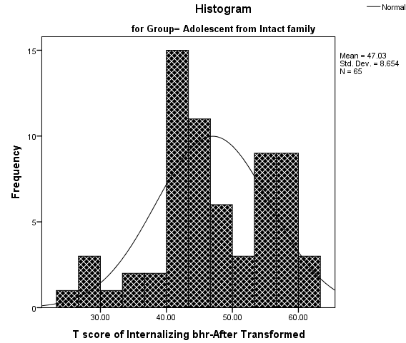
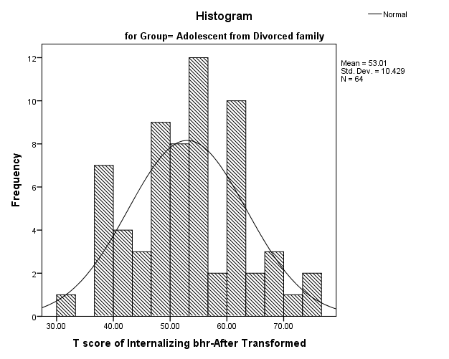
Supplementary Figure 9
Box plot of Internalizing behavior symptoms for Both Groups
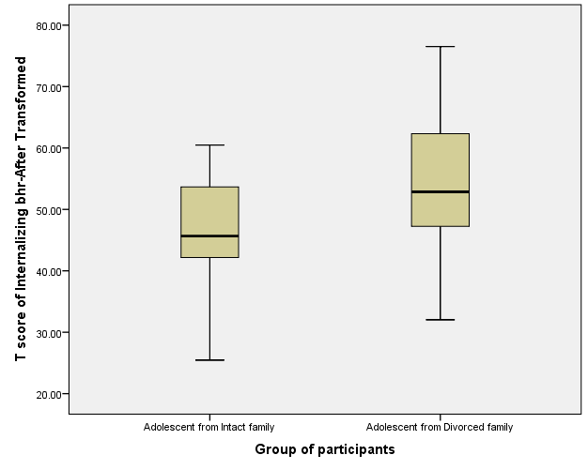

  - Externalizing behavior symptoms
Supplementary Figure S10
Histograms of Externalizing behavior symptoms for Both Groups

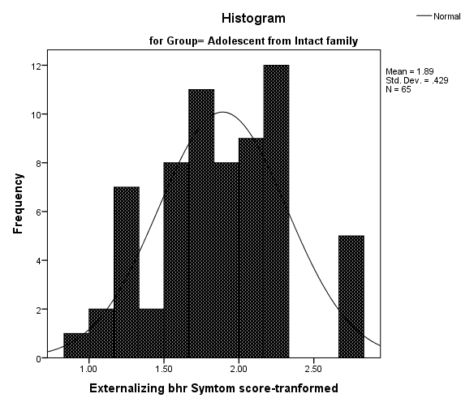
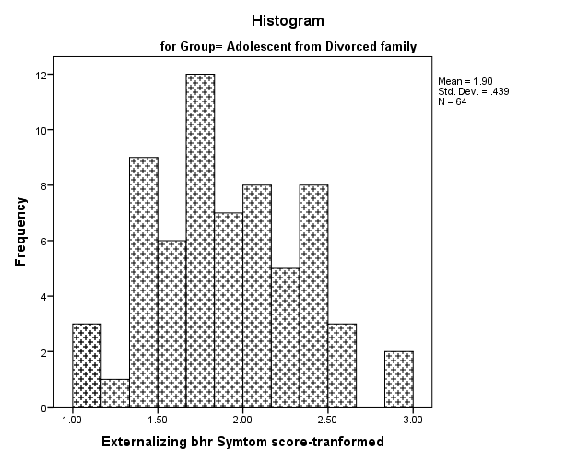
Supplementary Figure S11 Supplementary Figure S12
Box Plot Q-Q Plot
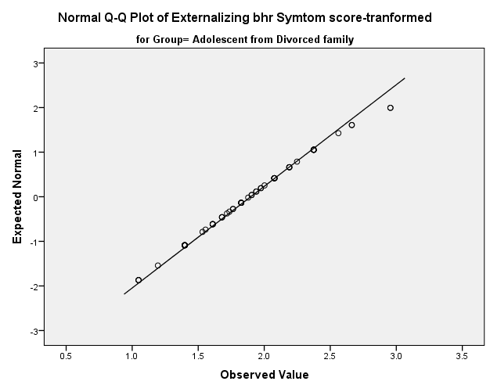
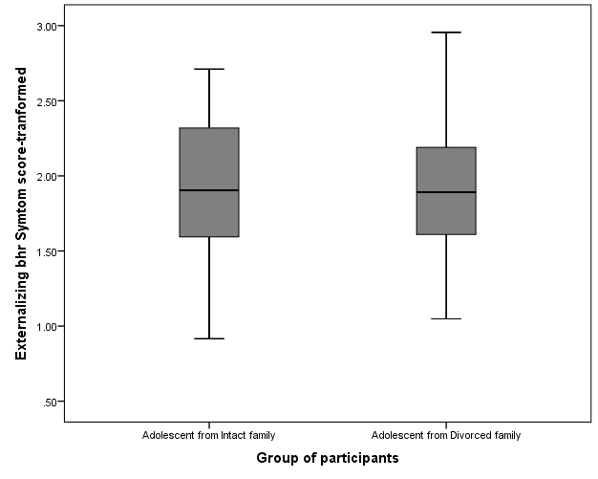
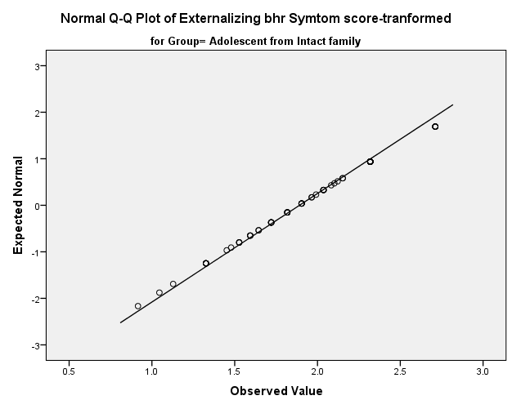
- Social functions or wellbeing
  - Loneliness
Supplementary Figure S13
Histograms of Loneliness for both groups
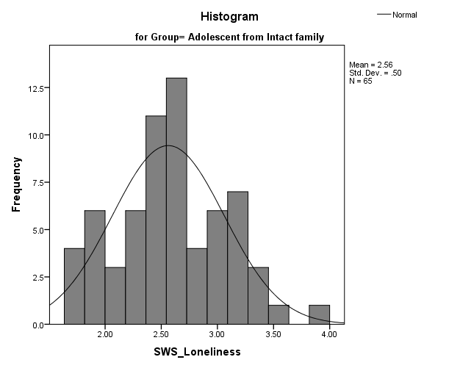
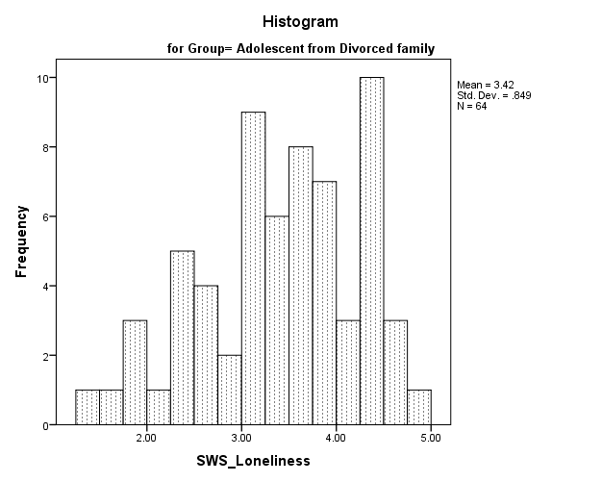

Supplementary Figure S14
Box Plot
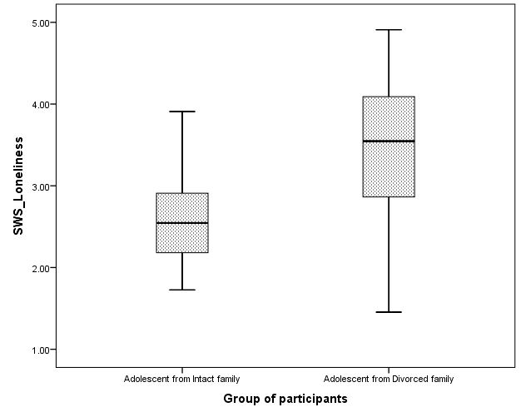

  - Social Rejection
Supplementary Figure S15
Histograms of Social Rejection for both groups
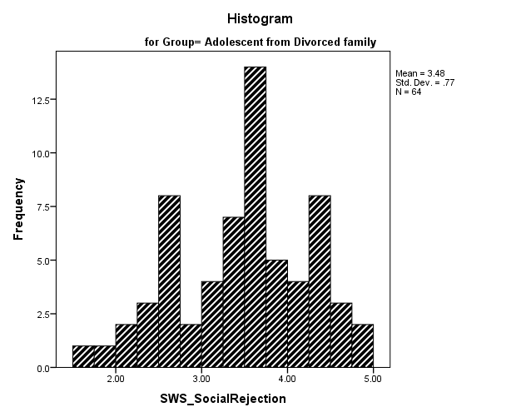

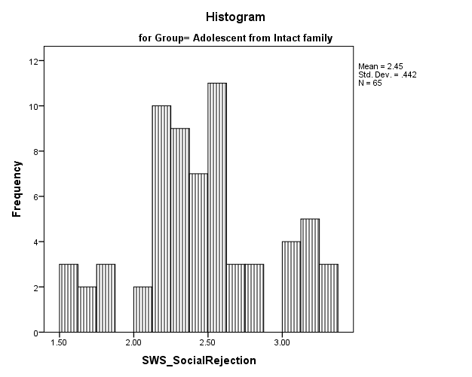
Supplementary Figure S16 Supplementary Figure S17
Box Plot Q-Q Plot
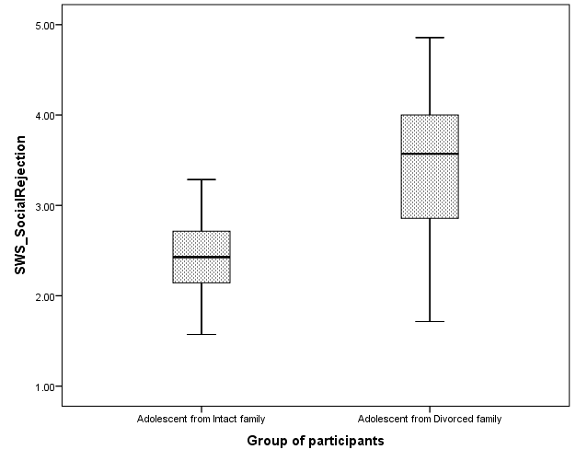
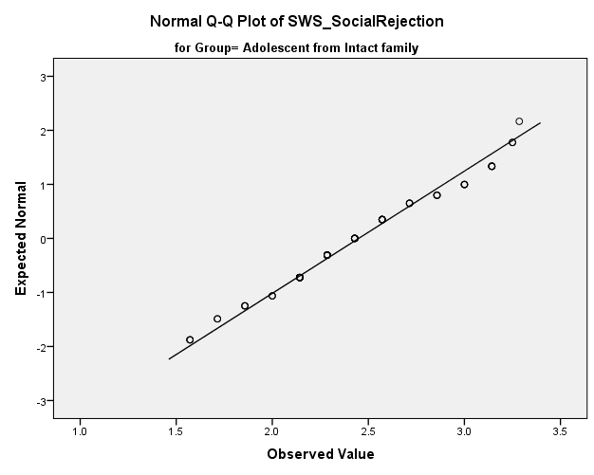

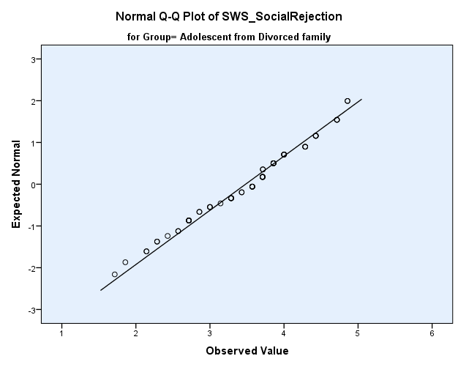

  - Social Anxiety
Supplementary Figure S18
Histograms of Social Anxiety for both groups
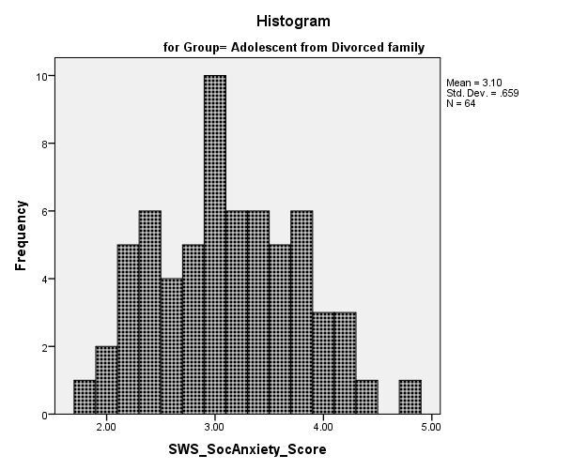

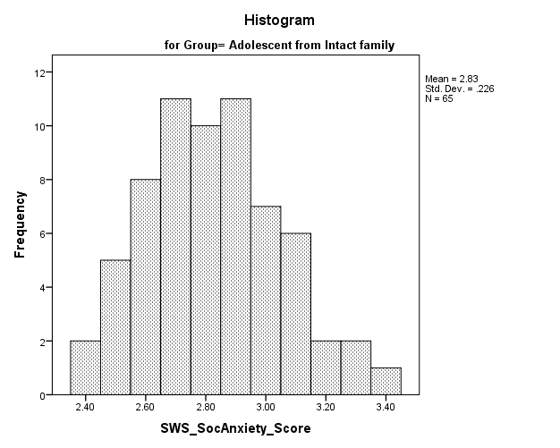

Supplementary Figure S19 Supplementary Figure S20
Box Plot of Social Anxiety for both groups Q-Q Plot

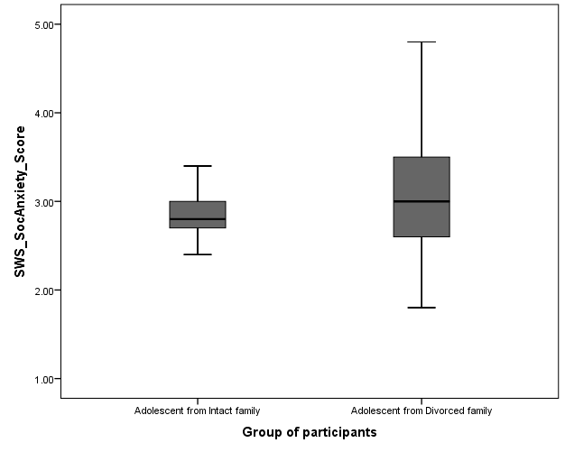
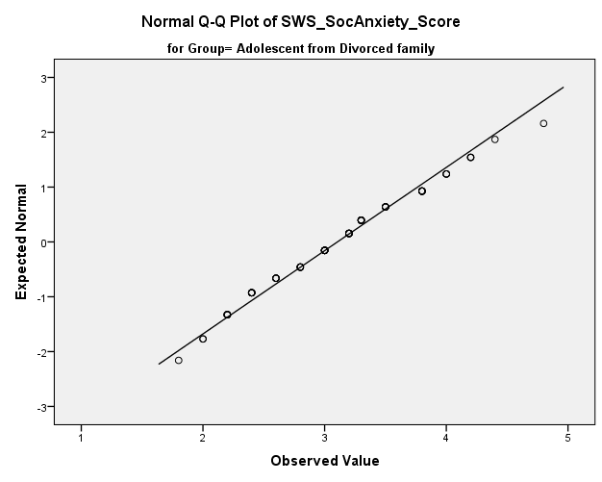

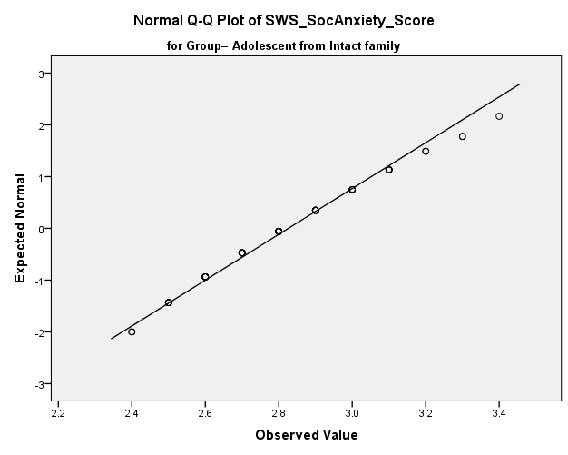

Supplementary Figure S21
Scatter matrix of students’ academic functioning outcomes (Students' Semester Average Point and Students academic self-perception) with groups.

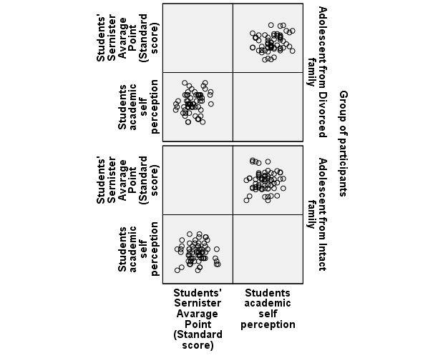

Supplementary Figure S22
Test of Linearity as an assumption of MANCOVA
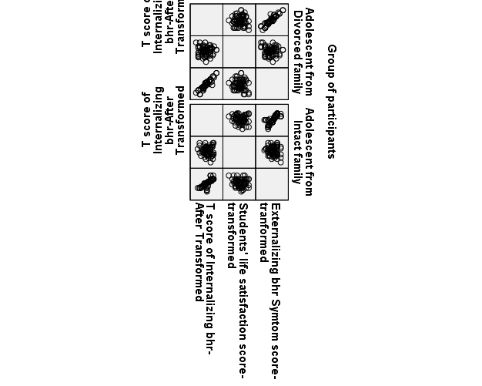
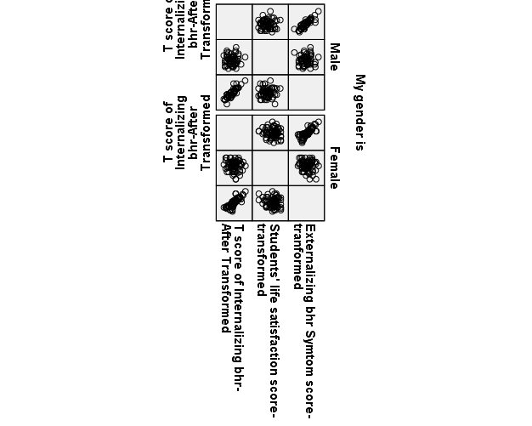

Supplementary Figure S23
Overall Summary of Missing Values
