Table 1. Docking score of human Estrogen Receptor alpha (ERα) [PDB: 3ERT] and our selected three compounds along with control given below.
ID | Binding affinity | 2D structure
Beta-Amyrin  (CID 73145) | -10.3 | 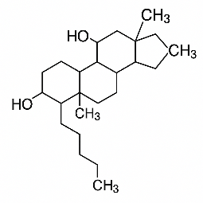
Pseudotaraxasterol  (CID 12305110) | -10.3 | 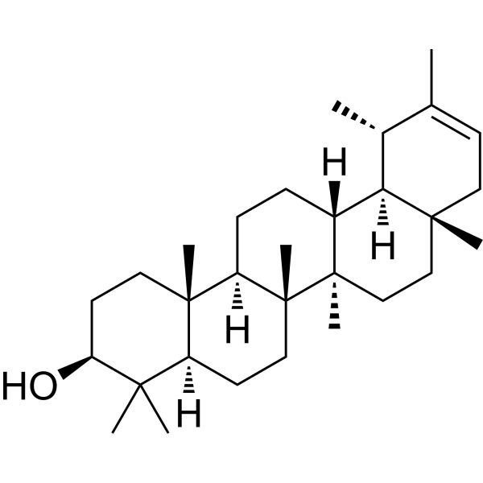
Tamoxifen (control)  (CID 2733526) | -6.8 | 