Supplementary Figure 1: Risk of Bias Domain Summary Plot (Cochrane RoB 2) Across All Included Studies
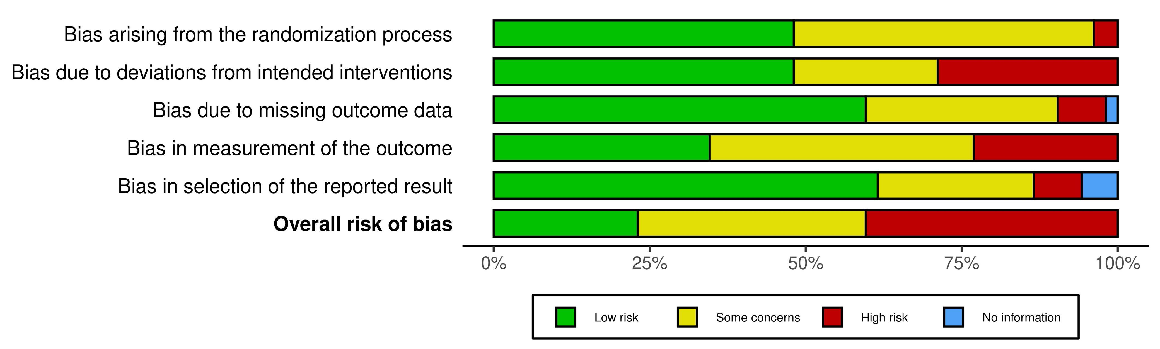
Supplementary Figure 2: Risk of Bias Traffic-Light Plot by Study and Domain (Cochrane RoB 2)
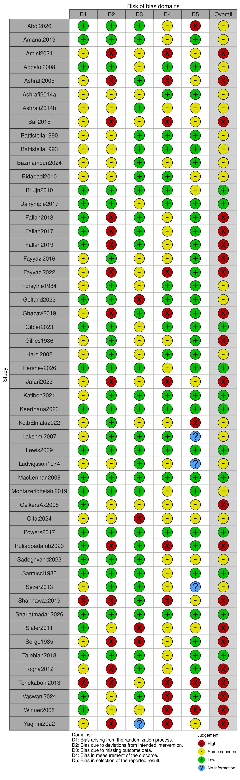
Supplementary Figure 3: Node-Splitting Forest Plot (Direct vs Indirect Evidence) – Migraine Frequency Change
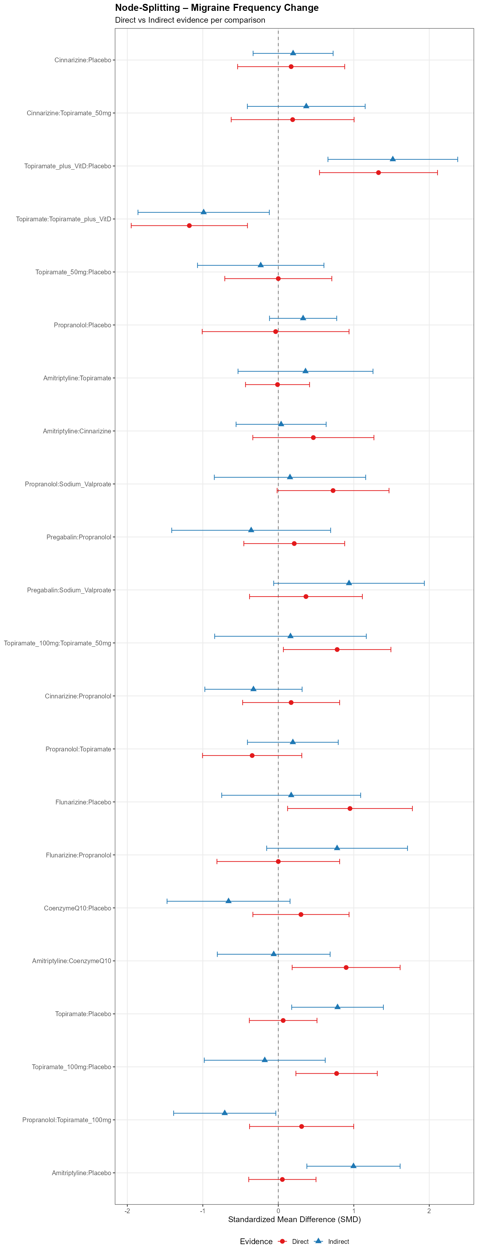
Supplementary Figure 4: Node-Splitting P-values for Loop Inconsistency – Migraine Frequency Change
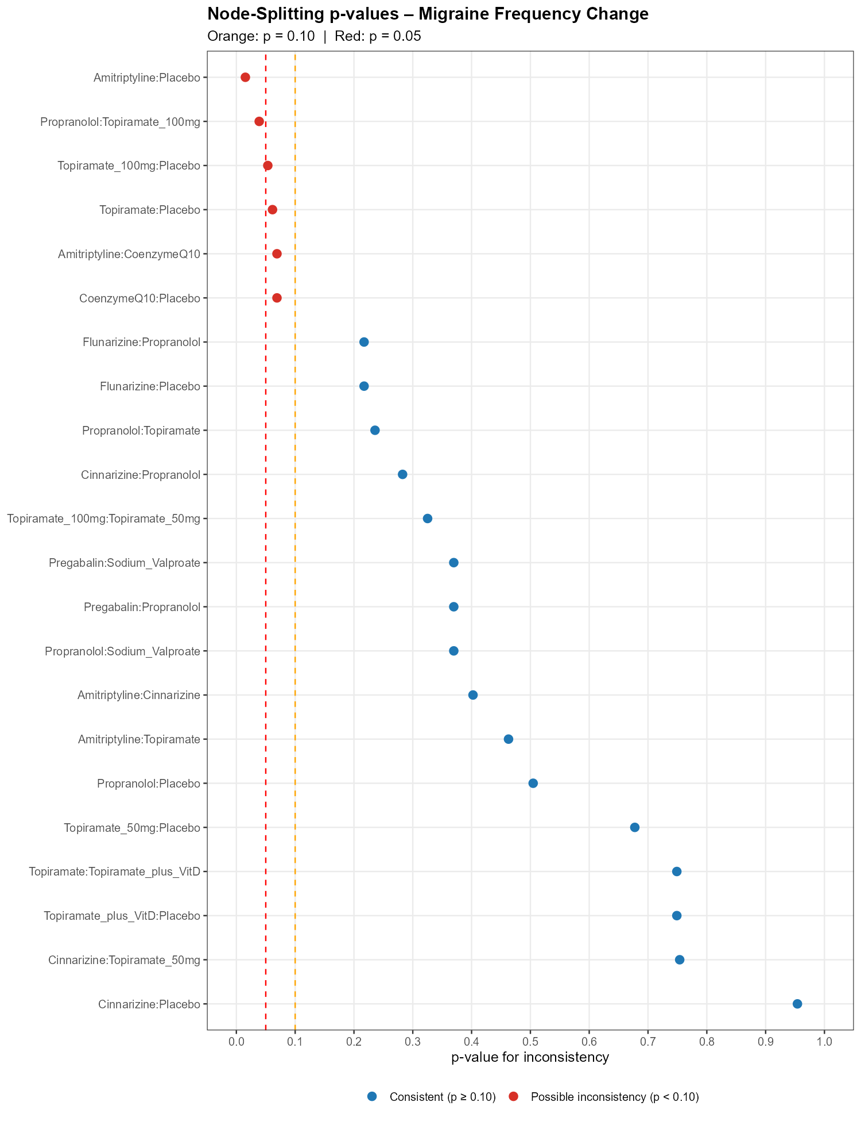
Supplementary Figure 5: League Table Heatmap of Pairwise Treatment Effects – Migraine Frequency Change
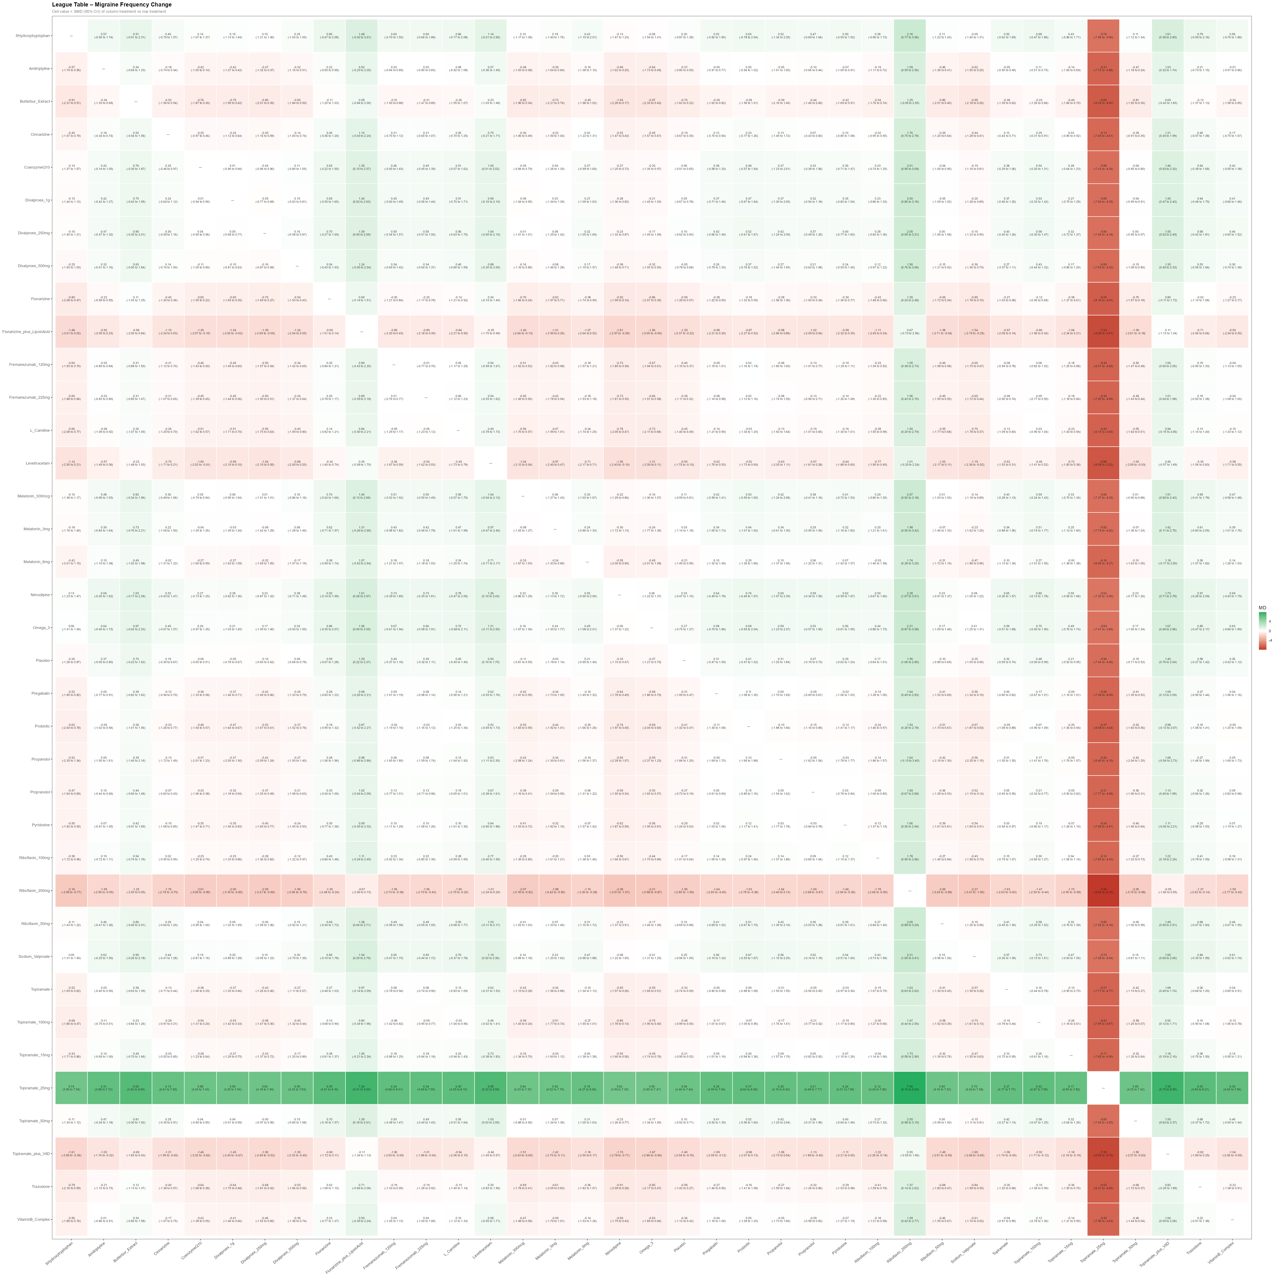
Supplementary Figure 6: Ranking Probability Heatmap – Migraine Frequency Change
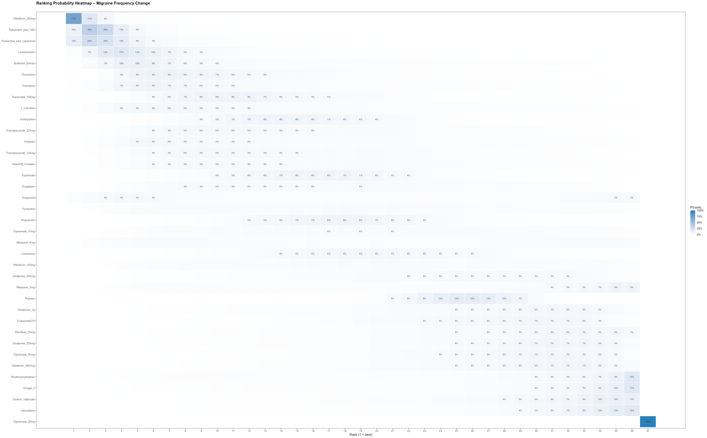
Supplementary Figure 7: SUCRA Ranking Bar Chart – Migraine Frequency Change
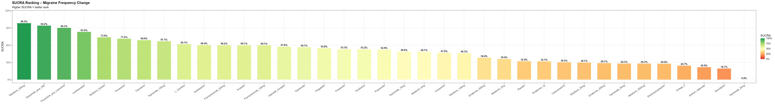
Supplementary Figure 8: Cumulative SUCRA Curve – Migraine Frequency Change
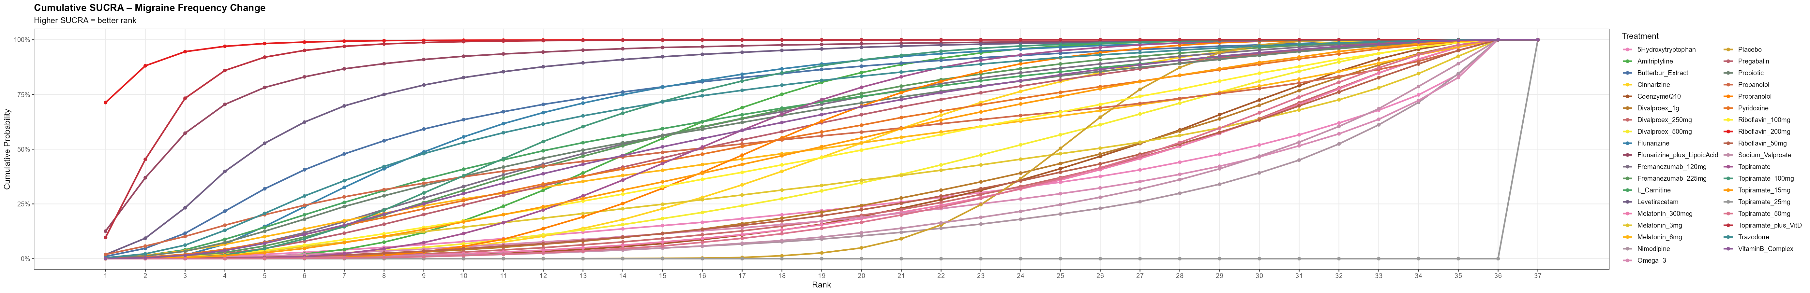
Supplementary Figure 9: Node-Splitting Forest Plot (Direct vs Indirect Evidence) – Migraine Severity Change
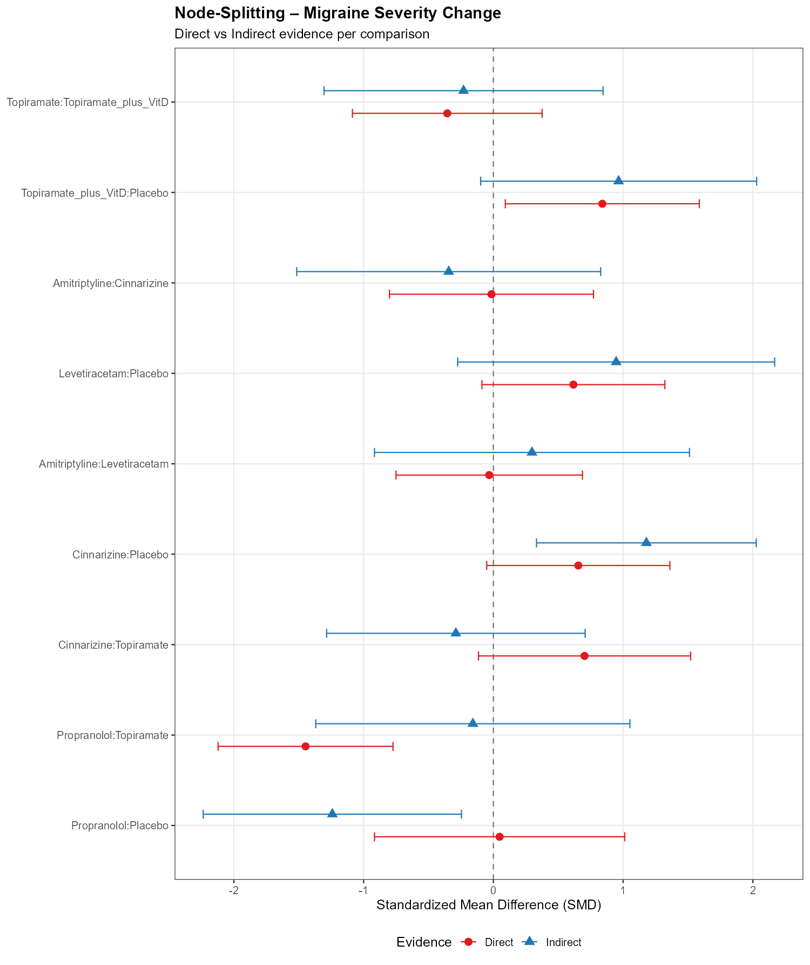
Supplementary Figure 10: Node-Splitting P-values for Loop Inconsistency – Migraine Severity Change
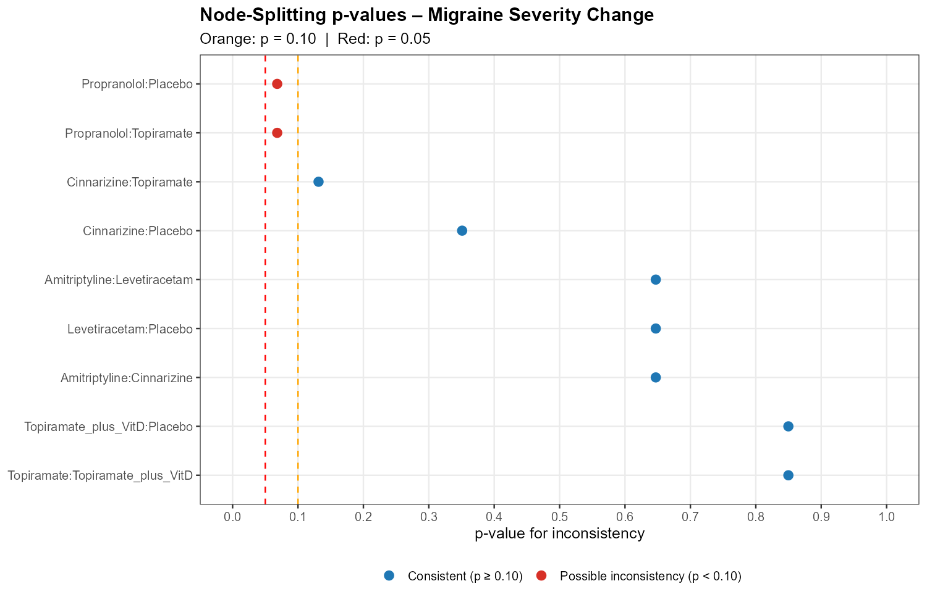
Supplementary Figure 11: League Table Heatmap of Pairwise Treatment Effects – Migraine Severity Change
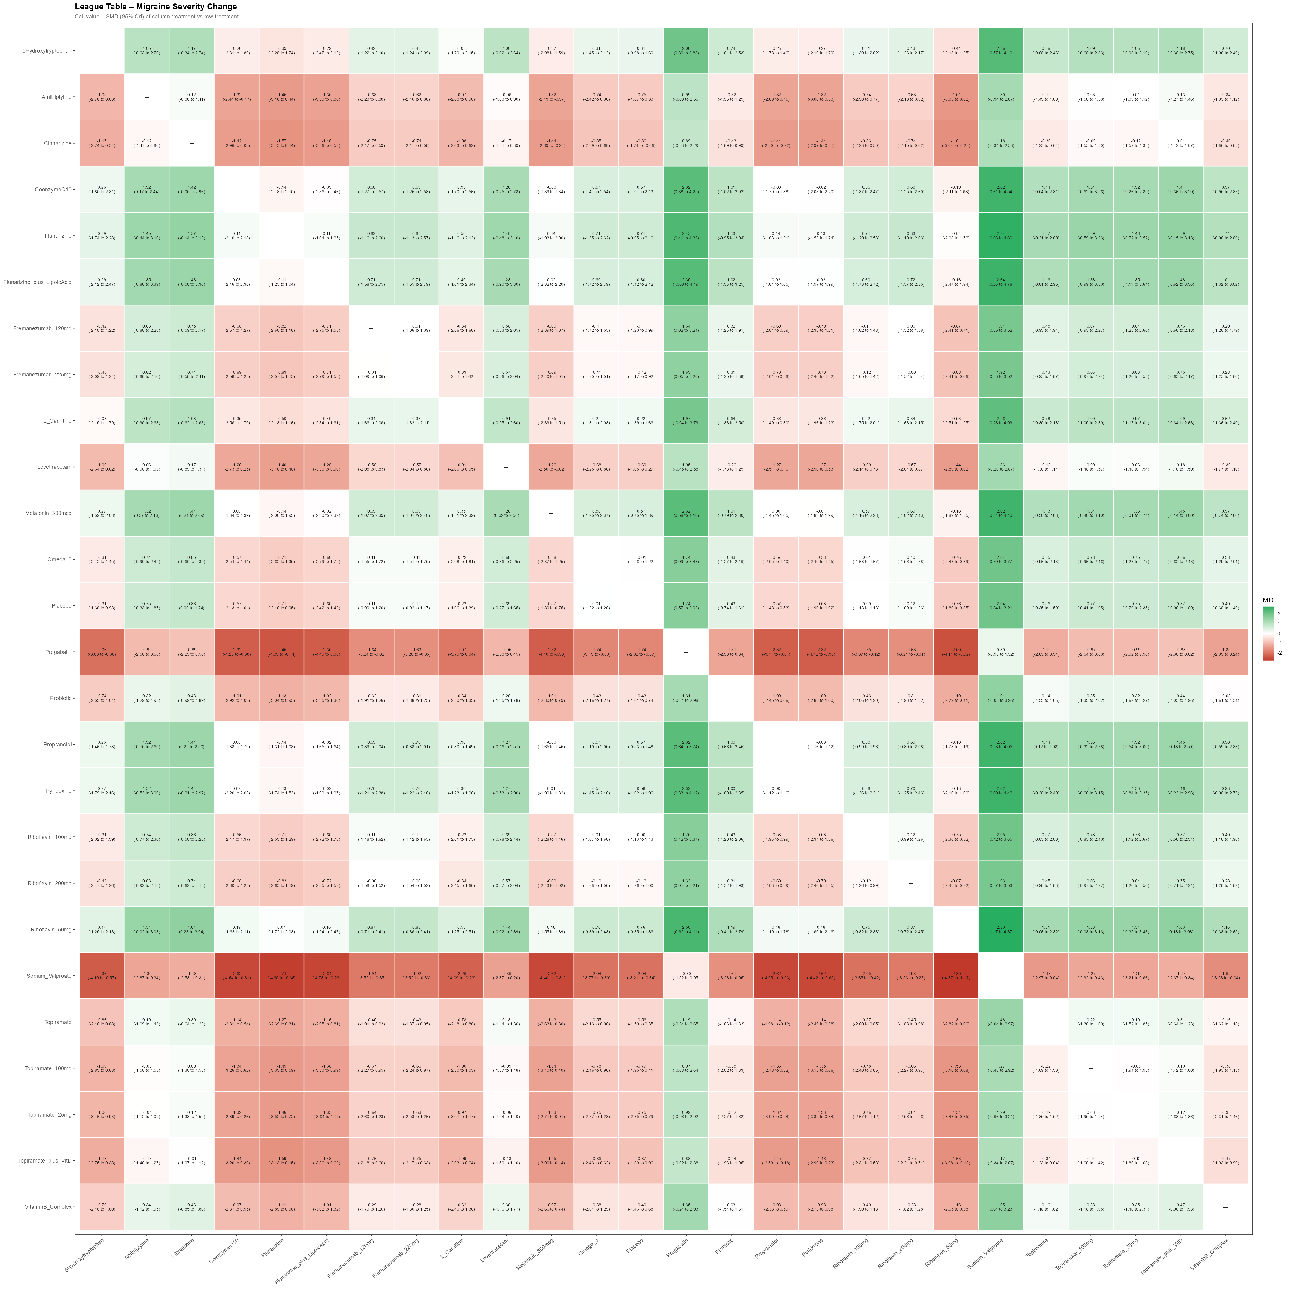
Supplementary Figure 12: Ranking Probability Heatmap – Migraine Severity Change
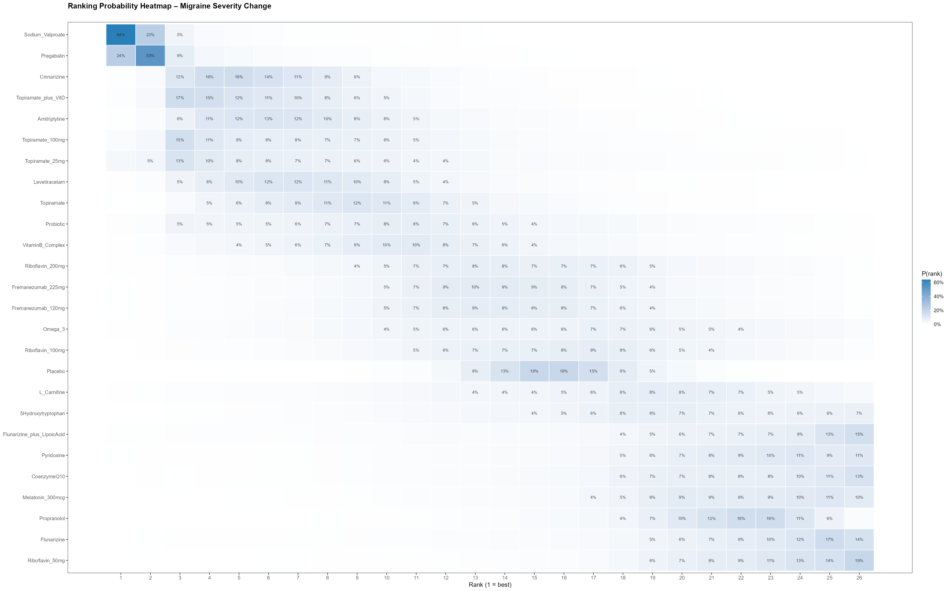
Supplementary Figure 13: SUCRA Ranking Bar Chart – Migraine Severity Change
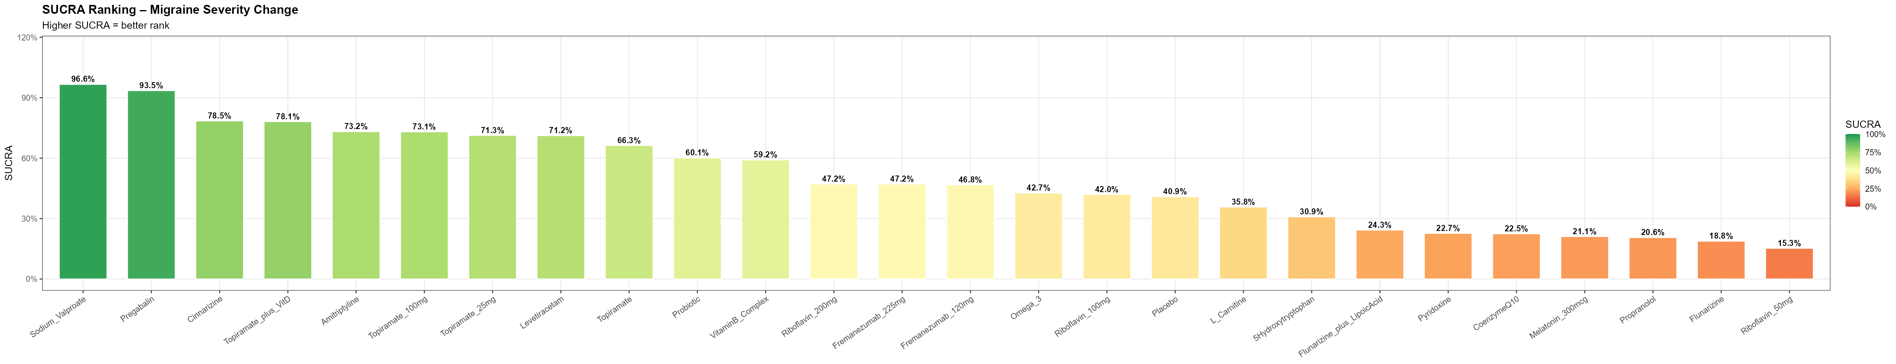
Supplementary Figure 14: Cumulative SUCRA Curve – Migraine Severity Change
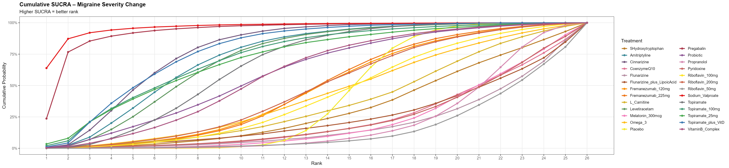
Supplementary Figure 15: Node-Splitting Forest Plot (Direct vs Indirect Evidence) – Migraine Duration Change
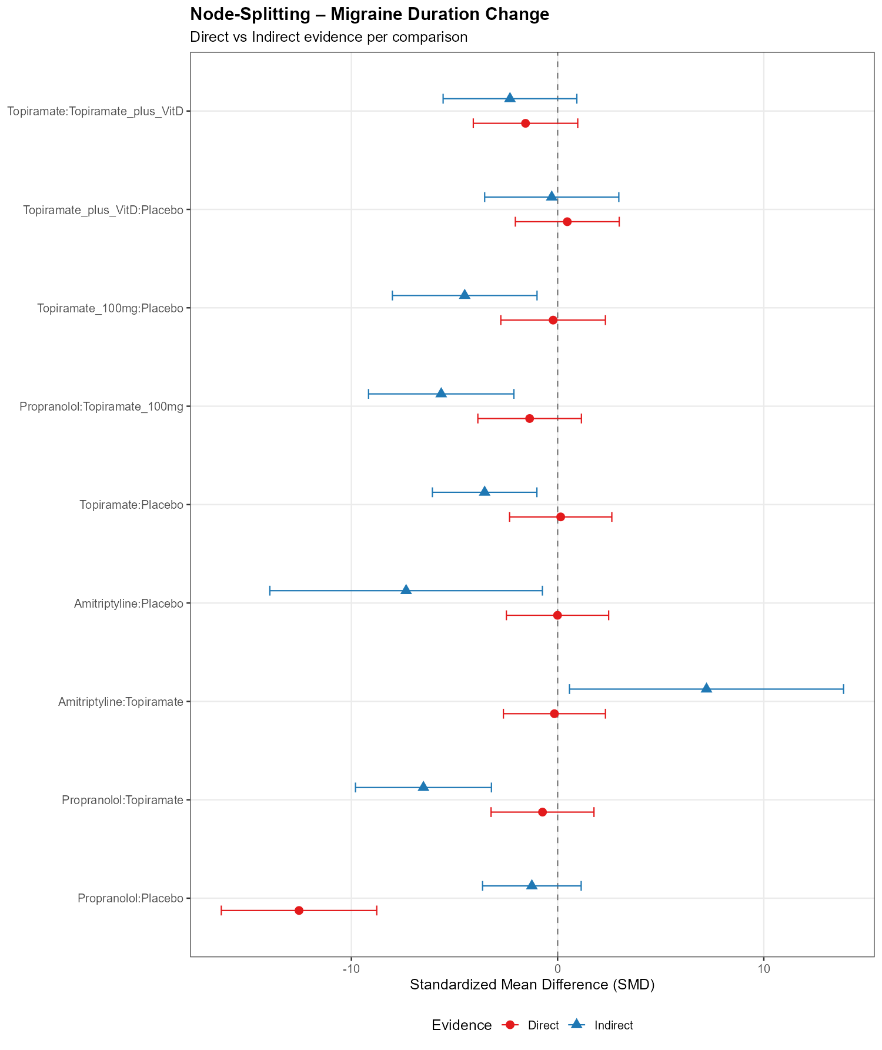
Supplementary Figure 16: Node-Splitting P-values for Loop Inconsistency – Migraine Duration Change
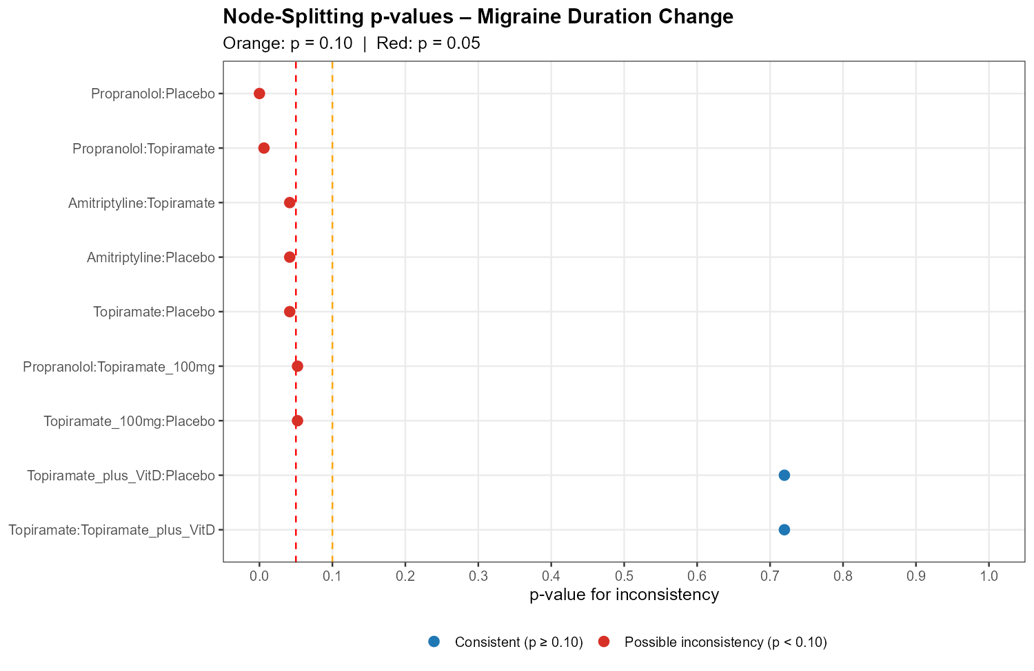
Supplementary Figure 17: League Table Heatmap of Pairwise Treatment Effects – Migraine Duration Change
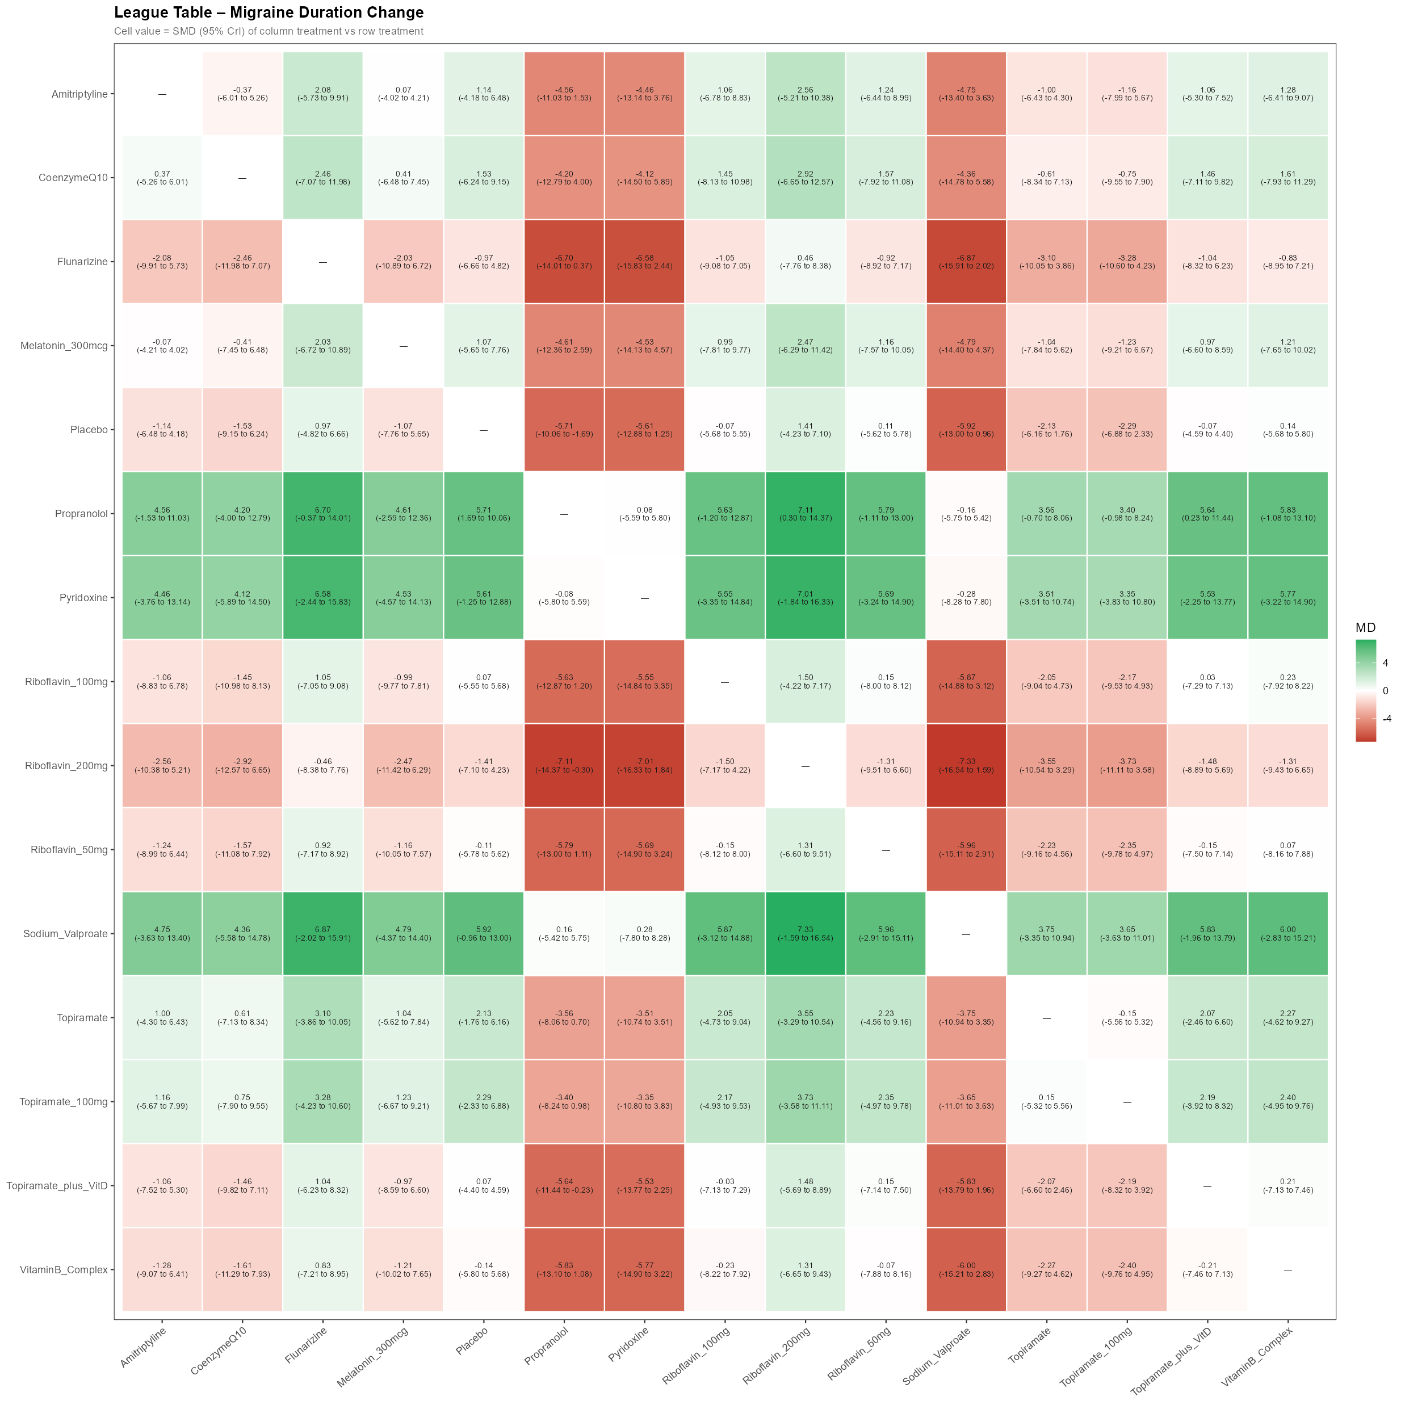
Supplementary Figure 18: Ranking Probability Heatmap – Migraine Duration Change
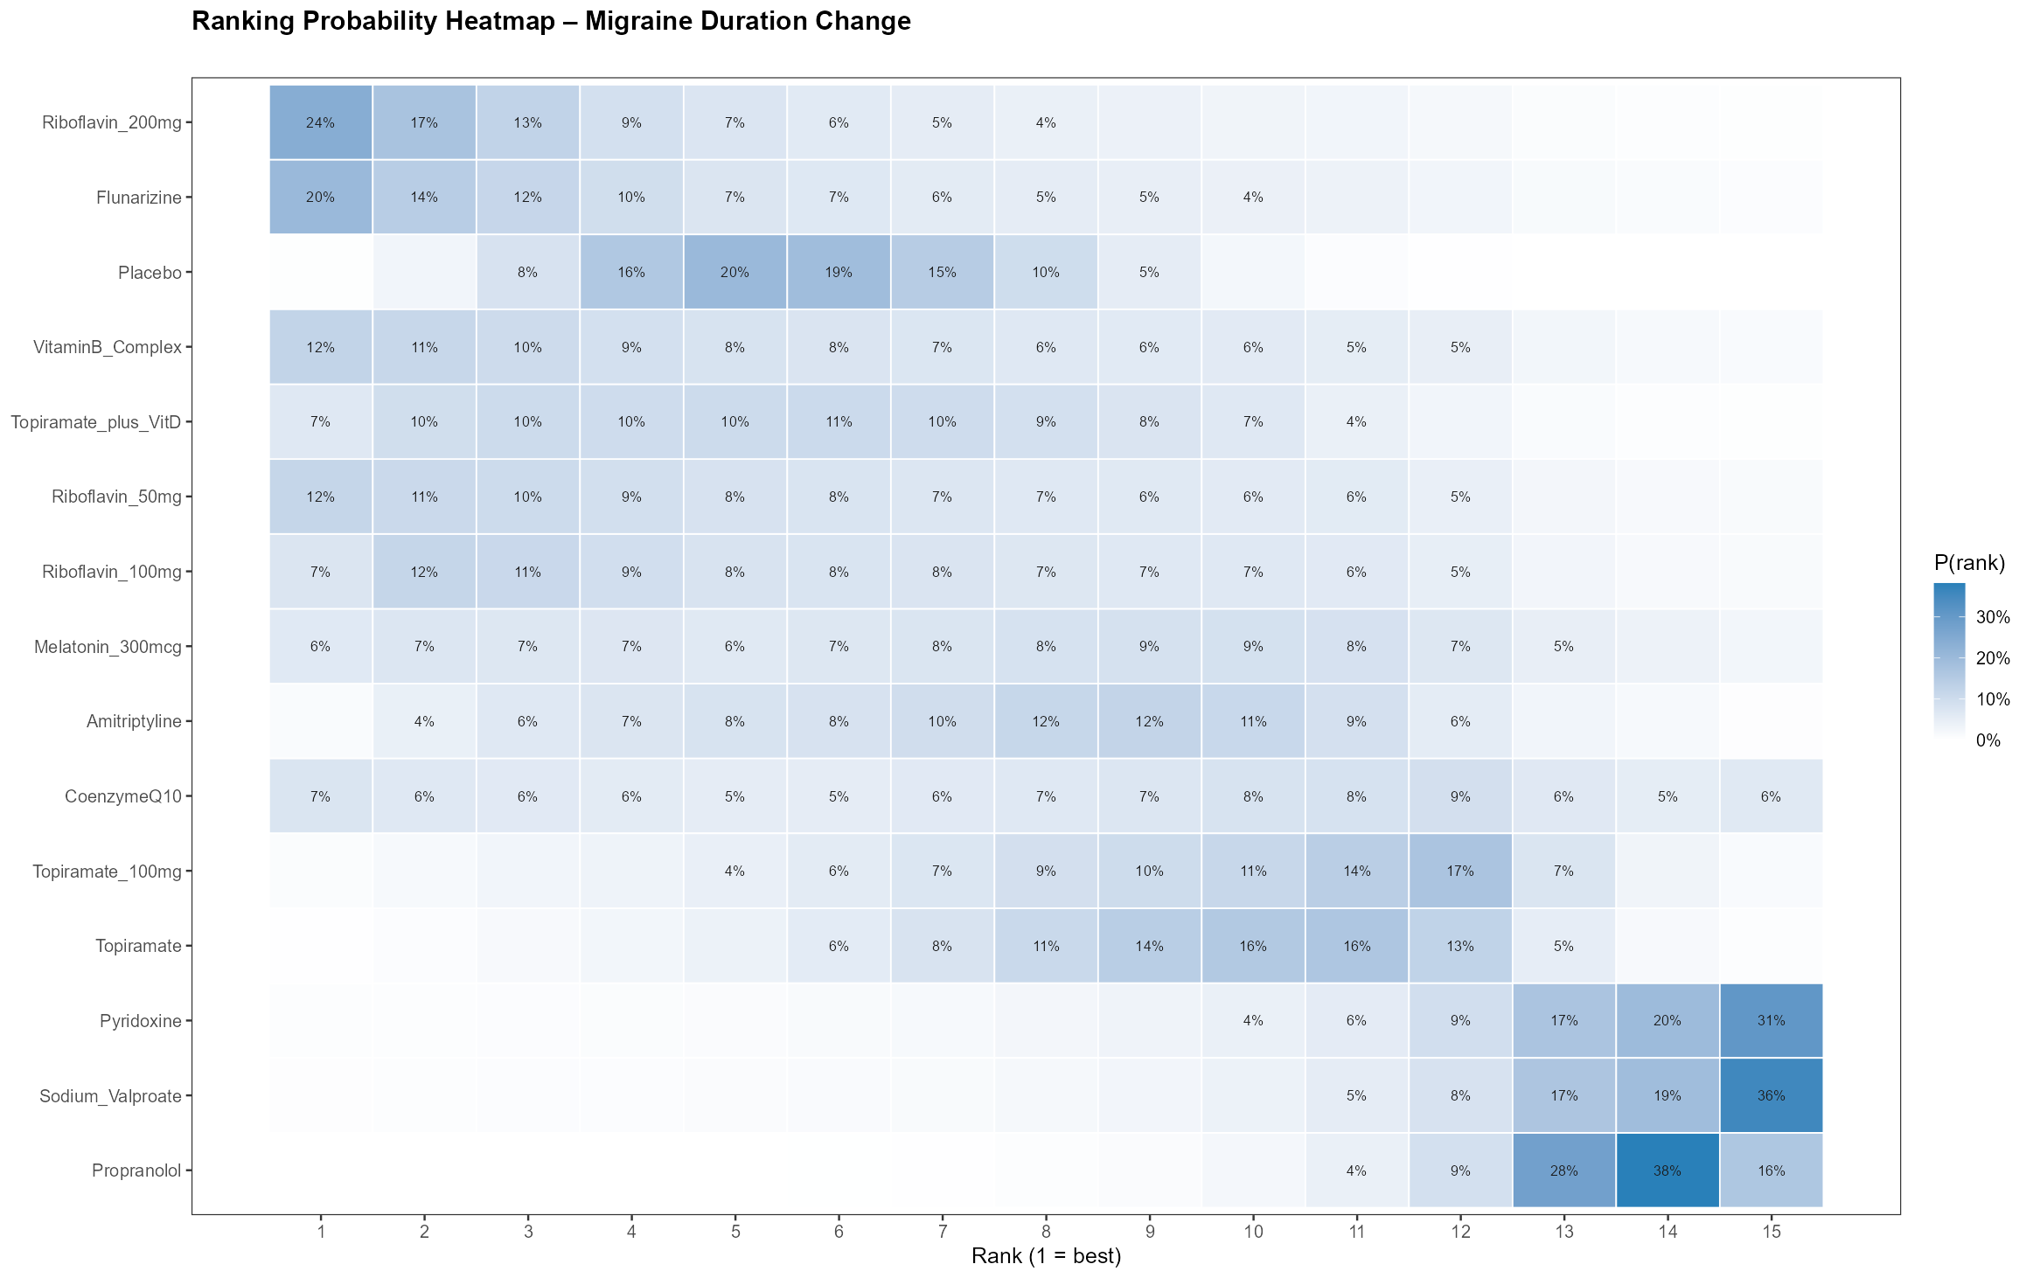
Supplementary Figure 19: SUCRA Ranking Bar Chart – Migraine Duration Change
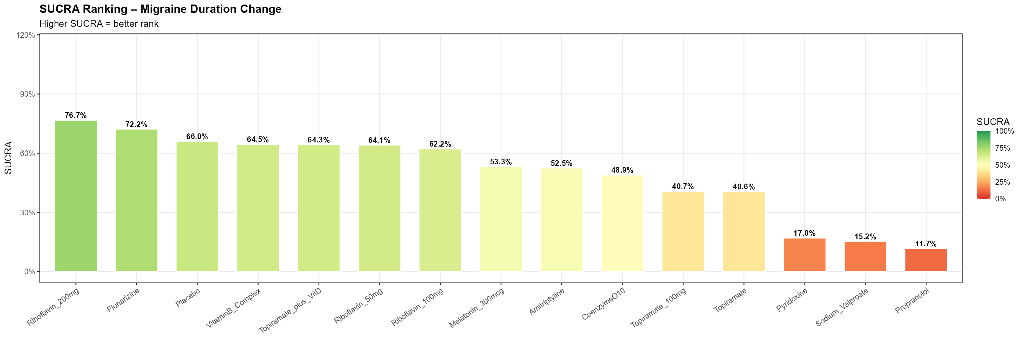
Supplementary Figure 20: Cumulative SUCRA Curve – Migraine Duration Change
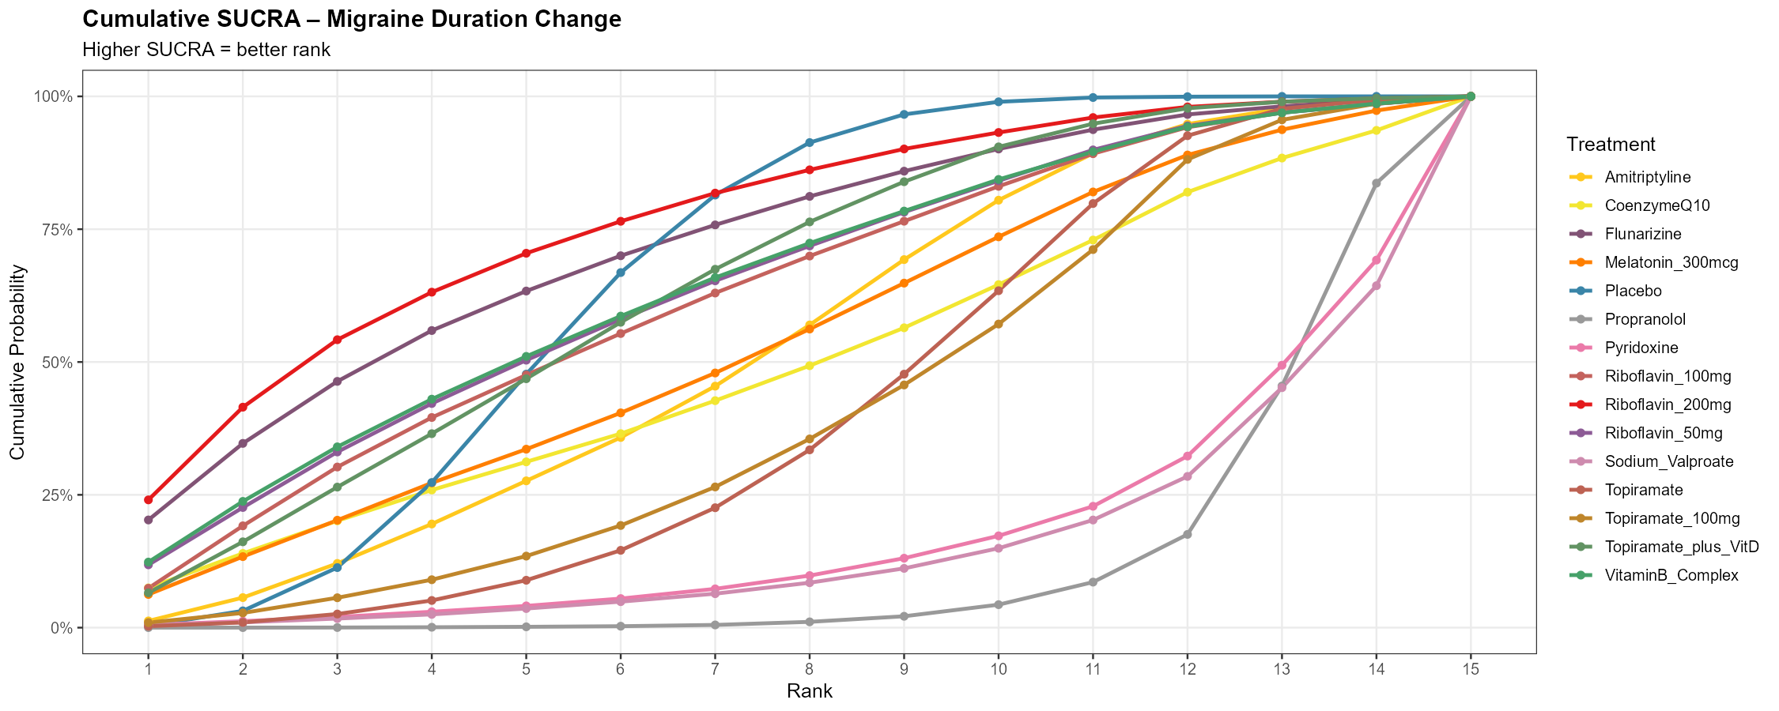
Supplementary Figure 21: Node-Splitting Forest Plot (Direct vs Indirect Evidence) – ≥50% Response Rate
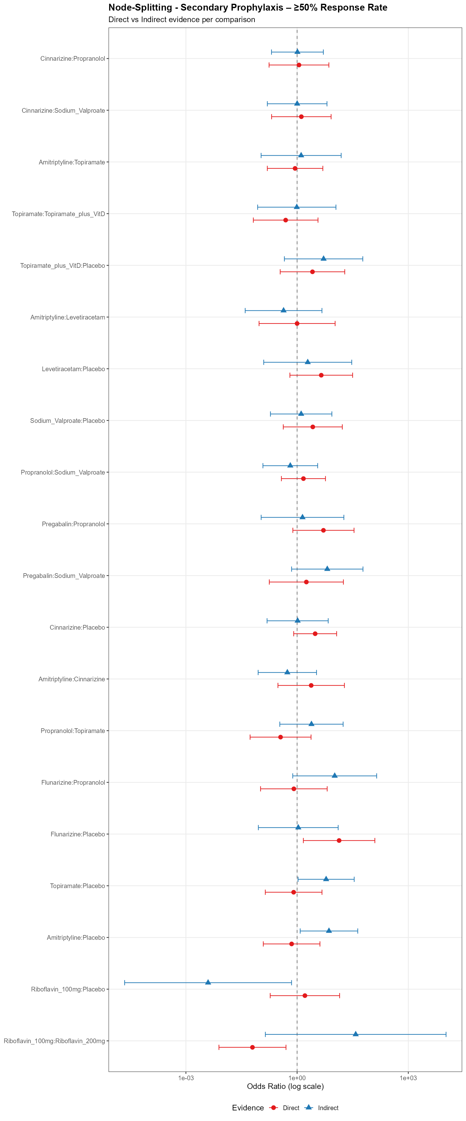
Supplementary Figure 22: Node-Splitting P-values for Loop Inconsistency – ≥50% Response Rate
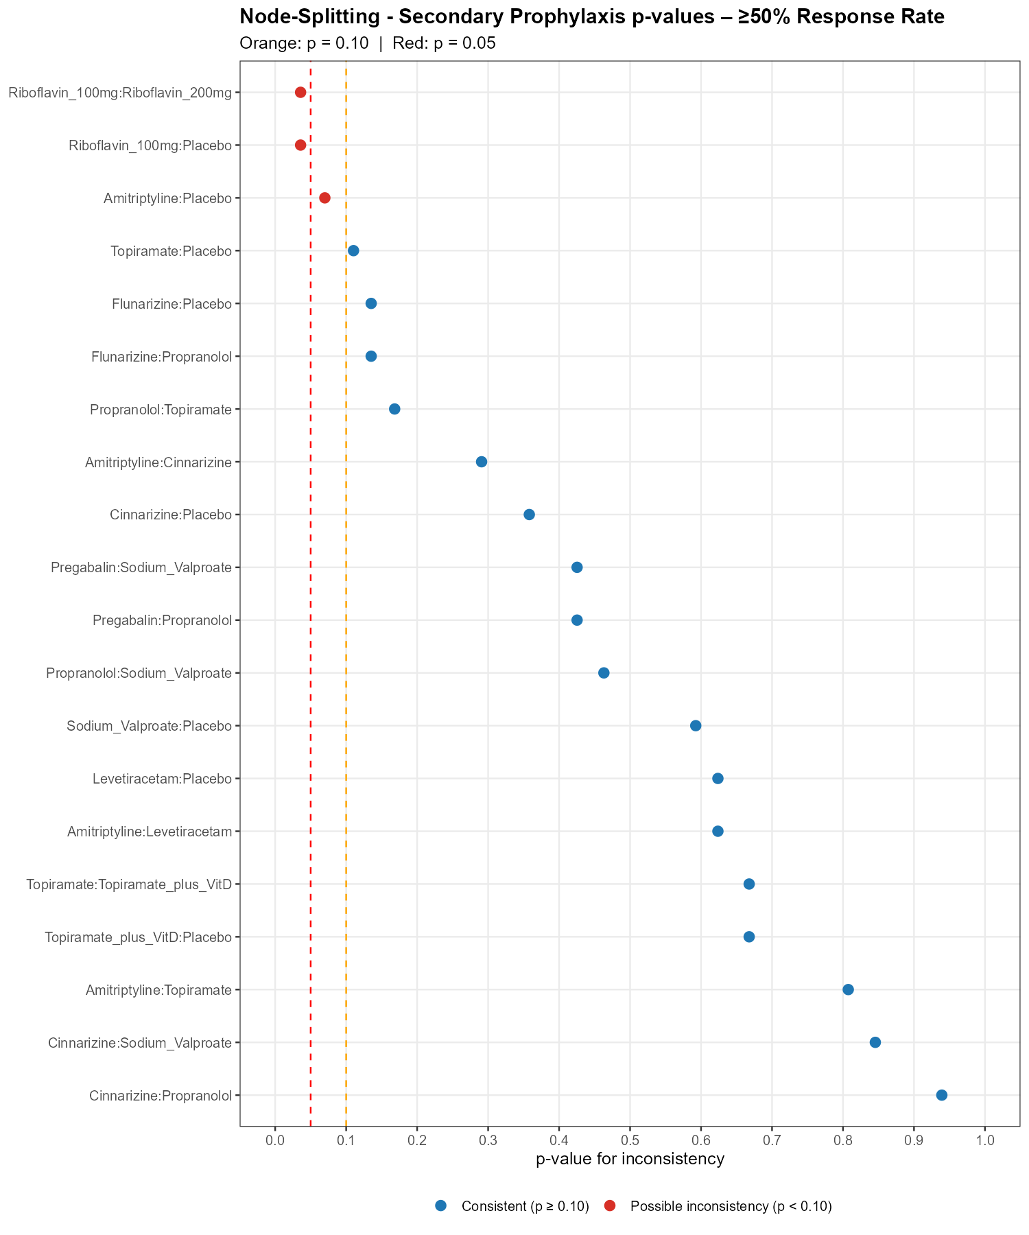
Supplementary Figure 23: League Table Heatmap of Pairwise Treatment Effects – ≥50% Response Rate
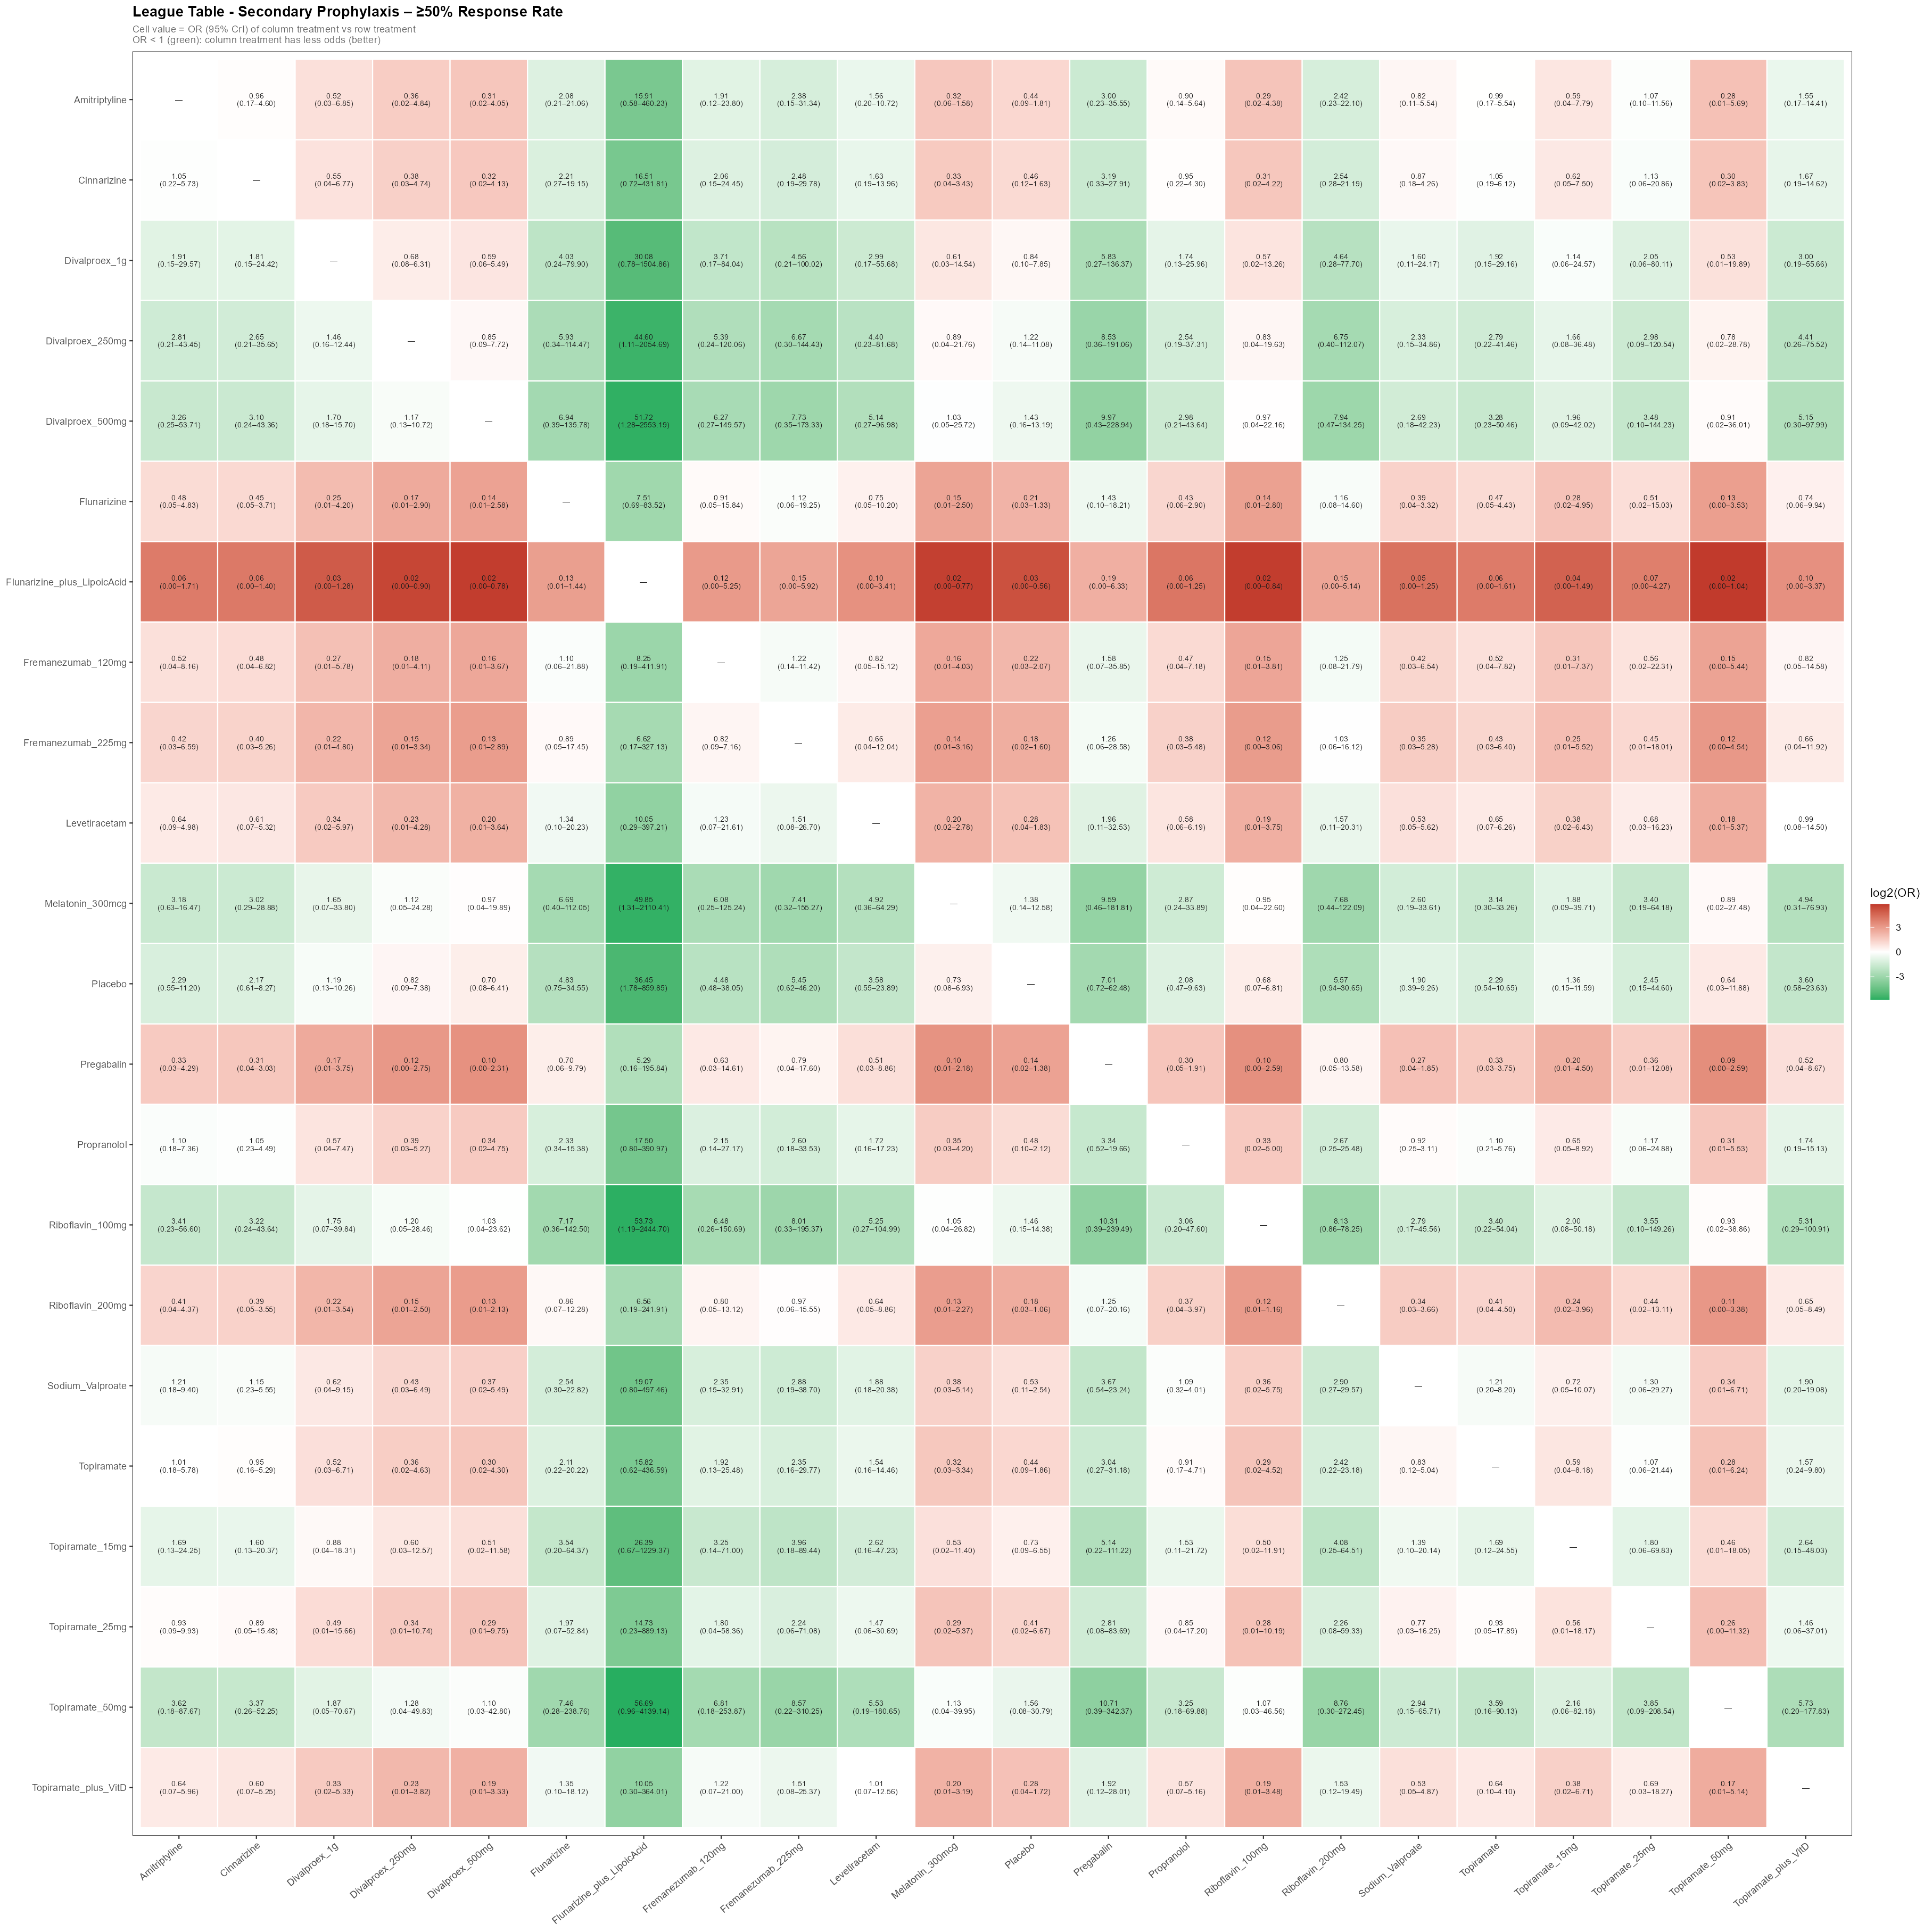
Supplementary Figure 24: Ranking Probability Heatmap – ≥50% Response Rate
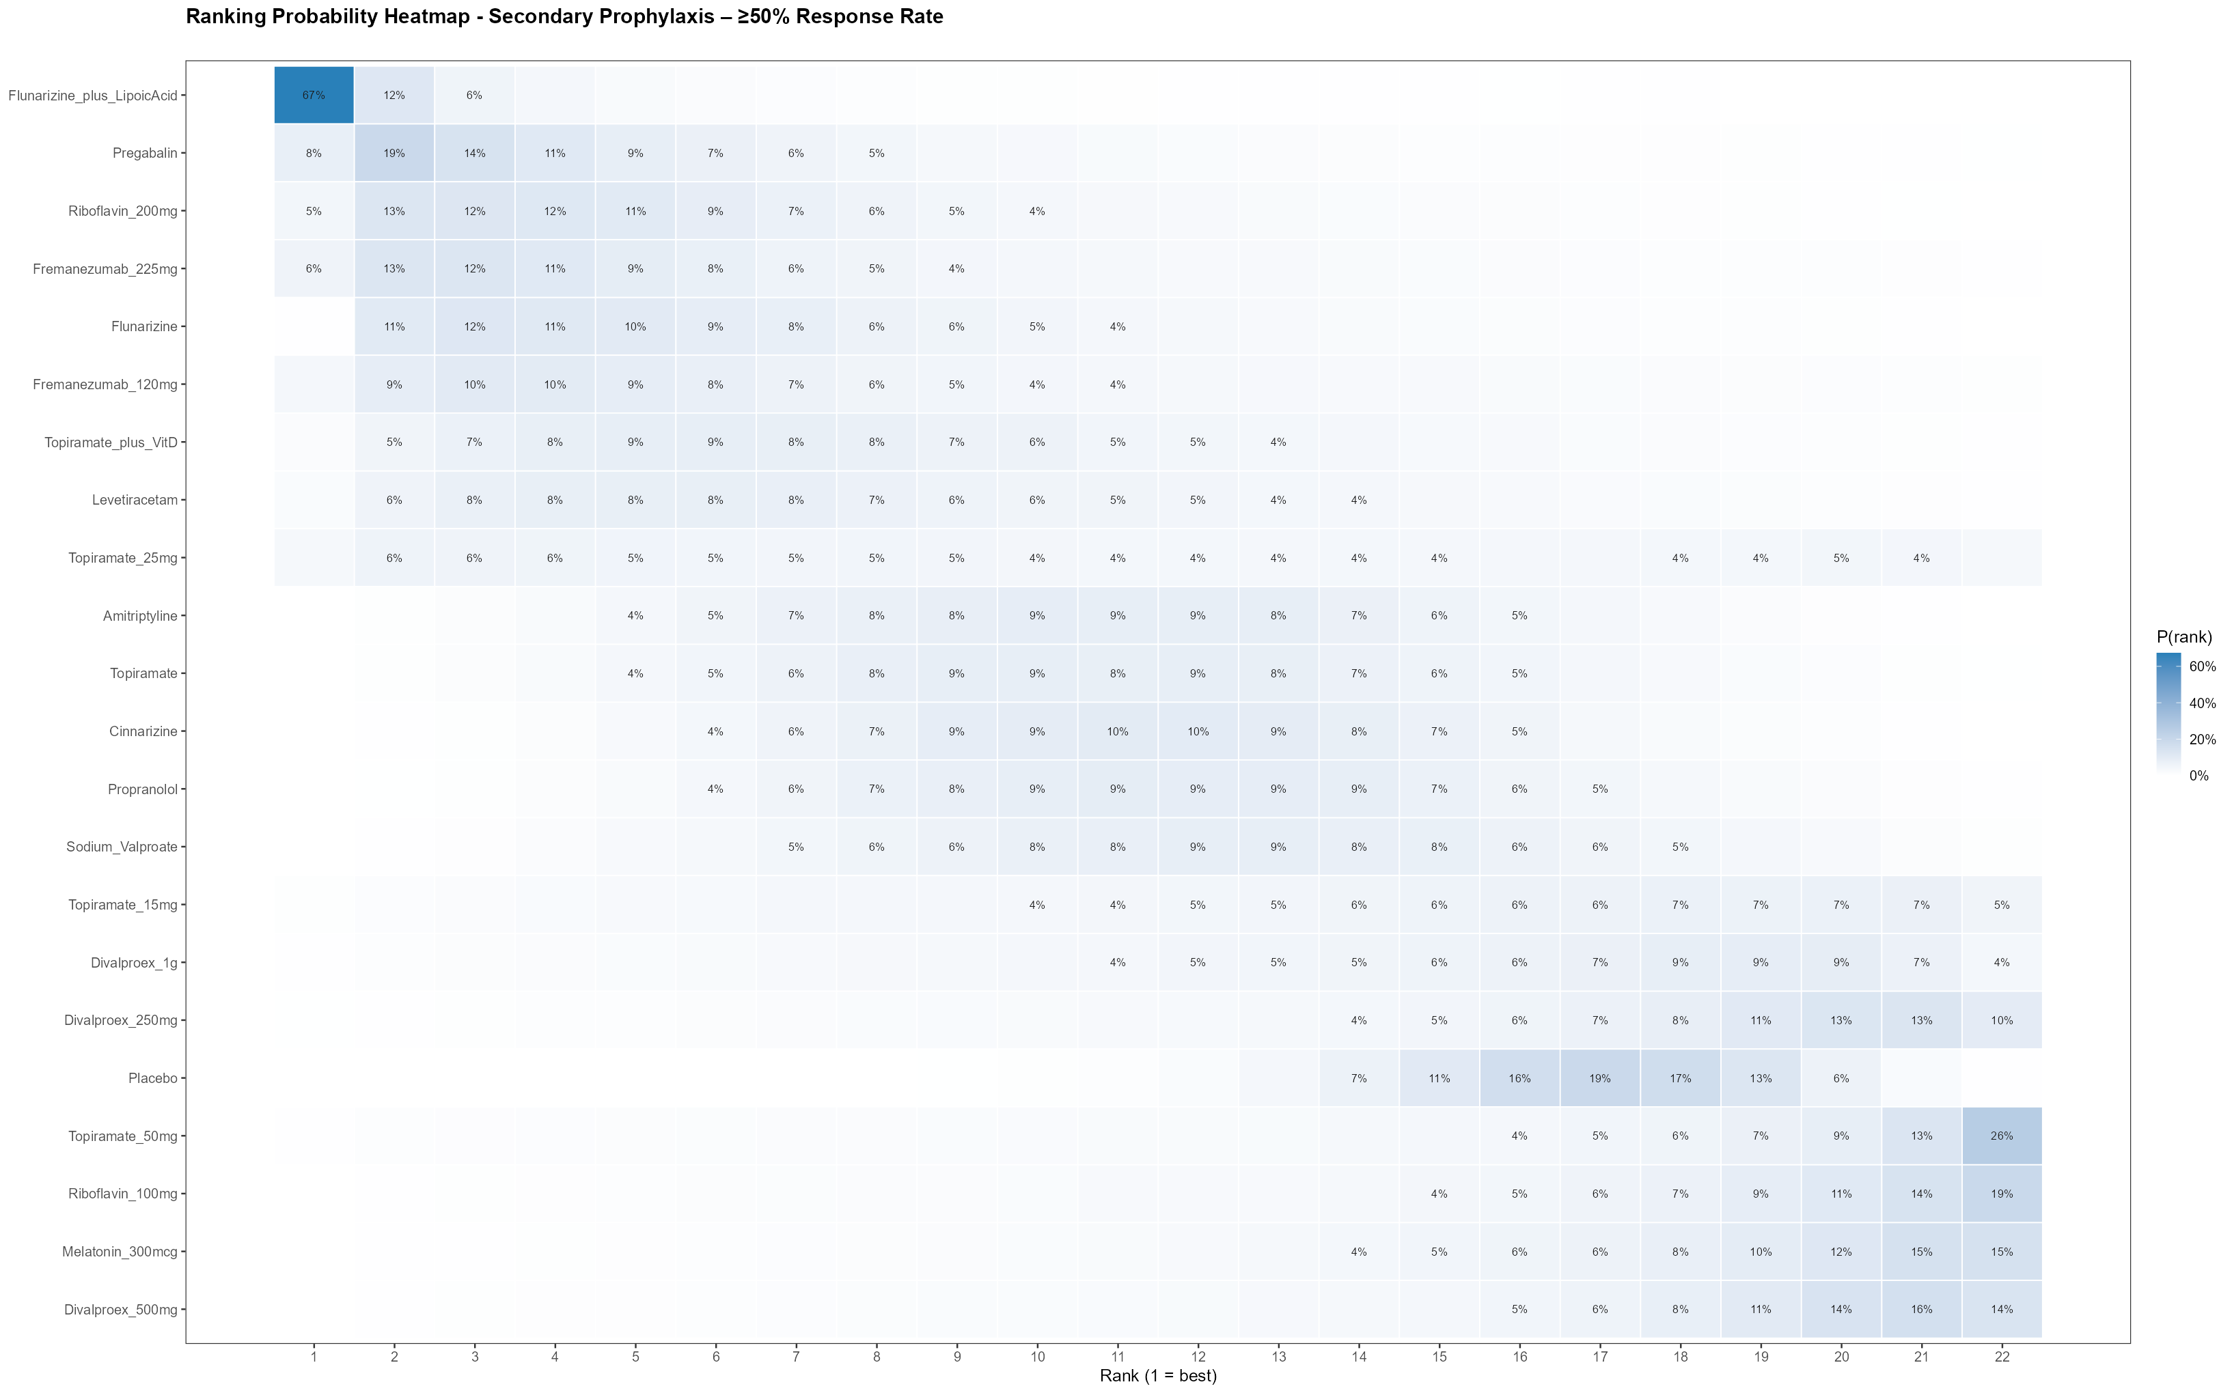
Supplementary Figure 25: SUCRA Ranking Bar Chart – ≥50% Response Rate
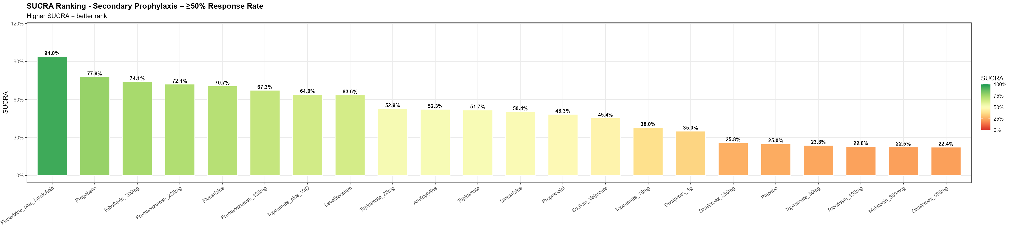
Supplementary Figure 26: Cumulative SUCRA Curve – ≥50% Response Rate
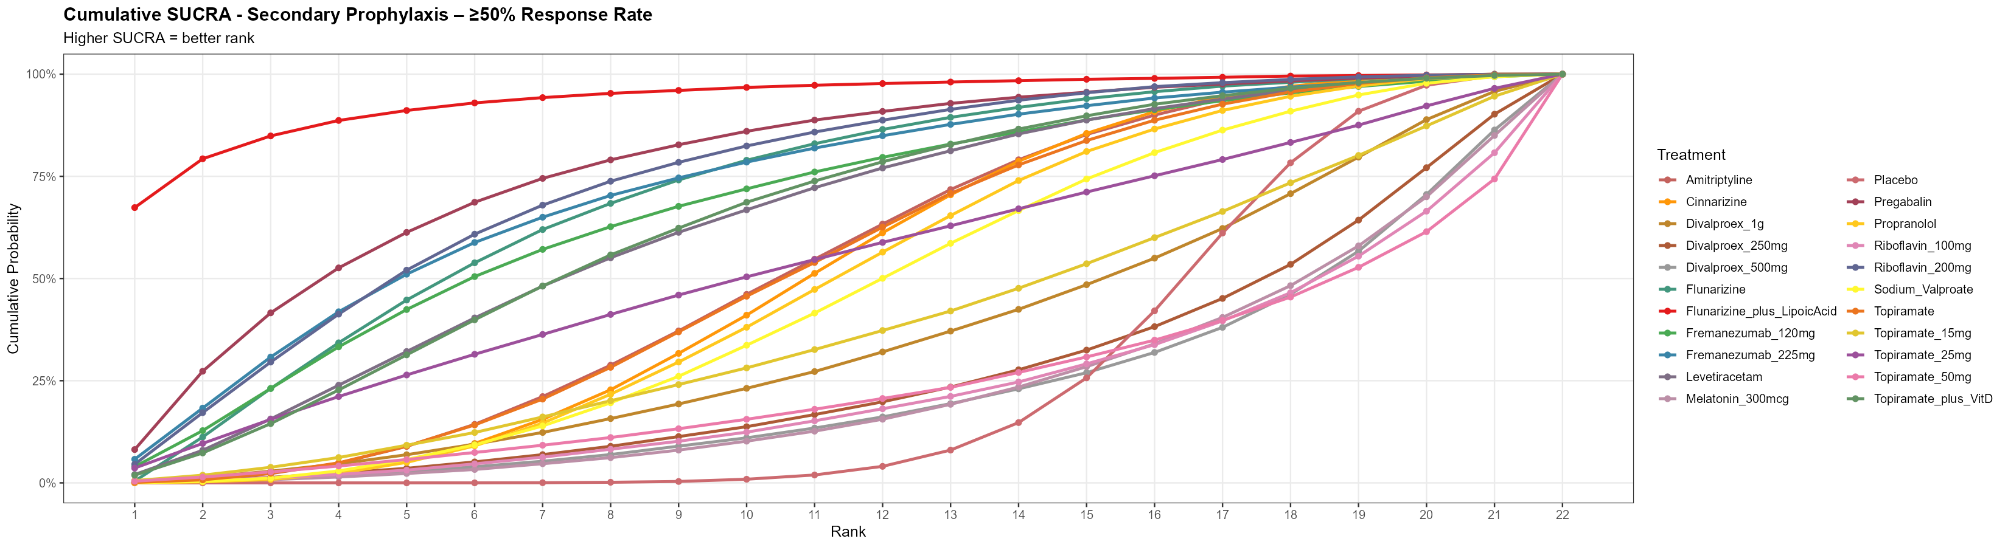
Supplementary Figure 27: Node-Splitting Forest Plot (Direct vs Indirect Evidence) – Overall Adverse Events
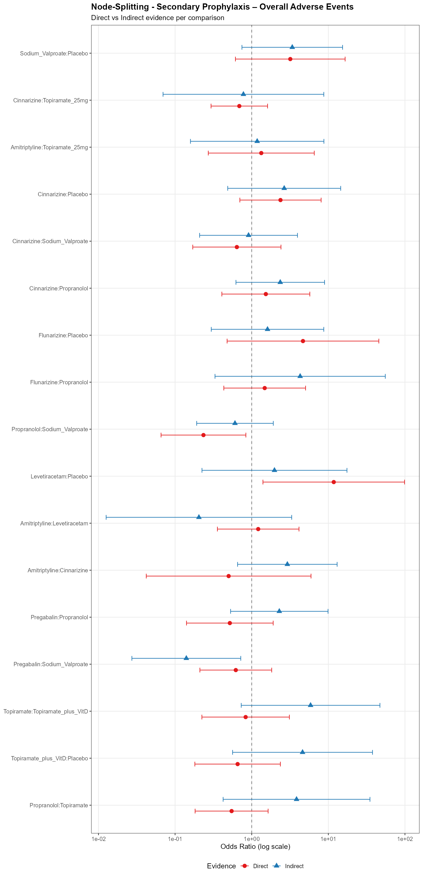
Supplementary Figure 28: Node-Splitting P-values for Loop Inconsistency – Overall Adverse Events
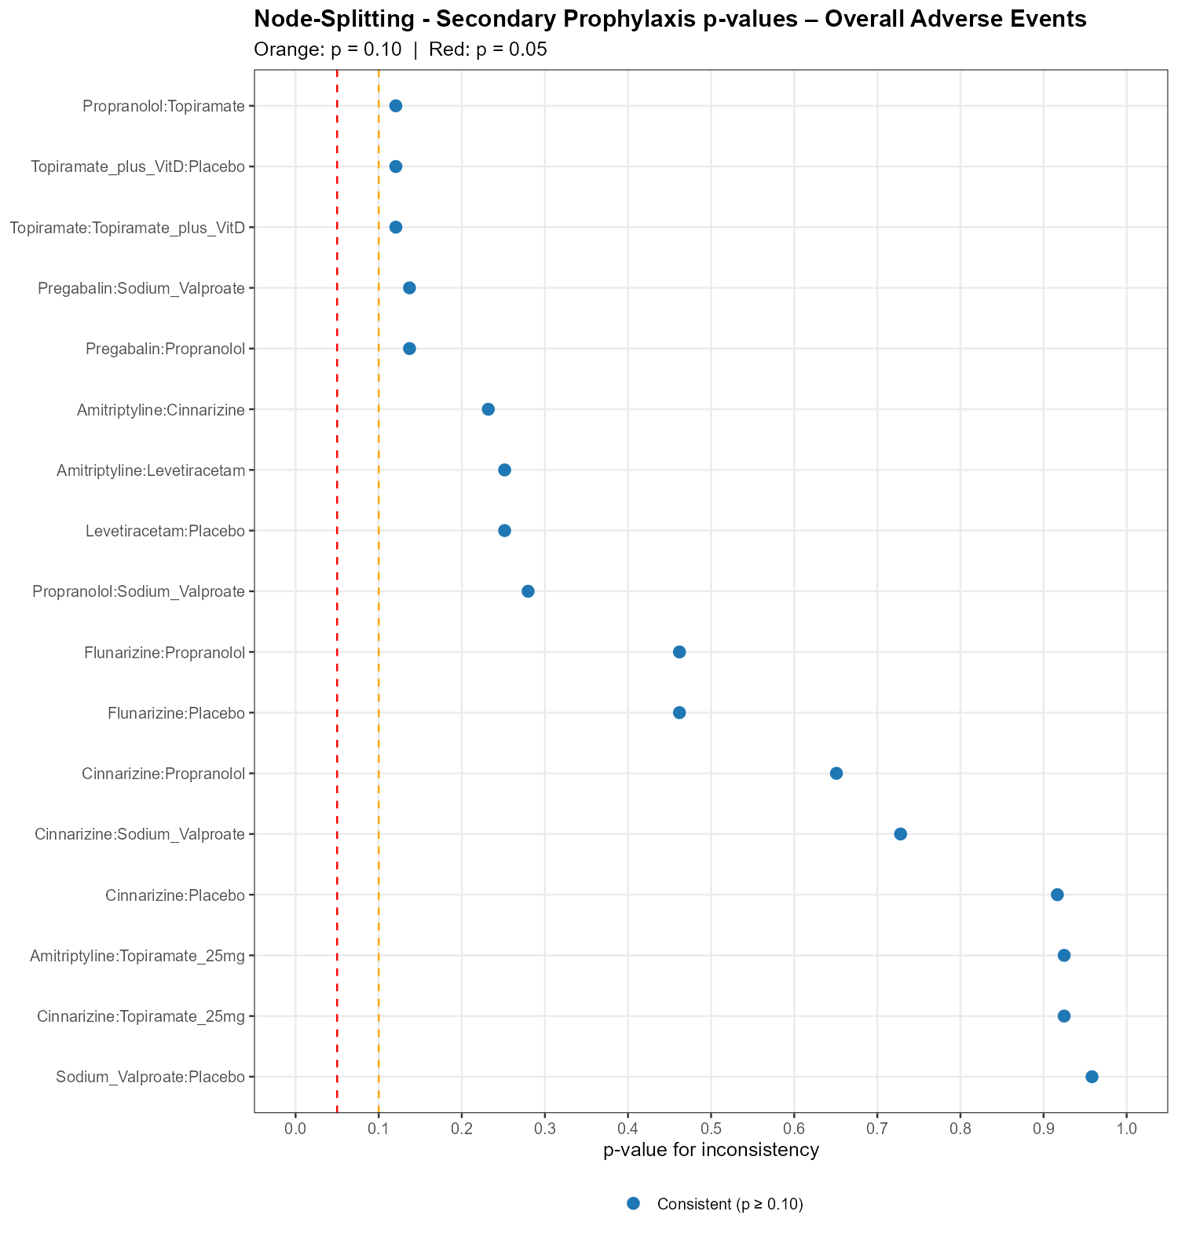
Supplementary Figure 29: League Table Heatmap of Pairwise Treatment Effects – Overall Adverse Events
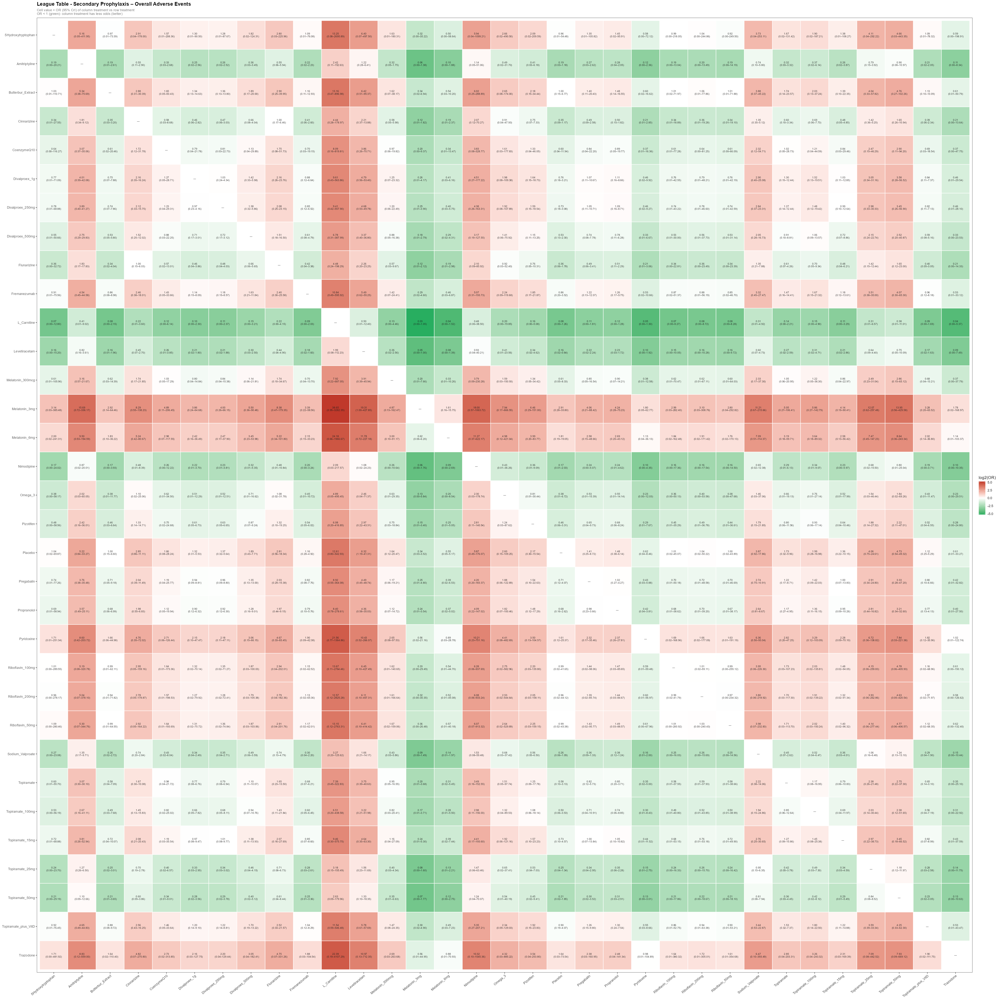
Supplementary Figure 30: Ranking Probability Heatmap – Overall Adverse Events
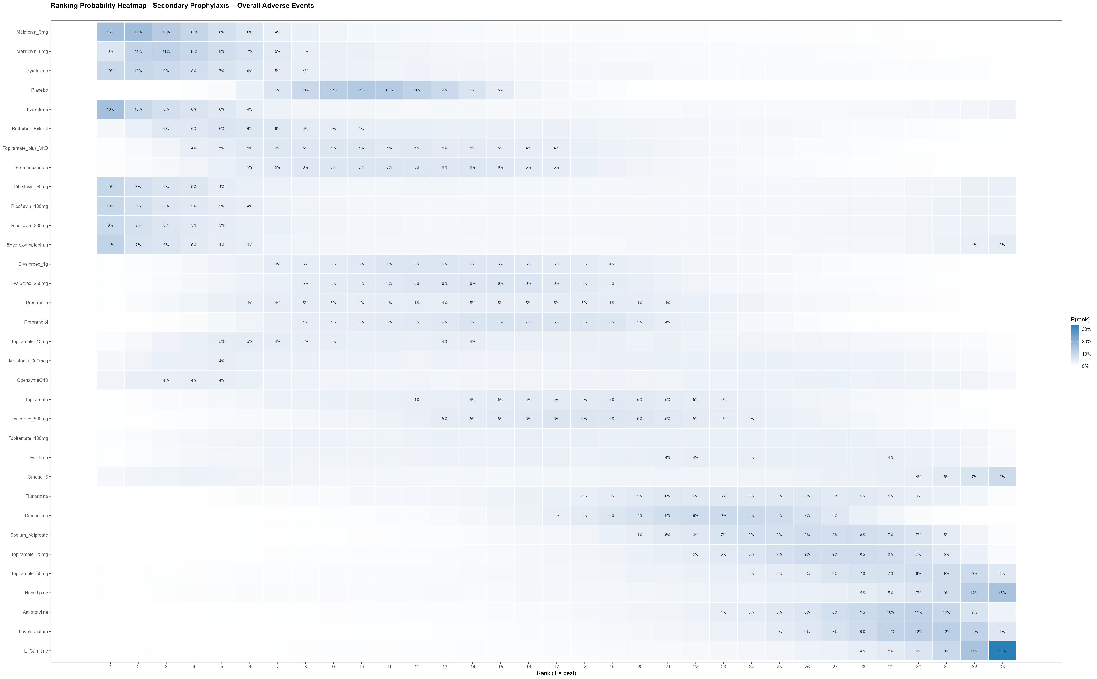
Supplementary Figure 31: SUCRA Ranking Bar Chart – Overall Adverse Events
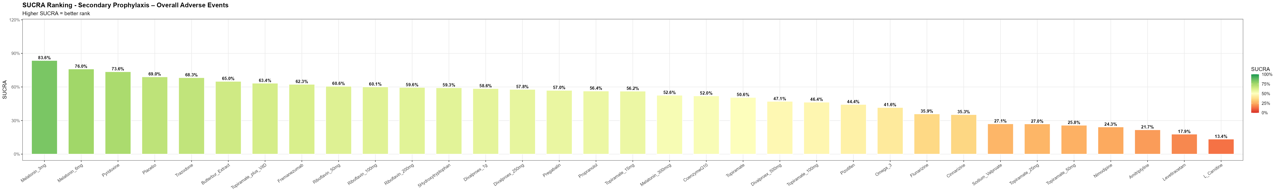
Supplementary Figure 32: Cumulative SUCRA Curve – Overall Adverse Events
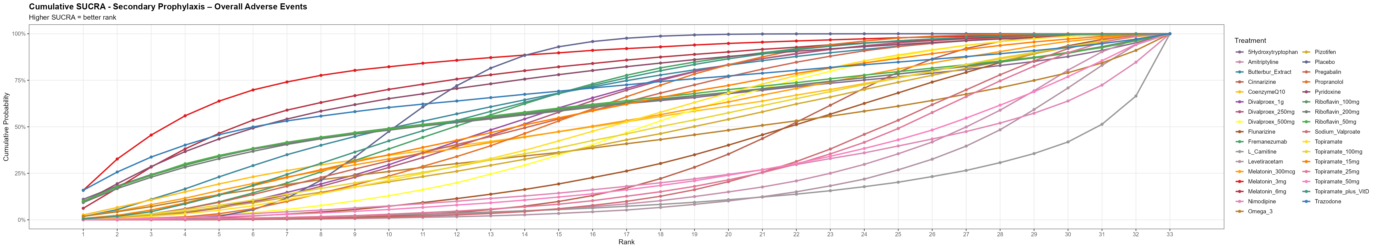

Supplementary figure 33: Network plot for change in migraine frequency

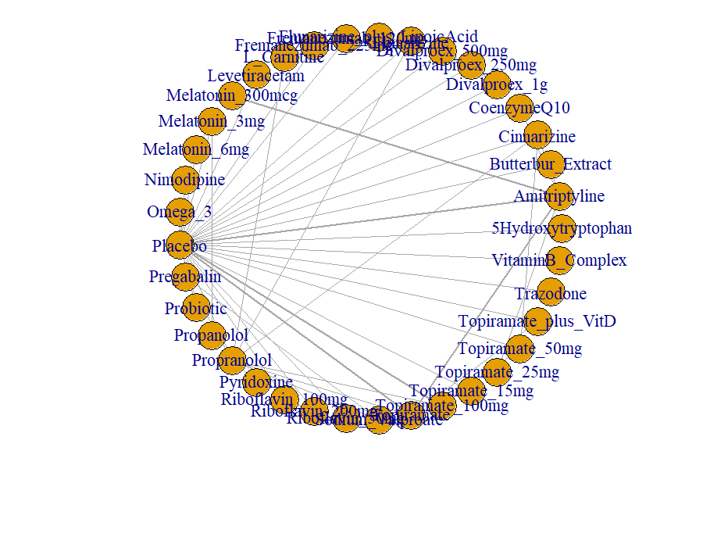

Supplementary figure 34: Network plot for change in migraine severity
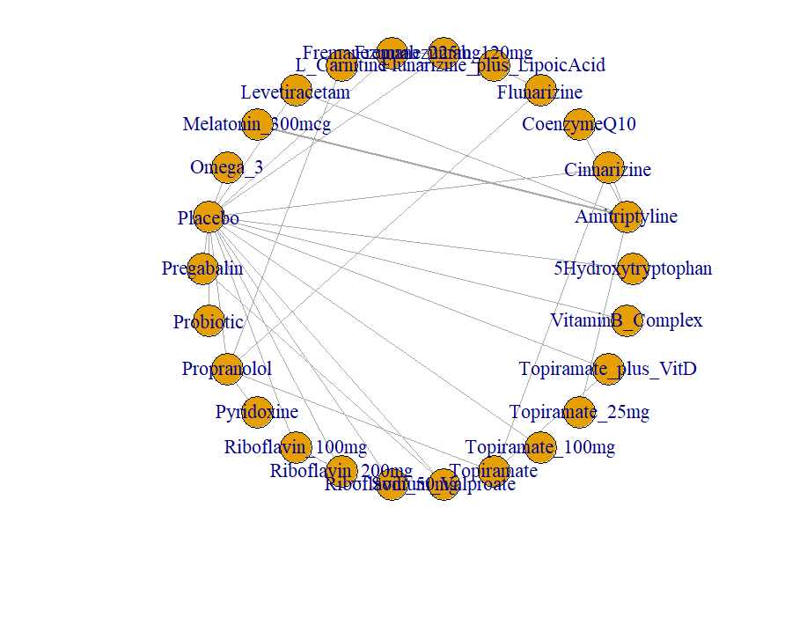

Supplementary figure 35. Network plot for change in migraine duration
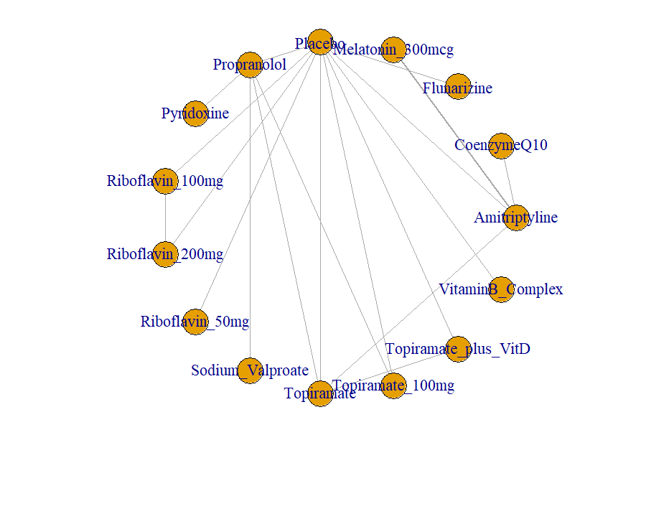

Supplementary figure 36. Network plot for ≥50% reduction in headache frequency
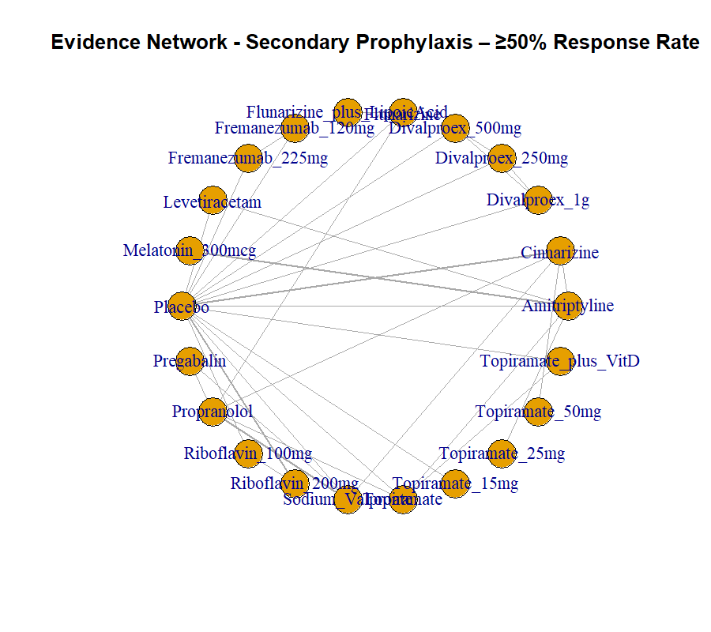

Supplementary Figure 37. Network plot for overall adverse events
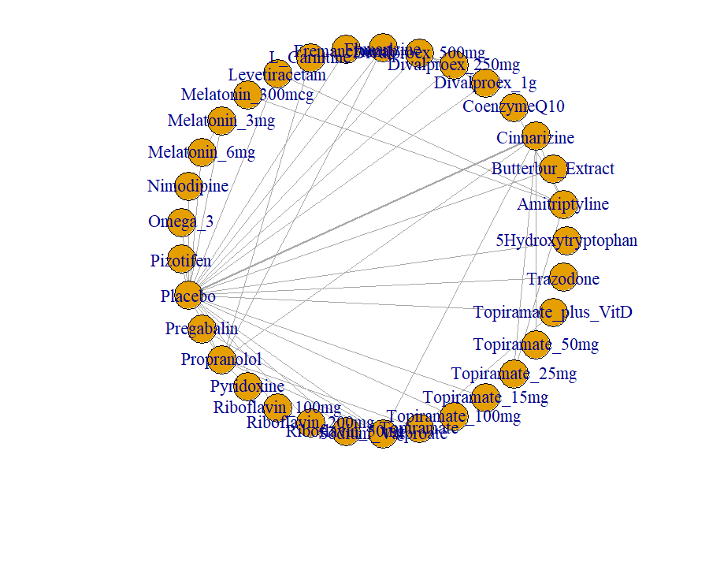

Supplementary Table 1: Search Strategies and Results from Individual Databases
Database | Search | Results
PubMed | ((((((((((((((Disorder, Migraine) OR (Disorders, Migraine)) OR (Migraine Disorder)) OR (Headache, Migraine)) OR (Headaches, Migraine)) OR (Migraine Headaches)) OR (Migraine)) OR (Migraines)) OR (Migraine Headache)) OR (Variants, Migraine)) OR (Sick Headache)) OR (Headache, Sick)) AND (((Pediatric) OR (Paediatric)) OR (Children))) AND (((Prophylaxis) OR (Prevent)) OR (Recurrent))) AND ((((((((((((((((((((((((Coenzyme Q10) OR (Ubiquinone)) OR (Pregabalin)) OR (Topiramate)) OR (Vitamin D3)) OR (Flunarizine)) OR (Levetiracetam)) OR (Riboflavin)) OR (Melatonin)) OR (Propranolol)) OR (Cinnarizine)) OR (Amitriptyline)) OR (Pizotifen)) OR (Vitamin B)) OR (Valproate)) OR (Omega-3)) OR (Carnitine)) OR (5-HTP)) OR (Nimodipine)) OR (Trazodone)) OR (Butterbur)) OR (Fremanezumab)) OR (monoclonal antibody)) OR (calcitonin)) | 537
Cochrane CENTRAL | ((((((((((((((Disorder, Migraine) OR (Disorders, Migraine)) OR (Migraine Disorder)) OR (Headache, Migraine)) OR (Headaches, Migraine)) OR (Migraine Headaches)) OR (Migraine)) OR (Migraines)) OR (Migraine Headache)) OR (Variants, Migraine)) OR (Sick Headache)) OR (Headache, Sick)) AND (((Pediatric) OR (Paediatric)) OR (Children))) AND (((Prophylaxis) OR (Prevent)) OR (Recurrent))) AND ((((((((((((((((((((((((Coenzyme Q10) OR (Ubiquinone)) OR (Pregabalin)) OR (Topiramate)) OR (Vitamin D3)) OR (Flunarizine)) OR (Levetiracetam)) OR (Riboflavin)) OR (Melatonin)) OR (Propranolol)) OR (Cinnarizine)) OR (Amitriptyline)) OR (Pizotifen)) OR (Vitamin B)) OR (Valproate)) OR (Omega 3)) OR (Carnitine)) OR (5 HTP)) OR (Nimodipine)) OR (Trazodone)) OR (Butterbur)) OR (Fremanezumab)) OR (monoclonal antibody)) OR (calcitonin)) | 197
Scopus | (TITLE-ABS-KEY("migraine disorder" OR "migraine headache" OR "migraine headaches" OR "migraine variants" OR "sick headache" OR "migraine" OR "migraines")) AND (TITLE-ABS-KEY("pediatric" OR "paediatric" OR "children" OR "p*ediatric")) AND (TITLE-ABS-KEY("prophylaxis" OR "prevent" OR "recurrent")) AND (TITLE-ABS-KEY("coenzyme q10" OR "ubiquinone" OR "pregabalin" OR "topiramate" OR "vitamin d3" OR "flunarizine" OR "levetiracetam" OR "riboflavin" OR "melatonin" OR "propranolol" OR "cinnarizine" OR "amitriptyline" OR "pizotifen" OR "vitamin b" OR "valproate" OR "omega 3" OR "carnitine" OR "5 htp" OR "nimodipine" OR "trazodone" OR "butterbur" OR "fremanezumab" OR "monoclonal antibody" OR "calcitonin")) | 251
Embase | ('migraine'/exp OR 'migraine':ti,ab OR 'migraines':ti,ab OR 'migraine disorder':ti,ab OR 'migraine headaches':ti,ab OR 'migraine headache':ti,ab OR 'migraine variants':ti,ab OR 'sick headache':ti,ab) AND ('child'/exp OR 'pediatric':ti,ab OR 'paediatric':ti,ab OR 'children':ti,ab) AND ('prevention'/exp OR 'prophylaxis':ti,ab OR 'prevent':ti,ab OR 'recurrent':ti,ab) AND ('coenzyme q10':ti,ab OR 'ubiquinone':ti,ab OR 'pregabalin':ti,ab OR 'topiramate':ti,ab OR 'vitamin d3':ti,ab OR 'flunarizine':ti,ab OR 'levetiracetam':ti,ab OR 'riboflavin':ti,ab OR 'melatonin':ti,ab OR 'propranolol':ti,ab OR 'cinnarizine':ti,ab OR 'amitriptyline':ti,ab OR 'pizotifen':ti,ab OR 'vitamin b':ti,ab OR 'valproate':ti,ab OR 'omega 3':ti,ab OR 'carnitine':ti,ab OR '5 htp':ti,ab OR 'nimodipine':ti,ab OR 'trazodone':ti,ab OR 'butterbur':ti,ab OR 'fremanezumab':ti,ab OR 'monoclonal antibody':ti,ab OR 'calcitonin':ti,ab) | 532
Supplementary table 2. CINeMA certainty of evidence assessment
CINeMA certainty assessment — Migraine Frequency Change (vs Placebo)
Treatment vs Placebo | Effect (95% CrI) | Within-study bias | Indirectness | Imprecision | Heterogeneity | Incoherence | Overall confidence
Riboflavin 200 mg | 1.95 (1.06 to 2.85) | None/minor | Some concerns [AD] | Some concerns | Some concerns | Not estimable (no closed loop) | Very low
Topiramate + Vitamin D | 1.40 (0.76 to 2.04) | Some concerns [ND] | Some concerns [ND] | None/minor | Some concerns | None/minor | Very low
Flunarizine + Lipoic Acid | 1.29 (0.22 to 2.37) | Some concerns [ND] | Some concerns [ND] | Some concerns | Some concerns | Not estimable (no closed loop) | Very low
Levetiracetam | 0.94 (0.10 to 1.75) | Some concerns | None/minor | Some concerns | Some concerns | Not estimable (no closed loop) | Very low
Butterbur extract | 0.70 (-0.22 to 1.62) | Major concerns | None/minor | Some concerns | Some concerns | Not estimable (no closed loop) | Very low
Flunarizine | 0.59 (-0.07 to 1.28) | Major concerns | None/minor | Some concerns | Some concerns | None/minor | Very low
Trazodone | 0.58 (-0.27 to 1.42) | Some concerns | None/minor | Some concerns | Some concerns | Not estimable (no closed loop) | Very low
Topiramate 100 mg | 0.48 (-0.00 to 0.99) | Some concerns [?] | Some concerns [AD] | None/minor | Some concerns | Not estimable (no closed loop) | Very low
L-Carnitine | 0.45 (-0.49 to 1.40) | Some concerns [ND] | Some concerns [ND] | Some concerns | Some concerns | Not estimable (no closed loop) | Very low
Probiotic | 0.42 (-0.47 to 1.32) | Some concerns | None/minor | Some concerns | Some concerns | Not estimable (no closed loop) | Very low
Fremanezumab 120 mg | 0.40 (-0.37 to 1.16) | None/minor | None/minor | Some concerns | Some concerns | Not estimable (no closed loop) | Low
Fremanezumab 225 mg | 0.39 (-0.32 to 1.11) | None/minor | None/minor | Some concerns | Some concerns | Not estimable (no closed loop) | Low
Amitriptyline | 0.37 (-0.05 to 0.79) | None/minor | None/minor | Some concerns | Some concerns | Major concerns | Very low
Vitamin B-complex | 0.36 (-0.42 to 1.12) | Some concerns | None/minor | Some concerns | Some concerns | Not estimable (no closed loop) | Very low
Topiramate (unspecified/weight-adj.) | 0.32 (-0.09 to 0.74) | Some concerns | Some concerns [AD] | Some concerns | Some concerns | Some concerns | Very low
Propranolol | 0.27 (-0.19 to 0.73) | Some concerns [?] | None/minor | Some concerns | Some concerns | None/minor | Very low
Pregabalin | 0.31 (-0.47 to 1.09) | Some concerns [ND] | Some concerns [ND] | Some concerns | Some concerns | None/minor | Very low
Pyridoxine | 0.30 (-0.63 to 1.24) | Some concerns [ND] | Some concerns [ND] | Some concerns | Some concerns | Not estimable (no closed loop) | Very low
Topiramate 15 mg | 0.22 (-0.52 to 0.95) | Some concerns [?] | Some concerns [AD] | Some concerns | Some concerns | Not estimable (no closed loop) | Very low
Melatonin 6 mg | 0.21 (-0.95 to 1.40) | Some concerns | None/minor | Some concerns | Some concerns | Not estimable (no closed loop) | Very low
Cinnarizine | 0.19 (-0.30 to 0.67) | Some concerns | None/minor | Some concerns | Some concerns | None/minor | Very low
Riboflavin 100 mg | 0.17 (-0.64 to 1.01) | Some concerns [?] | Some concerns [AD] | Some concerns | Some concerns | Not estimable (no closed loop) | Very low
Divalproex 500 mg | 0.05 (-0.68 to 0.78) | Some concerns | None/minor | Some concerns | Some concerns | Not estimable (no closed loop) | Very low
Melatonin 3 mg | -0.03 (-1.18 to 1.14) | Some concerns | None/minor | Some concerns | Some concerns | Not estimable (no closed loop) | Very low
Divalproex 1 g | -0.05 (-0.78 to 0.67) | Some concerns | None/minor | Some concerns | Some concerns | Not estimable (no closed loop) | Very low
CoenzymeQ10 | -0.06 (-0.65 to 0.51) | Major concerns | None/minor | Some concerns | Some concerns | Some concerns | Very low
Riboflavin 50 mg | -0.10 (-0.88 to 0.69) | None/minor | None/minor | Some concerns | Some concerns | Not estimable (no closed loop) | Low
Topiramate 50 mg | -0.10 (-0.71 to 0.51) | Some concerns [?] | Some concerns [AD] | Some concerns | Some concerns | None/minor | Very low
Divalproex 250 mg | -0.11 (-0.83 to 0.62) | Some concerns | None/minor | Some concerns | Some concerns | Not estimable (no closed loop) | Very low
Melatonin 300 mcg | -0.11 (-0.81 to 0.59) | Some concerns [?] | Some concerns [AD] | Some concerns | Some concerns | Not estimable (no closed loop) | Very low
5-Hydroxytryptophan | -0.21 (-1.28 to 0.87) | None/minor | None/minor | Some concerns | Some concerns | Not estimable (no closed loop) | Low
Sodium Valproate | -0.25 (-1.05 to 0.56) | Some concerns | None/minor | Some concerns | Some concerns | Not estimable (no closed loop) | Very low
Omega-3 | -0.27 (-1.27 to 0.75) | Some concerns | Some concerns [AO] | Some concerns | Some concerns | Not estimable (no closed loop) | Very low
Nimodipine | -0.33 (-1.15 to 0.47) | Some concerns | None/minor | Some concerns | Some concerns | Not estimable (no closed loop) | Very low
Topiramate 25 mg | -5.95 (-7.44 to -4.46) | Some concerns [?] | Major concerns [OUT] | Some concerns | Some concerns | Not estimable (no closed loop) | Very low

CINeMA certainty assessment — Migraine Severity Change (vs Placebo)
Treatment vs Placebo | Effect (95% CrI) | Within-study bias | Indirectness | Imprecision | Heterogeneity | Incoherence | Overall confidence
Sodium Valproate | 2.04 (0.84 to 3.21) | Some concerns | None/minor | Some concerns | Some concerns | Not estimable (no closed loop) | Very low
Pregabalin | 1.75 (0.57 to 2.92) | Some concerns [ND] | Some concerns [ND] | Some concerns | Some concerns | Not estimable (no closed loop) | Very low
Cinnarizine | 0.87 (0.06 to 1.74) | Some concerns | None/minor | Some concerns | Some concerns | None/minor | Very low
Topiramate + Vitamin D | 0.87 (-0.06 to 1.80) | Some concerns [ND] | Some concerns [ND] | Major concerns | Some concerns | None/minor | Very low
Topiramate 100 mg | 0.78 (-0.41 to 1.95) | Some concerns [?] | Some concerns [AD] | Some concerns | Some concerns | Not estimable (no closed loop) | Very low
Topiramate 25 mg | 0.75 (-0.79 to 2.34) | Some concerns [?] | Some concerns [AD] | Major concerns | Some concerns | Not estimable (no closed loop) | Very low
Amitriptyline | 0.75 (-0.33 to 1.87) | None/minor | None/minor | Some concerns | Some concerns | None/minor | Low
Levetiracetam | 0.69 (-0.27 to 1.65) | Some concerns | None/minor | Some concerns | Some concerns | None/minor | Very low
Topiramate (unspecified/weight-adj.) | 0.57 (-0.35 to 1.51) | Some concerns | Some concerns [AD] | Some concerns | Some concerns | Not estimable (no closed loop) | Very low
Probiotic | 0.43 (-0.74 to 1.61) | Some concerns | None/minor | Some concerns | Some concerns | Not estimable (no closed loop) | Very low
Vitamin B-complex | 0.40 (-0.68 to 1.46) | Some concerns | None/minor | Some concerns | Some concerns | Not estimable (no closed loop) | Very low
Fremanezumab 225 mg | 0.12 (-0.92 to 1.17) | None/minor | None/minor | Some concerns | Some concerns | Not estimable (no closed loop) | Low
Riboflavin 200 mg | 0.12 (-1.00 to 1.26) | Some concerns [?] | Some concerns [AD] | Some concerns | Some concerns | Not estimable (no closed loop) | Very low
Fremanezumab 120 mg | 0.11 (-0.99 to 1.20) | None/minor | None/minor | Some concerns | Some concerns | Not estimable (no closed loop) | Low
Omega-3 | 0.00 (-1.22 to 1.26) | Some concerns | Some concerns [AO] | Some concerns | Some concerns | Not estimable (no closed loop) | Very low
Riboflavin 100 mg | 0.00 (-1.13 to 1.13) | Some concerns [?] | Some concerns [AD] | Some concerns | Some concerns | Not estimable (no closed loop) | Very low
L-Carnitine | -0.20 (-1.66 to 1.39) | Some concerns [ND] | Some concerns [ND] | Major concerns | Some concerns | Not estimable (no closed loop) | Very low
5-Hydroxytryptophan | -0.31 (-1.60 to 0.98) | None/minor | None/minor | Some concerns | Some concerns | Not estimable (no closed loop) | Low
Propranolol | -0.55 (-1.48 to 0.53) | Some concerns [?] | None/minor | Some concerns | Some concerns | Some concerns | Very low
Pyridoxine | -0.55 (-1.96 to 1.02) | Some concerns [ND] | Some concerns [ND] | Some concerns | Some concerns | Not estimable (no closed loop) | Very low
CoenzymeQ10 | -0.57 (-2.13 to 1.01) | Major concerns | None/minor | Major concerns | Some concerns | Not estimable (no closed loop) | Very low
Melatonin 300 mcg | -0.57 (-1.89 to 0.75) | Some concerns [?] | Some concerns [AD] | Some concerns | Some concerns | Not estimable (no closed loop) | Very low
Flunarizine + Lipoic Acid | -0.58 (-2.42 to 1.42) | Some concerns [ND] | Some concerns [ND] | Major concerns | Some concerns | Not estimable (no closed loop) | Very low
Flunarizine | -0.68 (-2.16 to 0.95) | Major concerns | None/minor | Major concerns | Some concerns | Not estimable (no closed loop) | Very low
Riboflavin 50 mg | -0.76 (-1.87 to 0.35) | None/minor | None/minor | Some concerns | Some concerns | Not estimable (no closed loop) | Low

CINeMA certainty assessment — Migraine Duration Change (vs Placebo) [selected comparisons; entire network forced to Very Low — see rationale below]
Treatment vs Placebo | Effect (95% CrI) | Within-study bias | Indirectness | Imprecision | Heterogeneity | Incoherence | Overall confidence
Propranolol | -5.76 (-10.06 to -1.69) | Some concerns [?] | Major concerns [INC] | Some concerns | Major concerns | Major concerns | Very low
Riboflavin 200 mg | 1.42 (-4.23 to 7.10) | Some concerns [?] | Some concerns [AD] | Major concerns | Major concerns | Not estimable (no closed loop) | Very low
Sodium Valproate | -5.94 (-13.00 to 0.96) | Some concerns | Major concerns [INC] | Major concerns | Major concerns | Not estimable (no closed loop) | Very low
Pyridoxine | -5.67 (-12.88 to 1.25) | Some concerns [ND] | Major concerns [INC] | Major concerns | Major concerns | Not estimable (no closed loop) | Very low
Topiramate 100 mg | -2.30 (-6.88 to 2.33) | Some concerns [?] | Major concerns [INC] | Major concerns | Major concerns | Some concerns | Very low
Topiramate (unspecified) | -2.15 (-6.15 to 1.76) | Some concerns | Major concerns [INC] | Major concerns | Major concerns | Some concerns | Very low
Flunarizine | 0.96 (-4.82 to 6.66) | Major concerns | None/minor | Major concerns | Major concerns | Not estimable (no closed loop) | Very low

CINeMA certainty assessment — [≥]50% Responder Rate (vs Placebo) [selected/flagged comparisons]
Treatment vs Placebo | Effect (95% CrI) | Within-study bias | Indirectness | Imprecision | Heterogeneity | Incoherence | Overall confidence
Flunarizine + Lipoic Acid | 36.79 (1.78 to 859.85) | Some concerns [ND] | Major concerns [OUT] | Some concerns | Major concerns | Not estimable (no closed loop) | Very low
Riboflavin 200 mg | 5.54 (0.94 to 30.65) | Some concerns [?] | Some concerns [AD] | Some concerns | Major concerns | Major concerns | Very low
Pregabalin | 6.93 (0.72 to 62.48) | Some concerns [ND] | Some concerns [ND] | Major concerns | Major concerns | Not estimable (no closed loop) | Very low
Fremanezumab 225 mg | 5.41 (0.62 to 46.21) | None/minor | None/minor | Major concerns | Major concerns | Not estimable (no closed loop) | Very low
Fremanezumab 120 mg | 4.39 (0.48 to 38.05) | None/minor | None/minor | Major concerns | Major concerns | Not estimable (no closed loop) | Very low
Topiramate + Vitamin D | 3.64 (0.58 to 23.63) | Some concerns [ND] | Some concerns [ND] | Some concerns | Major concerns | None/minor | Very low
Levetiracetam | 3.58 (0.55 to 23.89) | Some concerns | None/minor | Some concerns | Major concerns | None/minor | Very low
Amitriptyline | 2.34 (0.55 to 11.20) | Some concerns [?] | None/minor | Some concerns | Major concerns | None/minor | Very low
Riboflavin 100 mg | 0.68 (0.07 to 6.81) | Some concerns [?] | Some concerns [AD] | Major concerns | Major concerns | Major concerns | Very low

CINeMA certainty assessment — Overall Adverse Events (vs Placebo) [selected/flagged comparisons]
Treatment vs Placebo | Effect (95% CrI) | Within-study bias | Indirectness | Imprecision | Heterogeneity | Incoherence | Overall confidence
Levetiracetam | 6.54 (1.19 to 41.31) | Some concerns | None/minor | Some concerns | Some concerns | Not estimable (no closed loop) | Very low
L-Carnitine | 14.63 (0.80 to 542.93) | Some concerns [ND] | Some concerns [ND] | Major concerns | Some concerns | Not estimable (no closed loop) | Very low
Nimodipine | 6.58 (0.49 to 176.07) | Some concerns | None/minor | Major concerns | Some concerns | Not estimable (no closed loop) | Very low
Amitriptyline | 5.29 (0.84 to 33.27) | Some concerns [?] | None/minor | Some concerns | Some concerns | Some concerns | Very low
Topiramate 25 mg | 4.14 (0.75 to 24.61) | Some concerns [?] | Some concerns [AD] | Some concerns | Some concerns | None/minor | Very low
Sodium Valproate | 3.92 (0.92 to 17.86) | Some concerns | None/minor | Some concerns | Some concerns | None/minor | Very low
Melatonin 3 mg | 0.34 (0.03 to 3.52) | Some concerns | None/minor | Major concerns | Some concerns | Not estimable (no closed loop) | Very low
Riboflavin 200 mg | 1.04 (0.02 to 50.22) | Some concerns [?] | Some concerns [AD] | Major concerns | Some concerns | Not estimable (no closed loop) | Very low

Legend for indirectness/within-study-bias flags: [ND] = no direct placebo-controlled trial for this node (effect estimated only through an active-comparator evidence chain); [AD] = specific dose-arm could not be confidently matched to its source trial from the materials provided; [AO] = source trial used an add-on/background-therapy design rather than a clean monotherapy-vs-placebo contrast; [OUT] = extreme/implausible effect size flagged as a likely single-study statistical artefact; [INC] = comparison sits within a network subregion showing pervasive local inconsistency; [?] = source trial’s overall risk-of-bias judgment was “no information” in RoB 2.
Note on the Reporting bias domain: this was rated “undetected / not formally testable” for every comparison in this assessment, and is therefore omitted as a repeated column above. Per-comparison networks were too sparse (typically 1–3 informing trials) for funnel-plot or Egger-test-based evaluation of reporting/publication bias; a comparison-adjusted funnel plot for each overall network (all comparisons pooled) should still be produced and reported by the review team using the full arm-level dataset.

Supplementary table 3: Summary of overall confidence ratings by outcome
Outcome | Comparisons assessed | High | Moderate | Low | Very low
Migraine frequency change | 35 | 0 | 0 | 4 | 31
Migraine severity change | 25 | 0 | 0 | 5 | 20
Migraine duration change | 7 (selected; entire network forced Very Low) | 0 | 0 | 0 | 7
≥50% responder rate | 9 (selected/flagged) | 0 | 0 | 0 | 9
Overall adverse events | 8 (selected/flagged) | 0 | 0 | 0 | 8
No comparison in this network meta-analysis reached High or Moderate confidence. The handful of Low-confidence comparisons (fremanezumab 120/225 mg, riboflavin 50 mg, and 5-hydroxytryptophan vs. placebo for frequency; the same agents plus amitriptyline for severity) were distinguished mainly by deriving from single, low-risk-of-bias trials with no detected local inconsistency — not by having genuinely precise or directionally strong effects. This should be stated explicitly in the manuscript’s Discussion/Limitations as the single most important caveat on the SUCRA rankings reported in the main results: rankings communicate relative ordering under the model’s assumptions, not certainty, and certainty here is uniformly low-to-very-low.

