Figures (Manuscript Number: ESEU-D-19-00199)
Screening of organic micropollutants in raw and drinking water in the Yangtze River Delta, China
Hanwei Renª, Rikard Tröger^{b}, Lutz Ahrens^{b}, Karin Wiberg^{b*}, Daqiang Yin^{a*}

ªKey Laboratory of Yangtze River Water Environment, Ministry of Education, College of Environmental Science and Engineering, Tongji University, Shanghai 200092, China
^{b}Department of Aquatic Sciences and Assessment, Swedish University of Agricultural Sciences (SLU)
Box 7050, SE-750 07 Uppsala, Sweden

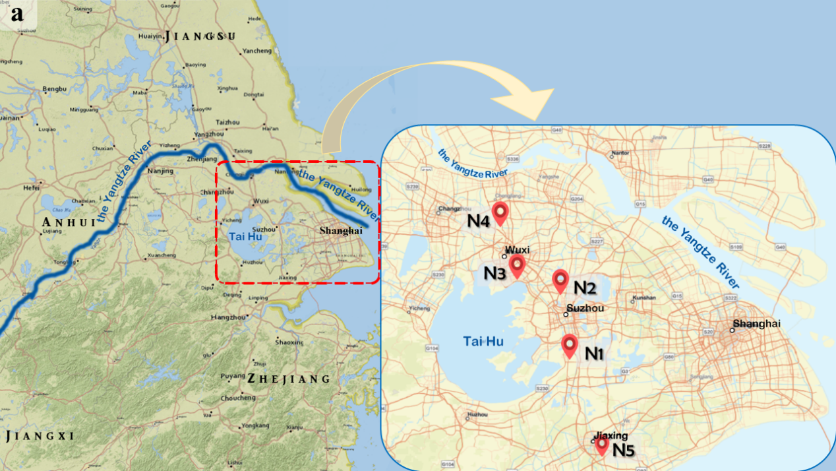

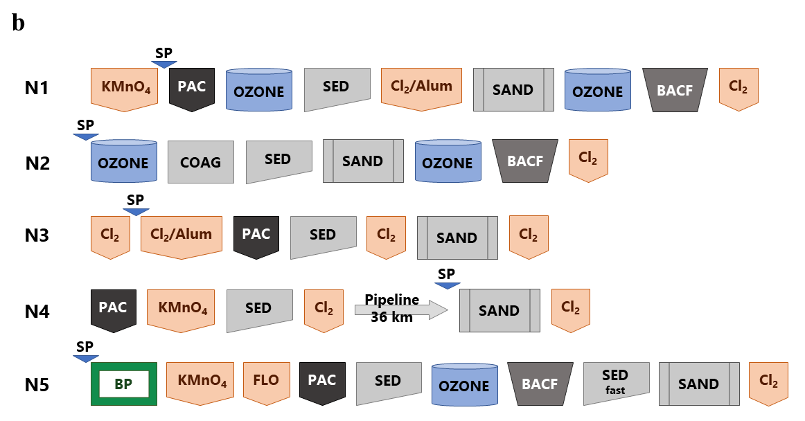

Figure 1 (a) Map showing the sampling locations at the Tai Hu Basin within the Yangtze River Delta (N1-N5). (b) DWTP treatment strategies and raw water sampling point. N1-N5: 5 different DWTP. PAC = powdered activated carbon, BACF = biological activated carbon filter, OZONE = ozone contactor, SED = flocculation/sedimentation, SAND = sand filter, COAG = aluminum coagulation, BP = biological pretreatment, FLO = flocculant, KMnO4/Cl2/Alum = chemical additive, SP = sampling point of raw water. Sampling point of drinking water were at the end of the procedure.

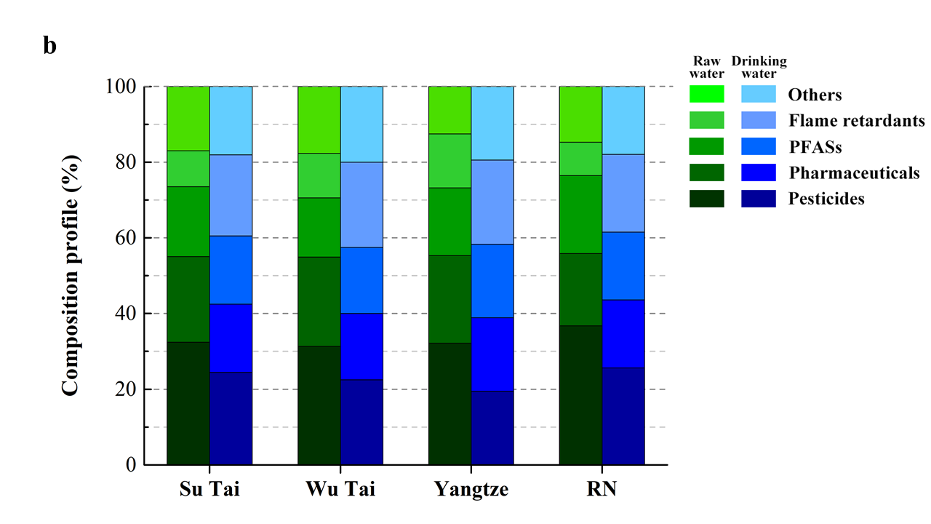
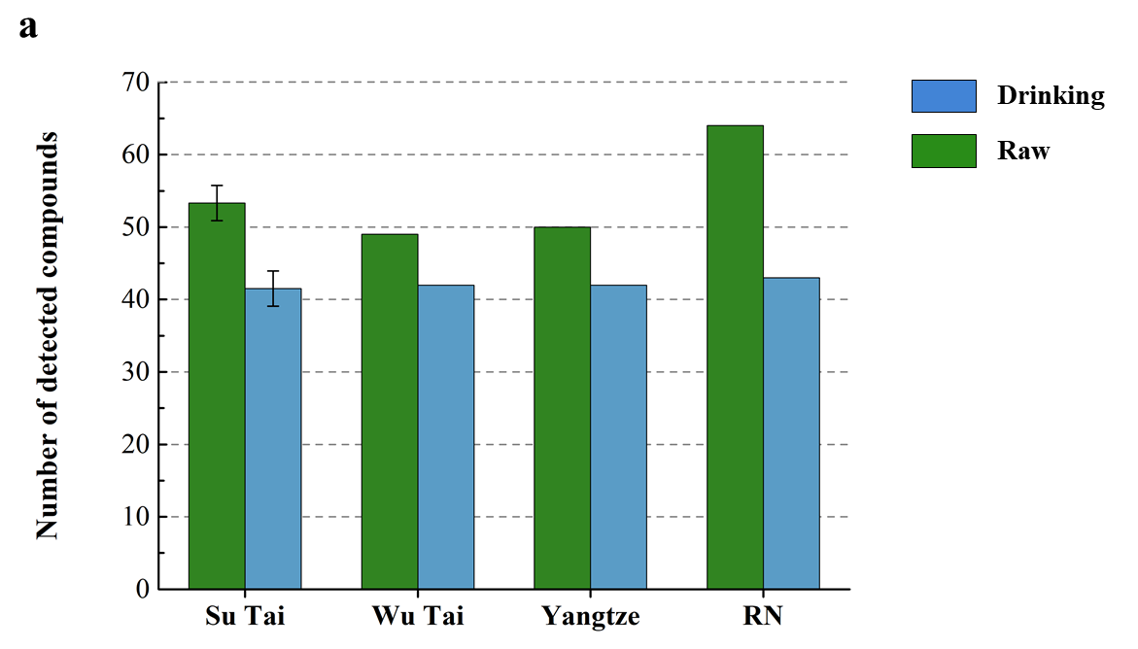

Figure 2 (a) Total number of compounds detected above MDL in raw and drinking (finished) water at the different sites. Su Tai shows the average (and error bars) of samples from N1 and N2 (n=6: 2 sites, 2 sampling occasions and 1 duplicate sample), while other bars show the result from n=1; (b) The fraction of the number of detected compounds (in relation to total) is shown on a compound category basis for each site. Compounds detected above MDL and their concentrations are given in Table A4 in Supporting Information. RN=river network.

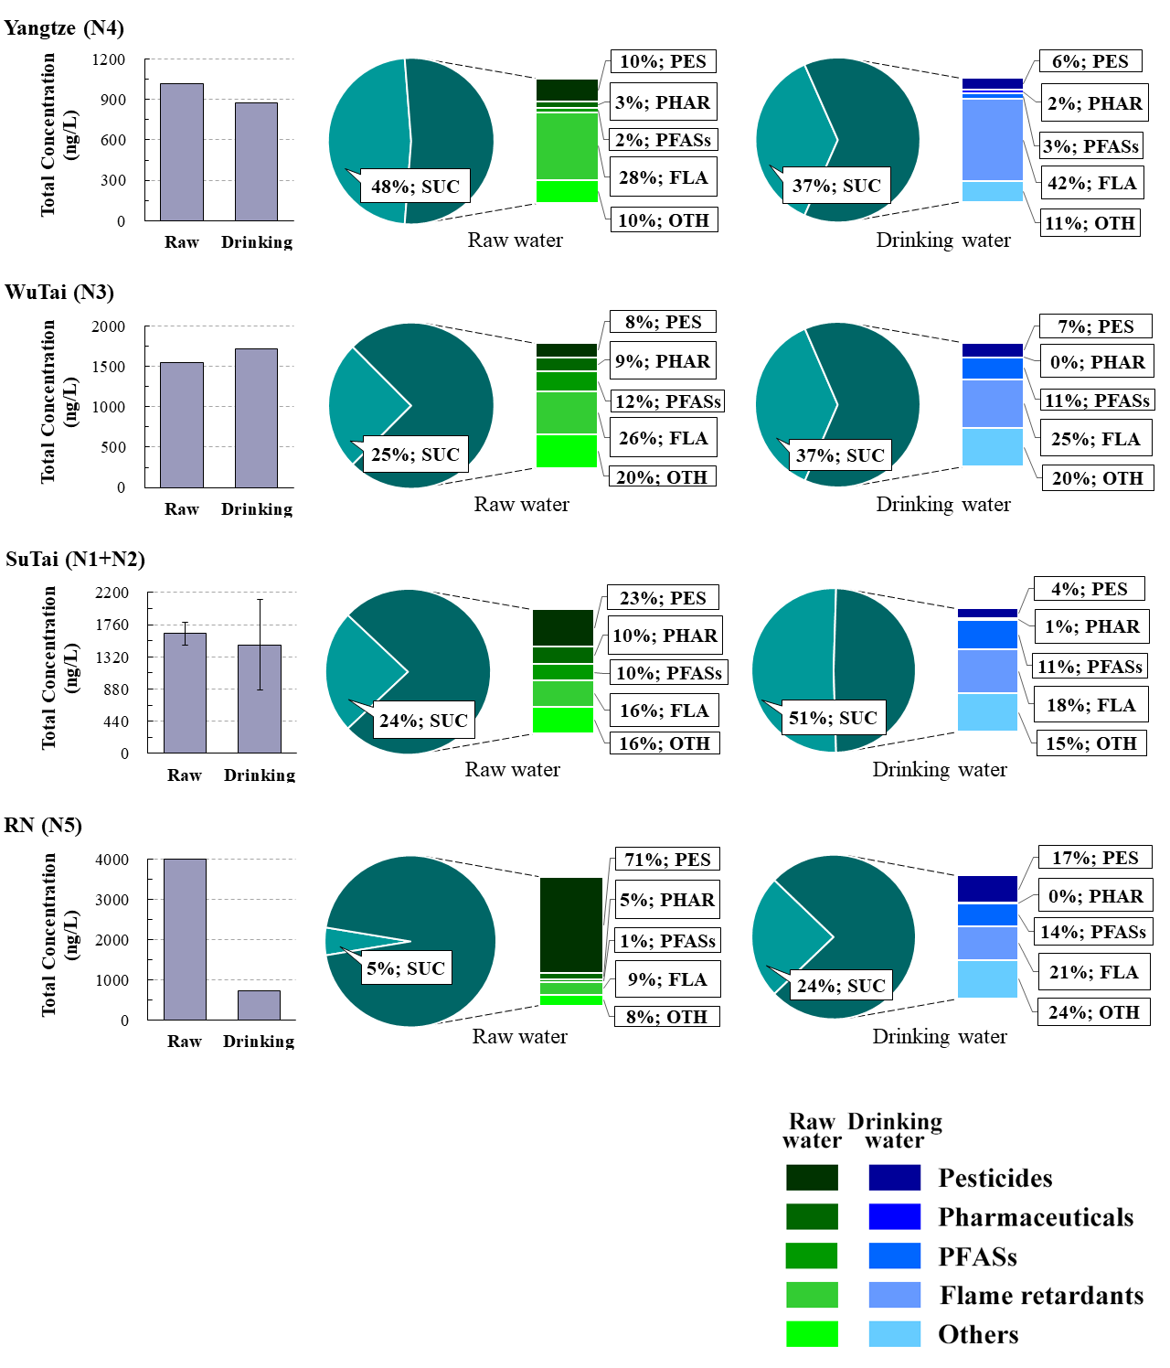

Figure 3 Total concentrations of detected micropollutants and percentage composition of sucralose and main compound categories in raw and drinking (finished) water for each site, with the most northern on top (N4), then going south (N3, N1+N2, and N5). Detected compounds above MDL and their concentrations are shown in Table A4 in Supporting Information. PES = pesticide, PHAR = pharmaceutical, FLA = flame retardant, PFAS = poly- and perfluoroalkyl substances, OTH = Others (food additive, fatty acid, surfactant, industrial chemical), ALL = all detected compounds in each DWTP.
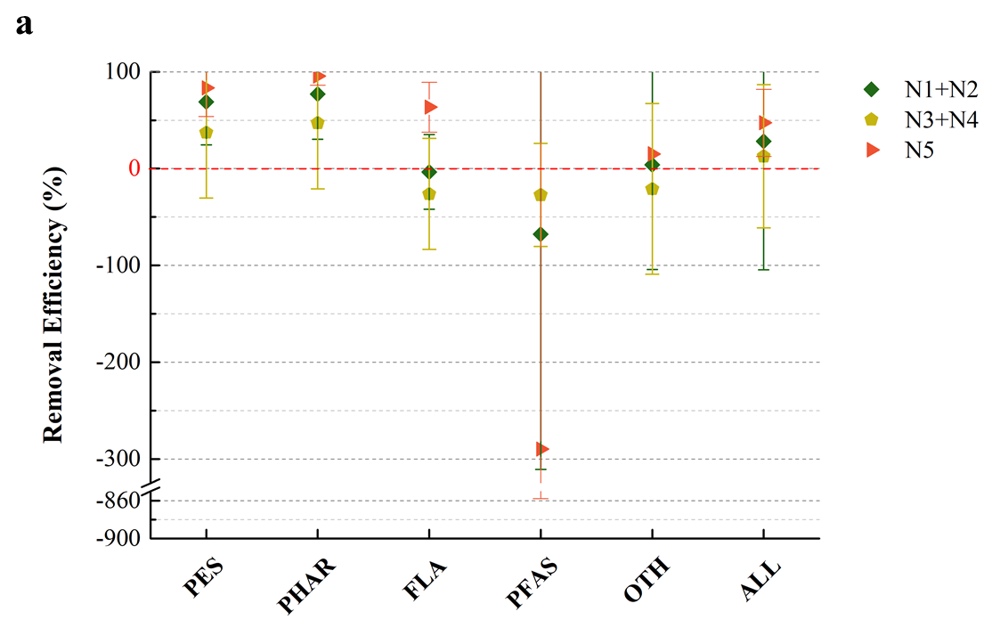

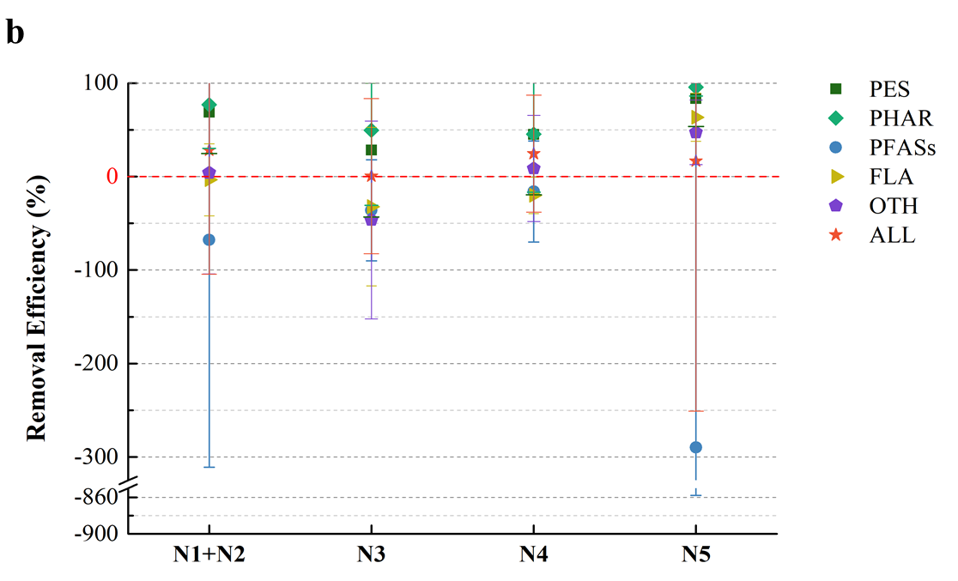

Figure 4 Treatment efficiency for (a) each compound category for DTWPs with similar treatment strategy and (b) DWTPs with similar treatment strategy per compound category. PES = pesticide, PHAR = pharmaceutical, FLA = flame retardant, PFAS = poly- and perfluoroalkyl substances, OTH = Others (food additive, fatty acid, surfactant, industrial chemical), ALL = all detected compounds in each DWTP.

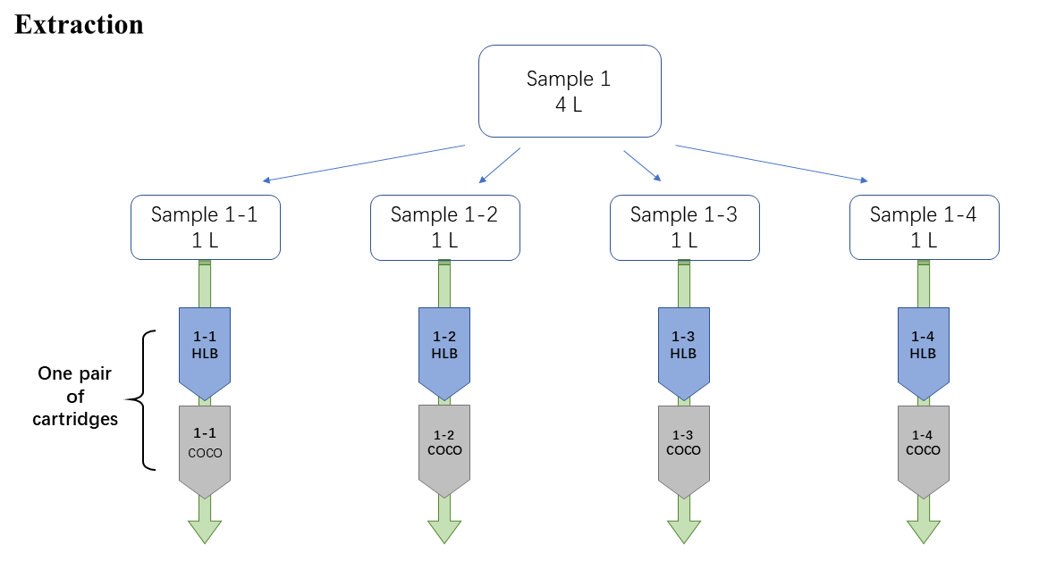
One randomly selected pair of SPE cartridges (out of the four pairs) was selected for analysis. Sample 1-2 is shown as an example.
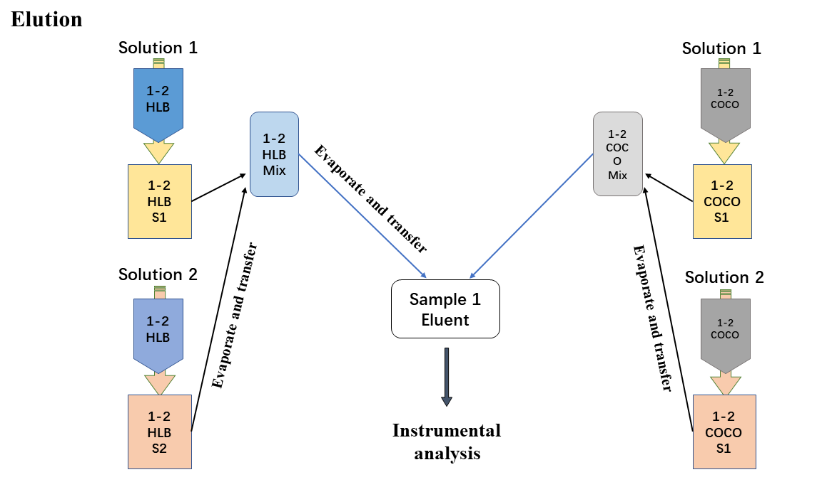

Figure S1 The sample preparation. S1 = Solution 1 = 10 mL mixture of acetone and hexane (V_{acetone}: V_{hexane}=1:1), S2 = Solution 2 = 10 mL methanol. HLB = HLB 6 cc Vac Cartridge, COCO = Coconut charcoal SPE cartridge.

