Supporting Information

Coordination-Defined Ionic Cocrystals Drive Electronic Structure Engineering in Ionic Carbon Nitrides for High-Performance H₂O₂ Photosynthesis

Anna Lo Presti,¹ Zahra Hajiahmadi,² Mu Xiao,³ Thomas D. Kühne,² and Christian Mark Pelicano^{*, 1}

¹Department of Colloid Chemistry, Max Planck Institute of Colloids and Interfaces, Potsdam, 14476, Germany
²CASUS-Center for Advanced Systems Understanding, Helmholtz-Zentrum, Dresden-Rossendorf e.V. (HZDR), Untermarkt 20, D-02826 Görlitz, Germany
³School of Chemical Engineering, The University of Queensland, St Lucia, QLD 4072, Australia

Corresponding author: christianmark.pelicano@mpikg.mpg.de

Supplementary Figures

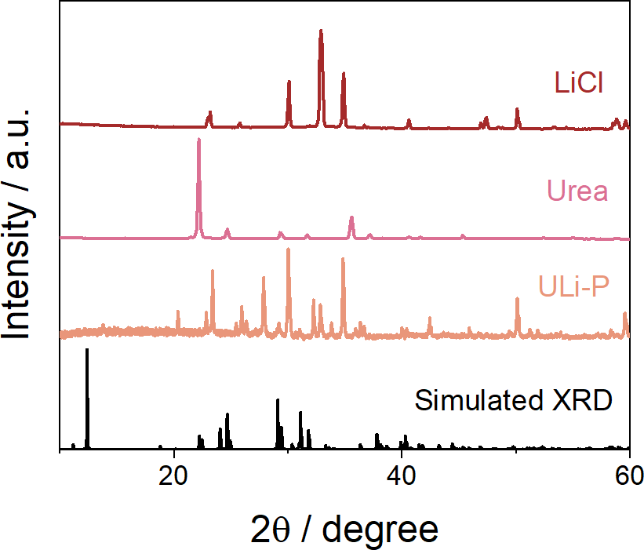

Figure S1. XRD patterns of ULi-P ionic cocrystal and its individual components (LiCl and Urea) compared to the theoretical XRD-U:LiCl cocrystal.

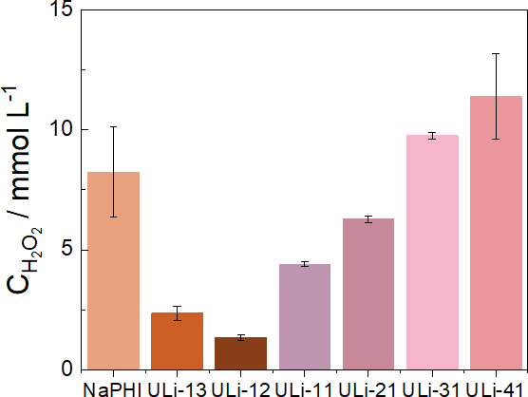

Figure S2. Photocatalytic H₂O₂ production of ULi-41 compared to pristine NaPHI and different molar ratios.

Table S1. Relative ratios of C, N, H and O in all samples determined by elemental analysis and the total amount of alkali metals in all catalyst via ICP.
Sample | C (%) | N (%) | H (%) | O (%) | Na (%) | Li (%)
NaPHI | 27.0 | 45.2 | 2.6 | 17.8 | 8.1 | /
ULiNa | 28.3 | 47.7 | 2.5 | 16.6 | 5.3 | 1.2
ULi | 29.4 | 49.7 | 2.6 | 16.9 | / | 2.6
U-PHI-MS | 28.6 | 47.5 | 2.6 | 14.5 | 5.3 | 0.9
U-PHI-2S | 30.1 | 48.6 | 2.5 | 14.5 | 5.1 | 1.2
Li-NaPHI | 29.6 | 48.6 | 2.8 | 13.0 | 1.9 | 2.4

Figure S3. (a) XRD patterns, (b) FTIR spectra, (c) UV-vis and (d) photocatalytic H₂O₂ production of ULiNa at different annealing temperatures.

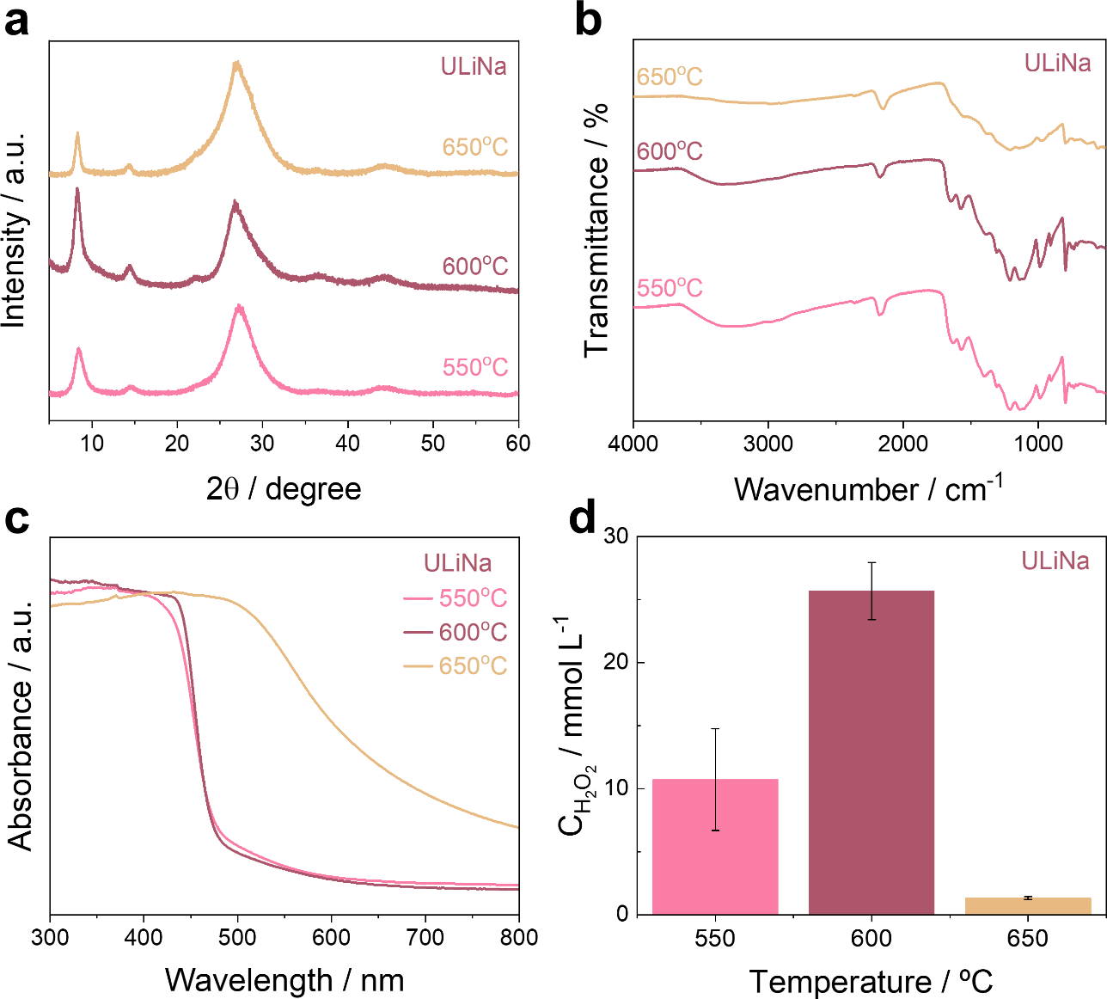

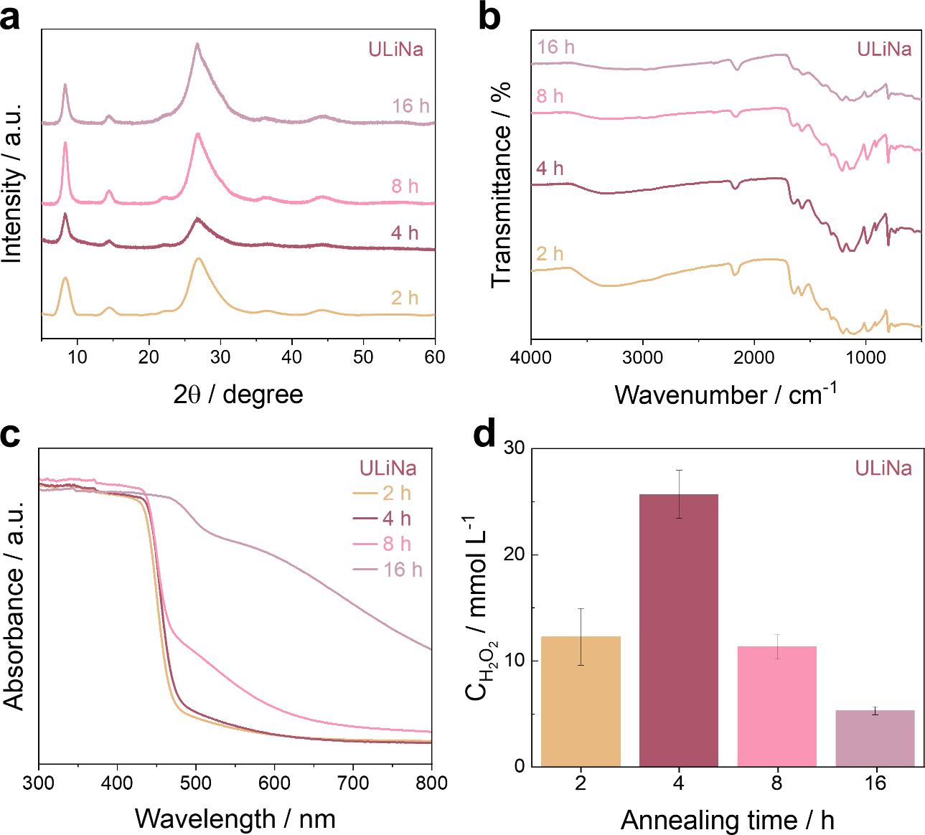
Figure S4. (a) XRD patterns, (b) FTIR spectra, (c) UV-vis and (d) photocatalytic H₂O₂ production of ULiNa at different annealing times.

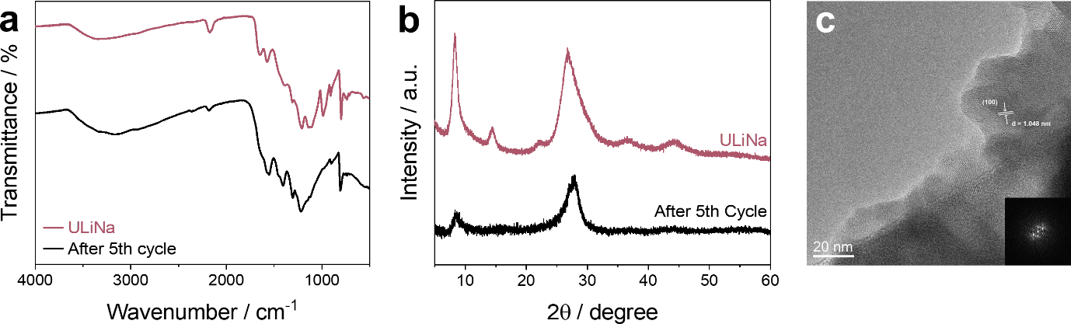

Figure S5. (a) FTIR spectra, (b) XRD patterns and (c) HRTEM image of ULiNa before and after stability test.

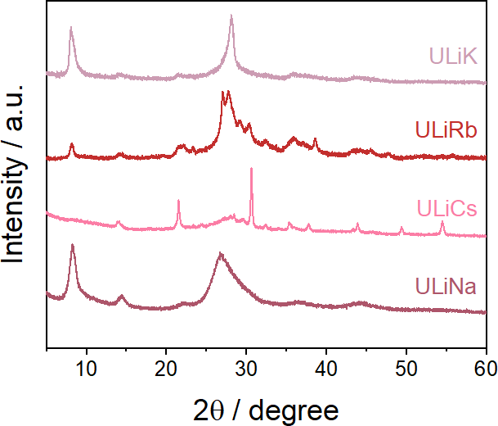
Figure S6. XRD patterns of dual-cation ICC-derived PHIs.

Table S2. Total amount of alkali metals, via ICP, in dual-cation materials.
Sample | Li (%) | Na (%) | Cs (%) | Rb (%) | K (%)
ULiNa | 1.2 | 5.3 | / | / | /
ULiCs | 1.0 | / | 45.7 | / | /
ULiRb | 1.2 | / | / | 29.2 | /
ULiK | 0.5 | / | / | / | 12.8

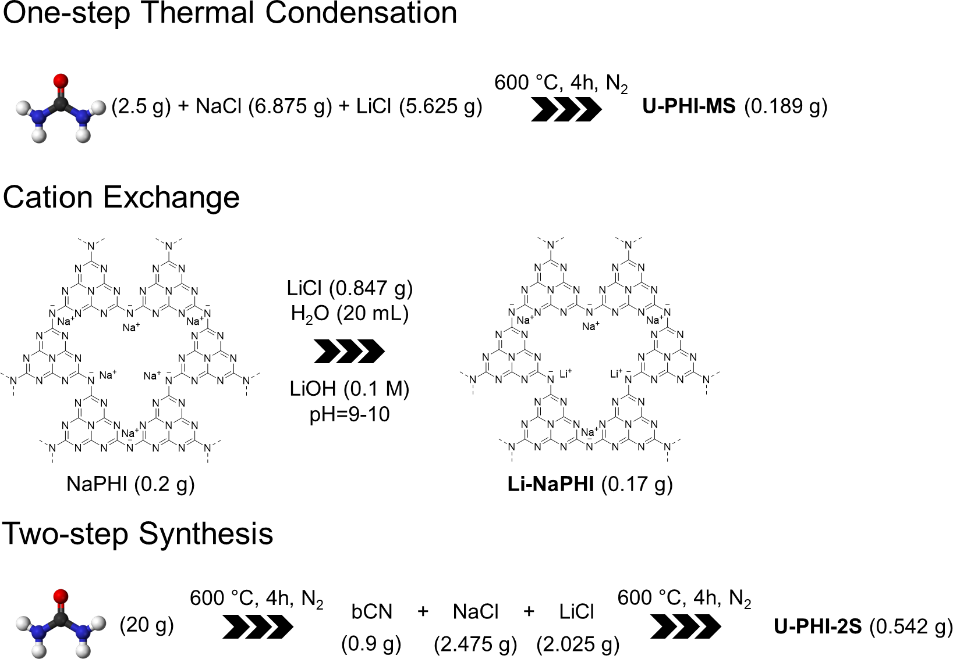
Scheme S1. Schematic representation of the reference PHIs obtained via established synthetic routes.

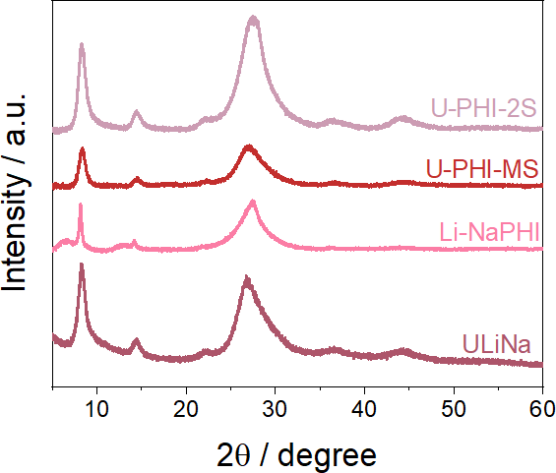

Figure S7. XRD patterns of U-PHI-MS, U-PHI-EX and Li-NaPHI compared to ULiNa.

Table S3. Product yields of ULiNa compared to U-PHI-MS and U-PHI-2S.
Sample | Precursor (g) | Salt (g) | Product (g) | Total Yield (%)
ULiNa | 6.006 | LiCl: 1.060, NaCl: 1.461 | 2.256 | 38
U-PHI-MS | 2.5 | LiCl: 5.625, NaCl: 6.875 | 0.189 | 8
U-PHI-2S | 20 | - | 0.9 | 2.7
U-PHI-2S | 0.9 | LiCl: 2.025, NaCl: 2.475 | 0.542 | 2.7

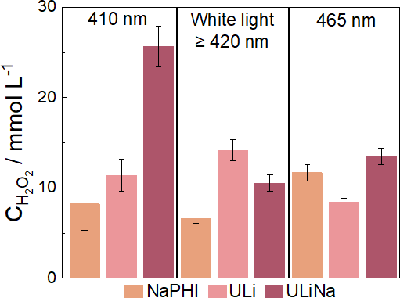

Figure S8. Photocatalytic H₂O₂ evolution activities of NaPHI, ULi, and ULiNa using different excitation wavelengths.

Table S4. Benchmark comparison of representative state-of-the-art photocatalysts for photocatalytic H₂O₂ synthesis. Carbon nitride- and non-carbon nitride-based photocatalysts reported in recent high-impact journals are compared in terms of engineering strategy, synthesis method, reaction conditions, inorganic salt loading during synthesis (where applicable), ion incorporation strategy, and AQY. The ICC-derived ULiNa developed in this work achieves the highest benchmarked AQY while requiring substantially lower inorganic salt loading than conventional molten-salt-derived ionic carbon nitrides.

Catalyst |  | Material Strategy | Synthesis method | Light Source |  | Solvent |  | Salt Loading  (g salt g⁻¹ precursor) |  | Ion Incorporation strategy | AQY (%) |  | Ref.
 | Carbon Nitride Photocatalysts
CNS-500 |  | - | Thermal exfoliation | Xe-lamp_{(λ ≥ 420 nm)} |  | 10% isopropanol |  | - |  | - | 4.41%  @420 nm |  | Appl. Catal. B: Environ. 2022, 320, 120845.
C₃N₅ |  | - | Thermal condensation | Xe-lamp_{(λ ≥ 420 nm)} |  | 10 vol% EtOH |  | - |  | - | 6.7%  @420 nm |  | Nat. Commun. 2023, 14, 5742.
ASCN |  | - | Hydrothermal molecule assembly + pyrolysis | Xe lamp, AM 1.5G |  | 0.2 mmol 4-methoxybenzyl alcohol |  | - |  | - | 11.7%  @420 nm |  | JACS 2023, 145, 38, 20837–20848
PCN-NaCA-2 |  | - | Thermal polymerization | AM 1.5 |  | 3.5 wt% glycerol solution |  | - |  | Concurrent incorporation | 11.85%  @420 nm |  | Nat. Commun.  2021, 12, 3701
MA⁺-PHI |  | NaCl salt + Cation exchange | Ionothermal/ Salt-melt treatment | LED_{427nm} |  | 10 wt% glycerol solution |  | 10 |  | Ion exchange | 13.9%  @427 nm |  | Angew. Chem. Int. Ed. 2026, e24638.
Nv–CN–CN |  | N vacancy,  –C≡N group | Thermal condensation | Xe-lamp_{(λ ≥ 420 nm)} |  | 10 vol % isopropanol |  | - |  | - | 22.1%  @420 nm |  | Energy Environ. Sci. 2022, 15(2), 830–842.
CN-KI₃-KI-MV |  | KI salt + Photooxidation | Thermal condensation | Xe-lamp_{(λ ≥ 420 nm)} |  | 10 vol% isopropanol |  | 3 |  | Concurrent incorporation | 27.6%  @400 nm |  | Nat. Commun. 2024, 15, 4718
CN-NH₄-NaK |  | NH₄Cl + NaCl/KCl salt melt | Ionothermal/ Salt-melt treatment | Xe-lamp_{(λ ≥ 420 nm)} |  | 10 vol % isopropanol |  | 5 |  | Molten-salt-mediated | 28.4%  @420 nm |  | Adv. Mater. 2024, 36, 2307490.
Ox-KPHI |  | Oxamide +  KCl/LiCl salt melt | Ionothermal/ Salt-melt treatment | LED_{410nm} |  | 10 wt% glycerol solution |  | 5 |  | Molten-salt-mediated | 40.72%  @402 nm |  | Adv. Mater. 2024, 36, e2412753.
CN-K₄Na₂ |  | KCl/NaCl salt melt | Ionothermal/ Salt-melt treatment | AM 1.5G |  | p-benzoquino, furfuryl alcohol |  | 0.6 |  | Molten-salt-mediated | 43.7%  @420 nm |  | Adv. Funct. Mater.2025, 35, 2500342
AC-KPHI |  | NH₄Cl + KCl/LiCl salt melt | Ionothermal/ Salt-melt treatment | LED_{410nm} |  | 10 wt% glycerol solution |  | 5 |  | Molten-salt-mediated | 49%  @410 nm |  | Adv. Mater. 2026, 38, e10585,
ULiNa |  | Ionic cocrystal precursor | Thermal condensation |  | LED_{410nm} |  | 10 wt% glycerol solution |  | 0.420 | Precursor-programmed |  | 88 % @410 nm |  | This work
 | Non-Carbon Nitride Photocatalysts
TiO2/MoS_{x}-Au |  | MoS_{x}-Au deposition | Co-catalyst deposition on TiO₂ nanoparticles | 300 W Xe lamp |  | 10% ethanol |  | - |  | - | 2.2%  400 nm |  | Nat. Commun.  2024, 15, 3212
Py-Da-COF |  | - | Schiff-base condensation | 300 W Xe-lamp_{(λ ≥ 420 nm)} |  | Bezylic alcohol |  | - |  | - | 4.5%  420 nm |  | Angew. Chem. Int. Ed.2023, 62, e202216719
PMCR-1 |  | - | Three component synthesis | 300 W Xe-lamp_{(λ ≥ 420 nm)} |  | H₂O:Benzylic alcohol (10:1) |  | - |  | - | 14%  420 nm |  | Angew. Chem. Int. Ed.2023, 62, e202304349
Tp-BTz-COF |  | Mass-transfer gating | Schiff-base condensation | Xe lamp |  | 10 vol% benzyl alcohol |  | - |  | - | 44.5%  420 nm |  | Adv. Mater. 2025, 37, e10201.
COF-300-D-F |  | Mixing with TAPA | Solvothermal imine condensation | 300 W Xe-lamp_{(λ ≥ 420 nm)} |  | H₂O:Benzylic alcohol (9:1) |  | - |  | - | 10.6%  420 nm |  | Nat. Commun. 2026, 17, 4505
PzTP@BTTP |  | Polymerization on SiO₂ spherical templates | Sonogashira coupling reactions | 300 W Xe-lamp_{(λ ≥ 420 nm)} |  | Benzylic alcohol |  | - |  | - | 4.42% 460 nm |  | Adv. Funct. Mater. 2026, 36, 7, e08538.
H2Se-COF |  | Stepwise Protonation | - | 300 W Xe-lamp_{(λ ≥ 420 nm)} |  | H₂O:Benzylic alcohol (9:1) |  | - |  | - | 6.2%  420 nm |  | Angew. Chem. Int. Ed.2024, 63, e202405313
PyIm-BT_F |  | - | Schiff base condensation | 300 W Xe-lamp_{(λ ≥ 420 nm)} |  | 5 mL isopropanol |  | - |  | - | 2.7%  420 nm |  | Adv. Energy Mater. 2025, 15, 2500341
sonoCOF |  | - | Sonochemical synthesis | 300 W Xe-lamp_{(λ ≥ 420 nm)} |  | H₂O:Benzylic alcohol (9:1) |  | - |  | - | 4.8%  420 nm |  | JACS 2022, 144, 22, 9902–9909

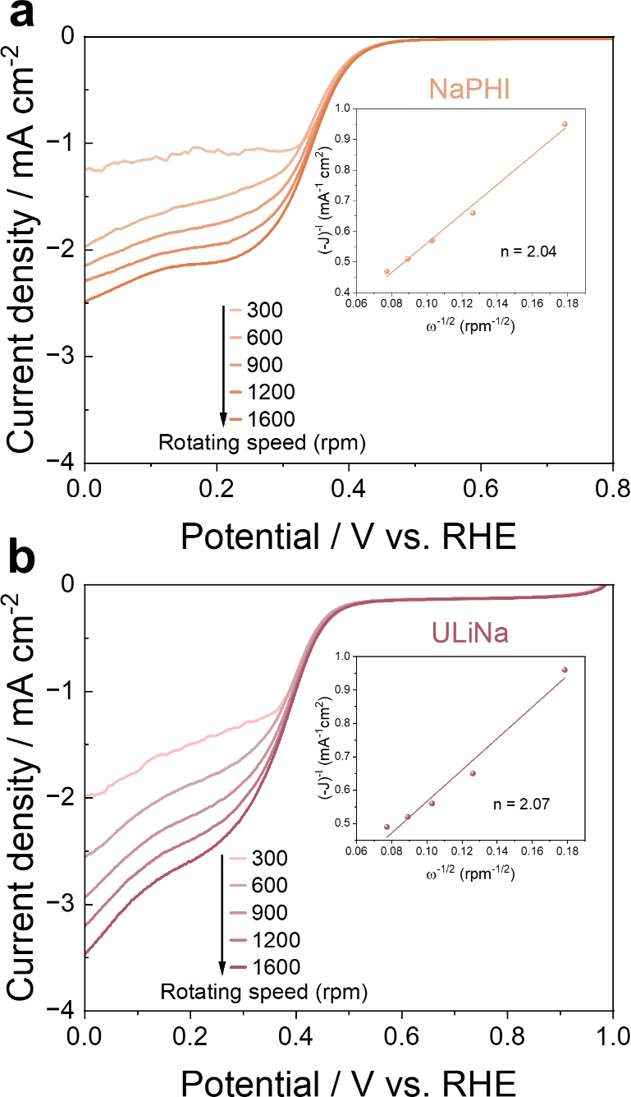

Figure S9. Linear sweep voltammetry (LSV) curves of (a) NaPHI and (b) ULiNa recorded on a rotating disk glassy carbon electrode (inset graphs: K-L analysis plot).

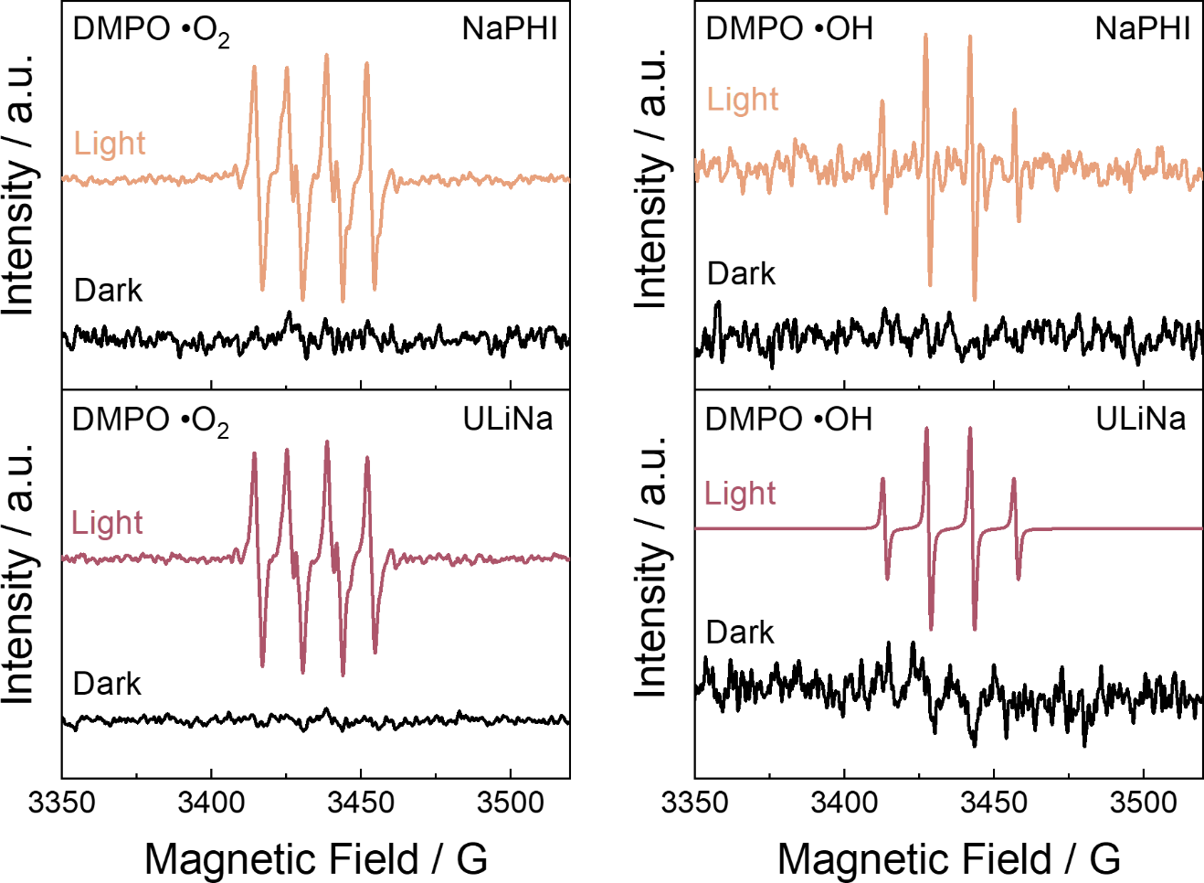

Figure S10. EPR signals of (a) DMPO-•OH and (b) DMPO-•O₂⁻ over NaPHI and ULiNa.

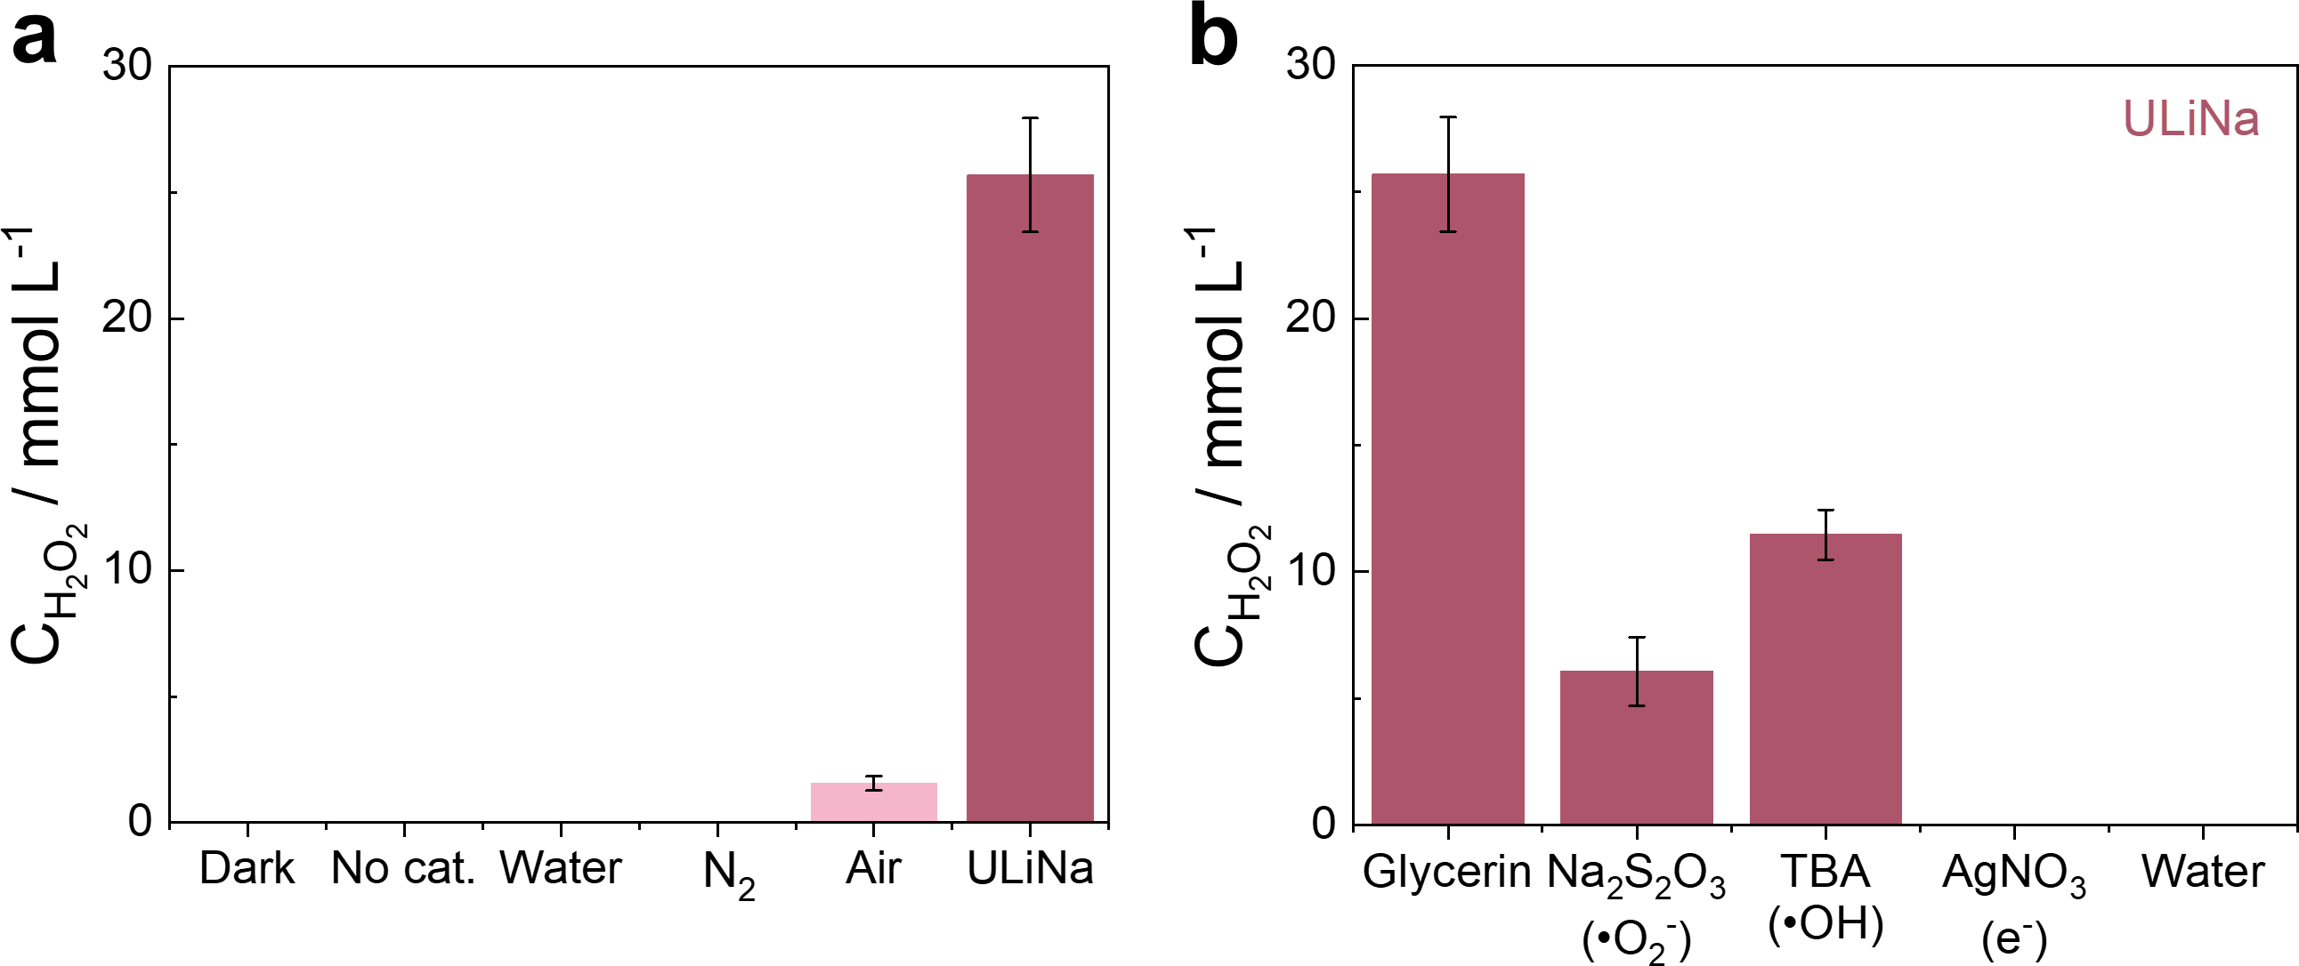
Figure S11. Photocatalytic H₂O₂ production of ULiNa (a) under the influence of different scavengers and (b) under different testing conditions.

To elucidate the photocatalytic mechanism of H₂O₂ production, control experiments were conducted over ULiNa under varied conditions (Figure S11a), along with free radical trapping tests using AgNO₃, tert-butyl alcohol (TBA), and Na₂S₂O₃ (Figure S11b). These scavengers were selected to probe the roles of electrons (e⁻), hydroxyl radicals (•OH), and superoxide radicals (•O₂⁻), respectively. When the reaction system was purged with N₂ instead of O₂, H₂O₂ formation was completely suppressed, confirming that molecular oxygen is indispensable for the reaction. The addition of AgNO₃ markedly decreased the H₂O₂ production rate, highlighting the essential role of photogenerated electrons in driving oxygen reduction.
Upon introduction of TBA, a slight decrease in H₂O₂ yield was observed, indicating the presence of •OH radicals during the reaction. This was further corroborated by EPR measurements showing the formation of DMPO-•OH adducts under light irradiation (Figure S10). However, the relatively modest suppression of activity suggests that •OH is not a primary intermediate in H₂O₂ formation. Instead, •OH likely originates from the partial decomposition of in situ generated H₂O₂ rather than from direct water oxidation. This interpretation is supported by the absence of H₂O₂ production in pure water, which rules out water oxidation as a significant pathway under the present conditions.
In contrast, the addition of Na₂S₂O₃ led to a substantial decrease in H₂O₂ evolution (by approximately one-fourth), indicating that •O₂⁻ plays a crucial role as a key intermediate. Taken together, these results demonstrate that H₂O₂ formation proceeds predominantly via a two-step, single-electron oxygen reduction pathway (O₂ → •O₂⁻ → H₂O₂), while •OH is generated as a secondary species through subsequent H₂O₂ transformation rather than being directly involved in the main production pathway.

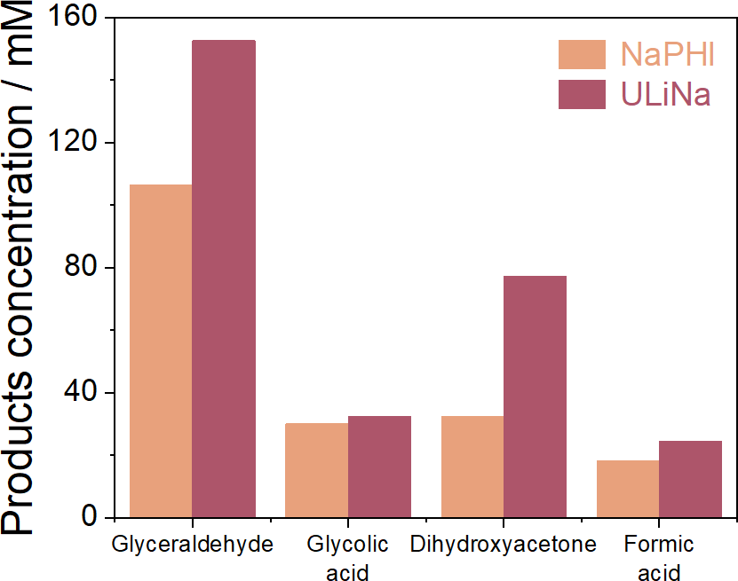

Figure S12. Amount of the glycerol oxidation products after 1 hour of reaction using ULiNa and NaPHI.

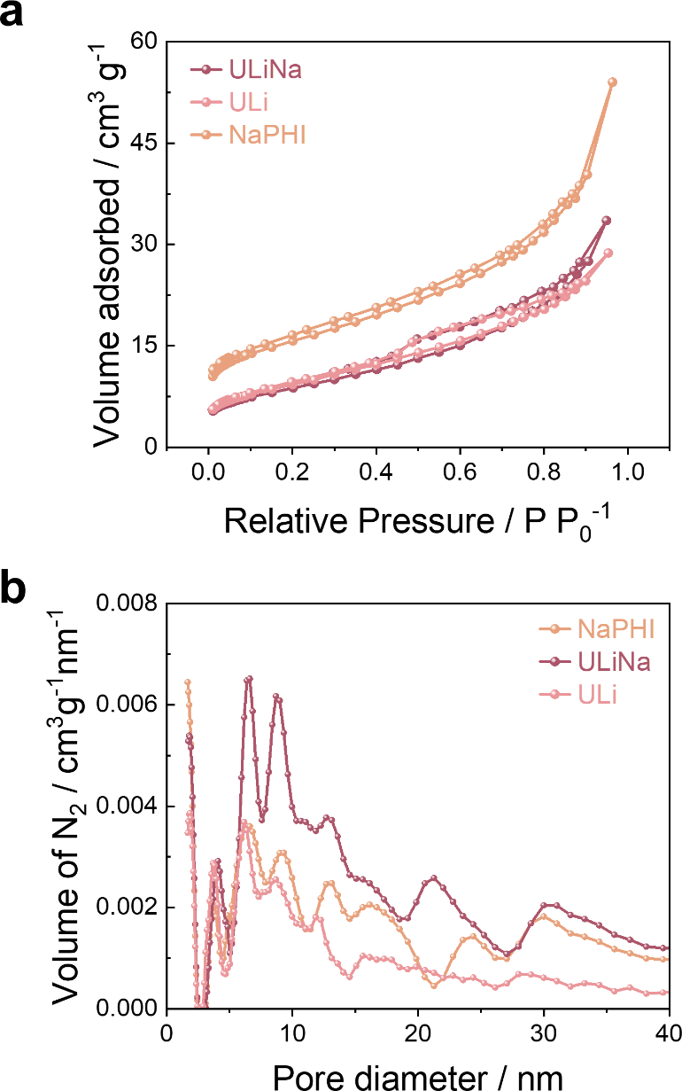

Figure S13. (a) N₂ adsorption/desorption isotherm at 77K and (b) Barrett-Joyner-Halenda (BJH) pore size distribution from N₂ adsorption branch at 77K of NaPHI, ULi and ULiNa catalysts.

Table S5. BET specific area, pore volume and diameter size for NaPHI, ULi and ULiNa.
Sample | S_{BET} (m² g⁻¹) |  | V_{p} (cm³ g⁻¹) |  | D_{p} (nm)
ULiNa | 31.47 | 0.05 |  | 1.73
NaPHI | 55.42 | 0.08 |  | 1.67
ULi | 33.44 | 0.04 |  | 1.85

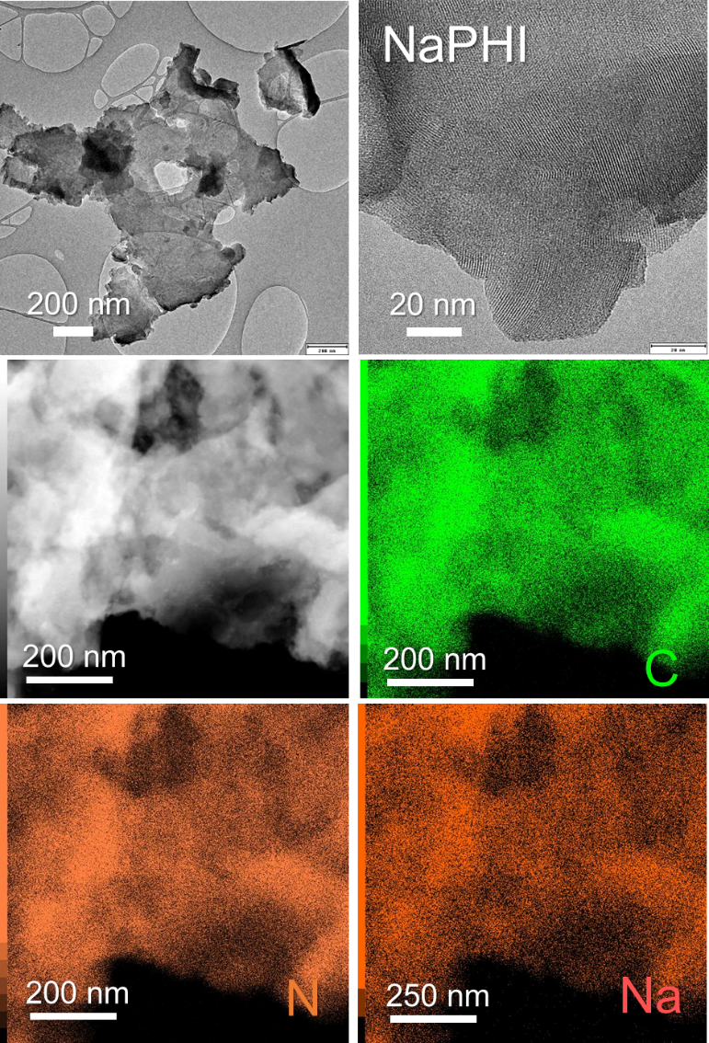
Figure S14. HRTEM and STEM images of NaPHI and its corresponding elemental mapping images.

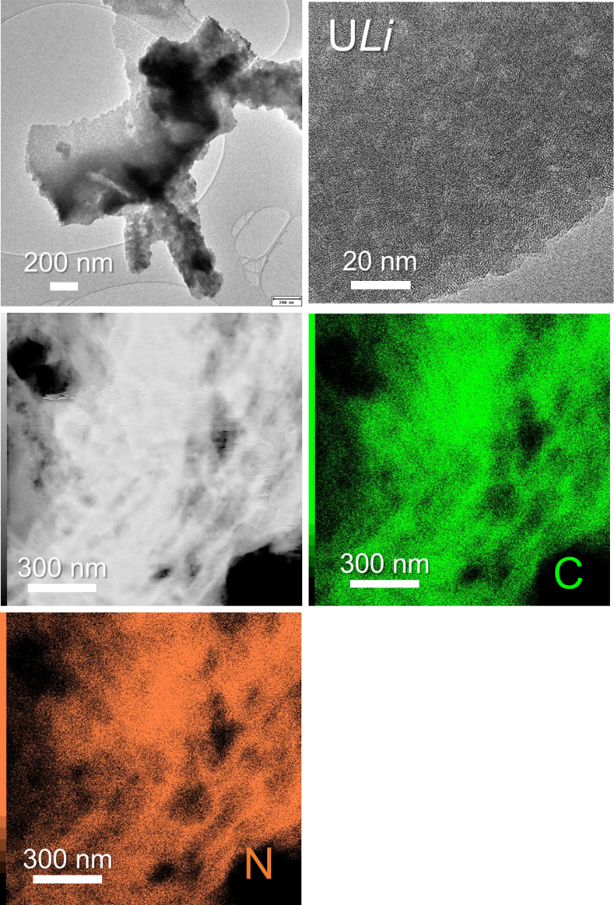

Figure S15. HRTEM and STEM images of ULi and its corresponding elemental mapping images.

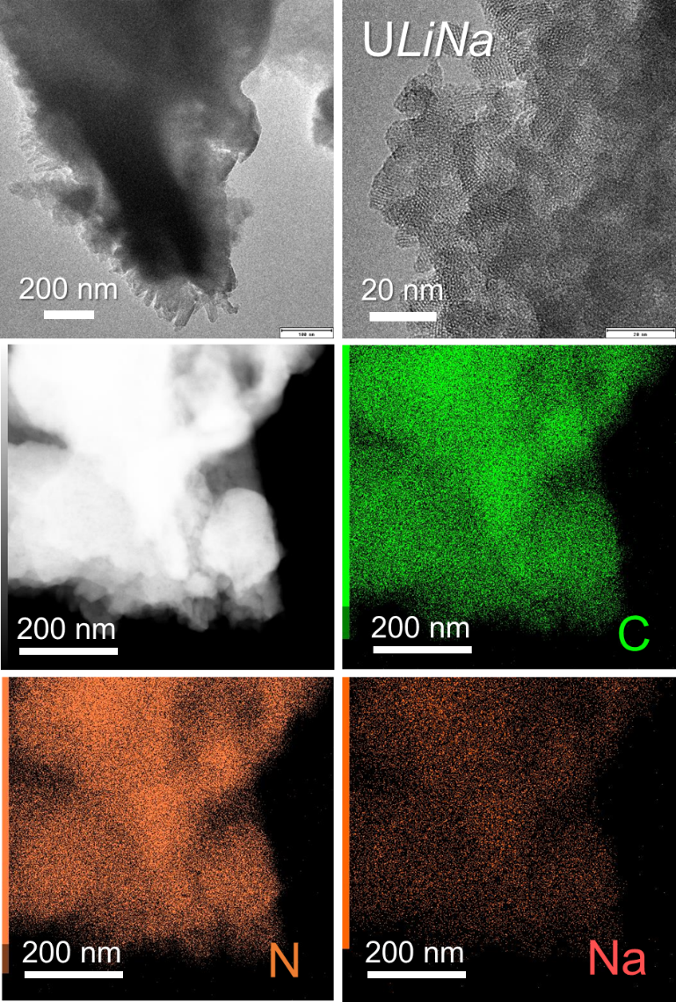

Figure S16. HRTEM and STEM images of ULiNa and its corresponding elemental mapping images.

Table S6. Total amount of alkali metals, via ICP, in ULiNa treated with H⁺ or K⁺.
Sample | Na (wt%) | Li (wt%)
ULiNa | 5.3 | 1.2
Na-exchanged  ULiNa | 8.2 | 0.1
H-exchanged ULiNa | 0.2 | 0.1

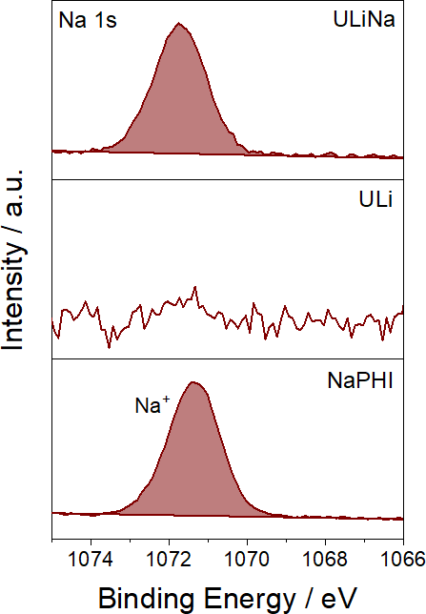

Figure S17. High-resolution Na 1s XPS spectra of NaPHI, ULi, and ULiNa.

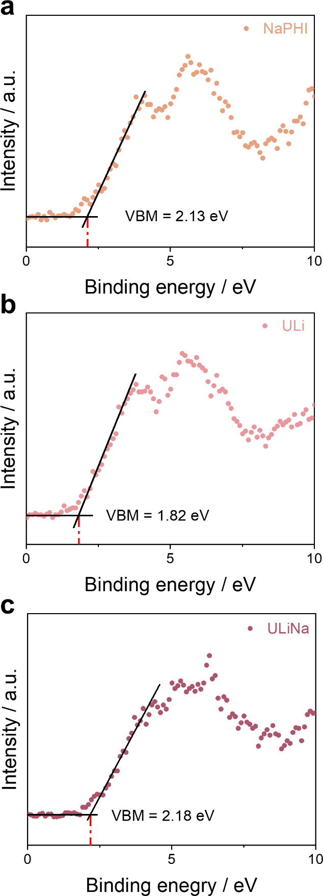

Figure S18. Valence band XPS of ULiNa, ULi and NaPHI.

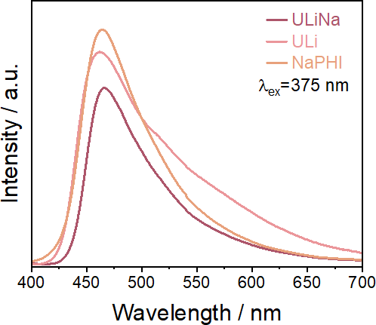

Figure S19. Room temperature steady-state PL emission spectra with an excitation wavelength of 375 nm of ULiNa, ULi and NaPHI.

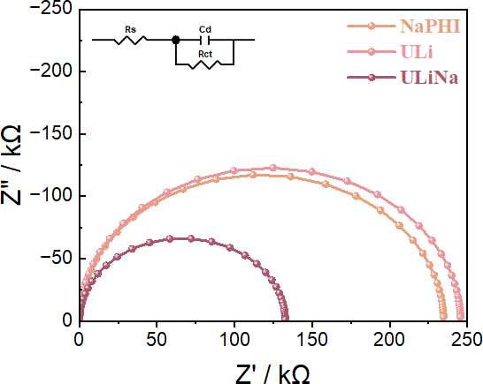

Figure S20. Electrochemical impedance spectroscopy (EIS) Nyquist plots (Inset: equivalent Randle circuit).

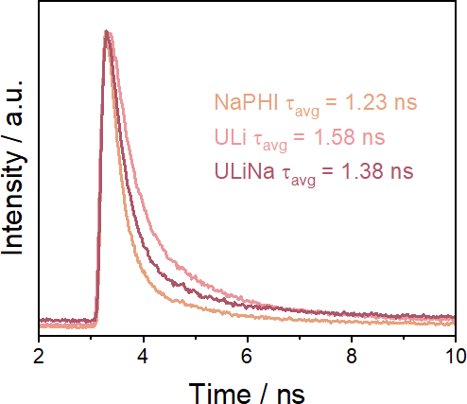

Figure S21. Room temperature solid-state time-resolved PL decay of ULiNa, ULi and NaPHI.

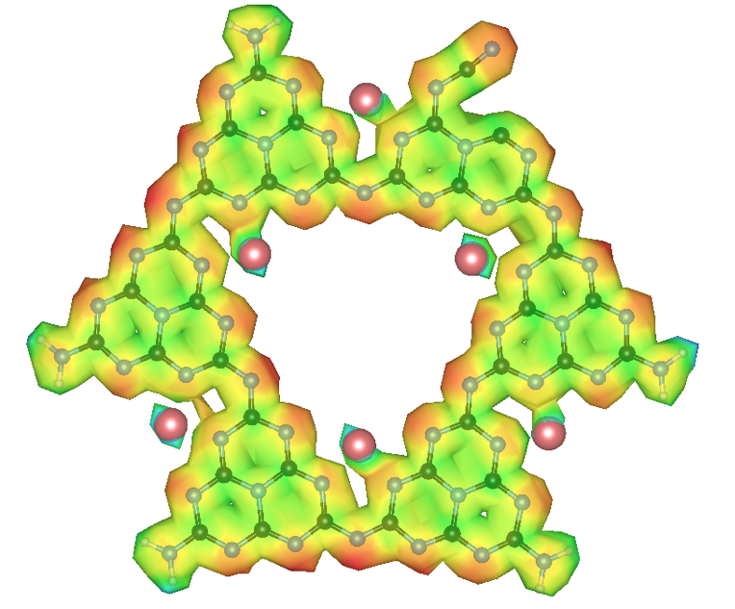

Figure S22. Electrostatic potential map for ULi, the red and blue regions represent electron enrichment and electron depletion potential with 0.05 isosurface value.

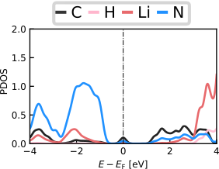

Figure S23. Projected density of state (PDOS) of ULi.

Figure S24. HOMO (right) and LUMO distribution for ULi.
Figure S24 shows the frontier orbital distributions of ULi. Unlike NaPHI and ULiNa, the HOMO is redistributed to the opposite side of the PHI framework rather than the cyano-functionalized edge, while the LUMO exhibits a similar spatial distribution in all three structures.

References
1. Chen Z, Savateev A, Pronkin S, Papaefthimiou V, Wolff C, Willinger MG, et al. "The Easier the Better" Preparation of Efficient Photocatalysts-Metastable Poly(heptazine imide) Salts. Adv Mater 2017, 29(32).

2. Pelicano CM, Li J, Cabrero-Antonino M, Silva IF, Peng L, Tarakina NV, et al. Rational design of a carbon/potassium poly(heptazine imide) heterojunction for enhanced photocatalytic H2 and H2O2 evolution. Journal of Materials Chemistry A 2024, 12(1): 475–482.

3. Lin L, Ou H, Zhang Y, Wang X. Tri-s-triazine-Based Crystalline Graphitic Carbon Nitrides for Highly Efficient Hydrogen Evolution Photocatalysis. ACS Catalysis 2016, 6(6): 3921–3931.

4. Kröger J, Podjaski F, Savasci G, Moudrakovski I, Jiménez-Solano A, Terban MW, et al. Conductivity Mechanism in Ionic 2D Carbon Nitrides: From Hydrated Ion Motion to Enhanced Photocatalysis. Advanced Materials 2022, 34(7): 2107061.

5. Sing KSW. Reporting physisorption data for gas/solid systems with special reference to the determination of surface area and porosity (Recommendations 1984). Pure and Applied Chemistry 1985, 57(4): 603–619.

6. Sellers RM. Spectrophotometric determination of hydrogen peroxide using potassium titanium(IV) oxalate. The Analyst 1980, 105(1255).

7. Neese F, Wennmohs F, Becker U, Riplinger C. The ORCA quantum chemistry program package. J Chem Phys 2020, 152(22): 224108.

8. Grimme S, Hansen A, Ehlert S, Mewes JM. r(2)SCAN-3c: A "Swiss army knife" composite electronic-structure method. J Chem Phys 2021, 154(6): 064103.

9. Giannozzi P, Baroni S, Bonini N, Calandra M, Car R, Cavazzoni C, et al. QUANTUM ESPRESSO: a modular and open-source software project for quantum simulations of materials. J Phys Condens Matter 2009, 21(39): 395502.

10. Perdew JP, Burke K, Ernzerhof M. Generalized Gradient Approximation Made Simple. Phys Rev Lett 1996, 77(18): 3865–3868.

11. Grimme S. Semiempirical GGA-type density functional constructed with a long-range dispersion correction. J Comput Chem 2006, 27(15): 1787–1799.

