Supporting Information for
An Operative Framework for Risk to People Mapping of Landslide-Triggered Tsunami in Lakes
R. Bonomelli¹, M. Pilotti¹, and G. Farina^{1,2}
¹Dipartimento di Ingegneria Civile, Architettura, Territorio, Ambiente e di Matematica, DICATAM, Università di Brescia, Brescia, 25123, Italy.
²LHSV, ENPC, Institut Polytechnique de Paris, EDF R&D, Chatou, France.
Corresponding author: Riccardo Bonomelli (riccardo.bonomelli@unibs.it)

Contents of this file

- Numerical model
- Coupling between landslide and wave motion
- Validation
  - Laboratory test cases
  - The 2014 Lake Askja rockslide induced tsunami
- Human vulnerability model
- Detailed modelling of onshore flooding
- Additional figures
- References

1 Numerical model
The mathematical model used in this paper is based on the 2D Shallow Water Equations (SWE). The system of 2D SWE describes the momentum and mass balance which can be written in conservative vectorial formulation as

$$U_{t}+F{\left(U\right)}_{x}+G{\left(U\right)}_{y}=S\left(U\right)$$  $U=\left[\begin{aligned}h \\ hu \\ hv\end{aligned}\right]$ $F\left(U\right)=\left[\begin{aligned}hu \\ hu^{2}+\frac{1}{2}gh^{2} \\ huv\end{aligned}\right]$ $G\left(U\right)=\left[\begin{aligned}hv \\ huv \\ hv^{2}+\frac{1}{2}gh^{2}\end{aligned}\right]$  $$S\left(U\right)=\left[\begin{aligned}0 \\ -gh(S_{bx}+S_{fx}) \\ -gh(S_{by}+S_{fy})\end{aligned}\right]$$ | (1)

where $h [m]$ is the fluid depth, $u$and $v [m s^{-1}]$ are the mean velocities of the flow in $x$ and $y$ direction, respectively, $g [m s^{-2}]$ is the acceleration of gravity, $z_{b} [m]$ is the bed elevation, $S_{bx}=∂z_{b}/∂x$ and $S_{by}=∂z_{b}/∂y$, $S_{fx}$ and $S_{fy}$ are respectively the bed slope source terms and friction source terms in $x$, $y$ directions. The finite volume numerical scheme described in Bonomelli et al. [1] has been adopted to solve system (1). By diving the computational domain into $N$ triangular shaped control volumes $K_{i}$, the model can effectively describe complex geometries along the boundaries of the domain or the presence of internal break lines. Using an explicit Euler scheme and denoting the current time step as $t^{n}=n Δt$, system (1) can be approximated as

$$U_{i}^{n+1}=U_{i}^{n}-\frac{Δt}{A_{i}}\sum_{j=1}^{m}{H\left(U\right)∙n_{ij}L_{ij}+{Δt S}_{i}}$$  $$U_{i}=\frac{1}{A_{i}}\int_{K_{i}}^{ }{U(x,t^{n})}dA$$  $$S_{i}^{n}=\frac{1}{A_{i}Δt}\int_{t^{n}}^{t^{n}+Δt}{\int_{K_{i}}^{ }{S(U_{i}(x,t)})dA dt}$$ | (2)

where $L_{ij}$ is the $j$ side of the $i$ cell, characterized by a normal vector $n_{ij}$, while $A_{i}$ is the area of the cell. Eq. (2) is obtained by the integration of system (1) in the $(x-t)$ space, i.e. $V=K_{i}×[t^{n},t^{n+1}]$. Furthermore $U_{i}^{n}$ is the averaged spatial integral of the solution at time $t^{n}$ and $S_{i}$ is the volume integral average in $V$ of the source term vector. To compute the intercell fluxes $H\left(U\right)=[F\left(U\right) G\left(U\right)]$ needed to update the conserved variables on the triangular grid one can exploit the rotational invariance property of the system between $F$ and $G$ over each side, meaning that the computation of the fluxes reduces to a local 1D problem over each side of the triangular element. The application of the finite volume method requires a way to determine the numerical flux and the numerical source or sink term $S_{i}$. In this approach the numerical flux is computed using the Weighted Averaged Flux (WAF) approximation applied to a HLLC-type flux. The friction terms $S_{fx}$ and $S_{fy}$ characterize the rheological behaviour of the modelled fluid. In the following, the described numerical scheme will be used to model both the solid phase (conserved variables $h_{s}, u_{s}$ and $v_{s}$) and the liquid phase (conserved variables $h_{w}, u_{w}$ and $v_{w}$) on the same triangular mesh.

2 Coupling between landslide and wave motion
The following procedure was originally introduced by Franz et al. [2]. To the authors’ knowledge, the cases described in this application represent the first time this method has been applied to a real tsunami. Following Franz et al. [2], by applying both the conservation of momentum and kinetic energy and assuming that the mass is constant after collision, it is possible to write two equations for the velocities after the collision

$$u_{sa}=\frac{m_{s}u_{sb}-m_{w}u_{sb}+2m_{w}u_{wb}}{m_{s}+m_{w}}$$  $$u_{wa}=\frac{2m_{s}u_{sb}-m_{s}u_{wb}+m_{w}u_{wb}}{m_{s}+m_{w}}$$ | (3)

where $u_{sb}$ and $u_{sa}$ are the velocities of the solid phase before and after the collision, similarly for $u_{wb}$ and $u_{wa}$ considering the water phase. The discrete finite control volume masses $m_{s}$ and $m_{w}$, having lateral dimensions $dx$ and $dy$ can be defined as follows

$$m_{s}=ρ_{s} dx dy h_{s}$$  $$m_{w}=ρ_{w} dx dy h_{w}$$ | (4)

where $ρ_{s}$ and $ρ_{w}$ are the solid and water density and $h_{s}$ and $h_{w}$ are the depth of the solid and water phase respectively. Using Eq. (3) and (4) the variations of velocity can be cast in a form like the time- and space-discretized depth averaged momentum equations

$$\frac{∂\left(ρ_{s}h_{s}u_{s}\right)}{∂t}≈\frac{ρ_{s}h_{s}\left(u_{sa}-u_{sb}\right)}{Δt}=-\frac{2}{\frac{1}{h_{w}ρ_{w}}+\frac{1}{h_{s}ρ_{s}}}\frac{u_{sb}-u_{wb}}{Δt}$$  $$\frac{∂\left(ρ_{w}h_{w}u_{w}\right)}{∂t}≈\frac{ρ_{w}h_{w}\left(u_{wa}-u_{wb}\right)}{Δt}=\frac{2}{\frac{1}{h_{w}ρ_{w}}+\frac{1}{h_{s}ρ_{s}}}\frac{u_{sb}-u_{wb}}{Δt}$$ | (5)

The momentum transfer term $MT$ during the collision is suitably modified by a nondimensional shape factor $SF$ as a fitting parameter to reproduce the laboratory experiments from Miller et al. [3], given by
$$MT_{s}=-SF\frac{2}{\frac{1}{h_{w}ρ_{w}}+\frac{1}{h_{s}ρ_{s}}}\frac{\left(u_{sb}-u_{wb}\right)}{Δt}$$  $$MT_{w}=SF\frac{2}{\frac{1}{h_{w}ρ_{w}}+\frac{1}{h_{s}ρ_{s}}}\frac{\left(u_{sb}-u_{wb}\right)}{Δt}$$  $$SF=0.145{\left(\frac{s_{max}}{H}\right)}^{1.465}$$ | (6)

where $s_{max}$ is the maximum landslide thickness at impact (recorded during the simulation by the numerical code) and the still water level $H$. Considering the solid phase, the system of equations solved by the numerical model is given by

$$U_{t}+F{\left(U\right)}_{x}+G{\left(U\right)}_{y}=S\left(U\right)$$  $U=\left[\begin{aligned}h_{s} \\ h_{s}u_{s} \\ h_{s}v_{s}\end{aligned}\right]$ $F\left(U\right)=\left[\begin{aligned}h_{s}u_{s} \\ h_{s}u_{s}^{2}+\frac{1}{2}gh_{s}^{2} \\ h_{s}u_{s}v_{s}\end{aligned}\right]$ $G\left(U\right)=\left[\begin{aligned}h_{s}v_{s} \\ h_{s}u_{s}v_{s} \\ h_{s}v_{s}^{2}+\frac{1}{2}gh_{s}^{2}\end{aligned}\right]$  $$S\left(U\right)=\left[\begin{aligned}0 \\ -gh_{s}\left(S_{bx}+S_{fx}\right)+\frac{MT_{sx}}{ρ_{s}} \\ -gh_{s}\left(S_{by}+S_{fy}\right)+\frac{MT_{sy}}{ρ_{s}}\end{aligned}\right]$$ | (7)

where $MT_{sx}$ and $MT_{sy}$ are the momentum transfer terms in the $x$ and $y$ direction. Considering landslide motion, which commonly exhibits fluid-like behavior with an appropriate rheology [4], the Voellmy model can be adopted [5]

$$S_{fx}=\frac{u_{s}}{\sqrt{u_{s}^{2}+v_{s}^{2}}}\left[μ+\frac{u_{s}^{2}+v_{s}^{2}}{ξ h_{s}}\right]$$  $$S_{fy}=\frac{v_{s}}{\sqrt{u_{s}^{2}+v_{s}^{2}}}\left[μ+\frac{u_{s}^{2}+v_{s}^{2}}{ξ h_{s}}\right]$$ | (8)

where $μ [-]$ is a Coulomb friction coefficient and $ξ [m s^{-2}]$ is a turbulent friction coefficient. On the other hand, the system of equations solved by the numerical model describing the water phase can be written as

$$U_{t}+F{\left(U\right)}_{x}+G{\left(U\right)}_{y}=S\left(U\right)$$  $U=\left[\begin{aligned}h_{w} \\ h_{w}u_{w} \\ h_{w}v_{w}\end{aligned}\right]$ $F\left(U\right)=\left[\begin{aligned}h_{w}u_{w} \\ h_{w}u_{w}^{2}+\frac{1}{2}gh_{w}^{2} \\ h_{w}u_{w}v_{w}\end{aligned}\right]$ $G\left(U\right)=\left[\begin{aligned}h_{w}v_{w} \\ h_{w}u_{w}v_{w} \\ h_{w}v_{w}^{2}+\frac{1}{2}gh_{w}^{2}\end{aligned}\right]$  $$S\left(U\right)=\left[\begin{aligned}0 \\ -gh_{w}\left(S_{bx}+S_{fx}\right)+\frac{MT_{wx}}{ρ_{w}} \\ -gh_{w}\left(S_{by}+S_{fy}\right)+\frac{MT_{wy}}{ρ_{w}}\end{aligned}\right]$$ | (9)

where $MT_{wx}$ and $MT_{wy}$ are the momentum transfer terms in the $x$ and $y$ direction and where the Manning’s relation has been implemented

$$S_{fx}=\frac{n^{2}u_{w}\sqrt{u_{w}^{2}+v_{w}^{2}}}{h_{w}^{4/3}}$$  $$S_{fy}=\frac{n^{2}v_{w}\sqrt{u_{w}^{2}+v_{w}^{2}}}{h_{w}^{4/3}}$$ | (10)

being $n [s m^{-1/3}]$ the Manning’s coefficient. Furthermore, considering the water phase only, the $S_{b}$ term in $x$, $y$directions is dynamically computed at each time step by summing the bed elevation and the landslide thickness $h_{s}$

$$S_{bx}=\frac{∂\left(z_{b}+h_{s}\right)}{∂x}$$  $$S_{by}=\frac{∂(z_{b}+h_{s})}{∂y}$$ | (11)

Accordingly, the solid and liquid phases are treated as two separated fluids propagating on the same computational grid. Their interaction is achieved in two ways: on one hand the momentum transfer term in each phase is a function of the velocity and depth of the other phase at each cell, on the other the landslide thickness $h_{s}$ modifies the bathymetry on which the liquid phase is propagating. This represents a way to effectively simulate a two-phase SWE flow using two instances of a single-phase SWE based model.

3 Validation
3.1 Laboratory test cases
We validated the implemented approach with the test cases considered by Miller et al. [3], who studied experimentally the interaction between a granular landslide and water in a flume like the one sketched in Figure S1 [2, 3]. The experimental setup consisted of a 6.7 $m$ aluminium plate inclined at an angle of 30°, attached to a 33 $m$ long concrete flat section and ending in a 2.4 m long smooth slope of 27°. The width of the described flume was 2.09 m. Several experiments were conducted by varying the still water depth in the range from $h_{tank}=0.05 m$ to $h_{tank}=0.5 m$. For each test, a granular mass of 0.34 $m^{3}$ (510 $kg$) was released from the top of the left slope. The granular material consisted of ceramic beads of $3 mm$ in diameter, characterized by a material density of $2400 kg m^{-3}$, a bulk density of $1500 kg m^{-3}$, an internal friction angle of 33.7° and a bed friction angle of 22°. Five probes were used to measure the wave propagation in the tank.

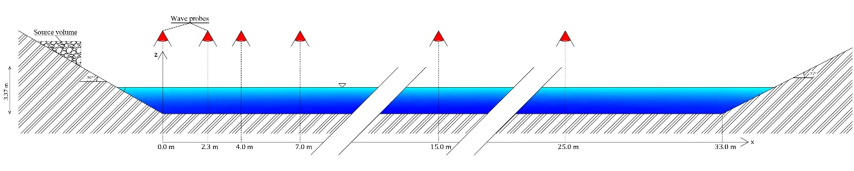
Figure S1. Experimental apparatus by Miller et al. [3] used for the validation of the numerical model used in this application.

As a benchmark, both the computed landslide deposit and water elevation can be validated against the experimental evidence. To this purpose, the flume has been discretized using 507 766 triangular elements with an average size of $0.02 m$. The results using $h_{tank}=0.2 m$ and $h_{tank}=0.5 m$are shown in Figure S2 and Figure S3 respectively.

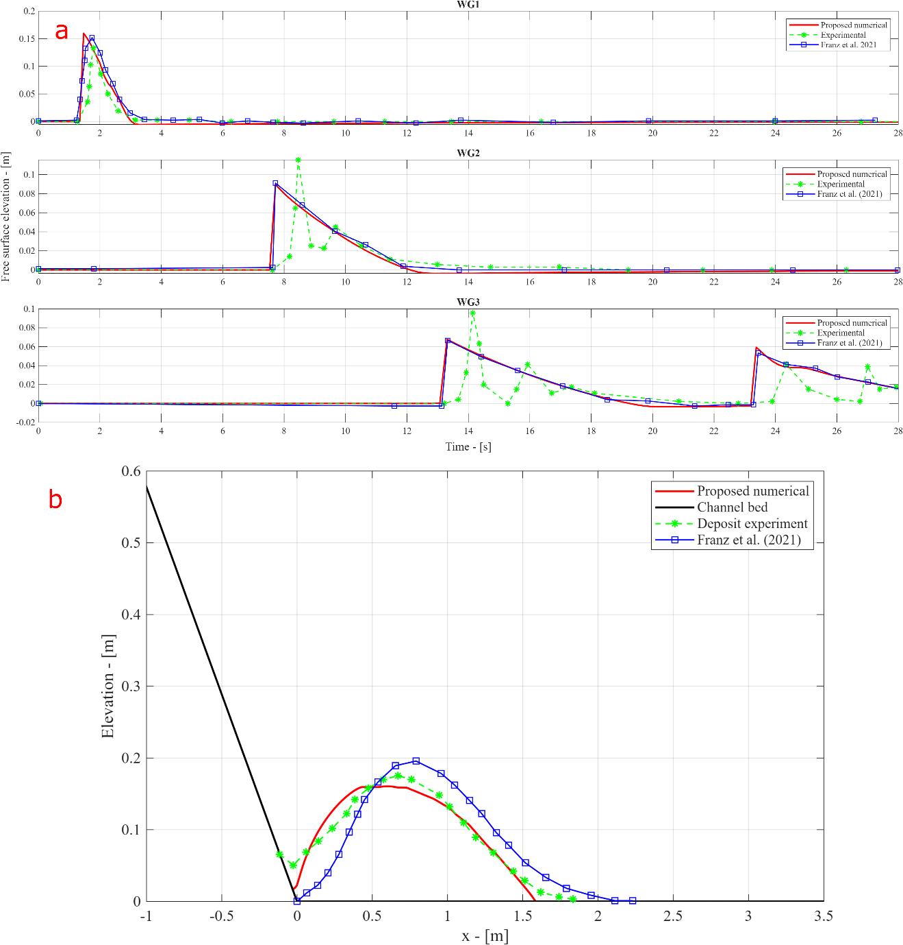
Figure S2. Panel a shows the comparison between numerical and experimental water surface elevation for a still water depth of $0.2 m$ (adopted as the zero level for the free surface elevation) at different wave gauges ($2.3 m$for WG1$, 15 m$ for WG2 and $25 m$ for WG3). Panel b shows the comparison between numerical and experimental elevation of the landslide deposit at the end of the simulation $(t_{end}=30 s)$. In all plots the results shown in the paper of Franz et al. [2] are plotted for an additional comparison.
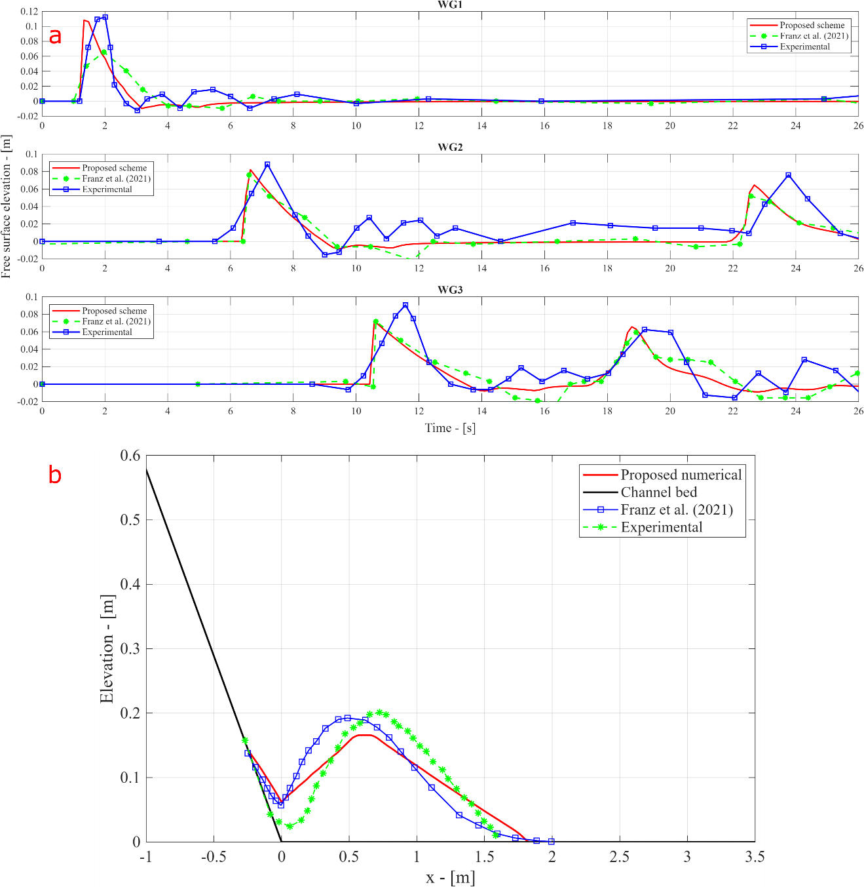
Figure S3. Panel a shows the comparison between numerical and experimental water surface elevation for a still water depth of $0.5 m$ (adopted as the zero level for the free surface elevation) at different wave gauges ($2.3 m$for WG1$, 15 m$ for WG2 and $25 m$ for WG3). Panel b shows the comparison between numerical and experimental elevation of the landslide deposit at the end of the simulation $(t_{end}=30 s)$. In all plots the results shown in the paper of Franz et al. [2] are plotted for an additional comparison.

3.2 The 2014 Lake Askja rockslide-induced tsunami
As a validation with a real case, we tested the numerical model described in the main paper with a large tsunami occurred in 2014 in Lake Askja, Iceland [6]. A ${10}^{7} m^{3}$ landslide caused a tsunami that inundated the shore with vertical runup up to $60-80 m$ [6]. The event is well documented and studied [6, 7] and it shows how the proposed numerical chain can capture the main effects of a landslide generated tsunami along the coasts. Following [6], the landslide is defined as a block of fixed width with a wedge shaped longitudinal cross section having a width of 550 m and initial thickness of 30 m. Additional data used are the internal friction angle of the landslide, i.e. $μ=0.18$, and the landslide density $ρ_{s}=2000 kg/m^{3},$ see [6, 7] for additional details regarding the event. An unstructured mesh of 1 036 118 triangular elements having an average spacing of 4 m has been used, further mesh refinement did not alter the results significantly. The resolution of the available terrain was 5 m, while the Manning coefficient was set to $n=0.01 s/m^{1/3}$. Lastly, the empirical $SF$ coefficient was set to 0.01.

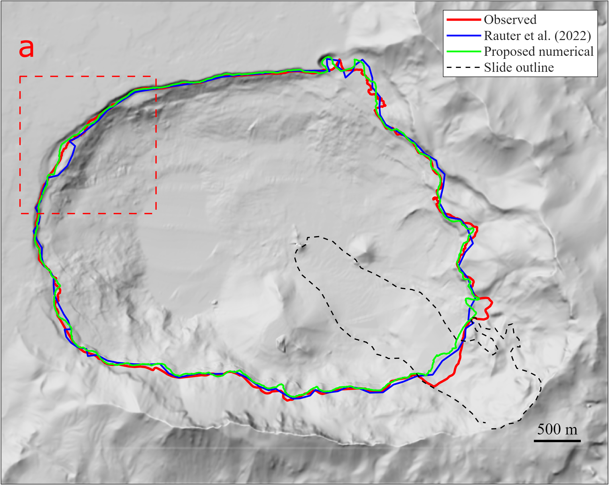
Figure S4. Lake Askja maximum inundation extent. The observed inundation is displayed by the solid red line, while in solid blue color the output of the fully 3D model adopted by Rauter et al. [7] is shown. In solid green color the output of the proposed SWE-based model is displayed. The dashed black line shows the observed outline of the landslide. The results in the dashed rectangle a are further magnified in Figure S5

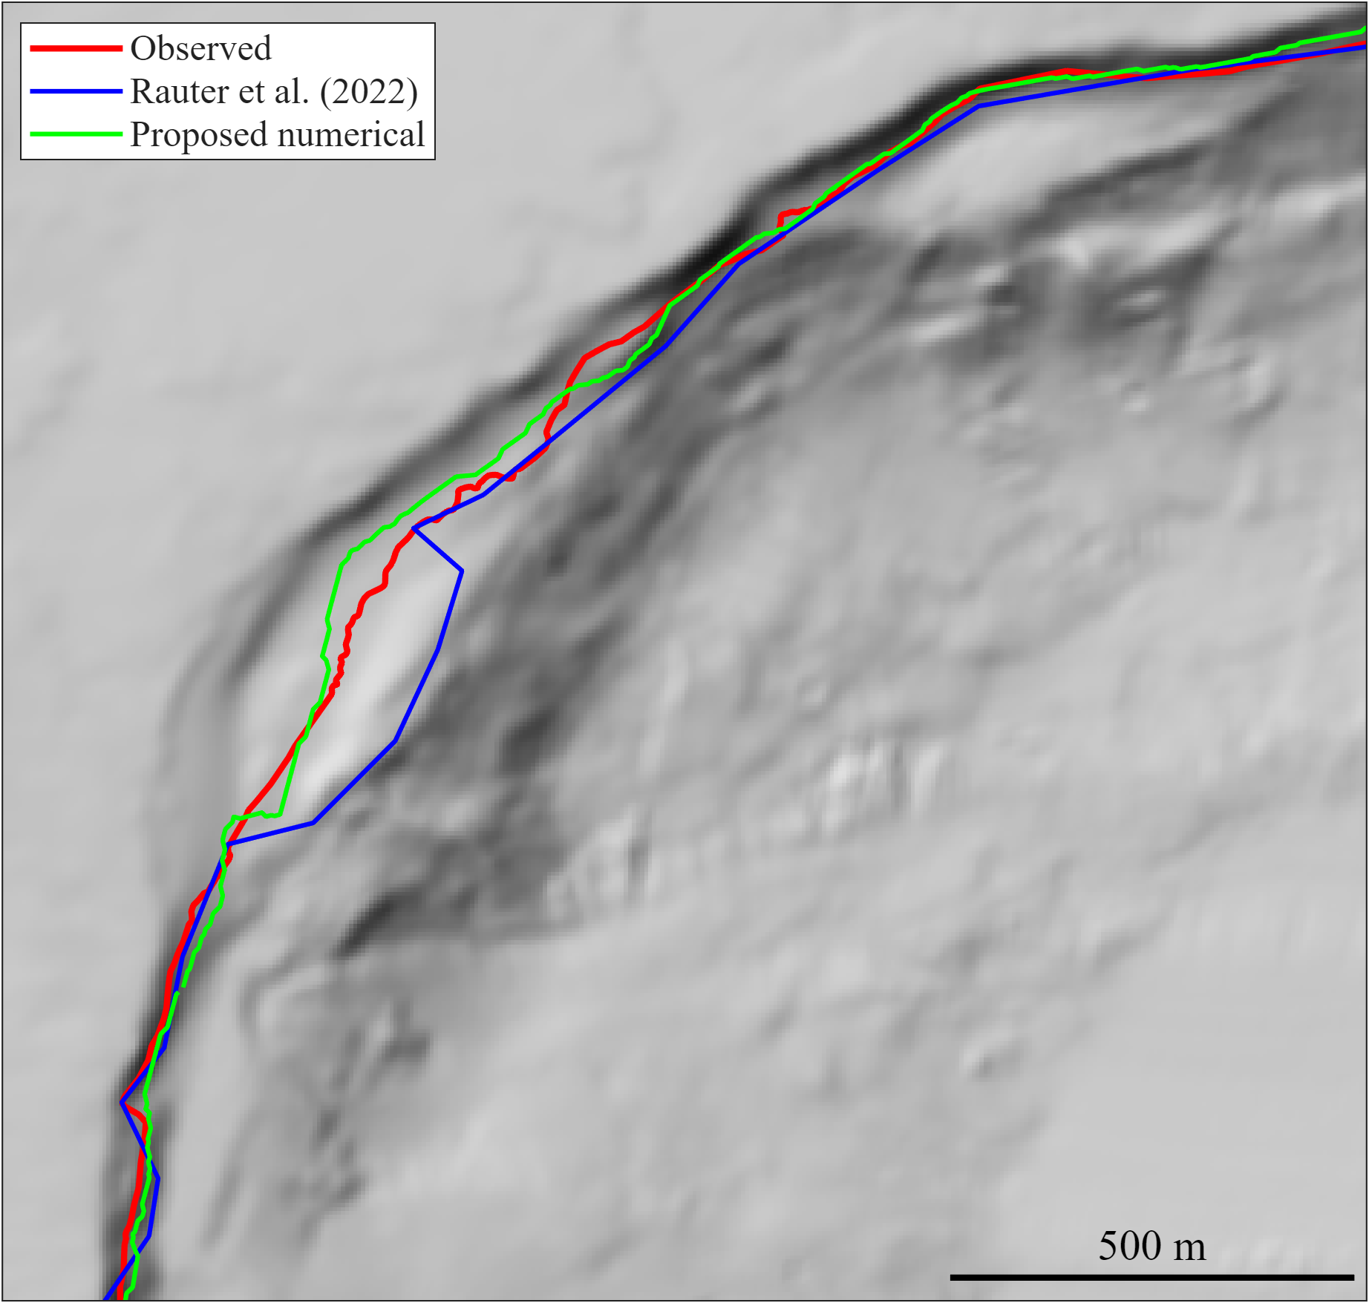
Figure S5. Enlargement of the north-eastern part of the lake in panel a, dashed red line, of Figure S4. As can be noticed, the maximum inundation extent computed by the SWE-based model is comparable to the one computed by Rauter et al. [7] using a fully multiphase 3D model.

The results show clearly that the maximum inundation extent computed by the proposed modelling chain is comparable both to the observations (see Figure S4 and S5) and to the output of the fully 3D Navier-Stokes multiphase based model of Rauter et al. [7]. The simulation lasted 6 hours for 300 s of coupled motion, in contrast to the 600 hours for the same simulation performed by Rauter et al. [7], using a more complex model. The workstation used to perform the simulation is equipped with an AMD Ryzen 9 7950X 4.5 GHz Processor. These overall results show that the proposed modelling chain can be used to predict maximum inundation for a landslide-generated tsunami.

4 Human vulnerability model
Model outputs expressed solely in terms of local maximum water depth and velocity are not sufficient for risk mapping unless they are interpreted through an appropriate vulnerability function for the most valuable asset, i.e. people. The mechanical model proposed by Milanesi et al. [8, 9] who studied the stability of a person impacted frontally by a flow with velocity $U$ and depth $h$ through a physically based stability function which considers both fluid density and local ground slope, was adopted for this scope. The human vulnerability is evaluated considering sliding and toppling by means of a force equilibrium in the direction of the flow and a moment equilibrium around the heel. Vulnerability to drowning is also considered by introducing a maximum water depth. In this way, using literature parameters summarizing the physical features of children and European adults, two vulnerability curves can be obtained [10]: one valid for adults ($h_{adults})$ and the other valid for a 7-year-old child $(h_{children})$, given by Eq. (12)
$$h_{adults}=\min\left(1.4;\frac{2.809}{U+1.102}-0.416\right)$$  $$h_{children}=\min\left(1;\frac{1.565}{U+0.884}-0.275\right)$$ | (12)

Moreover, considering that most casualties in urban floods are related to drivers, the assessment of vehicle stability under inundation conditions can be included as an additional criterion for evaluating human safety. To this end, Milanesi & Pilotti [10] proposed a conceptual stability model for a stationary vehicle impacted by the flow accounting for fluid density and the slope of the terrain. Two easy to use approximate formulation of the stability limit as a function of the flow velocity $U$, depth $h$ and local slope $ϑ$ are given, for parallel and perpendicular orientation of the flow, are shown below
$$U≤{\left[\frac{\left(604-685\tan{ϑ}-1218 h\right)\cos{ϑ}}{38 h+1}\right]}^{1/2}$$  $$U≤{\left[\frac{\left(390-443\tan{ϑ}-788 h\right)\cos{ϑ}}{68 h-1}\right]}^{1/2}$$ | (13)
Eq. (13) are defined for $0.158<h<h_{b}≈0.495 m$, where the latter is the depth at which the vehicle starts floating in static water. Together, Eq. (12) and Eq. (13) can be combined to obtain conditions of growing vulnerability. Considering Figure S6, the $(h,U)$ space has been divided into 5 regions: from white (no vulnerability at all, the origin) to purple (maximum vulnerability), through yellow, orange and red. The V4 zone corresponds to areas where adult people’s life is challenged, V3 to areas where children’s life is challenged and V2 to areas where children are safe but not people in cars. Finally, the V1 zone corresponds to areas where people in a flooded area are safe.
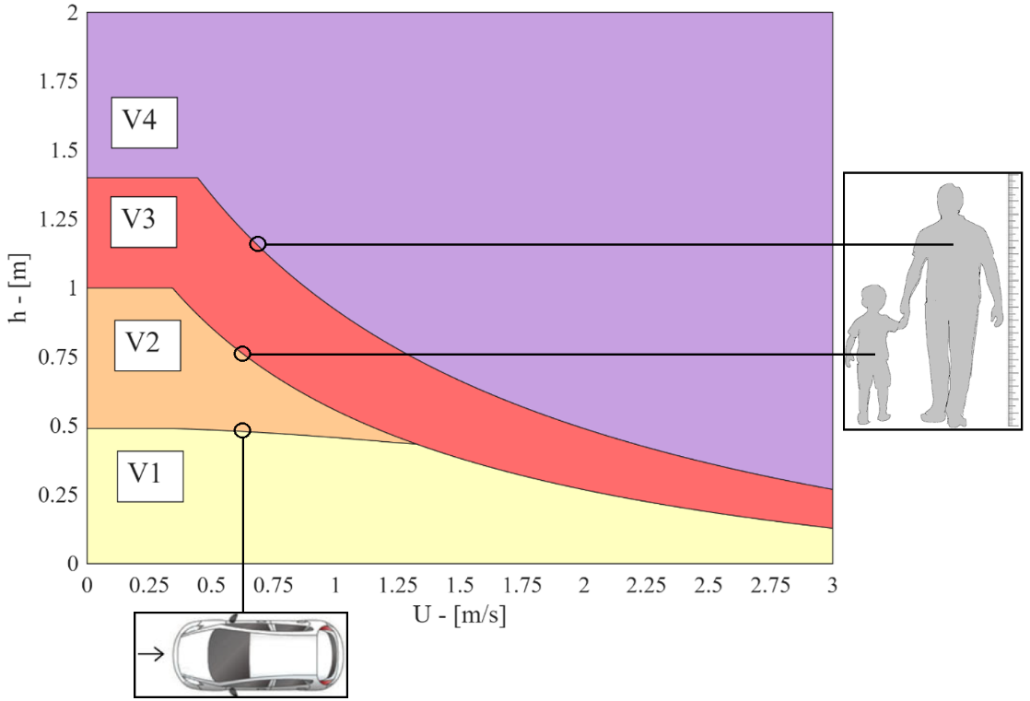
Figure S6. Human vulnerability space under flood conditions. V4 zone: life of adults is in danger, V3 zone: child life is in danger, V2 zone: safe for a child life but not for people in cars and V1 zone: people are safe also in cars.

5 Detailed modeling of onshore flooding
The comparative analysis of the envelope of maximum water depth along the shoreline, obtained from the ensemble simulations, and of the preliminary human exposure computed above enabled the prioritization of areas where detailed hazard and population vulnerability were subsequently assessed through high-resolution SWE simulations encompassing both the lake surface and the onshore floodable areas. Mesh generation in onshore areas must be carried out with a higher level of detail than over the lake, accounting for the larger topographic variability and for the presence of buildings, which must be explicitly included in the computational mesh. Indeed, buildings significantly alter the flow field under impulsive forcing conditions [12], thereby affecting the subsequent risk assessment. Compared to the simpler approach of artificially increasing ground elevation at building locations (the so-called building-block technique), buildings are represented in our SWE solver using the more accurate building-hole technique. In onshore areas, surface roughness is then characterized by the assignment of Manning’s roughness coefficients, which can be derived from locally available land-use information. At the end of this modeling phase, spatially distributed values of maximum water depth and flow velocity occurring simultaneously at each cell over the computational domain are obtained and subsequently used for population risk assessment.

6 Additional figures

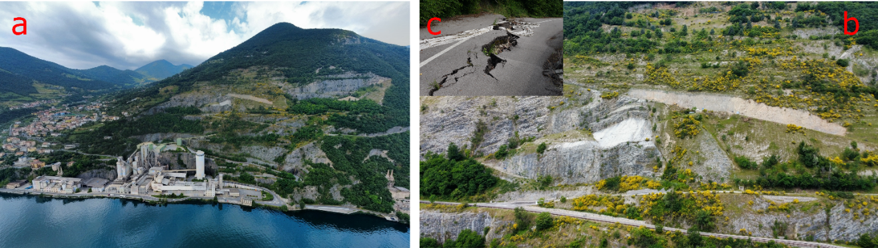
Figure S7. Panel a shows an aerial view of Mount Saresano located near the town of Tavernola, where the landslide is situated. Panel b displays a close-up of the landslide mass, with a road damaged by the movement of the landslide (Panel c).

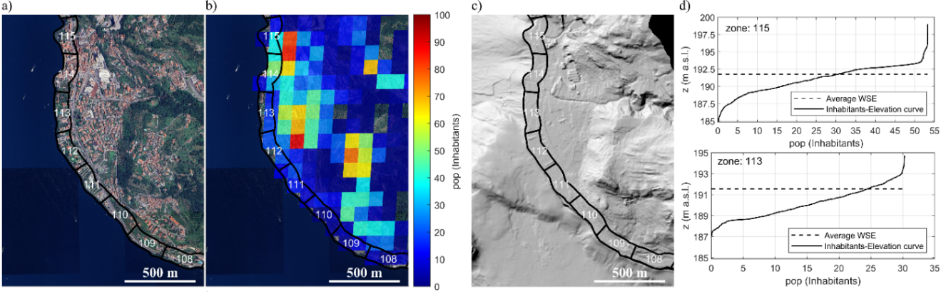
Figure S8. Procedure applied for the preliminary evaluation of the population exposure. a) Location of the zones, b) GHS-POP spatial raster used to evaluate the population density for each cell of the DTM, c) DTM adopted in this study, d) Intersection between inhabitants-elevation curve and the maximum wave elevation envelope which provides the exposed population for each considered zone.

7 References
[1] Bonomelli R., Farina G., Pilotti M., Molinari D., & Ballio F. (2023). Historical comparison of the damage caused by the propagation of a dam break wave in a pre-alpine valley. Journal of Hydrology: Regional Studies, 48, 101467. https://doi.org/10.1016/j.ejrh.2023.101467

[2] Franz, M., Jaboyedoff, M., Mulligan, R. P., Podladchikov, Y., & Take, W. A. (2021). An efficient two-layer landslide-tsunami numerical model: effects of momentum transfer validated with physical experiments of waves generated by granular landslides. Natural Hazards and Earth System Sciences, 21, 1229-1245. https://doi.org/10.5194/nhess-21-1229-2021

[3] Miller, G. S., Take, W. A., Mulligan, R. P., McDougall, S. (2016). Tsunamis generated by long and thin granular landslides in a large flume. Journal of Geophysical Research: Oceans, 122, 1, 653, 668. https://doi.org/10.1002/2016JC012177

[4] Yavari-Ramshe, S., Ataie-Ashtiani, B. (2016). Numerical modeling of subaerial and submarine landslide-generated tsunami waves – recent advances and future challenges. Landslides, 13, 1325-1368. https://doi.org/10.1007/s10346-016-0734-2

[5] Bonomelli, R., Pilotti, M., & Farina, G. (2025). Use of simple analytical solutions in the calibration of shallow water equation debris flow models. Earth Surface Dynamics, 13, 665–681. https://doi.org/10.5194/esurf-13-665-2025

[6] Gylfadóttir, S. S., Kim, J., Helgason, J. K., Brynjólfsson, S., Höskuldsson, A., Jóhannesson, T., Harbit, C. B., Løvholt, F. (2017). The 2014 Lake Askja rockslide-induced tsunami: Optimization of numerical tsunami model using observed data, Journal Geophysical Research Oceans, 122, 4110–4122, doi:10.1002/2016JC012496

[7] Rauter, M., Viroulet, S., Gylfadóttir, S.S. et al. Granular porous landslide tsunami modelling – the 2014 Lake Askja flank collapse (2022). Nature Scientific Communication, 13, 678, https://doi.org/10.1038/s41467-022-28296-7

[8] Milanesi, L., Pilotti, M. & Ranzi, R. (2015). A conceptual model of people’s vulnerability to flood. Water Resources Research, 51, 1, 182–197. https://doi.org/10.1002/2014WR016172

[9] Milanesi, L., Pilotti, M. & Bacchi, B. (2016). Using web-based observations to identify thresholds of a person’s stability in a flow. Water Resources Research, 52, 10, 7793-7805. https://doi.org/10.1002/2016WR019182

[10] Pilotti, M., Farina, G., Bonomelli, R. & Milanesi, L. (2022). Physically Based Vulnerability Functions for Flood Risk Mapping in Mountain Areas. Proceedings of the 39th IAHR World Congress, Granada 2022. https://doi:10.3850/IAHR- 39WC252171192022458

[11] Milanesi, L. & Pilotti, M. (2019). A conceptual model of vehicles stability in flood flows. Journal of Hydraulic Research, 58, 4. https://doi.org/10.1080/00221686.2019.1647887

[12] Milanesi, L. & Pilotti, M. (2021). Coupling Flood Propagation Modeling and Buildings Collapse in Flash Flood Studies. Journal of Hydraulics Engineering, 147, 12. https://doi.org/10.1061/(ASCE)HY.1943-7900.0001941

