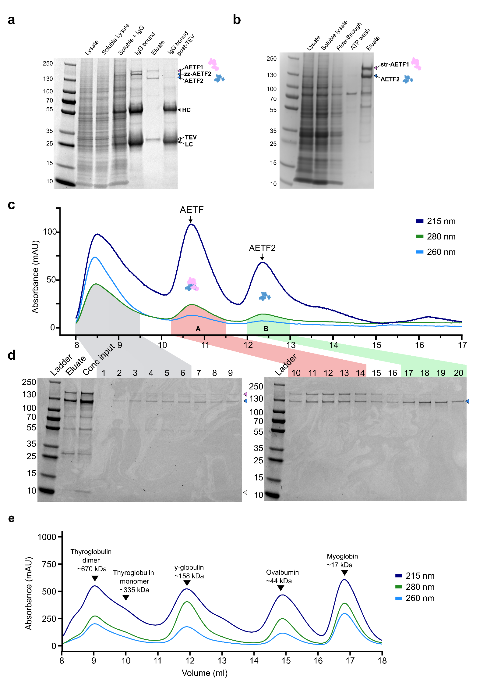
Supplementary Figure 1. (a) SDS-PAGE (Bio-Rad 4-20% Mini-PROTEAN TGX Precast Gels) of samples collected from zz-tag affinity purification of AETF from insect cell lysate. IgG refers to samples mixed with the IgG beads, HC and LC refer to the heavy chain and light chain therein. (b) AETF purification via N-terminal twin-strep tag on AETF1. (c) Typical gel filtration chromatogram of AETF elution from affinity purification, on Superdex 200 Increase 10/300, showing absorbance of wavelengths (215 nm, 280 nm, 260 nm) during size exclusion. (d) 4-20% SDS-PAGE of elution fractions from 8ml to 13ml. Peak regions near void volume (grey), A (red), and B (green) are highlighted on the chromatogram in (c) and their associated elution fractions are highlighted in (d). Conc refers to the eluate from zz-tag purification, concentrated to 500 µl before loading on the column. Migration of known bands for AETF1 (pink), and AETF2 (blue) are annotated. (e) A molecular weight gel filtration standard (Bio-Rad, Cat no. 1511901) was run under the same conditions as (c).

Protein Family | Accession | # Peptide seqs | Details
1 | BMS211207.01 A7_Q65177 | 7156 | A7_Q65177
2 | BMS211207.01 D6_Q89525 | 808 | D6_Q89525
3 | K2C1_HUMAN | 222 | K2C1_HUMAN
3 | P35908 | 77 | SWISS-PROT:P35908 Tax_Id=9606 Gene_Symbol=KRT2 Keratin, type II cytoskeletal 2 epidermal
4 | TRYP_PIG | 220 | TRYP_PIG
5 | K1C9_HUMAN | 186 | K1C9_HUMAN
6 | K1C10_HUMAN | 146 | K1C10_HUMAN
7 | P13647 | 81 | SWISS-PROT:P13647 Tax_Id=9606 Gene_Symbol=KRT5 Keratin, type II cytoskeletal 5
7 | P02538 | 47 | SWISS-PROT:P02538 Tax_Id=9606 Gene_Symbol=KRT6A Keratin, type II cytoskeletal 6A
8 | P02533 | 61 | SWISS-PROT:P02533 Tax_Id=9606 Gene_Symbol=KRT14 Keratin, type I cytoskeletal 14
9 | BMS211025.01 | 59 | TmCE7 [thermatoga maritima]
10 | BMS210129.01 EV20840_Pool1 | 57 | EV20840_Pool1
Supplementary Table 1. The top 10 most abundant and significant protein family hits (p <0.05) for peptide sequences from all three searched databases: ‘contaminants 20160129’, ‘BMS 211207’ and ‘cRAP 20190304’, from upper ~150 kDa band following gel filtration.
Protein Family | Accession | # Peptide seqs | Details
1 | BMS211207.01 | 8146 | D6_Q89525
2 | BMS211207.01 | 1093 | A7_Q65177
3 | K1C10_HUMAN | 682 | K1C10_HUMAN
3 | P35527 | 362 | SWISS-PROT:P35527 Tax_Id=9606 Gene_Symbol=KRT9 Keratin, type I cytoskeletal 9
3 | P02533 | 441 | SWISS-PROT:P02533 Tax_Id=9606 Gene_Symbol=KRT14 Keratin, type I cytoskeletal 14
3 | P08779 | 425 | SWISS-PROT:P08779 Tax_Id=9606 Gene_Symbol=KRT16 Keratin, type I cytoskeletal 16
4 | K2C1_HUMAN | 423 | K2C1_HUMAN
4 | P35908 | 384 | SWISS-PROT:P35908 Tax_Id=9606 Gene_Symbol=KRT2 Keratin, type II cytoskeletal 2 epidermal
4 | P02538 | 121 | SWISS-PROT:P02538 Tax_Id=9606 Gene_Symbol=KRT6A Keratin, type II cytoskeletal 6A
4 | P13647 | 183 | SWISS-PROT:P13647 Tax_Id=9606 Gene_Symbol=KRT5 Keratin, type II cytoskeletal 5
5 | TRYP_PIG | 197 | TRYP_PIG
6 | Q5D862 | 45 | SWISS-PROT:Q5D862 Tax_Id=9606 Gene_Symbol=FLG2 Filaggrin-2
7 | BMS004692 | 40 | tubulin
8 | BGAL_ECOLI | 37 | BGAL_ECOLI
9 | BMS049858 | 33 | EV12992 [human]
10 | RS27A_HUMAN | 32 | RS27A_HUMAN
Supplementary Table 2. The top 10 most abundant and significant protein family hits (p <0.05) for peptide sequences from all three searched databases: ‘contaminants 20160129’, ‘BMS 211207’ and ‘cRAP 20190304’, from lower ~130 kDa band following gel filtration.
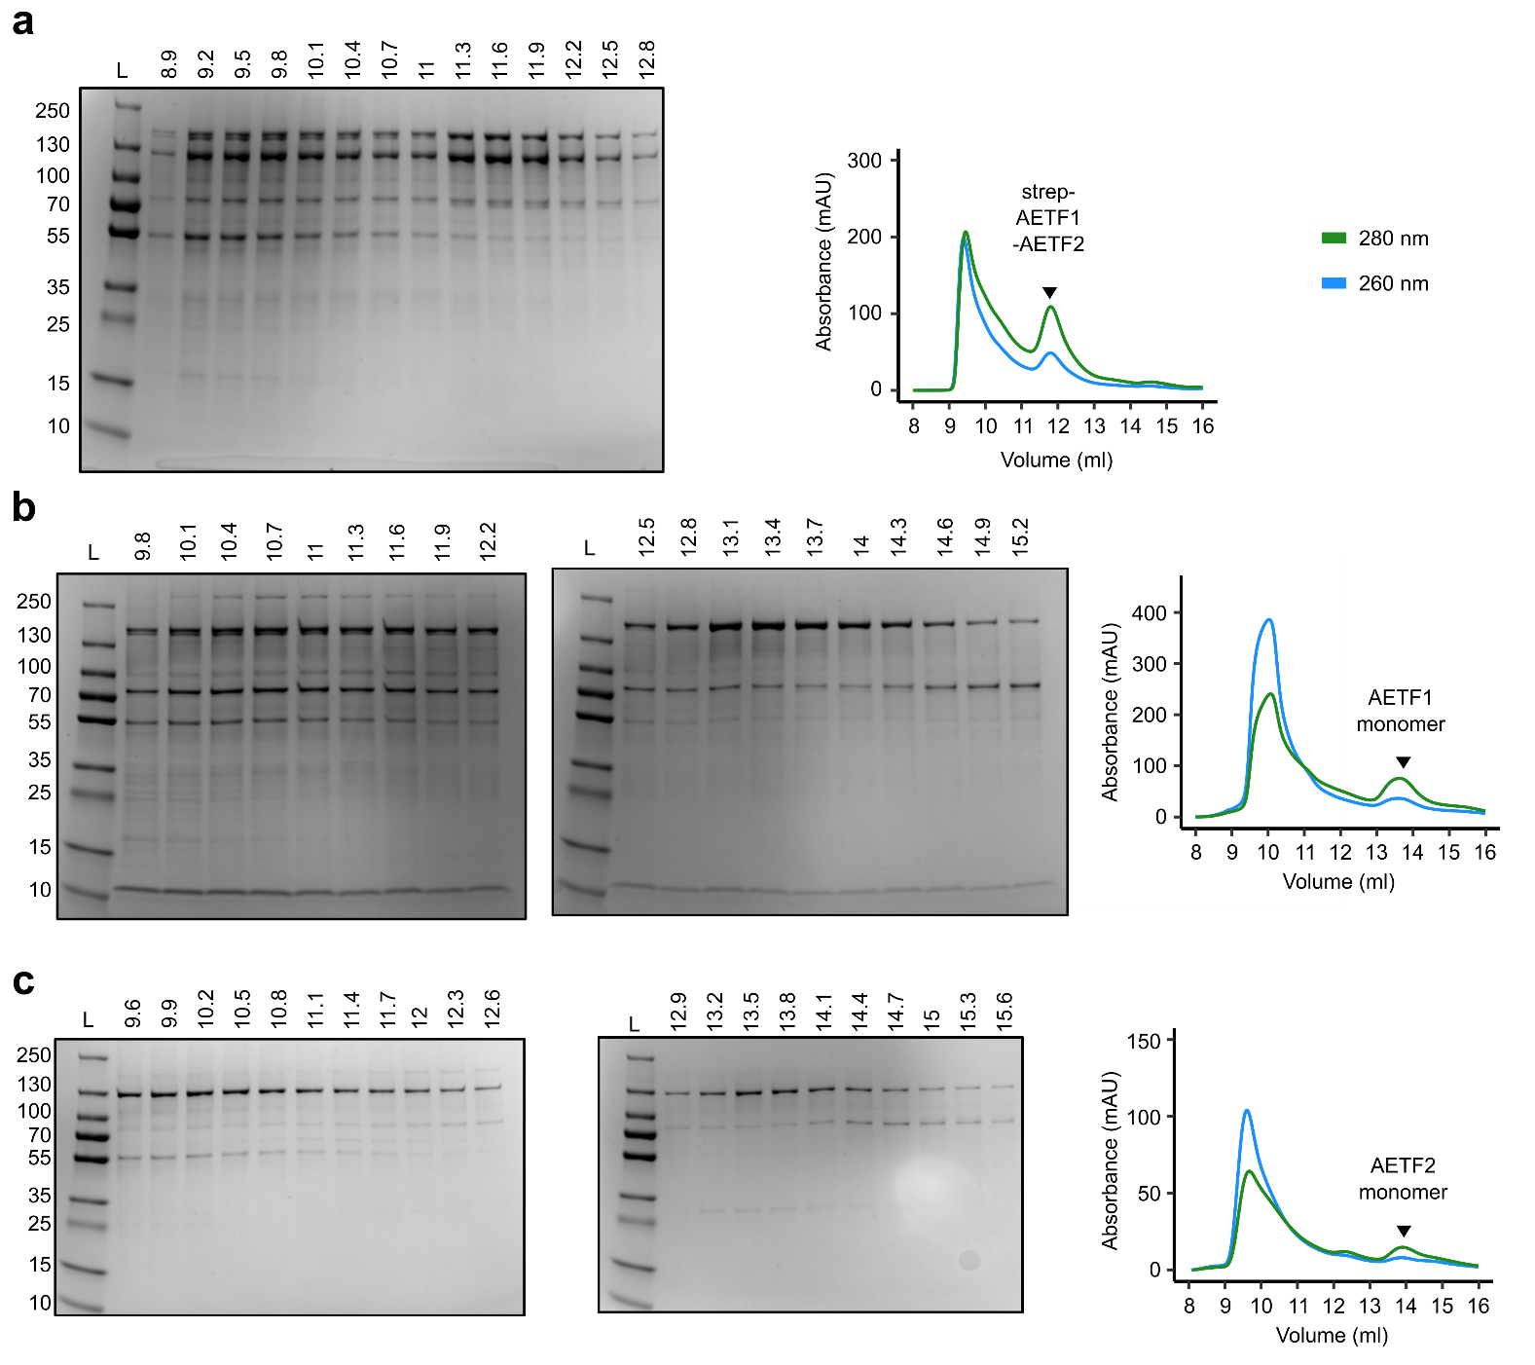
Supplementary Figure 2.Purification of AETF variants. (a) Gel filtration of strep-AETF. (b) Gel filtration of AETF1 following purification of AETF1 via N-terminal twin-strep tag. (c) Gel filtration of AETF2 following purification via zz-tag pulldown with IgG and TEV-cleavage.
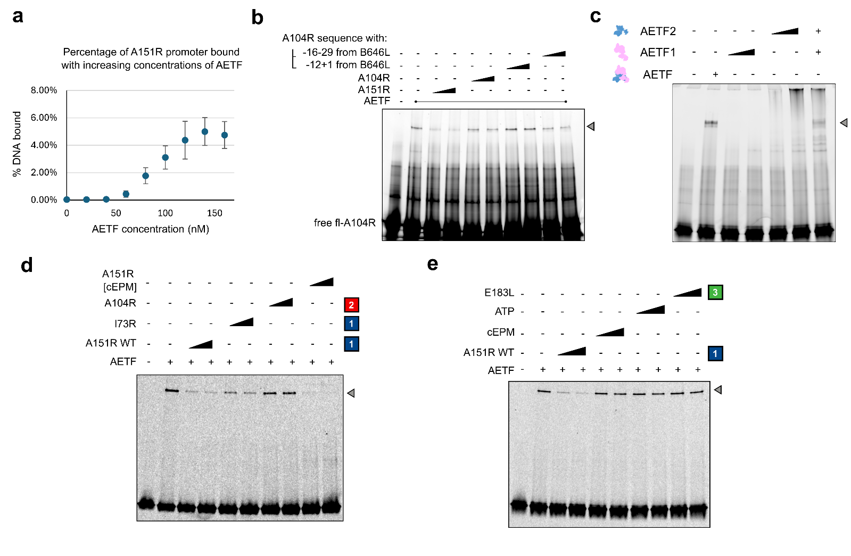
Supplementary Figure 3. Supplementary AETF EMSA analysis. (a) Quantification of relative DNA bound fraction of AETF of Figure 2.b using ImageQuant to quantify intensity of free probe (highest intensity in lower large band) and bound DNA (region of distinct AETF band). (b) EMSA with fluorescent AF647-A104R dsDNA promoter, competing with unlabelled promoters from A151R, A104R and chimeric A104R sequences with regions replaced by that from B646L sequence. (c) EMSA comparison of A151R DNA binding with co-expressed strep-AETF1-AETF2 (AETF), individually-expressed strep-AETF1 (AETF1), zz-AETF2 (AETF2), both these monomers combined in EMSA reactions. (d) Competition EMSA of WT AETF 350 nM of zz-tag purified AETF incubated with AttoN647-A151R dsDNA and two different concentrations (black triangle) of competing substrates. Concentrations were 0.6 µM or 1.2 µM for unlabelled dsDNA competitors, and 0.5 mM and 1mM for ATP. (e) A similar EMSA to (d), except using 280 nM of zz-tag purified AETF and different dsDNA competitors.

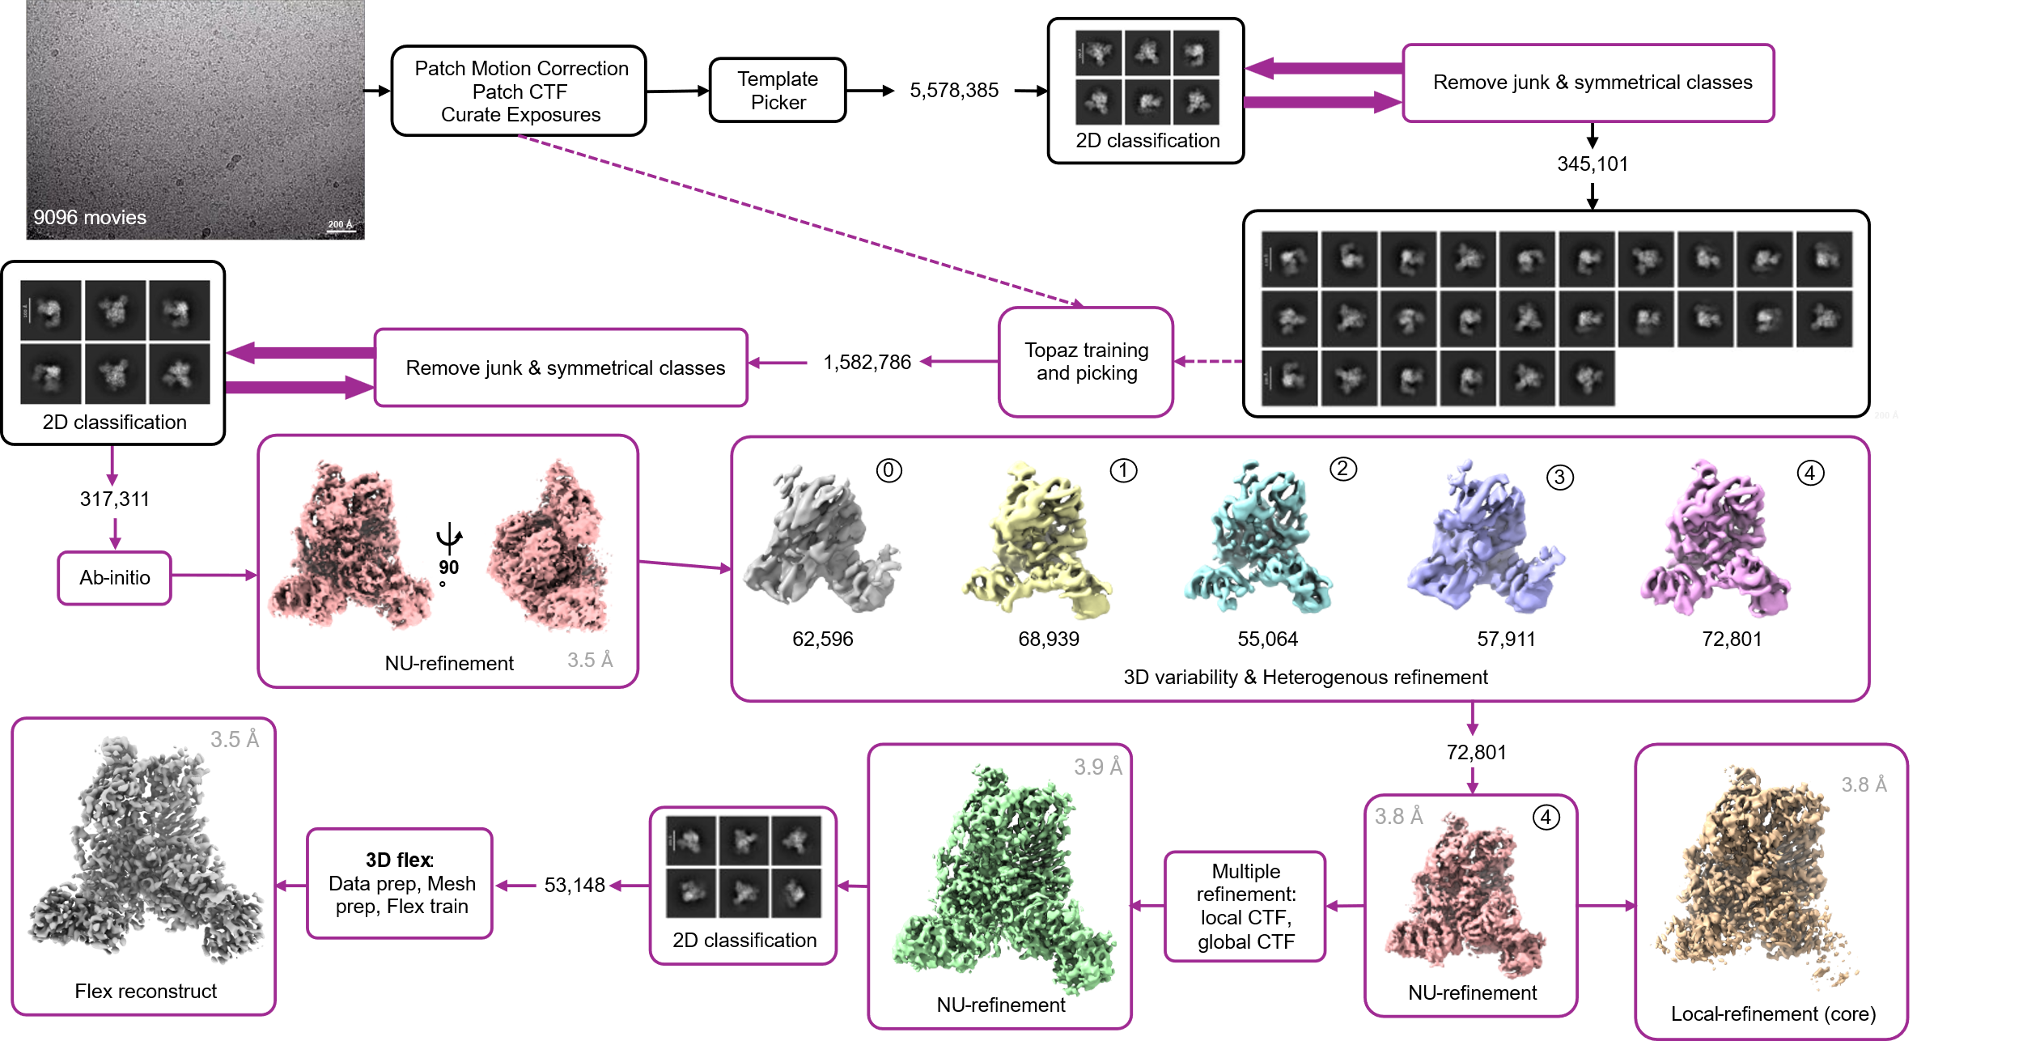
Supplementary Figure 4. Cryo-EM data processing pipeline in CryoSPARC ¹ to generate 3 main maps used to generate a composite map, from Non-Uniform (NU) refinement, 3D Flex and focused refinement on the protein core. In grey are resolutions from FSC after FSC-mask auto-tightening for NU-refinement and Local Refinement and Flex reconstruction FSC.

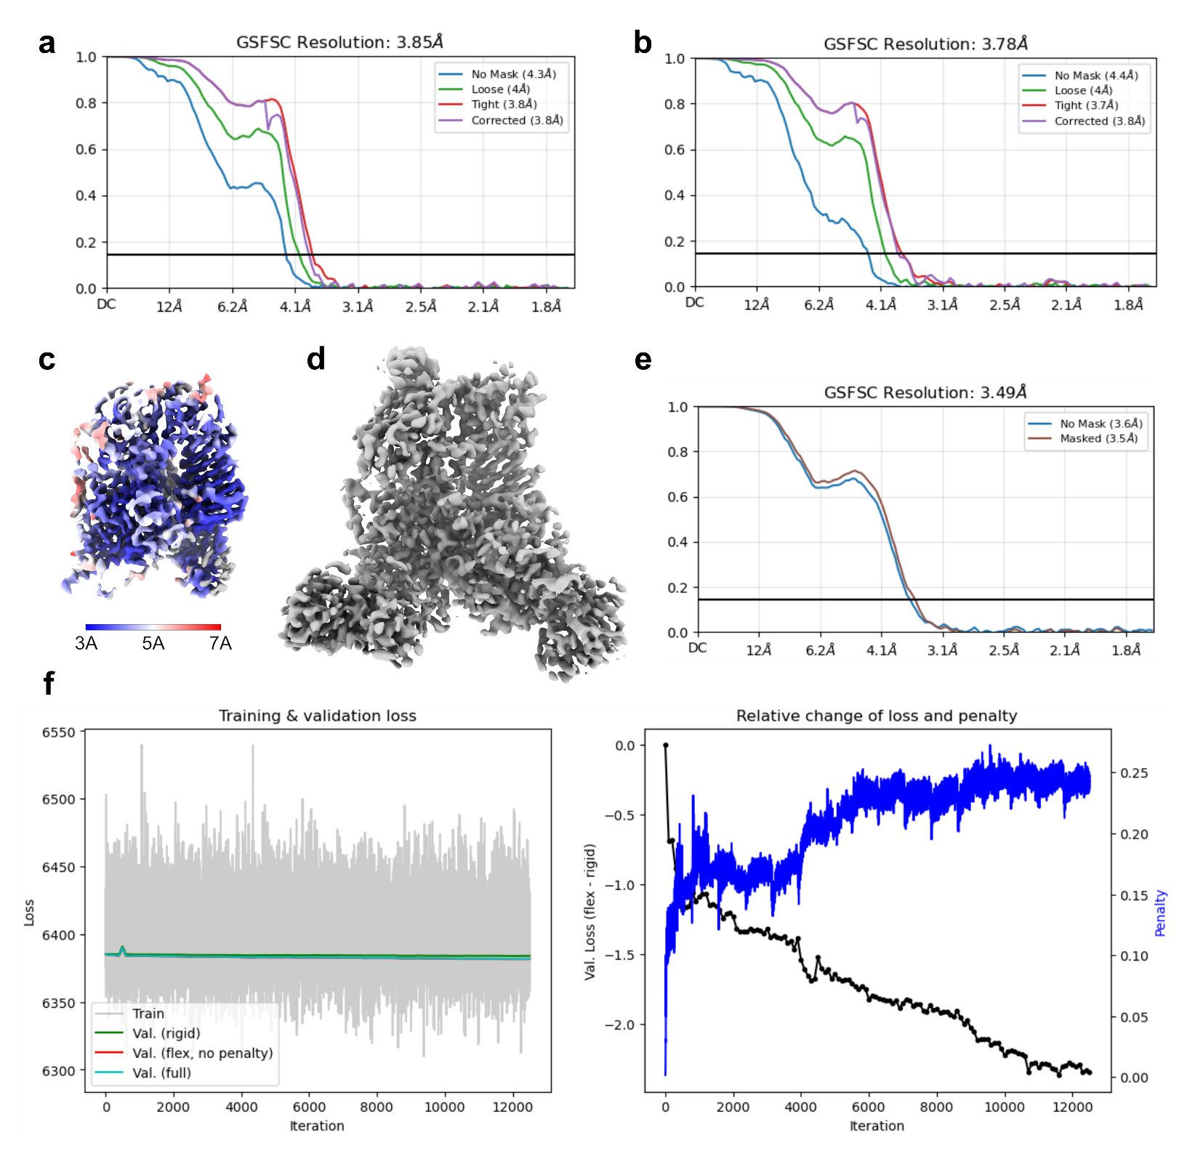
Supplementary Figure 5. Details of EM maps. (a) Gold Standard Fourier Shell Correlation (GSFC) curve with FSC-mask auto-tightening from non-uniform refinement in CryoSPARC from Non-Uniform refinement shown in Fig. 2a. (b) GSFSC resolution curve from local refinement map (core) with FSC-mask auto-tightening in CryoSPARC. (c) Map from local-refinement coloured according to local resolution (from 3Å to 7Å). (d) Sharpened map following 3D Flexible refinement, with a B-factor of -66.7 (e) Flex reconstruction FSC. (f) 3D Flexibible refinement: output from Flex Train.
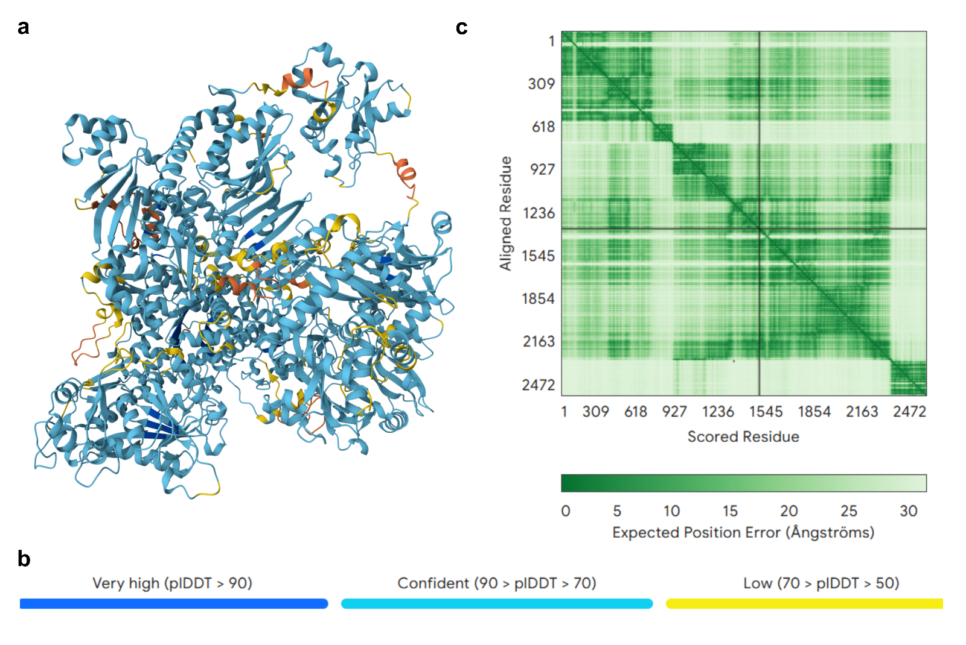
Supplementary Figure 6. Summary from AlphaFold3 (https://alphafoldserver.com/) prediction of AETF subunits. (a) Model coloured according to Predicted Local Distance Difference Test (pLDDT), as indicated in (b). (c) Expected Position Error across the sequence for AETF1 and AETF2, with chains separated by a black line on the matrix.

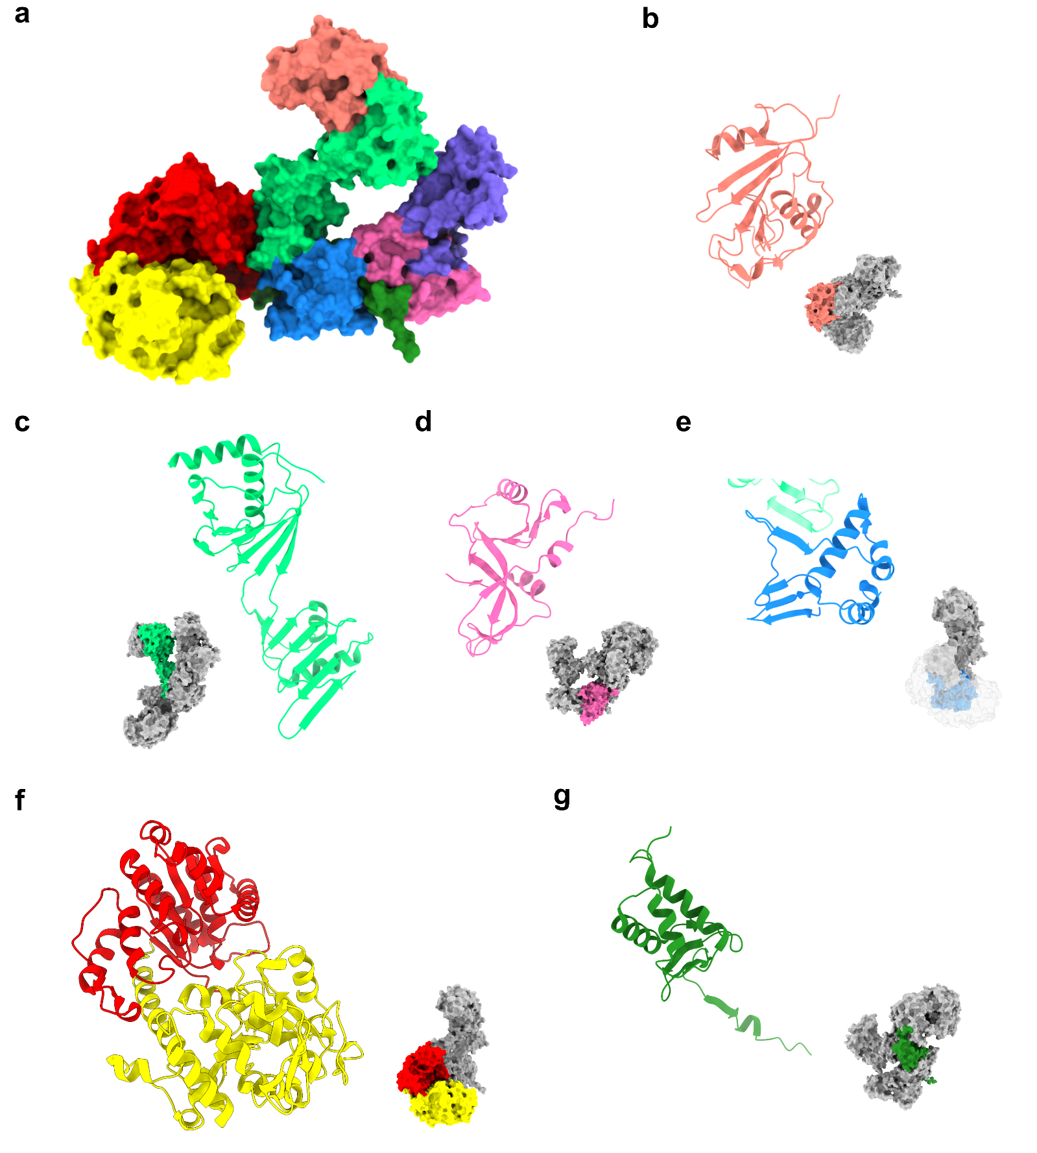
Supplementary Figure 7. Domains of the VETF, represented in the same manner as Figure 4. (a) Surface representation of the VETF structure (pdb: 7AMV). with the VETF domains coloured. Ribbon representations of each domain and their relative locations shown in (b) VETFl-NTD, (c) TBPLD, (d) OTU-like Domain 4, (e) VETFl-CTD, (f) VETFs helicase lobes, (g) VETFs-CTD.

Search query | Viral family | Scientific Name | Target | Seq. Id. | E-Value | Query legnth
AETF Structure | Asfarviridae | Abalone asfa-like virus | A0A5K7Y0V4 | 26.7 | 5.34E-81 | 1-1094
AETF Structure | Unclassified | Faustovirus | A0A141ZNB2 | 18.4 | 1.10E-55 | 1-1094
AETF Structure | Unclassified | Kaumoebavirus | A0A1V0CNJ2 | 16.2 | 1.04E-46 | 1-1094
AETF Structure | Mimiviridae | Moumouvirus Monve | H2EE59 | 10.8 | 1.55E-16 | 1-1094
AETF Structure | Phycodnaviridae | Phaeocystis globosa virus 14T | G8DEL3 | 10.7 | 1.50E-13 | 1-1094
AF2 model | Marseilleviridae | Marseillevirus LCMAC101 | A0A481YQW8 | 12.4 | 4.30E-25 | 1-1340
AF2 model | Iridoviridae | Iridovirus CN01 | A0A8T9VRA7 | 11.7 | 6.99e-27 | 1-1340
AF2 model | Unclassified | Pithovirus LCPAC102 | A0A4D5XFI7 | 9 | 6.43E-25 | 1-1340
Structure and AF2 model | Poxviridae Orthopoxvirus | VACV | pdb: 7AMV (K) | Not detected as a match
Supplementary Table 3. Summary of NCLDV representatives from FoldSeek homologous to AETF1. Also included are 2 additional viral groups detected when using the full length AlphaFold2 model to account for ~300 residues deleted due to poor density in our structure.

PDB entry | Name | Species | Seq. Id. | E-Value | Alignment in target
 |  |  |  |  | Start | End
8cen chain O | Yeast RNA polymerase II transcription pre-initiation complex with core Mediator | Saccharomyces cerevisiae | 10 | 1.35E-03 | 273 | 560
1mp9 chain B | TBP from a mesothermophilic archaeon, Sulfolobus acidocaldarius | Sulfolobus acidocaldarius | 9.3 | 1.28E-03 | 274 | 591
8ffz chain H | TFIIIA-TFIIIC-Brf1-TBP complex bound to 5S rRNA gene | Saccharomyces cerevisiae S288C | 9.4 | 2.59E-03 | 264 | 555
1cdw chain A | HUMAN TBP CORE DOMAIN COMPLEXED WITH DNA | Homo sapiens | 9.2 | 3.32E-03 | 274 | 565
1ais chain A | TATA-BINDING PROTEIN/TRANSCRIPTION FACTOR (II)B/TATA-BOX COMPLEX FROM PYROCOCCUS WOESEI | Pyrococcus woesei | 10.5 | 4.96E-03 | 274 | 565
6e16 chain A | Ternary structure of c-Myc-TBP-TAF1 | Saccharomyces cerevisiae S288C | 8.7 | 3.01E-03 | 274 | 561
6uep chain B | Structure of A. thaliana TBP bound to a DNA site with a C-C mismatch | Arabidopsis thaliana | 8 | 4.27E-03 | 274 | 554
7ena chain DP | TFIID-based PIC-Mediator holo-complex in pre-assembled state (pre-hPIC-MED) | Homo sapiens | 9.2 | 2.72E-03 | 273 | 566
6e24 chain A | Ternary structure of c-Myc-TBP-TAF1 | Saccharomyces cerevisiae S288C | 10.6 | 5.22E-03 | 261 | 565
4b0a chain A | The high-resolution structure of yTBP-yTAF1 identifies conserved and competing interaction surfaces in transcriptional activation | Saccharomyces cerevisiae | 8.3 | 4.96E-03 | 274 | 559
Supplementary Table 4. Summary of closest representatives from FoldSeek matches to AETF1 from the PDB. No VACV structures were detected as matches.

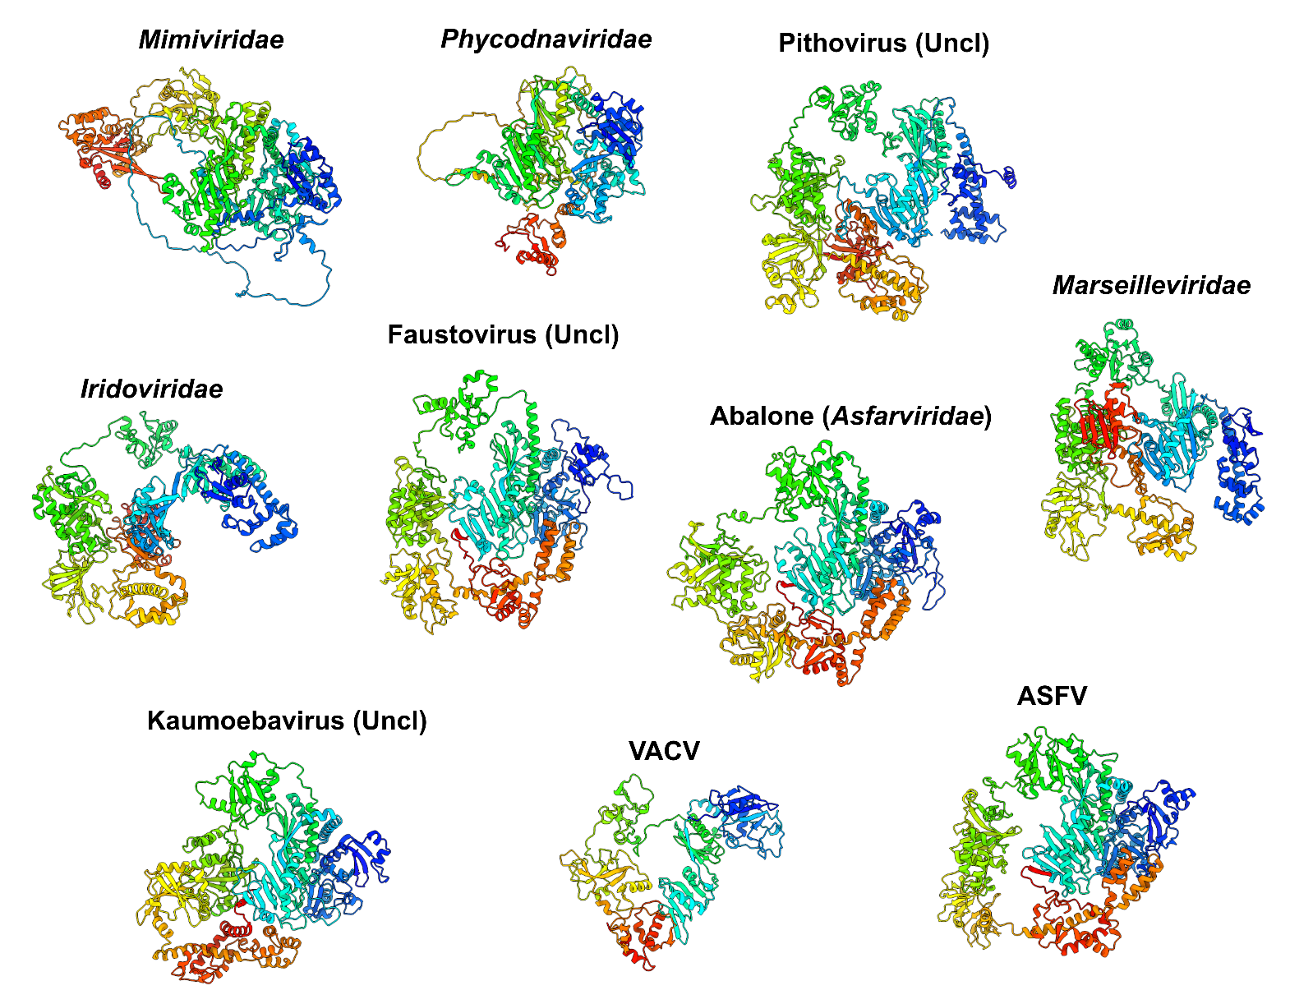
Supplementary Figure 8. AlphaFold models for NCLDV AETF1 homologs. The pdb files are from BFVD of the closest FoldSeek hits to our AlphaFold2-predicted structure of AETF1 (ASFV in figure), with representatives from a range of NCLDVs (see TABLE for details). VACV is the VETFl structure from pdb: 7AMV.

Viral group | Virus Name | Accession Code | Seq. Id. | E-Value | Database match
Unclassified | Kaumoebavirus | A0A886NHS2 | 29.1 | 9.93e-44 | BFVD
Phycodnaviridae | Organic Lake phycodnavirus 1 | F2Y171 | 16.5 | 1.21e-23 | BFVD
Marseilleviridae | Golden Marseillevirus | A0A1D6Y781 | 17.9 | 8.39e-21 | BFVD
Mimiviridae | Mimiviridae sp. ChoanoV1 | A0A5B8IGX7 | 15.9 | 2.39e-21 | BFVD
Poxviridae, Entomopoxvirinae | Diachasmimorpha longicaudata entomopoxvirus | A0A7R5WF24 | 14.4 | 8.87e-21 | BFVD
Unclassified | Pithovirus sibericum | W5S4I8 | 16.3 | 1.61e-19 | BFVD
Iridoviridae | Spotted knifejaw iridovirus | A0A8F9RTQ3 | 17.7 | 1.15e-18 | BFVD
Poxviridae, Chordopoxvirinae | VACV | pdb: 7AMV (W) | 14.1 | 2.19e-16 | PDB
Unclassified | Faustovirus | A0A7D3UH11 | 13.5 | 3.52e-11 | BFVD
Supplementary Table 5. Summary of NCLDV representatives from FoldSeek homologous to AETF2.

PDB entry | Name | Species | Seq. Id. | E-value
8atf chain G | Nucleosome-bound Ino80 ATPase | Thermochaetoides thermophila | 10.4 | 3.44E-08
7vdt chain A | The motor-nucleosome module of human chromatin remodeling PBAF-nucleosome complex | Homo sapiens | 14.4 | 2.49E-09
7oop chain b | Pol II-CSB-CSA-DDB1-UVSSA-PAF-SPT6 (Structure 3) | Homo sapiens | 11.2 | 1.52E-08
8b3f chain b | Pol II-CSB-CSA-DDB1-ELOF1 | Homo sapiens | 11.4 | 3.09E-08
7nkx chain W | RNA polymerase II-Spt4/5-nucleosome-Chd1 structure | Saccharomyces cerevisiae S288C | 12.3 | 3.26E-08
7vdv chain A | The overall structure of human chromatin remodeling PBAF-nucleosome complex | Homo sapiens | 13.6 | 1.60E-08
7zb5 chain H | Mot1(1-1836):TBP:DNA - post-hydrolysis complex dimer | Thermochaetoides thermophila | 11 | 1.21E-07
7zb5 chain E | Mot1(1-1836):TBP:DNA - post-hydrolysis complex dimer | Thermochaetoides thermophila | 10.8 | 1.28E-07
7enn chain K | The structure of ALC1 bound to the nucleosome | Homo sapiens | 12.6 | 5.61E-07
7tn2 chain W | Composite model of a Chd1-nucleosome complex in the nucleotide-free state derived from 2.3A and 2.7A Cryo-EM maps | Saccharomyces cerevisiae | 13.4 | 3.07E-07
Supplementary Table 6. Summary of closest non-VACV representatives from FoldSeek matches to AETF2 from the PDB. VACV matches were PDB entries 7AMV, 6RFL and 7AOH.
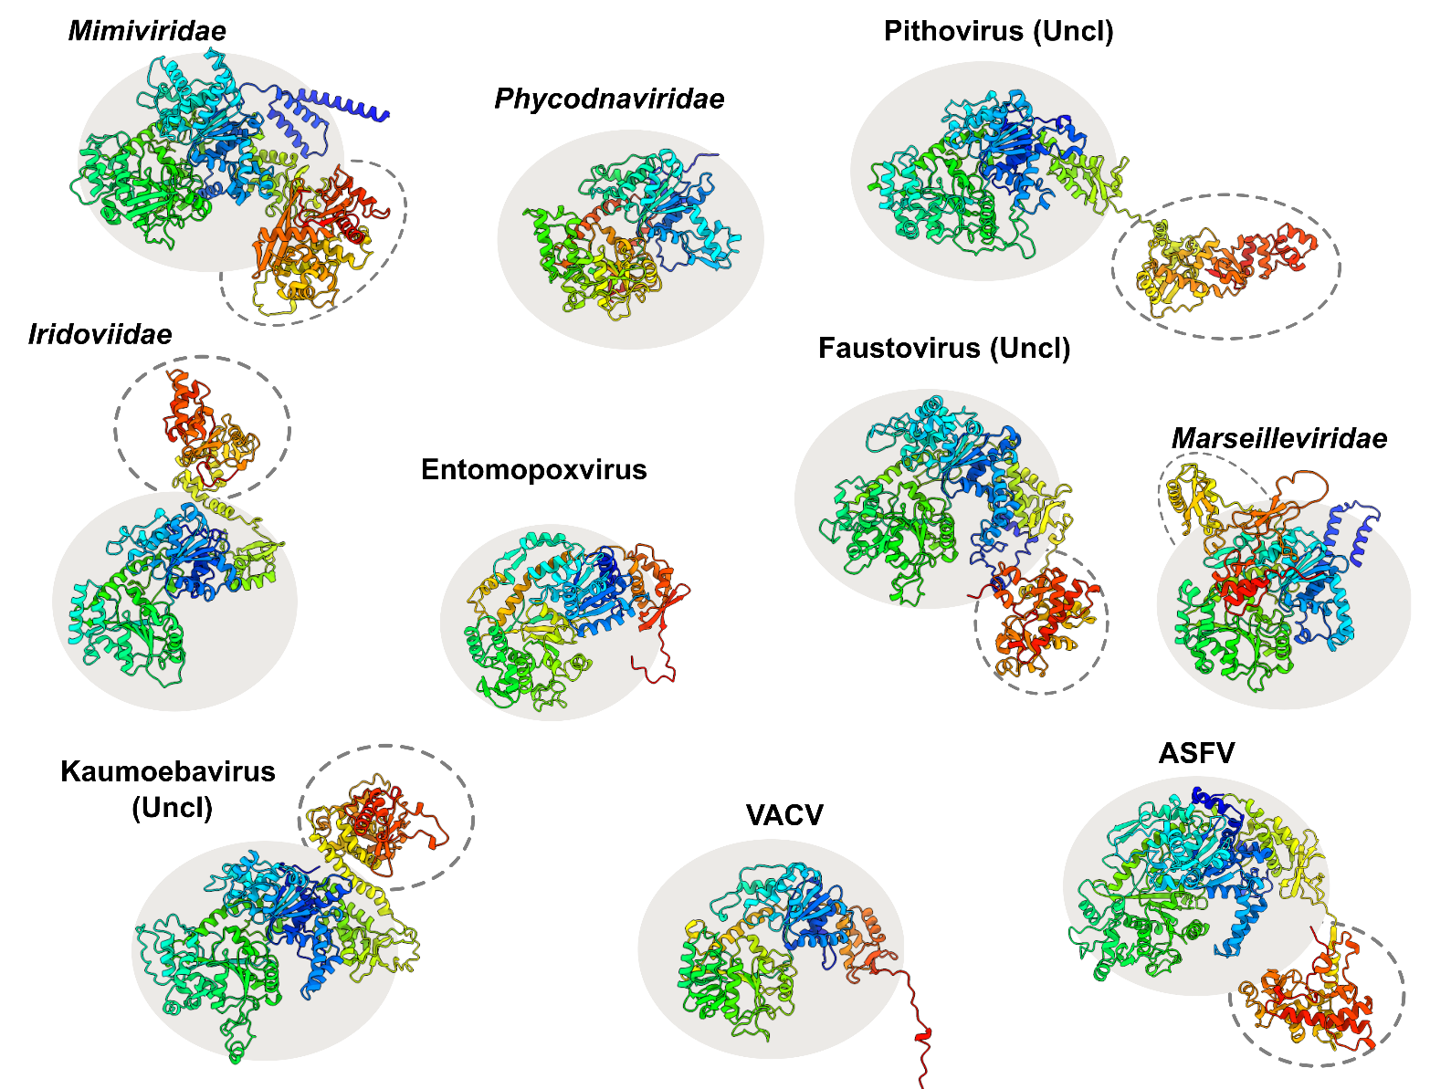
Supplementary Figure 9. AlphaFold models for NCLDV AETF2 homologs in different NCLDVs. The pdb files are from BFVD ² of the closest FoldSeek ³ hits to our AlphaFold3-predicted structure of AETF2 (ASFV in figure), with representatives from a range of NCLDVs (see TABLE for the closest 30 BFVD matches). Structures are shown in ribbon diagram form with rainbow colouring from N- to C-terminus. VACV is the VETFs structure from pdb: 7AMV Grey circles indicate the helicase lobes shared between structures and dotted grey lines indicate additional C-terminal domains.

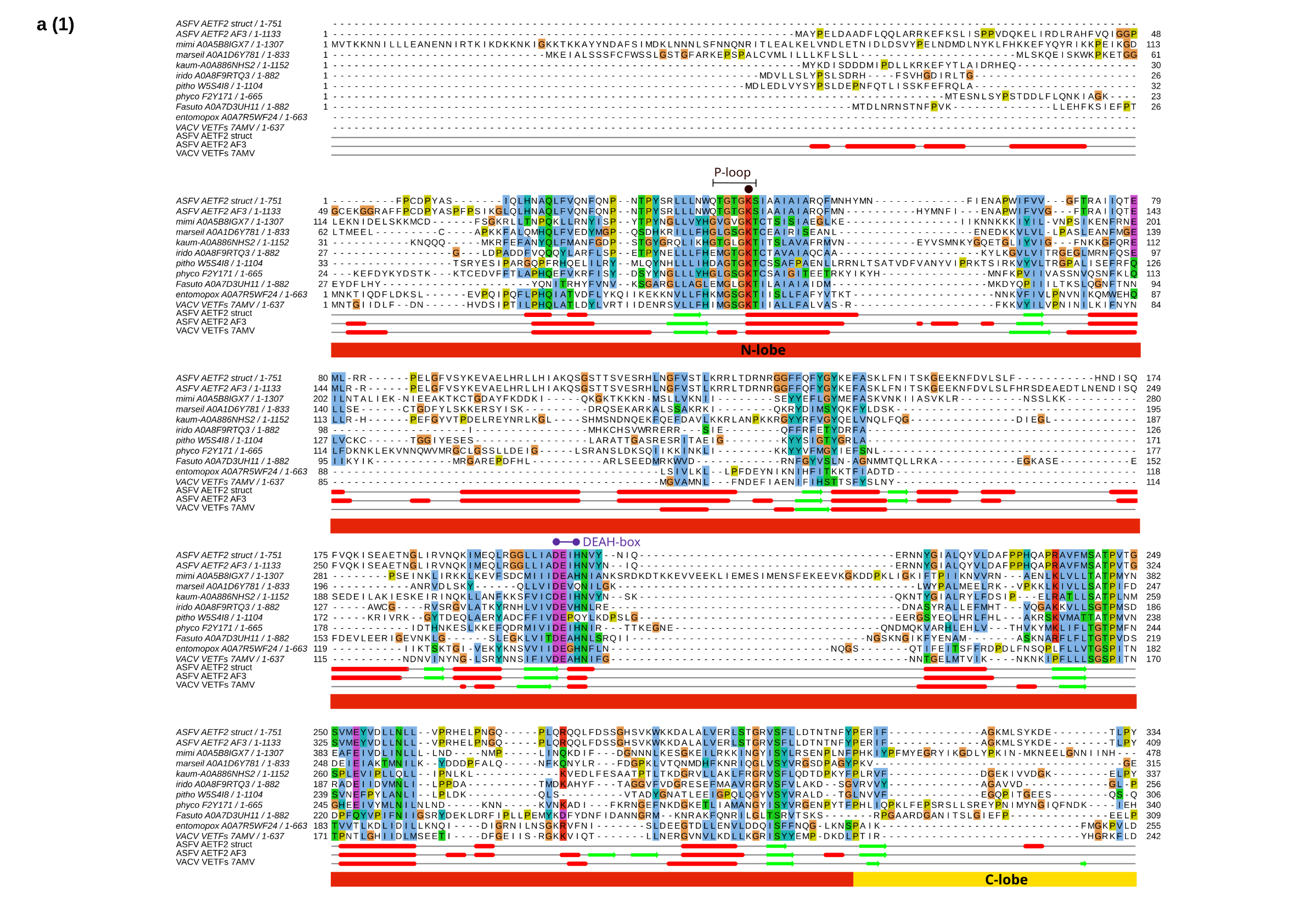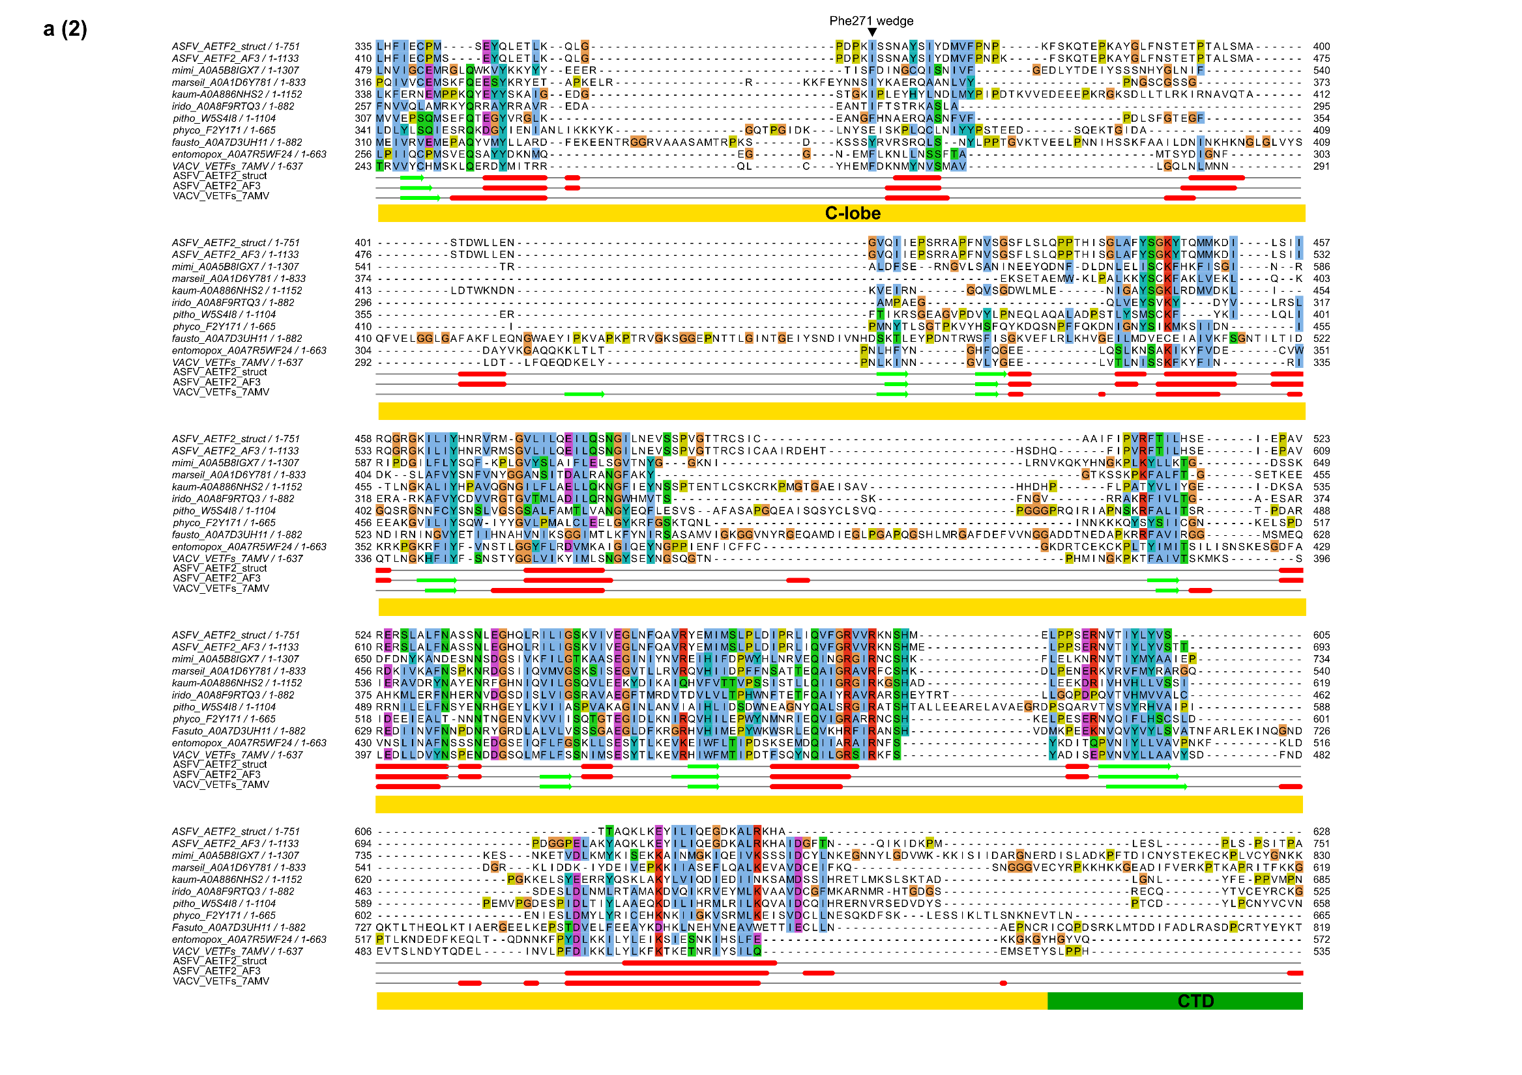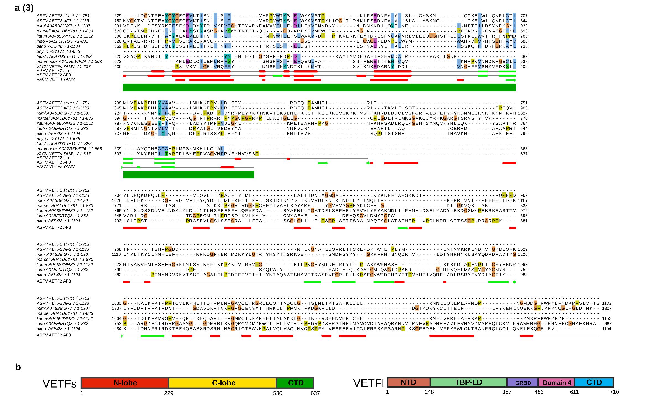
Supplementary Figure 10. (a) Structure-based sequence alignment performed with Foldmason ⁴ on pdb files from Supplementary Fig. 8. Beneath the alignment, the secondary structure from the cryo-EM structure ⁵ of the VETFs (pdb: 7amv, chain W) is shown. (b) Diagram of domain layout of VETFs and VETFl subunits is shown.
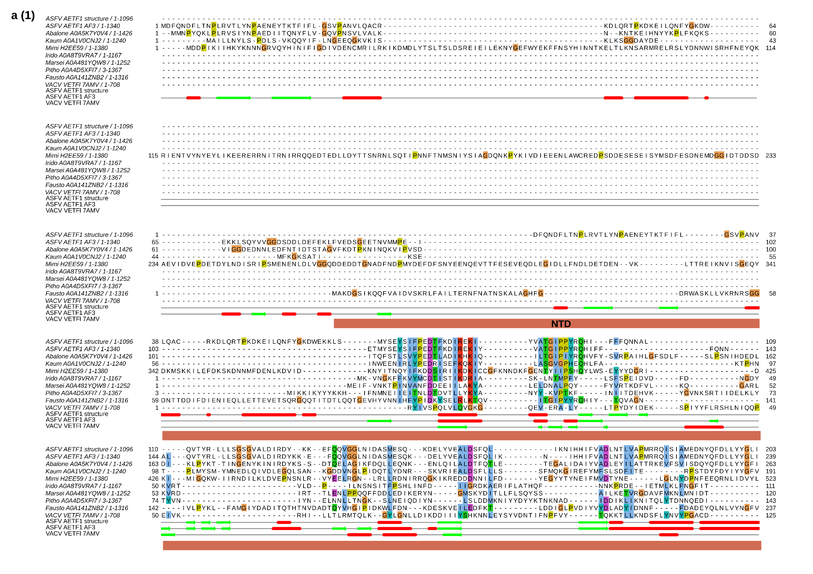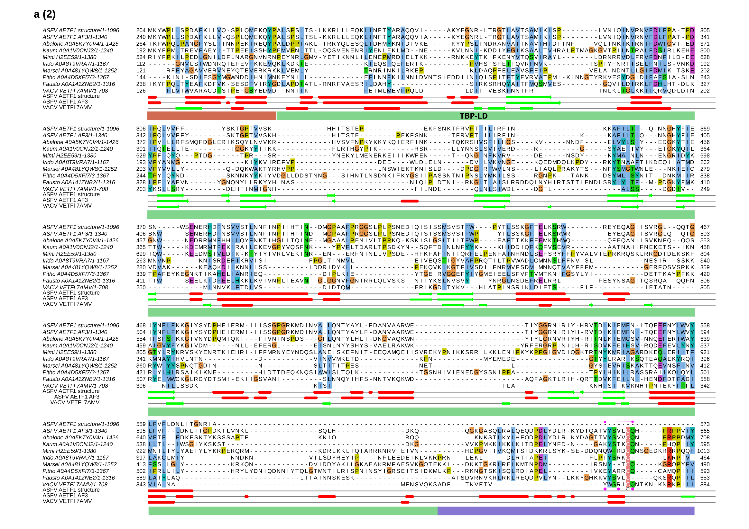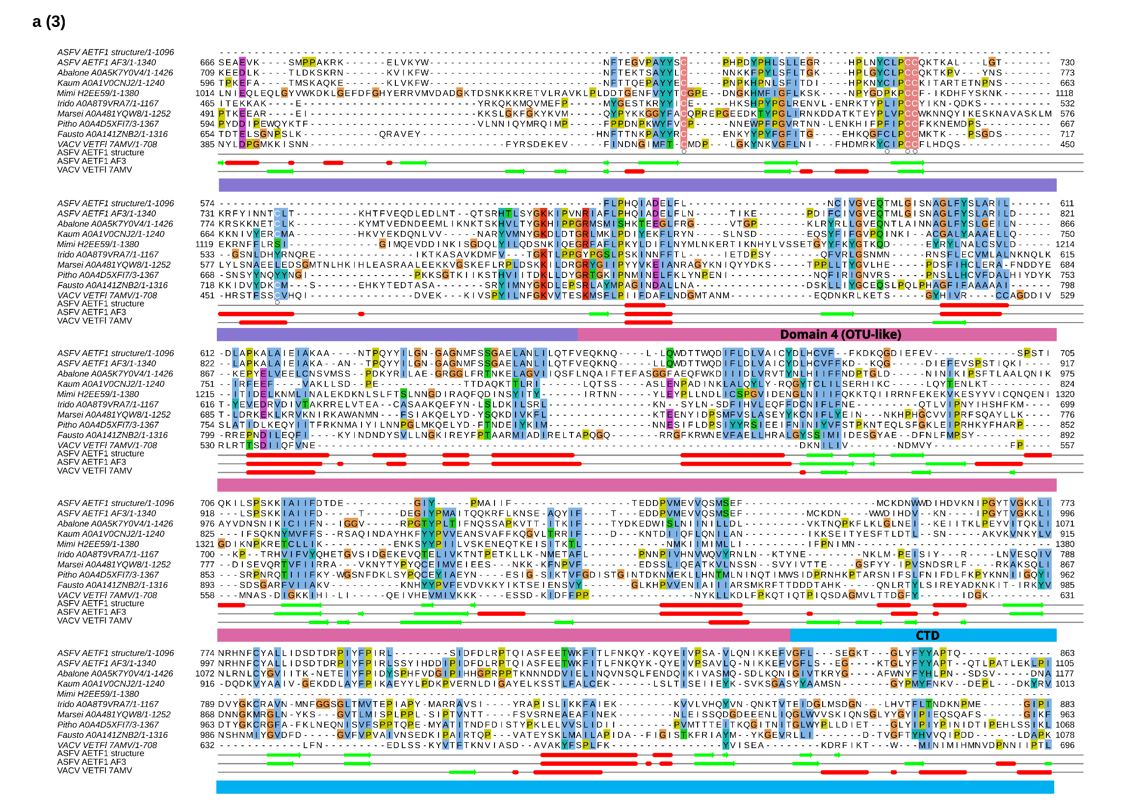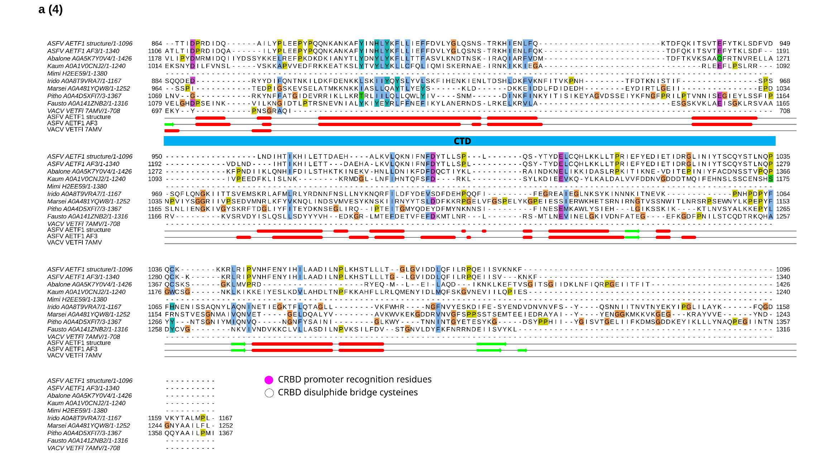
Supplementary Figure 11. (a) Structure-based sequence alignment performed with Foldmason on pdb files from BFVD of the closest FoldSeek hits to our AETF1 structure in Supplementary Fig. 9, with representatives from each type of NCLDV. Beneath the alignment, the secondary structure from the cryo-EM structure of the VETFl (pdb: 7amv, chain K) is shown. Key CRBD residues are shown as circles in pink (reader residues involved in promoter recognition) and white (disulphide bond forming cysteines).

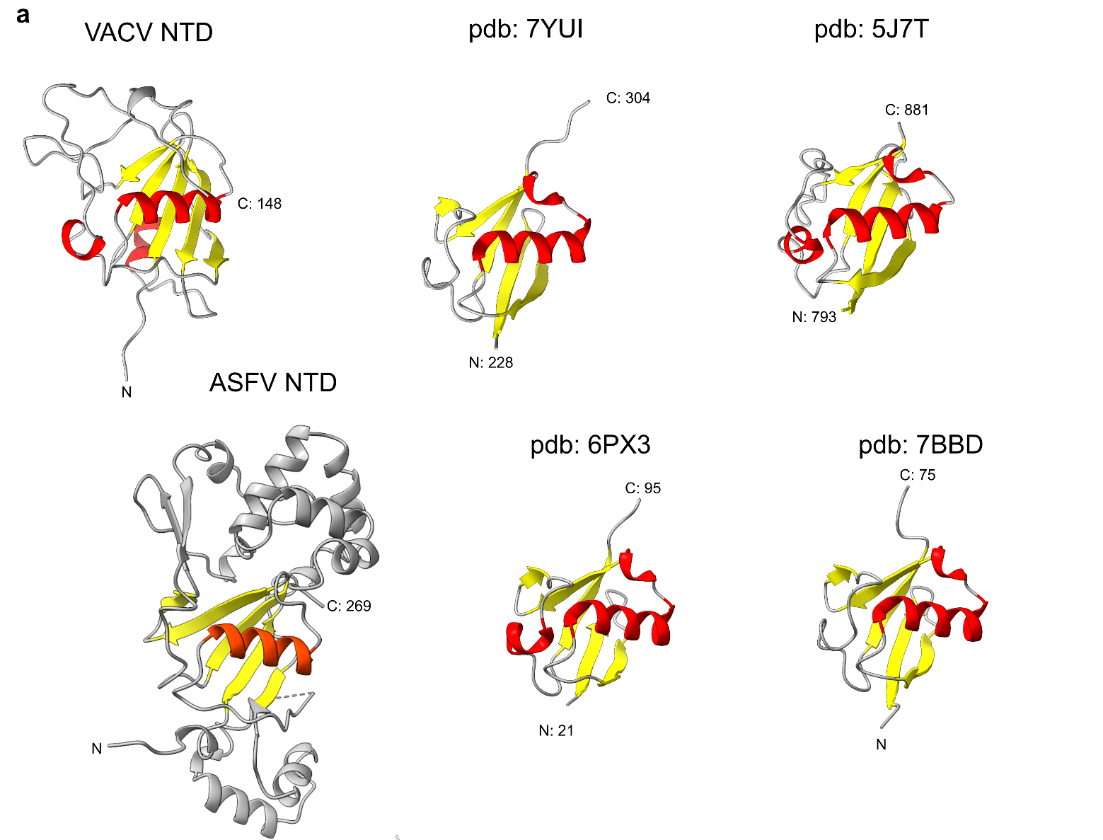
Supplementary Figure 12. The Ubi-like fold of the VETFs and AETF1 NTD. (a) VETFs NTD is shown with the secondary structure of the Ubi-like fold coloured. DALI searches of the NTDs returned predominantly Ub-fold containing matching structures and two examples are shown for each. To the right of VETFs NTD are Polyubiquitin-C (pdb: 7YUI, Z-score 5.8, RMSD: 2.7) and Ubiquitin carboxyl-terminal hydrolase 7 (pdb: 7BBD, Z-score 5.6, RMSD: 2.6). AETF1 NTD with the Ub-like fold in Ubiquitin-60S ribosomal protein L40,Histone H2A (pdb: 6PX3, Z-score 7.8, RMSD: 9.8) and Polyubiquitin-B,E3 ubiquitin-protein ligase TRIM21 (pdb: 7BBD, Z-score 7.2, RMSD: 2.9).
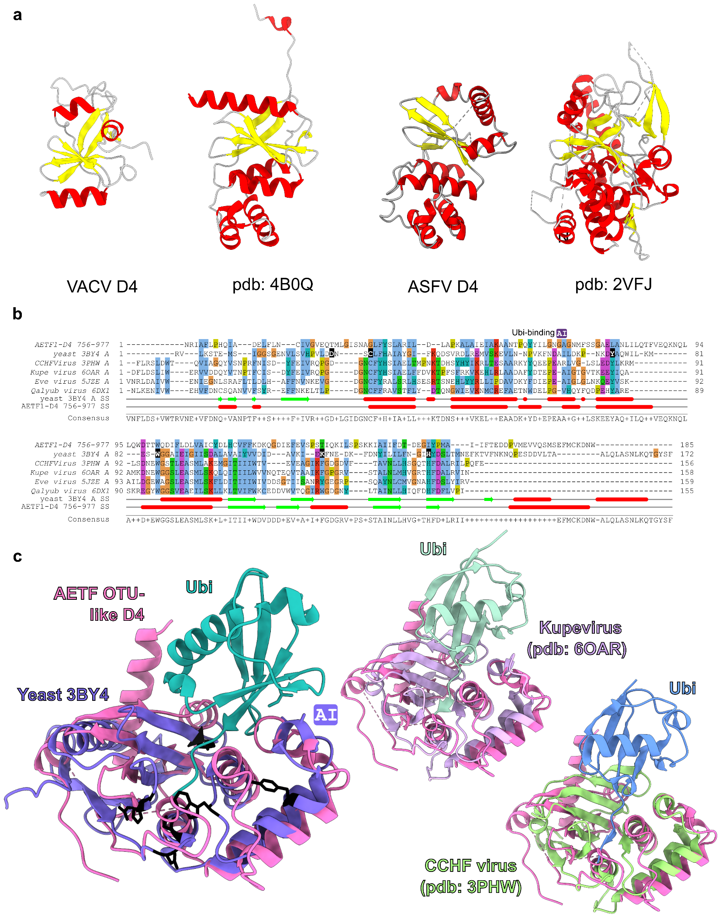
Supplementary Figure 13. The Ovarian Tumour (OTU)-like Domain 4. (a) VETFl Domain 4 and its structural homolog found via FoldSeek search: OTUD2 OTU domain (pdb: 4B0Q, Seq id: 10.8 , E-value: 2.66e-1, TM-Score: 0.36969, RMSD: 6). (b) AETF1 Domain 4 and its structural homolog A20 Ovarian Tumour (OTU) domain (pdb: 2VJF, Seq id: 11.2, E-value: 5.22e-1, TM-score: 0.47112, RMSD: 7.43). (b) FoldMason structure-based sequence alignment of AETF1 OTU-like D4 and significant hits with FoldSeek search including from yeast (pdb: 3BYU)⁶ and examples of OTU domains in other viruses. Highlighted in black are essential residue for activity in the yeast deubiquitinase. (c) Structurally aligned OTU domain examples with yeast catalytically important residues shown in black.
Protein Family | Accession | # Peptide seqs | Details
1 | BMS211207.01 | 8500 | A7_Q65177
2 | BMS211207.02 | 2520 | D6_Q89525
3 | BMS230217.18 | 449 | Greig CLTC, Clathrin heavy chain
4 | BMS241111.01 | 346 | Trypsin [Sus scrofa]
5 | BMS251103.02 | 266 | C38196
6 | BMS049610| | 257 | Ubiquitin [Spodoptera frugiperda]
7 | BMS049251 | 170 | alpha-tubulinTN [Trichoplusia ni]
8 | BMS049252 | 84 | beta-tubulinSF [Spodoptera frugiperda]
9 | BMS049358 | 73 | RNAP_polymerase_beta_prime_subunit [E coli]
10 | SSO3254 | 50 | 480 aa DE: DNA-directed RNA polymerase subunit B''
Supplementary Table 7. The top 10 most abundant and significant protein family hits (p <0.05) for peptide sequences including specific search sequences of A7_Q65177, D6_Q89525, and Spodoptera frugiperda ubiquitin.

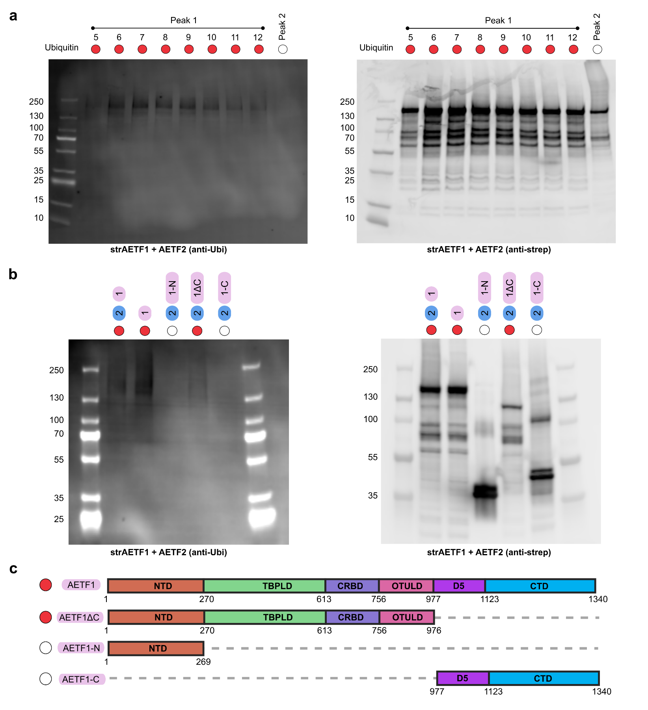
Supplementary Figure 14. Assessing ubiquitination of AETF1 following gel filtration, and strep-pulldown of truncation variants. (a) Samples from elution fractions of strepAETF1-AETF2 gel filtration (numbered), Peak 2 consisted of fractions 17-18 pooled. Samples were run on SDS-PAGE and subjected to western blot with anti-Ubiquitin AlexaFluor488 conjugate antibody. And then with anti-strep AlexaFluor659 antibody. (b) The truncation variants from Supplementary Figure 13 were subjected to the same SDS-PAGE and western blotting protocol as in (a). (c) Schematic summary of AETF1 variants which were ubiquitinated during insect cell expression.

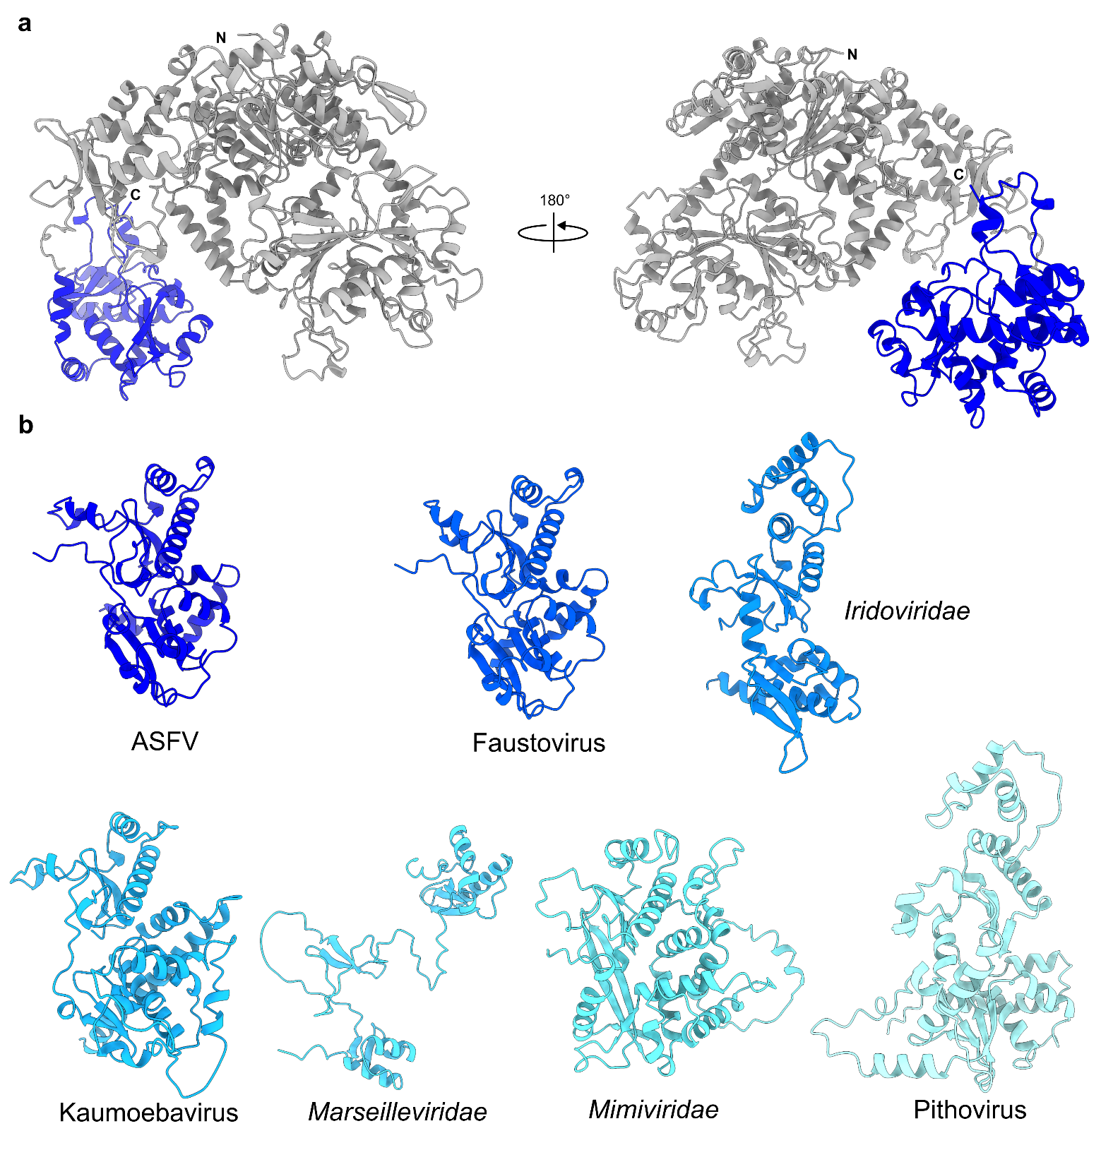
Supplementary Figure 15. Conservation of the CTDb domain. (a) AlphaFold3-predicted structure of AETF2 with CTDb coloured dark blue. (b) Isolated additional C-terminal domains in NCLDVs compared to that of ASFV.
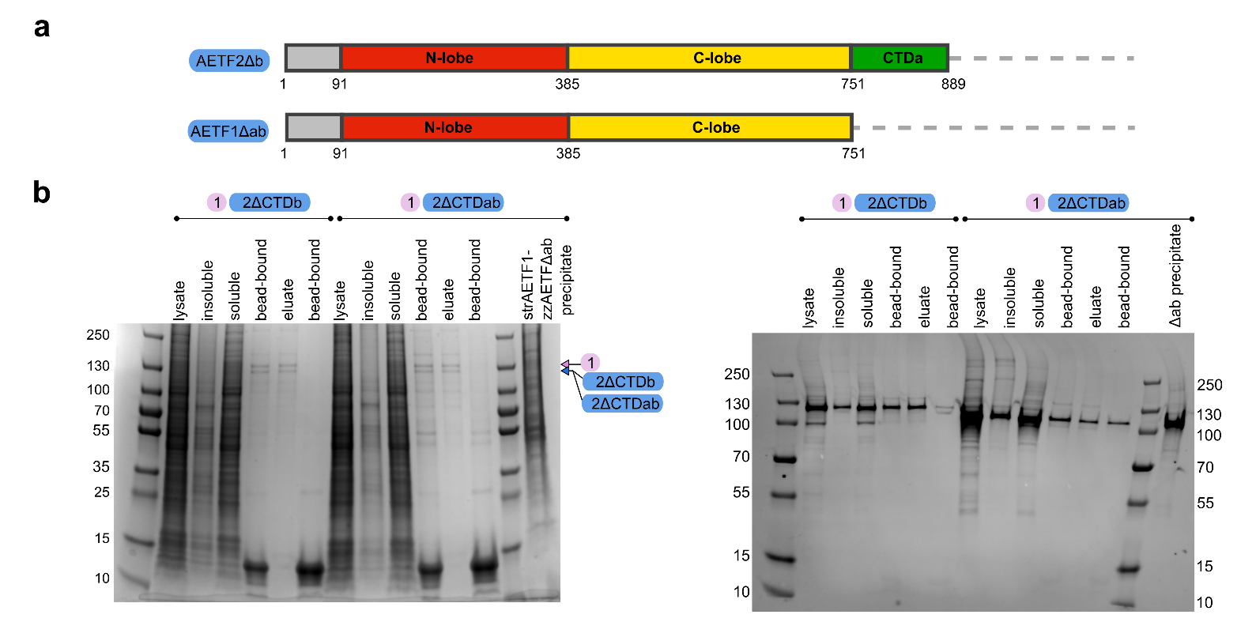
Supplementary Figure 16. AETF2 truncation variants. (a) Schematic diagram of AETF2 CTD truncation variants. (b) On the left, SDS-PAGE showing Strep-Tactin XT purifications via the twin-strep tag on AETF1. Precipitation was observed with the AETF1-AETF2ΔCTDab variant during incubation of the soluble lysate with the Strep-Tactin XT resin. On the right, is the same samples ran in parallel to the SDS-PAGE, except subjected to western blot via a rabbit anti-AETF2 peptide antibody (primary) and a donkey anti-rabbit DyLight 680 nm secondary antibody.

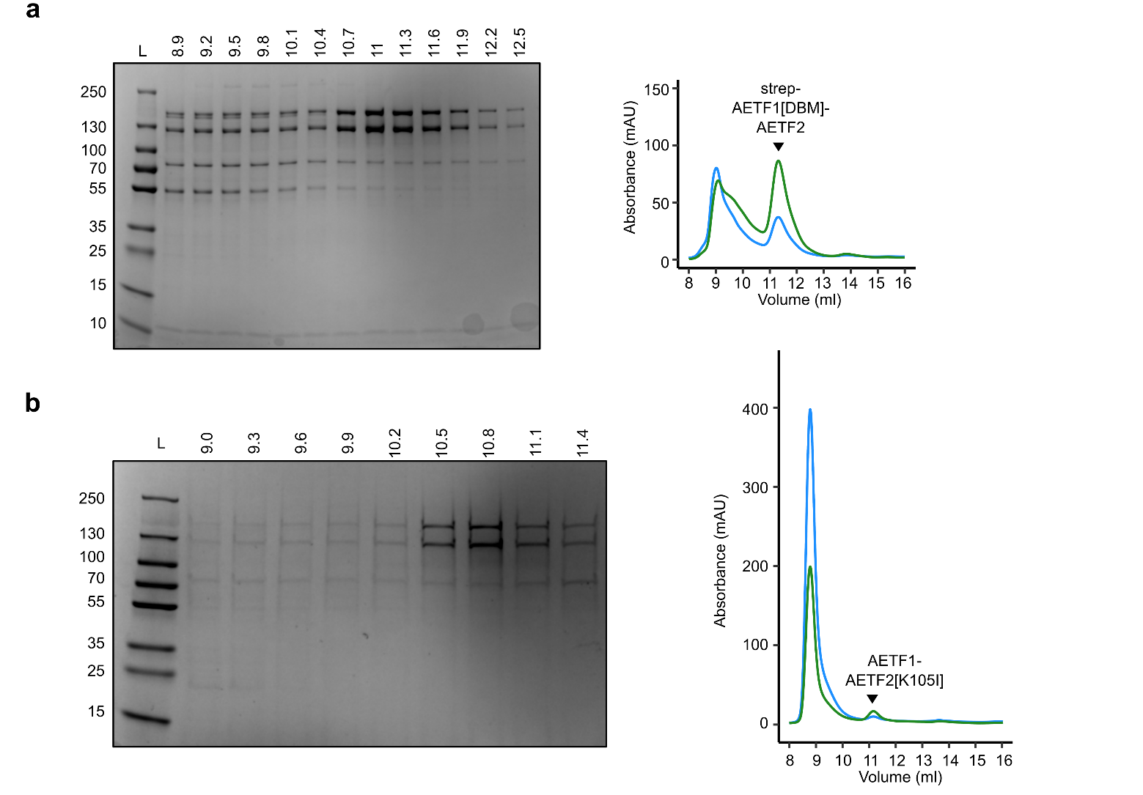
Supplementary Figure 17. Size exclusion chromatography of mutant AETF variants. (a) SDS-PAGE of gel filtration elution fractions and chromatogram following StrepTactin-XT purification of strepAETF1[DBM]-AETF2. (b) SDS-PAGE of gel filtration elution fractions and chromatogram following zz-tag purification of AETF1-AETF2[K105I].

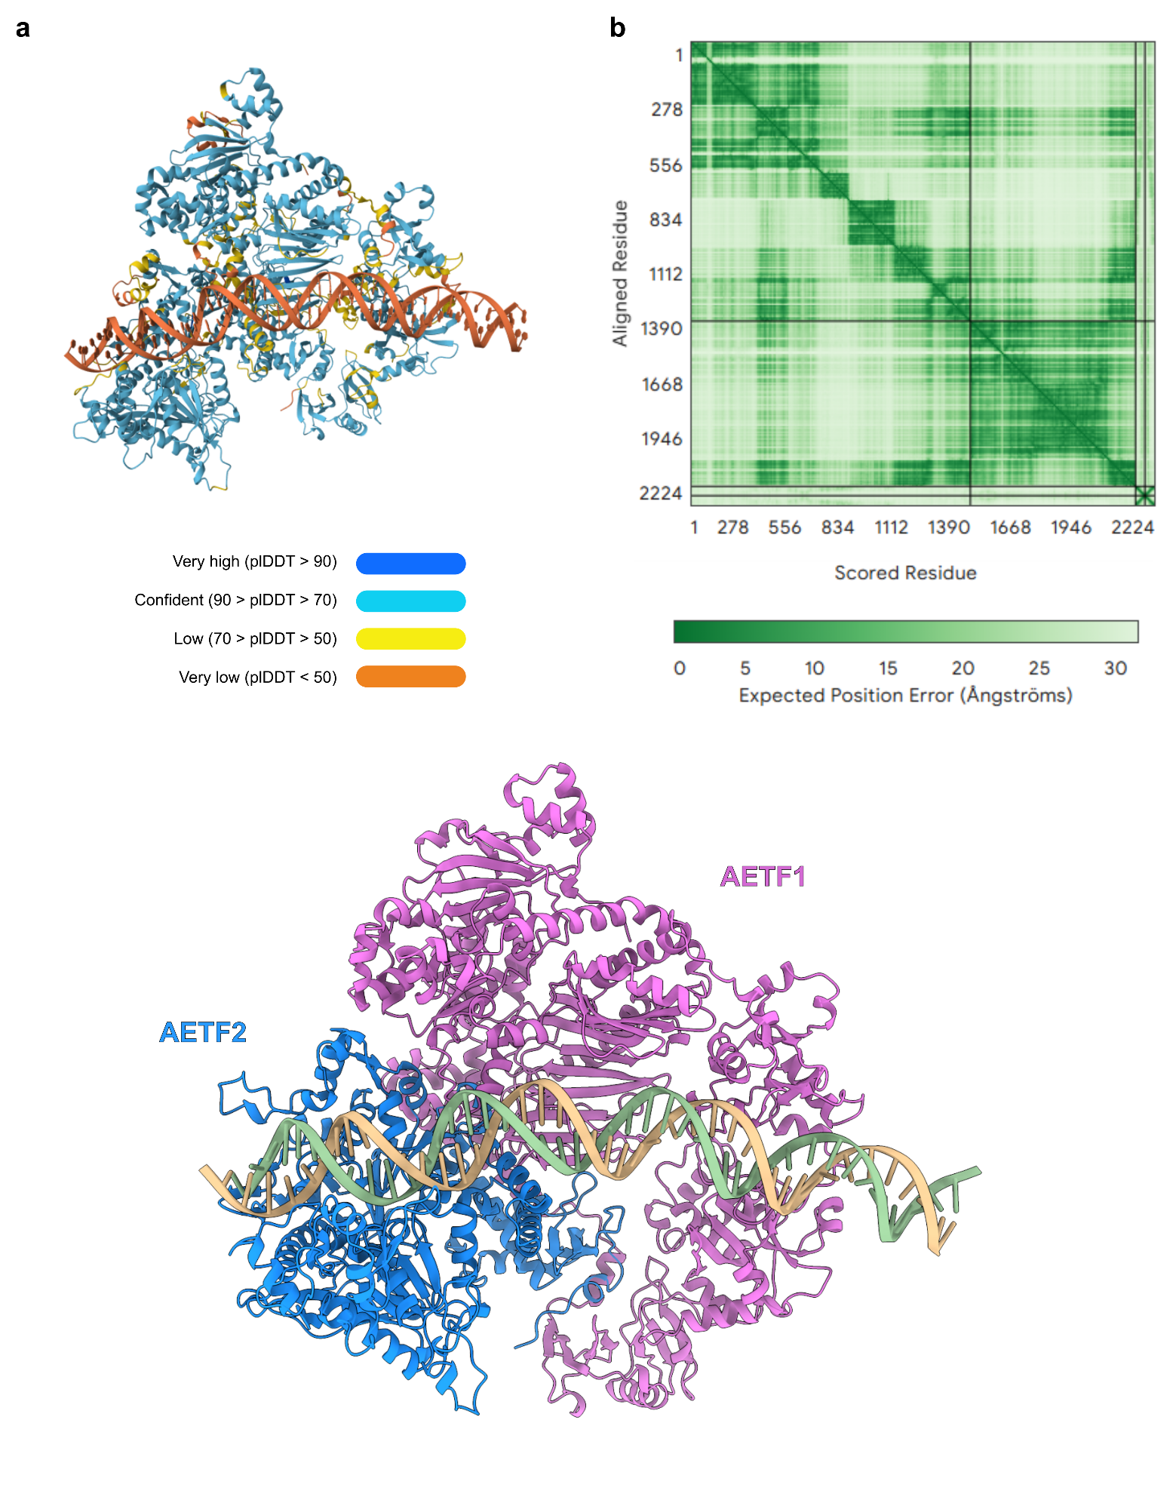
Supplementary Figure 18. Modelling AETF1/2 dsDNA binding. Alphafold3 model of AETF1, AETF2 and A151R dsDNA sequence used in EMSAs.

Name | 5’ to 3’ sequence
AF647 1 A151R F | TAAGGAAAACAAATTTGAATAAAAAAATAATTGTTATGATGGCGTTGTTACACAA
AF647 1 I73R F | TTTTTTTTTTAAAATTTAATACAAAAAAAAGAAGTATAGACTCTTCTTCTAGTCC
AF647 2 A104R F | ATTTAATATTTTTATAAAAAAATATTTAGTTTTTTATACAAGAATGTCGACAAAA
AF647 2 B646L F | ATTTAATAAAAACAATAAATTATTTTTATAACATTATATATGGCATCAGGAGGAG
AF647 3 B119L F | AAAATTCTCCATGGAAAAAAAATATTTACCTCTATATGGAATGAGATTTTTCAAA
AF647 3 I196L F | CCTAATTATACTTATTTTTTTTTTCTGCTCATATTATAACAGGATGTTGTTTAGG
AF647 4 A179L F | CAATTGTGATAACATTGAAACCTAAATAAAAAAATATAGGGTGCCGCTATGGAGG
AF647 4 A238L F | AAGGACATTAAAAATTAAAGGAGTAAAATCATATAGTGGAGTAGGGGCGACATTC
AF647 5 MGF 360-21R F | AGGCCTGACCACTAAAACTTAAACGATTTTGTAAAAAAAAATGTCTACTCCACTT
AF647 5 MGF 505-5R F | AATCTGAGTAAAATTTATTTTTTTGATCAGAGTAAGAAAATGTTCTCCCTCCAGG
1 A151R R | TTGTGTAACAACGCCATCATAACAATTATTTTTTTATTCAAATTTGTTTTCCTTA
1 I73R R | GGACTAGAAGAAGAGTCTATACTTCTTTTTTTTGTATTAAATTTTAAAAAAAAAA
2 A104R R | TTTTGTCGACATTCTTGTATAAAAAACTAAATATTTTTTTATAAAAATATTAAAT
2 B646L R | CTCCTCCTGATGCCATATATAATGTTATAAAAATAATTTATTGTTTTTATTAAAT
3 B119L R | TTTGAAAAATCTCATTCCATATAGAGGTAAATATTTTTTTTCCATGGAGAATTTT
3 I196L R | CCTAAACAACATCCTGTTATAATATGAGCAGAAAAAAAAAATAAGTATAATTAGG
4 A179L R | CCTCCATAGCGGCACCCTATATTTTTTTATTTAGGTTTCAATGTTATCACAATTG
4 A238L R | GAATGTCGCCCCTACTCCACTATATGATTTTACTCCTTTAATTTTTAATGTCCTT
5 MGF 360-21R R | AAGTGGAGTAGACATTTTTTTTTACAAAATCGTTTAAGTTTTAGTGGTCAGGCCT
5 MGF 505-5R R | CCTGGAGGGAGAACATTTTCTTACTCTGATCAAAAAAATAAATTTTACTCAGATT
A151R+cEPM F | TAAGGAAAATAAAATTGAAATATTTTTTAATTGTTATGATGGCGTTGTTACACAA
A151R+cEPM R | TTGTGTAACAACGCCATCATAACAATTAAAAAATATTTCAATTTTATTTTCCTTA
Core cEPM F | AATAAAATTGAAATATTTTT
Core cEPM R | AAAAATATTTCAATTTTATT
A104R_with_-12+1_from_B646L_F | ATTTAATATTTTTATAAAAAAATTTTTATAACATTATACAAGAATGTCGACAAAA
A104R_with_-16-29_from_B646L_F | ATTTAATAAAAACAATAAATAATATTTAGTTTTTTATACAAGAATGTCGACAAAA
A104R_with_-12+1_from_B646L_R | TTTTGTCGACATTCTTGTATAATGTTATAAAAATTTTTTTATAAAAATATTAAAT
A104R_with_-16-29_from_B646L_R | TTTTGTCGACATTCTTGTATAAAAAACTAAATATTATTTATTGTTTTTATTAAAT
Supplementary Table 8. DNA sequences used for EMSAs with AETF. Non-template sequences are shown for oligos which were annealed to the reverse complement to form dsDNA. They are named with the gene name, and the promoter cluster.

 | AETF1/2, main map.  31GD / EMD-58394 | Local Refinement of inflexible core.  EMD-58445 | AETF1/2 map from 3DFlex.  EMD-58446
Data collection and processing
Magnification | 105,000
Voltage (kV) | 300
Electron exposure (e–/Å²) | 50
Defocus range (μm) | 1.5 - 2.7
Pixel size (Å) | 0.828
Symmetry imposed | C1
Initial particle images (no.) | 5,578,385
Final particle images (no.) | 72,801 |  | 53,148
Map resolution (Å)  FSC threshold | 4.12  0.143 | 3.62  0.143 | 3.49  ª
Map resolution range (Å) | ^{b} | ^{b} | ^{b}
Refinement
Initial model used (PDB code) | N/A | - | -
Model resolution (Å)  FSC threshold | 3.86  0.143 | - | -
Model resolution range (Å)  Unmasked FSC (model) = 0/0.143/0.5 | 3.79, 3.92, 4.41 | - | -
Map sharpening B factor (Å²) | -136.4 | -133.1 | -66.7
Model composition  Non-hydrogen atoms  Protein residues  Ligands | 15001  1845  - | - | -
B factors (Å²)  Protein  Ligand | 194.09  - | - | -
R.m.s. deviations  Bond lengths (Å)  Bond angles (°) | 0.004 (0)  0.545 (0) | - | -
Validation  MolProbity score  Clashscore  Poor rotamers (%) | 1.79  12.79  0 | - | -
Ramachandran plot  Favored (%)  Allowed (%)  Disallowed (%) | 97.02  2.98  0 | - | -
Supplementary Table 9. Cryo-EM data collection, refinement and validation statistics. ª 3D Flex reconstruction outputs GSFSC resolution reported here calculated via Flex Reconstruction FSC. ^{b} The local resolution evaluation was carried out in cryoSPARC which does not provide this information.

1. Punjani, A, Rubinstein, JL, Fleet, DJ , Brubaker, MA. cryoSPARC: algorithms for rapid unsupervised cryo-EM structure determination. Nat Methods. (2017) 14:290–296. doi: 10.1038/nmeth.4169.
2. Kim, RS, Levy Karin, E, Mirdita, M, Chikhi, R , Steinegger, M. BFVD—a large repository of predicted viral protein structures. Nucleic Acids Research. (2025) 53:doi: 10.1093/nar/gkae1119.
3. van Kempen, M, Kim, SS, Tumescheit, C, Mirdita, M, Lee, J, Gilchrist, CLM, Soding, J , Steinegger, M. Fast and accurate protein structure search with Foldseek. Nat Biotechnol. (2024) 42:243–246. doi: 10.1038/s41587-023-01773-0.
4. Gilchrist, CLM, Mirdita, M , Steinegger, M. Multiple protein structure alignment at scale with FoldMason. Science. (2026) 391:485–488. doi: 10.1126/science.ads6733.
5. Grimm, C, Bartuli, J, Boettcher, B, Szalay, AA , Fischer, U. Structural basis of the complete poxvirus transcription initiation process. Nat Struct Mol Biol. (2021) 28:779–788. doi: 10.1038/s41594-021-00655-w.
6. Messick, TE, Russell, NS, Iwata, AJ, Sarachan, KL, Shiekhattar, R, Shanks, JR, Reyes-Turcu, FE, Wilkinson, KD , Marmorstein, R. Structural basis for ubiquitin recognition by the Otu1 ovarian tumor domain protein. J Biol Chem. (2008) 283:11038–49. doi: 10.1074/jbc.M704398200.

