Supplementary material 1-Part 1:
Italics: p-value <0.1
Italics and bold: p-value<0.05
Letter: significant difference by depth and species, p-value < 0.05
Supplementary material 1-Part 2:
Italics: p-value <0.1
Italics and bold: p-value<0.05
Letter: significant difference by depth and species, p-value < 0.05
Supplementary material 1-Part 3:
Italics: p-value <0.1
Italics and bold: p-value<0.05
Letter: significant difference by depth and species, p-value < 0.05
Supplementary material 1-Part 4:
Italics: p-value <0.1
Italics and bold: p-value<0.05
Letter: significant difference by depth and species, p-value < 0.05
Supplementary material 2:
 |  |  |  |  | LOI (%)
 | Species |  |  |  | 2001 |  |  |  | 2019 |  |  |  | Δ 2019-2001
 |  |  |  |  | mean |  | sd |  | mean |  | sd |  | mean
 | CwS |  |  |  | 56.61 |  | 10.2 |  | 91.48 |  | 10.2 |  | 34.87
 | Beech |  |  | 61.02 |  |  | 11.02 |  | 84.24 |  | 2.68 |  | 23.22
 | Oak |  |  | 62.56 |  |  | 19.1 |  | 86.29 |  | 2.75 |  | 23.73
 | Douglas fir |  |  | 39.25 |  |  | 16.7 |  | 81.13 |  | 2.12 |  | 41.88
 | Nordamnn fir |  |  | 63.62 |  |  | 22.82 |  | 90.64 |  | 4.8 |  | 27.02
 | Laricio pine |  |  | 58.5 |  |  | 14.96 |  | 93.64 |  | 4.59 |  | 35.14
 | Norway spruce |  |  | 55.6 |  |  | 13.78 |  | 89.31 |  | 1.34 |  | 33.72

Supplementary material 3:
Allometric equations established for each plot: biomass = $a×⌀^{b}$with biomass in kg,$⌀ diameter$ of the tree in mm, a and b adjusted parameters for trunk with a diameter superior to 7 cm (wood and bark), each species and each element (Ca, Mg, K).
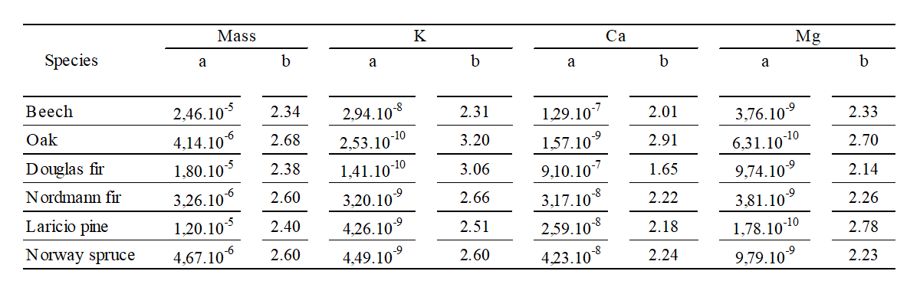

Supplementary material 4:
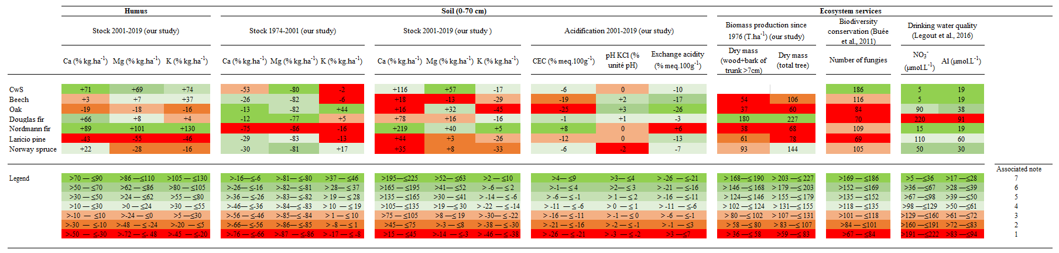

Supplementary material 5:

Italics: p-value <0.1
Italics and bold: p-value<0.05
Letter: significant difference by depth and species, p-value < 0.05

Supplementary material 6:
 |  | 1974 |  |  |  |  |  | 2001 |  |  |  |  |  | 2019
Species |  | Mg/Ca |  | Mg/K |  | Ca/K |  | Mg/Ca |  | Mg/K |  | Ca/K |  | Mg/Ca |  | Mg/K |  | Ca/K
CwS |  | 2.14 |  | 0.64 |  | 0.30 |  | 0.92 |  | 0.13 |  | 0.14 |  | 0.67 |  | 0.25 |  | 0.37
Beech |  |  |  |  |  |  |  | 0.52 |  | 0.12 |  | 0.24 |  | 0.38 |  | 0.15 |  | 0.39
Oak |  |  |  |  |  |  |  | 0.44 |  | 0.08 |  | 0.18 |  | 0.50 |  | 0.19 |  | 0.38
Douglas fir |  |  |  |  |  |  |  | 0.55 |  | 0.14 |  | 0.25 |  | 0.36 |  | 0.19 |  | 0.53
Nordmann fir |  |  |  |  |  |  |  | 1.17 |  | 0.10 |  | 0.09 |  | 0.51 |  | 0.14 |  | 0.27
Laricio pine |  |  |  |  |  |  |  | 0.52 |  | 0.13 |  | 0.24 |  | 0.37 |  | 0.18 |  | 0.47
Norway spruce |  |  |  |  |  |  |  | 0.58 |  | 0.10 |  | 0.18 |  | 0.46 |  | 0.17 |  | 0.36

