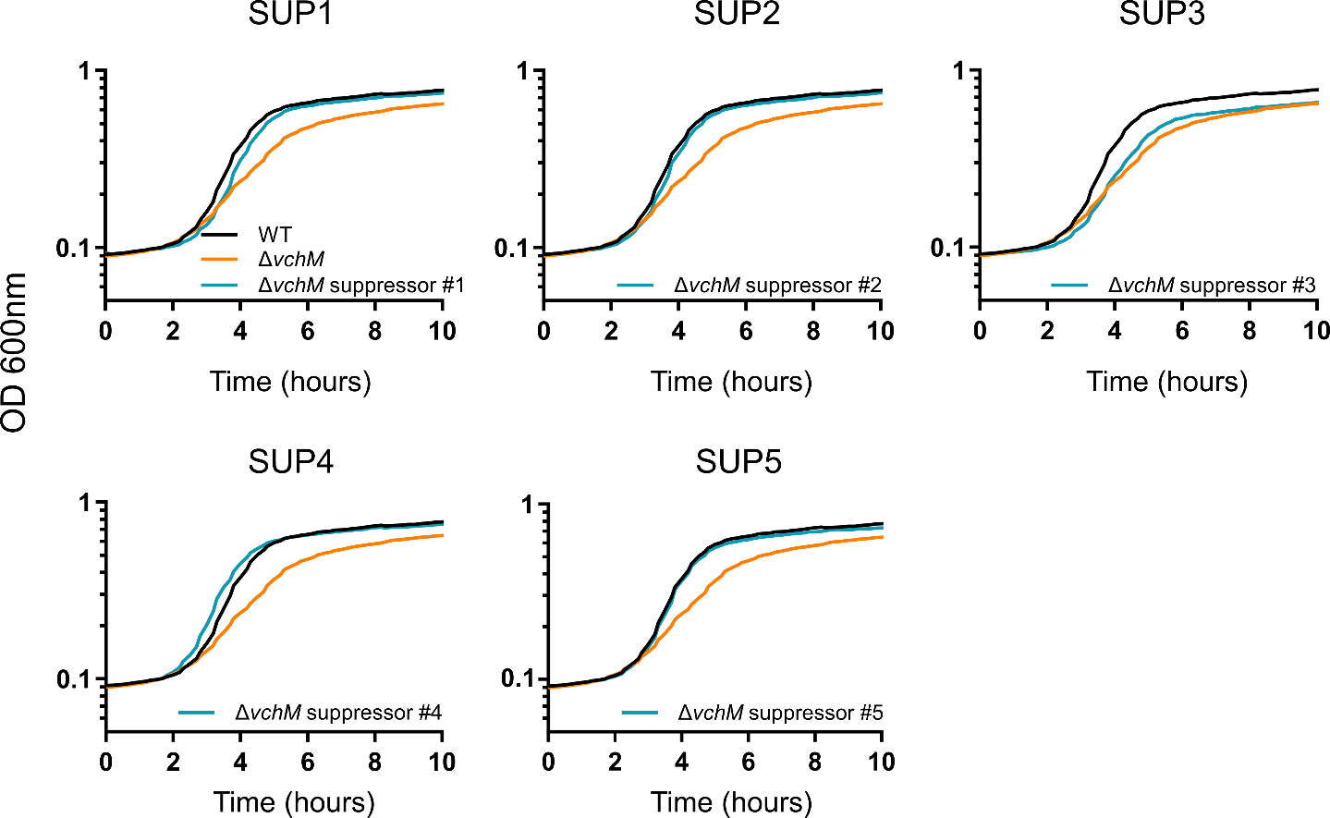
Supplementary figure 1

Supplementary figure 1. Growth curves of independently isolated ∆vchM suppressors.. Growth curves of the WT strain, the ∆vchM mutant, and five independently isolated ∆vchM suppressor strains grown in rich LB medium. Error bars indicate SD, n = 3.

Supplementary figure 2

Supplementary Figure 2. Predicted multimerization propensity of MenshenVc components. Heatmap showing the interface predicted template modeling (ipTM) scores obtained from AlphaFold3 predictions of homomultimeric assemblies containing two to six copies of each MenshenVc component. Higher ipTM values indicate greater confidence in multimer formation. Among the three proteins, VCA0200 displayed the highest predicted propensity to multimerize, with the strongest prediction obtained for a tetrameric assembly (ipTM = 0.85).

Supplementary figure 3

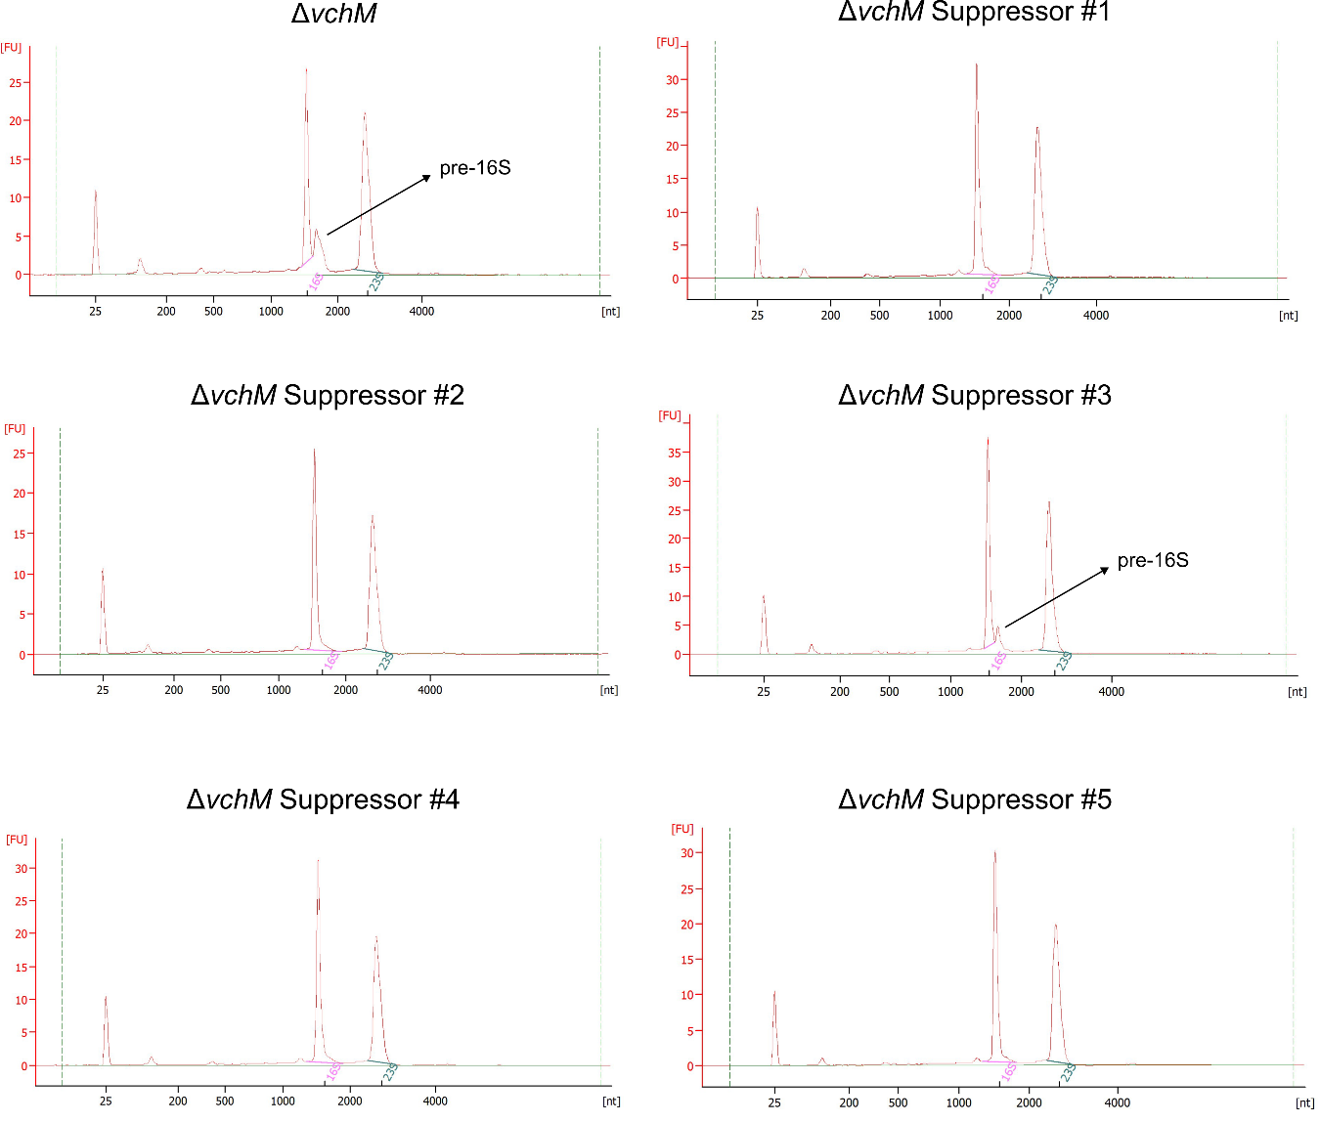

Supplementary Figure 3. rRNA processing profiles of independent ∆vchM suppressors. Bioanalyzer electropherograms showing rRNA profiles of the ΔvchM mutant and five independently isolated ∆vchM suppressors. The accumulation of the pre-16S rRNA species observed in the ∆vchM mutant is absent in suppressors #1, #2, #4, and #5, but persists in suppressor #3, consistent with its incomplete restoration of the ∆vchM growth phenotype.

Supplementary figure 4

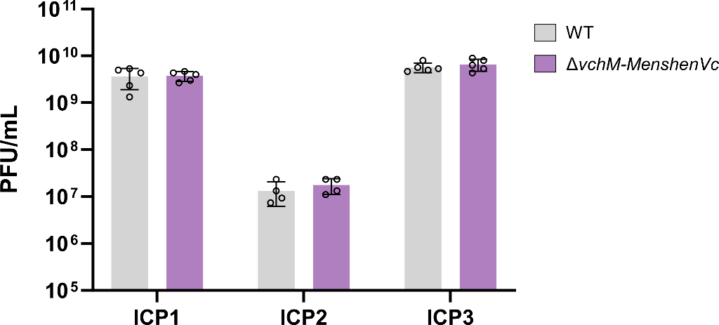

Supplementary Figure 4. Plaque-forming units (PFU/mL) of ICP1, ICP2, and ICP3 phage stocks titrated on either WT or ∆vchM-MenshenVc strains. Error bars indicate SD, n = 3.

Supplementary figure 5

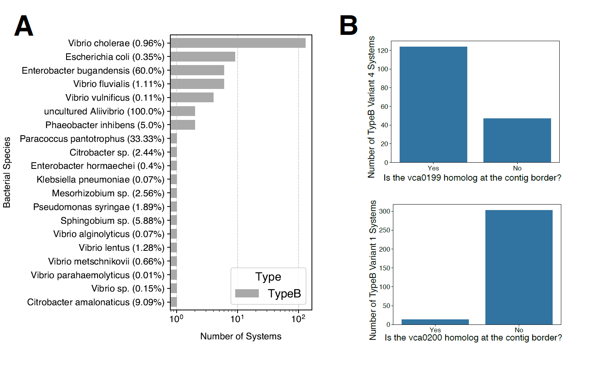
Supplementary Figure 5. Analysis of MenhenVc systems without a detected VchM. a) In the x-axis, the number of detected Type B variant 4 systems (lacking the VchM component) across different species (y-axis). The percentage in front of each species indicates the proportion of the total genomes of the species where at least one TypeB variant 4 system was detected. b) In top, quantification of Type B variant 4 systems where the component of the system immediately after the missing VchM (vca0199) is at the border (first or last gene) of the contig where the MenshenVc system was identified. For comparison, at the bottom is shown the quantification of Type B variant 1 systems where the component of the system immediately before the missing vca0201 (vca0200) is at the border (first or last gene) of the contig where the MenshenVc system was identified.

Supplementary figure 6
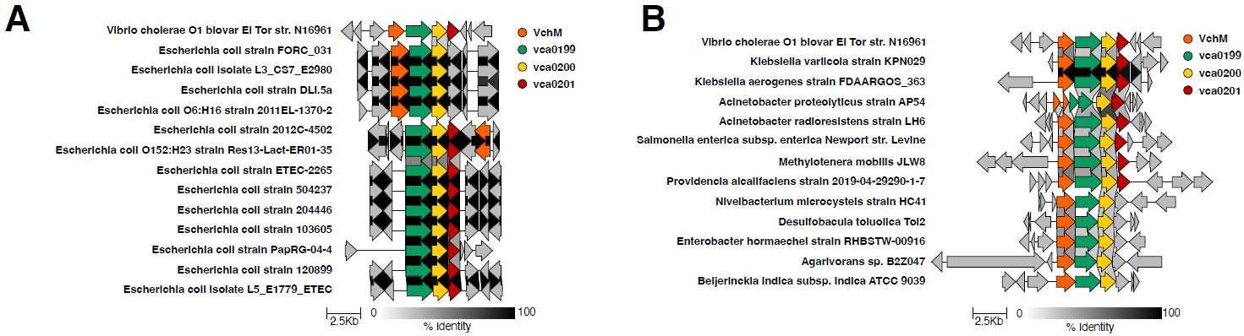

Supplementary Figure 6. Genomic comparisons of VchM+MenshenVc system homologs. a) Homologs of the systems in several E. coli genomes. b) Homologs of the systems in non-Vibrionaceae and non-E. coli genomes. In both a) and b), at the top, we include the VchM+MenshenVc system from the V. cholerae El Tor strain used in this study.

