Additional File 1
Early-life Poverty, Social Disadvantage and Adiposity
from Childhood to Young Adulthood

Karlijn J. Stekelenburg MD^{1,2}, Romy Gaillard MD PhD^{1,2},
Vincent W.V. Jaddoe MD PhD^{1,2},

¹ The Generation R Study Group, Erasmus MC, University Medical Center, Rotterdam, the Netherlands.
² Department of Pediatrics, Sophia’s Children’s Hospital, Erasmus MC, University Medical Center, Rotterdam, the Netherlands.

Corresponding author
Vincent W.V. Jaddoe, Department of Pediatrics, Erasmus University Medical Center, PO Box 2040, 3000 CA Rotterdam, the Netherlands (v.jaddoe@erasmusmc.nl) Telephone number: 0031 10 704 3405.

Content
Figure S1 Flowchart of the study population
Figure S2 Directed acyclic graph
Table S1 Non-response analysis of participants included and excluded from the study population
Table S2 Non-response analysis of participants included and excluded from the study population
Table S3 Parental pregnancy socioeconomic indicators and BMI SDS from childhood to adulthood
Table S4 Parental pregnancy socioeconomic indicators and overweight and obesity from childhood to adulthood
Table S5 Regression Coefficients for Age-Independent (Intercept) and Age-Dependent Differences (Interaction) of the Associations of SES indicators and BMI SDS Trajectories
Table S6 Parental pregnancy socioeconomic indicators and total fat mass SDS from childhood to adulthood
Table S7 Regression Coefficients for Age-Independent (Intercept) and Age-Dependent Differences (Interaction) of the Associations of SES indicators and total fat mass SDS Trajectories
Table S8 Parental pregnancy socioeconomic indicators and android/gynoid fat mass ratio SDS from childhood to adulthood
Table S9 Regression Coefficients for Age-Independent (Intercept) and Age-Dependent Differences (Interaction) of the Associations of SES indicators and android/gynoid fat mass ratio SDS Trajectories
Table S10 Parental pregnancy socioeconomic indicators, visceral fat mass SDS and liver fat fraction SDS from childhood to adulthood

Figure S1. Flowchart of the study population
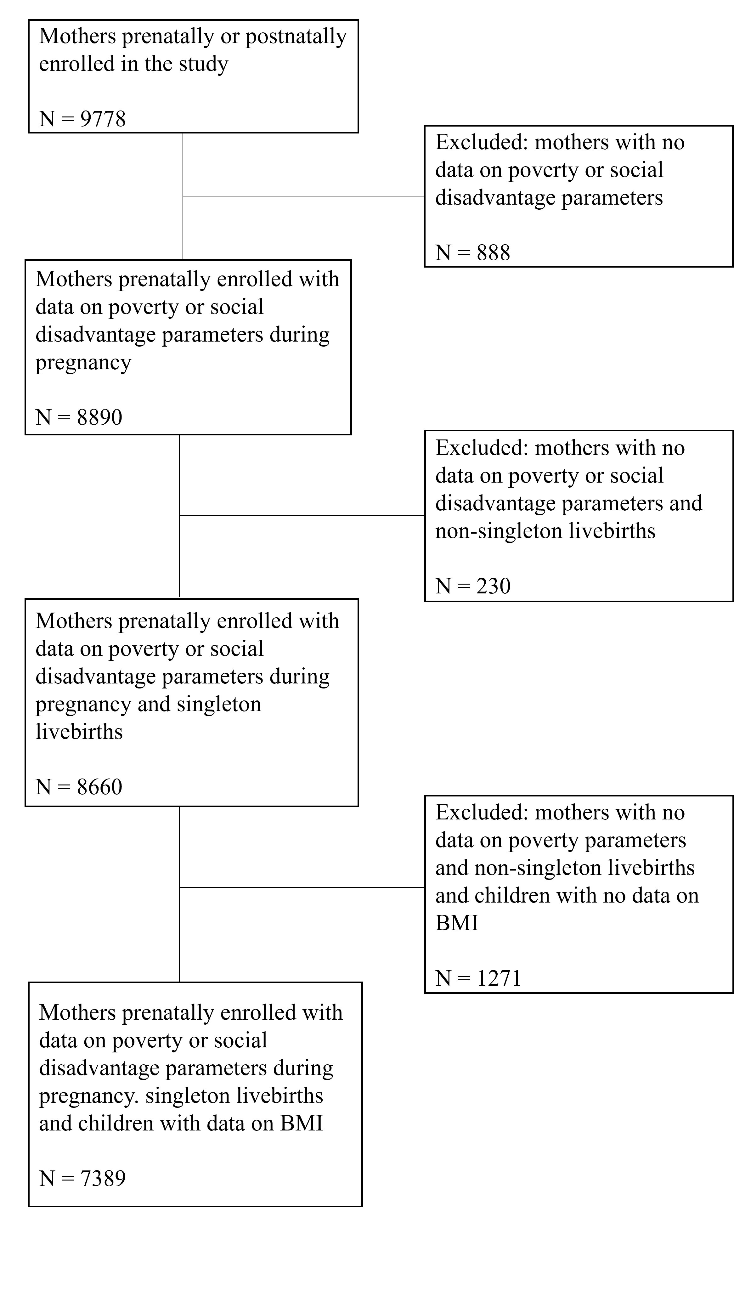

Figure S2. Directed acyclic graph

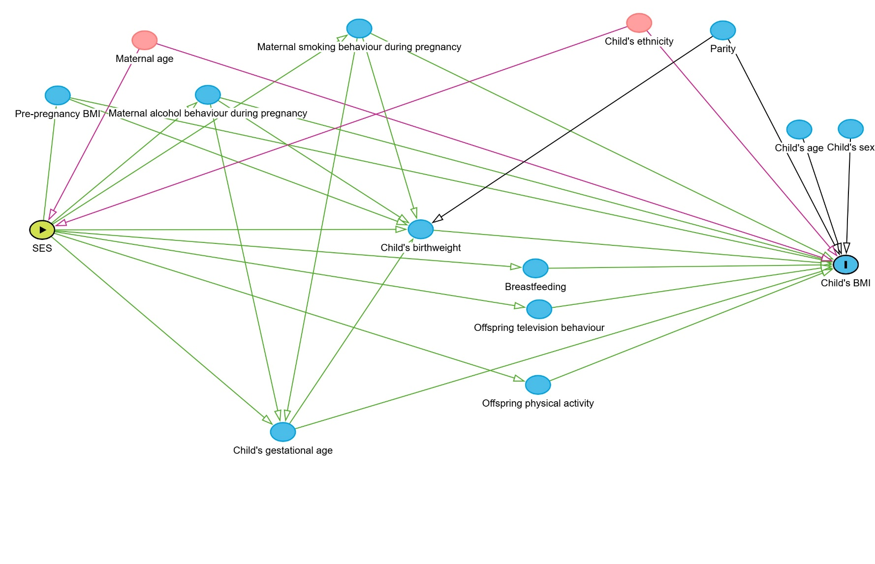

Table S1. Non-response analysis of participants included and excluded from the study population
Characteristic | Non-responders  N= 1271 | Responders  N= 7389 | P value
Maternal
Age at birth child in years, mean (± SD) | 28.22 (5.64) | 30.75 (5.13) | <0.001
Pre-pregnancy BMI (kg/m²), median (IQR) | 22.6 (20.7, 25.8) | 22.60 (20.8, 25.4) | 0.52
Parity, n(%)
Nulliparous | 662 (52.7) | 4097 (56.7) | 0.010
Multiparous | 593 (47.3) | 3129 (43.3) | 0.010
Ethnicity, n(%)
European | 532 (43.8) | 4491 (61.6) | <0.001
Non-European | 682 (56.2) | 2803 (38.4)
Smoking during pregnancy, n(%)
Continued smoking in pregnancy | 271 (23.0) | 1149 (17.1) | <0.001
Smoked until pregnancy was known | 90 (7.6) | 586 (8.7) | <0.001
Never smoked during pregnancy | 818 (69.4) | 4986 (74.2) | <0.001
Alcohol use during pregnancy, n(%)
Yes | 468 (40.1) | 3538 (54.7) | <0.001
No | 698 (59.9) | 2935 (45.3) | <0.001
Folic acid started preconceptionally, n(%)
Yes | 242 (25.6) | 2275 (42.3) | <0.001
No | 703 (74.4) | 3107 (57.7) | <0.001
Educational level
Low (primary or lower secondary, high school, associate degree) | 896 (74.5) | 3873 (54.3) | <0.001
High (higher education phase 1 or 2) | 306 (25.5) | 3254 (45.7) | <0.001
Household income, n(%)
Low (<1600 euros/month) | 388 (52.3) | 1642 (28.0) | <0.001
High (≥1600 euros/month) | 354 (47.7) | 4223 (72.0) | <0.001
Financial difficulties during pregnancy, n(%)
Yes | 204 (29.1) | 935 (17.2) | <0.001
No | 497 (70.9) | 4488 (82.8) | <0.001
Poverty
Yes | 148 (20.8) | 575 (10.2) | <0.001
No | 565 (79.2) | 5055 (89.8) | <0.001
Marital status
Married | 513 (43.0) | 3580 (50.8) | <0.001
Unmarried | 681 (57.0) | 3466 (49.2) | <0.001
Paternal
Age biological father in years, mean (± SD) | 31.19 (6.37) | 33.24 (5.92) | <0.001
Educational level during pregnancy, n(%)
Low (primary or lower secondary, high school, associate degree) | 337 (63.2) | 2202 (47.8) | <0.001
High (higher education phase 1 or 2) | 196 (36.8) | 2406 (52.2) | <0.001
Ethnicity, n(%)
European | 418 (42.5) | 4273 (61.7) | <0.001
Non-European | 565 (57.5) | 2647 (38.3) | <0.001
BMI (kg/m²), mean (± SD) | 25.4 (3.9) | 25.3 (3.4) | 0.33
Smoking 2 months before pregnancy, n(%)
Yes | 252 (47.4) | 1950 (43.6) | 0.11
No | 280 (52.6) | 2525 (56.4) | 0.11
Alcohol use 2 months before pregnancy, n(%)
Yes | 395 (74.0) | 3804 (84.3) | <0.001
No | 139 (26.0) | 709 (15.7) | <0.001

Table S2. Non-response analysis of participants included and excluded from the study population
At birth | Non-responders  N= 1271 | Responders  N= 7389 | P value
Gestational age at birth (weeks), median (IQR)
Preterm birth (<37 weeks), n(%) | 99 (8.4) | 355 (5.2) | <0.001
Term birth (≥37 weeks), n(%) | 1086 (91.6) | 6518 (94.8) | <0.001
Sex, n(%)
Male | 656 (51.7) | 3718 (50.3) | 0.40
Female | 614 (48.3) | 3671 (49.7) | 0.40
Birth weight (grams), mean (± SD) | 3337 (583) | 3429 (557) | <0.001
Low birthweight (<2500g), n(%) | 83 (6.8) | 329 (4.5) | 0.001
Macrosomia, (>4000g), n(%) | 139 (11.3) | 986 (13.4) | 0.001
Duration of breastfeeding (months), n(%)
<3 | 144 (56.2) | 1691 (41.1) | <0.001
≥3 | 112 (43.8) | 2423 (58.9) | <0.001
Ethnicity, n(%)
European | 600 (49.2) | 4723 (64.6) | <0.001
Non-European | 620 (50.8) | 2584 (35.4) | <0.001

Table S3. Parental pregnancy socioeconomic indicators and BMI SDS from childhood to adulthood
 |  | Total,  n | BMI SDS  (n=7389)
 |  | Total,  n | 2 years  EE (95% CI) | 6 years  EE (95% CI) | 10 years  EE (95% CI) | 14 years  EE (95% CI) | 18 years  EE (95% CI)
Poverty
Basic model | Yes | 575 | 0.04 (-0.07, 0.14) | 0.31 (0.22, 0.39) | 0.41 (0.31, 0.51) | 0.48 (0.37, 0.59) | 0.41 (0.27, 0.55)
 | No | 5055 | Reference | Reference | Reference | Reference | Reference
Confounder model | Yes | 575 | 0.00 (-0.11, 0.11) | 0.17 (0.09, 0.26) | 0.22 (0.12, 0.33) | 0.26 (0.14, 0.37) | 0.24 (0.10, 0.39)
 | No | 5055 | Reference | Reference | Reference | Reference | Reference
Fully adjusted model | Yes | 575 | 0.01 (-0.09, 0.12) | 0.13 (0.04, 0.21) | 0.12 (0.02, 0.23) | 0.15 (0.04, 0.26) | 0.17 (0.01, 0.32)
 | No | 5055 | Reference | Reference | Reference | Reference | Reference
Household income (euros/month)
Basic model | Less than 1,600 | 1642 | 0.09 (0.02, 0.17) | 0.33 (0.27, 0.38) | 0.48 (0.41, 0.54) | 0.57 (0.48, 0.65) | 0.46 (0.37, 0.56)
 | Equal/ more than 1,600 | 4223 | Reference | Reference | Reference | Reference | Reference
Confounder model | Less than 1,600 | 1642 | 0.04 (-0.05, 0.13) | 0.19 (0.13, 0.25) | 0.28 (0.21, 0.36) | 0.34 (0.25, 0.44) | 0.30 (0.18, 0.41)
 | Equal/ more than 1,600 | 4223 | Reference | Reference | Reference | Reference | Reference
Fully adjusted model | Less than 1,600 | 1642 | 0.06 (-0.02, 0.15) | 0.15 (0.09, 0.21) | 0.19 (0.12, 0.26) | 0.24 (0.15, 0.33) | 0.22 (0.10, 0.34)
 | Equal/ more than 1,600 | 4223 | Reference | Reference | Reference | Reference | Reference
Educational level of women
Basic model | Low | 3873 | -0.00 (-0.06, 0.05) | 0.28 (0.24, 0.33) | 0.46 (0.41, 0.51) | 0.54 (0.48, 0.60) | 0.46 (0.38, 0.53)
 | High | 3254 | Reference | Reference | Reference | Reference | Reference
Confounder model | Low | 3873 | -0.05 (-0.11, 0.01) | 0.17 (0.12, 0.22) | 0.32 (0.26, 0.37) | 0.37 (0.31, 0.44) | 0.33 (0.25, 0.41)
 | High | 3254 | Reference | Reference | Reference | Reference | Reference
Fully adjusted model | Low | 3873 | -0.08 (-0.14, -0.01) | 0.08 (0.02, 0.13) | 0.15 (0.09, 0.21) | 0.19 (0.13, 0.26) | 0.17 (0.08, 0.26)
 | High | 3254 | Reference | Reference | Reference | Reference | Reference
Educational level of men
Basic model | Low | 2202 | -0.12 (-0.18, -0.05) | 0.14 (0.08, 0.19) | 0.34 (0.28, 0.41) | 0.40 (0.33, 0.47) | 0.31 (0.23, 0.40)
 | High | 2406 | Reference | Reference | Reference | Reference | Reference
Confounder model | Low | 2202 | -0.14 (-0.22, -0.07) | 0.07 (0.02, 0.13) | 0.27 (0.20, 0.33) | 0.30 (0.22, 0.37) | 0.23 (0.15, 0.32)
 | High | 2406 | Reference | Reference | Reference | Reference | Reference
Fully adjusted model | Low | 2202 | -0.14 (-0.22, -0.06) | 0.01 (-0.04, 0.07) | 0.15 (0.08, 0.21) | 0.17 (0.09, 0.25) | 0.12 (0.03, 0.21)
 | High | 2406 | Reference | Reference | Reference | Reference | Reference
Results are effect estimates with 95% confidence intervals
Based on imputed data of BMI SDS
SDS: standard deviation score
Basic model: unadjusted (BMI SDS is adjusted for age and sex)
Confounder model: adjusted for maternal age and child ethnicity
Fully adjusted model: additionally adjusted for pre-pregnancy BMI, smoking during pregnancy, alcohol use during pregnancy, parity, gestational age, birth weight, duration of breastfeeding, childhood physical activity and screen time.

Table S4. Parental pregnancy socioeconomic indicators and overweight and obesity from childhood to adulthood
 |  | Total,  n | Overweight + obesity  (n=7389)
 |  | Total,  n | 2 years  OR (95% CI) | 6 years  OR (95% CI) | 10 years  OR (95% CI) | 14 years  OR (95% CI) | 18 years  OR (95% CI)
Poverty
Basic model | Yes | 5055 | 1.89 (1.42, 2.50) | 2.25 (1.82, 2.78) | 2.27 (1.81, 2.85) | 2.10 (1.64, 2.70) | 2.33 (1.79, 3.05)
 | No | 575 | Reference | Reference | Reference | Reference | Reference
Confounder model | Yes | 5055 | 1.34 (0.99, 1.82) | 1.51 (1.21, 1.89) | 1.48 (1.16, 1.89) | 1.38 (1.06, 1.81) | 1.64 (1.21, 2.20)
 | No | 575 | Reference | Reference | Reference | Reference | Reference
Fully adjusted model | Yes | 5055 | 1.24 (0.89, 1.72) | 1.35 (1.07, 1.71) | 1.22 (0.96, 1.56) | 1.19 (0.88, 1.61) | 1.45 (1.06, 2.00)
 | No | 575 | Reference | Reference | Reference | Reference | Reference
Household income (euros/month)
Basic model | Less than 1,600 | 1642 | 2.07 (1.70, 2.52) | 2.52 (2.16, 2.94) | 2.98 (2.51, 3.54) | 2.84 (2.37, 3.41) | 2.74 (2.36, 3.18)
 | Equal/ more than 1,600 | 4223 | Reference | Reference | Reference | Reference | Reference
Confounder model | Less than 1,600 | 1642 | 1.44 (1.14, 1.83) | 1.65 (1.38, 1.98) | 1.98 (1.63, 2.40) | 1.86 (1.50, 2.31) | 1.93 (1.61, 2.33)
 | Equal/ more than 1,600 | 4223 | Reference | Reference | Reference | Reference | Reference
Fully adjusted model | Less than 1,600 | 1642 | 1.36 (1.06, 1.75) | 1.49 (1.23, 1.80) | 1.68 (1.36, 2.08) | 1.64 (1.29, 2.09) | 1.75 (1.44, 2.12)
 | Equal/ more than 1,600 | 4223 | Reference | Reference | Reference | Reference | Reference
Educational level of women
Basic model | Low | 3873 | 2.16 (1.81, 2.58) | 2.77 (2.40, 3.19) | 3.08 (2.66, 3.57) | 3.22 (2.72, 3.82) | 2.81 (2.43, 3.24)
 | High | 3254 | Reference | Reference | Reference | Reference | Reference
Confounder model | Low | 3873 | 1.65 (1.34, 2.03) | 2.09 (1.78, 2.44) | 2.33 (2.00, 2.72) | 2.43 (2.01, 2.94) | 2.13 (1.81, 2.49)
 | High | 3254 | Reference | Reference | Reference | Reference | Reference
Fully adjusted model | Low | 3873 | 1.38 (1.10, 1.73) | 1.69 (1.41, 2.01) | 1.70 (1.43, 2.02) | 1.80 (1.45, 2.24) | 1.68 (1.39, 2.04)
 | High | 3254 | Reference | Reference | Reference | Reference | Reference
Educational level of men
Basic model | Low | 2202 | 1.67 (1.34, 2.09) | 2.00 (1.67, 2.40) | 2.48 (2.03, 3.02) | 2.35 (1.91, 2.88) | 2.22 (1.83, 2.70)
 | High | 2406 | Reference | Reference | Reference | Reference | Reference
Confounder model | Low | 2202 | 1.36 (1.06, 1.73) | 1.61 (1.32, 1.95) | 2.02 (1.64, 2.48) | 1.86 (1.49, 2.33) | 1.81 (1.46, 2.25)
 | High | 2406 | Reference | Reference | Reference | Reference | Reference
Fully adjusted model | Low | 2202 | 1.20 (0.92, 1.56) | 1.31 (1.05, 1.63) | 1.57 (1.26, 1.97) | 1.43 (1.12, 1.82) | 1.53 (1.20, 1.95)
 | High | 2406 | Reference | Reference | Reference | Reference | Reference
Results are effect estimates with 95% confidence intervals
Based on imputed data of overweight
SDS: standard deviation score
Basic model: unadjusted (IOTF grade is adjusted for age and sex)
Confounder model: adjusted for maternal age and child ethnicity
Fully adjusted model: additionally adjusted for pre-pregnancy BMI, smoking during pregnancy, alcohol use during pregnancy, parity, gestational age, birth weight, duration of breastfeeding, childhood physical activity and screen time.

Table S5. Regression Coefficients for Age-Independent (Intercept) and Age-Dependent Differences (Interaction) of the Associations of SES indicators and BMI SDS Trajectories
Poverty | Intercept (95% CI)  BMI SDS | Slope (95% CI)  BMI SDS
Yes | -0.09 (-0.18; 0.01) | 0.02 (0.01; 0.03)
No | Reference | Reference
Household income (euros/month)
Less than 1,600 | -0.04 (-0.12; 0.03) | 0.02 (0.02; 0.03)
Equal/ more than 1,600 | Reference | Reference
Education level of women
Low | -0.16 (-0.22; -0.10) | 0.03 (0.03; 0.03)
High | Reference | Reference
Education level of men
Low | -0.20 (-0.26; -0.13) | 0.03 (0.02; 0.03)
High | Reference | Reference
Regression coefficients (β) with 95% confidence intervals from linear mixed models with random intercept and slope, examining age-independent (intercept) and age-dependent (slope) differences in BMI SDS trajectories between socioeconomic groups. Models were the fully adjusted model. Reference categories are: no poverty, high income, and higher parental education.

Table S6. Parental pregnancy socioeconomic indicators and total fat mass SDS from childhood to adulthood
 |  | Total,  n | Total fat mass SDS  (n=6591)
 |  | Total,  n | 6 years  OR (95% CI) | 10 years  OR (95% CI) | 14 years  OR (95% CI) | 18 years  OR (95% CI)
Poverty
Basic model | Yes | 489 | 0.26 (0.17, 0.34) | 0.37 (0.27, 0.47) | 0.39 (0.29, 0.49) | 0.35 (0.21, 0.49)
 | No | 4566 | Reference | Reference | Reference | Reference
Confounder model | Yes | 489 | 0.14 (0.05, 0.23) | 0.21 (0.11, 0.31) | 0.24 (0.14, 0.35) | 0.24 (0.09, 0.39)
 | No | 4566 | Reference | Reference | Reference | Reference
Fully adjusted model | Yes | 489 | 0.09 (0.00, 0.18) | 0.11 (0.02, 0.21) | 0.15 (0.04, 0.25) | 0.17 (0.02, 0.33)
 | No | 4566 | Reference | Reference | Reference | Reference
Household income (euros/month)
Basic model | Less than 1,600 | 1423 | 0.30 (0.25, 0.36) | 0.45 (0.39, 0.52) | 0.48 (0.42, 0.54) | 0.39 (0.31, 0.46)
 | Equal/ more than 1,600 | 3847 | Reference | Reference | Reference | Reference
Confounder model | Less than 1,600 | 1423 | 0.18 (0.11, 0.25) | 0.30 (0.22, 0.37) | 0.36 (0.28, 0.43) | 0.30 (0.21, 0.39)
 | Equal/ more than 1,600 | 3847 | Reference | Reference | Reference | Reference
Fully adjusted model | Less than 1,600 | 1423 | 0.13 (0.07, 0.20) | 0.20 (0.13, 0.27) | 0.26 (0.18, 0.33) | 0.22 (0.13, 0.31)
 | Equal/ more than 1,600 | 3847 | Reference | Reference | Reference | Reference
Educational level of women
Basic model | Low | 3406 | 0.30 (0.25, 0.35) | 0.46 (0.41, 0.51) | 0.45 (0.40, 0.51) | 0.39 (0.34, 0.45)
 | High | 2959 | Reference | Reference | Reference | Reference
Confounder model | Low | 3406 | 0.22 (0.17, 0.27) | 0.36 (0.30, 0.41) | 0.36 (0.30, 0.42) | 0.33 (0.26, 0.39)
 | High | 2959 | Reference | Reference | Reference | Reference
Fully adjusted model | Low | 3406 | 0.11 (0.05, 0.16) | 0.17 (0.12, 0.23) | 0.19 (0.12, 0.25) | 0.18 (0.11, 0.24)
 | High | 2959 | Reference | Reference | Reference | Reference
Educational level of men
Basic model | Low | 1982 | 0.18 (0.13, 0.23) | 0.35 (0.29, 0.40) | 0.33 (0.27, 0.39) | 0.30 (0.24, 0.36)
 | High | 2181 | Reference | Reference | Reference | Reference
Confounder model | Low | 1982 | 0.12 (0.06, 0.17) | 0.27 (0.21, 0.33) | 0.26 (0.20, 0.32) | 0.25 (0.18, 0.31)
 | High | 2181 | Reference | Reference | Reference | Reference
Fully adjusted model | Low | 1982 | 0.05 (-0.01, 0.10) | 0.14 (0.08, 0.20) | 0.14 (0.08, 0.20) | 0.14 (0.07, 0.21)
 | High | 2181 | Reference | Reference | Reference | Reference
Results are effect estimates with 95% confidence intervals
Based on imputed data of total fat mass
SDS: standard deviation score
Basic model: adjusted for age and sex
Confounder model: adjusted for maternal age and child ethnicity
Fully adjusted model: additionally adjusted for pre-pregnancy BMI, smoking during pregnancy, alcohol use during pregnancy, parity, gestational age, birth weight, duration of breastfeeding, childhood physical activity and screen time.

Table S7. Regression Coefficients for Age-Independent (Intercept) and Age-Dependent Differences (Interaction) of the Associations of SES indicators and total fat mass SDS Trajectories
Poverty | Intercept (95% CI)  Total fat mass SDS | Slope (95% CI)  Total fat mass SDS
Yes | 0.26 (0.12; 0.39) | -0.00 (-0.01; 0.01)
No | Reference | Reference
Household income (euros/month)
Less than 1,600 | 0.33 (0.23; 0.42) | -0.00 (-0.01; 0.00)
Equal/ more than 1,600 | Reference | Reference
Education level of women
Low | 0.34 (0.27; 0.41) | 0.00 (0.00; 0.00)
High | Reference | Reference
Education level of men
Low | 0.19 (0.12; 0.26) | 0.00 (-0.00; 0.01)
High | Reference | Reference
Regression coefficients (β) with 95% confidence intervals from linear mixed models with random intercept and slope, examining age-independent (intercept) and age-dependent (slope) differences in total fat mass SDS trajectories between socioeconomic groups. Models were the fully adjusted model. Reference categories are: no poverty, high income, and higher parental education.

Table S8. Parental pregnancy socioeconomic indicators and android/gynoid fat mass ratio SDS from childhood to adulthood
 |  | Total,  n | Android/gynoid fat mass ratio SDS  (n=6591)
 |  | Total,  n | 6 years  OR (95% CI) | 10 years  OR (95% CI) | 14 years  OR (95% CI) | 18 years  OR (95% CI)
Poverty
Basic model | Yes | 489 | 0.12 (0.03, 0.22) | 0.32 (0.23, 0.42) | 0.35 (0.24, 0.46) | 0.30 (0.19, 0.40)
 | No | 4566 | Reference | Reference | Reference | Reference
Confounder model | Yes | 489 | 0.02 (-0.07, 0.12) | 0.17 (0.07, 0.27) | 0.19 (0.07, 0.31) | 0.19 (0.08, 0.31)
 | No | 4566 | Reference | Reference | Reference | Reference
Fully adjusted model | Yes | 489 | -0.04 (-0.14, 0.06) | 0.06 (-0.04, 0.16) | 0.08 (-0.04, 0.20) | 0.11 (-0.01, 0.23)
 | No | 4566 | Reference | Reference | Reference | Reference
Household income (euros/month)
Basic model | Less than 1,600 | 1423 | 0.19 (0.13, 0.25) | 0.39 (0.33, 0.46) | 0.44 (0.37, 0.51) | 0.31 (0.23, 0.38)
 | Equal/ more than 1,600 | 3847 | Reference | Reference | Reference | Reference
Confounder model | Less than 1,600 | 1423 | 0.07 (0.00, 0.14) | 0.23 (0.16, 0.31) | 0.30 (0.21, 0.38) | 0.20 (0.11, 0.29)
 | Equal/ more than 1,600 | 3847 | Reference | Reference | Reference | Reference
Fully adjusted model | Less than 1,600 | 1423 | 0.01 (-0.06, 0.08) | 0.11 (0.04, 0.19) | 0.18 (0.09, 0.26) | 0.11 (0.02, 0.20)
 | Equal/ more than 1,600 | 3847 | Reference | Reference | Reference | Reference
Educational level of women
Basic model | Low | 3406 | 0.25 (0.19, 0.30) | 0.45 (0.40, 0.51) | 0.46 (0.40, 0.51) | 0.34 (0.27, 0.40)
 | High | 2959 | Reference | Reference | Reference | Reference
Confounder model | Low | 3406 | 0.17 (0.12, 0.23) | 0.35 (0.30, 0.41) | 0.35 (0.29, 0.41) | 0.26 (0.20, 0.33)
 | High | 2959 | Reference | Reference | Reference | Reference
Fully adjusted model | Low | 3406 | 0.06 (-0.00, 0.12) | 0.16 (0.10, 0.22) | 0.17 (0.10, 0.23) | 0.11 (0.04, 0.18)
 | High | 2959 | Reference | Reference | Reference | Reference
Educational level of men
Basic model | Low | 1982 | 0.15 (0.10, 0.21) | 0.36 (0.30, 0.42) | 0.34 (0.27, 0.40) | 0.26 (0.19, 0.33)
 | High | 2181 | Reference | Reference | Reference | Reference
Confounder model | Low | 1982 | 0.09 (0.03, 0.15) | 0.29 (0.23, 0.35) | 0.25 (0.19, 0.32) | 0.20 (0.13, 0.27)
 | High | 2181 | Reference | Reference | Reference | Reference
Fully adjusted model | Low | 1982 | 0.00 (-0.06, 0.06) | 0.13 (0.06, 0.20) | 0.10 (0.03, 0.17) | 0.08 (0.00, 0.15)
 | High | 2181 | Reference | Reference | Reference | Reference
Results are effect estimates with 95% confidence intervals
Based on imputed data of android/gynoid fat mass
SDS: standard deviation score
Basic model: adjusted for age and sex
Confounder model: additionally adjusted for maternal age and child ethnicity
Fully adjusted model: additionally adjusted for pre-pregnancy BMI, smoking during pregnancy, alcohol use during pregnancy, parity, gestational age, birth weight, duration of breastfeeding, childhood physical activity and screen time.

Table S9. Regression Coefficients for Age-Independent (Intercept) and Age-Dependent Differences (Interaction) of the Associations of SES indicators and android/gynoid fat mass ratio SDS Trajectories
Poverty | Intercept (95% CI)  Android/gynoid fat mass ratio SDS | Slope (95% CI)  Android/gynoid fat mass ratio SDS
Yes | 0.02 (-0.11; 0.16) | 0.01 (0.00; 0.02)
No | Reference | Reference
Household income (euros/month)
Less than 1,600 | 0.10 (0.01; 0.19) | 0.01 (0.00; 0.02)
Equal/ more than 1,600 | Reference | Reference
Education level of women
Low | 0.23 (0.16; 0.30) | 0.01 (0.00; 0.01)
High | Reference | Reference
Education level of men
Low | 0.14 (0.07; 0.22) | 0.01 (0.00; 0.01)
High | Reference | Reference
Regression coefficients (β) with 95% confidence intervals from linear mixed models with random intercept and slope, examining age-independent (intercept) and age-dependent (slope) differences in android/gynoid fat mass ratio SDS trajectories between socioeconomic groups. Models were the fully adjusted model. Reference categories are: no poverty, high income, and higher parental education.

Table S10. Parental pregnancy socioeconomic indicators, visceral fat mass SDS and liver fat fraction SDS from childhood to adulthood
 |  | Total,  N | Visceral fat mass SDS  (n=2661) | Liver fat fraction SDS  (n=3010)
 |  | Total,  N | 10 years  OR (95% CI)
Poverty
Basic model | Yes | 631 | 0.03 (-0.12, 0.19) | 0.17 (0.02, 0.31)
 | No | 2193 | Reference | Reference
Confounder model | Yes | 631 | -0.01 (-0.17, 0.16) | 0.10 (-0.05, 0.26)
 | No | 2193 | Reference | Reference
Fully adjusted model | Yes | 631 | -0.11 (-0.27, 0.05) | 0.04 (-0.11, 0.20)
 | No | 2193 | Reference | Reference
Household income (euros/month)
Basic model | Less than 1,600 | 543 | 0.12 (0.01, 0.22) | 0.16 (0.07, 0.25)
 | Equal/ more than 1,600 | 1908 | Reference | Reference
Confounder model | Less than 1,600 | 543 | 0.08 (-0.04, 0.20) | 0.11 (0.00, 0.21)
 | Equal/ more than 1,600 | 1908 | Reference | Reference
Fully adjusted model | Less than 1,600 | 543 | -0.03 (-0.15, 0.08) | 0.04 (-0.07, 0.15)
 | Equal/ more than 1,600 | 1908 | Reference | Reference
Education level of women
Basic model | Low | 1384 | 0.25 (0.18, 0.33) | 0.19 (0.11, 0.26)
 | High | 1542 | Reference | Reference
Confounder model | Low | 1384 | 0.22 (0.14, 0.31) | 0.15 (0.07, 0.23)
 | High | 1542 | Reference | Reference
Fully adjusted model | Low | 1384 | 0.06 (-0.03, 0.15) | 0.05 (-0.04, 0.13)
 | High | 1542 | Reference | Reference
Educational level of men
Basic model | Low | 884 | 0.22 (0.13, 0.32) | 0.17 (0.09, 0.25)
 | High | 1105 | Reference | Reference
Confounder model | Low | 884 | 0.20 (0.11, 0.30) | 0.14 (0.06, 0.23)
 | High | 1105 | Reference | Reference
Fully adjusted model | Low | 884 | 0.03 (-0.07, 0.13) | 0.05 (-0.04, 0.14)
 | High | 1105 | Reference | Reference
Results are effect estimates with 95% confidence intervals
Based on non-imputed data of visceral fat and liver fat fraction
SDS: standard deviation score
Basic model: adjusted for age and sex
Confounder model: additionally adjusted for maternal age and child ethnicity
Fully adjusted model: additionally adjusted for pre-pregnancy BMI, smoking during pregnancy, alcohol use during pregnancy, parity, gestational age, birth weight, duration of breastfeeding, childhood physical activity and screen time.

