Appendix A. Spatial distribution of twelve LGA-level indicators
Prioritisation Manuscript supplementaryPrioritisation Manuscript supplementarysupplementaryPrioritisation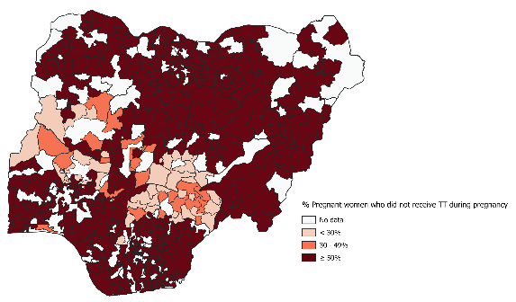
Figure 8 Percentage of pregnant women who did not receive TT during pregnancy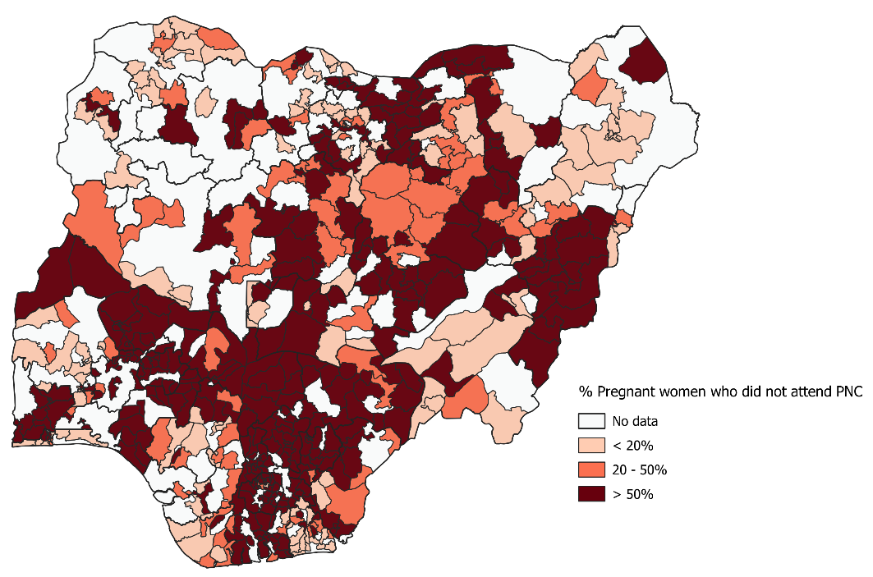
Figure 9 Percentage of pregnant women who did not attend PNC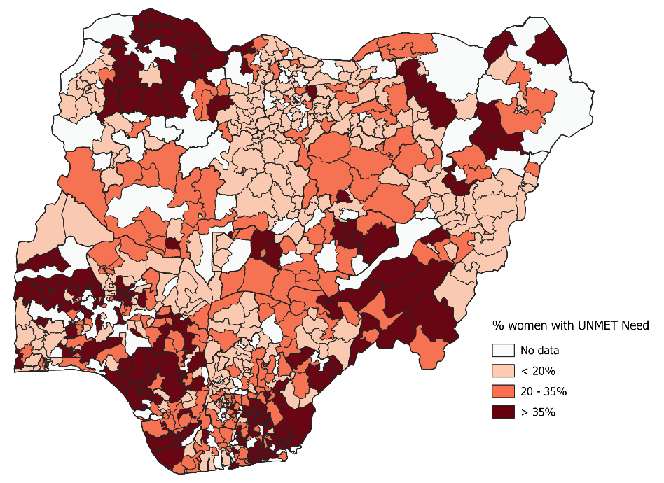
Figure 10 . Percentage of women with unmet need
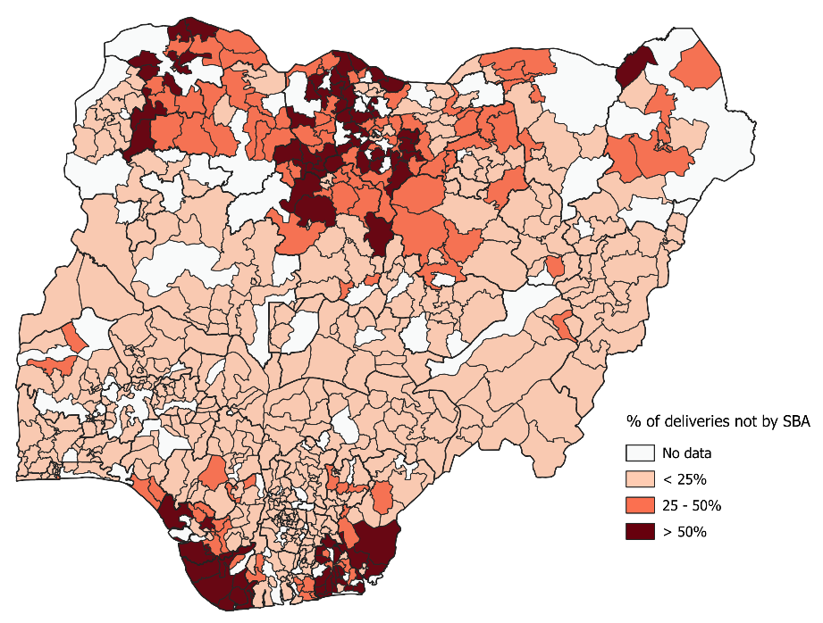
Figure 11 . Percentage of deliveries not by SBA
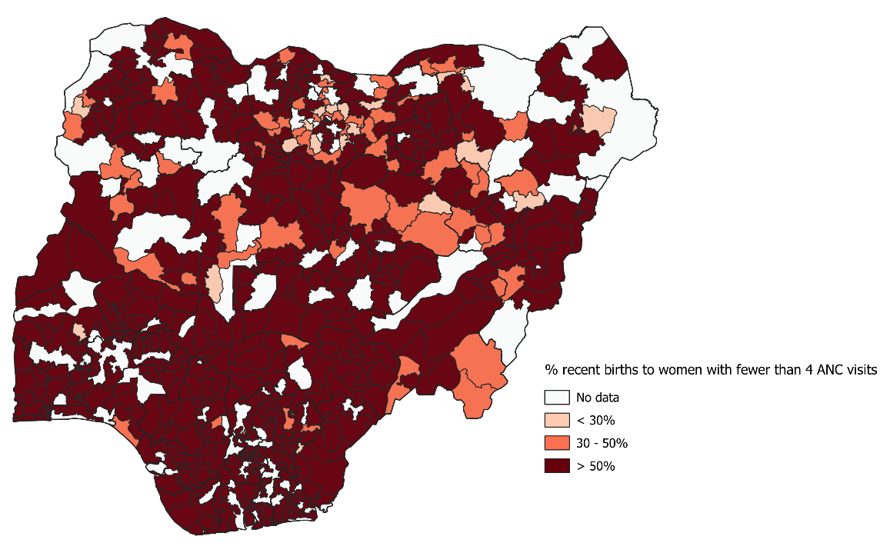
Figure 12 . Percentage of recent births to women with fewer than 4 ANC visits
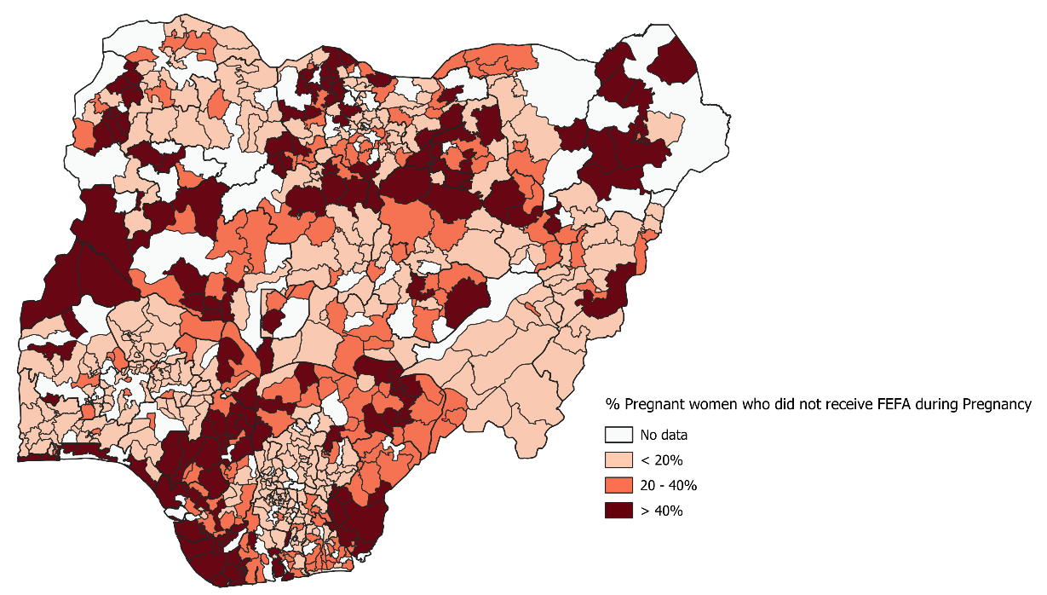
Figure 13 . Percentage of pregnant women who did not receive FEFA during pregnancy
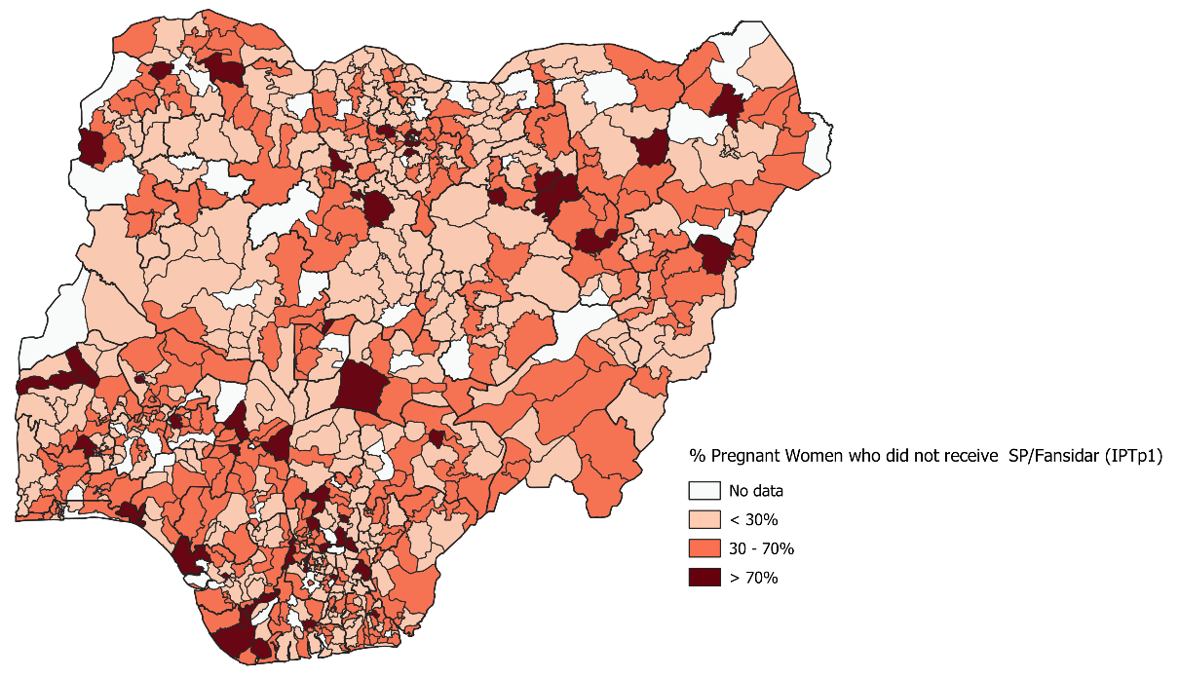
Figure 14 . Percentage of pregnant women who did not receive SP/Fansidar (IPTp1)
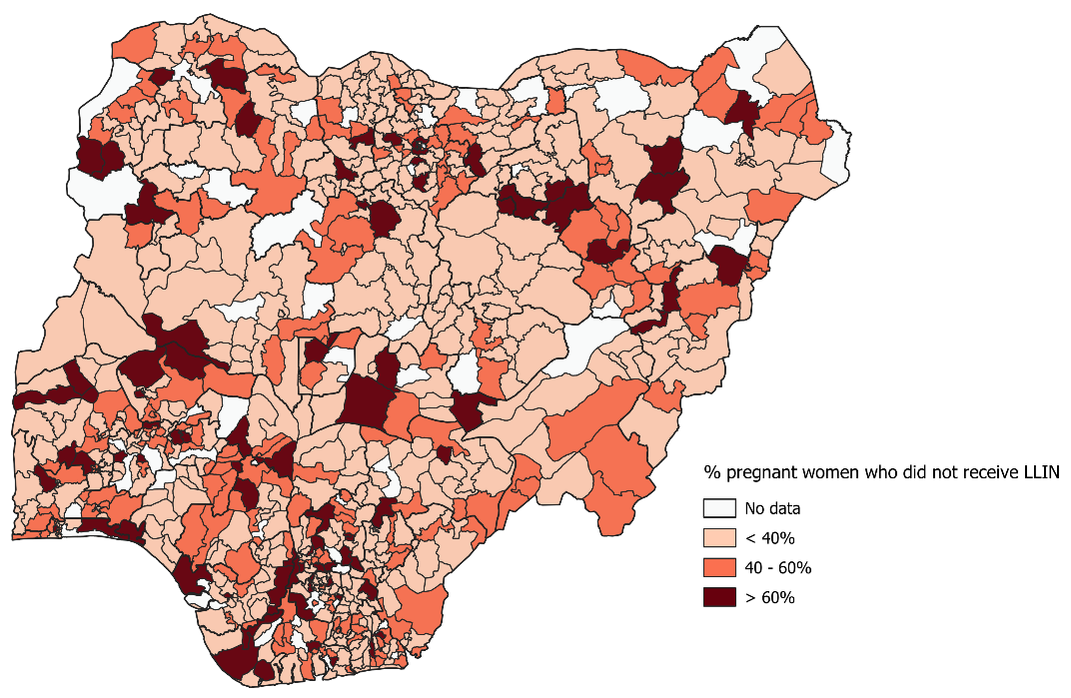
Figure 15 . Percentage of pregnant women who did not receive LLIN
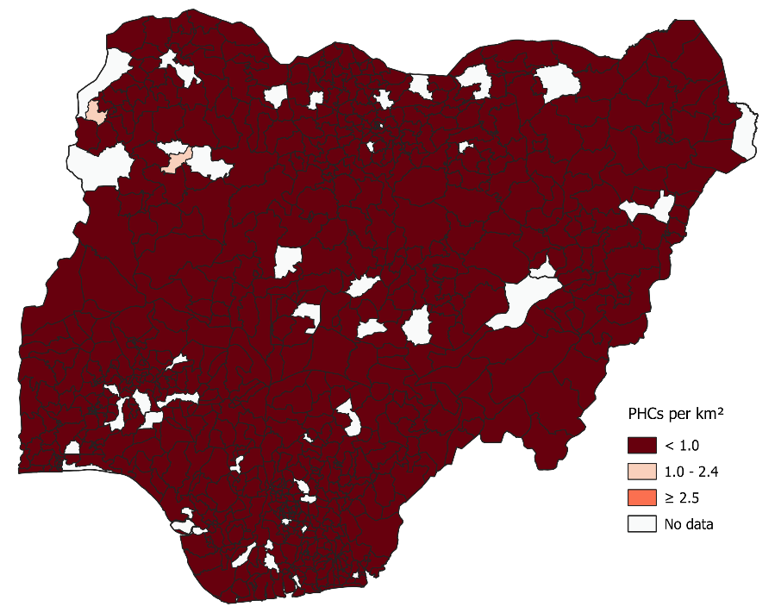
Figure 16 . Primary Health Care facility density (per km²)

Appendix B. List of Prioritised LGAs across Eight Scenarios

Scenario 1 (Approach 1)
Table 4 List of priority LGAs by state from scenario 1
S/N | STATE | LGA | S/N | STATE | LGA
1 | Abia State | Ukwa East LGA | 76 | Jigawa State | Jahun LGA
2 | Abia State | Umuahia South LGA | 77 | Kaduna State | Makarfi LGA
3 | Abia State | Obi Ngwa LGA | 78 | Kano State | Bagwai LGA
4 | Abia State | Ugwunagbo LGA | 79 | Kano State | Bichi LGA
5 | Abia State | Isiala-Ngwa South LGA | 80 | Kano State | Tofa LGA
6 | Adamawa State | Yola North LGA | 81 | Kano State | Kano Municipal LGA
7 | Adamawa State | Mayo-Belwa LGA | 82 | Kano State | Tudun Wada LGA
8 | Akwa-Ibom State | Eastern Obolo LGA | 83 | Kano State | Dawakin Tofa LGA
9 | Akwa-Ibom State | Ibeno LGA | 84 | Katsina State | Sandamu LGA
10 | Akwa-Ibom State | Ukanafun LGA | 85 | Katsina State | Baure LGA
11 | Akwa-Ibom State | Mkpat Enin LGA | 86 | Katsina State | Dutsin-Ma LGA
12 | Akwa-Ibom State | Oruk Anam LGA | 87 | Katsina State | Daura LGA
13 | Akwa-Ibom State | Eket LGA | 88 | Katsina State | Mani LGA
14 | Akwa-Ibom State | Etim Ekpo LGA | 89 | Katsina State | Batagarawa LGA
15 | Akwa-Ibom State | Oron LGA | 90 | Katsina State | Kankara LGA
16 | Akwa-Ibom State | Onna LGA | 91 | Katsina State | Batsari LGA
17 | Akwa-Ibom State | Ikot Abasi LGA | 92 | Katsina State | Charanchi LGA
18 | Akwa-Ibom State | Esit Eket LGA | 93 | Katsina State | Katsina LGA
19 | Anambra state | Aguata LGA | 94 | Katsina State | Ingawa LGA
20 | Anambra state | Anambra West LGA | 95 | Katsina State | Danja LGA
21 | Bayelsa State | Brass LGA | 96 | Katsina State | Kankia LGA
22 | Bayelsa State | Sagbama LGA | 97 | Katsina State | Funtua LGA
23 | Bayelsa State | Southern Ijaw LGA | 98 | Kebbi State | Koko/Besse LGA
24 | Benue State | Otukpo LGA | 99 | Kogi State | Idah LGA
25 | Benue State | Guma LGA | 100 | Kogi State | Ajaokuta LGA
26 | Benue State | Okpokwu LGA | 101 | Kwara State | Irepodun LGA
27 | Benue State | Oju LGA | 102 | Lagos State | Alimosho LGA
28 | Benue State | Kwande LGA | 103 | Lagos State | Epe LGA
29 | Benue State | Ado LGA | 104 | Lagos State | Lagos Island LGA
30 | Benue State | Buruku LGA | 105 | Lagos State | Ibeju/Lekki LGA
31 | Benue State | Ushongo LGA | 106 | Lagos State | Badagry LGA
32 | Benue State | Logo LGA | 107 | Lagos State | Agege LGA
33 | Benue State | Gwer West LGA | 108 | Lagos State | Surulere LGA
34 | Benue State | Tarka LGA | 109 | Nasarawa State | Akwanga LGA
35 | Benue State | Agatu LGA | 110 | Nasarawa State | Obi LGA
36 | Borno State | Magumeri LGA | 111 | Nasarawa State | Karu LGA
37 | Borno State | Gubio LGA | 112 | Nasarawa State | Wamba LGA
38 | Borno State | Bayo LGA | 113 | Niger State | Kontagora LGA
39 | Borno State | Marte LGA | 114 | Niger State | Tafa LGA
40 | Borno State | Mobbar LGA | 115 | Niger State | Borgu LGA
41 | Delta State | Warri South West LGA | 116 | Niger State | Rafi LGA
42 | Delta State | Oshimili South LGA | 117 | Niger State | Suleja LGA
43 | Delta State | Ndokwa East LGA | 118 | Niger State | Lavun LGA
44 | Delta State | Ndokwa West LGA | 119 | Niger State | Paikoro LGA
45 | Delta State | Ethiope East LGA | 120 | Ogun State | Remo North LGA
46 | Delta State | Ughelli South LGA | 121 | Ondo State | Akoko South East LGA
47 | Delta State | Bomadi LGA | 122 | Oyo State | Akinyele LGA
48 | Delta State | Ethiope West LGA | 123 | Oyo State | Iwajowa LGA
49 | Ebonyi State | Ebonyi LGA | 124 | Plateau State | Langtang North LGA
50 | Ebonyi State | Afikpo North LGA | 125 | Plateau State | Langtang South LGA
51 | Edo State | Owan East LGA | 126 | Plateau State | Pankshin LGA
52 | Edo State | Egor LGA | 127 | Plateau State | Mangu LGA
53 | Ekiti State | Ido-Osi LGA | 128 | Plateau State | Barkin Ladi LGA
54 | Enugu State | Enugu East LGA | 129 | Plateau State | Kanam LGA
55 | Enugu State | Enugu South LGA | 130 | Rivers State | Akuku Toru LGA
56 | Enugu State | Uzo-Uwani LGA | 131 | Rivers State | Gokana LGA
57 | Gombe State | Nafada LGA | 132 | Rivers State | Port-Harcourt LGA
58 | Gombe State | Akko LGA | 133 | Rivers State | Khana LGA
59 | Imo State | Aboh-Mbaise LGA | 134 | Sokoto State | Dange-Shuni LGA
60 | Imo State | Onuimo LGA | 135 | Sokoto State | Sokoto South LGA
61 | Imo State | Ngor-Okpala LGA | 136 | Sokoto State | Wurno LGA
62 | Imo State | Okigwe LGA | 137 | Sokoto State | Gada LGA
63 | Imo State | Ikeduru LGA | 138 | Taraba State | Gashaka LGA
64 | Imo State | Ideato North LGA | 139 | Taraba State | Donga LGA
65 | Imo State | Isu LGA | 140 | Taraba State | Karim-Lamido LGA
66 | Imo State | Ezinihitte-Mbaise LGA | 141 | Taraba State | Kurmi LGA
67 | Imo State | Ahiazu-Mbaise LGA | 142 | Taraba State | Ibi LGA
68 | Imo State | Nkwerre LGA | 143 | Yobe State | Bade LGA
69 | Jigawa State | Hadejia LGA | 144 | Yobe State | Fika LGA
70 | Jigawa State | Birniwa LGA | 145 | Yobe State | Machina LGA
71 | Jigawa State | Babura LGA | 146 | Zamfara State | Gusau LGA
72 | Jigawa State | Birnin Kudu LGA | 147 | Zamfara State | Anka LGA
73 | Jigawa State | Dutse LGA | 148 | Zamfara State | Maru LGA
74 | Jigawa State | Kazaure LGA | 149 | Zamfara State | Talata Mafara LGA
75 | Jigawa State | Gwaram LGA

Scenario 2 (Approach 1)
Table 5 List of priority LGAs by state from scenario 2
S/N | STATE | LGA | S/N | STATE | LGA
1 | Abia State | Ukwa East LGA | 76 | Jigawa State | Ringim LGA
2 | Abia State | Umuahia South LGA | 77 | Kaduna State | Makarfi LGA
3 | Abia State | Obi Ngwa LGA | 78 | Kano State | Bagwai LGA
4 | Adamawa State | Yola North LGA | 79 | Kano State | Tofa LGA
5 | Adamawa State | Mubi South LGA | 80 | Kano State | Bichi LGA
6 | Akwa-Ibom State | Ibeno LGA | 81 | Kano State | Tudun Wada LGA
7 | Akwa-Ibom State | Onna LGA | 82 | Kano State | Kano Municipal LGA
8 | Akwa-Ibom State | Nsit Ubium LGA | 83 | Kano State | Dawakin Tofa LGA
9 | Akwa-Ibom State | Ukanafun LGA | 84 | Kano State | Ajingi LGA
10 | Akwa-Ibom State | Oruk Anam LGA | 85 | Katsina State | Dutsin-Ma LGA
11 | Akwa-Ibom State | Mkpat Enin LGA | 86 | Katsina State | Kankara LGA
12 | Akwa-Ibom State | Eket LGA | 87 | Katsina State | Charanchi LGA
13 | Akwa-Ibom State | Etinan LGA | 88 | Katsina State | Katsina LGA
14 | Anambra state | Ihiala LGA | 89 | Katsina State | Ingawa LGA
15 | Anambra state | Anambra West LGA | 90 | Katsina State | Batagarawa LGA
16 | Anambra state | Anambra East LGA | 91 | Katsina State | Danja LGA
17 | Anambra state | Orumba South LGA | 92 | Katsina State | Daura LGA
18 | Bayelsa State | Brass LGA | 93 | Katsina State | Mani LGA
19 | Bayelsa State | Southern Ijaw LGA | 94 | Katsina State | Bakori LGA
20 | Bayelsa State | Sagbama LGA | 95 | Katsina State | Malumfashi LGA
21 | Benue State | Okpokwu LGA | 96 | Katsina State | Baure LGA
22 | Benue State | Oju LGA | 97 | Katsina State | Batsari LGA
23 | Benue State | Otukpo LGA | 98 | Katsina State | Kankia LGA
24 | Benue State | Guma LGA | 99 | Kebbi State | Koko/Besse LGA
25 | Benue State | Buruku LGA | 100 | Kebbi State | Yauri LGA
26 | Benue State | Logo LGA | 101 | Kogi State | Ibaji LGA
27 | Benue State | Gwer West LGA | 102 | Kogi State | Idah LGA
28 | Benue State | Ushongo LGA | 103 | Kwara State | Irepodun LGA
29 | Benue State | Ado LGA | 104 | Kwara State | Edu LGA
30 | Benue State | Katsina-Ala LGA | 105 | Lagos State | Alimosho LGA
31 | Benue State | Gboko LGA | 106 | Lagos State | Epe LGA
32 | Borno State | Magumeri LGA | 107 | Lagos State | Lagos Island LGA
33 | Borno State | Bayo LGA | 108 | Lagos State | Ikorodu LGA
34 | Borno State | Gubio LGA | 109 | Lagos State | Apapa LGA
35 | Borno State | Mobbar LGA | 110 | Lagos State | Badagry LGA
36 | Cross River State | Akamkpa LGA | 111 | Nasarawa State | Obi LGA
37 | Delta State | Warri South West LGA | 112 | Niger State | Kontagora LGA
38 | Delta State | Ndokwa East LGA | 113 | Niger State | Tafa LGA
39 | Delta State | Oshimili South LGA | 114 | Niger State | Borgu LGA
40 | Delta State | Ethiope West LGA | 115 | Niger State | Suleja LGA
41 | Delta State | Ethiope East LGA | 116 | Niger State | Chanchaga LGA
42 | Delta State | Ughelli North LGA | 117 | Niger State | Lavun LGA
43 | Ebonyi State | Ebonyi LGA | 118 | Niger State | Wushishi LGA
44 | Ebonyi State | Afikpo North LGA | 119 | Niger State | Mokwa LGA
45 | Ekiti State | Ekiti South West LGA | 120 | Osun State | Irepodun LGA
46 | Ekiti State | Ido-Osi LGA | 121 | Oyo State | Iwajowa LGA
47 | Ekiti State | Ikole LGA | 122 | Oyo State | Saki East LGA
48 | Enugu State | Uzo-Uwani LGA | 123 | Plateau State | Langtang North LGA
49 | Enugu State | Enugu East LGA | 124 | Plateau State | Langtang South LGA
50 | Gombe State | Nafada LGA | 125 | Plateau State | Kanam LGA
51 | Gombe State | Akko LGA | 126 | Plateau State | Shendam LGA
52 | Gombe State | Gombe LGA | 127 | Rivers State | Akuku Toru LGA
53 | Gombe State | Funakaye LGA | 128 | Rivers State | Gokana LGA
54 | Imo State | Onuimo LGA | 129 | Rivers State | Ogu/Bolo LGA
55 | Imo State | Aboh-Mbaise LGA | 130 | Rivers State | Etche LGA
56 | Imo State | Isu LGA | 131 | Sokoto State | Sokoto South LGA
57 | Imo State | Nkwerre LGA | 132 | Sokoto State | Dange-Shuni LGA
58 | Imo State | Ideato North LGA | 133 | Sokoto State | Gada LGA
59 | Imo State | Ahiazu-Mbaise LGA | 134 | Taraba State | Donga LGA
60 | Imo State | Okigwe LGA | 135 | Taraba State | Gashaka LGA
61 | Imo State | Nwangele LGA | 136 | Taraba State | Kurmi LGA
62 | Imo State | Ngor-Okpala LGA | 137 | Taraba State | Takum LGA
63 | Imo State | Ezinihitte-Mbaise LGA | 138 | Taraba State | Ibi LGA
64 | Imo State | Ikeduru LGA | 139 | Taraba State | Lau LGA
65 | Imo State | Oru West LGA | 140 | Yobe State | Bade LGA
66 | Imo State | Oguta LGA | 141 | Yobe State | Machina LGA
67 | Jigawa State | Hadejia LGA | 142 | Yobe State | Potiskum LGA
68 | Jigawa State | Birniwa LGA | 143 | Yobe State | Damaturu LGA
69 | Jigawa State | Babura LGA | 144 | Zamfara State | Gusau LGA
70 | Jigawa State | Birnin Kudu LGA | 145 | Zamfara State | Maru LGA
71 | Jigawa State | Dutse LGA | 146 | Zamfara State | Anka LGA
72 | Jigawa State | Kazaure LGA | 147 | Zamfara State | Talata Mafara LGA
73 | Jigawa State | Gumel LGA | 148 | Zamfara State | Shinkafi LGA
74 | Jigawa State | Jahun LGA | 149 | Zamfara State | Kaura Namoda LGA
75 | Jigawa State | Kafin Hausa LGA

Scenario 3
Table 6 List of priority LGAs by state from scenario 3
S/N | STATE | LGA | S/N | STATE | LGA
1 | Abia State | Umuahia South LGA | 67 | Kebbi State | Argungu LGA
2 | Abia State | Obi Ngwa LGA | 68 | Kebbi State | Aleiro LGA
3 | Abia State | Isiala-Ngwa South LGA | 69 | Kogi State | Omala LGA
4 | Adamawa State | Madagali LGA | 70 | Kogi State | Ajaokuta LGA
5 | Akwa-Ibom State | Eket LGA | 71 | Lagos State | Badagry LGA
6 | Akwa-Ibom State | Etim Ekpo LGA | 72 | Lagos State | Alimosho LGA
7 | Anambra state | Orumba South LGA | 73 | Lagos State | Ojo LGA
8 | Bayelsa State | Brass LGA | 74 | Lagos State | Ifako/Ijaye LGA
9 | Benue State | Ado LGA | 75 | Niger State | Rijau LGA
10 | Benue State | Agatu LGA | 76 | Niger State | Edati LGA
11 | Benue State | Ogbadibo LGA | 77 | Niger State | Mashegu LGA
12 | Borno State | Marte LGA | 78 | Ondo State | Irele LGA
13 | Borno State | Mobbar LGA | 79 | Ondo State | Ose LGA
14 | Borno State | Ngala LGA | 80 | Ondo State | Akure South LGA
15 | Borno State | Gubio LGA | 81 | Osun State | Oriade LGA
16 | Borno State | Bama LGA | 82 | Osun State | Ayedire LGA
17 | Borno State | Chibok LGA | 83 | Osun State | Ifedayo LGA
18 | Borno State | Monguno LGA | 84 | Oyo State | Atisbo LGA
19 | Borno State | Kukawa LGA | 85 | Oyo State | Afijio LGA
20 | Borno State | Gwoza LGA | 86 | Oyo State | Surulere LGA
21 | Borno State | Kaga LGA | 87 | Oyo State | Itesiwaju LGA
22 | Borno State | Dikwa LGA | 88 | Oyo State | Olorunsogo LGA
23 | Borno State | Damboa LGA | 89 | Oyo State | Ido LGA
24 | Cross River State | Odukpani LGA | 90 | Oyo State | Orelope LGA
25 | Cross River State | Bakassi LGA | 91 | Oyo State | Ori Ire LGA
26 | Cross River State | Obudu LGA | 92 | Oyo State | Iwajowa LGA
27 | Cross River State | Biase LGA | 93 | Oyo State | Atiba LGA
28 | Delta State | Sapele LGA | 94 | Oyo State | Ibarapa Central LGA
29 | Delta State | Warri South West LGA | 95 | Oyo State | Lagelu LGA
30 | Delta State | Ndokwa West LGA | 96 | Oyo State | Ibadan North East LGA
31 | Delta State | Warri North LGA | 97 | Plateau State | Langtang South LGA
32 | Delta State | Bomadi LGA | 98 | Plateau State | Pankshin LGA
33 | Delta State | Ethiope West LGA | 99 | Plateau State | Barkin Ladi LGA
34 | Delta State | Isoko South LGA | 100 | Plateau State | Shendam LGA
35 | Edo State | Orhionmwon LGA | 101 | Plateau State | Wase LGA
36 | Edo State | Owan West LGA | 102 | Plateau State | Kanam LGA
37 | Edo State | Igueben LGA | 103 | Plateau State | Kanke LGA
38 | Edo State | Owan East LGA | 104 | Rivers State | Oyigbo LGA
39 | Edo State | Esan Central LGA | 105 | Rivers State | Asari-Toru LGA
40 | Edo State | Ovia North-East LGA | 106 | Rivers State | Akuku Toru LGA
41 | Edo State | Ovia South-West LGA | 107 | Rivers State | Khana LGA
42 | Edo State | Egor LGA | 108 | Rivers State | Emohua LGA
43 | Edo State | Oredo LGA | 109 | Rivers State | Omumma LGA
44 | Edo State | Etsako West LGA | 110 | Sokoto State | Rabah LGA
45 | Edo State | Uhunmwonde LGA | 111 | Sokoto State | Binji LGA
46 | Ekiti State | Ekiti West LGA | 112 | Sokoto State | Dange-Shuni LGA
47 | Ekiti State | Irepodun/Ifelodun LGA | 113 | Sokoto State | Shagari LGA
48 | Ekiti State | Oye LGA | 114 | Sokoto State | Gudu LGA
49 | Enugu State | Ezeagu LGA | 115 | Taraba State | Karim-Lamido LGA
50 | Gombe State | Dukku LGA | 116 | Taraba State | Ibi LGA
51 | Gombe State | Funakaye LGA | 117 | Taraba State | Donga LGA
52 | Imo State | Owerri Municipal LGA | 118 | Taraba State | Wukari LGA
53 | Imo State | Owerri North LGA | 119 | Yobe State | Yunusari LGA
54 | Jigawa State | Gumel LGA | 120 | Yobe State | Geidam LGA
55 | Jigawa State | Babura LGA | 121 | Yobe State | Tarmuwa LGA
56 | Jigawa State | Ringim LGA | 122 | Yobe State | Gujba LGA
57 | Kaduna State | Makarfi LGA | 123 | Yobe State | Gulani LGA
58 | Kano State | Gwarzo LGA | 124 | Yobe State | Fune LGA
59 | Kano State | Shanono LGA | 125 | Zamfara State | Maru LGA
60 | Kano State | Kibiya LGA | 126 | Zamfara State | Talata Mafara LGA
61 | Katsina State | Dutsin-Ma LGA | 127 | Zamfara State | Shinkafi LGA
62 | Katsina State | Batsari LGA | 128 | Zamfara State | Bukkuyum LGA
63 | Katsina State | Safana LGA | 129 | Zamfara State | Gusau LGA
64 | Katsina State | Charanchi LGA | 130 | Zamfara State | Birnin Magaji LGA
65 | Katsina State | Rimi LGA | 131 | Zamfara State | Maradun LGA
66 | Katsina State | Sandamu LGA | 132 | Zamfara State | Gummi LGA

Scenario 4
Table 7 List of priority LGAs by state from scenario 4
S/N | STATE | LGA | S/N | STATE | LGA
1 | Abia State | Umuahia South LGA | 65 | Kebbi State | Argungu LGA
2 | Abia State | Obi Ngwa LGA | 66 | Kebbi State | Aleiro LGA
3 | Adamawa State | Mubi South LGA | 67 | Kogi State | Omala LGA
4 | Adamawa State | Madagali LGA | 68 | Lagos State | Badagry LGA
5 | Akwa-Ibom State | Etim Ekpo LGA | 69 | Lagos State | Alimosho LGA
6 | Akwa-Ibom State | Eket LGA | 70 | Lagos State | Ifako/Ijaye LGA
7 | Akwa-Ibom State | Itu LGA | 71 | Lagos State | Ojo LGA
8 | Anambra state | Orumba South LGA | 72 | Niger State | Rijau LGA
9 | Anambra state | Ihiala LGA | 73 | Niger State | Edati LGA
10 | Anambra state | Awka South LGA | 74 | Niger State | Mashegu LGA
11 | Bayelsa State | Brass LGA | 75 | Niger State | Agwara LGA
12 | Benue State | Ohimini LGA | 76 | Ogun State | Ijebu North East LGA
13 | Benue State | Ogbadibo LGA | 77 | Ondo State | Irele LGA
14 | Borno State | Marte LGA | 78 | Ondo State | Ose LGA
15 | Borno State | Mobbar LGA | 79 | Ondo State | Akure South LGA
16 | Borno State | Chibok LGA | 80 | Ondo State | Ifedore LGA
17 | Borno State | Kukawa LGA | 81 | Osun State | Ifedayo LGA
18 | Borno State | Ngala LGA | 82 | Osun State | Irepodun LGA
19 | Borno State | Bama LGA | 83 | Osun State | Ayedire LGA
20 | Cross River State | Odukpani LGA | 84 | Osun State | Egbedore LGA
21 | Cross River State | Bakassi LGA | 85 | Osun State | Oriade LGA
22 | Cross River State | Calabar Municipal LGA | 86 | Osun State | Ede South LGA
23 | Cross River State | Obudu LGA | 87 | Osun State | Atakumosa East LGA
24 | Cross River State | Etung LGA | 88 | Osun State | Ilesa West LGA
25 | Delta State | Sapele LGA | 89 | Oyo State | Afijio LGA
26 | Delta State | Warri North LGA | 90 | Oyo State | Surulere LGA
27 | Ebonyi State | Afikpo South LGA | 91 | Oyo State | Itesiwaju LGA
28 | Edo State | Etsako West LGA | 92 | Oyo State | Olorunsogo LGA
29 | Edo State | Owan West LGA | 93 | Oyo State | Ibarapa Central LGA
30 | Edo State | Orhionmwon LGA | 94 | Oyo State | Atisbo LGA
31 | Edo State | Igueben LGA | 95 | Oyo State | Orelope LGA
32 | Edo State | Esan Central LGA | 96 | Oyo State | Ori Ire LGA
33 | Ekiti State | Oye LGA | 97 | Oyo State | Saki East LGA
34 | Ekiti State | Ekiti West LGA | 98 | Oyo State | Irepo LGA
35 | Ekiti State | Ido-Osi LGA | 99 | Oyo State | Ido LGA
36 | Ekiti State | Ado Ekiti LGA | 100 | Plateau State | Barkin Ladi LGA
37 | Ekiti State | Irepodun/Ifelodun LGA | 101 | Plateau State | Shendam LGA
38 | Enugu State | Ezeagu LGA | 102 | Plateau State | Pankshin LGA
39 | Enugu State | Igbo-Etiti LGA | 103 | Plateau State | Kanke LGA
40 | Enugu State | Uzo-Uwani LGA | 104 | Plateau State | Langtang South LGA
41 | Enugu State | Igbo-Eze North LGA | 105 | Rivers State | Asari-Toru LGA
42 | Enugu State | Isi-Uzo LGA | 106 | Rivers State | Omumma LGA
43 | Gombe State | Funakaye LGA | 107 | Rivers State | Oyigbo LGA
44 | Gombe State | Dukku LGA | 108 | Rivers State | Opobo/Nkoro LGA
45 | Imo State | Ideato South LGA | 109 | Rivers State | Tai LGA
46 | Imo State | Nwangele LGA | 110 | Rivers State | Akuku Toru LGA
47 | Imo State | Owerri Municipal LGA | 111 | Rivers State | Ogba/Egbema/Ndoni LGA
48 | Imo State | Mbaitoli LGA | 112 | Rivers State | Emohua LGA
49 | Imo State | Ehime-Mbano LGA | 113 | Sokoto State | Rabah LGA
50 | Jigawa State | Gumel LGA | 114 | Sokoto State | Dange-Shuni LGA
51 | Jigawa State | Ringim LGA | 115 | Sokoto State | Gudu LGA
52 | Jigawa State | Buji LGA | 116 | Taraba State | Ibi LGA
53 | Jigawa State | Roni LGA | 117 | Taraba State | Donga LGA
54 | Jigawa State | Yankwashi LGA | 118 | Taraba State | Takum LGA
55 | Kaduna State | Makarfi LGA | 119 | Yobe State | Gujba LGA
56 | Kano State | Gwarzo LGA | 120 | Yobe State | Yunusari LGA
57 | Kano State | Rimin Gado LGA | 121 | Yobe State | Geidam LGA
58 | Kano State | Shanono LGA | 122 | Yobe State | Tarmuwa LGA
59 | Katsina State | Batsari LGA | 123 | Yobe State | Gulani LGA
60 | Katsina State | Dutsin-Ma LGA | 124 | Zamfara State | Maru LGA
61 | Katsina State | Rimi LGA | 125 | Zamfara State | Shinkafi LGA
62 | Katsina State | Charanchi LGA | 126 | Zamfara State | Talata Mafara LGA
63 | Katsina State | Safana LGA | 127 | Zamfara State | Gusau LGA
64 | Katsina State | Danja LGA

Scenario 5
Table 8 List of priority LGAs by state from scenario 5
S/N | STATE | LGA | S/N | STATE | LGA
1 | Bauchi State | Gamawa LGA | 76 | Kebbi State | Sakaba LGA
2 | Bauchi State | Ganjuwa LGA | 77 | Kebbi State | Birnin Kebbi LGA
3 | Bauchi State | Bogoro LGA | 78 | Kebbi State | Fakai LGA
4 | Bauchi State | Kirfi LGA | 79 | Kebbi State | Jega LGA
5 | Bauchi State | Dambam LGA | 80 | Kebbi State | Augie LGA
6 | Bauchi State | Darazo LGA | 81 | Kebbi State | Dandi LGA
7 | Bayelsa State | Brass LGA | 82 | Kebbi State | Danko/Wasagu LGA
8 | Bayelsa State | Southern Ijaw LGA | 83 | Kebbi State | Kalgo LGA
9 | Bayelsa State | Sagbama LGA | 84 | Kebbi State | Shanga LGA
10 | Bayelsa State | Ekeremor LGA | 85 | Kebbi State | Yauri LGA
11 | Borno State | Marte LGA | 86 | Nasarawa State | Karu LGA
12 | Borno State | Magumeri LGA | 87 | Nasarawa State | Wamba LGA
13 | Borno State | Mobbar LGA | 88 | Nasarawa State | Akwanga LGA
14 | Borno State | Ngala LGA | 89 | Nasarawa State | Nasarawa Eggon LGA
15 | Borno State | Bama LGA | 90 | Nasarawa State | Toto LGA
16 | Borno State | Gubio LGA | 91 | Niger State | Rijau LGA
17 | Borno State | Monguno LGA | 92 | Niger State | Wushishi LGA
18 | Borno State | Chibok LGA | 93 | Niger State | Mashegu LGA
19 | Borno State | Damboa LGA | 94 | Niger State | Borgu LGA
20 | Borno State | Dikwa LGA | 95 | Niger State | Lapai LGA
21 | Borno State | Gwoza LGA | 96 | Niger State | Agwara LGA
22 | Borno State | Kaga LGA | 97 | Niger State | Bosso LGA
23 | Borno State | Askira/Uba LGA | 98 | Niger State | Gurara LGA
24 | Borno State | Kwaya Kusar LGA | 99 | Niger State | Katcha LGA
25 | Borno State | Bayo LGA | 100 | Niger State | Lavun LGA
26 | Borno State | Konduga LGA | 101 | Niger State | Muya LGA
27 | Borno State | Mafa LGA | 102 | Niger State | Suleja LGA
28 | Borno State | Shani LGA | 103 | Niger State | Bida LGA
29 | Gombe State | Dukku LGA | 104 | Niger State | Gbako LGA
30 | Gombe State | Funakaye LGA | 105 | Niger State | Mokwa LGA
31 | Gombe State | Billiri LGA | 106 | Niger State | Rafi LGA
32 | Gombe State | Akko LGA | 107 | Niger State | Shiroro LGA
33 | Gombe State | Nafada LGA | 108 | Sokoto State | Rabah LGA
34 | Gombe State | Yamaltu/Deba LGA | 109 | Sokoto State | Binji LGA
35 | Kano State | Gwarzo LGA | 110 | Sokoto State | Dange-Shuni LGA
36 | Kano State | Kibiya LGA | 111 | Sokoto State | Gudu LGA
37 | Kano State | Shanono LGA | 112 | Sokoto State | Shagari LGA
38 | Kano State | Bagwai LGA | 113 | Sokoto State | Tangaza LGA
39 | Kano State | Rimin Gado LGA | 114 | Sokoto State | Wurno LGA
40 | Kano State | Bichi LGA | 115 | Sokoto State | Goronyo LGA
41 | Kano State | Dawakin Kudu LGA | 116 | Sokoto State | Kebbe LGA
42 | Kano State | Ajingi LGA | 117 | Sokoto State | Silame LGA
43 | Kano State | Fagge LGA | 118 | Sokoto State | Tambuwal LGA
44 | Kano State | Gabasawa LGA | 119 | Sokoto State | Bodinga LGA
45 | Kano State | Kumbotso LGA | 120 | Sokoto State | Sabon Birni LGA
46 | Kano State | Takai LGA | 121 | Sokoto State | Wamako LGA
47 | Kano State | Dala LGA | 122 | Sokoto State | Yabo LGA
48 | Kano State | Tarauni LGA | 123 | Sokoto State | Gada LGA
49 | Katsina State | Batsari LGA | 124 | Sokoto State | Gwadabawa LGA
50 | Katsina State | Dutsin-Ma LGA | 125 | Taraba State | Karim-Lamido LGA
51 | Katsina State | Rimi LGA | 126 | Taraba State | Ibi LGA
52 | Katsina State | Safana LGA | 127 | Taraba State | Donga LGA
53 | Katsina State | Charanchi LGA | 128 | Taraba State | Wukari LGA
54 | Katsina State | Sandamu LGA | 129 | Taraba State | Bali LGA
55 | Katsina State | Batagarawa LGA | 130 | Taraba State | Gassol LGA
56 | Katsina State | Baure LGA | 131 | Taraba State | Kurmi LGA
57 | Katsina State | Danja LGA | 132 | Taraba State | Takum LGA
58 | Katsina State | Funtua LGA | 133 | Taraba State | Sardauna LGA
59 | Katsina State | Bindawa LGA | 134 | Taraba State | Ardo-Kola LGA
60 | Katsina State | Dan Musa LGA | 135 | Taraba State | Gashaka LGA
61 | Katsina State | Dandume LGA | 136 | Taraba State | Zing LGA
62 | Katsina State | Daura LGA | 137 | Zamfara State | Maru LGA
63 | Katsina State | Ingawa LGA | 138 | Zamfara State | Bukkuyum LGA
64 | Katsina State | Kankia LGA | 139 | Zamfara State | Shinkafi LGA
65 | Katsina State | Mani LGA | 140 | Zamfara State | Gummi LGA
66 | Katsina State | Faskari LGA | 141 | Zamfara State | Gusau LGA
67 | Katsina State | Katsina LGA | 142 | Zamfara State | Maradun LGA
68 | Katsina State | Malumfashi LGA | 143 | Zamfara State | Talata Mafara LGA
69 | Katsina State | Sabuwa LGA | 144 | Zamfara State | Birnin Magaji LGA
70 | Kebbi State | Aleiro LGA | 145 | Zamfara State | Zurmi LGA
71 | Kebbi State | Argungu LGA | 146 | Zamfara State | Anka LGA
72 | Kebbi State | Suru LGA | 147 | Zamfara State | Bakura LGA
73 | Kebbi State | Zuru LGA | 148 | Zamfara State | Bungudu LGA
74 | Kebbi State | Bagudo LGA | 149 | Zamfara State | Kaura Namoda LGA
75 | Kebbi State | Koko/Besse LGA

Scenario 6
Table 9 List of priority LGAs by state from scenario 6
S/N | STATE | LGA | S/N | STATE | LGA
1 | Bauchi State | Bogoro LGA | 73 | Kebbi State | Suru LGA
2 | Bauchi State | Gamawa LGA | 74 | Kebbi State | Zuru LGA
3 | Bauchi State | Ganjuwa LGA | 75 | Kebbi State | Bagudo LGA
4 | Bauchi State | Kirfi LGA | 76 | Kebbi State | Koko/Besse LGA
5 | Bauchi State | Dambam LGA | 77 | Kebbi State | Sakaba LGA
6 | Bauchi State | Darazo LGA | 78 | Kebbi State | Birnin Kebbi LGA
7 | Bayelsa State | Brass LGA | 79 | Kebbi State | Fakai LGA
8 | Bayelsa State | Southern Ijaw LGA | 80 | Kebbi State | Jega LGA
9 | Bayelsa State | Sagbama LGA | 81 | Kebbi State | Yauri LGA
10 | Bayelsa State | Ekeremor LGA | 82 | Kebbi State | Augie LGA
11 | Bayelsa State | Kolokuma/Opokuma LGA | 83 | Kebbi State | Dandi LGA
12 | Borno State | Marte LGA | 84 | Kebbi State | Danko/Wasagu LGA
13 | Borno State | Ngala LGA | 85 | Kebbi State | Kalgo LGA
14 | Borno State | Bama LGA | 86 | Nasarawa State | Karu LGA
15 | Borno State | Monguno LGA | 87 | Nasarawa State | Nasarawa Eggon LGA
16 | Borno State | Chibok LGA | 88 | Nasarawa State | Toto LGA
17 | Borno State | Dikwa LGA | 89 | Niger State | Rijau LGA
18 | Borno State | Gwoza LGA | 90 | Niger State | Mashegu LGA
19 | Borno State | Mobbar LGA | 91 | Niger State | Lapai LGA
20 | Borno State | Kwaya Kusar LGA | 92 | Niger State | Agwara LGA
21 | Borno State | Gubio LGA | 93 | Niger State | Gurara LGA
22 | Borno State | Damboa LGA | 94 | Niger State | Borgu LGA
23 | Borno State | Kaga LGA | 95 | Niger State | Katcha LGA
24 | Borno State | Askira/Uba LGA | 96 | Niger State | Lavun LGA
25 | Borno State | Bayo LGA | 97 | Niger State | Suleja LGA
26 | Borno State | Konduga LGA | 98 | Niger State | Bosso LGA
27 | Borno State | Mafa LGA | 99 | Niger State | Mokwa LGA
28 | Borno State | Shani LGA | 100 | Niger State | Muya LGA
29 | Gombe State | Dukku LGA | 101 | Niger State | Bida LGA
30 | Gombe State | Funakaye LGA | 102 | Niger State | Gbako LGA
31 | Gombe State | Billiri LGA | 103 | Sokoto State | Rabah LGA
32 | Gombe State | Akko LGA | 104 | Sokoto State | Gudu LGA
33 | Gombe State | Nafada LGA | 105 | Sokoto State | Tangaza LGA
34 | Gombe State | Yamaltu/Deba LGA | 106 | Sokoto State | Binji LGA
35 | Gombe State | Balanga LGA | 107 | Sokoto State | Dange-Shuni LGA
36 | Gombe State | Gombe LGA | 108 | Sokoto State | Shagari LGA
37 | Kano State | Gwarzo LGA | 109 | Sokoto State | Goronyo LGA
38 | Kano State | Kibiya LGA | 110 | Sokoto State | Kebbe LGA
39 | Kano State | Shanono LGA | 111 | Sokoto State | Silame LGA
40 | Kano State | Rimin Gado LGA | 112 | Sokoto State | Tambuwal LGA
41 | Kano State | Dawakin Kudu LGA | 113 | Sokoto State | Wamako LGA
42 | Kano State | Fagge LGA | 114 | Sokoto State | Wurno LGA
43 | Kano State | Bagwai LGA | 115 | Sokoto State | Yabo LGA
44 | Kano State | Ajingi LGA | 116 | Sokoto State | Bodinga LGA
45 | Kano State | Bichi LGA | 117 | Sokoto State | Gada LGA
46 | Kano State | Kumbotso LGA | 118 | Sokoto State | Gwadabawa LGA
47 | Kano State | Gabasawa LGA | 119 | Sokoto State | Sabon Birni LGA
48 | Kano State | Takai LGA | 120 | Taraba State | Ibi LGA
49 | Kano State | Dala LGA | 121 | Taraba State | Takum LGA
50 | Kano State | Tarauni LGA | 122 | Taraba State | Donga LGA
51 | Katsina State | Batsari LGA | 123 | Taraba State | Karim-Lamido LGA
52 | Katsina State | Dutsin-Ma LGA | 124 | Taraba State | Wukari LGA
53 | Katsina State | Rimi LGA | 125 | Taraba State | Bali LGA
54 | Katsina State | Safana LGA | 126 | Taraba State | Kurmi LGA
55 | Katsina State | Sandamu LGA | 127 | Taraba State | Gassol LGA
56 | Katsina State | Charanchi LGA | 128 | Taraba State | Sardauna LGA
57 | Katsina State | Batagarawa LGA | 129 | Taraba State | Ardo-Kola LGA
58 | Katsina State | Baure LGA | 130 | Taraba State | Gashaka LGA
59 | Katsina State | Danja LGA | 131 | Taraba State | Zing LGA
60 | Katsina State | Dan Musa LGA | 132 | Zamfara State | Maru LGA
61 | Katsina State | Dandume LGA | 133 | Zamfara State | Birnin Magaji LGA
62 | Katsina State | Daura LGA | 134 | Zamfara State | Shinkafi LGA
63 | Katsina State | Funtua LGA | 135 | Zamfara State | Bukkuyum LGA
64 | Katsina State | Ingawa LGA | 136 | Zamfara State | Gummi LGA
65 | Katsina State | Kankia LGA | 137 | Zamfara State | Gusau LGA
66 | Katsina State | Malumfashi LGA | 138 | Zamfara State | Maradun LGA
67 | Katsina State | Mani LGA | 139 | Zamfara State | Talata Mafara LGA
68 | Katsina State | Faskari LGA | 140 | Zamfara State | Zurmi LGA
69 | Katsina State | Katsina LGA | 141 | Zamfara State | Anka LGA
70 | Katsina State | Sabuwa LGA | 142 | Zamfara State | Bakura LGA
71 | Kebbi State | Aleiro LGA | 143 | Zamfara State | Kaura Namoda LGA
72 | Kebbi State | Argungu LGA | 144 | Zamfara State | Bungudu LGA

Scenario 7
Table 10 List of priority LGAs by state from scenario 7
S/N | STATE | LGA | S/N | STATE | LGA
1 | Abia State | Umuahia South LGA | 84 | Kwara State | Pategi LGA
2 | Abia State | Obi Ngwa LGA | 85 | Lagos State | Badagry LGA
3 | Abia State | Ohafia LGA | 86 | Lagos State | Ojo LGA
4 | Abia State | Bende LGA | 87 | Lagos State | Alimosho LGA
5 | Abia State | Isiala-Ngwa South LGA | 88 | Lagos State | Ifako/Ijaye LGA
6 | Adamawa State | Fufore LGA | 89 | Lagos State | Eti-Osa LGA
7 | Adamawa State | Shelleng LGA | 90 | Lagos State | Oshodi/Isolo LGA
8 | Adamawa State | Song LGA | 91 | Lagos State | Shomolu LGA
9 | Adamawa State | Toungo LGA | 92 | Niger State | Bosso LGA
10 | Akwa-Ibom State | Eket LGA | 93 | Niger State | Edati LGA
11 | Anambra state | Ayamelum LGA | 94 | Niger State | Katcha LGA
12 | Anambra state | Awka South LGA | 95 | Niger State | Gbako LGA
13 | Bauchi State | Gamawa LGA | 96 | Niger State | Muya LGA
14 | Bauchi State | Ganjuwa LGA | 97 | Ogun State | Ijebu North East LGA
15 | Bayelsa State | Brass LGA | 98 | Ogun State | Ijebu East LGA
16 | Benue State | Ado LGA | 99 | Ogun State | Ado Odo/Ota LGA
17 | Benue State | Agatu LGA | 100 | Ogun State | Ipokia LGA
18 | Borno State | Mobbar LGA | 101 | Ogun State | Odeda LGA
19 | Borno State | Damboa LGA | 102 | Ogun State | Odogbolu LGA
20 | Borno State | Gubio LGA | 103 | Ogun State | Sagamu LGA
21 | Borno State | Kaga LGA | 104 | Ondo State | Akure South LGA
22 | Borno State | Kukawa LGA | 105 | Ondo State | Akoko North East LGA
23 | Cross River State | Biase LGA | 106 | Ondo State | Ilaje LGA
24 | Cross River State | Boki LGA | 107 | Ondo State | Akoko North West LGA
25 | Cross River State | Odukpani LGA | 108 | Ondo State | Ile-Oluji/Okeigbo LGA
26 | Cross River State | Yala LGA | 109 | Ondo State | Irele LGA
27 | Cross River State | Calabar Municipal LGA | 110 | Ondo State | Odigbo LGA
28 | Cross River State | Yakurr LGA | 111 | Ondo State | Ose LGA
29 | Delta State | Sapele LGA | 112 | Osun State | Oriade LGA
30 | Delta State | Isoko South LGA | 113 | Osun State | Ayedire LGA
31 | Delta State | Ndokwa West LGA | 114 | Osun State | Ifedayo LGA
32 | Delta State | Warri South West LGA | 115 | Oyo State | Afijio LGA
33 | Delta State | Bomadi LGA | 116 | Oyo State | Atiba LGA
34 | Delta State | Burutu LGA | 117 | Oyo State | Ibadan North East LGA
35 | Delta State | Ethiope West LGA | 118 | Oyo State | Ibarapa Central LGA
36 | Delta State | Ika South LGA | 119 | Oyo State | Surulere LGA
37 | Delta State | Warri North LGA | 120 | Oyo State | Itesiwaju LGA
38 | Ebonyi State | Afikpo South LGA | 121 | Oyo State | Oyo West LGA
39 | Edo State | Orhionmwon LGA | 122 | Oyo State | Saki West LGA
40 | Edo State | Owan West LGA | 123 | Oyo State | Egbeda LGA
41 | Edo State | Ovia South-West LGA | 124 | Oyo State | Ibadan South East LGA
42 | Edo State | Esan Central LGA | 125 | Oyo State | Ibadan South West LGA
43 | Edo State | Etsako West LGA | 126 | Oyo State | Iwajowa LGA
44 | Edo State | Ovia North-East LGA | 127 | Oyo State | Ori Ire LGA
45 | Edo State | Etsako Central LGA | 128 | Oyo State | Saki East LGA
46 | Edo State | Igueben LGA | 129 | Plateau State | Pankshin LGA
47 | Edo State | Oredo LGA | 130 | Plateau State | Wase LGA
48 | Edo State | Owan East LGA | 131 | Plateau State | Kanke LGA
49 | Edo State | Akoko-Edo LGA | 132 | Plateau State | Shendam LGA
50 | Edo State | Egor LGA | 133 | Plateau State | Bassa LGA
51 | Ekiti State | Ado Ekiti LGA | 134 | Plateau State | Kanam LGA
52 | Ekiti State | Ekiti West LGA | 135 | Rivers State | Oyigbo LGA
53 | Ekiti State | Moba LGA | 136 | Rivers State | Ahoada West LGA
54 | Enugu State | Ezeagu LGA | 137 | Rivers State | Okrika LGA
55 | Gombe State | Dukku LGA | 138 | Rivers State | Akuku Toru LGA
56 | Gombe State | Funakaye LGA | 139 | Rivers State | Asari-Toru LGA
57 | Gombe State | Billiri LGA | 140 | Rivers State | Bonny LGA
58 | Gombe State | Yamaltu/Deba LGA | 141 | Rivers State | Khana LGA
59 | Imo State | Owerri Municipal LGA | 142 | Rivers State | Ogba/Egbema/Ndoni LGA
60 | Imo State | Isiala Mbano LGA | 143 | Sokoto State | Binji LGA
61 | Imo State | Mbaitoli LGA | 144 | Sokoto State | Goronyo LGA
62 | Imo State | Owerri North LGA | 145 | Sokoto State | Shagari LGA
63 | Jigawa State | Ringim LGA | 146 | Sokoto State | Dange-Shuni LGA
64 | Jigawa State | Babura LGA | 147 | Sokoto State | Kebbe LGA
65 | Jigawa State | Buji LGA | 148 | Sokoto State | Silame LGA
66 | Jigawa State | Sule-Tankarkar LGA | 149 | Sokoto State | Tambuwal LGA
67 | Kaduna State | Kaduna North LGA | 150 | Taraba State | Karim-Lamido LGA
68 | Kaduna State | Makarfi LGA | 151 | Taraba State | Wukari LGA
69 | Kano State | Kumbotso LGA | 152 | Taraba State | Bali LGA
70 | Kano State | Dala LGA | 153 | Taraba State | Gassol LGA
71 | Kano State | Gabasawa LGA | 154 | Taraba State | Takum LGA
72 | Kano State | Tarauni LGA | 155 | Taraba State | Donga LGA
73 | Katsina State | Charanchi LGA | 156 | Yobe State | Fune LGA
74 | Katsina State | Dan Musa LGA | 157 | Yobe State | Jakusko LGA
75 | Katsina State | Dandume LGA | 158 | Yobe State | Yusufari LGA
76 | Katsina State | Faskari LGA | 159 | Zamfara State | Bukkuyum LGA
77 | Kebbi State | Argungu LGA | 160 | Zamfara State | Gummi LGA
78 | Kebbi State | Sakaba LGA | 161 | Zamfara State | Maradun LGA
79 | Kebbi State | Suru LGA | 162 | Zamfara State | Shinkafi LGA
80 | Kebbi State | Zuru LGA | 163 | Zamfara State | Talata Mafara LGA
81 | Kogi State | Omala LGA | 164 | Zamfara State | Gusau LGA
82 | Kogi State | Ajaokuta LGA | 165 | Zamfara State | Zurmi LGA
83 | Kogi State | Olamaboro LGA

Scenario 8
Table 11 List of priority LGAs by state from scenario 8
S/N | STATE | LGA | S/N | STATE | LGA
1 | Bauchi State | Gamawa LGA | 69 | Kebbi State | Fakai LGA
2 | Bauchi State | Bogoro LGA | 70 | Kebbi State | Jega LGA
3 | Bauchi State | Ganjuwa LGA | 71 | Kebbi State | Augie LGA
4 | Bauchi State | Kirfi LGA | 72 | Kebbi State | Birnin Kebbi LGA
5 | Bauchi State | Dambam LGA | 73 | Kebbi State | Dandi LGA
6 | Bauchi State | Itas/Gadau LGA | 74 | Kebbi State | Danko/Wasagu LGA
7 | Bayelsa State | Brass LGA | 75 | Kebbi State | Kalgo LGA
8 | Bayelsa State | Ekeremor LGA | 76 | Kebbi State | Koko/Besse LGA
9 | Bayelsa State | Southern Ijaw LGA | 77 | Kebbi State | Shanga LGA
10 | Borno State | Marte LGA | 78 | Nasarawa State | Karu LGA
11 | Borno State | Ngala LGA | 79 | Nasarawa State | Nasarawa Eggon LGA
12 | Borno State | Bama LGA | 80 | Nasarawa State | Toto LGA
13 | Borno State | Mobbar LGA | 81 | Nasarawa State | Wamba LGA
14 | Borno State | Monguno LGA | 82 | Niger State | Rijau LGA
15 | Borno State | Damboa LGA | 83 | Niger State | Mashegu LGA
16 | Borno State | Dikwa LGA | 84 | Niger State | Agwara LGA
17 | Borno State | Gwoza LGA | 85 | Niger State | Edati LGA
18 | Borno State | Chibok LGA | 86 | Niger State | Gurara LGA
19 | Borno State | Kukawa LGA | 87 | Niger State | Lapai LGA
20 | Borno State | Gubio LGA | 88 | Niger State | Bosso LGA
21 | Borno State | Kaga LGA | 89 | Niger State | Katcha LGA
22 | Borno State | Nganzai LGA | 90 | Niger State | Borgu LGA
23 | Borno State | Kwaya Kusar LGA | 91 | Niger State | Gbako LGA
24 | Borno State | Askira/Uba LGA | 92 | Niger State | Muya LGA
25 | Borno State | Konduga LGA | 93 | Niger State | Bida LGA
26 | Borno State | Mafa LGA | 94 | Niger State | Lavun LGA
27 | Borno State | Shani LGA | 95 | Niger State | Mariga LGA
28 | Gombe State | Dukku LGA | 96 | Niger State | Suleja LGA
29 | Gombe State | Billiri LGA | 97 | Sokoto State | Rabah LGA
30 | Gombe State | Funakaye LGA | 98 | Sokoto State | Binji LGA
31 | Gombe State | Yamaltu/Deba LGA | 99 | Sokoto State | Gudu LGA
32 | Kano State | Gwarzo LGA | 100 | Sokoto State | Tangaza LGA
33 | Kano State | Kibiya LGA | 101 | Sokoto State | Dange-Shuni LGA
34 | Kano State | Shanono LGA | 102 | Sokoto State | Goronyo LGA
35 | Kano State | Dawakin Kudu LGA | 103 | Sokoto State | Kebbe LGA
36 | Kano State | Rimin Gado LGA | 104 | Sokoto State | Shagari LGA
37 | Kano State | Fagge LGA | 105 | Sokoto State | Silame LGA
38 | Kano State | Gabasawa LGA | 106 | Sokoto State | Tambuwal LGA
39 | Kano State | Kumbotso LGA | 107 | Sokoto State | Wamako LGA
40 | Kano State | Bagwai LGA | 108 | Sokoto State | Wurno LGA
41 | Kano State | Dala LGA | 109 | Sokoto State | Yabo LGA
42 | Kano State | Takai LGA | 110 | Sokoto State | Bodinga LGA
43 | Kano State | Tarauni LGA | 111 | Sokoto State | Isa LGA
44 | Kano State | Ajingi LGA | 112 | Sokoto State | Sabon Birni LGA
45 | Kano State | Bichi LGA | 113 | Taraba State | Karim-Lamido LGA
46 | Kano State | Bunkure LGA | 114 | Taraba State | Wukari LGA
47 | Kano State | Garko LGA | 115 | Taraba State | Bali LGA
48 | Katsina State | Rimi LGA | 116 | Taraba State | Gassol LGA
49 | Katsina State | Safana LGA | 117 | Taraba State | Ibi LGA
50 | Katsina State | Batsari LGA | 118 | Taraba State | Takum LGA
51 | Katsina State | Dutsin-Ma LGA | 119 | Taraba State | Donga LGA
52 | Katsina State | Charanchi LGA | 120 | Taraba State | Kurmi LGA
53 | Katsina State | Dan Musa LGA | 121 | Taraba State | Sardauna LGA
54 | Katsina State | Dandume LGA | 122 | Taraba State | Ardo-Kola LGA
55 | Katsina State | Faskari LGA | 123 | Taraba State | Zing LGA
56 | Katsina State | Sandamu LGA | 124 | Zamfara State | Maru LGA
57 | Katsina State | Batagarawa LGA | 125 | Zamfara State | Bukkuyum LGA
58 | Katsina State | Baure LGA | 126 | Zamfara State | Gummi LGA
59 | Katsina State | Bindawa LGA | 127 | Zamfara State | Maradun LGA
60 | Katsina State | Danja LGA | 128 | Zamfara State | Shinkafi LGA
61 | Katsina State | Funtua LGA | 129 | Zamfara State | Birnin Magaji LGA
62 | Katsina State | Sabuwa LGA | 130 | Zamfara State | Gusau LGA
63 | Kebbi State | Aleiro LGA | 131 | Zamfara State | Talata Mafara LGA
64 | Kebbi State | Argungu LGA | 132 | Zamfara State | Zurmi LGA
65 | Kebbi State | Sakaba LGA | 133 | Zamfara State | Bungudu LGA
66 | Kebbi State | Suru LGA | 134 | Zamfara State | Anka LGA
67 | Kebbi State | Zuru LGA | 135 | Zamfara State | Bakura LGA
68 | Kebbi State | Bagudo LGA

Appendix C. List of prioritised LGAs across approaches 2, 3 and 4

Approach 2
Table 12 List of prioritised LGAs based on approach 2
S/N | State | LGA | S/N | State | LGA
1 | Abia State | Obi Ngwa LGA | 67 | Katsina State | Rimi LGA
2 | Abia State | Umuahia South LGA | 68 | Katsina State | Safana LGA
3 | Akwa-Ibom State | Eket LGA | 69 | Katsina State | Sandamu LGA
4 | Bauchi State | Gamawa LGA | 70 | Katsina State | Dan Musa LGA
5 | Bauchi State | Ganjuwa LGA | 71 | Katsina State | Dandume LGA
6 | Benue State | Ado LGA | 72 | Katsina State | Faskari LGA
7 | Borno State | Mobbar LGA | 73 | Katsina State | Funtua LGA
8 | Borno State | Gubio LGA | 74 | Katsina State | Katsina LGA
9 | Borno State | Marte LGA | 75 | Kwara State | Irepodun LGA
10 | Borno State | Bama LGA | 76 | Lagos State | Alimosho LGA
11 | Borno State | Chibok LGA | 77 | Lagos State | Badagry LGA
12 | Borno State | Damboa LGA | 78 | Lagos State | Surulere LGA
13 | Borno State | Kaga LGA | 79 | Nasarawa State | Akwanga LGA
14 | Borno State | Ngala LGA | 80 | Nasarawa State | Karu LGA
15 | Borno State | Bayo LGA | 81 | Nasarawa State | Wamba LGA
16 | Borno State | Dikwa LGA | 82 | Niger State | Lavun LGA
17 | Borno State | Gwoza LGA | 83 | Niger State | Suleja LGA
18 | Borno State | Kukawa LGA | 84 | Niger State | Agwara LGA
19 | Borno State | Monguno LGA | 85 | Niger State | Borgu LGA
20 | Bayelsa State | Brass LGA | 86 | Niger State | Mashegu LGA
21 | Bayelsa State | Sagbama LGA | 87 | Niger State | Rijau LGA
22 | Bayelsa State | Southern Ijaw LGA | 88 | Niger State | Bosso LGA
23 | Delta State | Ethiope West LGA | 89 | Niger State | Edati LGA
24 | Delta State | Warri South West LGA | 90 | Niger State | Gbako LGA
25 | Edo State | Egor LGA | 91 | Niger State | Katcha LGA
26 | Ekiti State | Ido-Osi LGA | 92 | Niger State | Mokwa LGA
27 | Enugu State | Uzo-Uwani LGA | 93 | Niger State | Muya LGA
28 | Gombe State | Funakaye LGA | 94 | Osun State | Irepodun LGA
29 | Gombe State | Dukku LGA | 95 | Oyo State | Iwajowa LGA
30 | Gombe State | Akko LGA | 96 | Oyo State | Surulere LGA
31 | Gombe State | Nafada LGA | 97 | Plateau State | Kanam LGA
32 | Gombe State | Billiri LGA | 98 | Plateau State | Langtang South LGA
33 | Gombe State | Yamaltu/Deba LGA | 99 | Plateau State | Pankshin LGA
34 | Jigawa State | Babura LGA | 100 | Plateau State | Shendam LGA
35 | Jigawa State | Ringim LGA | 101 | Rivers State | Akuku Toru LGA
36 | Kaduna State | Makarfi LGA | 102 | Sokoto State | Dange-Shuni LGA
37 | Kebbi State | Argungu LGA | 103 | Sokoto State | Binji LGA
38 | Kebbi State | Aleiro LGA | 104 | Sokoto State | Gudu LGA
39 | Kebbi State | Koko/Besse LGA | 105 | Sokoto State | Rabah LGA
40 | Kebbi State | Birnin Kebbi LGA | 106 | Sokoto State | Shagari LGA
41 | Kebbi State | Sakaba LGA | 107 | Sokoto State | Gada LGA
42 | Kebbi State | Suru LGA | 108 | Sokoto State | Goronyo LGA
43 | Kebbi State | Yauri LGA | 109 | Sokoto State | Kebbe LGA
44 | Kebbi State | Zuru LGA | 110 | Sokoto State | Silame LGA
45 | Kano State | Ajingi LGA | 111 | Sokoto State | Tambuwal LGA
46 | Kano State | Bagwai LGA | 112 | Sokoto State | Wurno LGA
47 | Kano State | Bichi LGA | 113 | Taraba State | Donga LGA
48 | Kano State | Gwarzo LGA | 114 | Taraba State | Ibi LGA
49 | Kano State | Rimin Gado LGA | 115 | Taraba State | Takum LGA
50 | Kano State | Shanono LGA | 116 | Taraba State | Karim-Lamido LGA
51 | Kano State | Dala LGA | 117 | Taraba State | Kurmi LGA
52 | Kano State | Gabasawa LGA | 118 | Taraba State | Wukari LGA
53 | Kano State | Kibiya LGA | 119 | Taraba State | Bali LGA
54 | Kano State | Kumbotso LGA | 120 | Taraba State | Gashaka LGA
55 | Kano State | Tarauni LGA | 121 | Taraba State | Gassol LGA
56 | Katsina State | Charanchi LGA | 122 | Zamfara State | Gusau LGA
57 | Katsina State | Batsari LGA | 123 | Zamfara State | Talata Mafara LGA
58 | Katsina State | Danja LGA | 124 | Zamfara State | Maru LGA
59 | Katsina State | Dutsin-Ma LGA | 125 | Zamfara State | Shinkafi LGA
60 | Katsina State | Daura LGA | 126 | Zamfara State | Anka LGA
61 | Katsina State | Kankia LGA | 127 | Zamfara State | Bukkuyum LGA
62 | Katsina State | Batagarawa LGA | 128 | Zamfara State | Gummi LGA
63 | Katsina State | Baure LGA | 129 | Zamfara State | Maradun LGA
64 | Katsina State | Ingawa LGA | 130 | Zamfara State | Birnin Magaji LGA
65 | Katsina State | Malumfashi LGA | 131 | Zamfara State | Kaura Namoda LGA
66 | Katsina State | Mani LGA | 132 | Zamfara State | Zurmi LGA

Approach 3
Table 13 List of prioritised LGAs based on approach 3
S/N | States | List of LGAs | S/N | States | List of LGAs
1 | Abia State | Isiala-Ngwa South | 68 | Katsina State | Funtua
2 | Abia State | Obi Ngwa | 69 | Katsina State | Kankia
3 | Abia State | Umuahia South | 70 | Katsina State | Katsina
4 | Akwa-Ibom State | Eket | 71 | Katsina State | Malumfashi
5 | Akwa-Ibom State | Etim Ekpo | 72 | Katsina State | Mani
6 | Akwa-Ibom State | Ukanafun | 73 | Kebbi State | Arewa
7 | Anambra state | Orumba South | 74 | Kebbi State | Bagudo
8 | Bauchi State | Gamawa | 75 | Kebbi State | Bunza
9 | Bauchi State | Ganjuwa | 76 | Kebbi State | Danko/Wasagu
10 | Bayelsa State | Brass | 77 | Kebbi State | Fakai
11 | Bayelsa State | Nembe | 78 | Kebbi State | Kalgo
12 | Bayelsa State | Sagbama | 79 | Kebbi State | Koko/Besse
13 | Bayelsa State | Southern Ijaw | 80 | Kebbi State | Sakaba
14 | Benue State | Ado | 81 | Kebbi State | Shanga
15 | Benue State | Guma | 82 | Kogi State | Ajaokuta
16 | Benue State | Obi | 83 | Kwara State | Irepodun
17 | Benue State | Oju | 84 | Lagos State | Alimosho
18 | Borno State | Bama | 85 | Lagos State | Badagry
19 | Borno State | Bayo | 86 | Lagos State | Surulere
20 | Borno State | Chibok | 87 | Nasarawa State | Akwanga
21 | Borno State | Damboa | 88 | Nasarawa State | Karu
22 | Borno State | Dikwa | 89 | Nasarawa State | Obi
23 | Borno State | Gubio | 90 | Nasarawa State | Wamba
24 | Borno State | Gwoza | 91 | Niger State | Agwara
25 | Borno State | Kwaya Kusar | 92 | Niger State | Borgu
26 | Borno State | Marte | 93 | Niger State | Bosso
27 | Borno State | Mobbar | 94 | Niger State | Gurara
28 | Borno State | Monguno | 95 | Niger State | Lavun
29 | Borno State | Ngala | 96 | Niger State | Mashegu
30 | Delta State | Bomadi | 97 | Niger State | Mokwa
31 | Delta State | Ndokwa East | 98 | Niger State | Rijau
32 | Delta State | Warri South West | 99 | Niger State | Suleja
33 | Ebonyi State | Ebonyi | 100 | Osun State | Irepodun
34 | Edo State | Owan East | 101 | Oyo State | Saki East
35 | Ekiti State | Ido-Osi | 102 | Oyo State | Surulere
36 | Enugu State | Enugu East | 103 | Plateau State | Barkin Ladi
37 | Enugu State | Uzo-Uwani | 104 | Plateau State | Kanam
38 | Gombe State | Akko | 105 | Plateau State | Langtang South
39 | Gombe State | Dukku | 106 | Plateau State | Pankshin
40 | Gombe State | Funakaye | 107 | Plateau State | Shendam
41 | Gombe State | Nafada | 108 | Rivers State | Akuku Toru
42 | Imo State | Ezinihitte-Mbaise | 109 | Rivers State | Gokana
43 | Imo State | Ikeduru | 110 | Rivers State | Ogu/Bolo
44 | Imo State | Ngor-Okpala | 111 | Sokoto State | Bodinga
45 | Jigawa State | Babura | 112 | Sokoto State | Isa
46 | Jigawa State | Birnin Kudu | 113 | Sokoto State | Kebbe
47 | Jigawa State | Birniwa | 114 | Sokoto State | Sabon Birni
48 | Jigawa State | Gumel | 115 | Sokoto State | Shagari
49 | Jigawa State | Jahun | 116 | Sokoto State | Sokoto North
50 | Kano State | Bagwai | 117 | Sokoto State | Sokoto South
51 | Kano State | Bichi | 118 | Sokoto State | Tangaza
52 | Kano State | Dawakin Kudu | 119 | Sokoto State | Yabo
53 | Kano State | Fagge | 120 | Taraba State | Donga
54 | Kano State | Gwarzo | 121 | Taraba State | Gashaka
55 | Kano State | Kibiya | 122 | Taraba State | Ibi
56 | Kano State | Kumbotso | 123 | Taraba State | Karim-Lamido
57 | Kano State | Rimin Gado | 124 | Taraba State | Kurmi
58 | Kano State | Shanono | 125 | Taraba State | Sardauna
59 | Katsina State | Bakori | 126 | Taraba State | Takum
60 | Katsina State | Batagarawa | 127 | Zamfara State | Anka
61 | Katsina State | Batsari | 128 | Zamfara State | Bakura
62 | Katsina State | Baure | 129 | Zamfara State | Bukkuyum
63 | Katsina State | Charanchi | 130 | Zamfara State | Gusau
64 | Katsina State | Dandume | 131 | Zamfara State | Kaura Namoda
65 | Katsina State | Danja | 132 | Zamfara State | Tsafe
66 | Katsina State | Daura | 133 | Zamfara State+ | Maru
67 | Katsina State | Dutsin-Ma

Approach 4: LGAs selected for final prioritisations selected
Table 14 List of prioritised LGAs based on approach 4
S/N | State | LGA | S/N | State | LGA
1 | Abia | Bende | 87 | Kano | Bunkure
2 | Abia | Obi Ngwa | 88 | Kano | Dala
3 | Abia | Ukwa East | 89 | Kano | Doguwa
4 | Adamawa | Demsa | 90 | Kano | Garko
5 | Adamawa | Ganye | 91 | Kano | Gaya
6 | Adamawa | Gombi | 92 | Kano | Kano Municipal
7 | Adamawa | Hong | 93 | Kano | Kumbotso
8 | Adamawa | Lamorde | 94 | Kano | Madobi
9 | Adamawa | Maiha | 95 | Kano | Makoda
10 | Adamawa | Numan | 96 | Kano | Rogo
11 | Adamawa | Shelleng | 97 | Kano | Sumaila
12 | Adamawa | Song | 98 | Kano | Takai
13 | Akwa Ibom | Ikot Abasi | 99 | Kano | Tarauni
14 | Akwa Ibom | Uruan | 100 | Kano | Tofa
15 | Akwa Ibom | Uyo | 101 | Kano | Warawa
16 | Anambra | Idemili South | 102 | Katsina | Charanchi
17 | Anambra | Onitsha South | 103 | Katsina | Dan Musa
18 | Bauchi | Dambam | 104 | Katsina | Dutsi
19 | Bauchi | Darazo | 105 | Katsina | Faskari
20 | Bauchi | Dass | 106 | Katsina | Ingawa
21 | Bauchi | Gamawa | 107 | Katsina | Kafur
22 | Bauchi | Giade | 108 | Katsina | Kurfi
23 | Bauchi | Itas/Gadau | 109 | Katsina | Kusada
24 | Bauchi | Jama'Are | 110 | Katsina | Mai'Adua
25 | Bauchi | Kafin Hausa | 111 | Katsina | Mani
26 | Bauchi | Katagum | 112 | Katsina | Mashi
27 | Bauchi | Misau | 113 | Katsina | Musawa
28 | Bauchi | Shira | 114 | Katsina | Sabuwa
29 | Benue | Gwer West | 115 | Katsina | Zango
30 | Borno | Bayo | 116 | Kebbi | Arewa Dandi
31 | Borno | Biu | 117 | Kebbi | Argungu
32 | Borno | Damboa | 118 | Kebbi | Augie
33 | Borno | Gubio | 119 | Kebbi | Bagudu
34 | Borno | Hawul | 120 | Kebbi | Fakai
35 | Borno | Jere | 121 | Kebbi | Koko-Besse
36 | Borno | Kaga | 122 | Kebbi | Sakaba
37 | Borno | Konduga | 123 | Kebbi | Shanga
38 | Borno | Kukawa | 124 | Kebbi | Suru
39 | Borno | Mafa | 125 | Kebbi | Wasagu-Danko
40 | Borno | Maiduguri | 126 | Kogi | Lokoja
41 | Borno | Mobbar | 127 | Kwara | Ilorin East
42 | Borno | Shani | 128 | Kwara | Moro
43 | Cross River | Abi | 129 | Lagos | Ibeju Lekki
44 | Delta | Aniocha North | 130 | Nasarawa | Keffi
45 | Delta | Ndokwa East | 131 | Nasarawa | Nasarawa
46 | Delta | Sapele | 132 | Niger | Borgu
47 | Delta | Udu | 133 | Niger | Gbako
48 | Delta | Ughelli North | 134 | Niger | Munya
49 | Ebonyi | Ivo | 135 | Niger | Paikoro
50 | Ebonyi | Ohaukwu | 136 | Ogun | Ado Odo/Ota
51 | Edo | Esan South-East | 137 | Ogun | Ijebu North East
52 | Edo | Esan West | 138 | Ondo | Akure South
53 | Edo | Ovia North-East | 139 | Ondo | Ese Odo
54 | Edo | Owan East | 140 | Ondo | Ifedore
55 | Enugu | Igbo-Eze North | 141 | Ondo | Ondo West
56 | Enugu | Isi-Uzo | 142 | Ondo | Owo
57 | Enugu | Oji-River | 143 | Oyo | Afijio
58 | Gombe | Billiri | 144 | Oyo | Ibadan South West
59 | Gombe | Dukku | 145 | Oyo | Iwajowa
60 | Gombe | Funakaye | 146 | Oyo | Ori Ire
61 | Gombe | Kaltungo | 147 | Plateau | Jos East
62 | Gombe | Kwami | 148 | Rivers | Ahoada West
63 | Gombe | Nafada | 149 | Rivers | Akuku Toru
64 | Gombe | Shomgom | 150 | Rivers | Andoni
65 | Gombe | Yamaltu/Deba | 151 | Rivers | Bonny
66 | Imo | Ideato South | 152 | Rivers | Emohua
67 | Imo | Ngor-Okpala | 153 | Rivers | Etche
68 | Imo | Njaba | 154 | Sokoto | Dange Shuni
69 | Jigawa | Auyo | 155 | Sokoto | Goronyo
70 | Jigawa | Gagarawa | 156 | Sokoto | Gwandu
71 | Jigawa | Gwaram | 157 | Sokoto | Isa
72 | Jigawa | Jahun | 158 | Sokoto | Sabon Birni
73 | Jigawa | Kafin Hausa | 159 | Taraba | Ardo-Kola
74 | Jigawa | Maigatari | 160 | Taraba | Gashaka
75 | Jigawa | Taura | 161 | Taraba | Lau
76 | Kaduna | Chikun | 162 | Taraba | Ussa
77 | Kaduna | Danja | 163 | Taraba | Zing
78 | Kaduna | Giwa | 164 | Yobe | Bade
79 | Kaduna | Kagarko | 165 | Yobe | Bursari
80 | Kaduna | Kauru | 166 | Yobe | Jakusko
81 | Kaduna | Kubau | 167 | Yobe | Nangere
82 | Kaduna | Kudan | 168 | Yobe | Yusufari
83 | Kaduna | Zaria | 169 | Zamfara | Anka
84 | Kano | Ajingi | 170 | Zamfara | Gummi
85 | Kano | Albasu | 171 | Zamfara | Shinkafi
86 | Kano | Bagwai | 172 | Zamfara | Tsafe

